# **Technical Instructions for CDC’s Contact Information Collection Order**

Applicability

Audience

Purpose

Procedures to Establish a Secure, Electronic Transmission Method with CDC

Procedures for Formatting Retained, Designated Information Prior to Transmission to CDC

Procedures for Securely Transmitting Formatted, Retained Designated Information to CDC

**Applicability**

These Technical Instructions apply to the [Requirement for Airlines and Operators to Collect and Transmit Designated Information for Passengers and Crew Arriving into the United States; Requirement for Passengers to Provide Designated Information](https://www.cdc.gov/quarantine/order-collect-contact-info.html) (Contact Information Collection Order).

Airlines and aircraft operators that transmit designated information using established U.S. Department of Homeland Security (DHS) data systems are not required to retain any designated information transmitted via those systems and will not be required to send a separate transmission to the Centers for Disease Control and Prevention (CDC).

**Audience**

Airlines and aircraft operators conducting flights from a foreign last point of departure to the United States that do not transmit designation information using established DHS data systems.

**Purpose**

This document is intended to assist airlines and aircraft operators in the following:

1. Establishing a secure, electronic transmission method for CDC;
2. Formatting collected and retained designated information outlined in the Order prior to transmission to CDC. [See FAQs for this Order](https://www.cdc.gov/quarantine/order-collect-contact-info.html) for the list of required data elements for the designated information; and
3. Transmitting retained designated information to CDC.

CDC will update these instructions as needed to reflect any changes to relevant CDC guidance.

**Procedures to Establish a Secure, Electronic Transmission Method with CDC**

Airlines and aircraft operators that do not transmit designated information using established DHS data systems will be required to establish a secure, electronic transmission method and complete the required onboarding process prior to transmitting the designated information to CDC. Airlines and aircraft operators are encouraged to complete these one-time steps proactively to avoid any delays in transmitting designated information upon request by CDC.

To establish a secure, electronic transmission method, airlines and aircraft operators should email [eocgmtftasksuprt@cdc.gov](mailto:eocgmtftasksuprt@cdc.gov?subject=Contact%20Information%20Transmission%20Onboarding) with the subject line “Contact Information Transmission Onboarding” and provide the following:

* Legal name of the airline or aircraft operator;
* Legal name of the individual submitting the request; and
* Preferred email address for the authorized airline or aircraft operator employee establishing the account.

Airlines or aircraft operators may elect to use one of two options

* the CDC Secure Access Management System (SAMS), OR
* the CDC Secure File Transport Protocol (SFTP) service

Once the airline or aircraft operator contacts CDC, CDC will provide additional details and onboarding instructions. This one-time onboarding and setup process, including test transmissions, may take up to ten (10) business days. Once an airline or aircraft operator elects an option, it cannot be changed.

If an airline or aircraft operator begins securely transmitting designated information using established DHS data systems, a separate secure, electronic submission to CDC will not be required.

**CDC Secure Access Management System (SAMS)**

The SAMS portal is a website operated by CDC designed to provide secure, centralized access to public health information and computer applications. CDC SAMS uses a web-based user interface to accept manual file uploads and does not require any third-party software or tools.

If an airline or aircraft operator initiates the process to use SAMS, it will receive a follow up email from sams-no-reply@cdc.gov. The subject will be “U.S. Centers for Disease Control: SAMS Partner Portal – Invitation to Register.” It will include a web link to the SAMS registration pages along with the airline’s or aircraft operator’s assigned Partner Portal User ID and a temporary password.

The authorized employee of the airline or aircraft operator should click the link provided, enter the Partner Portal User ID and temporary password included in the invitation email, and follow the onscreen instructions to complete the registration.

Once a SAMS portal account is established, each airline and aircraft operator will have its own SAMS login credentials. Any individual authorized by the airline or aircraft operator and trained to properly format retained, designated information may use the SAMS login credentials to submit designated information upon request by CDC. Airlines and operators are responsible for protecting their login credentials and ensuring they are only used by authorized individuals.

For additional information, please refer to the [User Guide for CDC's SAMS Partner Portal](https://auth.cdc.gov/sams/SAMSUserGuide.pdf).

**CDC Secure File Transport Protocol (SFTP)**

The CDC SFTP service will accept file uploads using a third-party FTP client or automated file uploads directly from an airline or aircraft operator.

If an airline or aircraft operator elects to use SFTP, CDC will provide a unique username and password which will be used to access the CDC SFTP service. After the username and password are provided, the airline or aircraft operator should conduct test transmissions to ensure proper connectivity and data formatting.

Any individual authorized by the airline or aircraft operator and trained to properly format retained, designated information may use the SFTP login credentials to submit designated information upon request by CDC. Airlines and operators are responsible for protecting their login credentials and ensuring they are only used by authorized individuals.

**Procedures for Formatting Retained, Designated Information Prior to Transmission to CDC**

Prior to transmitting retained, designated information to CDC, the information must be formatted using one of the following:

* a CDC-provided Java Script Object Notation (JSON) messaging format (recommended); OR
* a CDC-provided text-based file format (e.g., comma-separated values (.csv) file).

Once an airline elects a data format, it cannot be changed. Both the JSON messaging format and a template for the text-based file format will be provided during the onboarding and setup process and can be obtained by emailing [eocgmtftasksuprt@cdc.gov](mailto:eocgmtftasksuprt@cdc.gov?subject=Airline%20Contact%20Information%20Template%20Request) with the subject line “Airline Contact Information Template Request.”

At any time, an airline or aircraft operator may elect to transmit designated information using established DHS data systems, in which case a separate secure, electronic submission to CDC will not be required.

**Procedures for Securely Transmitting Formatted, Retained Designated Information to CDC**

For any designated information not transmitted using established DHS data systems, airlines and aircraft operators must properly format the information and transmit it to CDC using SAMS or SFTP within 24 hours of a request. Airlines and aircraft operators are encouraged to proactively establish a secure, electronic transmission method (including the one-time, required onboarding steps) early to avoid any delays in transmitting designated information upon request by CDC.

**Transmitting Designated information Utilizing the CDC Secure Access Management System (SAMS)**

1. Navigate to <https://sams.cdc.gov>.
2. Log in with airline’s or aircraft operator’s SAMS credentials or using the SAMS Grid Card (if provided by CDC).  
   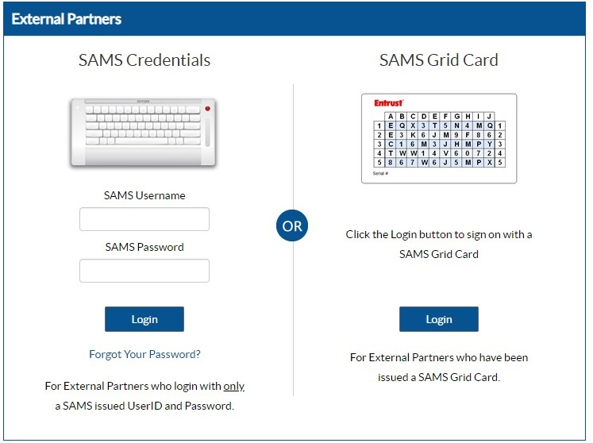
   * Airlines and aircraft operators that have lost or forgotten their SAMS credentials should contact the SAMS helpdesk at +1-877-681-2901 or [samshelp@cdc.gov](mailto:samshelp@cdc.gov). The SAMS Helpdesk is available Monday-Friday, 8:00AM to 6:00PM EST (excluding U.S. federal holidays).
3. Click the Data Upload hyperlink for your airline or operator under “Traveler Data Upload” 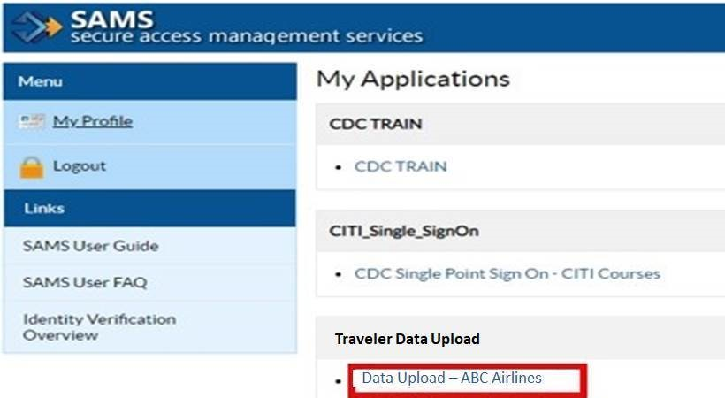
4. To upload a file, from the top of any folder list, click Upload > Upload Files.  
   Select one or more files, and then upload them to the folder.
   1. Alternative: From an open folder on the desktop or enterprise content source, drag one or more files to the folder. Click the “Upload” button   
      Screenshot of the upload file options

Airlines and aircraft operators should only upload designated information that has been properly formatted using one of the approved methods listed in these Technical Instructions. Airlines and aircraft operators should not include any additional data other than the designated information for the passengers covered by the request from CDC.

**Transmitting Formatted, Designated Information Utilizing Secure File Transport Protocol (SFTP)**

1. Start the SFTP Client (the examples below utilize [FileZilla](https://filezilla-project.org/)) and enter the host information and the SAMS login credentials for the airline or aircraft operator to connect to the SFTP server.  
     
   Host: sftp://eft.cdc.gov  
   Username: enter assigned username  
   Password: enter provided password  
   Port: 22  
     
   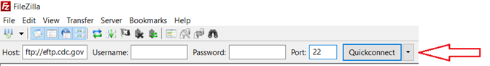
2. Users will now see a directory window like the one below. The list of files you have available may be different than what you see here.  
   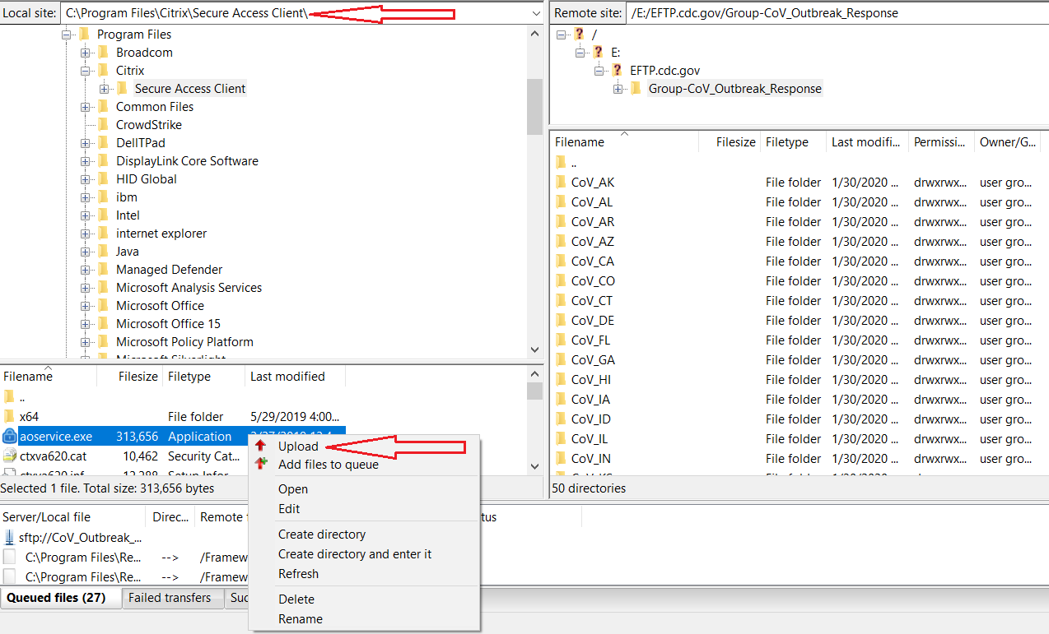  
   Locate your files/directories on the left side. The right side is the shared remote site and the left side is the local directory that is not shared with others.   
   IMPORTANT: If the files are not on your local drive, you may copy the network directory into the “local site” box and then locate the file(s) or directory.
3. Drag the files in to the folder assigned to the airline or aircraft operator on the right bottom side OR right-click on the applicable folder and select “Upload” from the menu and it will automatically be placed in the remote site.

CDC cannot provide technical assistance for downloading, installing, or updating third-party software. Airlines and aircraft operators should consult with their organization’s technical support team for any questions related to obtaining an SFTP client. CDC will work with airlines and aircraft operators during the onboarding process to ensure proper connectivity and troubleshoot transmission issues.

Airlines and aircraft operators should only upload designated information that has been properly formatted using one of the approved methods listed in these Technical Instructions. Airlines and aircraft operators should not include any additional data other than the designated information, unless otherwise requested by CDC.

**Temporary Option: Transmitting Designated Information Using Encrypted Email**

CDC will temporarily allow airlines and aircraft operators that are unable to transmit formatted, retained information using SDX to submit information using encrypted email. This temporary option requires pre-arrangement with CDC. To make these arrangements, airlines or aircraft operators should email [eocgmtftasksuprt@cdc.gov](mailto:eocgmtftasksuprt@cdc.gov?subject=Ariline%20Request%20for%20Encrypted%20Email%20Option%20for%20Contact%20Information)for further instructions.

This temporary option expires on December 9, 2021 for the following:

* all operations conducted under 14 CFR part 121, including operations that are conducted as public charters under 14 CFR part 380;
* all operations conducted under 14 CFR part 129, including operations that are conducted as public charters under 14 CFR part 380; and
* all on-demand operations conducted under 14 CFR part 135 on airplanes having a passenger-seat configuration of 10 seats or more, when such operations are conducted as public charters under 14 CFR part 380.

This temporary option expires on January 23, 2022 for the following:

* all passenger-carrying operations conducted under 14 CFR part 91, including operations under fractional ownership programs;
* all operations conducted under 14 CFR part 125;
* all commuter operations conducted under 14 CFR part 135;
* all on-demand operations conducted under 14 CFR part 135 on airplanes having a passenger-seat configuration of 9 seats or less, when such operations are conducted as public charters under 14 CFR part 380; and
* all on-demand operations conducted under 14 CFR part 135 on airplanes having a passenger-seat configuration of 30 seats or less, when the departure time, departure location, and arrival location are specifically negotiated with the customer or the customer's representative.