**Instrument 1: Implementation Plan Template**

|  |
| --- |
| The Paperwork Reduction Act Statement: The referenced collection of information is voluntary and will be used to systematically document *Child Welfare Community Collaborations to Strengthen and Preserve Families* (CWCC)grantees’ implementation plans. Information provided in this collection will be kept private. The time required to complete this collection of information is estimated to average 10 hours per response, including the time to review instructions and complete and review the collection of information. An agency may not conduct or sponsor, and a person is not required to respond to, a collection of information unless it displays a currently valid OMB control number. The valid OMB control number for this collection is 0970-0531, which expires on 7/31/2022. Send comments regarding this burden estimate or any other aspect of this collection of information, including suggestions for reducing this burden, to James Bell Associates, 3033 Wilson Boulevard, Suite 650, Arlington, VA 22201, Attn: Elliott Graham |

**2019 COMMUNITY COLLABORATIONS TO STRENGTHEN AND PRESERVE FAMILIES**

**IMPLEMENTATION PLAN TEMPLATE**

Children’s Bureau (CB) discretionary grants offer awardees an opportunity to develop new and innovative approaches to addressing child abuse and neglect. Once grants are awarded, grantees can begin to put their proposed vision into action. While the grant award itself is an indication of your organization’s capability and capacity to implement a federally funded project, careful planning, systematic implementation, and rigorous evaluation will further promote the success of your project and help build evidence for its impact on children and families involved in the child welfare system.

To ensure a strategic and deliberate approach to implementation, your discretionary grant includes a 10-month collaborative planning process. During this planning period awardees will develop a formal Implementation Plan to document how their grant-funded projects will be implemented. This Plan will include a detailed work plan that delineates key activities and milestones for all five years of the project.

This document serves as a template for your Implementation Plan. The sections and topics included in the template will help you articulate the specific strategies, practices, and activities you plan to implement in a systematic manner, and will guide your implementation process over the next five years. While CB understands that certain details of your project may not be finalized during its early stages and that certain project components may need to be revised over time, you should include as much information in the Plan as you are able at this time. In addition, grantees should use the plan to describe existing or potential barriers to implementation, as well as areas in which they could benefit from technical assistance or input from their fellow grantees.

A draft of the Plan must be submitted to the CB for review no later than **May 29, 2020**; you will receive feedback from your Federal Project Officer and implementation TA provider by **June 26, 2020**. A finalized Plan must be submitted to CB by **July 31, 2020**. Each section of the template includes a text box in which you can add the information requested for each section; however, you do not need to limit your responses to the space in the text boxes, and you should feel free to include appendices and any additional materials needed to ensure you submit a comprehensive and detailed plan.

In developing your plan, we encourage you to incorporate concepts described in the Capacity Building Center for State’s (CBCS) Change and Implementation Practice Series, which provides guidance on developing and implementing strategies, practices, and activities in child welfare. An introductory brief to this series and related resources can be found at: <https://capacity.childwelfare.gov/states/focus-areas/cqi/change-implementation/>. Figure 1 from the brief provides an overview of the key phases of the implementation process that should be followed to ensure effective implementation.

**Figure 1. Key Implementation Phases**

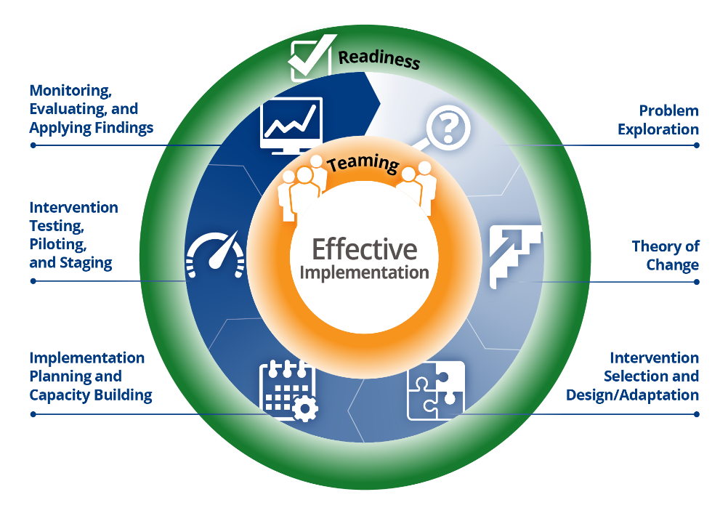

**SECTION 1: INTRODUCTION**

Provide a general overview of your organization, funded project, and your approach to implementing it and achieving your desired results. This section should include:

* A brief description of your organization and your key partner organizations
* The overarching philosophy that will guide implementation, e.g., core values and principles, organizational strategies that have informed similar initiatives
* A description of the team responsible for developing this plan, and the roles/responsibilities of team members in drafting it
* The process you employed to create the plan, e.g., regular meetings, an initial draft created by one person followed by rounds of review and editing

Narrative

*You can use this text box or attach your narrative. Do not limit your response to the space in the box.*

**SECTION 2: PROBLEM EXPLORATION AND TARGET AREA FOR PROJECT IMPLEMENTATION**

Provide a detailed description of the problem(s) your funded project seeks to address and the geographic area your project will serve. The CBCS’ brief on problem exploration and related resources may be helpful in developing this component of your Plan: <https://capacity.childwelfare.gov/states/focus-areas/cqi/change-implementation/problem-exploration/>. At a minimum, this section of your Plan should include the following:

* An overview of the identified problem(s) and/or needs in the community(ies) in which you will implement the project
* Data analyses used to explore the needs, local barriers, and challenges in your target communities and to identify those at greatest risk of child maltreatment
* The results of these analyses
* Contributing factors to the problems/needs identified through your analyses, and possible root causes of the problems/needs
* Based on the above analyses, a reassessment of child welfare barriers and challenges in your target community related to the prevention of child maltreatment and out-of-home placement
* A clear and precise definition of your project’s target geographic area, including the demographic and case characteristics of children/families residing in it, key risk factors and inclusion/exclusion criteria. Include a sound rationale for selecting this population based on the problem exploration and root cause analyses you described earlier. Indicate the estimated number of individuals, cases, or families in the target geographic area that will be served during the first and subsequent years of your project

Narrative

*You can use this text box or attach your narrative. Do not limit your response to the space in the box.*

**SECTION 3: THEORY OF CHANGE**

Create a detailed and comprehensive theory of change (TOC) that clearly demonstrates how and why your project will achieve its stated goals. The CBCS’ TOC brief and related resources may be helpful in developing this component of your Plan: <https://capacity.childwelfare.gov/states/focus-areas/cqi/change-implementation/theory-of-change/>. Figure 2 below illustrates the basic components of a TOC. (Note: Your root cause analysis may have already been addressed in Section 2: Problem Exploration):

**Figure 2: TOC Components**

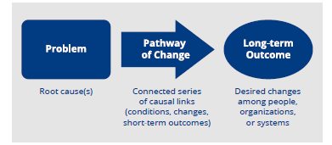

At a minimum, this section of your Plan should include the following:

* The specific long-term outcomes you seek to achieve. The FOA for your grant identified the following as required targeted outcomes:
  + Reduction of new referrals to the public child welfare agency
  + Reduction of entries into the foster care system
* Pathways of change: The specific conditions or changes that need to occur to address the root cause(s) of the problem(s) you seek to address and the causal linkages between these changes that will lead to improved long-term outcomes. (Note: It may be helpful to articulate these pathways of change using the “staircase” or “so that” chains described in the CBCS’ TOC brief). Include as many short-term and intermediate steps as you think are necessary to explain how you will achieve your desired outcomes
* The assumptions, beliefs, and expectations that condition the causal links you’ve identified between the root causes of the problems you seek to address and your ultimate outcomes. (For example, if your project involves staff training one of your assumptions might be that all targeted staff will in fact complete the training)

Narrative

*You can use this text box or attach your narrative. Do not limit your response to the space in the box.*

**SECTION 4: INTERVENTION**

Provide a detailed overview of your proposed intervention. The CBCS’ brief and related resources on Intervention Design and Selection/Adaptation may be helpful in developing this component of your Plan: <https://capacity.childwelfare.gov/states/focus-areas/cqi/change-implementation/intervention-selection-design-adaptation/>. At a minimum, this section of your Plan should include the following:

* A comprehensive description of your intervention, including the specific strategies, programs, practices, services, and activities you will implement. For each strategy, program, etc., provide the following information:
  + Core components (i.e., the essential features/functions that make it “work”) that make up the strategy, program, etc.
  + Operational definitions of the core components, i.e., specific activities, processes, etc., required to carry out each component
* The process used to research, design, and/or select your intervention’s specific strategies, programs, etc. Discuss:
  + Relevant literature that provides evidence to support your proposed strategies, programs, services, etc., and that links them to your project’s desired outcomes
  + If little or no research exists, a clear theoretical model or foundation that justifies your selection of the strategies, programs, etc. described above
* Based on the empirical and/or theoretical evidence provided above, describe the “fit and feasibility” of the intervention for your target population:
  + Why were your specific strategies, programs, services, etc. designed or selected instead of other possible options/solutions?
  + How will your specific strategies, etc. best address the needs and challenges of your target population(s)?
* Benchmarks, indicators, or measures that will be used to demonstrate that each component has been fully operationalized (Note: This information may also be included in your accompanying Evaluation Plan )
* If you are replicating an evidence-based program/practice (EBP), describe how you will maintain fidelity to the essential features that make the intervention evidence-based
* If you are adapting or modifying an existing EBP, document the specific change(s) you are making and the reasons for doing so
* If you are designing your intervention or one or more core components of it from scratch, provide a justification for doing so rather than selecting an available EBP, service model, etc.
* The individual impact of each core component
* The collective impact/effects of the intervention’s core components working in tandem
* For existing EBPs or other established programs/practices, include copies of any relevant manuals, handbooks, or related documentation in an appendix, or provide online links to these materials

It may be helpful to use the table below to summarize your intervention. Add additional rows as needed.

|  |  |  |  |  |  |  |
| --- | --- | --- | --- | --- | --- | --- |
| **Strategies, Programs, Practices, Services, Activities** | **Replicate, Adapt or Design (i.e., build from scratch)** | **Developer (Indicate “NA” if the component is “from scratch”** | **Core Components (i.e., essential features, functions)** | **Operational Definitions (i.e., specific activities, processes, etc.)** | **Benchmarks, indicators, measures used to demonstrate implementation** | **Individual Impact(s)** |
|  | * Replicate * Adapt * Design |  |  |  |  |  |
|  | * Replicate * Adapt * Design |  |  |  |  |  |
|  | * Replicate * Adapt * Design |  |  |  |  |  |

* Describe the anticipated major challenges to and facilitators of the full implementation of your intervention. This may include a discussion of the following variables and factors:
  + ***Influence Factors*:** Organizations exist in a shifting ecology of community, governmental, social, economic, cultural, political, and policy environments. Describe how these various contexts and environments may enable and/or impede the implementation and scaling up of your project
  + ***Organizational Components***. Your organization must make decisions about the selection and hiring of personnel, administrative supports, cooperation with external systems to assure adequate funding and support, etc. Describe how these or similar organizational factors may support and/or impede the implementation and scaling up of your project
  + ***Core Implementation Components*:** Core implementation components include intervention-specific and wider organizational characteristics and processes that are essential for the successful implementation of a project. These are also referred to as ***implementation drivers***

**Figure 3: Implementation Factors and Components**

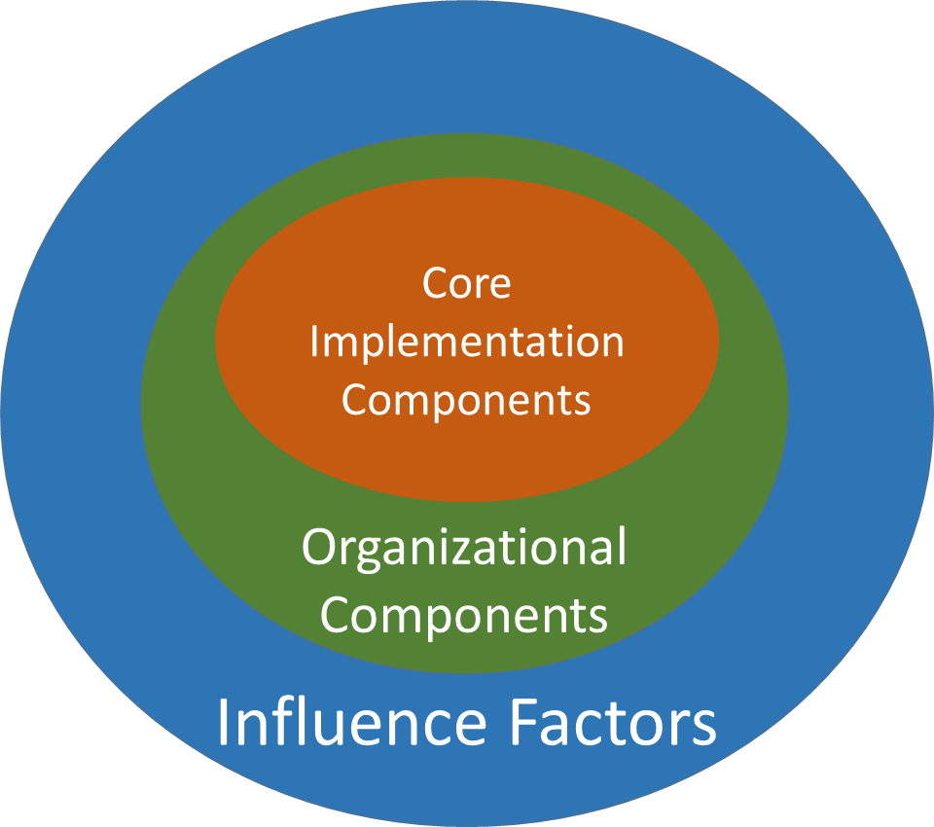

* + Implementation drivers can be organized into the following categories:
    - ***Competency drivers*** include decisions and activities around staff selection, training, and coaching
    - ***Organization drivers*** incorporate organizational infrastructure, policies, and procedures, e.g., information management/data systems, administrative systems/processes for scheduling appointments and assigning cases
    - ***Leadership drivers*** include the skills and experience required of supervisors, managers, and other organizational leaders to successfully implement the project. Leaders may be “adaptive” (i.e., are effective where there is little agreement and certainty when implementing a new intervention; can recognize and navigate layers of complexity within an organization) or “technical” (i.e., are effective when there is substantial agreement about what needs to be done and reasonable certainty about how to do it; can respond to issues, organize teams, and ensure timely implementation)

Figure 4 illustrates the relationships among these three implementation drivers and provides specific examples of each[1]:

**Figure 4: Implementation Drivers**



* ***Identify the specific implementation drivers that will have the greatest impact on the implementation of your intervention.*** Describe how they will facilitate the implementation of your project, or how they made impede implementation if they are insufficiently developed within your organization or implementation team.

Narrative

*You can use this text box or attach your narrative. Do not limit your response to the space in the box.*

**SECTION 5: IMPLEMENTATION TEAM(S)**

Identify and describe the implementation team(s) that will be responsible for planning, implementing, and overseeing the project, including key partner organizations and collaborative partners. The CBCS’ brief and related resources on Teaming may be helpful in developing this component of your Plan: <https://capacity.childwelfare.gov/states/focus-areas/cqi/change-implementation/teaming/>.

At a minimum, this section of your Plan should include the following:

* Core team members and project partners, including (as appropriate):

|  |  |
| --- | --- |
| * Public CW agency (required) * Youth and families with lived experience (required) * Legal and judicial community (required) * Family assistance program/agency (i.e. Title V maternal and child health services agency, Temporary Assistance for Needy Families (TANF), Low Income Home Energy Assistance Program (LIHEAP)) (required) * CBCAP grantee (required) * Public housing (required) * Public health agency (required) * Health and mental health agencies * Substance abuse treatment services * Juvenile justice agencies * Child support agencies * Fatherhood programs * Home visiting programs * Early childhood programs * Child care programs * Law enforcement | * Workforce development programs * Youth/adult education providers * Healthy marriage initiatives * Transportation services * Faith- and community-based providers * Prevention services providers * Other |

Note: If the team(s) do not include the organizations required in the FOA, provide an explanation and describe your plans for engaging these organizations or otherwise addressing their lack of participation

* Teaming structure and relationships among project partners as illustrated through an organizational chart or similar methods
* A description of how the leadership and teaming structures are linked and/or interact with the broader service system and/or target community
* Partners' shared values and principles, and how they will strengthen cross-system collaboration and facilitate the successful implementation of the project
* The status of organizational agreements to facilitate implementation of the project (i.e., whether MOUs, data sharing agreements, and other agreements are in place, or when these are expected to be in place). In addition, describe policies, procedures, and protocols for:
  + Maintaining joint accountability for implementation and shared project outcomes
  + Coordinating services and supports
  + Reviewing the structure, purpose, and membership of the implementation team(s) on a regular basis
  + Sharing information across organizations and systems, including data used for implementation, evaluation, or research purposes
  + Ensuring ongoing communication, consultation, and interaction across project partners
  + Implementing cross-training and staff development
  + Managing and coordinating activities carried out by projects partners, subcontractors, and consultants, including the coordination of internal and external TA providers, if applicable;
  + Monitoring implementation progress, including the ongoing identification of implementation barriers or emerging implementation issues and how they will be addressed
* Financial commitments of key organizations/partners beyond the amounts allocated through the discretionary grant itself
* Key personnel that will be assigned to work on the project, including, as appropriate, Project Directors, Project Managers/Coordinators, direct service staff, etc.
  + Indicate whether these key personnel are already in place or their expected hire/begin date.
  + Indicate the amount of time each key project team member has been allocated to work on the project (expressed in FTEs if possible).
* Potential challenges and barriers to effective teaming and project coordination, and plans to address them
* Include as appendices copies of the following, as appropriate and available:
  + Your current team charter. This document should articulate the implementation team's purpose and scope, roles and responsibilities, and communication processes.
  + Memorandums of Understanding (MOUs) or Agreement (MOAs)
  + Dating sharing agreements
  + Other documents (e.g., charts, memorandums) that will guide the governance and implementation of the project

Narrative

*You can use this text box or attach your narrative. Do not limit your response to the space in the box.*

**SECTION 6: IMPLEMENTATION READINESS AND CAPACITY BUILDING**

Provide an assessment of your Implementation Team’s readiness to implement your project and plans to enhance the Team’s capacity to implement it, including the processes you used to assess readiness and build capacity. The CBCS’ brief and related resources on Readiness may be helpful in developing this component of your Plan: <https://capacity.childwelfare.gov/states/focus-areas/cqi/change-implementation/readiness/>. It may also be helpful to frame your discussion of readiness and capacity using the three concepts described in Figure 5: (1) Motivation; (2) General or Foundational Capacity; and (3) Strategy, Practice, or Activity-Specific Capacity:

**Figure 5: Dimensions of Readiness and Capacity**

|  |  |  |
| --- | --- | --- |
| **Motivation** | **General/Foundational Capacity** | **Strategy, Practice, or Activity-Specific Capacity** |
| * Belief that change is needed/valuable * Belief that the selected strategy, practice, or activity is: * Compatible with existing practices, protocols, services * Doable/manageable * Important (i.e., it should be a priority) * Recognition that the strategy, practice, or activity has: * Advantages relative to other strategies, practices, or activities * Clear benefits/positive outcomes | * Leadership * Organizational innovativeness/receptivity to change * Organizational culture (shared behaviors and norms) * Organizational climate (staff perceptions of work environment) * Resource availability/use * Supportive organizational structures * Staff capacity | * Leadership buy-in and support * Program champions * Strategy, practice, or activity-specific knowledge, skills, and abilities * Implementation supports and structures * Relationships and networks |

***Readiness Assessment:*** With respect to readiness assessment, this section of your Plan should include, at a minimum, the following:

* An overview of how you assessed implementation readiness, including a description of any specific tools, processes, or methods that were used (Note: Include any readiness assessment tools/instruments in an appendix)
* An overview of the results of your assessment (including strengths to build on and barriers and challenges to address)

***Capacity Building***: Capacity building is a deliberate and structured approach to preparing for change. It is a dynamic and iterative process, and some areas of capacity may need to be developed or revisited over time. Given time and resource constraints, your Team may need to be strategic in deciding which areas to focus capacity building efforts and how to stage them over time. With respect to capacity building, this section should include, at a minimum, a description of your plan to:

* Build organizational capacity in areas that will be most critical to the successful implementation of the project. Per Figure 5 above, the focus of your capacity building efforts might be at the motivational, general (foundational), and/or strategy/practice/activity-specific level
* Increase motivation and buy-in: Describe in particular efforts to enhance the interest, buy-in, and motivation of front-line staff, community members, and other key stakeholders to implement, participate, or otherwise engage in the project
* Build on strengths: While many capacity-building activities focus on areas of need, it is also important to identify existing strengths that can be leveraged to further build capacity. For example, internal experts or “champions” of an existing intervention may be able to build motivation and buy-in among staff

Narrative

*You can use this text box or attach your narrative. Do not limit your answer to the space in the box.*

SECTION 7: Initiating and sustaining implementation

Describe plans to plan for, initiate, and sustain your funded project. At a minimum, this section of your Plan should address the following:

* ***Usability testing*** that is planned or that has been completed, including results and lessons learned from completed tests. Usability testing helps teams try out critical components of a strategy, practice, service, or activity and assess their functionality and feasibility in practice. It may be particularly helpful to test tools, forms, and processes that are being used or adapted for the first time, and then refine them, as needed, following the test period. See James Bell Associates’ Formative Evaluation Toolkit for more information on usability testing: <https://www.jbassoc.com/wp-content/uploads/2019/01/Formative-Evaluation-Toolkit.pdf>
* ***Pilot testing*** that is planned or that has been completed, including results and lessons learned from any completed pilots. A pilot test is a “trial run” that involves implementing the strategy, practice, service or activity in its entirety on a small scale, e.g., in a selected geographic area or with a portion of a larger target population. A pilot test provides a valuable opportunity to see if implementation “works,” identify and fix potential problems, and modify the intervention if necessary before full-scale implementation is attempted
* ***Transformation zone projects*** that are planned or that have been completed, including results and lessons learned from completed pilots. In this approach, an organization introduces a strategy, practice, or activity and builds capacity to implement it in a “vertical slice” of the agency, e.g., within selected offices, departments, or divisions. Transformation zones provide an opportunity try out an intervention in a manageable way that does not involve the entire organization, and observing its effects on various aspects of the system
* Plans and processes for selecting sites (e.g., geographic regions, offices) for initial implementation and preparing them for implementation
* Initiating service delivery, including processes for:
  + Screening and assessment of potential service recipients
  + Receiving and managing service referrals
  + Processes and protocols for enrolling new families, cases, etc.
  + Roll-out of new practices, services, etc., including any required staff training
  + Coordination of services among project partners
* Ongoing training, coaching, and staff development
* ***Sustainability planning***: Although you are just at the beginning of your funded projects, it is not too early to begin thinking about the long-term sustainability of your project post-grant. Document any current plans or preliminary thinking about the sustainability of your intervention, or components of it, in terms of funding, staffing, training, organizational changes, etc. The Child Welfare Information Gateway has numerous resources on sustainability planning that may be useful to reference in reflecting on and describing your sustainability plans: <https://www.childwelfare.gov/topics/management/funding/planning/sustainability/>

Narrative

*You can use this text box or attach your narrative. Do not limit your response to the space in the box.*

**SECTION 8: QUALITY ASSURANCE AND CONTINUOUS QUALITY IMPROVEMENT**

Describe your quality assurance (QA) and continuous quality improvement (CQI) plans for the project, i.e., activities you will implement to maintain the integrity and quality of implementation over time and to use information collected throughout the grant cycle to assess and improve project activities. (Note: Some of these activities may overlap with your evaluation plan and activities. Coordinate with your evaluation team around these activities as needed.) At a minimum, this section of your Plan should address the following:

* Your overarching approach/model for QA or CQI, if relevant (e.g., Plan Do Study Act)
* Selection or creation of indicators of implementation quality (including measures of implementation fidelity), and associated data collection tools/instruments
* Establishment of benchmarks, milestones, or performance targets for the quality indicators, as appropriate
* Procedures for tracking/monitoring quality over time (e.g., frequency of data collection, where data will be stored/maintained for future analysis)
* Persons or team responsible for tracking and reporting QA and CQI data
* Persons or team responsible for reviewing QA and CQI findings and making decisions or recommendations regarding changes to the intervention

Resources that may be useful in creating your QA/CQI plans include the Child Welfare Information Gateway’s CQI resource page (<https://capacity.childwelfare.gov/states/focus-areas/cqi/>) and the Children’s Bureau’s *Guide to Data Driven Decision Making* (<https://www.acf.hhs.gov/sites/default/files/cb/guide_to_dddm.pdf>)

Narrative

*You can use this text box or attach your narrative. Do not limit your response to the space in the box.*

**SECTION 9: COMMUNICATION AND DISSEMINATION**

Document your overall approach and specific strategies for communicating about your funded project and for disseminating information about it to internal and external stakeholders. At a minimum, this section of your Plan should address the following:

* Strategies for engaging and communicating with:
  + Organizational leadership
  + Front-line/direct service staff
  + Partner agencies (e.g., courts, community organizations) or service providers involved in referrals, service delivery, or providing implementation support
  + Internal and external TA providers
  + Program participants/service recipients
  + Other prevention service providers
  + Other community-based service organizations
  + The broader child welfare field
  + Other stakeholders with an interest on investment in the project
* Strategies for:
  + Messaging and strengthening buy-in to the intervention
  + Communicating and addressing concerns about modifications to the project over time
  + Communicating and presenting findings and lessons learned from the project evaluation
* Specific communication and dissemination methods:
  + News/press releases
  + Public information sessions
  + Newsletters
  + Internal progress reports
  + Internal briefings
  + External presentations
  + Social media (e.g., Twitter, Facebook, podcasts)
  + Journal articles or other academic publications
* Note in particular plans to foster and strengthen knowledge sharing with other community-based prevention service programs, as well as to disseminate findings and lessons learned within the child welfare field more broadly, including through the Child Welfare Information Gateway and other knowledge dissemination portals

Resources that may be helpful in developing your communication and dissemination strategy include the following:

* James Bell Associates’ brief titled *Reporting and Presenting Evaluation Findings*: <https://www.jbassoc.com/wp-content/uploads/2018/03/Reporting-Presenting-Evaluation-Findings.pdf>
* The Child Welfare Information Gateway’s *Dissemination Factsheet for CB Discretionary Grantees*: <https://www.childwelfare.gov/pubPDFs/cbdgdissemination.pdf>
* The Permanency Innovation Initiative’s tip sheet titled *Dissemination: Top 10 Tips*: <http://static.coreapps.net/nccan2016/handouts/4a83aded1b48a9819f33c94e3e371e1d_3.pdf>

Narrative

*You can use this text box or attach your narrative. Do not limit your response to the space in the box.*

**SECTION 10: TECHNICAL ASSISTANCE NEEDS**

Identify any areas in which your project currently needs implementation/programmatic TA or in which it may benefit from TA in the future. Consider and describe potential TA needs in each of the areas covered in your Implementation Plan:

* Problem Exploration and Target Population
* Theory of Change
* Intervention Design/Selection
* Implementation Teams
* Implementation Readiness and Organizational Capacity
* Initiating and Sustaining Implementation
* QA/CQI
* Communication and Dissemination

Narrative

*You can use this text box or attach your narrative. Do not limit your response to the space in the box.*

**SECTION 11: WORK PLAN AND TIMELINE**

Create a timeline that outlines the critical steps and phases in planning, starting, and scaling up your funded project. To the extent possible, the timeline should delineate: (1) specific tasks and activities; (2) the timeframes for beginning and completing them; (3) the person(s) and/or team(s) responsible for each task/activity; and (4) milestones or deliverables that serve as benchmarks of progress. The work plan covering the first year of the grant should be as detailed as possible; plans for subsequent years can be more general at this point, e.g., indicating less specific timeframes or “TBD” for certain task assignments.

You may use the template below to complete your work plan or use an alternative format, such as a Gantt chart, as long as it includes all of required information noted above. Add as many additional categories, activities, and tasks as needed.

Pre-Implementation Phase (10-month Planning Period)

Note: Certain pre-implementation activities (e.g., pilot testing) may extend into or begin during the Implementation Phase

| **Activity/Task** | **Timeframe**  *(Expected start and completion dates)* | **Milestone(s)**  *(Specific deliverables or other indicators of task completion)* | **Person(s)/Team(s) Responsible**  *(Lead person(s) or team(s)/sub-team(s))* | **Comments/Notes** |
| --- | --- | --- | --- | --- |
| Problem Exploration and Identification of Target Population | | | | |
|  |  |  |  |  |
|  |  |  |  |  |
| Theory of Change | | | | |
|  |  |  |  |  |
|  |  |  |  |  |
| Design, Selection, and/or Adaptation of Strategies, Practices, Services, Activities | | | | |
|  |  |  |  |  |
|  |  |  |  |  |
| Establishing Implementation Teams (e.g., hiring key staff, engaging implementation partners) | | | | |
|  |  |  |  |  |
|  |  |  |  |  |
| Implementation Readiness and Organizational Capacity Building | | | | |
|  |  |  |  |  |
|  |  |  |  |  |
|  |  |  |  |  |
| Site Selection | | | | |
|  |  |  |  |  |
|  |  |  |  |  |
| Usability Testing (if appropriate) | | | | |
|  |  |  |  |  |
|  |  |  |  |  |
| Pilot Testing (if appropriate) | | | | |
|  |  |  |  |  |
|  |  |  |  |  |

Implementation Phase (Last 2 months of Year 1 and All Subsequent Grant Years)

| Activity/Task | Timeframe  *(Expected start and completion dates)* | Milestone(s)  *(Specific deliverables or other indicators of task completion)* | Person(s)/Team(s) Responsible  *(Lead person(s) or team(s)/sub-team(s))* | Comments/Notes |
| --- | --- | --- | --- | --- |
| Start-up and Early Implementation | | | | |
|  |  |  |  |  |
|  |  |  |  |  |
| Scaling Up and Ongoing Implementation | | | | |
|  |  |  |  |  |
|  |  |  |  |  |
| Fidelity Monitoring, Quality Assurance, and CQI | | | | |
|  |  |  |  |  |
|  |  |  |  |  |
| Communication and Information Dissemination | | | | |
|  |  |  |  |  |
|  |  |  |  |  |
| Reporting (including required progress reports to CB) | | | | |
|  |  |  |  |  |
|  |  |  |  |  |
| Sustainability Planning | | | | |
|  |  |  |  |  |
|  |  |  |  |  |

**IMPLEMENTATION PLAN FORMATTING AND CONTENT GUIDELINES**

When drafting your plan, consider following these formatting and content guidelines:

* Use 12-point font and 1-inch margins. Number all pages for ease of reference
* Structure the Plan using the numbered subject headings in this template to ensure you address all required plan components
* In cases where information is complete and accurate, you may integrate previously developed material from your original grant proposal, planning documents, or other relevant materials
* If certain content has been adequately covered in previous sections, note this in subsequent sections rather than repeating it (e.g., “Please see Section *X* on page *x* for more information on this topic.”)
* Use graphics, including charts and tables, when doing so improves clarity and specificity
* Note any naming conventions used to identify elements of your project or organizations involved in implementing it, e.g., commonly used acronyms or abbreviations

1. Visit the National Implementation Research Network’s (NIRN) website for more information about implementation drivers: <https://nirn.fpg.unc.edu/module-1/implementation-drivers>