Caseworker Lead Letter
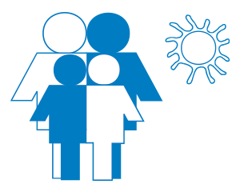 | National Survey of Child and Adolescent Well-Being
RTI International PO Box 12194 Research Triangle Park, North Carolina 27709l USA
Sponsored by: Administration for Children and Families
Conducted by: RTI International The University of North Carolina at Chapel Hill Washington University in St. Louis

Dear [CASEWORKER NAME],

The Administration for Children and Families (ACF), an agency within the U.S. Department of Health and Human Services, provides funding for activities related to the interests of children and families. ACF has hired RTI International (RTI) to conduct the National Survey of Child and Adolescent Well-Being (NSCAW).

NSCAW is the only source of nationally representative information on children and families being served by the child welfare system. NSCAW also offers the unique opportunity to learn more about the work experiences of the staff who serve these vulnerable children and families. In this phase of the study, we are asking agency directors/administrators, supervisors, and caseworkers in agencies participating in NSCAW to share their work experiences. ACF will use the information collected to make improvements to child welfare policies and practice.

Your agency agreed to help us with this important study. You were randomly selected for participation from a list of caseworkers who report to your supervisor. This one-time survey will take about 50 minutes to complete. The survey will ask about your roles and responsibilities as a caseworker, your educational background and skills, training and professional development, job performance and satisfaction, your relationship with your supervisor, and how the COVID-19 pandemic may have influenced your work.

A local interviewer will contact you to answer any questions you may have and to schedule your survey. We understand the heavy demands on your time. The interviewer will work with you to schedule the survey at a convenient time. If needed, the survey can be completed in more than one session. We will use the information you share for research purposes only and will keep your information private to the extent permitted by law. Reports or data files released by RTI will not identify you or any other participant.

The success of the study depends on those selected to take part. Thank you in advance for your support.

Sincerely yours,

Christine Fortunato, Ph.D., Project Officer
Administration for Children and Families

Participation in the described collection of information is voluntary. An agency may not conduct or sponsor, and a person is not required to respond to, a collection of information unless it displays a currently valid OMB control number. The OMB number for this information collection is 0970-0202 and the expiration date is XX/XX/XXXX.

