INSTRUMENT 3
Engagement Interview Guide

This page has been left blank for double-sided copying.

Early Care and Education Leadership Study (ExCELS)

Engagement Interview Guide

Introduction
[INTERVIEWER NOTES APPEAR IN ALL CAPS. DO NOT READ THIS TEXT OUT LOUD TO THE RESPONDENT.]
[REVISE THE FIRST SENTENCE IF YOU SPOKE DIRECTLY WITH THE PRIMARY SITE LEADER WHEN RECRUITING THE CENTER TO PARTICIPATE IN THE STUDY.]
Hello [PRIMARY SITE LEADER’S LAST NAME], my name is [LIAISON] and I am calling from Mathematica about your center’s participation in the Early Care and Education Leadership Study (also known as ExCELS). Thank you again for agreeing to participate in ExCELS and speaking with me today.
During today’s interview I will collect basic information about your center to confirm your center’s eligibility to participate in the study. We expect this interview to take about 20 minutes to complete.

[SKIP THIS SECTION IF YOU SPOKE DIRECTLY WITH THE PRIMARY SITE LEADER WHEN RECRUITING THE CENTER TO PARTICIPATE IN THE STUDY.]
Before we begin the interview, I want to make sure you are the primary site leader at [NAME OF CENTER]. That is, are you the person in the building who is responsible for oversight of all that happens in the center on a daily basis?
- [IF YES] Great. Could you please confirm your contact information? [CONFIRM TITLE, EMAIL ADDRESS, AND PHONE NUMBER COLLECTED DURING RECRUITMENT INTERVIEW.]
- [IF NO] This interview is intended for your center’s primary site leader. Again, we consider the center’s primary site leader the staff person in the building who is responsible for oversight of all that happens in the center on a daily basis. Could you provide me with the name, title, and contact information for that person? [COLLECT NAME, TITLE, EMAIL ADDRESS, AND PHONE NUMBER OF PRIMARY SITE LEADER AND END CALL.]

[ONLY MOVE FORWARD TO THE REST OF THE INTERVIEW IF YOU ARE SPEAKING WITH THE PRIMARY SITE LEADER.]
Taking part in ExCELS is voluntary. The purpose of this study is to learn about leadership in early care and education centers. There are no risks or direct benefits from taking part in the study. We will use the information the study collects only for research purposes and in ways that will not reveal who you are or identify your center or its staff. We have a certificate of confidentiality from the National Institutes of Health. It helps us protect your privacy. This means no one can force the study team to give out information that identifies you, even in court. However, in some cases federal or state laws might require us to show information to government officials or sponsors who monitor the safety of this study. Publications about the study will not identify anyone from the center. Nor will they identify the center itself. We will share some of the data the study collects with qualified individuals for research purposes. Nothing we share will identify people or specific centers. If you have questions about ExCELS, please contact Annalee Kelly, the survey director, at [STUDY PHONE] or by email at [STUDY EMAIL].
Before we get started, let me read you the following statement for your information: “Your participation is voluntary. An agency may not conduct or sponsor, and a person is not required to respond to, a collection of information unless it displays a currently valid OMB control number. The OMB number for this information collection is XXXX-XXXX and the expiration date is MM/DD/YYYY.”
Do you have any questions before we begin?

A. Center characteristics
To begin, I would like to confirm some information about your center.

A1. [CENTER IS PART OF A PUBLIC SCHOOL SYSTEM]
Does your center operate within a public school system?
SELECT ONE ONLY
1 Yes CONTINUE TO A1a
0 No SKIP TO A2

[ASK IF A1=1] A1a. Is there someone who oversees the center operations that is distinct from the principal or school administrator?
SELECT ONE ONLY
1 Yes CONTINUE TO A1b
0 No SKIP TO ELIGIBILITY CHECK BELOW

[ASK IF A1a=1] A1b. Does this person report to the principal or school administrator?
SELECT ONE ONLY
1 Yes CONTINUE TO ELIGIBILITY CHECK BELOW
0 No SKIP TO A2

ELIGIBILITY CHECK
[IF THE CENTER OPERATES WITHIN A PUBLIC SCHOOL SYSTEM, IT IS NOT ELIGIBLE TO PARTICIPATE IN ExCELS UNLESS IT HAS SOMEONE WHO OVERSEES THE CENTER OPERATIONS THAT IS DISTINCT FROM THE PRINCIPAL/SCHOOL ADMINISTRATOR AND THAT PERSON DOES NOT REPORT TO THE PRINCIPAL/SCHOOL ADMINISTRATOR.]: Unfortunately, at this time your center is not eligible to participate in ExCELS. We are unable to include centers that operate within a public school system and are overseen by the principal/school administrator or is overseen by a person that reports to the principal/school administrator. Thank you very much for your time and interest in participating. We will reach out in the future if our eligibility criteria change. [END CALL.]

A2. [CENTER AGENCY TYPE]
Is your center…? (N005)
SELECT ONE ONLY
1 A for-profit organization
2 A not-for-profit organization
99 Other (specify) ____________________________

A3. [CENTER IS PART OF A LARGER PROGRAM OR ORGANIZATION]
Is your center independently owned and operated or part of a larger organization? (N176)
Centers that are part of a larger organization include those that are corporate sponsored, part of a chain or franchise, part of a Head Start grantee program, or affiliated with a social service or human development agency, such as a YMCA or church. The larger organization may provide a combination of funding and administrative oversight or have reporting requirements. If the larger organization is solely a funding source, the center should be considered independently owned and operated.
SELECT ONE ONLY
1 Independently owned and operated
2 Part of a larger organization
d Don’t know

A4. [QRIS LEVEL]
Does your center currently participate in [NAME OF QUALITY RATING AND IMPROVEMENT SYSTEM]? (N015)
SELECT ONE ONLY
1 Yes CONTINUE TO A4a AND A4b
0 No SKIP TO A5
d Don’t know SKIP TO A5

[ASK IF A4=1] A4a. What is your center’s current rating? |___|___| RATING

[ASK IF A4=1] A4b. What month and year did your center receive this rating?
|___|___| MONTH |___|___|___|___| YEAR
d Don’t know

A5. [ACCREDITATION]
Is your center accredited by any of the following organizations? (N084)
SELECT ALL THAT APPLY (1,2,3,99) OR SELECT 0 ONLY
1 National Association for the Education of Young Children (NAEYC)
2 Council on Accreditation
3 National Early Childhood Program Accreditation
99 Another accrediting organization (specify) ____________________________
0 Center is not accredited by any accrediting body SKIP TO A6

[ASK IF A5 NE 0] A5a. What month and year did your center get accredited [IF MORE THAN ONE ACCREDITATION AT A5: most recently]?
|___|___| MONTH |___|___|___|___| YEAR
d Don’t know

A6. [EXTERNAL PROFESSIONAL DEVELOPMENT AND WORKFORCE SUPPORTS]
Since September 2021, have you or other management staff participated in a leadership institute, course, coaching, or another leadership development program?
SELECT ONE ONLY
1 Yes
0 No

B. Center operations
Let’s move on to your center’s operations.
B1. What days of the week does your center provide early care and education services to children?
SELECT ALL THAT APPLY
1 Monday
2 Tuesday
3 Wednesday
4 Thursday
5 Friday
6 Saturday
7 Sunday

B2. What are your center’s hours of operation? Are the hours the same every day or do they vary? [RECORD HOURS OF OPERATION BELOW]

B3. Does your center operate just a part-day program?
SELECT ONE ONLY
1 Yes CONTINUE TO ELIGIBILITY CHECK BELOW
0 No SKIP TO C1

ELIGIBILITY CHECK
[IF THE CENTER OPERATES A PART DATE PROGRAM]: Unfortunately, at this time your center is not eligible to participate in ExCELS. We are unable to include centers that are only open part-day in this study. Thank you very much for your time and interest in participating. We will reach out in the future if our eligibility criteria change. [END CALL.]

C. Funding
Next, I’d like to ask about your center’s funding. Please be as accurate as possible when answering the questions, but your best estimate is fine.
C1. [TYPE OF PUBLIC FUNDING]
Which of the following public programs provided funding to your center during the most recently completed fiscal year? (N177)
SELECT ALL THAT APPLY (1,2,3,99) OR SELECT 0 ONLY
1 Child care subsidy programs from [STATE SUBSIDY PROGRAM] or Child Care Development Fund (CCDF) (can include parent use of vouchers, contracted slots in the center, or tiered reimbursement)
2 Early Head Start or Head Start
3 State preschool or prekindergarten programs
99 Other (specify) ____________________________
0 No public funding

[ASK IF C1 = 1]
C2. [CCDF FUNDING (AS A PERCENT OF CHILDREN)]
For this next question, please think about children at your center from birth to age 5 and who are not yet in kindergarten. Do not include school-age children when answering this question.
C2a. About what percentage of children from birth to age 5 and not yet in kindergarten at your center receive child care subsidies from [STATE SUBSIDY PROGRAM] or Child Care Development Fund (CCDF)? (N187)
[IF RESPONDENT IS ABLE TO RESPOND, RECORD THE PERCENTAGE BELOW.]
|___|___| % OF CHILDREN
d Don’t know

[IF RESPONDENT IS UNABLE TO RESPOND OR SAYS THEY DO NOT KNOW, PROBE WITH THE FOLLOWING QUESTION.]
C2b. Would you say it is…
SELECT ONE ONLY
0 None SKIP TO C4
1 At least 1% but less than 25%
2 Between 25% and 50%
3 More than 50% but less than 75%
4 75% but less than 100%
5 Close to 100%

[IF RESPONDENT IS UNABLE TO ANSWER C2A or C2B PROBE: If you don’t know the answer, maybe there is someone at the center there with you that you can quickly consult with? I don’t mind holding.” IF NO: “I can call you back a little later today or tomorrow to gather this information. Would that be ok? Before I let you go, I want to preview a few more funding questions in case you might also need to gather this information before we speak again tomorrow. READ QUESTIONS C3, C4, AND C5. SCHEDULE A CALL WITH THE PRIMARY SITE LEADER AND END CALL.]

[ASK IF C2a OR C2b > 0]
C3. [CCDF FUNDING (OF TOTAL REVENUE)]
C3a. About what percentage of your total revenue was child care subsidy programs from [STATE SUBSIDY PROGRAM] or Child Care Development Fund (CCDF) funding? (N178)
[IF RESPONDENT IS ABLE TO RESPOND, RECORD THE PERCENTAGE BELOW.]
|___|___| % OF TOTAL REVENUE
d Don’t know

[IF RESPONDENT IS UNABLE TO RESPOND OR SAYS THEY DO NOT KNOW, PROBE WITH THE FOLLOWING QUESTION.]
C3b. Would you say it is 50% or more?
SELECT ONE ONLY
1 No, less than 50%
2 Yes, 50% or more

[IF RESPONDENT IS UNABLE TO ANSWER C3A or C3B PROBE: If you don’t know the answer, maybe there is someone at the center there with you that you can quickly consult with? I don’t mind holding.” IF NO: “I can call you back a little later today or tomorrow to gather this information. Would that be ok? Before I let you go, I want to preview a couple more funding questions in case you might also need to gather this information before we speak again tomorrow. READ QUESTIONS C4, AND C5. SCHEDULE A CALL WITH THE PRIMARY SITE LEADER AND END CALL.]

[ASK IF C1 = 2]
C4. [EARLY HEAD START / HEAD START FUNDING]
C4a. About what percentage of your total revenue was Early Head Start or Head Start funding? (N179)
[IF RESPONDENT IS ABLE TO RESPOND, RECORD THE PERCENTAGE BELOW.]
|___|___| % OF TOTAL REVENUE
d Don’t know

[IF RESPONDENT IS UNABLE TO RESPOND OR SAYS THEY DO NOT KNOW, PROBE WITH THE FOLLOWING QUESTION.]

C4b. Would you say it is 50% or more?
SELECT ONE ONLY
1 No, less than 50%
2 Yes, 50% or more

[IF RESPONDENT IS UNABLE TO ANSWER C4A or C4B PROBE: If you don’t know the answer, maybe there is someone at the center there with you that you can quickly consult with? I don’t mind holding.” IF NO: “I can call you back a little later today or tomorrow to gather this information. Would that be ok? Before I let you go, I want to preview another funding question in case you might also need to gather this information before we speak again tomorrow. READ QUESTION C5. SCHEDULE A CALL WITH THE PRIMARY SITE LEADER AND END CALL.]

[ASK IF C3(a OR b) AND C4(a OR b) < 50%]
C5. Would you say the combined funding your center gets from child care subsidy programs and Early Head Start or Head Start makes up 50% or more of total revenue?
SELECT ONE ONLY
1 No, less than 50% combined
2 Yes, 50% or more combined

[IF RESPONDENT IS UNABLE TO ANSWER C5 PROBE: If you don’t know the answer, maybe there is someone at the center there with you that you can quickly consult with? I don’t mind holding.” IF NO: “I can call you back a little later today or tomorrow to gather this information. Would that be ok? SCHEDULE A CALL WITH THE PRIMARY SITE LEADER AND END CALL.]

ELIGIBILITY CHECK
ENTER RESPONSES TO FUNDING QUESTIONS IN COLUMN C.
A | B | C
C2a | Enter % or DK.
C2b | Enter 0, 1, 2, 3, 4, or 5.
C3a | Enter “50% or more” or “< 50%” depending on % response, or enter DK.
C3b | Enter “50% or more” or “< 50%”.
C4a | Enter “50% or more” or “< 50%” depending on % response, or enter DK.
C4b | Enter “50% or more” or “< 50%”.
C5 | Enter “50% or more” or “< 50%”.

FOLLOW FLOW CHART TO DETERMINE ELIGIBILITY BASED ON RESPONSES NOTED IN THE TABLE ABOVE. IF C2a, C3a, OR C4a ARE “DON’T KNOW” USE THE RESPONSES TO C2b, C3b, AND C4b TO DETERMINE ELIGIBILITY.

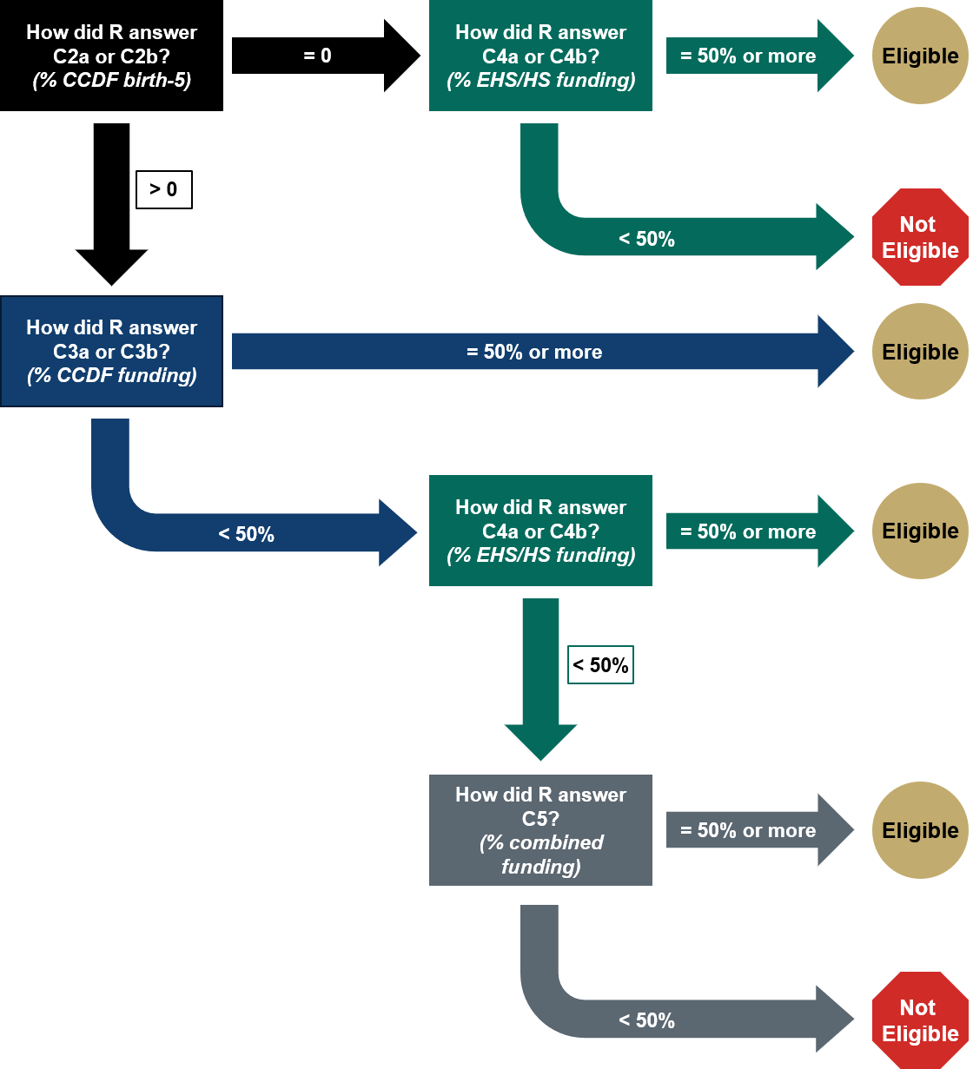
R= respondent
[IF THE CENTER IS NOT ELIGIBLE TO PARTICIPATE IN ExCELS.]: Unfortunately, at this time your center is not eligible to participate in ExCELS. We are looking for centers that receive at least half of it’s funding from Early Head Start or Head Start or CCDF child care subsidy programs. Thank you very much for your time and interest in participating. We will reach out in the future if our eligibility criteria change. [END CALL.]

D. Center size and the families and children served
Now I’d like to learn more about your center’s size and the families and children it serves.

D1. [CENTER’S CURRENT ENROLLMENT]
What is the center’s current enrollment? (N002)
|___|___|___| NUMBER OF CHILDREN ENROLLED

D2. [AGES SERVED]
What are the ages of children enrolled at the center? (N021)
SELECT ONE ONLY
1 Infants and toddlers only (birth to age 3)
2 Infants, toddlers, and preschool (birth to age 5, but not yet in kindergarten)
3 Preschool only (age 3 to age 5, but not yet in kindergarten)
SELECT IF IT APPLIES
4 School-age child care (kindergarten and older)

D3. [NUMBER OF CLASSROOMS SERVING 0-5]
Let’s focus on those children younger than school age. How many classrooms serve children from birth to age 5 and who are not yet in kindergarten? (N003)
|___|___|___| NUMBER OF CLASSROOMS SERVING 0-5

ELIGIBILITY CHECK
[IF CENTER HAS FEWER THAN TWO CLASSROOMS SERVING CHILDREN 0-5, IT IS NOT ELIGIBLE TO PARTICIPATE IN ExCELS.]: Unfortunately, at this time your center is not eligible to participate in ExCELS. We are unable to include centers that have fewer than two classrooms serving children from birth to age 5, not yet in kindergarten. Thank you very much for your time and interest in participating. We will reach out in the future if our eligibility criteria change. [END CALL.]

For the last few questions, please think about children at your center from birth to age 5 and who are not yet in kindergarten. Do not include school-age children when answering these questions.

D4. [PERCENT OF CHILDREN SPEAK LANGUAGE OTHER THAN ENGLISH]
About what percentage of children enrolled in your center from birth to age 5 speak a language other than English ? (N020)
These children may be learning two or more languages at the same time, as well as those learning a second language while continuing to develop their first or home language. These children are also often referred to as limited English proficient or LEP, dual language learners or DLLs, bilingual, English language learners or ELLs, English learners, and children who speak a language other than English or LOTE.
|___|___| % OF CHILDREN FROM BIRTH TO AGE 5 AND NOT YET IN KINDERGARTEN

D5. [PERCENT OF CHILDREN WITH IEP/IFSP]
About what percentage of children enrolled in your center from birth to age 5 have an IEP or IFSP for special education needs under the Individuals with Disabilities Education Act? (N019)
An IEP is an Individualized Education Program for children with disabilities who receive special education or related services provided by the school system. An IFSP is an Individualized Family Services Plan for children and their families who receive early intervention services, usually used for children from birth to 3 years old, but sometimes extended to 4- and 5-year-olds.)
|___|___| % OF CHILDREN FROM BIRTH TO AGE 5 AND NOT YET IN KINDERGARTEN

D6. [PERCENT OF CHILDREN SPECIAL NEEDS]
About what percentage of children from birth to age 5 enrolled in your center have physical, social-emotional, behavioral, or cognitive special needs that require additional support for learning and development, but do not have an IEP or IFSP for special education needs under the Individuals with Disabilities Education Act? Do not include children who need additional support because they speak a language other than English. (N018)
These children may or may not have a professional diagnosis but may have been referred for additional support and potential evaluation.
|___|___| % OF CHILDREN FROM BIRTH TO AGE 5 AND NOT YET IN KINDERGARTEN

E. Center eligibility
A CENTER IS ELIGIBLE IF IT MEETS EACH OF THE FOLLOWING CRITERIA AND THE CENTER’S SELECTION CELL IS NOT FULL. PROJECT LEADERSHIP WILL MAKE THE FINAL DECISION ON WHETHER TO INCLUDE THE CENTER IN THE STUDY.
- THE CENTER IS NOT PART OF A PUBLIC SCHOOL SYSTEM OR IF IT IS, IT HAS SOMEONE WHO OVERSEES THE CENTER OPERATIONS THAT IS DISTINCT FROM AND DOES NOT REPORT TO THE PRINCIPAL/SCHOOL ADMINISTRATOR
- THE CENTER DOES NOT OPERATE AS A PART-DAY PROGRAM
- FUNDING: AT LEAST 50% OF ITS REVENUE COMES FROM CCDF SUBSIDIES (AND SUBSIDIES SUPPORT CHILDREN FROM BIRTH TO AGE 5), OR AT LEAST 50% OF ITS REVENUE COMES FROM EHS/HS FUNDING, OR AT LEAST 50% OF ITS REVENUE COMES FROM A COMBINATION OF CCDF SUBSIDIES (AND SUBSIDIES SUPPORT CHILDREN FROM BIRTH TO AGE 5) OR EHS/HS FUNDING [SEE RESPONSES TO QUESTIONS C2,C3,C4,C5]
- THE CENTER HAS AT LEAST TWO CLASSROOMS SERVING CHILDREN FROM BIRTH TO AGE 5
[IF THE CENTER MEETS ALL THE ELIGIBILITY CRITERIA:] Based on the information you provided, it does appear that your center is eligible to participate in ExCELS. I’ve now collected your center’s information and will provide it to the study team for final confirmation of your center’s eligibility to participate in the study.

F. Next steps
As the next step, I’d like to go ahead and schedule another 30-minute interview with you to discuss your center’s staffing structure and leadership positions. [SCHEDULE THE SSLP INTERVIEW WITH THE PRIMARY SITE LEADER.]

That’s all we have to discuss today. Do you have any final questions?
Thank you again for your time.

