APPENDIX A
ExCELS Theory of Change

This page has been left blank for double-sided copying.

The Early Care and Education Leadership Study (ExCELS)
Theory of Change

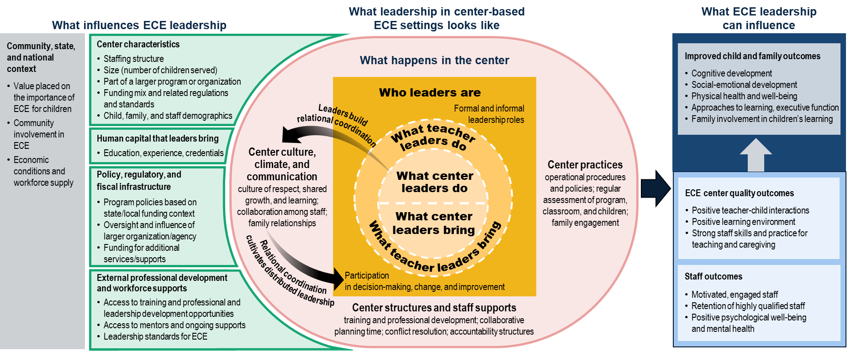
This page has been left blank for double-sided copying.

