APPENDIX B
ExCELS Center Recruitment Materials

This page has been left blank for double-sided copying.

ExCELS Advance Recruitment Letter/Email

This page has been left blank for double-sided copying.

TO: [PRIMARY SITE LEADER/HEAD START PROGRAM DIRECTOR EMAIL ADDRESS]
RE: Invitation to Participate in the Early Care and Education Leadership Study (ExCELS)
Dear [PRIMARY SITE LEADER/ HEAD START PROGRAM DIRECTOR NAME]:
We are reaching out to [CENTER: ask your center to be part of / HS PROGRAM: let you know about] an important study, the Early Care and Education Leadership Study, or ExCELS. As you know, leadership is widely recognized as an essential driver of performance and improvement in an organization. Little is known about who participates in leadership in early care and education centers, and what role leadership plays in improving the quality of care and education a center provides and outcomes for staff, children, and families. The U.S. Department of Health and Human Services, Administration for Children and Families, Office of Planning, Research, and Evaluation has partnered with Mathematica, an independent research firm, and the Institute for Early Education Leadership and Innovation at the University of Massachusetts Boston to conduct ExCELS. ExCELS will help us learn how effective leadership can improve the quality and outcomes for staff, children, and families in early care and education centers!
The study involves two interviews for the primary site leader, and surveys for two or three managers and all the teaching staff at [CENTER: your/ HS PROGRAM: a] center. We understand that [CENTER: you and your/ HS PROGRAM: center] staff are very busy, so we will be flexible about scheduling these activities with [CENTER: you/ HS PROGRAM: them].
For this study to be successful, it is critical to have the participation of a range of centers—such as big and small centers, and centers that receive different types of funding support. We will be reaching out to centers in your area soon to inform them that they have been selected for the study. If [CENTER: your center/ HS PROGRAM: a center in your program] is selected, [CENTER: your input, and the input of your management and teaching staff/ HS PROGRAM: the input of center management and teaching staff], will be valuable. We see [CENTER: you and your center/ HS START PROGRAM: centers] as important partners in this study, and we hope your [CENTER: center/ HS PROGRAM: program] will participate. We are offering participating centers $150 for taking part in the study.
Taking part in ExCELS is voluntary, but we hope you will participate. The purpose of this study is to learn about leadership in early care and education centers. There are no risks or direct benefits from taking part in the study. We will use the information the study collects only for research purposes and in ways that will not reveal [CENTER: who you are or identify your center or its staff/ HS PROGRAM: the organization, the center, or its staff]. We have a certificate of confidentiality from the National Institutes of Health. It helps us protect [CENTER: your privacy/ HS PROGRAM: the privacy of the organization, the center, and its staff]. This means no one can force the study team to give out information that identifies [CENTER: you/ HS PROGRAM: the organization, the center, and its staff], even in court. However, in some cases federal or state laws might require us to show information to government officials or sponsors who monitor the safety of the study. Publications about the study will not identify anyone from the center. Nor will they identify the center [CENTER: itself/ HS PROGRAM: or organization]. We will share some of the data the study collects with qualified individuals for research purposes. Nothing we share will identify people [CENTER: or specific centers/, HS PROGRAM: specific centers, or specific organizations].
I have attached a fact sheet and a brochure about the study [HS PROGRAM: that we are sharing with centers]. If you are interested in learning more about ExCELS and having [CENTER: your center/ HS PROGRAM: a center in your program participate in the study, please contact me, the survey director, at [STUDY PHONE] or by email at [STUDY EMAIL].
Sincerely,

---insert signature image here---
Annalee Kelly

This page has been left blank for double-sided copying.

ExCELS Joint-Agency Support Letter

This page has been left blank for double-sided copying.

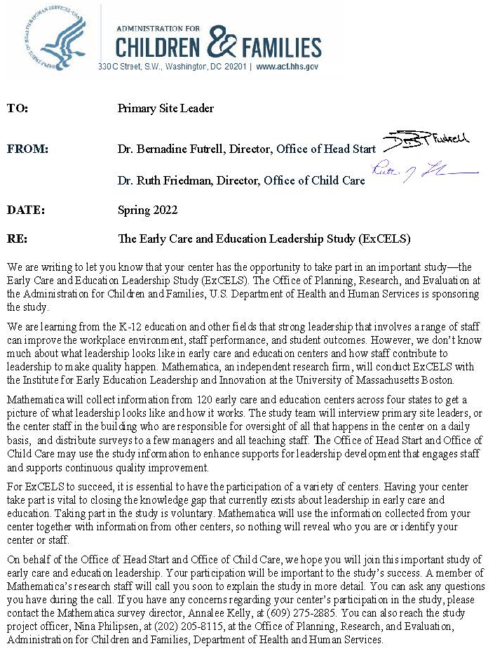

This page has been left blank for double-sided copying.

ExCELS Study Brochure

This page has been left blank for double-sided copying.

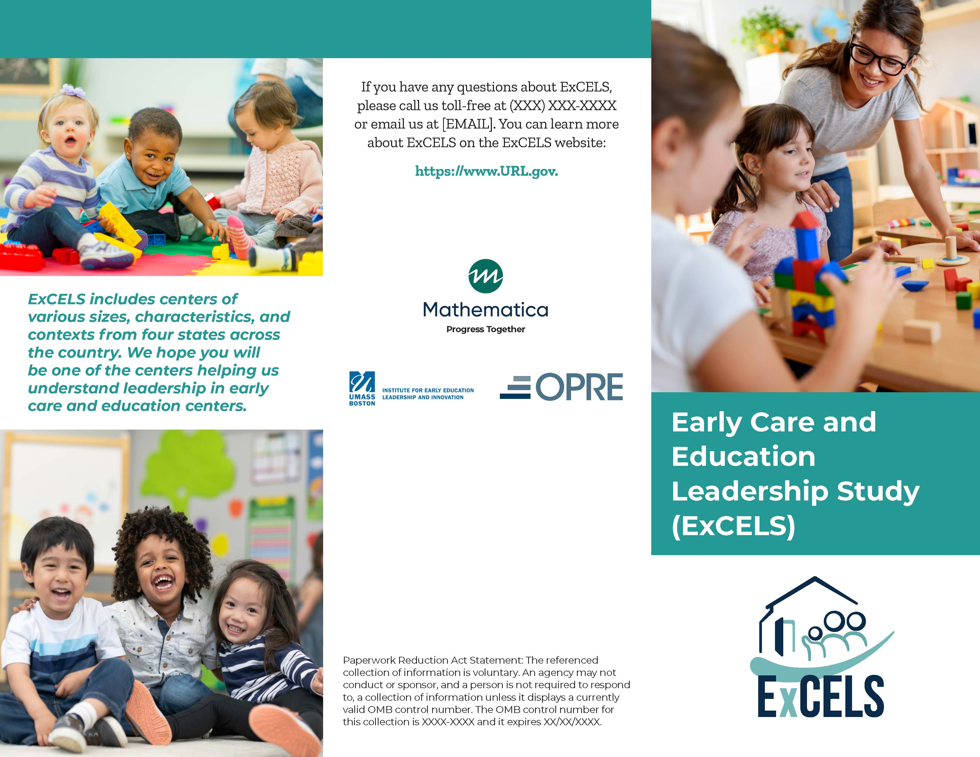

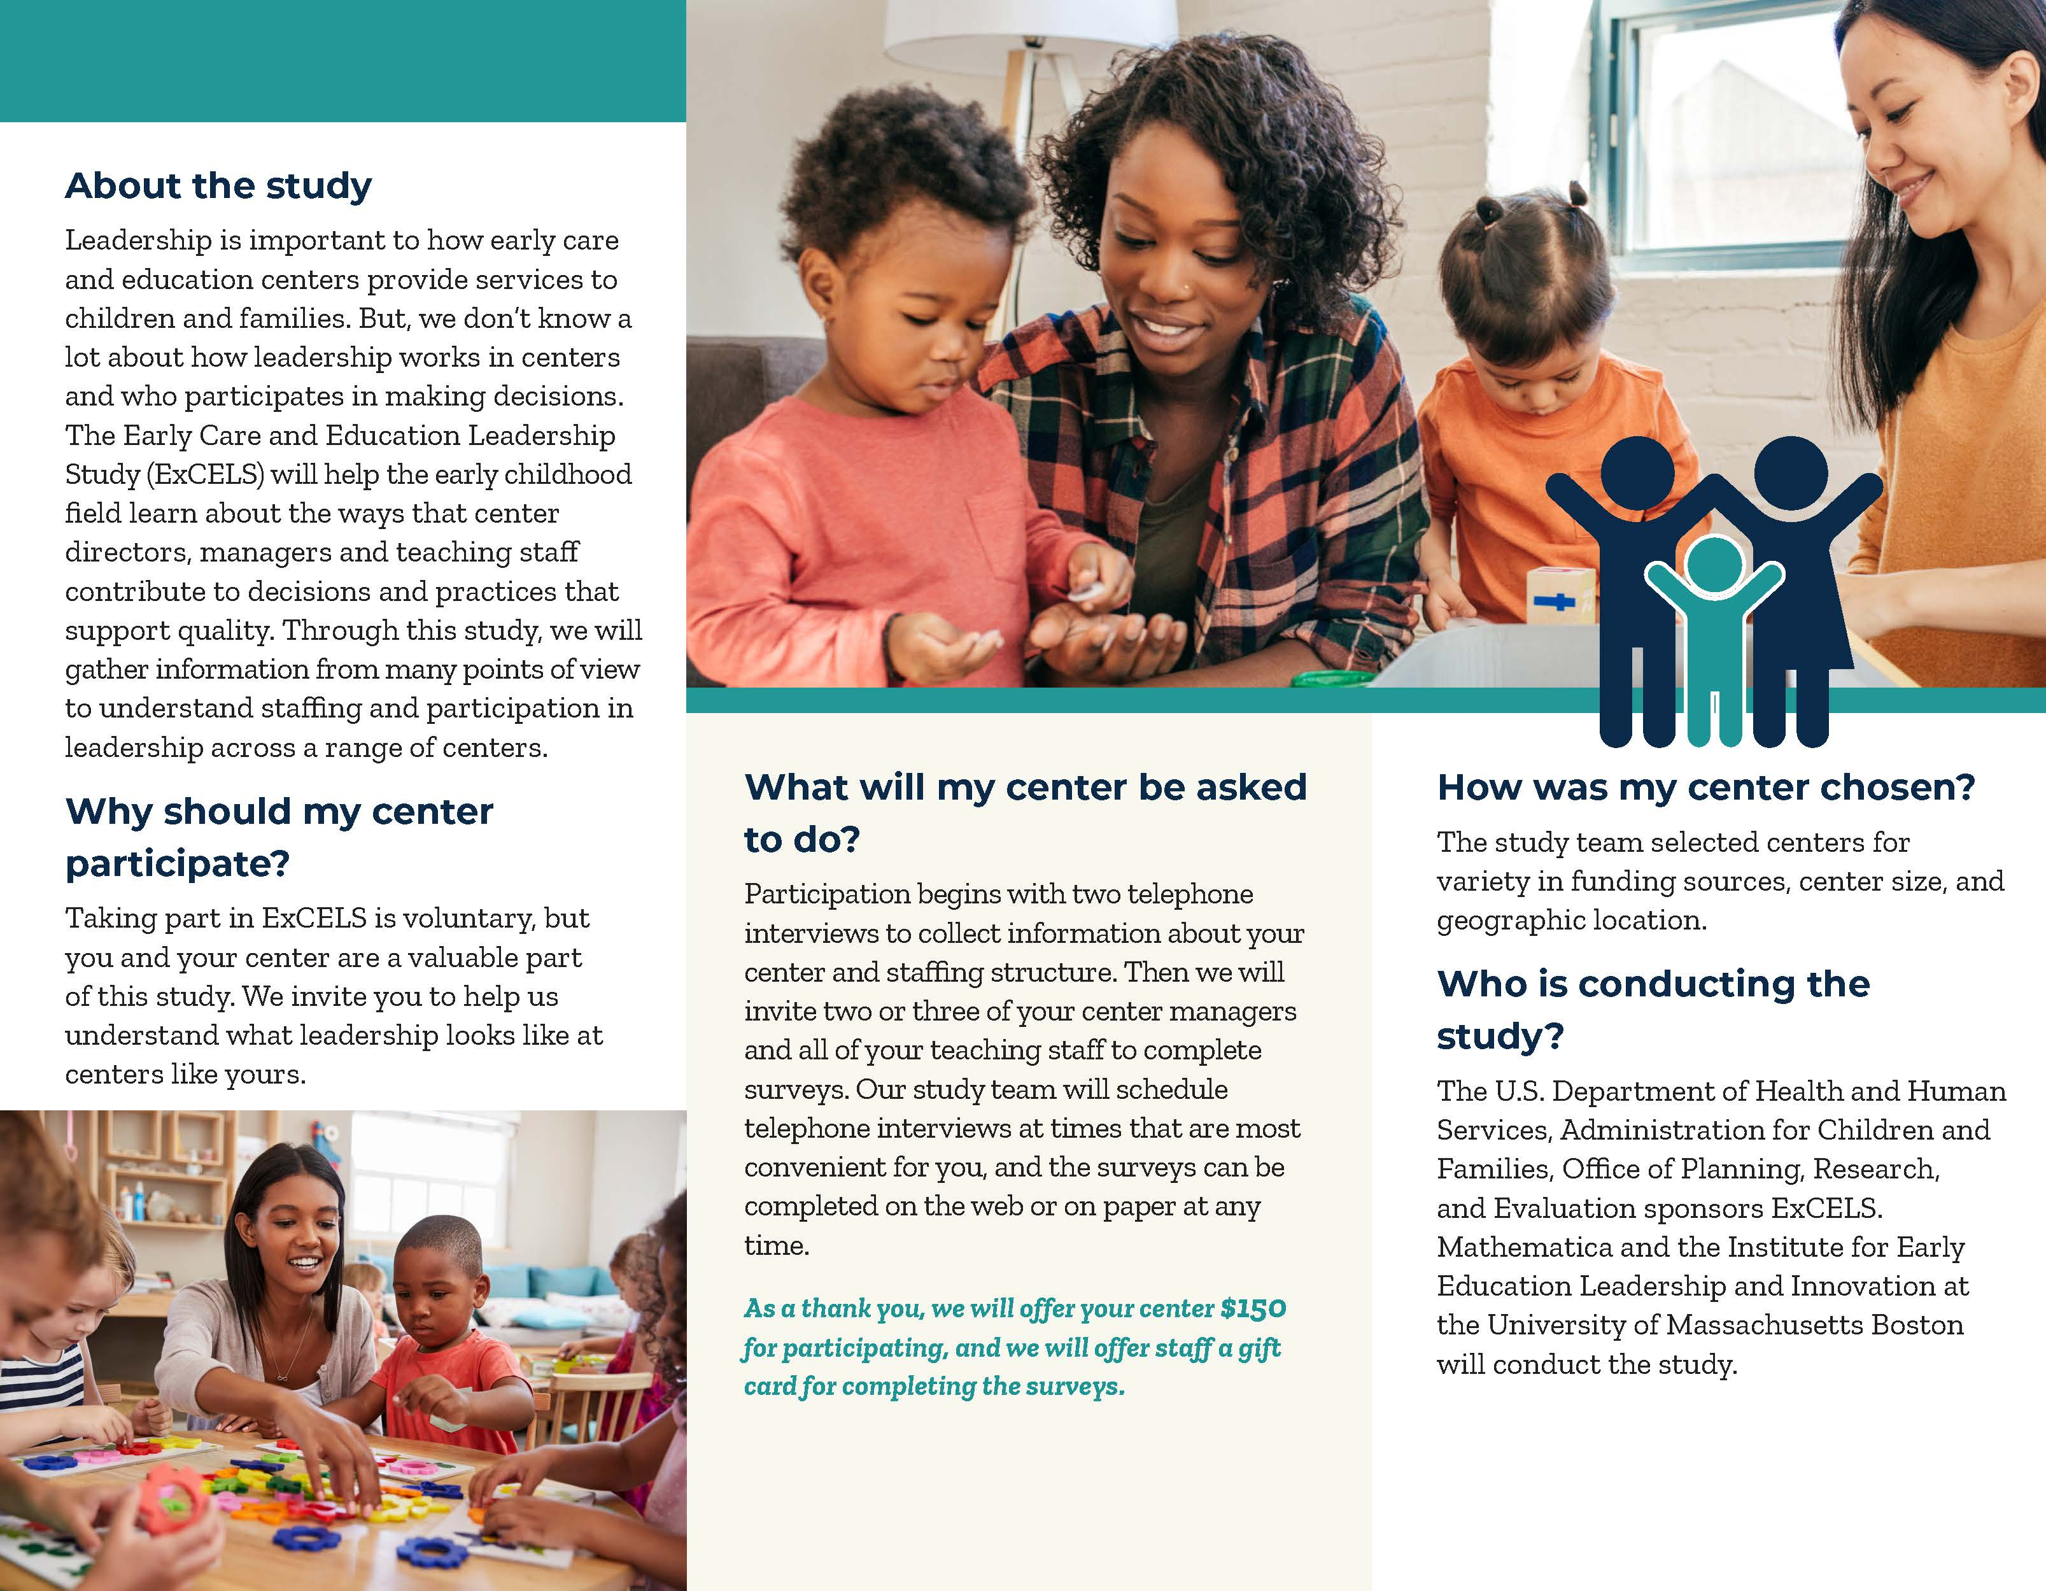

ExCELS Study Fact Sheet

This page has been left blank for double-sided copying.

Leadership is an essential driver in the performance and improvement of early care and education in centers. Unfortunately, there isn’t a lot of research about who plays a leadership role in early care and education. The Early Care and Education Leadership Study (ExCELS) wants to take a closer look at that. The study will allow us to get a better idea of the kinds of leadership roles that are available to staff in early care and education centers, and how center leadership can improve the quality and outcomes for staff, children, and families in early care and education centers.

The study team
The study is being conducted by Mathematica, an independent research firm, and the Institute for Early Education Leadership and Innovation at the University of Massachusetts Boston.

Center selection
The study will take place in 120 early care and education centers. We will select centers in urban and suburban areas in four different states. ExCELS will focus on centers that are funded by Head Start or the Child Care and Development Fund (CCDF) and have at least two classrooms serving children whose ages range from birth to 5 (but who are not yet in kindergarten).

Staff participation
We will ask the center’s primary site leader to participate in two phone interviews to get information about center characteristics, such as the size of the center and the ages of the children served, and to learn about the center’s staffing structure and leadership positions. We will ask two or three center managers to complete a 25-minute survey and ask all teaching staff to complete a 60-minute survey.

Benefits of ExCELS
We will offer each participating center $150 in recognition of the time and expertise that center staff contribute to the study. We will offer teaching staff who complete a survey a $40 gift card, and center managers who complete a survey a $25 gift card.

Privacy
Mathematica is committed to respecting and protecting the privacy of respondents and the data entrusted to us to the extent permitted by law. We will give participating staff a consent form that they will sign before participating in the study. They can withdraw their consent at any time. Mathematica senior project staff will be responsible for making sure that the whole study team understands the necessity of maintaining strict privacy of the information they collect. All staff involved with the study will sign confidentiality agreements.
At the end of the study, we intend to prepare files containing the data from this study. We will share some of the data with qualified researchers. We will protect the privacy of participants whenever study findings or data files are shared with qualified researchers. The names of centers and the names of participating staff members will not be included in these files.

Findings
We plan to produce a report and short briefs to advance understanding of early care and education leadership in centers. The materials will be suitable for a range of audiences, including researchers, program administrators, technical assistance providers, funders, and center leaders and staff. We also plan to release a new leadership survey that can be used for multiple purposes including program improvement, research, and evaluation.

To find out more
Contact: Annalee Kelly, the survey director, at Mathematica, [PHONE], [EMAIL].

ExCELS Targeted Recruitment Letter/Email

This page has been left blank for double-sided copying.

[DATE]
TO: [PRIMARY SITE LEADER EMAIL ADDRESS]
RE: Invitation to Participate in the Early Care and Education Leadership Study (ExCELS)
Dear [PRIMARY SITE LEADER NAME]:
We are reaching out to ask your center to be part of an important study, the Early Care and Education Leadership Study, or ExCELS.
As you know, leadership is widely recognized as an essential driver of performance and improvement in an organization. Little is known about who participates in leadership in early care and education centers, and what role leadership plays in improving the quality of care and education a center provides and outcomes for staff, children, and families. The U.S. Department of Health and Human Services, Administration for Children and Families, Office of Planning, Research, and Evaluation has partnered with Mathematica, an independent research firm, and the Institute for Early Education Leadership and Innovation at the University of Massachusetts Boston to conduct ExCELS. ExCELS will help us learn how effective leadership can improve the quality and outcomes for staff, children, and families in early care and education centers!
The study involves two interviews for the primary site leader, and surveys for two or three managers and all teaching staff at your center. We understand that you and your staff are very busy, so we will be flexible about scheduling these activities with you. We are offering participating centers $150 for taking part in the study.
For this study to be successful, it is critical to have the participation of a range of centers—such as big and small centers, and centers that receive different types of funding support. We view you and your center as important partners in this study and hope your center will participate.
Taking part in ExCELS is voluntary, but we hope you will participate. The purpose of this study is to learn about leadership in early care and education centers. There are no risks or direct benefits from taking part in the study. We will use the information the study collects only for research purposes and in ways that will not reveal who you are or identify your center or its staff. We have a certificate of confidentiality from the National Institutes of Health. It helps us protect your privacy. This means no one can force the study team to give out information that identifies you, even in court. However, in some cases federal or state laws might require us to show information to government officials or sponsors who monitor the safety of the study. Publications about the study will not identify anyone from the center. Nor will they identify the center itself. We will share some of the data the study collects with qualified individuals for research purposes. Nothing we share will identify people or specific centers. If you have questions about ExCELS, please call Annalee Kelly, the survey director at [STUDY PHONE] or by email at [STUDY EMAIL].
I have attached a fact sheet and a brochure about the study. I would like to schedule a time to talk with you by phone about the study in more detail. I would also like to discuss your center’s participation in the study and learn about some key characteristics of your center. If you can let me know some times when you would be available to talk with me by phone, that would be great. Otherwise, I will call you in the next few days to schedule a time.
Thank you for your time. I look forward to speaking with you soon. If you have any questions before our call, please contact me at [LIAISON PHONE] or by email at [LIAISON EMAIL].
Sincerely,

---insert signature image here---
[LIAISON NAME]

This page has been left blank for double-sided copying.

