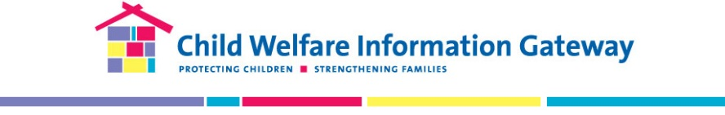
The Grantee Connection Survey
How are we doing? Please take 15 minutes to answer the questions below. Your input will help strengthen The Grantee Connection Newsletter to better meet your needs. Your input will help enhance future Grantee Connection newsletters. Your participation in this survey is voluntary, and your responses will be anonymously shared with Child Welfare Information Gateway staff and the Children’s Bureau to improve service delivery. You may exit the survey at any time and are free to decline to answer any question. There are no foreseeable risks and no direct benefits from participating in this survey. Proceeding with the survey is an indication of your consent. If you have any questions or require accessibility assistance with this survey, please contact Child Welfare Information Gateway staff by email at info@childwelfare.gov or by telephone at 800.394.3366. Thank you for helping us help you.
- Which of the following best describes your professional background? (Select all that apply)
- Prevention
- Family support
- Child protective services
- Foster care services
- Adoption services
- Youth services
- Juvenile justice
- Health/mental health
- Substance use
- Legal/courts
- Research/evaluation
- Early childhood (0–5yrs)
- Education (K–12)
- Higher education
- Training
- Other (Please describe): ___________
- Which of the following best describes your workplace? (Select one)
- Local or county child welfare agency
- State child welfare agency
- Tribal child welfare agency/organization
- Federal agency
- Community-based/faith-based organization
- National organization (e.g., nonprofit, advocacy)
- Training and technical assistance service provider
- Educational institution (early education, K–12, college, university)
- Other (Please describe): ________________________________
- Which of the following best describes your position? (Select one)
- Frontline worker (e.g., caseworker, direct service worker)
- Supervisor/manager
- Director/administrator
- Training specialist
- Evaluator/researcher
- Other (Please describe): _______________________________
- Do you have experience working on a Children's Bureau discretionary grant? (Check one)
- Yes, as a current grantee
- Yes, as a former grantee
- No, but I’m interested in being a future grantee
- No, I do not have any experience as a grantee.

- How did you first find out about The Grantee Connection? (Check one)
- Email/social media post from Child Welfare Information Gateway
- Federal Project Officer/Children's Bureau staff
- Colleague or friend
- Referred by other organization (Please describe): ____________
- Other (Please describe): ____________
- What topic(s) are you most interested in reading about in The Grantee Connection? (Check all that apply and briefly describe your topical interests in the text boxes provided.)
- Prevention ________________
- Substance use ________________
- Foster care ________________
- Kinship care/guardianship________________
- Adoption________________
- Tribal child welfare ________________
- Legal/courts ________________
- Mental health ________________
- Other ________________
- What type(s) of information are you most interested in receiving in The Grantee Connection? (Check all that apply)
- Discretionary grant opportunities/awards
- Grantee summaries and lessons learned
- Tools and resources developed by grantees (e.g., assessment tools)
- Grantee project updates and information
- Grantee final reports/evaluation reports
- Other types of information/resources (Please describe): ________________

- Which of the following best describes why you subscribe to The Grantee Connection?
- I am interested in finding information to help inform/support my work
- I am interested in information about what discretionary grantees are learning in the field
- I am interested in a specific grant topic (Please describe):
- I am looking for information to help me apply for current or future discretionary grant funding opportunities
- Other (Please describe):
- On a scale of 1 (poor) to 5 (excellent), please rate the following regarding your experience on the Grantee Connection newsletter and provide an explanation for your ratings.
 | 1 | 2 | 3 | 4 | 5 | N/A
Relevance of information to my work
Appeal/format of the newsletter design
Content that matches my interests

- Please describe your response for the ratings you provided in the previous question.
__________________________________________________________________________________

- What suggestions do you have for improving The Grantee Connection?
Thank you for your participation!
If you are interested in learning more about grant opportunities from the Children's Bureau or other program offices under the Administration for Children and Families, please visit Funding Opportunity Announcements.

