Appendix A: Project Information Sheet

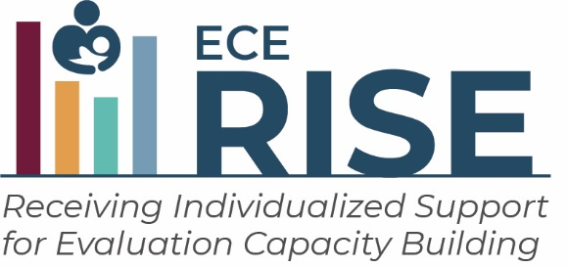

Curious about the effects of the COVID-19 pandemic on families’ child care choices? Are you hoping to streamline the application process for child care assistance? Do you want to examine child care supply and demand issues for special populations of children in your state? ECE-RISE may be a good opportunity for you.
As a CCDF Lead Agency administrator, you are increasingly asked to use research and evidence to inform your decisions. ECE-RISE is offering an opportunity for agencies to receive tailored support for their research and evaluation projects, free of charge. The ECE-RISE team will support your agency team as you work to answer a question that will help address a problem your agency faces or provide you with more information to improve policies, programs, or services.

Benefits of ECE-RISE
Participating in ECE-RISE offers you, as staff of CCDF Lead Agencies, several key benefits:
- Research and Evaluation Capacity Building support. ECE-RISE supports are tailored to what interests you most. ECE-RISE is designed to support you in your work to answer questions that will improve your agency’s child care policies and practices.
- Opportunities for peer networking. ECE-RISE will set up a peer learning community to give opportunities for CCDF agency staff to share knowledge and collaborate with each other. ECE-RISE will cover travel and hotel costs for up to three agency team members to attend two in-person meetings of the peer learning community.

Requirements for participating in ECE-RISE
If your agency is selected for ECE-RISE, you will:
- Identify staff and set aside time for the project. You must identify three staff members to work with the ECE-RISE team. More than three staff can participate but we would like to identify those who will lead and spend the most time on the project. Extensive expertise and skills are not required of agency staff as ECE-RISE will be providing tailored support. The agency staff will attend meetings with the ECE-RISE team at least twice a month, work in between meetings to make progress on goals, and participate in peer learning community gatherings (quarterly virtual meetings and two virtual or in-person peer learning meetings). Each agency team will need staff for the following roles (in some cases, one staff member may fill multiple roles).:
- Coordinator – staff who can help with scheduling and logistics, organizing materials, keeping documentation up to date (approximately 12 hours/month)
- Policy/practice lead – staff with content expertise who can think about policy practice implications of the research project (approximately 8 hours/month)
- Research lead – staff with research skills who can carry out the research project, access and manipulate data (approximately 20 hours/month)
- Plan and complete a research project. The ECE-RISE team will support your agency team as you plan and complete your own 18-month research project. Your research project will focus on a challenge or problem your agency is interested in addressing or a research question you would like to answer. Throughout the project period, the ECE-RISE team will provide support and guidance to help you with analyzing and understanding results and making decisions informed by the research findings.

The Application Process
All State, Territory and Tribal CCDF Lead Agencies can apply. If you are interested, please access the application here [URL]. Complete the application by [DATE]. Some agencies will be asked to complete follow-up interviews in [DATE]. You will be notified of your application status by [DATE]. Selection for ECE-RISE will be based on:
- How well an agency’s research and evaluation needs match the types of support ECE-RISE offers
- Whether an agency’s questions can be studied and answered within an 18-month period
- Whether the agency team and leadership can invest time and resources to work with the ECE-RISE team.

Timeline for the application and selection process
MONTH 2021 | MONTH 2021 | MONTH 2022 | MONTH 2022 | MONTH 2022
Application materials available | Applications due | Interviews | Select agencies | ECE-RISE starts

Providing feedback about ECE-RISE
Towards the end of the project period, ECE-RISE participants will be asked to provide feedback and information about how useful the supports provided by the ECE-RISE team were. This information will be collected by the Urban Institute to help ACF/OPRE improve efforts like ECE-RISE in the future.

The ECE-RISE Team
The ECE-RISE support team consists of research staff from Mathematica, an independent research organization. ECE-RISE is a part of the Child Care Research and Evaluation Capacity Building Center, which is operated by the Urban Institute in partnership with Mathematica. The Center is funded by the Office of Planning, Research, and Evaluation, Administration for Children and Families, the Department of Health and Human Services.

Applications are due by [DATE]

Access and complete your application here [URL]

Register for an information session about ECE-RISE and the application process [URL]

Contact the ECE-RISE team at [email] or [1-800-XXXX]

An agency may not conduct or sponsor, and a person is not required to respond to, a collection of information unless it displays a currently valid OMB control number. The OMB number and expiration date for the described collection are OMB #: 0970-0356, Exp: 02/29/2024.

