CCR 96771 - Revise language in question #13 regarding legal separation and allow optional spouse entry
Current AES Form:
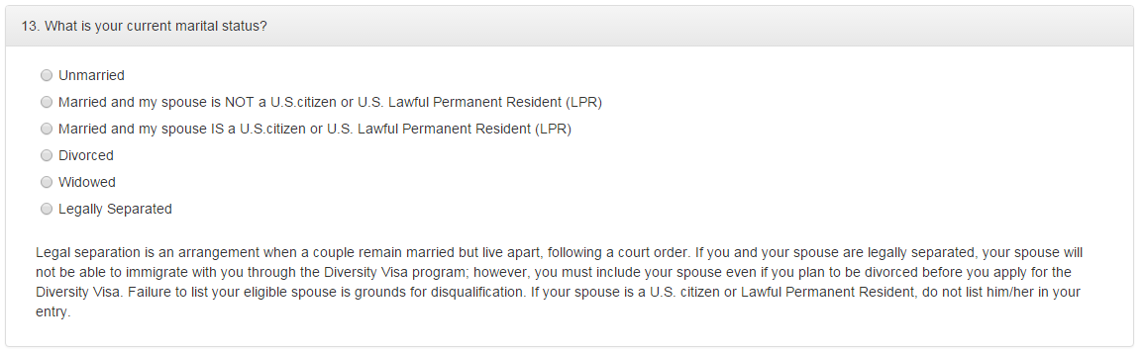

Proposed Change:
