ADDENDUM
EMERGENCY RENTAL ASSISTANCE PROGRAM REPORTING GUIDANCE
Revised Q1 and Q2 ERA1 and ERA2 Reporting Requirements for State, Local and Territorial Recipients
- ERA1 and ERA2 State, Local and Tribal (SLT) Recipients are no longer required to meet all reporting requirements detailed in Treasury’s ERA Reporting Guidance v 1.0 for the first (Q1) and second (Q2) quarter of 2021 by July 29, 2021, as previously scheduled.
- ERA1 and ERA2 SLT Recipients will be required to submit partial Q2 reports around August 6, 2021. A final submission deadline will be provided in the near future. The Q2 partial report consists of a subset of mandatory data elements that mirror the reports that Recipients already submitted for Treasury’s interim reporting cycle through Q1 and monthly submissions with minor updates and two brief narrative questions.
- In addition to the partial Q2 submission, ERA1 and ERA2 SLT Recipients must provide brief monthly reports for the months of July and August 2021, in keeping with previously announced guidance.
Quarterly Report Beginning in Q3
- ERA1 and ERA2 SLT Recipients are required to submit full quarterly financial and programmatic reports, consistent with Treasury’s ERA Reporting Guidance v 1.0, beginning with the Q3 2021 reporting period. Recipients are required to submit their Q1, Q2 and Q3 reports by October 15, 2021, and future quarterly reports as required in the ERA Reporting Guidance v 1.0.
Q1 and Q2 ERA Reporting Requirements for Tribes, Tribally Designated Housing Entities, and the Department of Hawaiian Home Lands
- ERA1 Recipients that are Tribes, Tribally Designated Housing Entities, and the Department of Hawaiian Home Lands will be required to submit Q2 partial reports around August 6, 2021. A final submission deadline will be provided in the near future. In addition, these Recipients are required to provide financial and programmatic reporting as detailed in Treasury’s ERA Reporting Guidance v 1.0 beginning with the Q3 2021 reporting period. These Recipients are not required to submit full Q1 and Q2 reports by July 29, 2021 and are not required to submit monthly reports.

Date: July 15, 2021

Required Data Elements for August 6, 2021
Program Overview
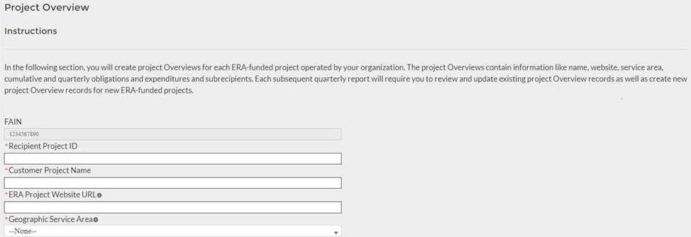
System for Prioritizing Assistance
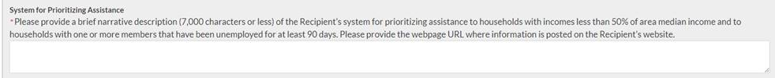
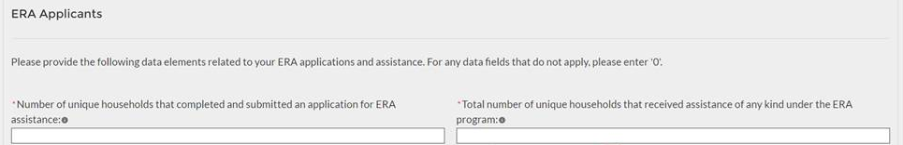
Households Assisted
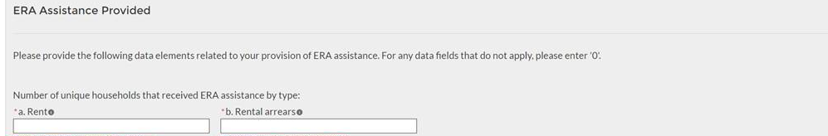

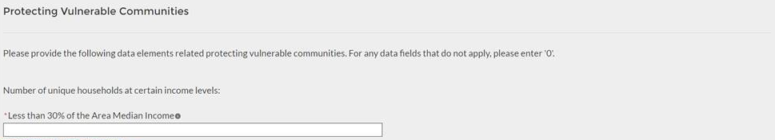
Total Obligations and Expenditures
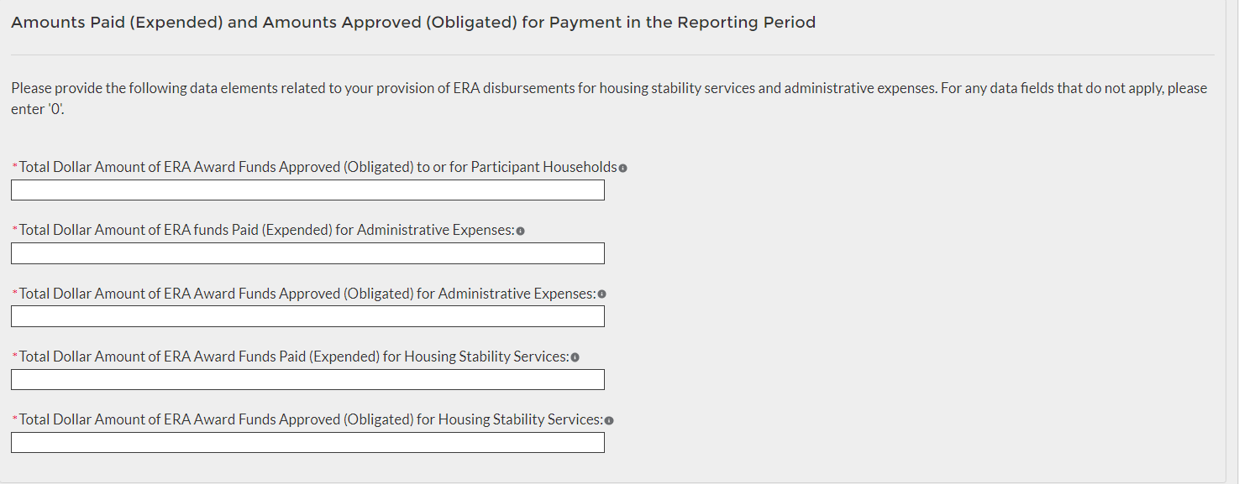

Certification
