Non-substantive Change Request
0535-0218 – Agricultural Resource Management and Chemical Use Surveys
The below listed surveys are now included in the newly approved Cooperator Funded Chemical Use Surveys ICR Package (OMB #0535-0273):
- Mississippi Cropping Practices Survey
- Pesticide & Fertilizer Use in Minnesota Survey
- Pesticide & Fertilizer Best Management Practices in Minnesota Survey
- Maryland Pesticide Usage Survey
- Illinois Nutrient Loss Reduction Strategy Survey
- Publicity Materials of Above Surveys
- Cognitive Testing of Above Surveys
As a result of this new approval and to remove the duplicate burden, this change request is to drop the above surveys from the Agricultural Resource Management and Chemical Use Surveys ICR (OMB #0535-0218):
In addition, there was a calculation error in the May 2022 change request that was corrected as an adjustment.
These changes will impact the current sample size and respondent burden for the Agricultural Resource Management and Chemical Use Surveys ICR as follows:
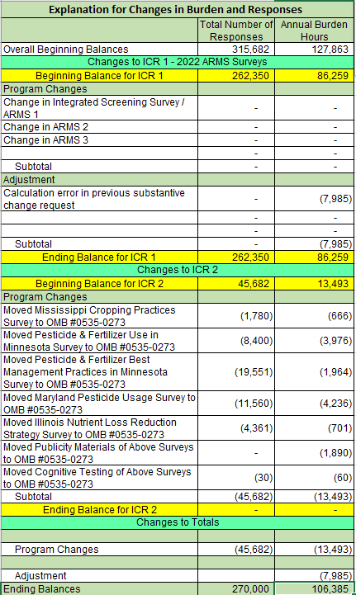

The questionnaires and supporting documents devoted solely to the dropped surveys have been removed from ROCIS.

