[Date]

Dear Vegetable Producer:

Enclosed is the 20XX Vegetable Grower Inquiry questionnaire. This survey collects year-end data used to determine the official USDA estimates of 20XX acreage, price, sales and production for vegetable crops in the United States. Vegetable producers rely on the results from this survey to make sound and informed business decisions to help promote the vegetable industry. Commodity markets, buyers, state and federal agencies, and others use the data to understand the market and to conduct research.

Your participation is important to ensure that vegetable producers like you are properly represented. Please respond in one of the following ways:

- Online at www.agcounts.usda.gov beginning October XX, 20XX. Online reporting is the easiest, fastest and most secure way to complete your survey. You need the 17-digit survey code on the enclosed form to begin. Instructions are on the back of this letter.
- By mail or fax. Complete the enclosed form and mail it back in the return envelope provided or fax it to [(XXX) XXX-XXXX].

If you do not respond by November XX, 20XX, a representative from our office will contact you to arrange for a telephone or personal interview. We will publish the survey results on February XX, 20XX in the Vegetables Annual Summary, available at www.nass.usda.gov/Publications/Reports_by_Release_Day.

Thank you for your participation and support of [State] agriculture. If you have questions or concerns, please contact [Firstname Lastname] at (800) [XXX-XXXX].

Sincerely,

[Director/State Statistician]

Enclosures

It’s Convenient. It’s Secure.
Online Survey Response

Responding to your agriculture survey online is both convenient and secure.

The online form:
- lets you skip questions that don’t apply to you
- calculates totals automatically
- eliminates the need for return postage and data entry

To complete your survey online, follow these steps:

- Go to www.agcounts.usda.gov.
- Read the message, then click the arrow to complete the survey.
- Enter your unique 17-digit Survey Code from the label on the letter or questionnaire you received in the mail, then click “Continue.”
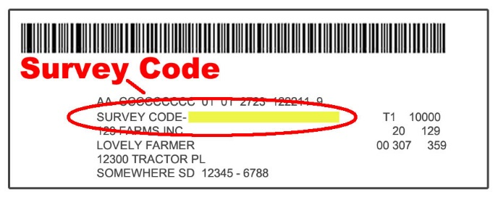

- Find the survey you are completing and click on it.
- Verify and complete your contact information, then continue to the survey.
- Complete the survey questions.

If you need to stop, press the “Save & Return Later” tab at the top of the page. When you return, go back to Step 1 above. After the opening page, the survey tool will take you to the last page you visited.

- When you finish the survey, click “Submit.” If you do not see the Submit button, reduce the zoom setting on your screen.

You will receive a confirmation code and can choose to view your completed survey form. Using the options provided by your browser (Internet Explorer, Chrome, Mozilla, etc.), you can print, copy, or save the completed form.

