OMB Submission # 0704-STEM
Survey – Look and Feel in Qualtrics

Preview of Survey Instrument on Qualtrics
The full survey instrument has been input into Qualtrics and may be viewed here:
https://idaorg.gov1.qualtrics.com/jfe/preview/SV_5ATajOVyWZFiTXw?Q_CHL=preview&Q_SurveyVersionID=current

Screenshots to Demonstrate Look and Feel
Introduction to the Survey 2
First Page of the Survey 4
Example: Question with Sliders 5
Example: Two Kinds of Multiple-Choice Questions – (1) Choose 1 and (2) Choose all that apply. 6
Example: Two Kinds of Text Entry Question – (1) Short Answer and (2) Long Answer 7
Last Page of the Survey 8

Introduction to the Survey
Showing both browser view (left), as well as what Respondents would see on a mobile device (right). Full page required two screen shots. Respondents would use scrollers.
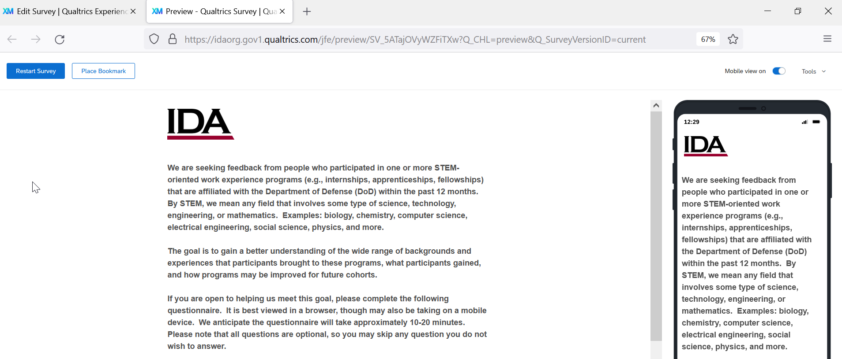
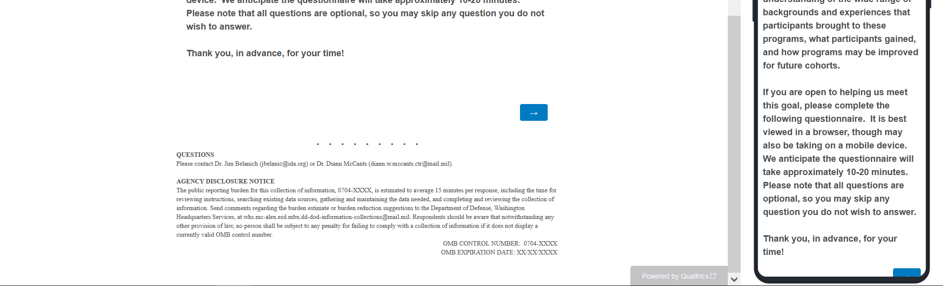

First Page of the Survey
Respondents use the scrollers to continue answering questions.
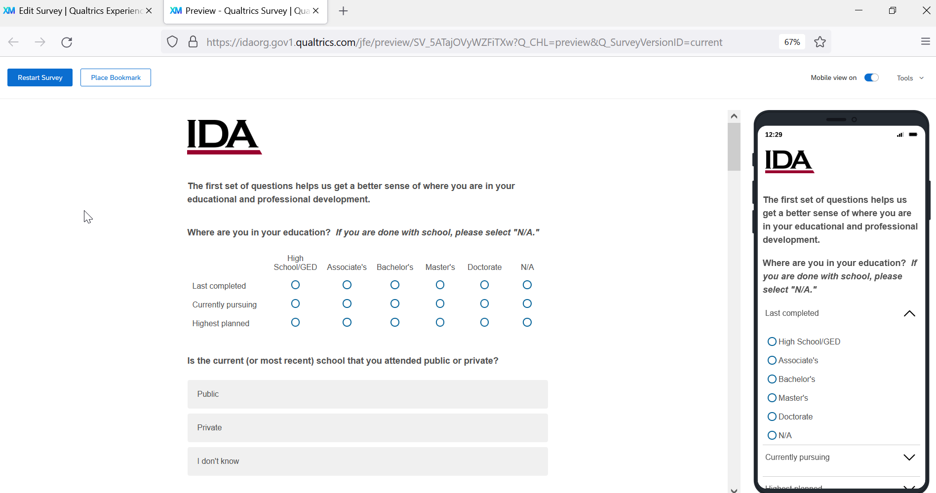

Example: Question with Sliders
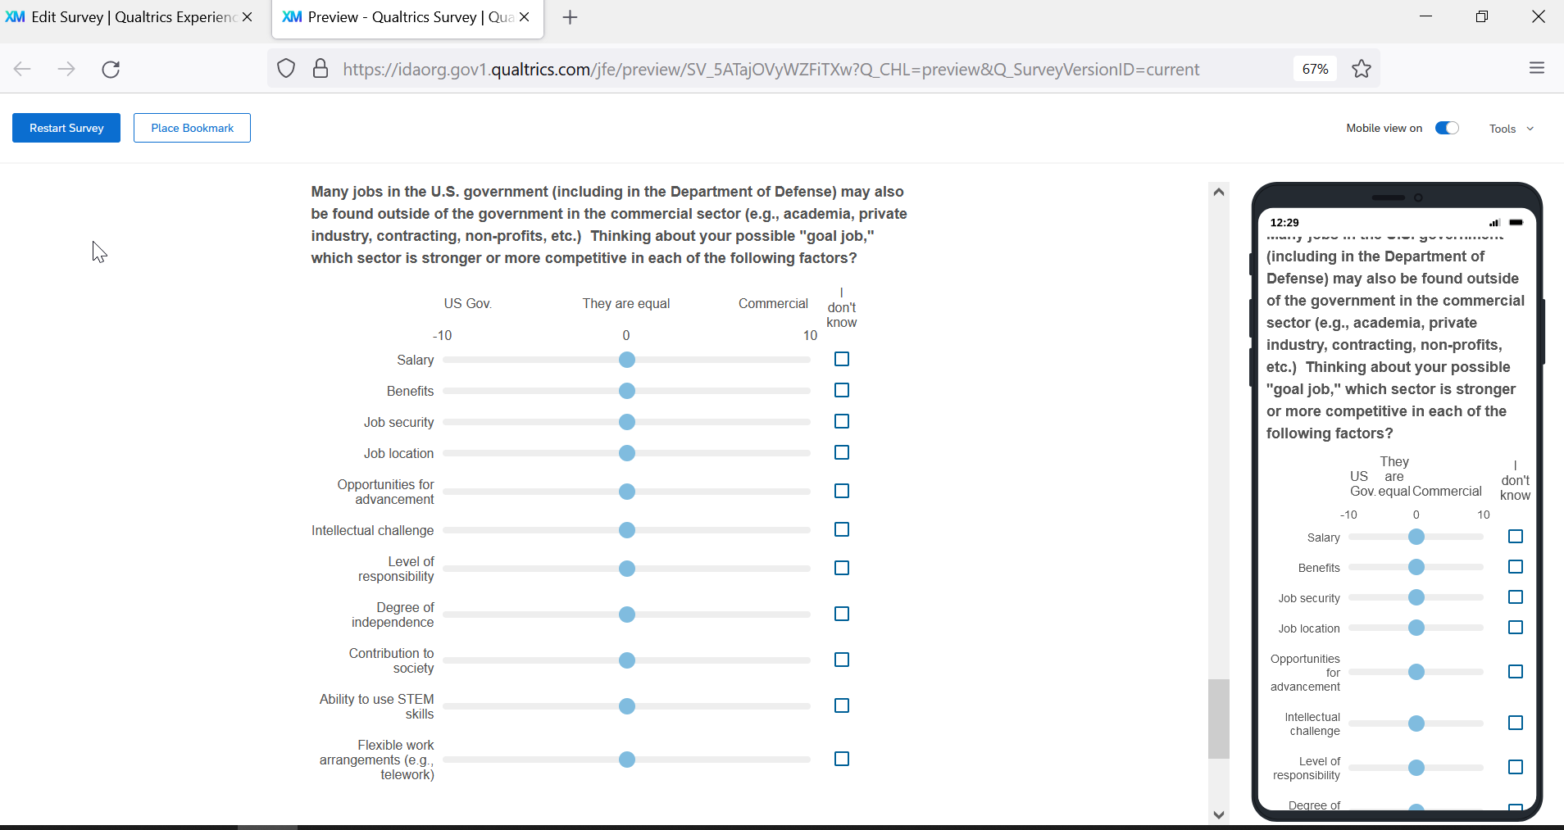

Example: Two Kinds of Multiple-Choice Questions – (1) Choose 1 and (2) Choose all that apply.
Updated ethnicity and race questions.
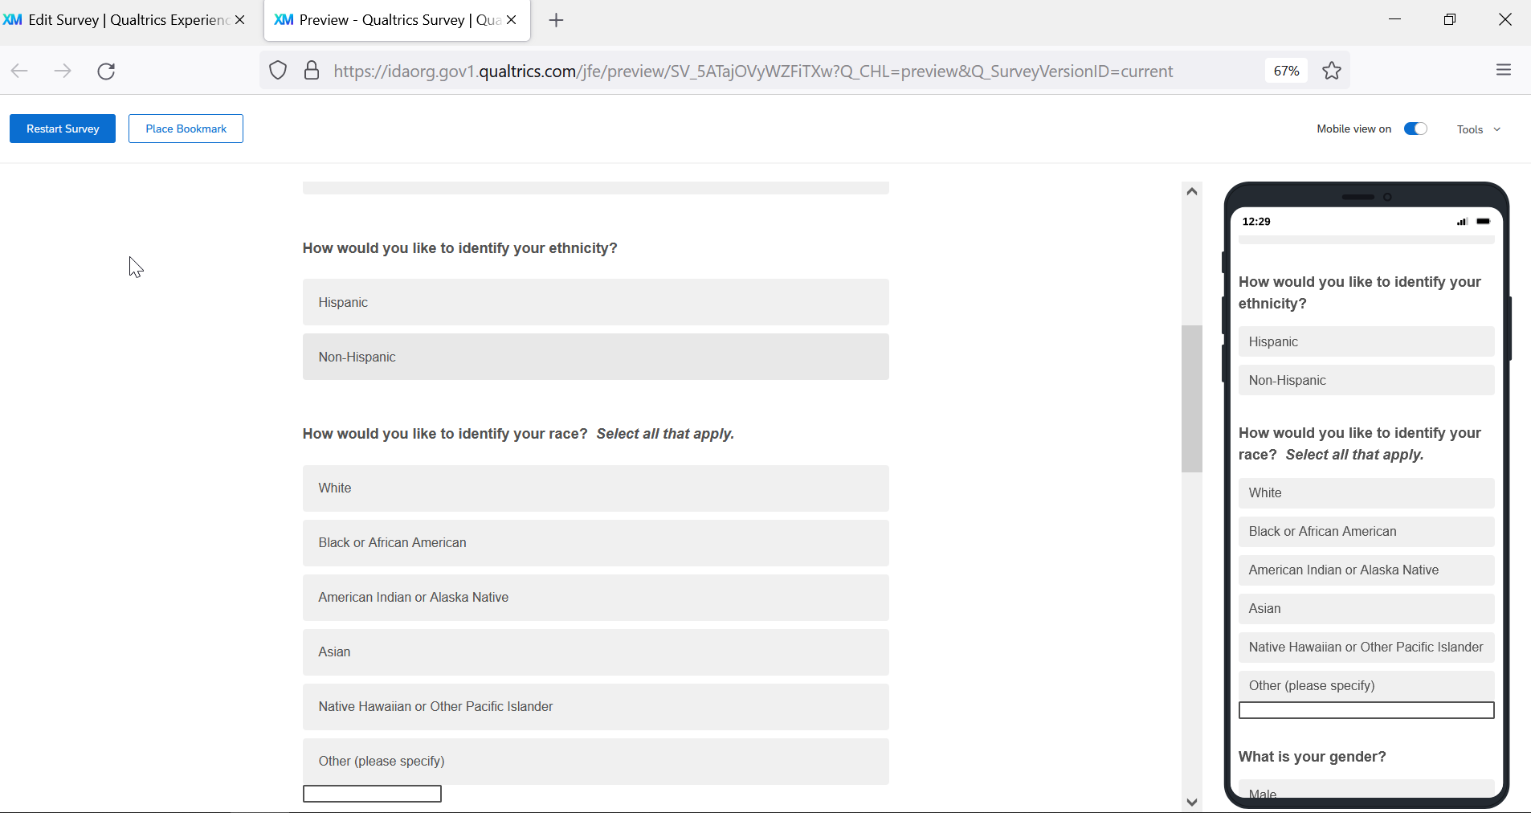

Example: Two Kinds of Text Entry Question – (1) Short Answer and (2) Long Answer
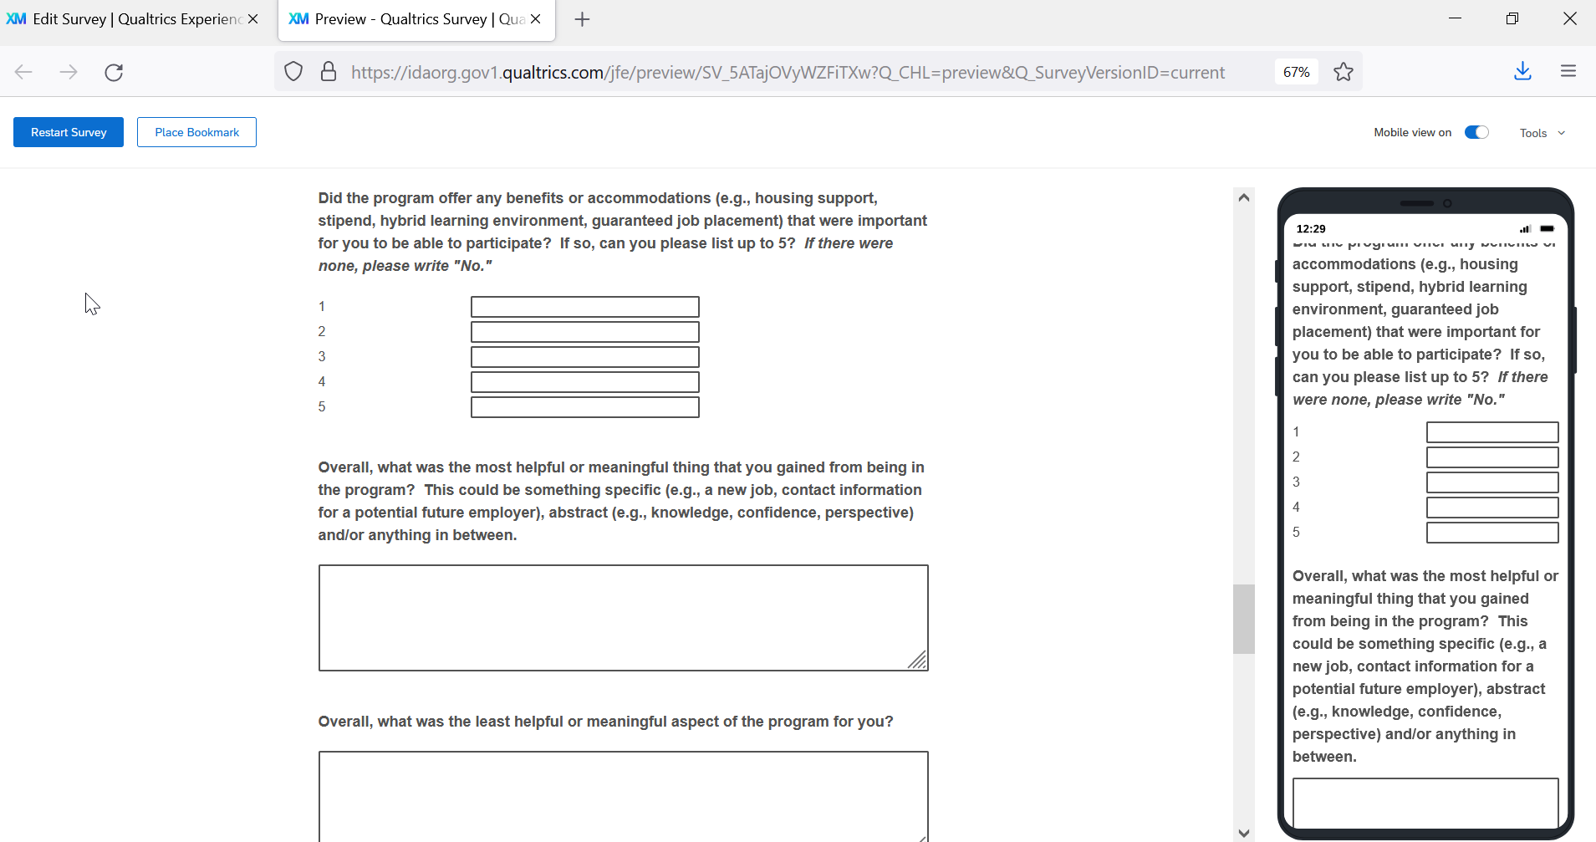

Last Page of the Survey
