|  |
| --- |
| **INITIAL INVITATION E-MAIL TO HEALTHCARE PROVIDERS OPTED INTO SCHLESINGER’S PANEL AT THE TIME OF RECRUITMENT FOR THE FOCUS GROUPS AND INTERVIEWS** |

|  |
| --- |
| Hello #SALUTATION#  We are currently offering **#INCENTIVE#** to our members who qualify and complete a research study on **#TOPIC#**.  **Pre-Qualification Questionnaire:** If you qualify for this study, we will contact you within the next 48 hours to verify your participation.  Please click on the following link or copy and paste it into your internet browser bar to see if you qualify.  [#SURVEYURL#](http://sams.schlesingerassociates.com/Administration/Utilities/Editor/TemplateEditor.aspx#SURVEYURL#)  **Study Honorarium:** #INCENTIVE# **Study Location:** #LOCATION# **Study Date(s):** #STUDYDATE# **Study Duration:** #DURATION# **Topic:** #TOPIC# **Reference #:** #JOBNUMBER#  **Additional Notes:** #ADDITIONALNOTES#  If your answers qualify you for this study, you will be contacted within the next 48 hours to verify your participation. Qualified respondents who are invited and who participate in the research will receive the study incentive above.  ***Please note:****Completion of the survey does not constitute confirmation for participation. If you are selected to participate, you will be contacted by one of our team members to complete the screening process and confirm your participation. This survey is for market research purposes only. There will be no direct sales or promotions as a result of your participation. Your individual responses will be kept confidential and anonymous and reported only in the aggregate.*  As always, thank you for your continued participation!  Do you want to see other studies you can qualify for? Login to your new Survey Dashboard to see all of your available studies: [profile link]  Please **do NOT forward this e-mail to others!**Your survey link is unique to your Focus Group by Schlesinger account and sharing it could cause your profile to be updated with the wrong information, causing you to miss research opportunities best suited to you!  If you know someone who is interested in participating in this study, please hit reply and let us know!     Focus Group by Schlesinger [Participate@FocusGroup.com](mailto:Participate@FocusGroup.com) | [www.focusgroup.com](https://www.focusgroup.com/)  **Stay Connected! Follow Us on Social Media!**        **Help us spread the word!   Forward the link below to your friends and family and help them earn rewards for sharing their opinions!** [**Click Here**](https://www.focusgroup.com/Account/Join?source=SG_Refer%20a%20Friend%20-%20Qual%20Invites&cst=0&subid=SubId&affsubid=AffSubId&country=US) |

|  |
| --- |
| **We Respect Your Privacy.** **Focus Group** is part of [Schlesinger Group](https://www.schlesingergroup.com/en/), an accredited market research company. We adhere to data protection law and market research codes of conduct. Our [Privacy Policy](https://www.focusgroup.com/Page/PrivacyPolicy) safeguards all personal information collected, which remains secure to the extent permitted by law and only is used for research. Your access and use of the service is subject to our [Terms and Conditions](https://www.focusgroup.com/Page/TermsandConditions).  Please take the time to add this address [Participate@FocusGroup.com](mailto:Participate@FocusGroup.com) to your trusted or safe sender list to ensure that our emails to you get delivered to your Inbox.  ***You have been sent this email because you subscribed as a member of the Focus Group by Schlesinger community.  If you no longer wish to receive emails please click***[***here***](mailto:Help@FocusGroup.com?subject=Unsubscribe)***to send an unsubscribe request to our customer service team.***  Schlesinger Group, 101 Wood Avenue South, Iselin, NJ 08330 |

**CONFIRMATION E-MAIL FOR QUALIFYING PARTICIPANTS**

**From:** FocusGroup Participate <participate@focusgroup.com>   
**Sent:** Monday, August 2, 2021 10:28 AM  
**To:** Jennifer Simon <Jennifer.Simon@SchlesingerGroup.com>  
**Subject:** Schlesinger Group - Confirmation Email

|  |
| --- |
|  |
| |  | | --- | | Jennifer  You have been **approved to participate**in our upcoming research.  **To confirm your participation**, please click on the link provided below and select **“Yes, I will participate (Confirm)”.**   Any **special instructions**, **homework assignments and directions to in-person locations**, in addition to **other pertinent study details** can also be found by clicking on the link.  <https://member.schlesingergroup.com/respondents/confirmation.aspx?jlid=92051eb1-73ed-4868-932e-0194b4931c50>  If you have trouble accessing this link, you may copy and paste the link into the address field of any browser.    **Confidentiality:**  We are compensating you to discuss your observations about various ideas that will be disclosed to you.  In return, you agree to respect the secrecy and confidentiality of these new ideas by not disclosing them to anyone.  In addition, you agree that any information, concepts, inventions, intellectual property, or ideas that are generated as a result of your participation will become the exclusive property of Schlesinger Group, Inc. and our client.  We look forward to your participation, | | |

|  |
| --- |
| Focus Group by Schlesinger [Participate@FocusGroup.com](mailto:Participate@FocusGroup.com) | [www.focusgroup.com](https://www.focusgroup.com)  **Help us spread the word!   Forward the link below to your friends and family and help them earn rewards for sharing their opinions!** [**Click Here**](https://www.focusgroup.com/Account/Join?source=SG_Refer%20a%20Friend%20-%20Qual%20Invites&cst=0&subid=SubId&affsubid=AffSubId&country=US) |

|  |
| --- |
| **We Respect Your Privacy. Focus Group** is part of [Schlesinger Group](https://www.schlesingergroup.com/en/), an accredited market research company. We adhere to data protection law and market research codes of conduct. Our [Privacy Policy](https://www.focusgroup.com/page/5) safeguards all personal information collected, which remains confidential and only is used for research. Your access and use of the service is subject to our [Terms and Conditions](https://www.focusgroup.com/Page/TermsandConditions)  Please take the time to add this address [Participate@FocusGroup.com](mailto:Participate@FocusGroup.com) to your trusted or safe sender list to ensure that our emails to you get delivered to your Inbox.  ***You have been sent this email because you subscribed as a member of the Focus Group by Schlesinger community.*If you no longer wish to receive emails please click**[***here***](mailto:Help@FocusGroup.com?subject=Unsubscribe)**to send an unsubscribe request to our customer service team.**   Schlesinger Group, 101 Wood Avenue South, Iselin, NJ 08330 **S2311205899X3TIG218009052** |

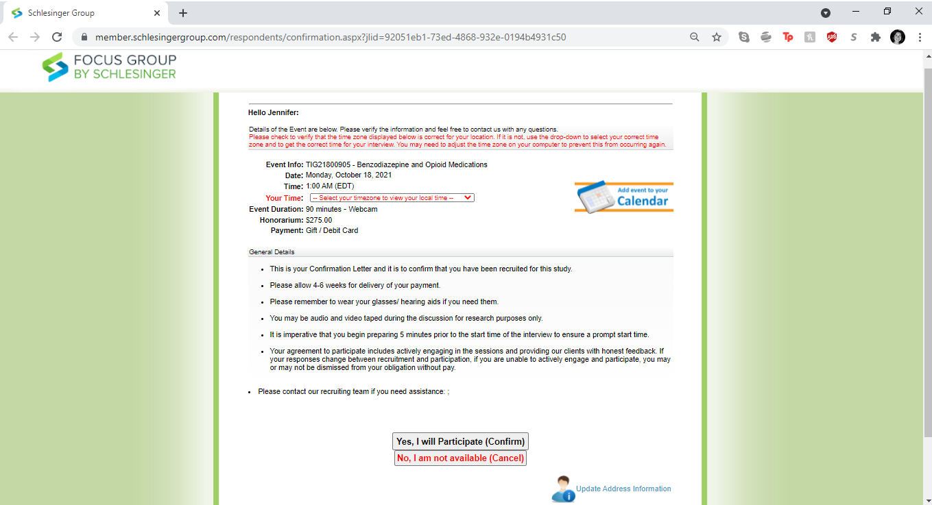**SCREENSHOT OF LINKED CONFIRMATION PARTICIPANTS WILL RECEIVE IN EMAIL ABOV**