Patient and Caregiver Diversity in FDA Patient Engagement Activities - Interviews

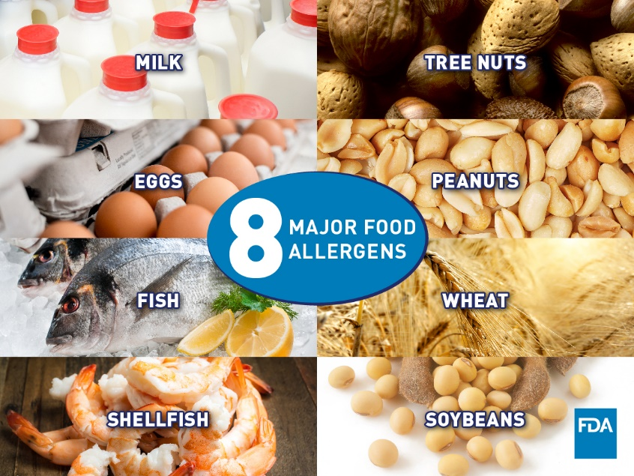

Why: The purpose of this research is to increase the U.S. Food and Drug Administration’s (also known as the FDA) understanding of patient and caregiver involvement in the development of therapies for food allergies.

Time commitment: 90 mins

Where: Virtual

Who: You can participate if you are 18 years or older and are:
- A person with a food allergy, or
- A caregiver (such as a parent or partner) to a person with a food allergy, or
- A representative from a food allergy patient advocacy organization
Participation is voluntary. If you participate you will receive a gift card for $75 as a token of appreciation.

More information?
Principal Investigator: Joey Mattingly (Email: jmattingly@rx.umaryland.edu; Phone: 410-706-8068)
Primary Contact: Andrea Melgar Castillo (Email: amelgarcastillo@rx.umaryland.edu; Phone: 410-706- 1753)

