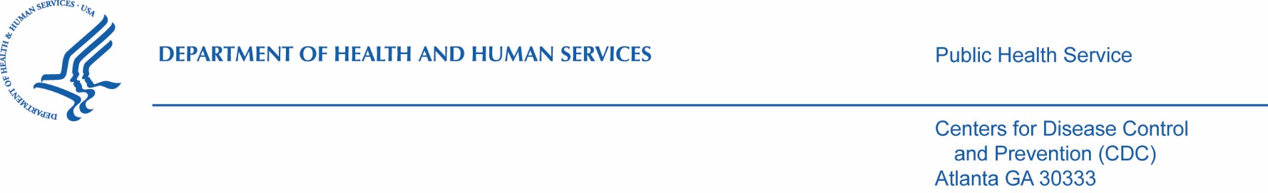

Memorandum
Date: May 9, 2022
From: Marion W. Carter, PhD
Associate Director for Science
Division of Scientific Education and Professional Development
Center for Surveillance, Epidemiology and Laboratory Services
Office of Public Health Scientific Services

Subject: ICR OMB 0920-0765 Fellowship Management System
2022 Request for Revision
Research Determination

To: Jeffrey M. Zirger, PhD
Chief, Information Collection Review Office
Office of Scientific Integrity
Office of the Associate Director for Science
Office of the Director
Centers for Disease Control and Prevention

Based on the description and justification for the Fellowship Management System activities, and the definition of research defined by Federal Policy for the Protection of Human Subjects (45 CFR 46), the request to collect and use data related to managing fellowship programs is not considered human subjects research, and therefore does not require IRB review or approval. This determination is reinforced in the determination documented in STARS, under accession number CSELS-BMA-7/6/21-710af.

If questions exist regarding the nonresearch determination or need for IRB review, please contact me at 404-639-8035 or acq0@cdc.gov.

