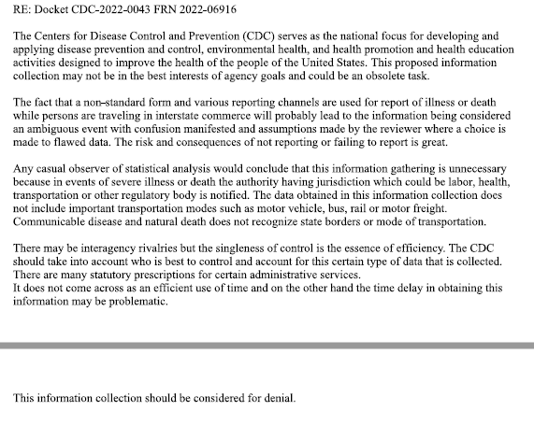
Public Comment:

Response:
Thank you for your comment. While there is no standard illness reporting form, since these reports are generally received by CDC verbally, CDC regulations define what an “ill person” is for the purpose of travel, and maintains this guidance on its website: https://www.cdc.gov/quarantine/air/reporting-deaths-illness/guidance-reporting-onboard-deaths-illnesses.html. CDC works closely with airlines to communicate and educate the specific requirements illness reporting, both in the domestic and international airspace. The purpose of allowing airline pilots, and other conveyance operators engaged in travel, to report illness or deaths occurring in real-time is to make sure the event is reported as soon as possible. CDC then works to inform state and local health authorities at the destination of arrival and then assists with coordination of any necessary public health follow up, as needed.
The data obtained in this collection does include other modes of transportation, such as interstate travel of buses, or trains, yet estimates that CDC will receive approximately 200 of those reports annually because reporting for domestic ground conveyances typically occur directly to the state or local hospital or health department where the individual is located and can be assessed and/or treated quickly.

