2021 Adolescent Behaviors and Experiences Survey

Attachment I6

Parental Permission Form and Fact Sheet (English)

PARENTAL PERMISSION FORM

Our school is taking part in the Adolescent Behaviors and Experiences Survey (ABES). This research project is sponsored by the Centers for Disease Control and Prevention (CDC). The survey will ask about the health behaviors of 9th through 12th grade students. The survey will ask about nutrition, physical activity, injuries, and tobacco, alcohol, and other drug use. It also will ask about sexual behaviors that lead to pregnancy and sexually transmitted diseases, including HIV. Other topics include student experiences during the COVID-19 pandemic.

Students will be asked to complete an electronic survey using an internet-connected device. The survey takes about 20-35 minutes.

Doing this survey will cause little or no risk to your child. The only potential risk is that some students might find certain questions to be sensitive. The survey has been designed to protect your child's privacy. Students will not be asked to provide their names on the survey. Also, no school or student will ever be mentioned by name in a report of the results. Your child will get no benefit right away from taking part in the survey. But the results of this survey will help your child and other children in the future. We would like all selected students to take part in the survey, but the survey is voluntary. No action will be taken against the school, you, or your child, if your child does not take part. Students can skip any questions that they do not wish to answer. In addition, students may stop participating in the survey at any point without penalty. If you would like to see the survey, a copy is available in the school office.

State and local school officials and a review board at CDC have approved the survey. You or your child may have questions about your child’s rights as a participant in this research survey. If so, please call the CDC Human Research Protections Office at 1-800-584-8814. Please leave a brief message with your name and phone number. Say that you are calling about CDC protocol #1969. We will return your call as soon as possible.

Please read the section below and check one box. Then, sign the form and return it to the school within 3 days. Please see the other side of this form for more facts about the survey. see the other side of this form for more facts about the survey. If your child's teacher or principal cannot answer your questions about the survey, call Alice Roberts, Project Director, toll-free at 1-800-675-9727. Thank you.

Child's name:___________________________________ Grade: __________________________

I have read this form and know what the survey is about.

Please check one box:
YES, my child may take part in this survey.

NO, my child may not take part in this survey.

Parent or guardian’s signature:_____________________ Date: ___________________________

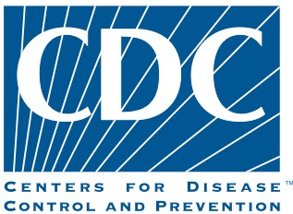

Why is the ABES being conducted? | In order to assess students’ health behaviors and experiences during the COVID-19 pandemic, and to help understand the pandemic’s impact on youth, the Centers for Disease Control and Prevention (CDC) will conduct the ABES in spring 2021.
Are sensitive questions asked? | Yes. Some questions may be considered sensitive. HIV infection and other sexually transmitted diseases (STDs) are major health problems. Sexual intercourse and injection drug use are among the behaviors known to increase the risk of HIV or other STDs. The only way to determine if adolescents are at risk of becoming infected with HIV or other STDs is to ask questions about these behaviors. Attempted suicide, tobacco use, alcohol and other drug use, weapon-carrying and COVID-related experiences also may be considered sensitive topics. Questions are presented in a straightforward manner and the survey is administered under conditions that are designed to protect student anonymity, thus reducing any uneasiness about answering questions considered sensitive. Also, if students are not comfortable answering a question, they may leave it blank.
Will student names be used or linked to the surveys? | No. The survey has been designed to protect your child’s privacy. Teachers are not involved directly. Students will not be asked to provide their names on the survey.
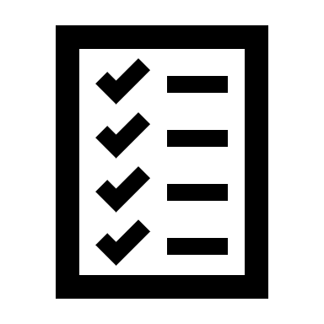  Do students take the survey more than once to see how their behaviors change? | No. The ABES will be administered only once, so there is no opportunity for your child or their school to be selected for participation again later.
How was my child selected to be in the survey? | One or two classes (about 25 to 50 students) in grades 9 through 12 were picked randomly to take part in each selected school.
How long does it take to complete the questionnaire? Is there some sort of physical test? | The survey takes approximately 20-35 minutes to complete. It has 110 multiple-choice questions. The survey does not include a physical test or exam.
Can I see the questions my child will be asked? | Yes, a copy of the survey is at your child’s school.

