**Survey Instrument for the Proper Formatting of OMB Approved Forms**

OMB # 0925-0348

Expiration Date: 07/31/2022

NIEHS HAZARDOUS WASTE WORKER TRAINING – 42 CFR Part 65

Public reporting burden for this collection of information is estimated to average 14 hours per response for the main program components below, including the time for reviewing instructions, searching existing data sources, gathering and maintaining the data needed, and completing and reviewing the collection of information. The Small Business Innovative Research (SBIR) Program survey is estimated to average one hour per response and does not require information input into the system below. An agency may not conduct or sponsor, and a person is not required to respond to, a collection of information unless it displays a currently valid OMB control number. Send comments regarding this burden estimate or any other aspect of this collection of information, including suggestions for reducing this burden, to: NIH, Project Clearance Branch, 6705 Rockledge Drive, MSC 7974, Bethesda, MD 20892-7974, ATTN: PRA (0925-0348). Do not return the completed form to this address.

The National Institute of Environmental Health Science (NIEHS) Worker Training Program (WTP) supports training and education of workers engaged in activities related to hazardous materials and waste generation, removal, containment, transportation, and disaster and emergency response in the following five areas:

* Hazardous Waste Worker Training Program (HWWT)
* Environmental Career Worker Training Program (ECWTP)
* Hazmat Disaster Preparedness Training Program (HDPTP)
* Brownfields Minority Worker Training Program (BMWT)
* DOE Nuclear Weapons Cleanup Training Program (DOE)
* The prior Biosafety and Infectious Disease Preparedness Training Program (BIDPTP) component has been integrated into the above WTP program components.
* Small Business Innovative Research Program (SBIR)

**Requested information from the grantees (input into the DMS through Data Entry):**

NIEHS Worker Training Program Data Management System Report

Component: (HWWTP, ECWTP, HDPTP, DOE)

Grantee Name:

Report Date:

☐Interim (6/01/2021 – 2/28/2022)

☐ Final (6/01/2021 – 5/31/2022)

**Does this report or an appendix contain photos?**

☐ Yes

☐ No

**Place your narrative for each section between the brackets []. You may overwrite the directions for each section. Please keep your text specific to the HWWT Program for this report.**

1. Briefly describe the objectives, key initiatives, or activities you had planned for the current program year.
2. Provide your projected and actual training numbers for the grant year.
3. Describe the updates on the implementation and progress on training programs, projects, or initiatives specific to the grant year and program component.
4. Describe at least two training highlights or success stories that emphasize accomplishments from this past year.
5. Summarize key evaluation findings about training program delivery and participant learning, including the following recommended optional training participant questions:
   1. The training has prepared me to recognize hazards on the job (Strongly Disagree – Disagree – Neutral – Agree – Strongly Agree)
   2. The training has increased my knowledge of how to control workplace hazards (Strongly Disagree – Disagree – Neutral – Agree – Strongly Agree)
6. Describe curricula updates from the grant year
7. Describe advisory board activities from the grant year.
8. Summarize key evaluation findings or reports about trainee follow-up, including the following recommended optional training participant question:
   1. Since you took the training course, how have you applied this training at your work or in the community? (open ended, provide example responses)
9. Describe activities that your program has undertaken to train instructors and assure quality instruction during this grant year.
10. Describe the program self-audit used by your organization this grant year to certify compliance with the training quality assurance sections of the NIEHS Minimum Criteria Document.
11. Describe progress on any funded supplemental grants or awarded carryover.
12. Summarize the significance of your HWWT training implementation, training outcomes, and curriculum development **for the last five years.** **[only ask in year 5/final year of NIH project period]**
13. Describe your training plans for the next grant year.
14. Describe any publications, media coverage, or outreach materials produced or published this grant year.
15. Describe or refer to text in other sections on timely or key NIEHS WTP topics, including disasters; infectious disease events; and any training or outreach activities that were focused on American Indians, Alaska Natives, or a tribal organization as the primary audience.

The NIEHS WTP collects information in the Curricula Information and Data Management System (DMS), which is a web-based application designed to store and track projected and actual training, student demographic data, and progress report material. WTP grantees have access to the DMS via the iTrust system – either using a Federated Login or a Google or Microsoft account login. The DMS is restricted to authorized users/grantees.  After grantees successfully log in via iTrust their login information is compared to the list of authorized users stored in the database. Only those users stored in the DMS database are allowed access to the system. Grantee users only have access to the data for their grantee organization.  WTP staff and selected contract staff have access to all grantee entered data.

DMS information options:

* Awardee Information: This is the home page of the application. This page loads when a user has successfully logged into the application. This page contains up-to-date information about deadlines, system maintenance and any other application changes or enhancements. It is important that this page be read each time someone logs onto the application.
* Curricula Catalog: Provides access to training curricula produced by organizations funded by the WTP. This option includes uploading and editing course curricula and materials and adding and editing curricula data coordinator information. The information in the [Curricula Catalog](https://tools.niehs.nih.gov/wetp/index.cfm?id=603) is accessed by the public on the National Clearinghouse for Worker Safety and Health Training [webpage](https://tools.niehs.nih.gov/wetp/index.cfm).
* Data Entry: This option allows a user to enter, edit, or change the status of course and or

student demographic data records.

* Progress Reports: This option allows a user to upload progress reports and/or appendices,

or view archived progress reports submitted for an awardee organization.

* Reports: This option allows a user to query course and student demographic data stored in the WTP application and output reports in an Excel spreadsheet or HTML table.
* Admin Functions: This option is only available to User Administrators. The Mark

Data Complete function allows the point of contact in the awardee organization to certify that all data and or progress report entry in a given period is complete.

**Data Management System Screenshots:**

**Awardee Information Page:**

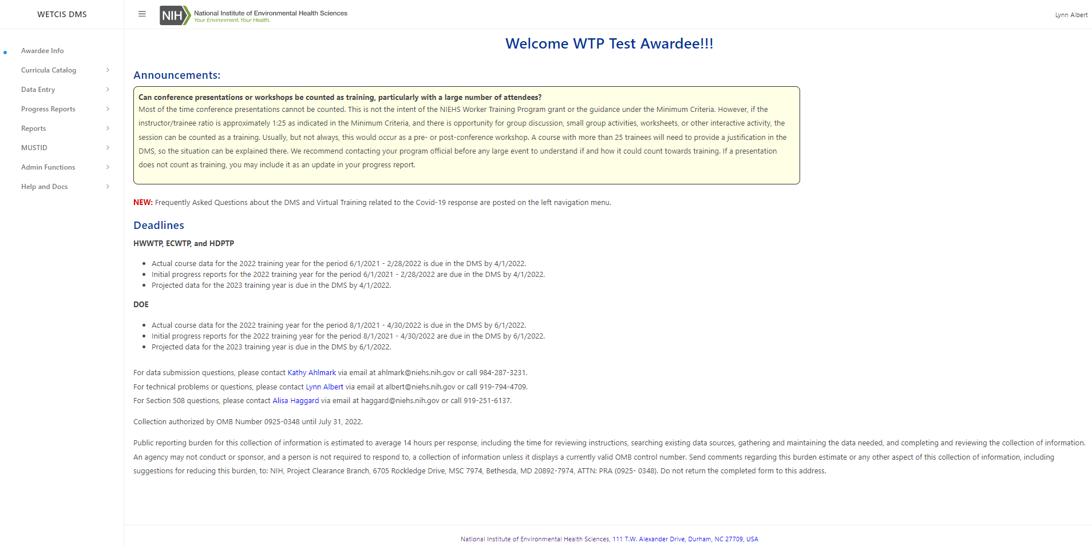

**Curricula Catalog Course Listing:**

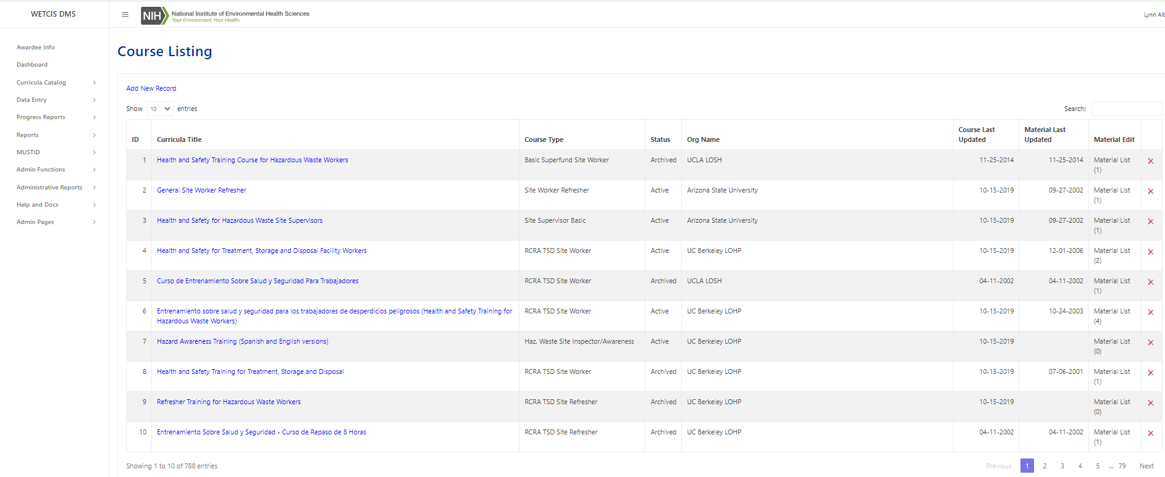

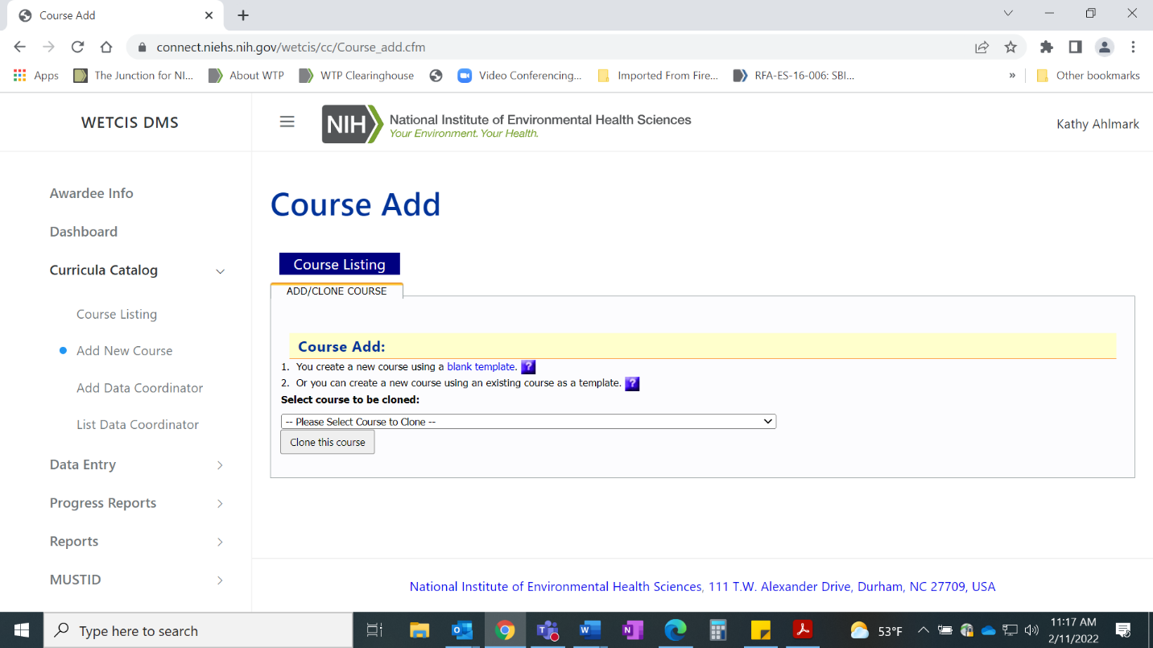

**Data Entry Screens:**

1. **Course Data Entry Form**

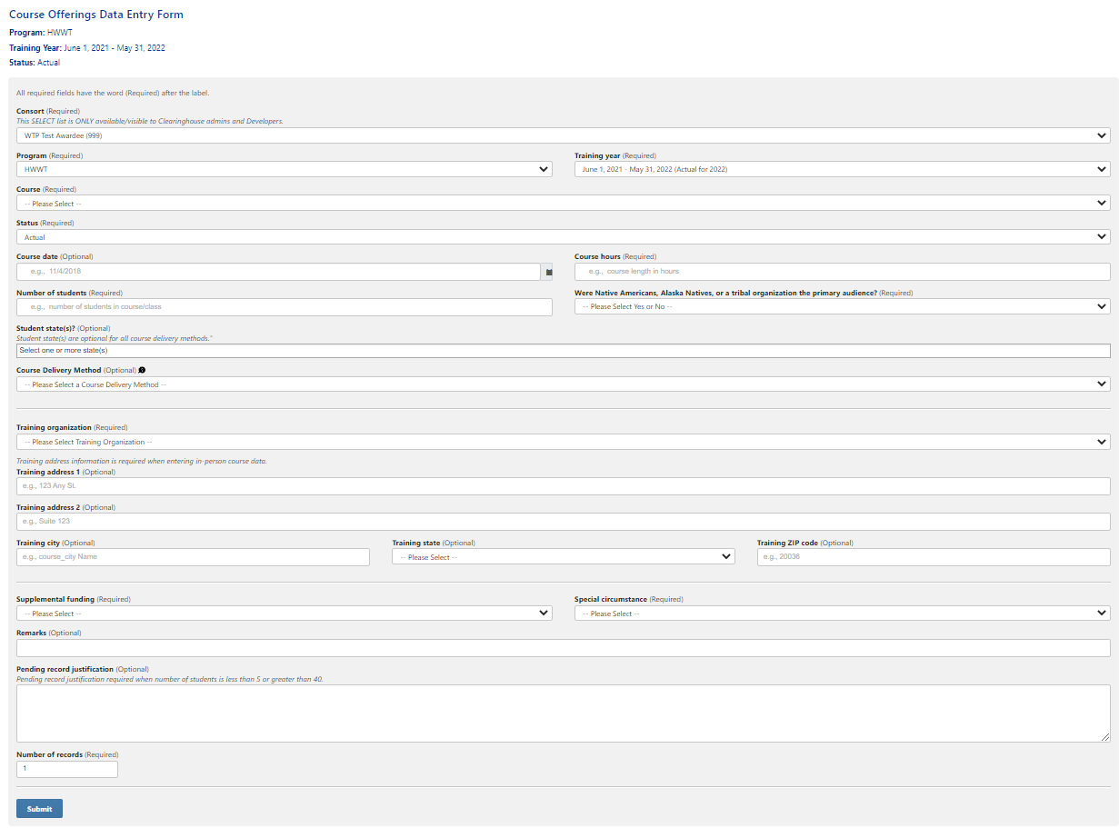

1. **Data Excel Upload**

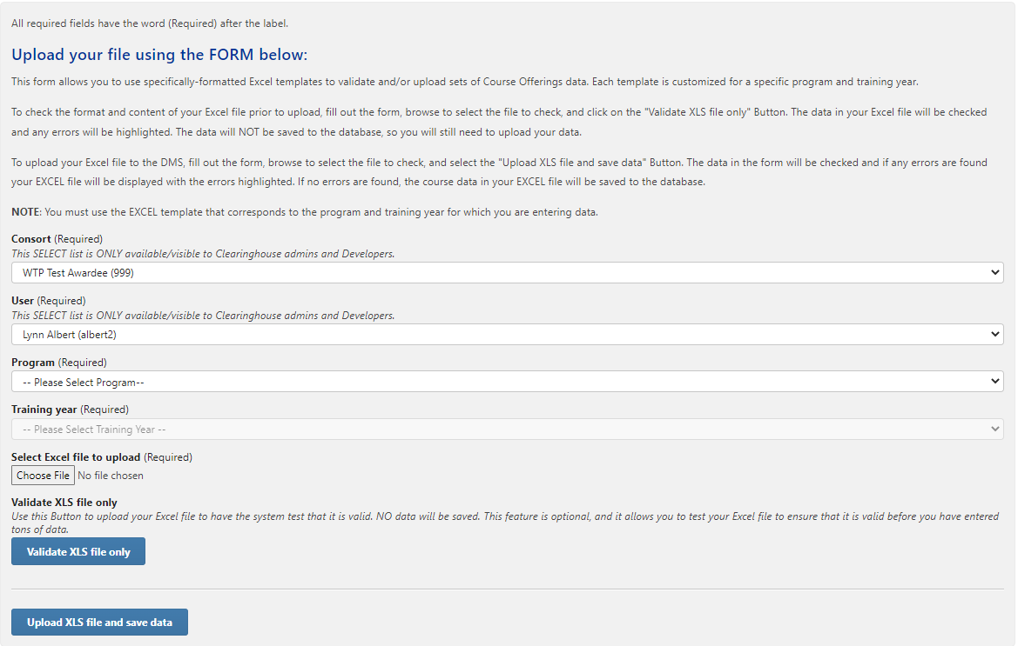

1. **Student Demographic Data Entry Form**

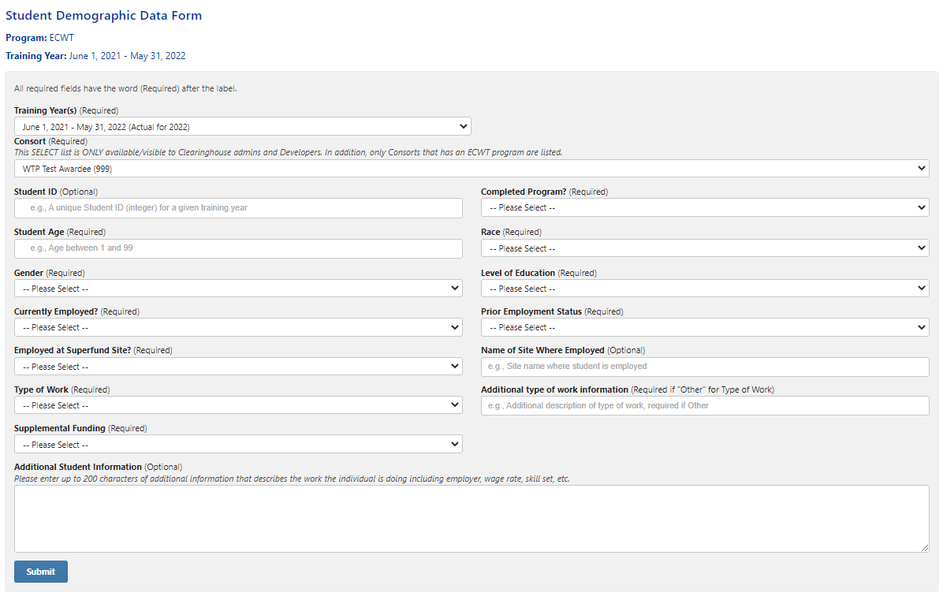

1. **Student Demographic Data Excel Upload**

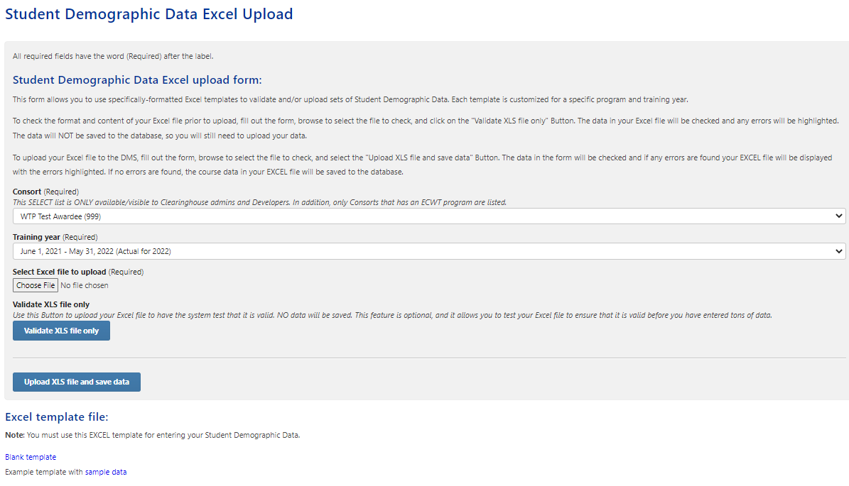

**Information output on Grantee Progress Reports (only available to WTP staff and selected contract staff)**

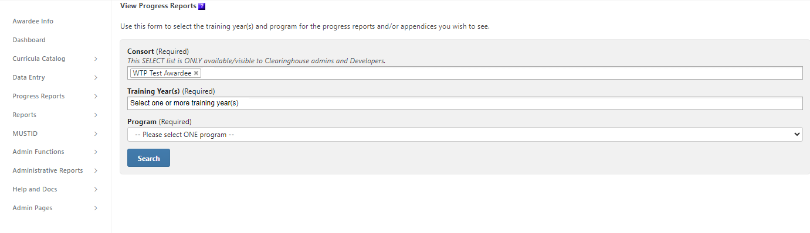

**Grantee Progress Report Upload:**

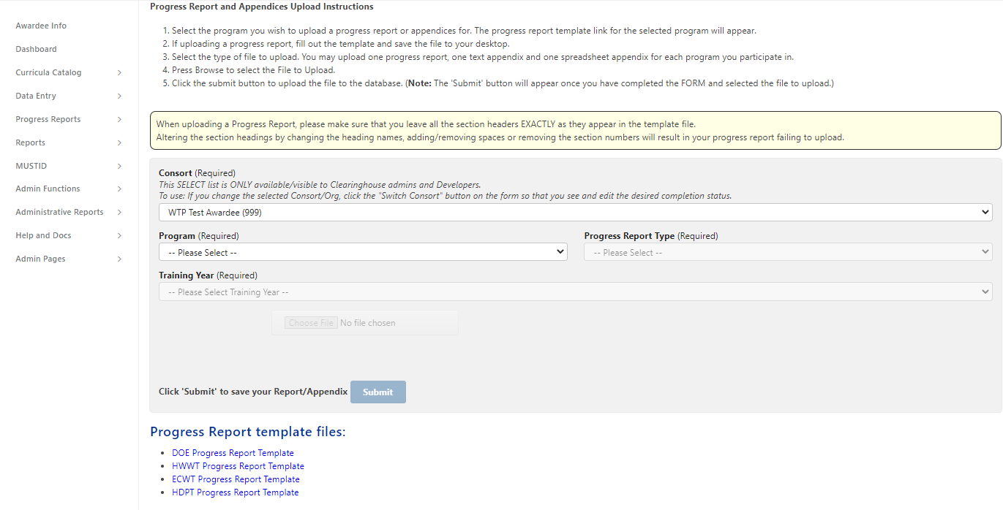

**Information output on course offerings (only available to WTP staff and selected contract staff):**

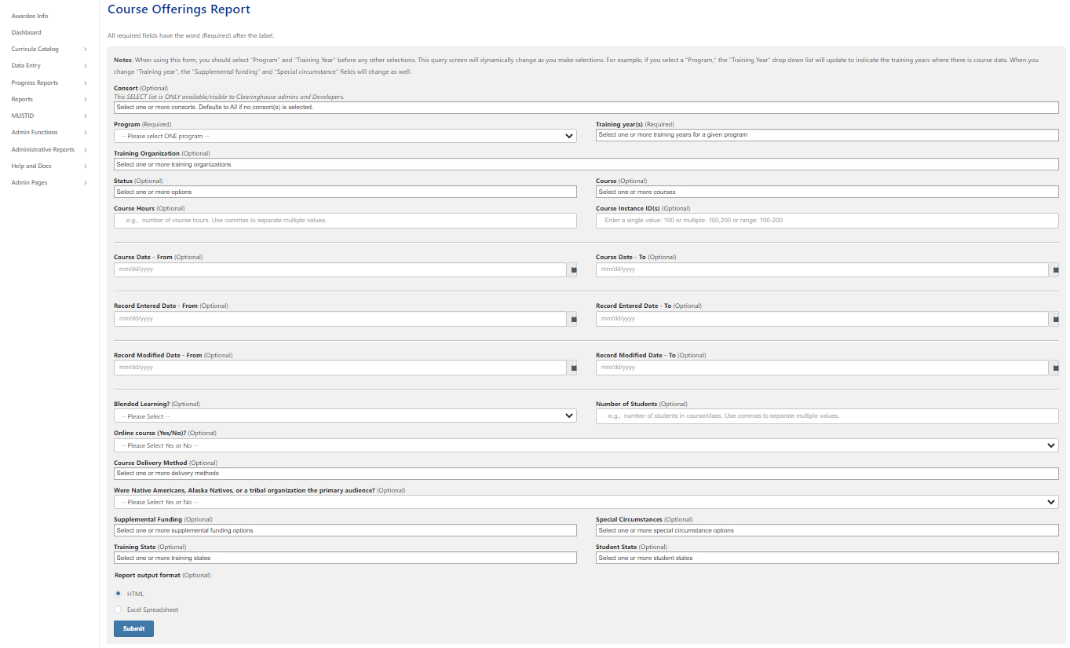

**Information output on student demographics for the ECWTP only (only available to WTP staff and selected contract staff):**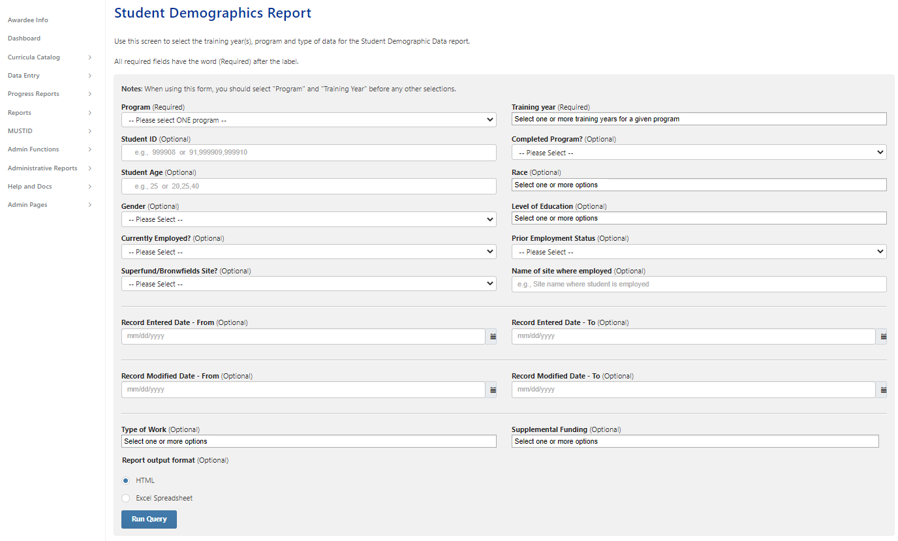

**Information output – resources on infectious disease and worker safety (restricted site for selected individuals with iTrust credentials)**

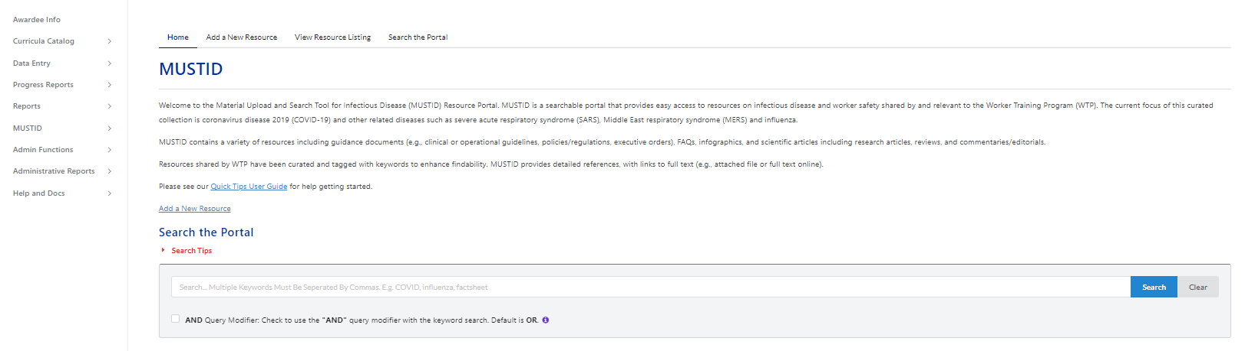

**Administrative functions for WTP staff and selected contract staff:**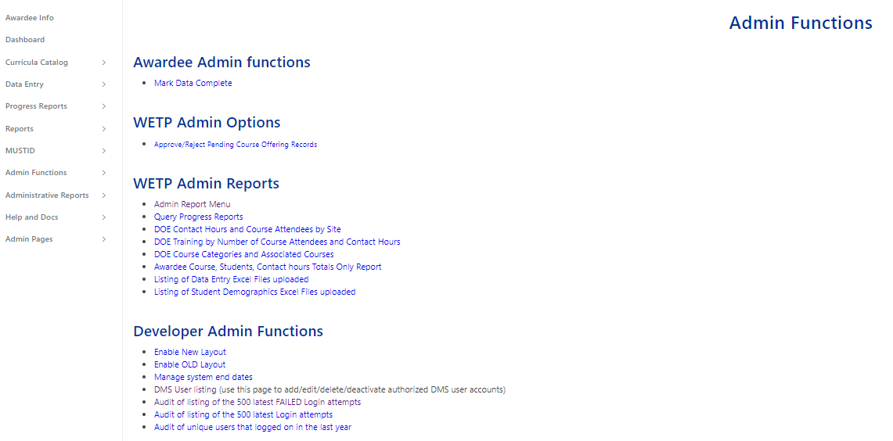

**Help and Docs information shown in the left navigation menu:**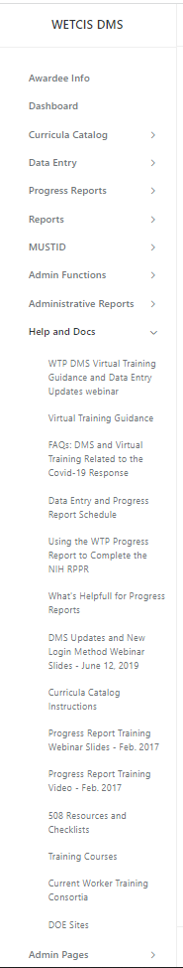

**Administrative pages shown on the left navigation menu:**

