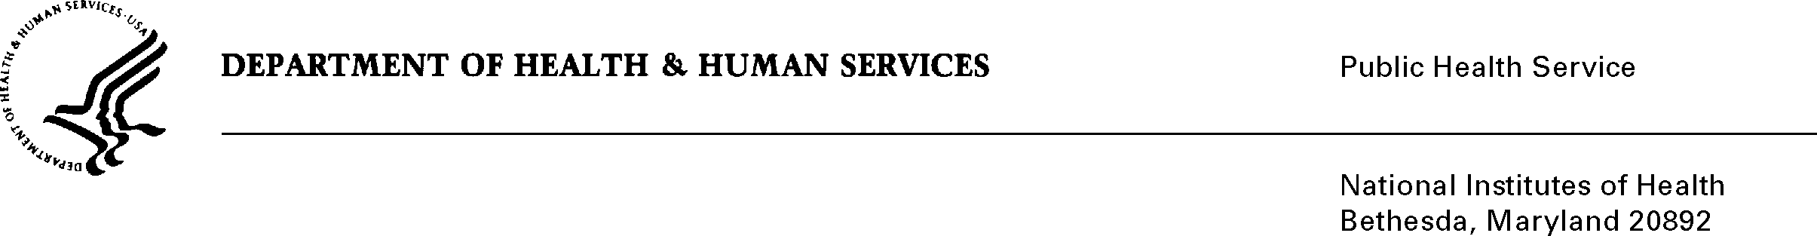

DATE: June 20th, 2022

TO: OMB Desk Officer NIH
Office of Management and Budget (OMB)
Reports Clearance Officer, DHHS

FROM: Mikia P. Currie
Chief, Project Clearance Branch

SUBJECT: Change Request to a Currently Approved Form
(NIH COVID-Vaccination Attestation Intake Form, OMB 0925-0771, expiration 4/30/2025)

This is a request for OMB to approve a non-substantial modification of the NIH COVID-Vaccination Attestation Intake Form. Initially, this request was submitted to comply with the vaccination attestation requirements for the Federal Safer Workforce Taskforce however, since the time of approval, the Centers for Disease Control and Prevention (CDC) has updated their vaccination recommendations several times to include multiple boosters. Also, NIH has finalized their mandatory vaccination requirement that affects several thousand staff (e.g., employees, contractors, trainees, guest researchers, etc.) working in our healthcare areas. Specifically, this form is critical to support the data collection for those persons that have received a tentative job offer, but do not have computer access to our system. Those persons cannot receive a final job offer until we complete their vaccination and booster verification.

NIH would like to expand the form elements to allow additional doses to be reported.
The additional doses are being collected to ensure compliance with our vaccination policies, ensuring we are able to capture all doses of COVID-19 vaccination, and to provide the highest levels of safety to our workforce and patient populations.

The timeframe and the burden on respondents due to this change is unchanged.

Attachments: 1a) Form Mockup
1b) Clean Version

Your full consideration is appreciated.

