June 28, 2021

Mindy Scott
Child Trends
7315 Wisconsin Ave, Suite 1200W
Bethesda, MD 20814

RE: Human Subjects Research Determination for “ACF Evidence Capacity Support – ORR Engagement” (1838.005)
Dear Ms. Scott,
Thank you for submitting a human subjects research determination request for ““ACF Evidence Capacity Support – ORR Engagement” (1838.005). The IRB has reviewed your request and determined that this study does not constitute human subject research as the project consists of providing guidance on how to revise performance data collection and internal performance measurement activities for the Office of Refugee Resettlement, and will not contribute to generalizable knowledge. Therefore, you do not need to submit the study protocol for IRB review.
Warm regards,
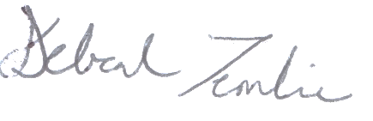

Deborah Temkin
Board Co-Chair

