APPENDIX U
LOGIC MODELS
This page has been left blank for double-sided copying.

FACES 2019 LOGIC MODEL
This page has been left blank for double-sided copying.

exhibit U.1. FACES 2019 Logic Model

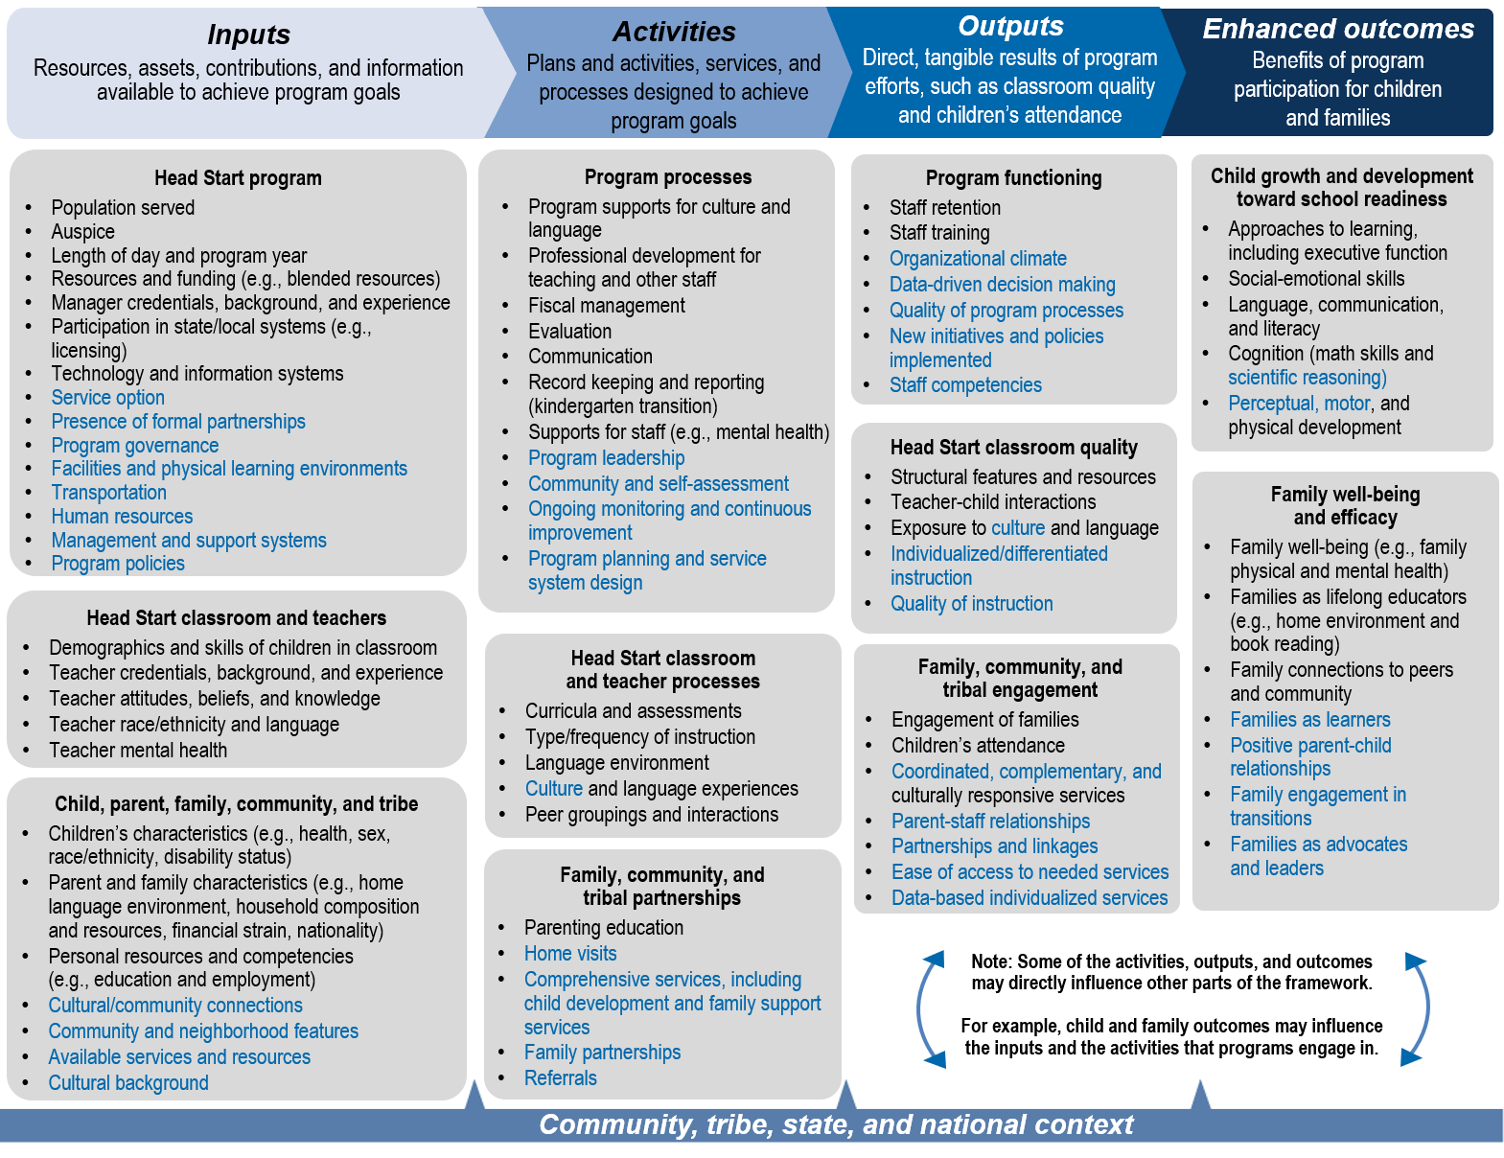

Note: The logic model depicts Head Start more generally, beyond what the FACES studies can measure. Black font indicates constructs that are measured in FACES 2019. Blue font indicates constructs that are not measured.
This page has been left blank for double-sided copying.

AIAN FACES 2019 LOGIC MODEL
This page has been left blank for double-sided copying.

Exhibit U.2. AIAN FACES 2019 Logic Model

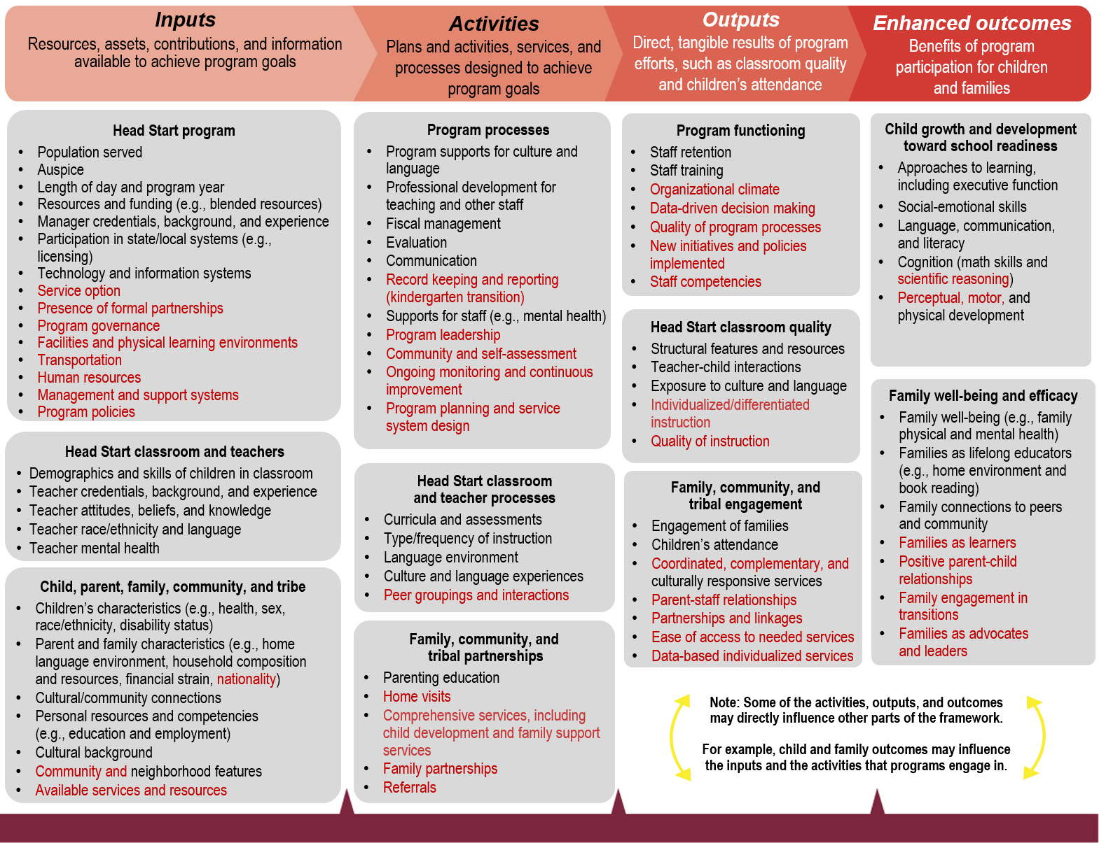

Note: The logic model depicts Head Start more generally, beyond what the AIAN FACES studies can measure. Items shown in black font indicates constructs that are measured in AIAN FACES 2019; items shown in red font indicates constructs not measured.
This page has been left blank for double-sided copying.

