Form Approved
OMB No. 0990-0379
Exp. Date 08/31/2023

HRSA BHW Website:

Usability Test Script (Test Instrument)

Intro & Pre-Test Questions
Thank you for participating in HRSA’s Bureau of Health Workforce (BHW) website study.
This activity will take you 15 to 20 minutes to complete.
Your response will help us understand how to organize the content on our website and make it more useful for you.
- With which of the following do you most identify? (Single Select) (Required)
  - Student
  - Healthcare Worker
  - Academic Institution
  - Researcher
  - Public Health Professional
  - Family Caregiver
  - Media/Journalist
  - Policymaker
  - Healthcare Administrator
  - Other: (Text field: “If other, please specify”)
According to the Paperwork Reduction Act of 1995, no persons are required to respond to a collection of information unless it displays a valid OMB control number. The valid OMB control number for this information collection is 0990-0379. The time required to complete this information collection is estimated to average 30 minutes per response, including the time to review instructions, search existing data resources, gather the data needed, and complete and review the information collection. If you have comments concerning the accuracy of the time estimate(s) or suggestions for improving this form, please write to: U.S. Department of Health & Human Services, OS/OCIO/PRA, 200 Independence Ave., S.W., Suite 336-E, Washington D.C. 20201, Attention: PRA Reports Clearance Officer
- Which content are you most likely to look for on the BHW site? (Single Select) (Required)
- Specific Bureau of Health Workforce programs
- General information about the Bureau of Health Workforce
- Grants and funding opportunities
- Loan repayment and scholarship opportunities
- Virtual Job Fairs or job opportunities
- NHSC-approved sites
- Health Professional Shortage Areas (HPSAs), Medically Underserved Area and Medically Underserved Population (MUA/Ps), scoring, and application process
- Health workforce data tools and research
- Other: (Text field: “If other, please specify”)
- Which content are you likely to look for second on the BHW site? (Single Select) (Required)
- Specific Bureau of Health Workforce programs
- General information about the Bureau of Health Workforce
- Grants and funding opportunities
- Loan repayment and scholarship opportunities
- Virtual Job Fairs or job opportunities
- NHSC-approved sites
- Health Professional Shortage Areas (HPSAs), Medically Underserved Area and Medically Underserved Population (MUA/Ps), scoring, and application process
- Health workforce data tools and research
- Other: (Text field: “If other, please specify”)
- Which option best describes how often you visit the BHW website? (Single Select) (Required)
  - Several times a day
  - Several times a week
  - Several times a month
  - Several times a year
  - I have never visited the BHW website.

Tasks
Each task starts here: https://bhw.hrsa.gov/
 | Task | Success
1 | How many scholarship programs does BHW have? | Funding > Apply for a Scholarship > 3 (Nurse Corps Scholarship Program; Native Hawaiian Health Scholarship Program; National Health Service Corps Scholarship Program)
2 | Find the eligibility requirements for the Advanced Nursing Education Program. | Funding > Apply for a Grant > “You are eligible*, if you are a school of nursing, a nursing center, an academic health center, a state or local government, or a public or private nonprofit entity that the Secretary deems appropriate.”
3 | Find out how to apply for an Auto-HPSA designation. | Workforce Shortage Areas > What is Shortage Designation > Reviewing Shortage Designation Applications > How do I request an Auto-HPSA designation?
4 | Find health workforce projections for geriatricians. | Data & Research > Review Workforce Research > Projecting Supply and Demand > Geriatricians accordion & PDF
5 | Where would you go to sign up for the BHW newsletter? | Scroll to footer > Subscribe
6 | Find how many virtual job fairs BHW hosted in 2019. | Job Search > Attend a Virtual Job Fair > 4
7 | Find the National Sample Survey of Registered Nurses. | Data & Research > Access Data Tools > National Sample Survey of Registered Nurses (NSSRN)

Post-Test Questions
- On a scale of 1 to 5, 1 being difficult and 5 being easy, how would you rate your experience finding the information? Why?
- What did you like most about your experience on the site today?
- What did you like least about your experience on the site today?
- Is there anything you wish that the site had?
- Do you have any final recommendations for improving the site?

UserZoom Screenshots
Note: These screenshots display the script and how it will look in the UserZoom tool.
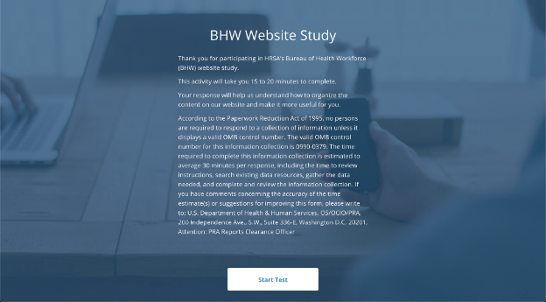
Screenshot 1: Welcome Message and PRA Statement
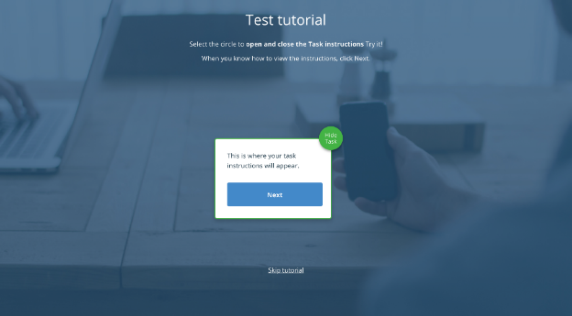
Screenshot 2: UserZoom Test Tutorial
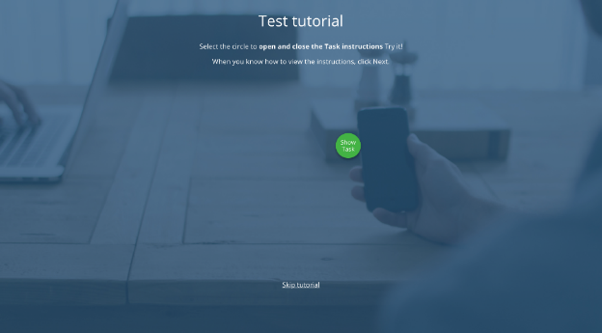
Screenshot 3: UserZoom Test Tutorial
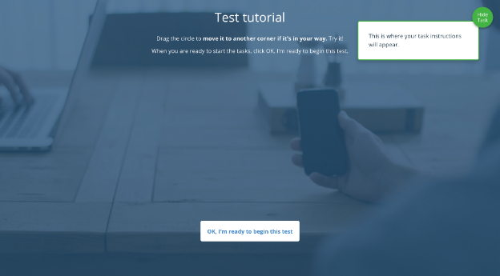
Screenshot 4: UserZoom Test Tutorial
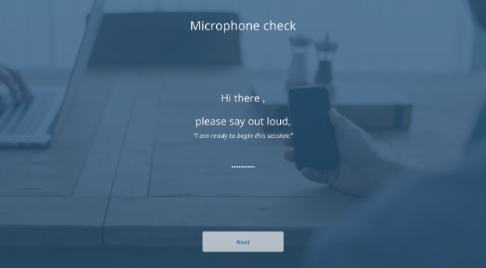
Screenshot 5: Microphone Check
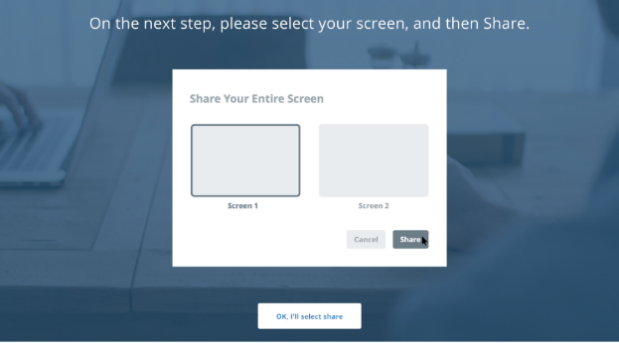
Screenshot 6: Screenshare Selection
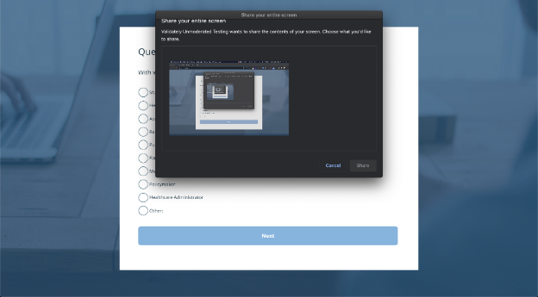
Screenshot 7: Screenshare Selection
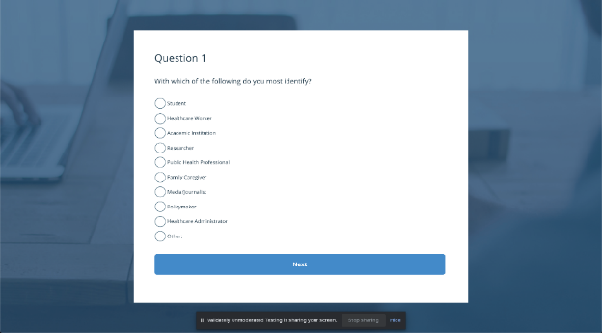
Screenshot 9: Pre-Test Question 1
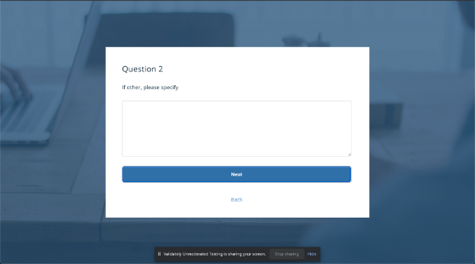
Screenshot 10: Pre-Test Question 2
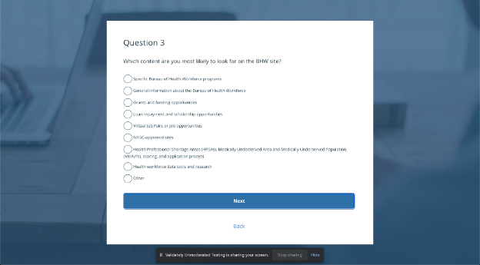
Screenshot 11: Pre-Test Question 3
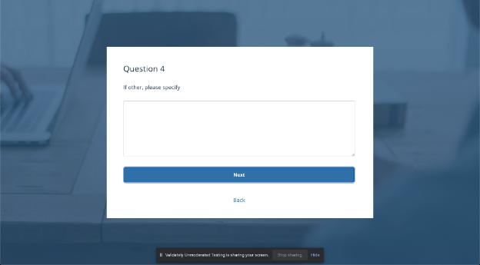
Screenshot 12: Pre-Test Question 4
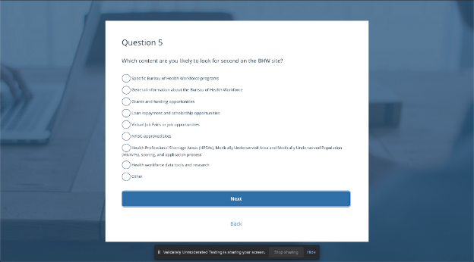
Screenshot 13: Pre-Test Question 5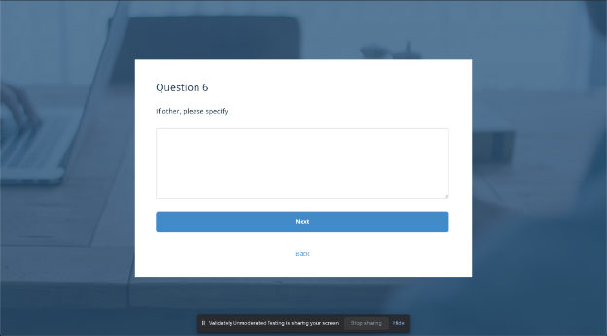Screenshot 14: Pre-Test Question 6
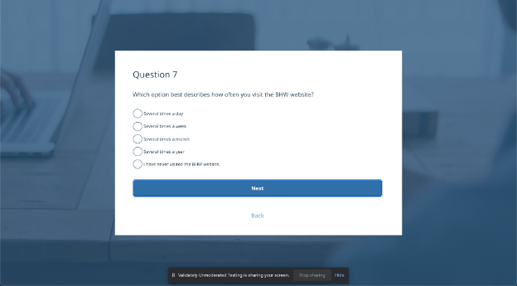
Screenshot 15: Pre-Test Question 7
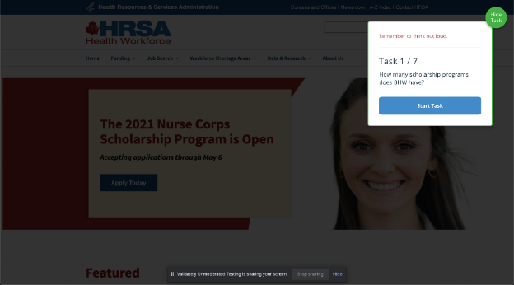
Screenshot 16: Task 1 Start
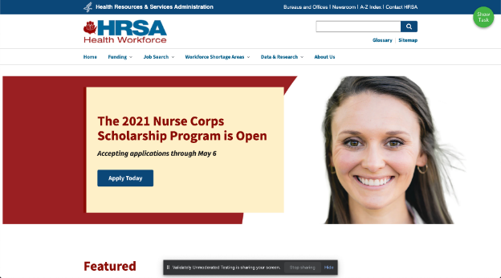
Screenshot 17: Task 1 Hide Task
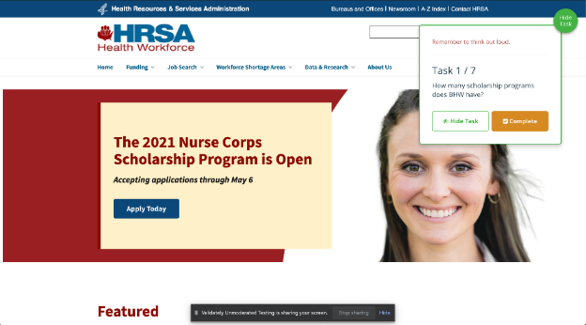
Screenshot 18: Task 1 Complete
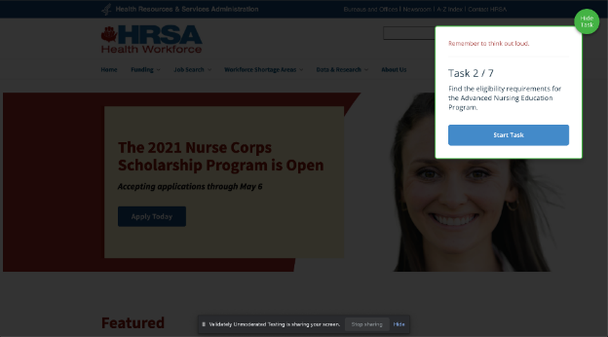
Screenshot 19: Task 2 Start
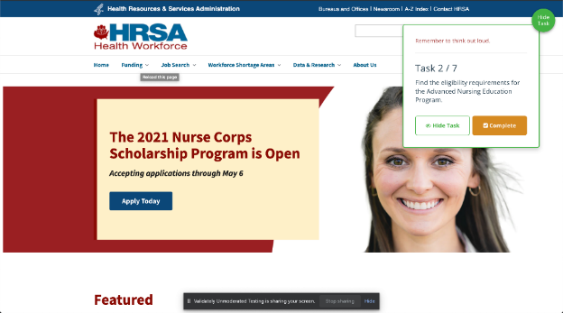
Screenshot 20: Task 2 Complete
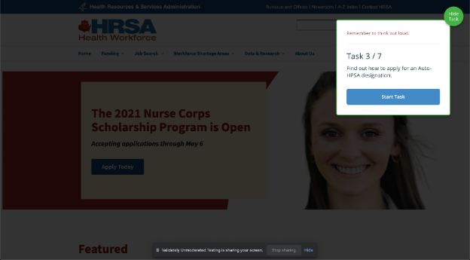
Screenshot 21: Task 3 Start
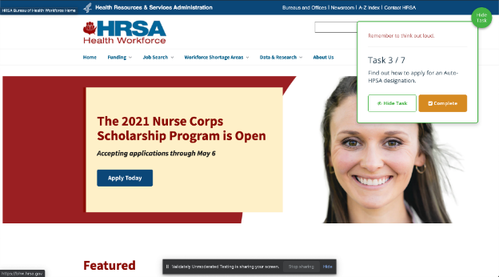
Screenshot 22: Task 3 Complete
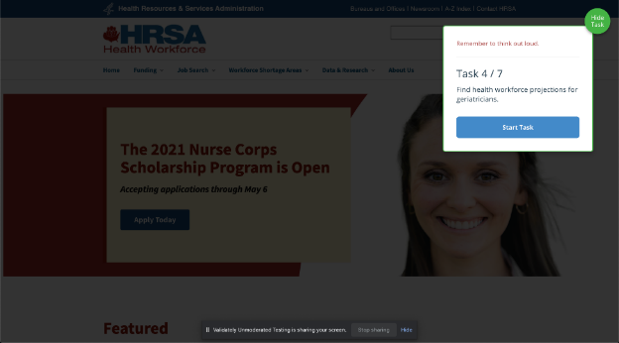
Screenshot 23: Task 4 Start
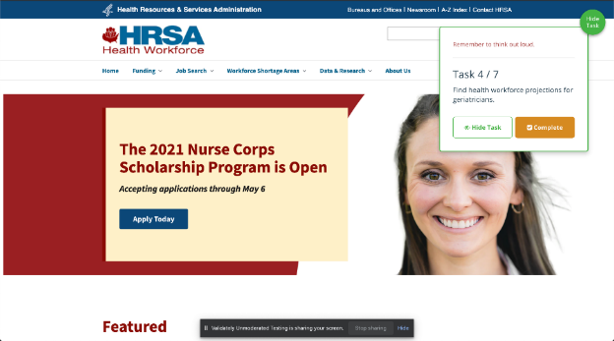
Screenshot 24: Task 4 Complete
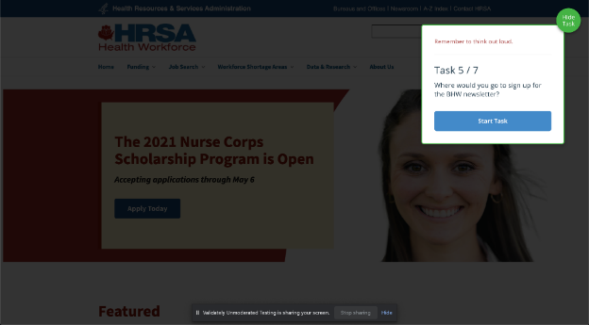
Screenshot 25: Task 5 Start
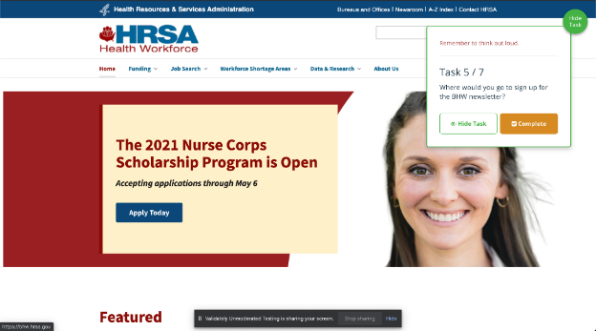
Screenshot 26: Task 5 Complete
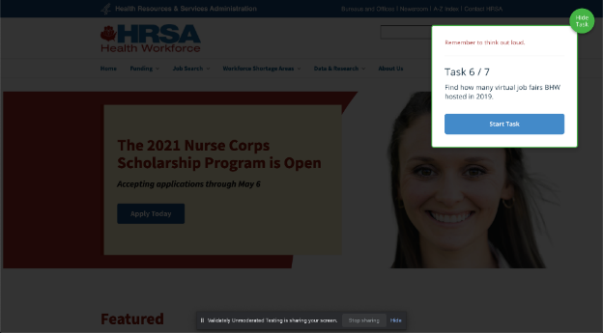
Screenshot 27: Task 6 Start
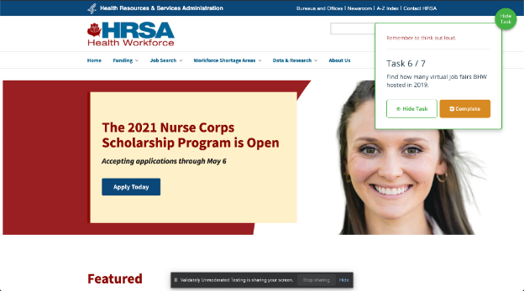
Screenshot 28: Task 6 Complete
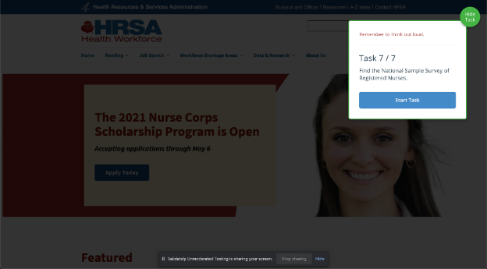
Screenshot 29: Task 7 Start
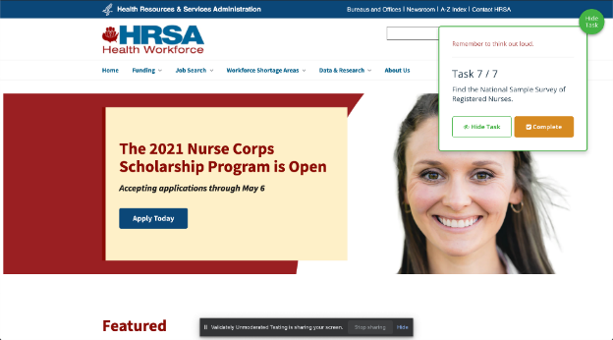
Screenshot 30: Task 7 Complete
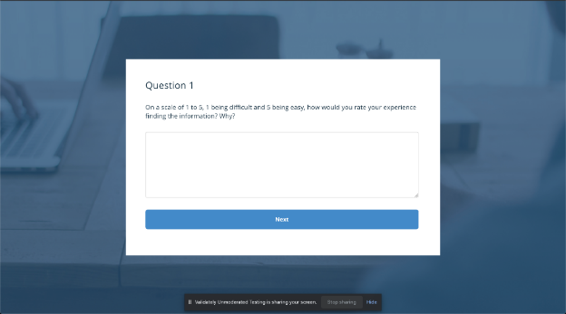
Screenshot 31: Post-Test Question 1
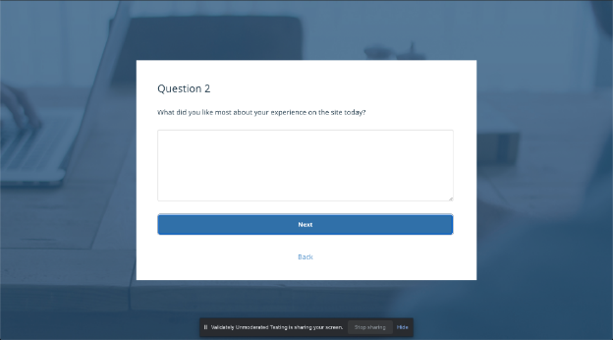
Screenshot 32: Post-Test Question 2
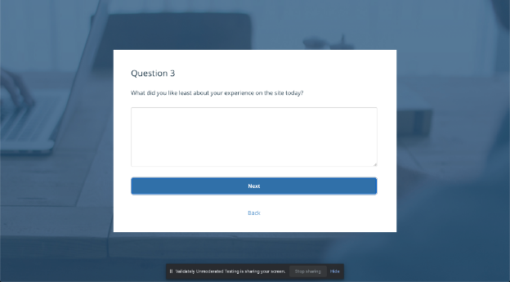
Screenshot 33: Post-Test Question 3
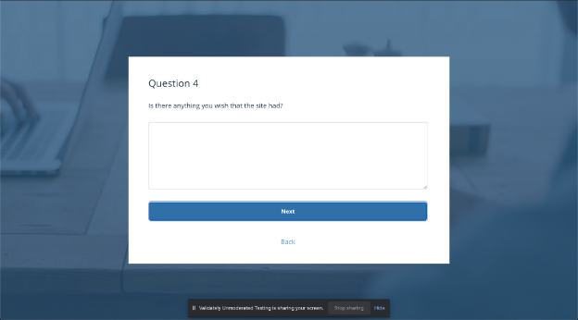
Screenshot 34: Post-Test Question 4
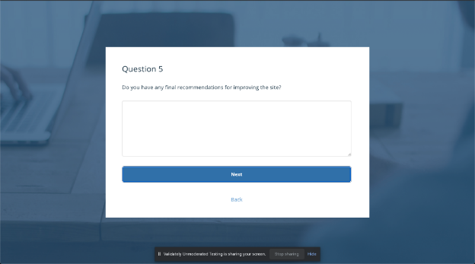
Screenshot 35: Post-Test Question 5
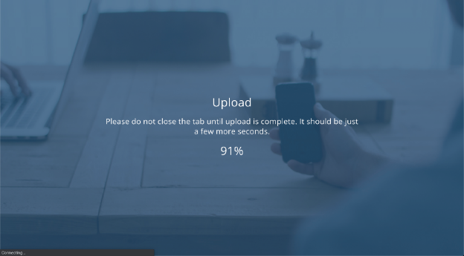
Screenshot 36: Post-Test Upload
Screenshot 37: Thank You Message

