Request for Approval under the “Generic Clearance for the Collection of Routine Customer Feedback” HHS Online Customer Surveys (OMB Control Number: 0990-0379)
TITLE OF INFORMATION COLLECTION: ASPR Candidate Experience Survey

PURPOSE: The purpose of the ASPR Candidate Experience Survey is to gather information to improve the recruitment and hiring process at ASPR. Our team would like to learn more about candidate perceptions of the application and interview process and determine what (if any) challenges exist in our current procedures. This survey is a small part of efforts to gather more Human Capital metrics and improve the employee experience at ASPR.

DESCRIPTION OF RESPONDENTS:
All individuals who interview for a position with ASPR, whether they receive or accept a job offer, will be asked to respond to the survey.

TYPE OF COLLECTION: (Check one)

[ ] Customer Comment Card/Complaint Form [ x] Customer Satisfaction Survey
[ ] Usability Testing (e.g., Website or Software [ ] Small Discussion Group
[] Focus Group [ ] Other: ______________________

CERTIFICATION:

I certify the following to be true:
- The collection is voluntary.
- The collection is low-burden for respondents and low-cost for the Federal Government.
- The collection is non-controversial and does not raise issues of concern to other federal agencies.
- The results are not intended to be disseminated to the public.
- Information gathered will not be used for the purpose of substantially informing influential policy decisions.
- The collection is targeted to the solicitation of opinions from respondents who have experience with the program or may have experience with the program in the future.

Name:___Rebecca Frizzell_____________________________________________

To assist review, please provide answers to the following question:

Personally Identifiable Information:
- Is personally identifiable information (PII) collected? [ x] Yes [ ] No
Although the survey will not be collecting PII, we will be utilizing the participants’ email addresses to distribute the survey. This will allow us to send survey reminders to only those individuals who have not completed the survey, rather than the entire sample.

- If Yes, is the information that will be collected included in records that are subject to the Privacy Act of 1974? [ ] Yes [ x ] No
- If Applicable, has a System or Records Notice been published? [ ] Yes [ x ] No
Gifts or Payments:
Is an incentive (e.g., money or reimbursement of expenses, token of appreciation) provided to participants? [ ] Yes [ x ] No

BURDEN HOURS

Category of Respondent | No. of Respondents | Participation Time | Burden hour
Individuals or Households | 1000 | 5/60 | 83.33
Totals

FEDERAL COST: The estimated annual cost to the Federal government is $900___________

If you are conducting a focus group, survey, or plan to employ statistical methods, please provide answers to the following questions:

The selection of your targeted respondents
- Do you have a customer list or something similar that defines the universe of potential respondents and do you have a sampling plan for selecting from this universe? [x ] Yes [ ] No

If the answer is yes, please provide a description of both below (or attach the sampling plan)? If the answer is no, please provide a description of how you plan to identify your potential group of respondents and how you will select them?

We will have a list of all individuals who interviewed for a federal position within ASPR in the last three months and we will send the survey link to all of them, regardless of whether they were offered or accepted the position. They will receive the survey through the following email:
Thank you for your interest in working for the Assistant Secretary for Preparedness and Response (ASPR). We would like to ensure that applying for a job with our organization is a positive experience for our applicants. Please help us accomplish this goal by completing a short (five minutes or less) survey. Your feedback will be used to improve our hiring processes.

Follow this link to the Survey: https://asprorgeffectiveness.az1.qualtrics.com/jfe/preview/SV_3WAzeLdSZkgEvt4?Q_CHL=preview&Q_SurveyVersionID=current
Or copy and paste the URL below into your internet browser:
https://asprorgeffectiveness.az1.qualtrics.com/jfe/preview/SV_3WAzeLdSZkgEvt4?Q_CHL=preview&Q_SurveyVersionID=current

Thank you for your feedback!
ASPR Talent Acquisition
Administration of the Instrument
- How will you collect the information? (Check all that apply)
[ x ] Web-based or other forms of Social Media
[ ] Telephone
[ ] In-person
[ ] Mail
[ ] Other, Explain
- Will interviewers or facilitators be used? [ ] Yes [ x ] No

Please make sure that all instruments, instructions, and scripts are submitted with the request.
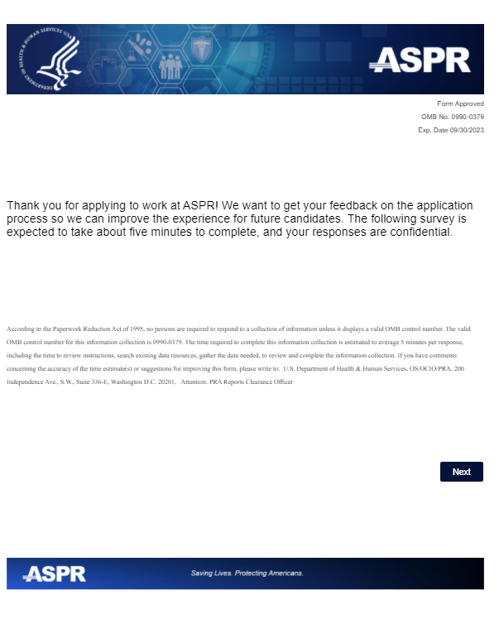
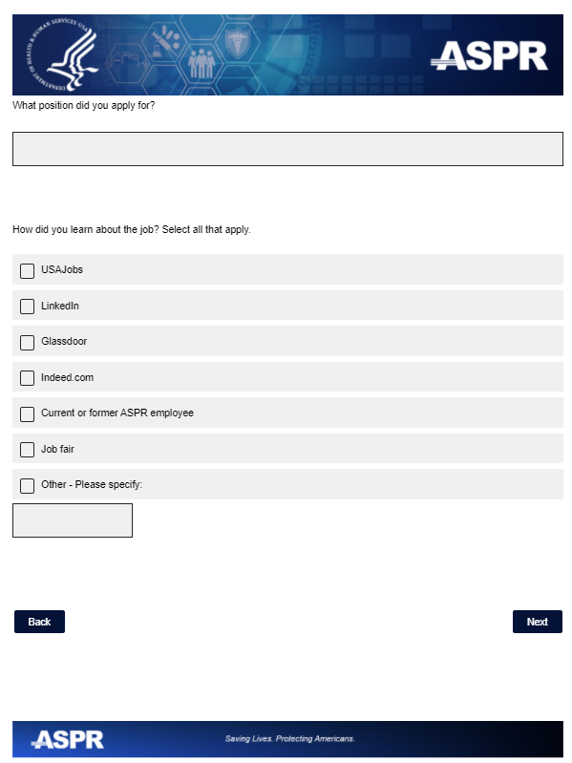

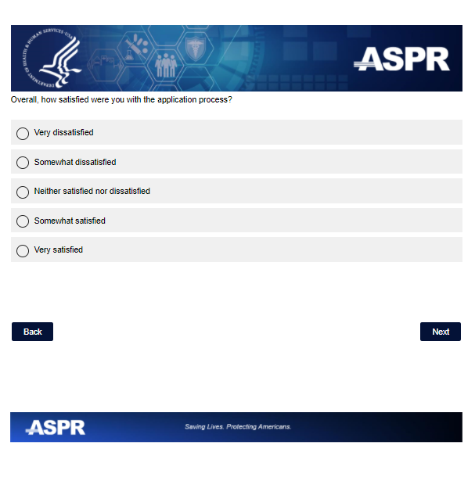
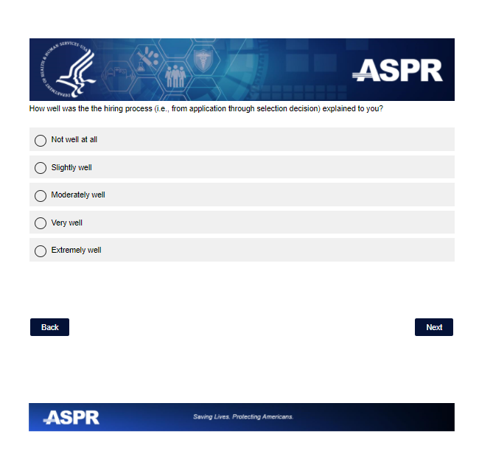
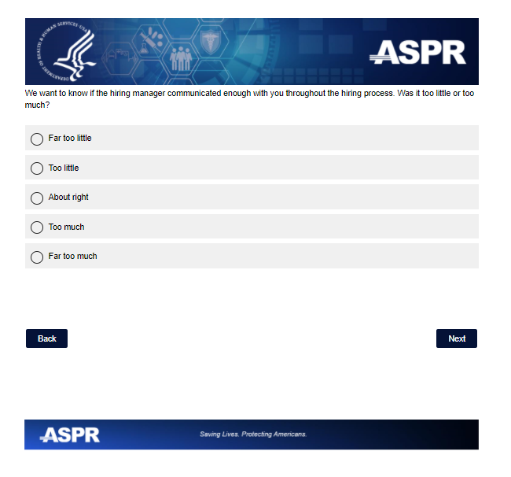
Note: Only survey participants who select “Far Too Little” or “Too Little” will see the next question.

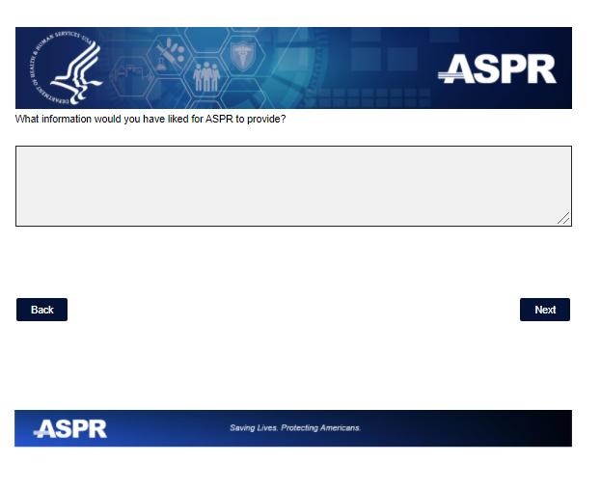
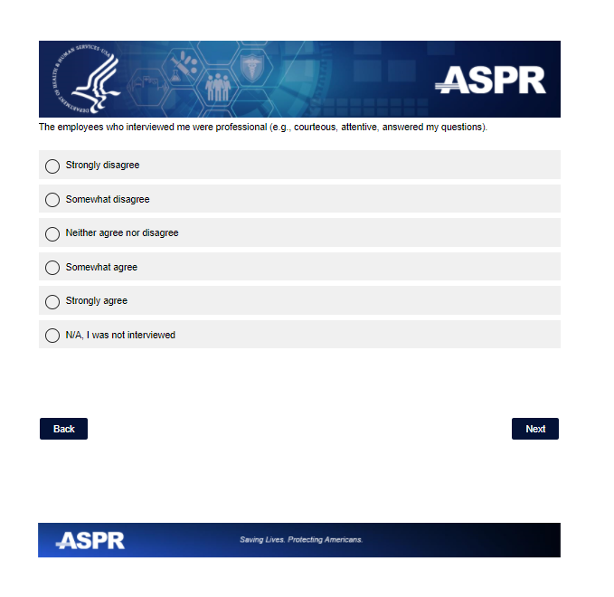

Note: Survey participants who select “N/A I was not interviewed” will skip the next two questions.
