Form Approved
OMB No. 0990-0379
Exp. Date 08/31/2023

HRSA: Tree Testing Script (Test Instrument)

Introduction
Thank you for participating in HRSA’s website study.
This activity will take you 15 to 20 minutes to complete.
Your response will help us understand how to organize the content on our website and make it more useful for you.

According to the Paperwork Reduction Act of 1995, no persons are required to respond to a collection of information unless it displays a valid OMB control number. The valid OMB control number for this information collection is 0990-0379. The time required to complete this information collection is estimated to average 30 minutes per response, including the time to review instructions, search existing data resources, gather the data needed, and complete and review the information collection. If you have comments concerning the accuracy of the time estimate(s) or suggestions for improving this form, please write to: U.S. Department of Health & Human Services, OS/OCIO/PRA, 200 Independence Ave., S.W., Suite 336-E, Washington D.C. 20201, Attention: PRA Reports Clearance Officer.

Pre-Survey Questionnaire
- How familiar are you with HRSA funding? (Required)
- Very familiar
- Somewhat familiar
- Not too familiar
- Have you previously applied for HRSA funding?
- Yes
- No
- Which of the following HRSA funding options are you interested in? Please select all that apply. (Required)
- Grants
- Loan Repayment Programs
- Loans for Schools
- Scholarships
- Not sure

Tasks

Task 1
You are a healthcare worker planning to apply for one of HRSA's loan repayment programs. Where do you expect to find information to help you determine if you qualify for any of HRSA’s loan repayment programs?

Task 2
You want to check if your organization is eligible to apply for any upcoming HRSA grants. Where would you expect to find this information?

Task 3
After reading eligibility requirements for the upcoming grant funding opportunity titled "Pregnancy Medical Home Demonstrations," you’re still not sure if your organization is eligible to apply. You want to contact someone to address your questions. Where would you expect to find contact information?

Task 4
Your organization is applying for the State Loan Repayment Program (SLRP) grant. Your supervisor asked you to submit the application. Where would you expect to find a link to the SLRP grant application?

Task 5
Your organization has submitted an application for a HRSA grant. You received an email with a tracking number. You want to check where in the review process your application is. Where would you expect to be able to do so?

Task 6
Your organization’s grant application has been under review for a couple months now. You want to learn what happens after HRSA selects the awardee. Where would you expect to find this information?

Task 7
Your supervisor asked you to find out which organization was awarded the "Rural Communities Opioid Response Program" grant. Where would you expect to find the award information?

Task 8
You have decided to register as a HRSA grant reviewer. Where would you expect to be able to do so?

Task 9
Your organization got awarded a HRSA grant. Your supervisor asked you to attend a workshop to learn more about grant management. Where would you expect to find information about it?

Task 10
You want to receive email updates about the upcoming HRSA grant titled "Pregnancy Medical Home Demonstrations". Where would you expect to be able to do so?

Post-Survey Questionnaire
- Please rate how difficult/easy it was to navigate the funding section. (Required)
- Extremely difficult
- Difficult
- Neither difficult or easy
- Easy
- Extremely easy
- What task(s) were particularly difficult for you and why? (Required)
- What task(s) were particularly easy for you and why? (Required)

Thank you message
All done, awesome! Thanks again for your participation. Your feedback is incredibly useful in helping to determine how our content should be organized, so we can make our website easier to use.
You may now close this window or navigate to another web page.

Information architecture
- Home
  - Funding
    - Grants for Organizations
      - Apply for a Grant
        - Determine Your Eligibility
        - Complete mandatory registrations
          - Step one: Register with DUNS
          - Step Two: Register with the SAM
          - Step Three: Register with Grants.gov
        - Find Grant Funding
          - Upcoming
            - Emerging Strategies to Improve Health Outcomes for People Aging with HIV
              - Who can apply
              - Get Updates
              - View Grant Details
                - About the program
                - Who can apply
                - Contact Us
            - Pregnancy Medical Home Demonstrations
              - Who can apply
              - Get Updates
              - View Grant Details
                - About the program
                - Who can apply
                - Contact Us
          - Open
            - Collaborative Improvement and Innovation Network 3.0 (HV CoIIN 3.0)
              - Who can apply
              - Apply on Grants.gov
              - View Grant Details
                - About the program
                - Who can apply
                - Track Your Application
                - Apply on Grants.gov
                - Contact Us
            - State Loan Repayment Program (SLRP)
              - Who can apply
              - Apply on Grants.gov
              - View Grant Details
                - About the program
                - Who can apply
                - Track Your Application
                - Apply on Grants.gov
                - Contact Us
          - Closed
            - Ryan White HIV/AIDS Early Intervention Services Program
              - View Grant Awards
              - View Grant Details
                - About the program
                - Who can apply
                - Contact Us
                - View on Grants.gov
                - View Grant Awards
          - Rural Communities Opioid Response Program
              - View Grant Awards
              - View Grant Details
                - About the program
                - Who can apply
                - Contact Us
                - View on Grants.gov
                - View Grant Awards
        - Prepare your application
        - Track your application
      - Manage Your Grant
        - Attend Grants Management Training
          - Healthy Grants Workshop
          - Join a conference call
        - Administrative Requirements
        - Financial Requirements
        - Reporting Requirements
        - Policies, Regulations & Guidance
      - Become a Grant Reviewer
        - Learn about the grant review process
        - Register as a HRSA grant reviewer
      - Frequently Asked Questions
        - Pre-award phase
          - Which organizations are eligible?
          - Can individuals apply for a grant?
          - Are faith and community-based organizations eligible?
          - Where can you find detailed eligibility information?
          - What should you do before you submit your grant application?
          - When should you submit your grant application?
          - What happens after you submit your grant application?
        - Award phase
          - What happens once we determine awards?
          - Why is the Freedom of Information Act (FOIA) Office contacting me?
          - Will my application receive a perfect score if there are no weakness comments in the summary statements?
          - Can I appeal the Objective Review Committee (ORC) decision?
        - Post-Award phase
          - How can I avoid unallowable costs?
          - Where can I find more information on Cost Principles?
          - I need to return funds. How do I do it?
          - Do I have to submit an Annual Performance Report?
          - Where do I submit my Federal Financial Report (FFR)?
          - How long after my grant ends do I have to drawdown funds from PMS?
    - Loan Programs for Schools
      - Health Professions Student Loans
        - Who can apply
        - Apply on bhw.hrsa.gov
      - Loans for Disadvantaged Students
        - Who can apply
        - Apply on bhw.hrsa.gov
      - Nursing Student Loans
        - Who can apply
        - Apply on bhw.hrsa.gov
      - Primary Care Loans
        - Who can apply
        - Apply on bhw.hrsa.gov
    - Loan Repayments for Health Care Workers
      - Nurse Corps Loan Repayment Program
        - Who can apply
        - Apply on bhw.hrsa.gov
      - National Health Service Corps Loan Repayment Programs
        - Who can apply
        - Apply on nhsc.hrsa.gov
      - Substance Use Disorder Treatment and Recovery Loan Repayment Program (STAR LRP)
        - Who can apply
        - Apply on bhw.hrsa.gov
      - Faculty Loan Repayment Program (FLRP)
        - Who can apply
        - Apply on bhw.hrsa.gov
    - Scholarships for Students
      - Nurse Corps Scholarship Program
        - Who can apply
        - Apply on bhw.hrsa.gov
      - Native Hawaiian Health Scholarship Program
        - Who can apply
        - Apply on bhw.hrsa.gov
      - National Health Service Corps Scholarship Program
        - Who can apply
        - Apply on bhw.hrsa.gov
  - Data Warehouse
    - Data Explorer
    - Download Data
    - Explore Maps
    - Find Shortage Areas
    - Find a Health Center
    - View Fact Sheets
  - Training & TA Hub
    - Behavioral Health
    - Care Teams
    - Child and Adolescent Health
    - Chronic and Infectious Diseases
    - Financing
    - Health Information Technology
    - HIV/AIDS
    - Maternal Health
    - Older Adult Health
    - Oral Health
    - Performance Measurement & Quality Improvement
    - Research
    - Rural Health
    - Social Determinants of Health
    - Telehealth
    - Training Centers
    - Workforce
  - About HRSA
    - Bureau & Offices
    - eNews
    - Key Staff
    - Organization Chart
    - Press Releases
    - Strategic Plan
    - Contact Us

Optimal Workshop Screenshots
Note: These screenshots display the script and how it will look in the Optimal Workshop tool.
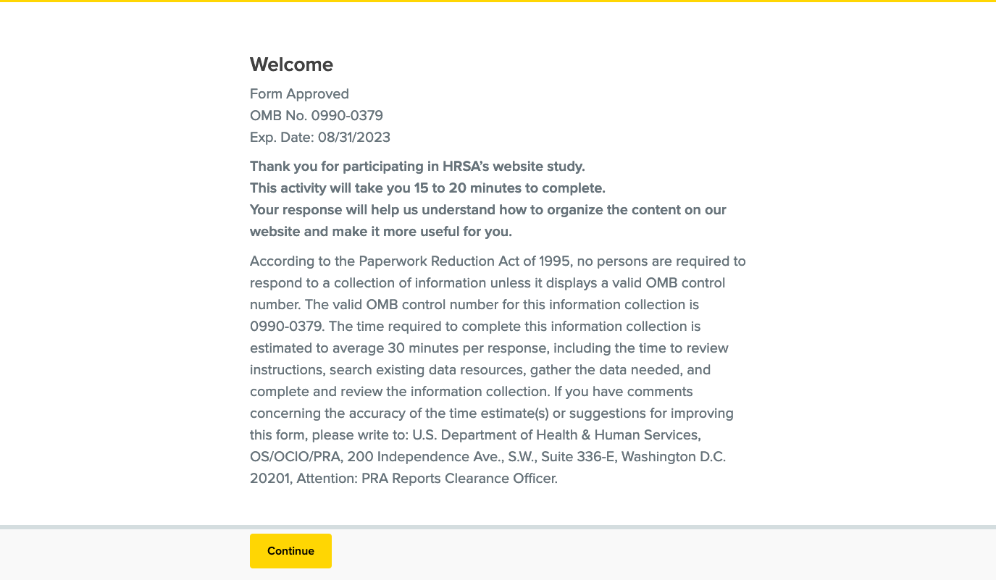
Screenshot 1: Welcome Message and PRA OMB Statement
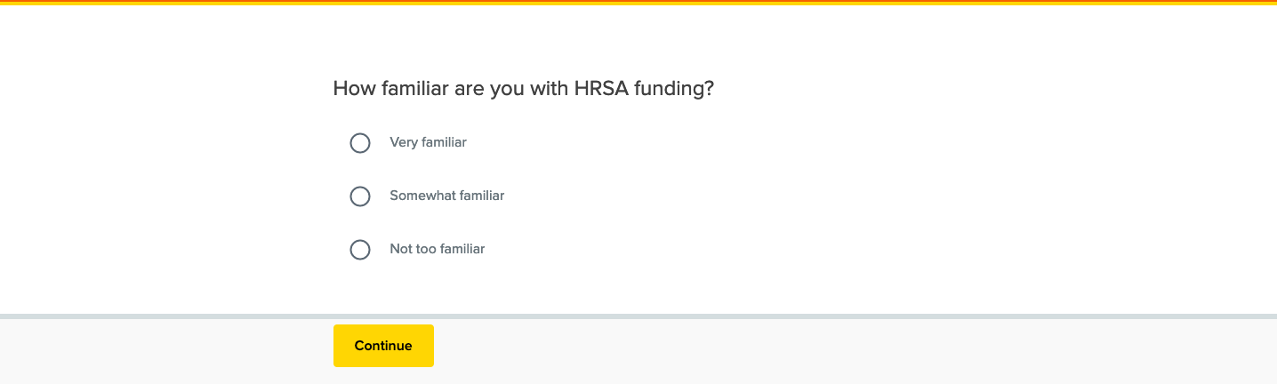
Screenshot 2: Pre-Test Question 1
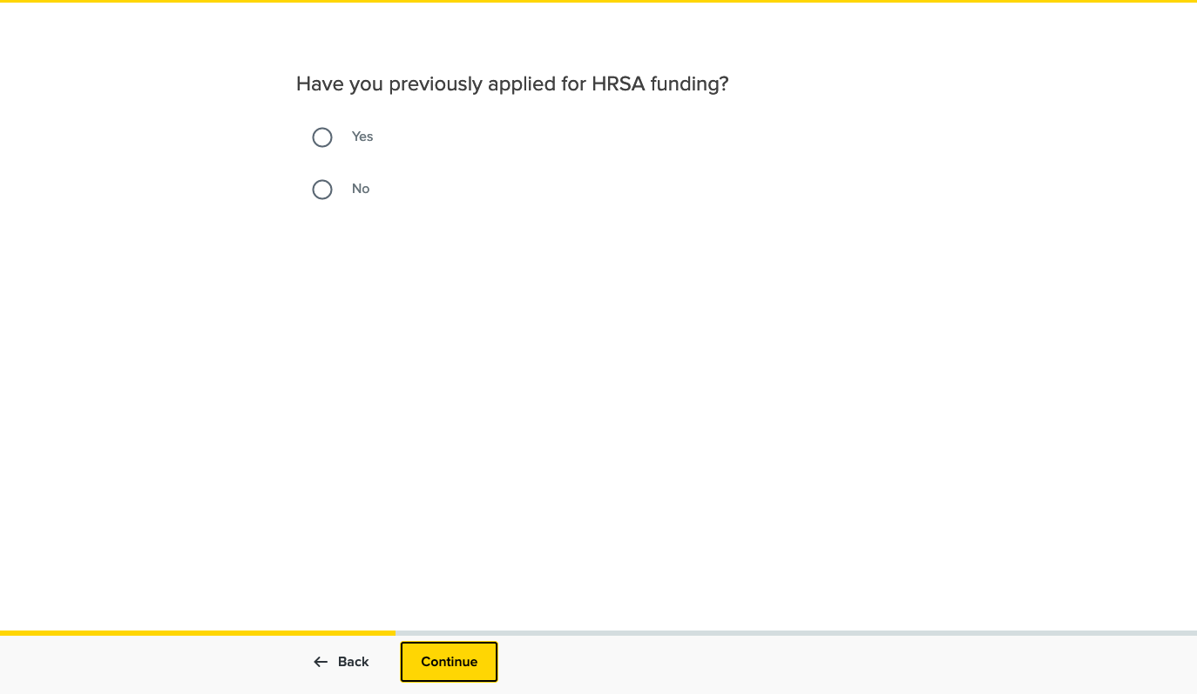
Screenshot 3: Pre-Test Question 2
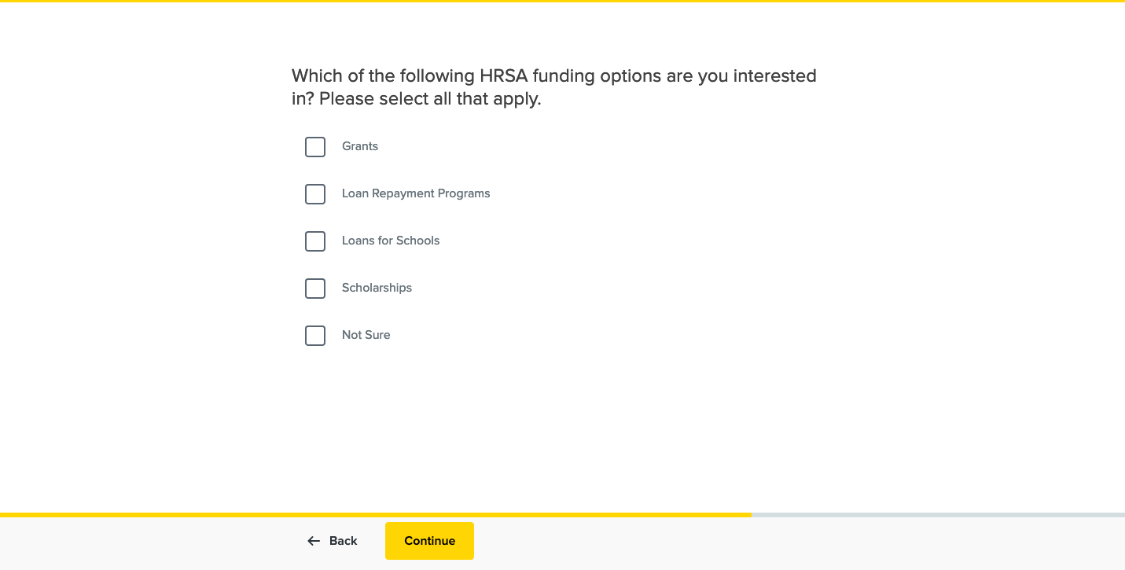Screenshot 4: Pre-Test Question 3

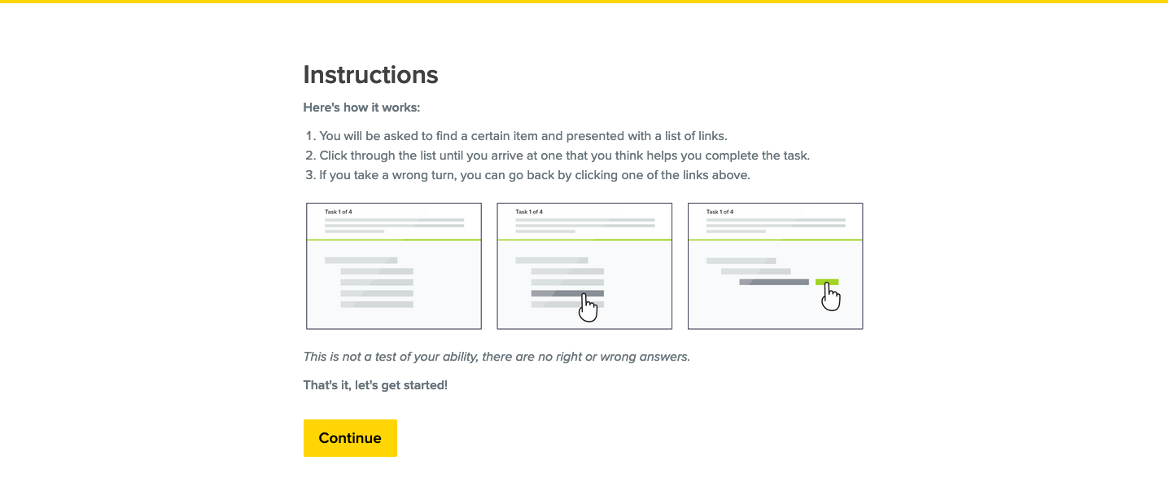
Screenshot 5: Instructions
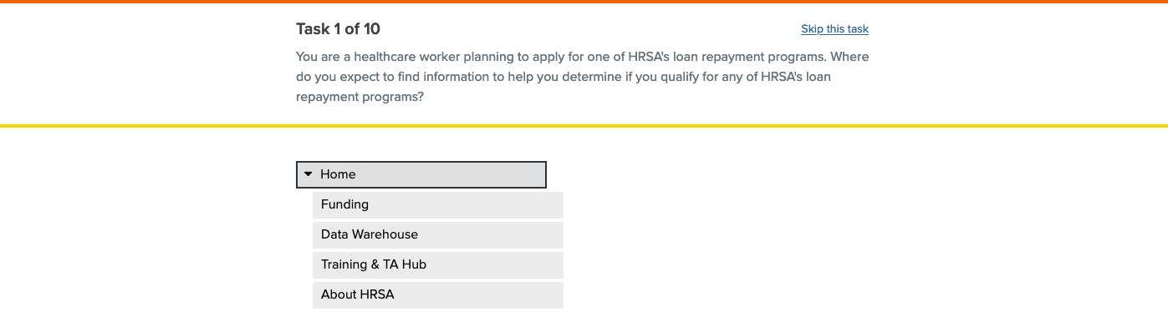
Screenshot 6: Task 1
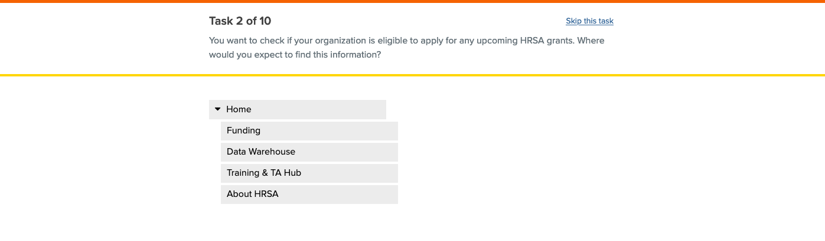
Screenshot 7: Task 2
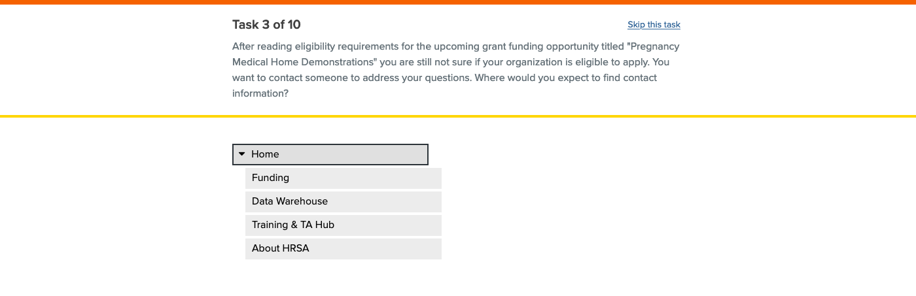
Screenshot 8: Task 3
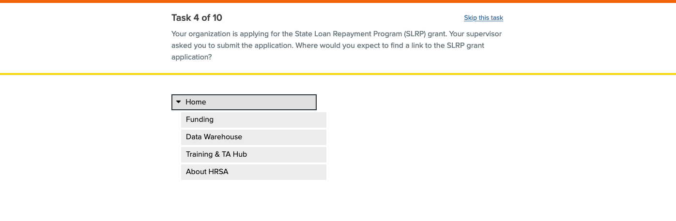
Screenshot 9: Task 4
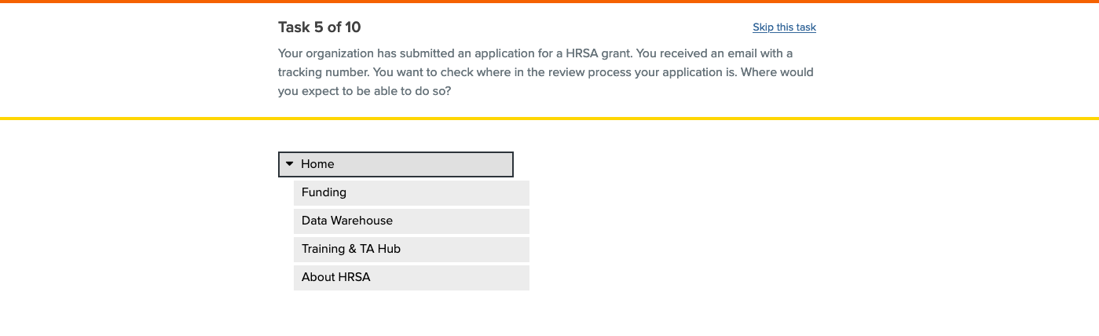
Screenshot 10: Task 5
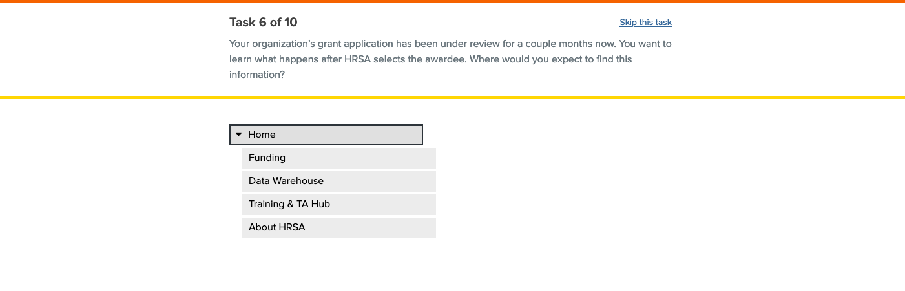
Screenshot 11: Task 6
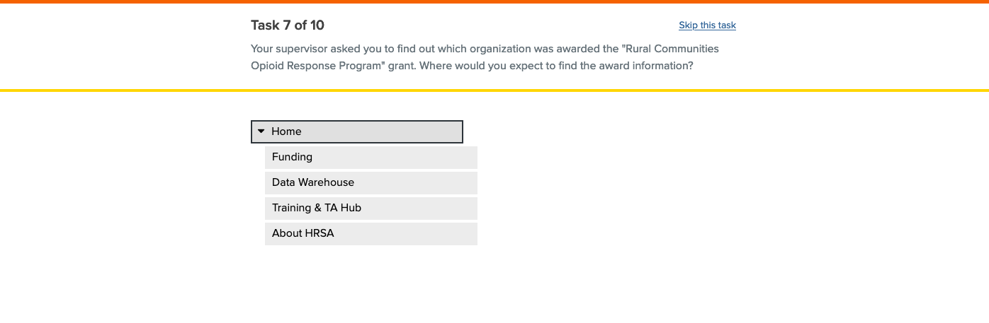
Screenshot 12: Task 7
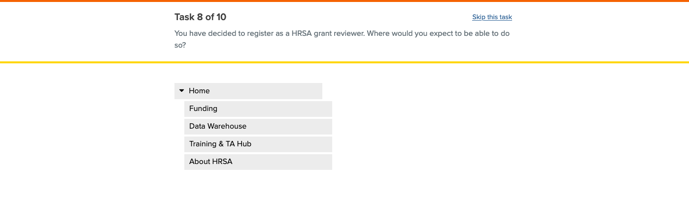
Screenshot 13: Task 8
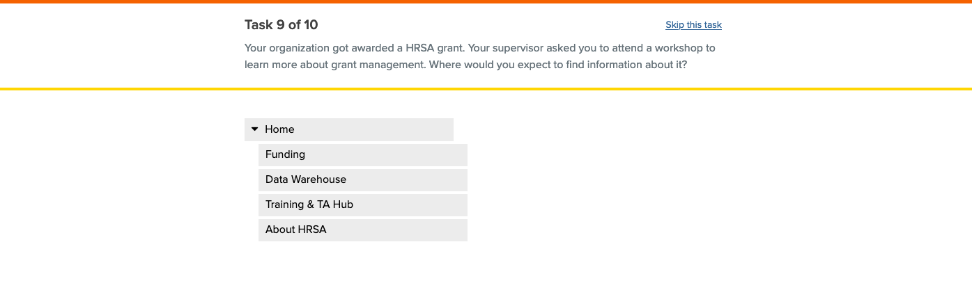
Screenshot 14: Task 9
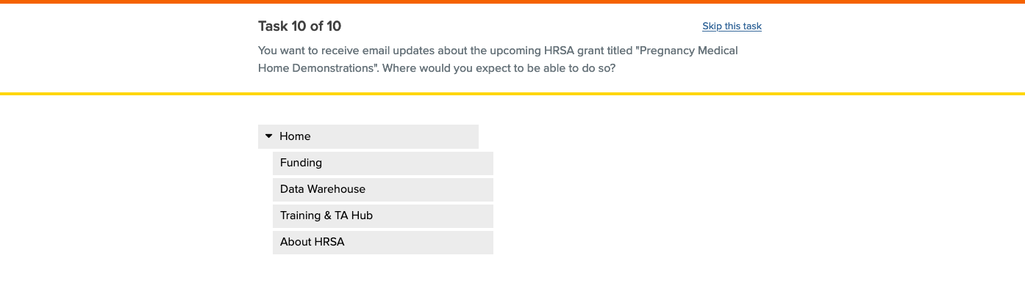
Screenshot 15: Task 10
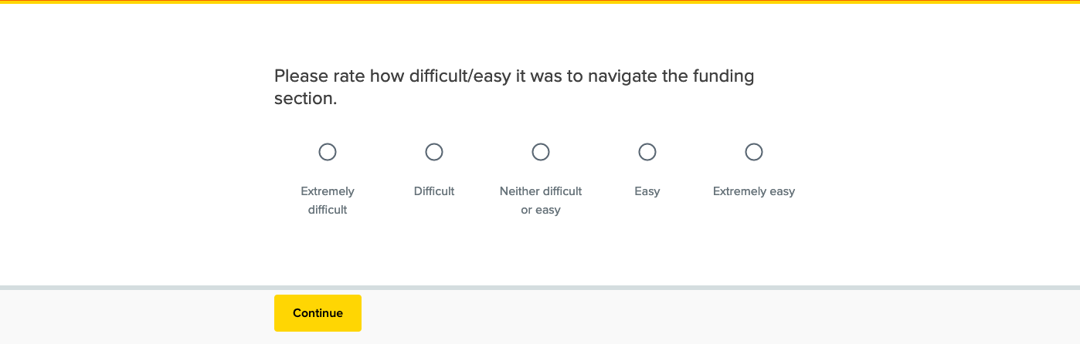
Screenshot 16: Post-Test Question 1
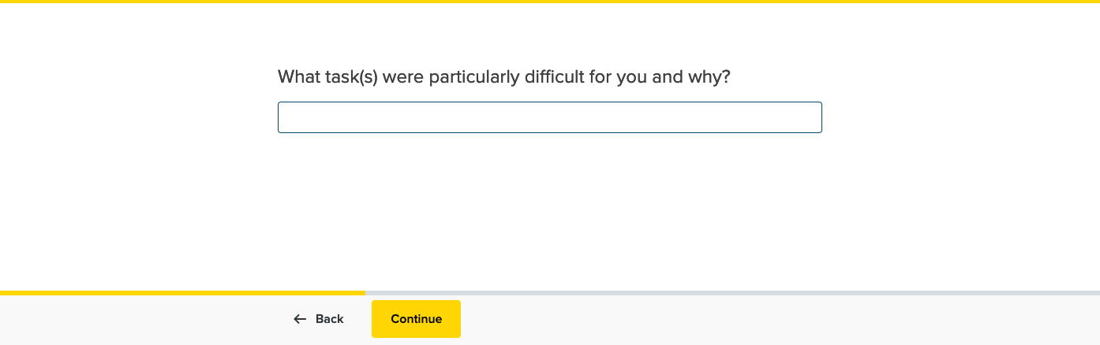
Screenshot 17: Post-Test Question 2
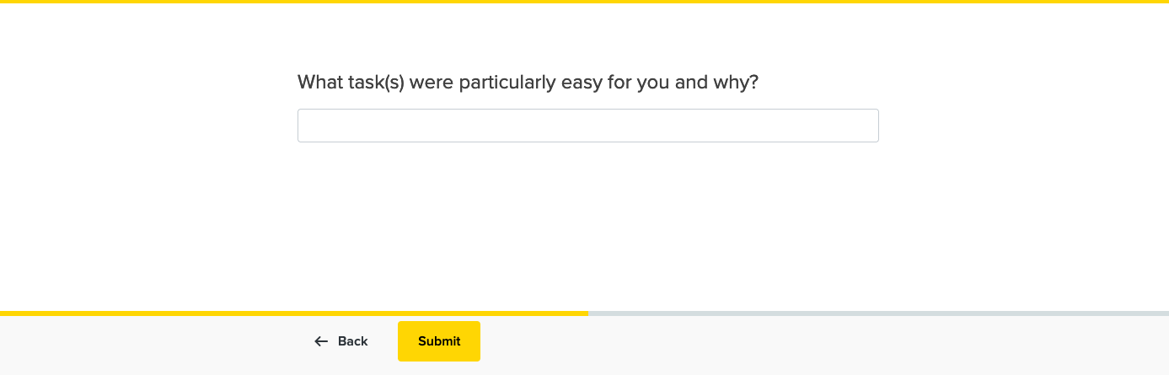
Screenshot 18: Post-Test Question 3
Screenshot 19: Completed Test Screen

