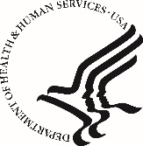
U.S DEPARTMENT OF HEALTH & HUMAN SERVICES Office of the Secretary
Assistant Secretary for Public Affairs
Washington, D.C. 20201

To: | OMB
From: | Brandi Chigewe
Date: | June 16, 2022
Re: | OMB# 0990-0379: Intranet Survey Change Request

ASPA is requesting a non-substantial change request to modernize the current Intranet Survey. The updated questions will gather more user feedback on search satisfaction (how easy or hard it was to find the information on the Intranet), experience on the Intranet, and input on content and design layout.

