Form Approved
OMB No. 0990-0379
Exp. Date 08/31/2023

HRSA MCHB: Card Sort Test Script (Survey Instrument)

Introduction
Thank you for participating in HRSA’s Maternal and Child Health Bureau (MCHB) website study.
This activity will take you between 15 to 20 minutes to complete.
Your response will help us understand how to organize and improve the content on our website to make it more useful for you.

Pre-Survey Questionnaire
Please answer the following questions to help us understand how you use the Maternal and Child Health Bureau (MCHB) website, and what content is most important to you.
- With which of the following do you represent or identify with?
Select all that apply: (multi-select) (Required)
- Prospective MCHB grant applicant
- Current MCHB grant awardee
- Past MCHB grant awardee
- MCH national membership organization
- MCH research network
- MCH technical assistance center
- Non-profit or community-based organization
- Federal government
- Congressional staff
According to the Paperwork Reduction Act of 1995, no persons are required to respond to a collection of information unless it displays a valid OMB control number. The valid OMB control number for this information collection is 0990-0379. The time required to complete this information collection is estimated to average 30 minutes per response, including the time to review instructions, search existing data resources, gather the data needed, and complete and review the information collection. If you have comments concerning the accuracy of the time estimate(s) or suggestions for improving this form, please write to: U.S. Department of Health & Human Services, OS/OCIO/PRA, 200 Independence Ave., S.W., Suite 336-E, Washington D.C. 20201, Attention: PRA Reports Clearance Officer
- If user answered they are an awardee, then:
How long have you been an awardee?
- Under 2 years
- 2 years to 5 years
- More than 5 years
- If user answered they are an awardee, then:
Are you a Title V Block Grant Recipient?
- Yes
- No (Text field: “Please specify the name of the grant(s) that you receive.”)
- What MCHB content are you likely to seek?
Select all that apply: (multi-select) (Required)
  - Specific HRSA programs on maternal and child health
  - Maternal and Child Health topics
  - General organizational information about HRSA’s Maternal Child Health Bureau
  - Information on how MCHB is funded
  - Information on MCHB’s current priorities
  - Information on what grantee’s activities involve
  - Information on past grants or programs of MCHB
  - Contact information for current and past program grantees
  - Future grant and funding opportunities
  - News and announcements
  - Job opportunities
  - Data, research, and epidemiology findings
  - Data, research, and epidemiological funding
  - Fact sheets, publications, and reports
  - Information on a specific subpopulation
  - MCH Workforce training materials
  - Information on Title V
  - National trends summarized for key priority areas (i.e. infant or maternal mortality numbers and targets?)
  - Technical Assistance (TA) resources
  - Contact information for MCHB and its programs.
  - Other: (Text field: “If other, please specify”)
- Which option best describes how often you use the MCHB website?
(single select) (Required)
  - Several times a year
  - Several times a month
  - Several times a week
  - Several times a day
  - I have never used the MCHB website.

Instructions

Step 1
Take a quick look at the list of items to the left. We'd like you to sort them into groups that make sense to you. There is no right or wrong answer. Just do what comes naturally.

Step 2
Drag an item from the left into this area to create your first group.

Step 3
Select the title to rename your new group.

Step 4
Add more items to this group by dropping them on top of it. You can also move items from one group to another if you decide it’s a better fit. Make more groups by dropping them in unused spaces. When you're done click "Finished" at the top right.

Card List
The cards below are the cards that will be featured in the study based on existing content on the current website. This list has been finalized based on input from MCHB staff. Group labels will not be provided given the approach of an open card sort.
- News and Announcements
- COVID-19 Frequently Asked Questions
- MCHB's Mission, Vision, and Approach
- Measuring the Success of the Maternal and Child Health Bureau's Efforts
- History of the Bureau
- Advisory Committees
- Key MCHB Staff
- Fact Sheets on Maternal and Child Health Topics
- Maternal and Child Health Infographics
- Open Funding Opportunities
- Current MCHB Grantees
- How to Complete Mandatory Registrations
- Determining your Eligibility for a Grant, Program, and/or Opportunity
- Prepare your Application
- The Application Process: Steps for Before and After Applying
- Maternal/Women's Health
- Information on Maternal Depression
- The Role of MCHB in Perinatal and Infant Health
- Child Health
- Newborn Screening
- Emergency Medical Services for Children
- Adolescent and Young Adult Health: What MCHB does in this field.
- Key Topics: Children and Youth with Special Health Care Needs
- MCHB's Efforts to Support Healthy Nutrition for Families.
- Full List of MCHB Programs and Initiatives
- Autism: MCHB's Role and Impact
- MCHB's Home Visiting Program: Goals, Grantees, Funding, and Impact
- The Title V Maternal and Child Health Services Block Grant: A Federal-State Partnership
- How MCHB improves the health of mothers and children before, during, and beyond pregnancy.
- MCHB Strategies Supporting Professional Development of Practicing Maternal and Child Health Professionals and Students
- HRSA Maternal and Child Health Navigator: Tools and Learning Resources for State Public Health Professionals
- How MCHB uses Collaborative Improvement and Innovation Networks to support it's work
- Mental and Behavioral Health: Mothers, Children & Families
- Resources and training for MCH programs and grantees
- Improving Health Equity in Maternal and Child Health Populations
- Program, Performance, and Financial Data for Title V Programs
- Discretionary Grant Program Data
- National Survey of Children’s Health
- Research & Epidemiology
- How Performance is Measured and Analyzed for the Title V Maternal and Child Health Services Block Grant
- HRSA Forecasted New Funding Opportunities
- MCHB Grand Challenges Prize Competitions

Post-Survey Questionnaire
- Which items were especially easy to place? (Required)
- Which items were especially difficult to place? (Required)
- Were there any items that seem to belong in two or more groups? If so, please describe your placement choice(s). (Optional)
- Which items could be better defined? (Required)
- Based on the groups that were created, what else would you expect to see in those groups if any? (Optional)
- Are there any items that you expect to see in MCHB’s navigation that aren’t represented here? (Optional)
- Is there anything else you would like us to know? (Optional)

Thanks
Thanks again for your participation. Your feedback is incredibly useful in helping to determine how our content should be organized, so we can make our website easier to use.
You may now close this window or navigate to another web page.

OptimalSort Screenshots
Note: These screenshots display the script presented previously, how they will look in the survey tool.
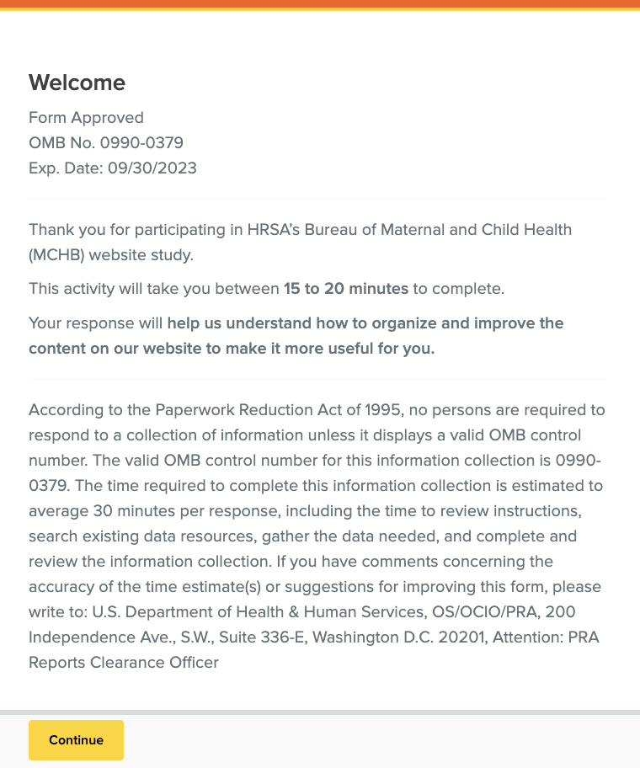
Screenshot 1: Welcome Message and PRA OMB Statement
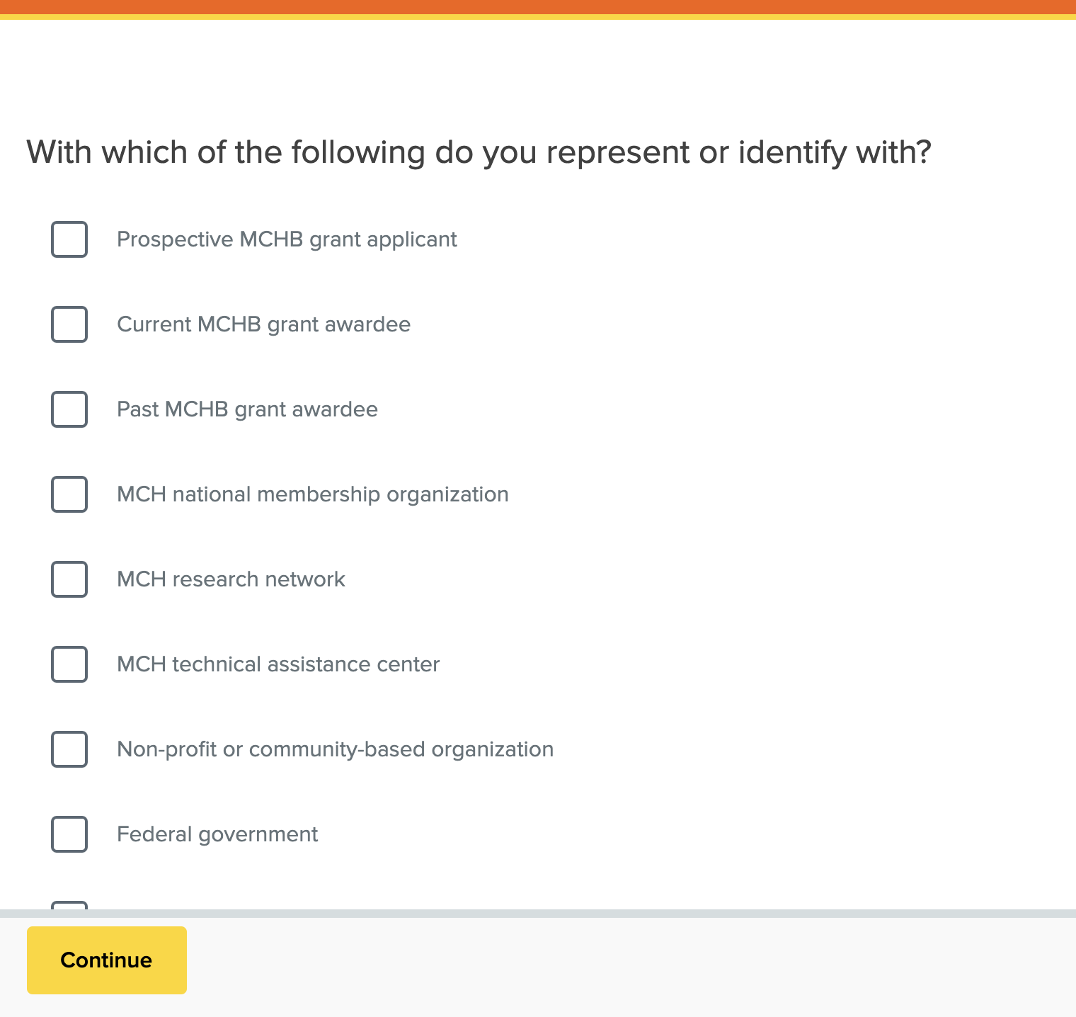
Screenshot 2: Pre-Test Question 1
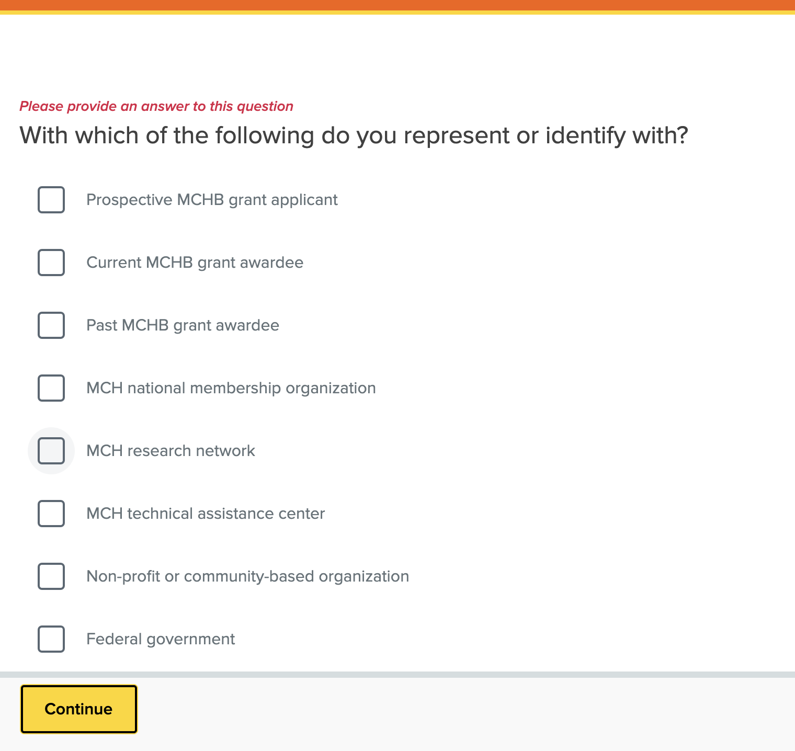
Screenshot 3: Pre-Test Question 2
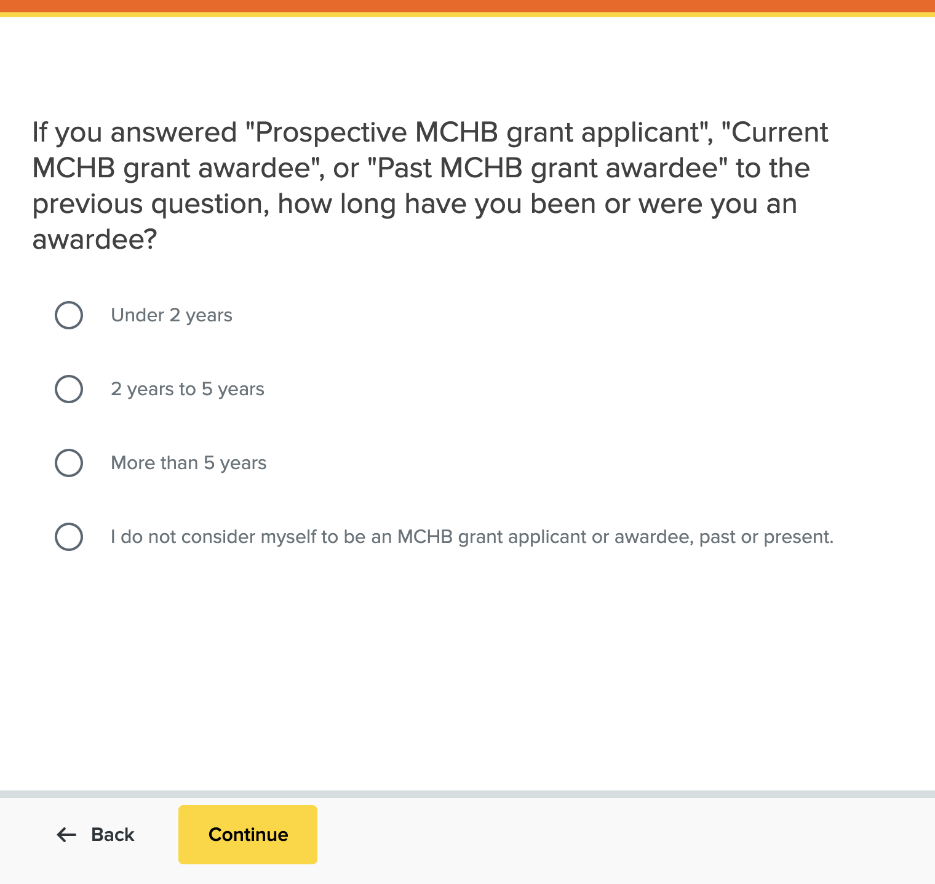
Screenshot 4: Pre-Test Question 3
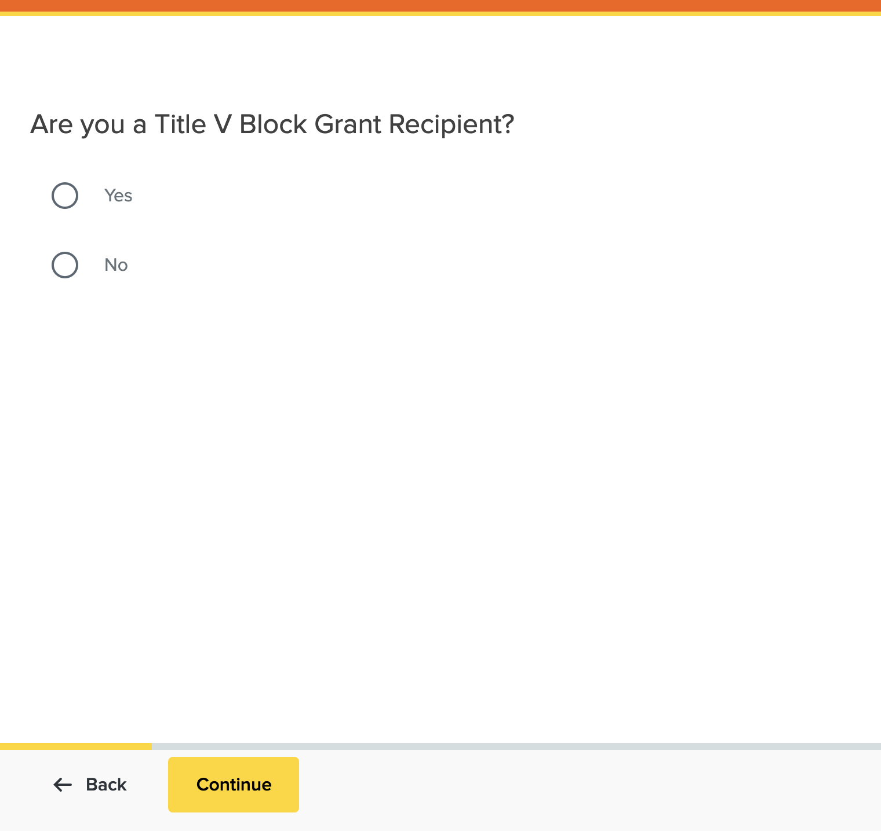
Screenshot 5: Pre-Test Question 4
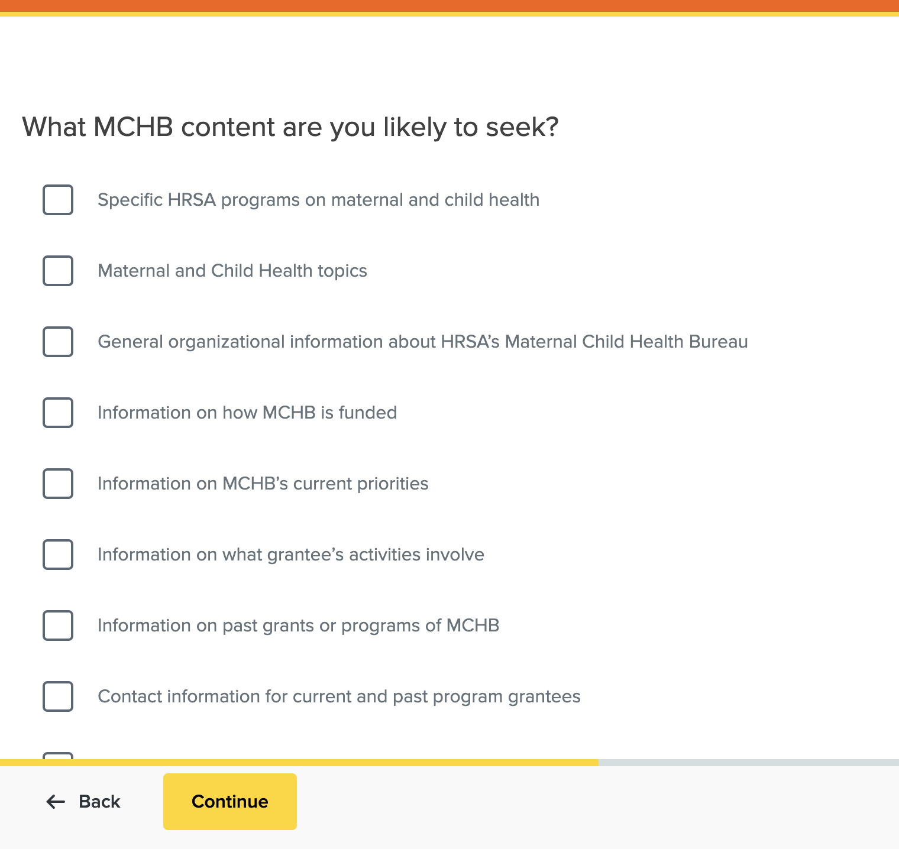
Screenshot 6: Pre-Test Question 5
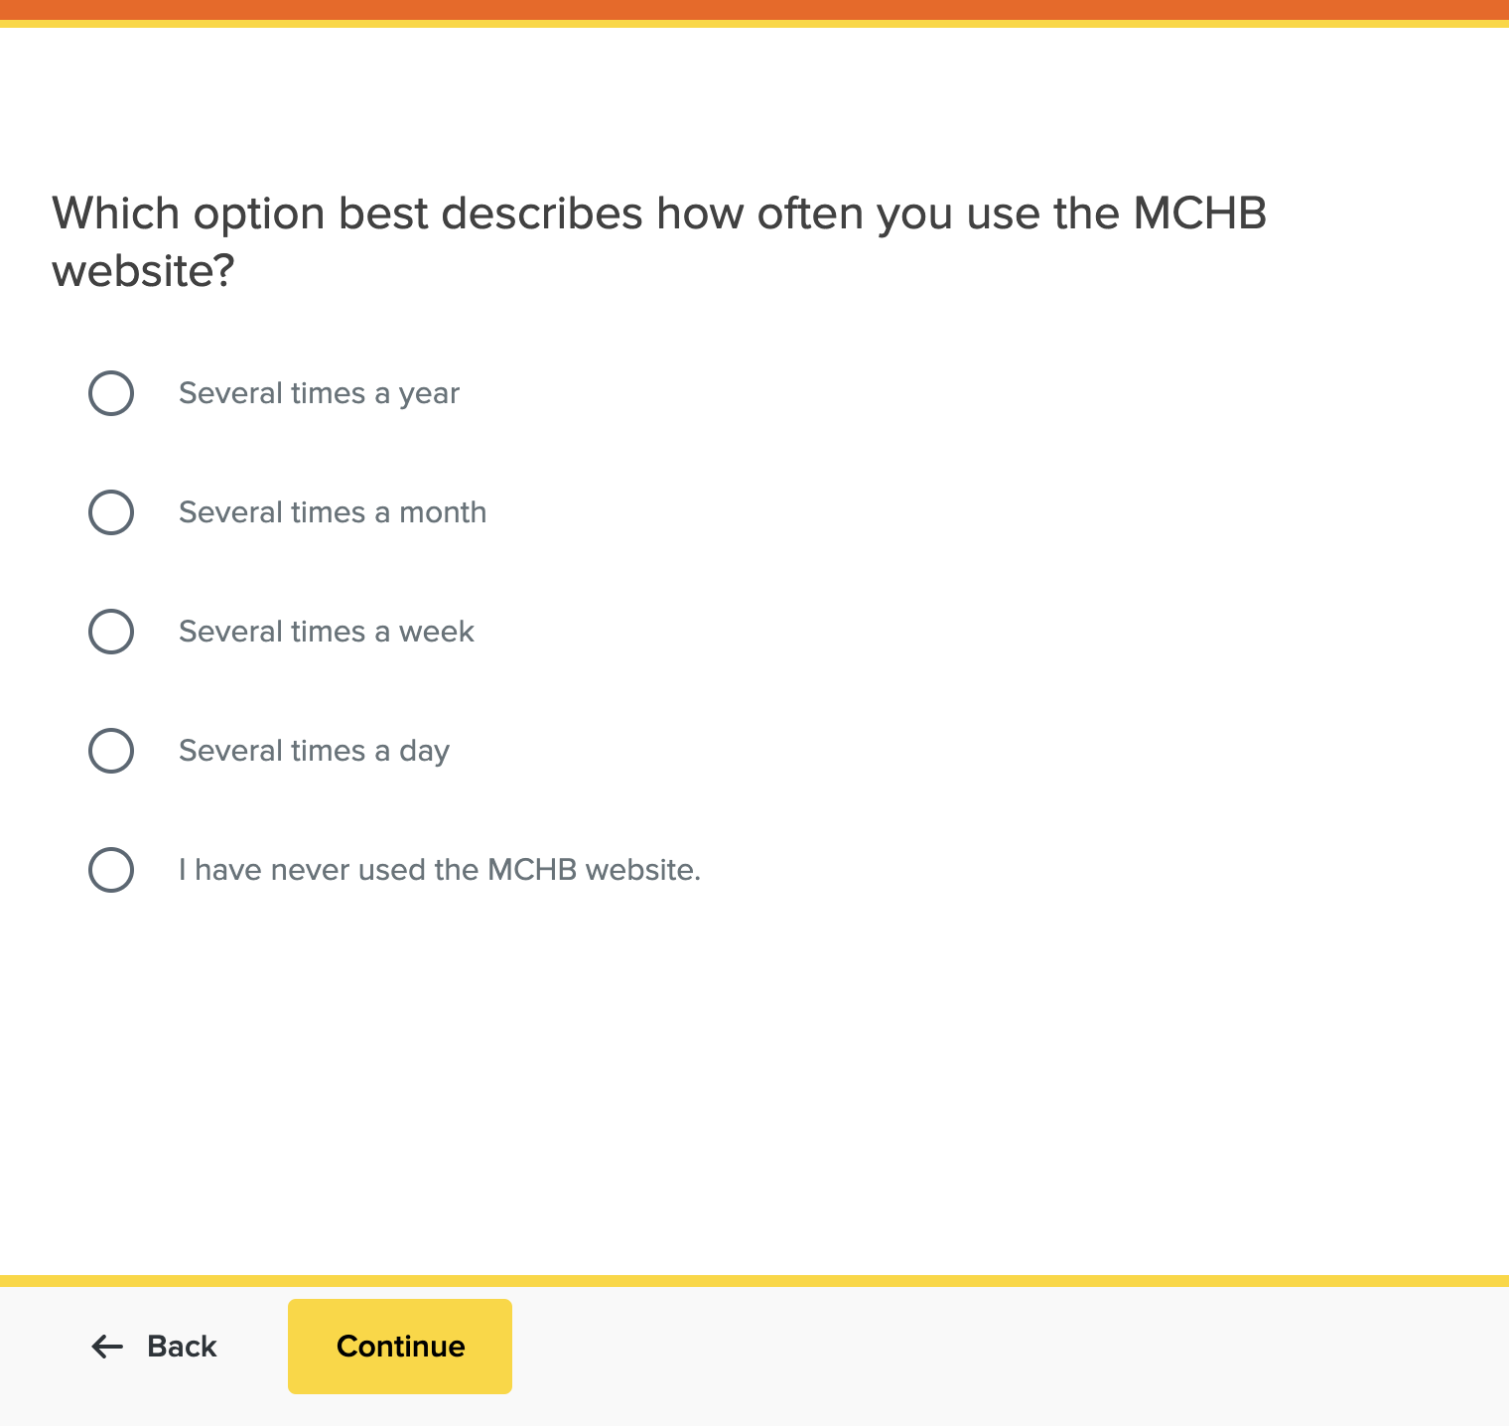
Screenshot 7: Pre-Test Question 6
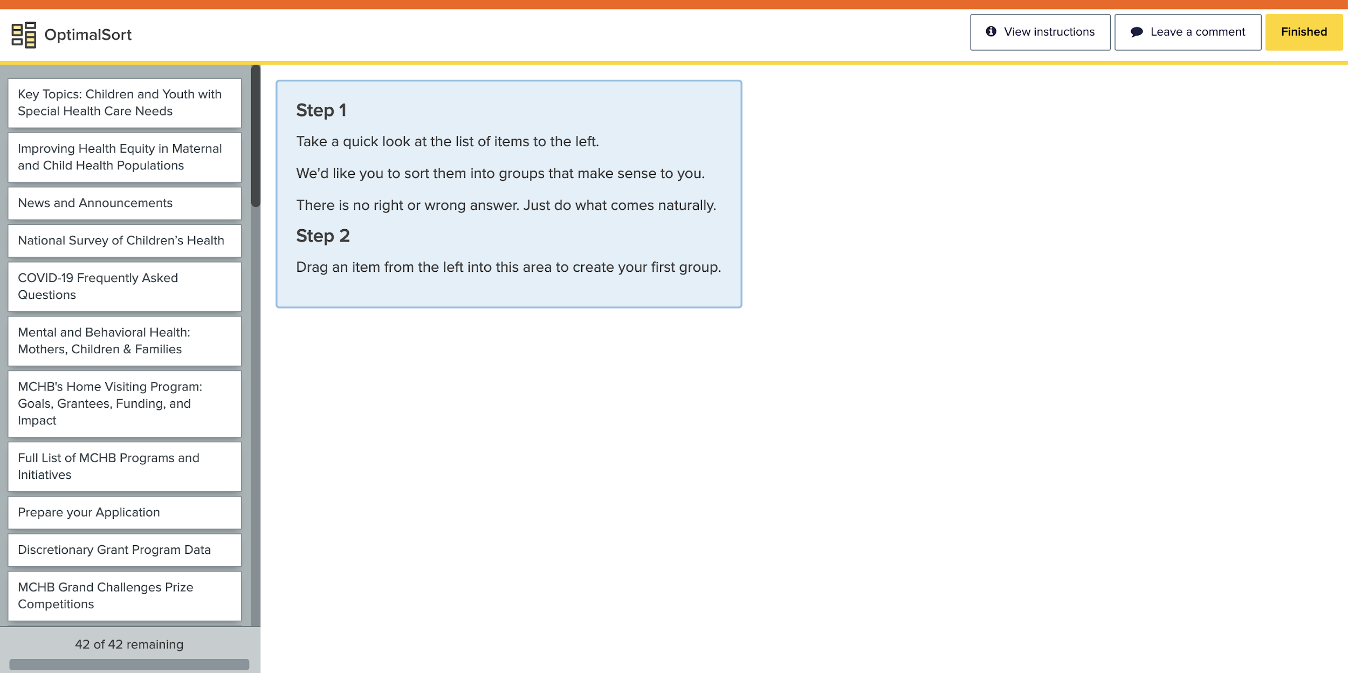
Screenshot 8: Test Screen and Part 1 of Instructions
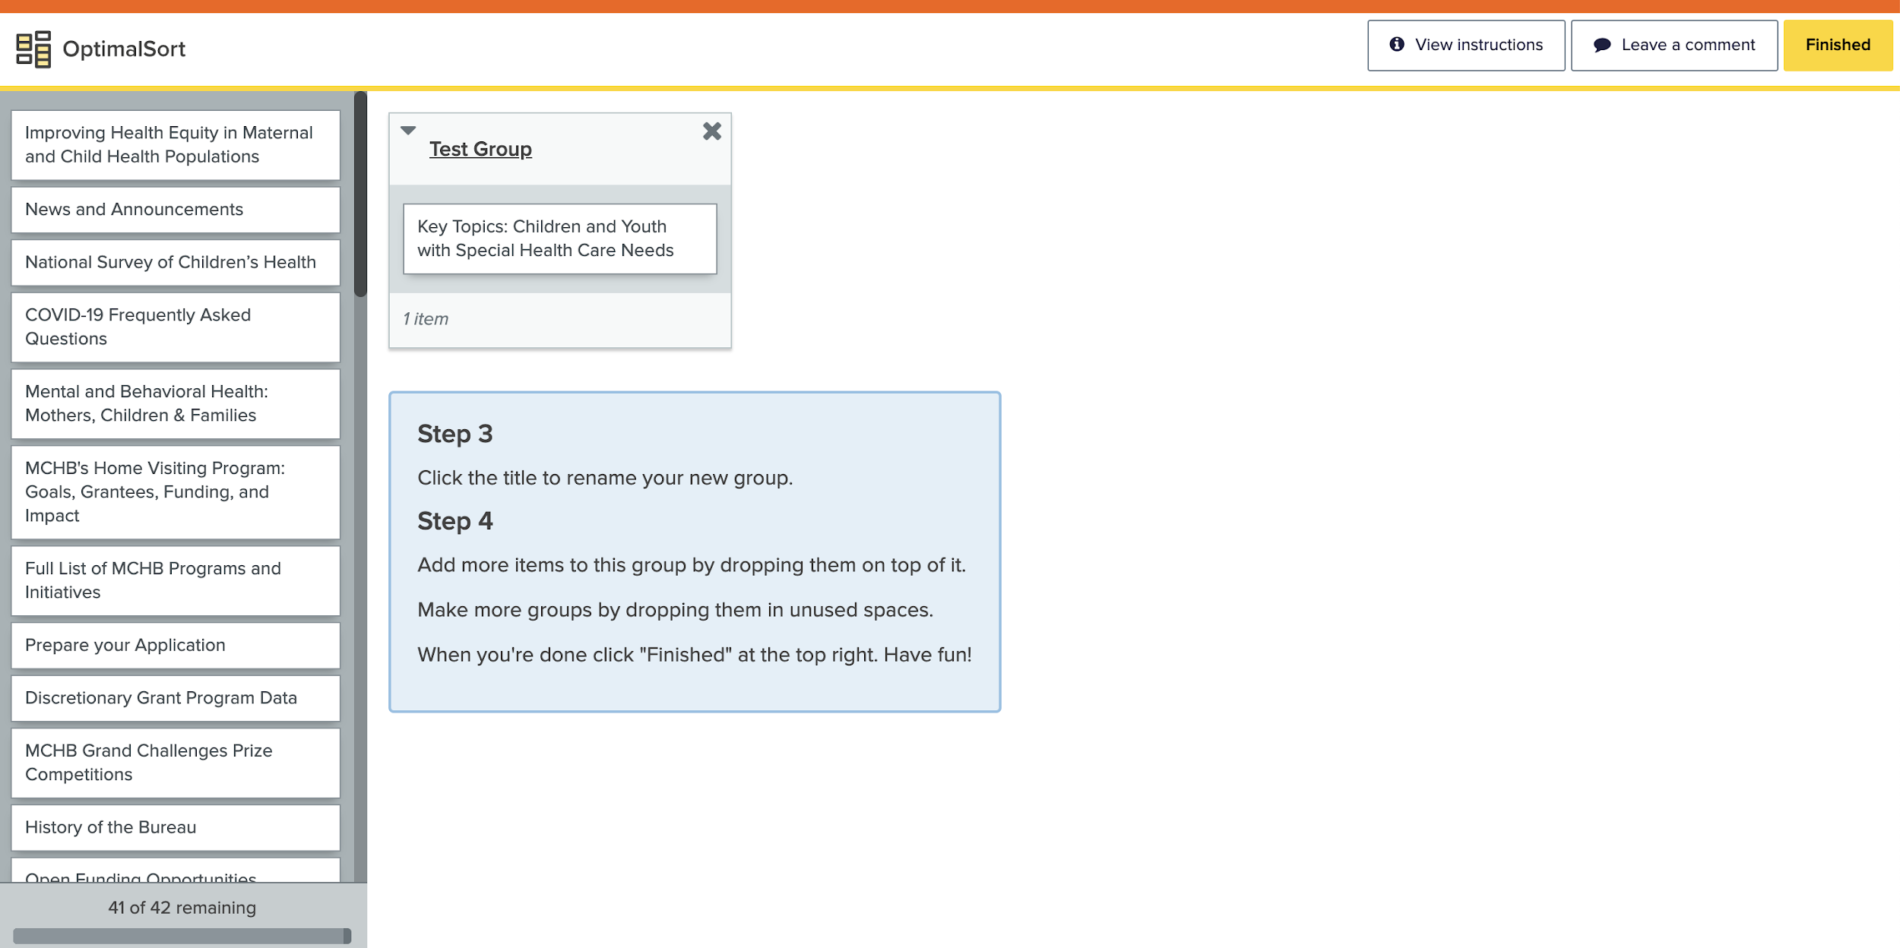
Screenshot 9: Test Screen and Part 2 of Instructions
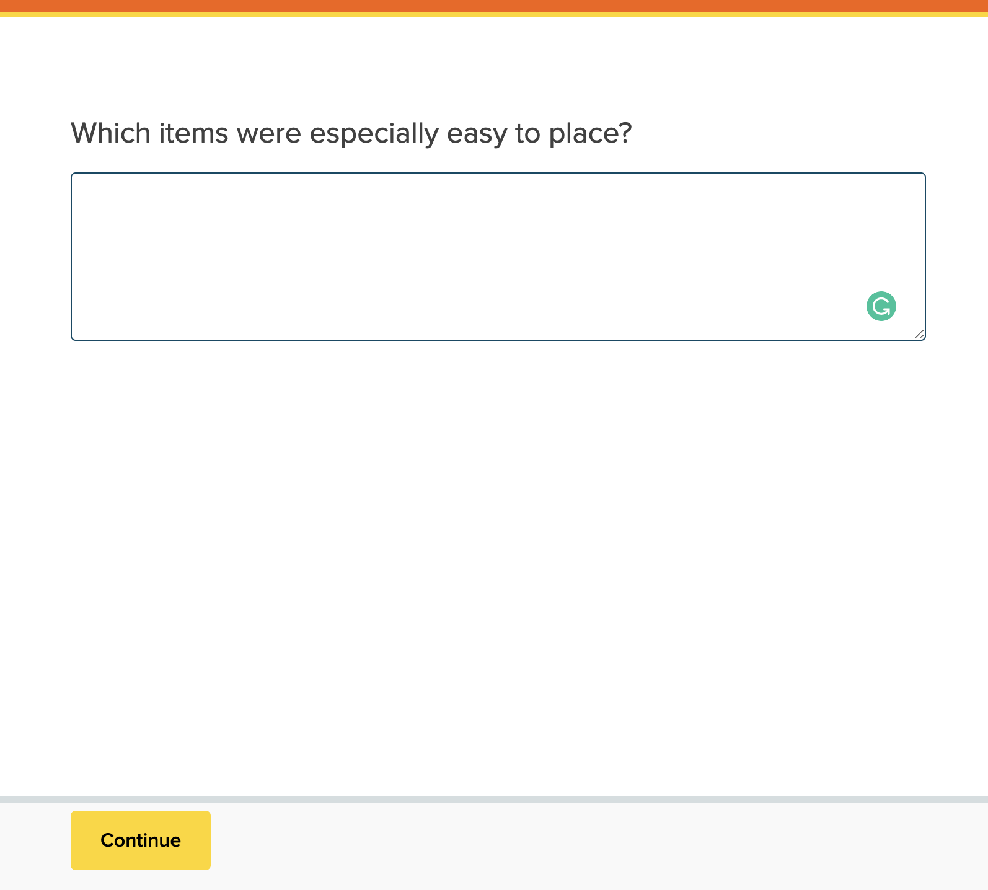
Screenshot 10: Post-Test Question 1
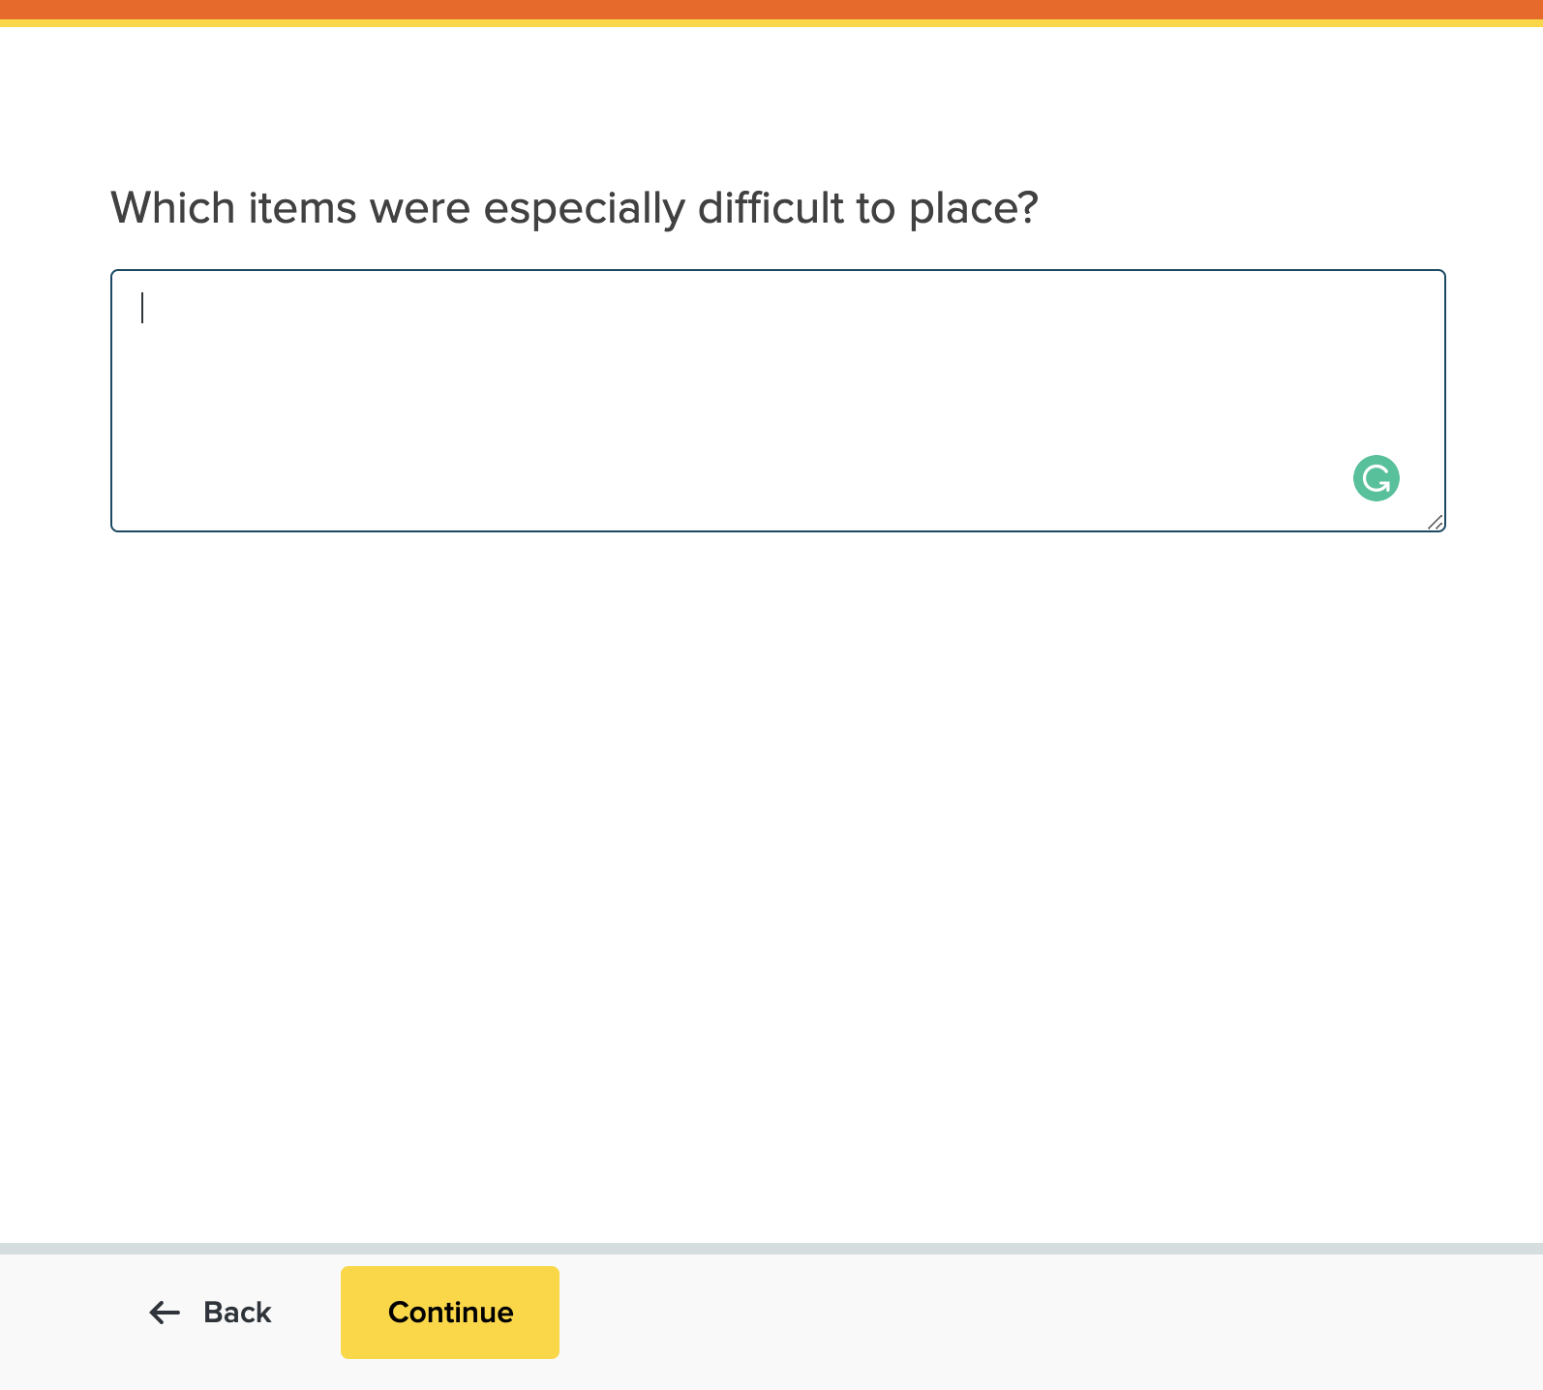
Screenshot 11: Post-Test Question 2
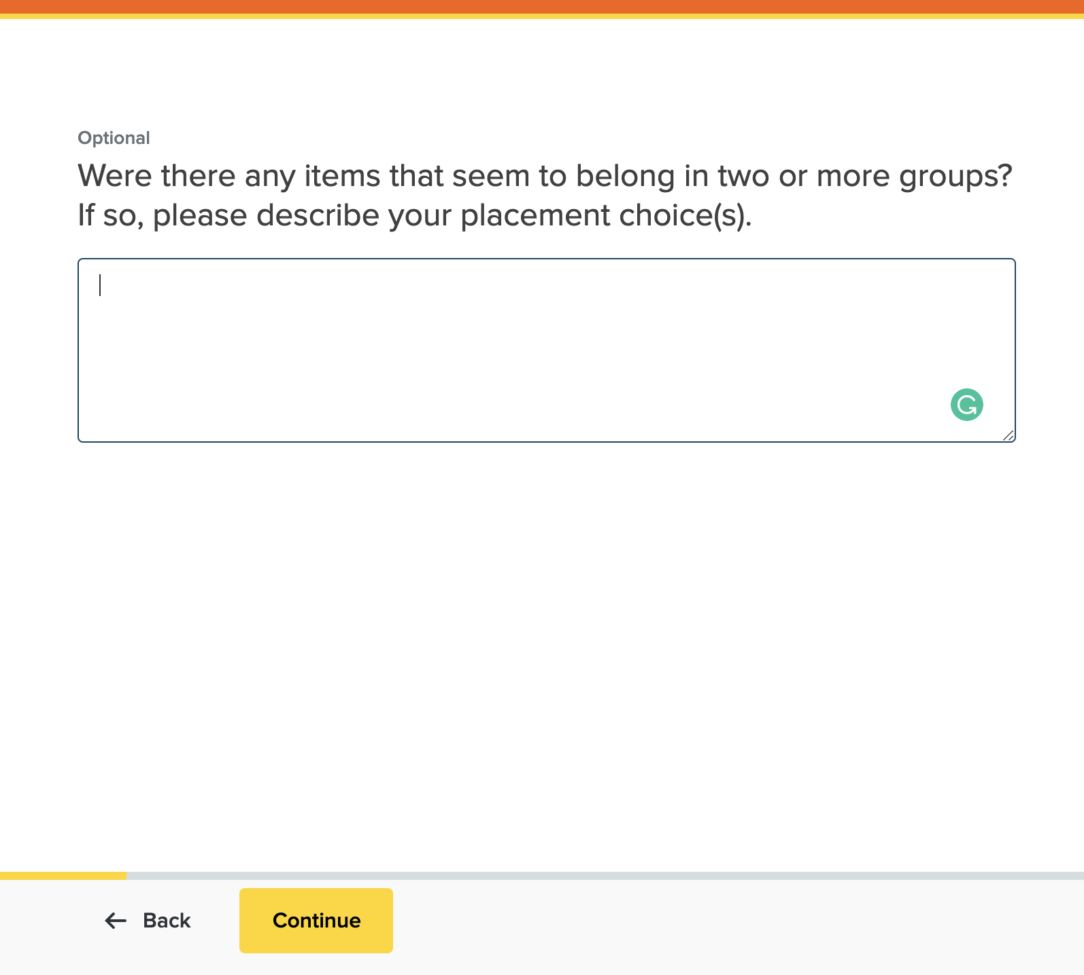
Screenshot 12: Post-Test Question 3
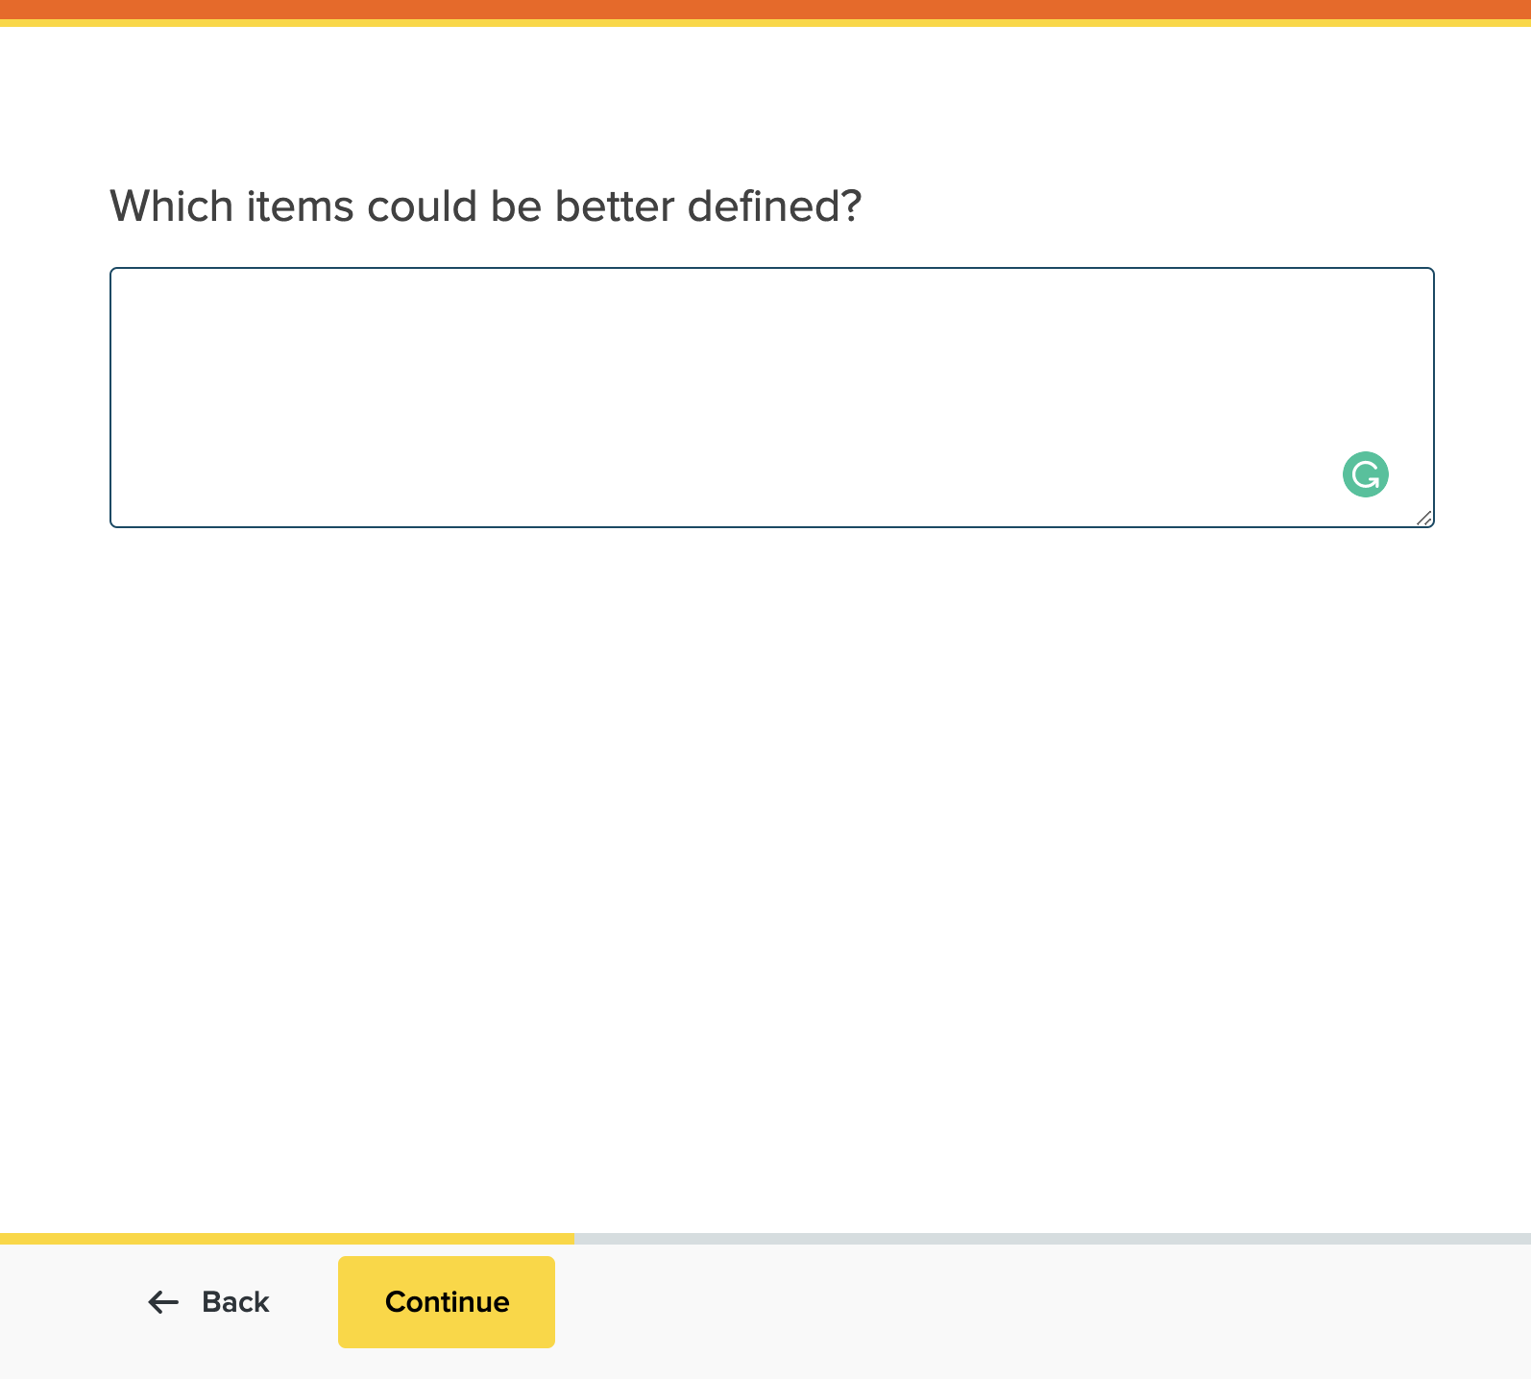
Screenshot 13: Post-Test Question 4
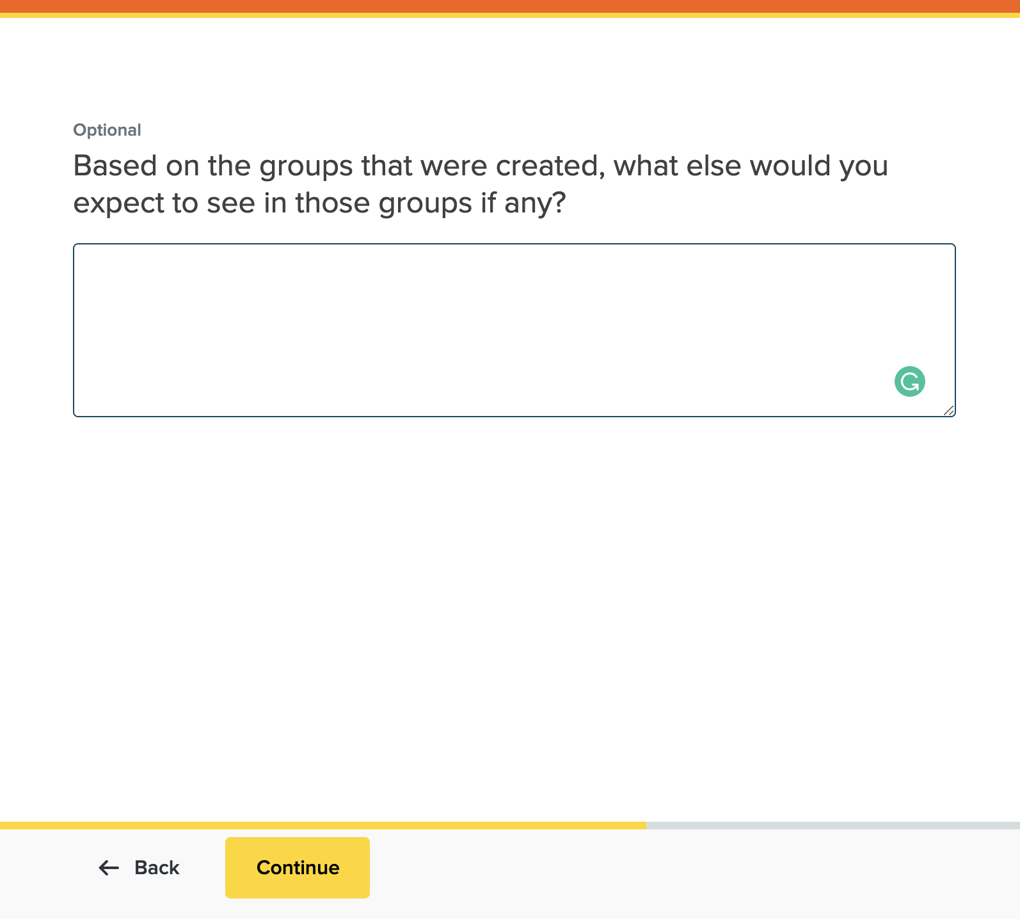
Screenshot 14: Post-Test Question 5
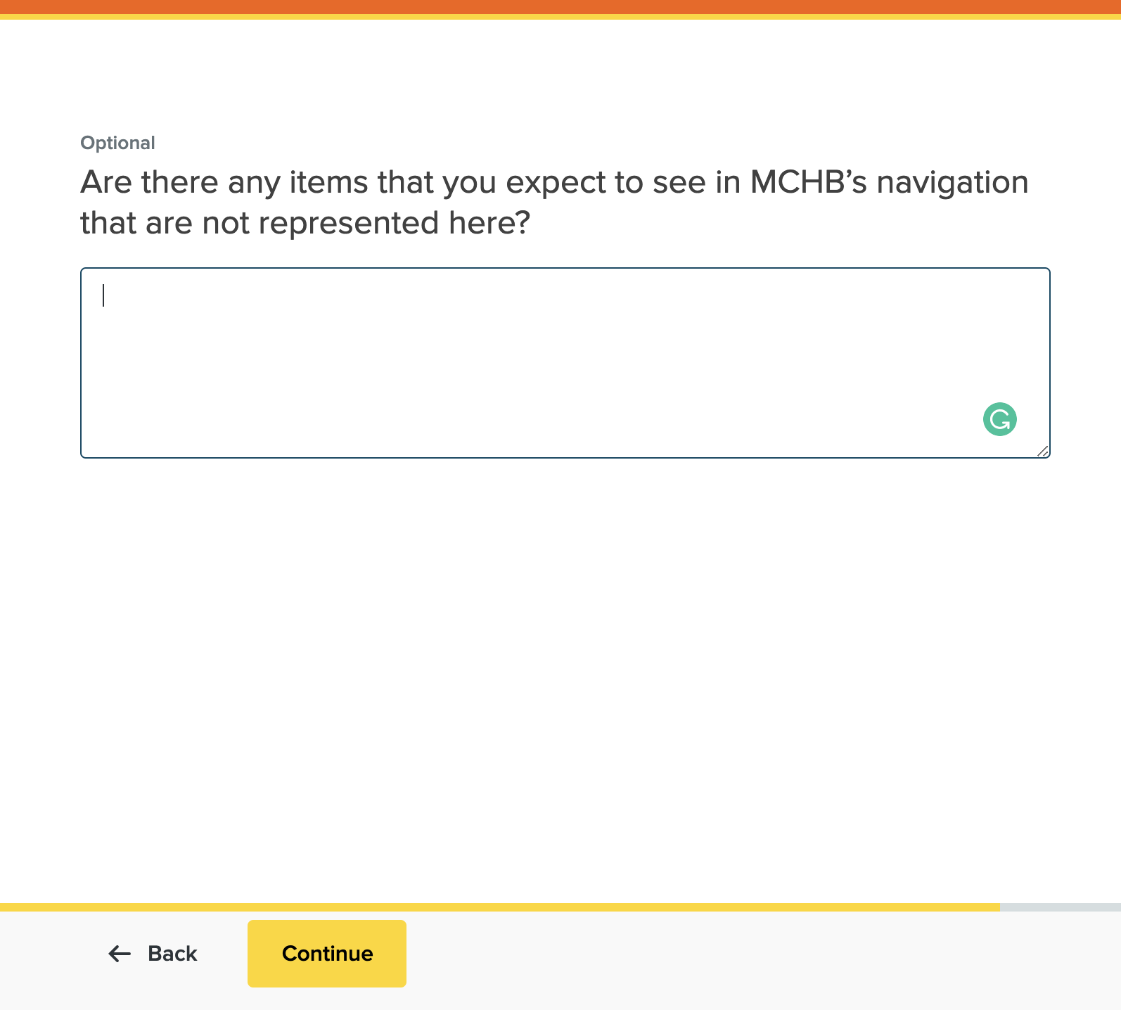
Screenshot 15: Post-Test Question 6
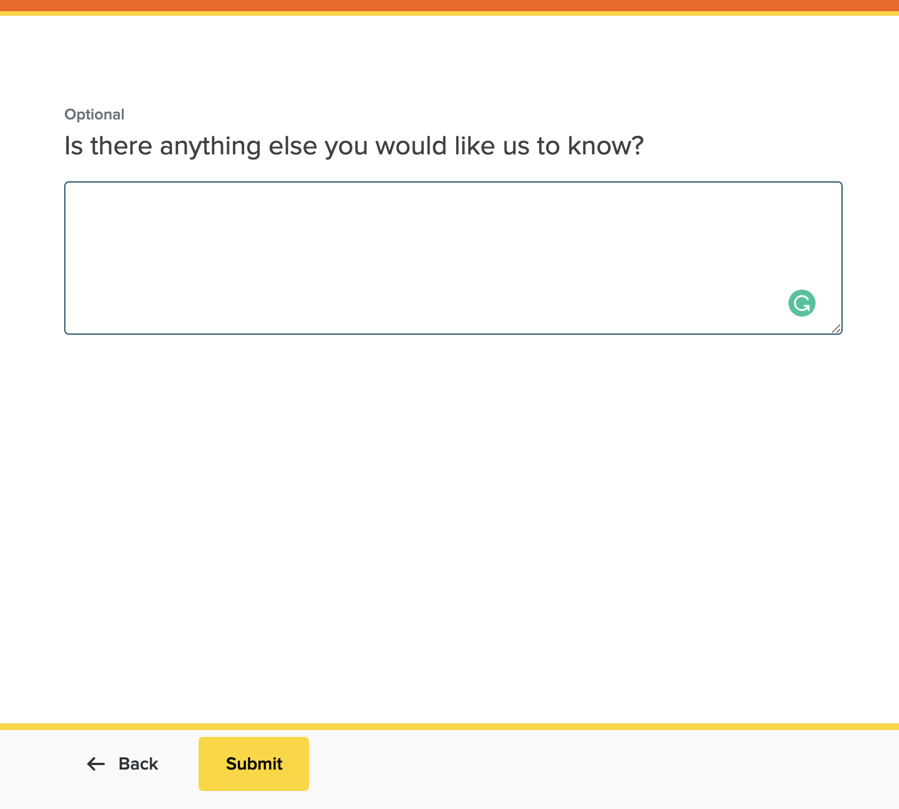
Screenshot 16: Post-Test Question 1
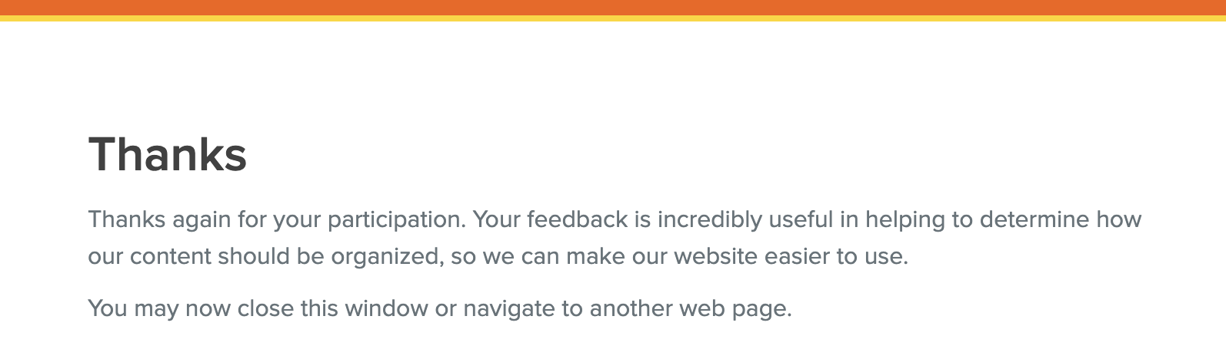
Screenshot 17: Completed Test Screen

