Form Approved
OMB No. 0990-0379
Exp. Date 09/30/2023

HRSA HIV/AIDS Bureau Website

Card Sort Script

Introduction
Welcome
Thank you for participating in the HRSA HIV/AIDS Bureau (HAB) website study.
This activity will take you between 15 to 20 minutes to complete.
Your response will help us understand how to organize and improve the content on our website to make it more useful for you.
According to the Paperwork Reduction Act of 1995, no persons are required to respond to a collection of information unless it displays a valid OMB control number. The valid OMB control number for this information collection is 0990-0379. The time required to complete this information collection is estimated to average 30 minutes per response, including the time to review instructions, search existing data resources, gather the data needed, and complete and review the information collection. If you have comments concerning the accuracy of the time estimate(s) or suggestions for improving this form, please write to: U.S. Department of Health & Human Services, OS/OCIO/PRA, 200 Independence Ave., S.W., Suite 336-E, Washington D.C. 20201, Attention: PRA Reports Clearance Officer

Pre-Survey Questionnaire
Before we begin
Please answer the following questions to help us understand how you use HRSA’s HIV/Aids Bureau (HAB) website, and what content is most important to you.
- With which of these do you identify?
Select all that apply: (multi-select) (Required)
  - Grant recipient
  - Cooperative agreement recipient
  - Federal contractor
  - Partner organization
  - Stakeholder organization
  - HAB staff
  - HIV/AIDS Service Delivery Organizations
  - Medical Community in general
  - Decision makers - public health officials, policy makers
  - Non-profit public health organizations interested in Ryan White work
  - Interested public - Ending the HIV Epidemic initiative
  - Other: (Text field: “If other, please specify”)
- What kind(s) of HIV/Aids Bureau (HAB) content are you likely to seek?
Select all that apply: (multi-select) (Required)
- Background and general information about HAB
- Background and general information about the Ryan White HIV/AIDS Program
- Information on Ryan White HIV/AIDS Program award recipients
- Background and general information about HIV care and treatment
- Legislation and national strategy related to the HIV/AIDS epidemic
- Contacts and organizational information about HAB
- COVID-19 resources and information
- Find HIV medical providers and care
- News & Announcements
- Allocation and expenditure reports
- Grants and funding opportunities
- Recipient resources and technical assistance
- Clinical care guidelines and resources
- Performance measure portfolio information
- Clinical and quality management resources
- Information about Ryan White the person
- CAREWare information
- Policy clarification notices and program letters
- Data, reports, or publications
- Journal manuscripts
- Communication tools, such as fact sheets, infographics, and toolkits
- Living History
- Other: (Text field: “If other, please specify”)
- Which option best describes how often you use the HIV/Aids Bureau (HAB) website? (single select) (Required)
  - Several times a day
  - Several times a week
  - Several times a month
  - Several times a year
  - I have never used the HAB website.

Instructions

Step 1
- Take a quick look at the list of items to the left.
- Sort them into groups that make sense to you.
- There’s no right or wrong answer. Just do what comes naturally.

Step 2
- Drag an item from the left into this area to create your first group.

Step 3
- Click the title to rename your new group.

Step 4
- Add more items to this group by dropping them on top of it.
- You can also move items from one group to another if you decide it’s a better fit.
- Make more groups by dropping them in unused spaces.
- When you're done click "Finished” at the top right. Have fun!

Cards
The cards below are the cards that will be featured in the study based on existing content on the website. This list has been finalized based on input from HAB staff. Group labels will not be provided given the approach of an open card sort.
- About the Ryan White HIV/AIDS Program
- Ryan White HIV/AIDS Program Parts (A-F)
- Program Legislation
- Find a Ryan White HIV/AIDS Program Medical Provider
- Ryan White HIV/AIDS Program Biennial Reports
- Data Reports and Slide Decks
- Fact Sheets
- Program Recipient Resources
- Policy Notices
- Program Letters
- Data Reporting Requirements and Technical Assistance
- CAREWare Information System
- HIV/AIDS Bureau Contacts
- Recipient Allocation and Expenditure Reports
- Program Funding: FY 2011-FY 2020 Appropriations by Program
- Program Recipient Audit Reports
- Apply for a Grant
- Ryan White HIV/AIDS Program Services Report
- ADAP Data Report
- Policy and Technical Assistance Webinars
- Clinical Care Guidelines and Resources
- Performance Measure Portfolio
- Publications
- eLibrary
- CAREAction Newsletters
- Infographics
- HIV Care and Treatment
- Living History

Post-Survey Questionnaire
- Which items were especially easy to place? (Required)
- Which items were especially difficult to place? (Required)
- Were there any items that seem to belong in two or more groups? If so, please describe your placement choice(s). (Optional)
- Is there anything else you would like us to know? (Optional)

Thanks
All done! We hope you had fun taking part in this card sort study. We’ll use the results to improve the HAB website.

OptimalSort Screenshots
Note: These screenshots display the script presented previously, how they will look in the survey tool.
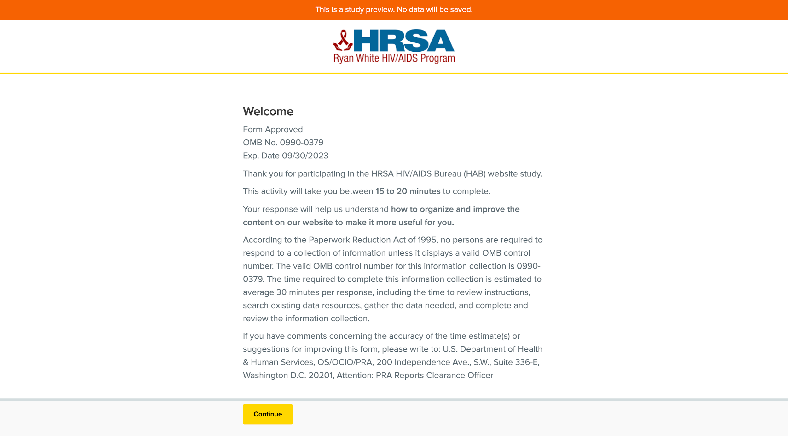Screenshot 1: Welcome Message and PRA Statement
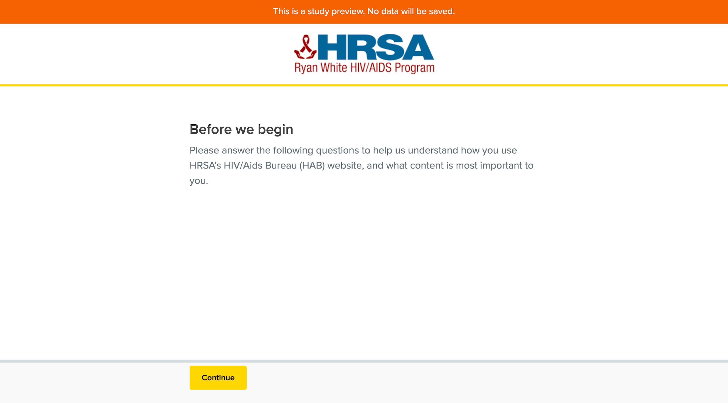
Screenshot 2: Pre-Test Questions Introduction
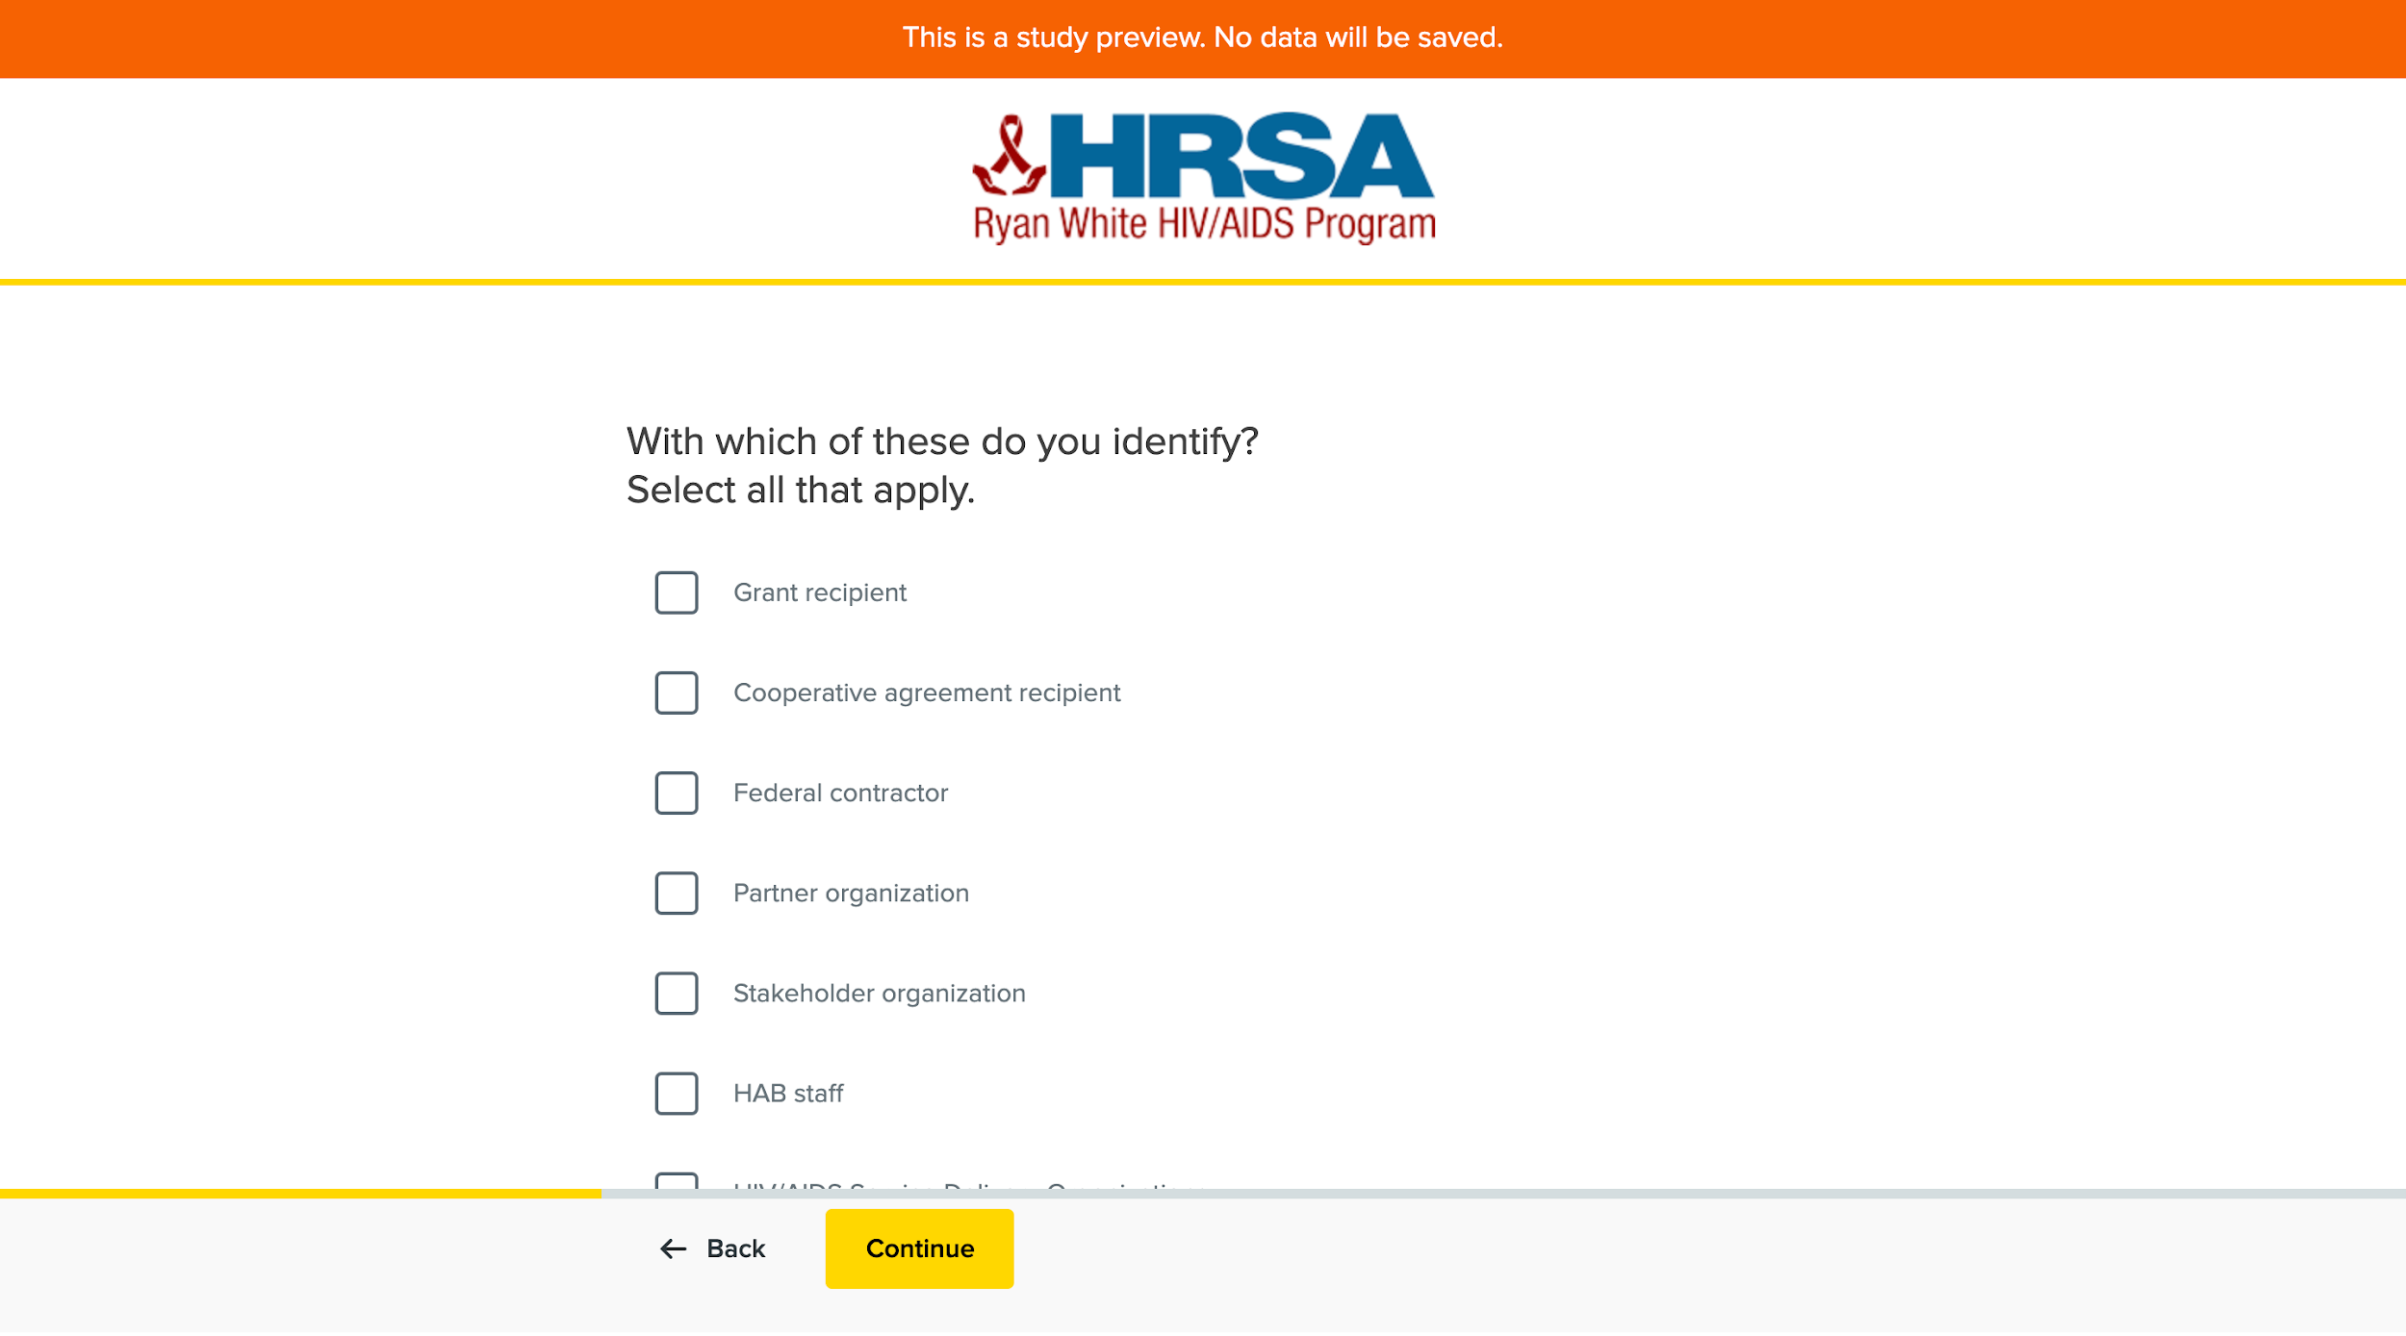
Screenshot 3: Pre-Test Question 1
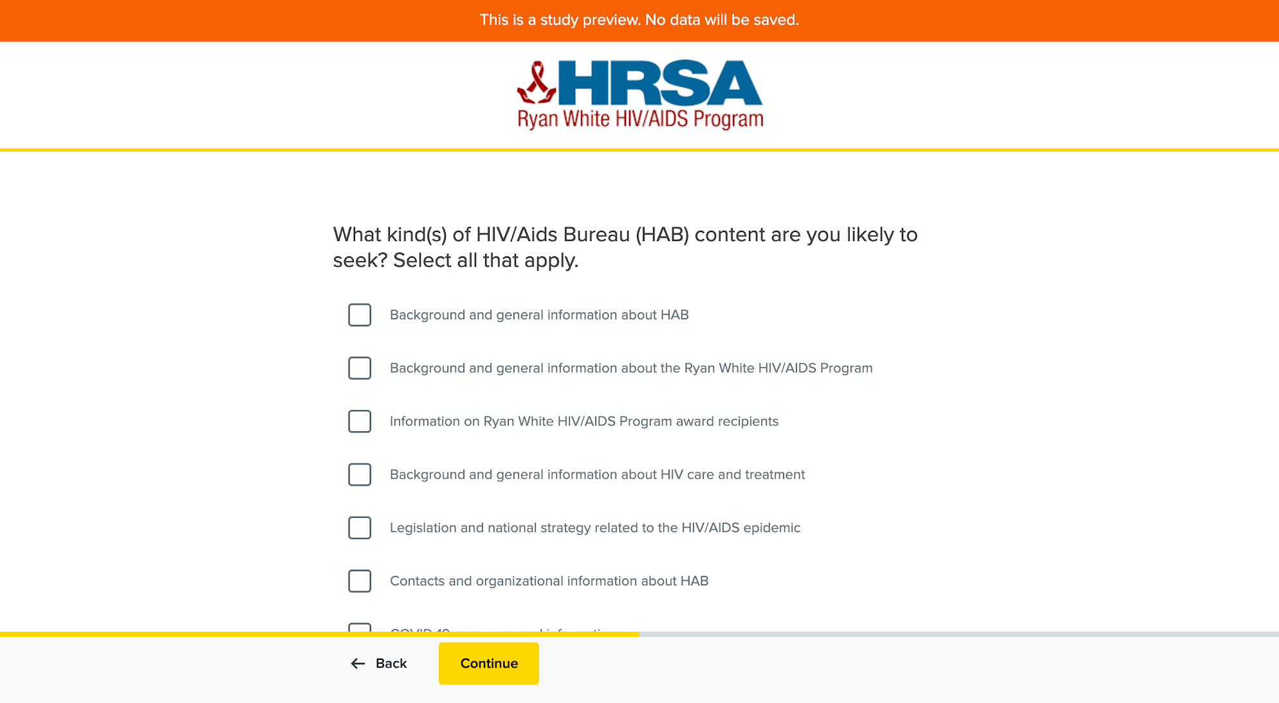Screenshot 4: Pre-Test Question 2
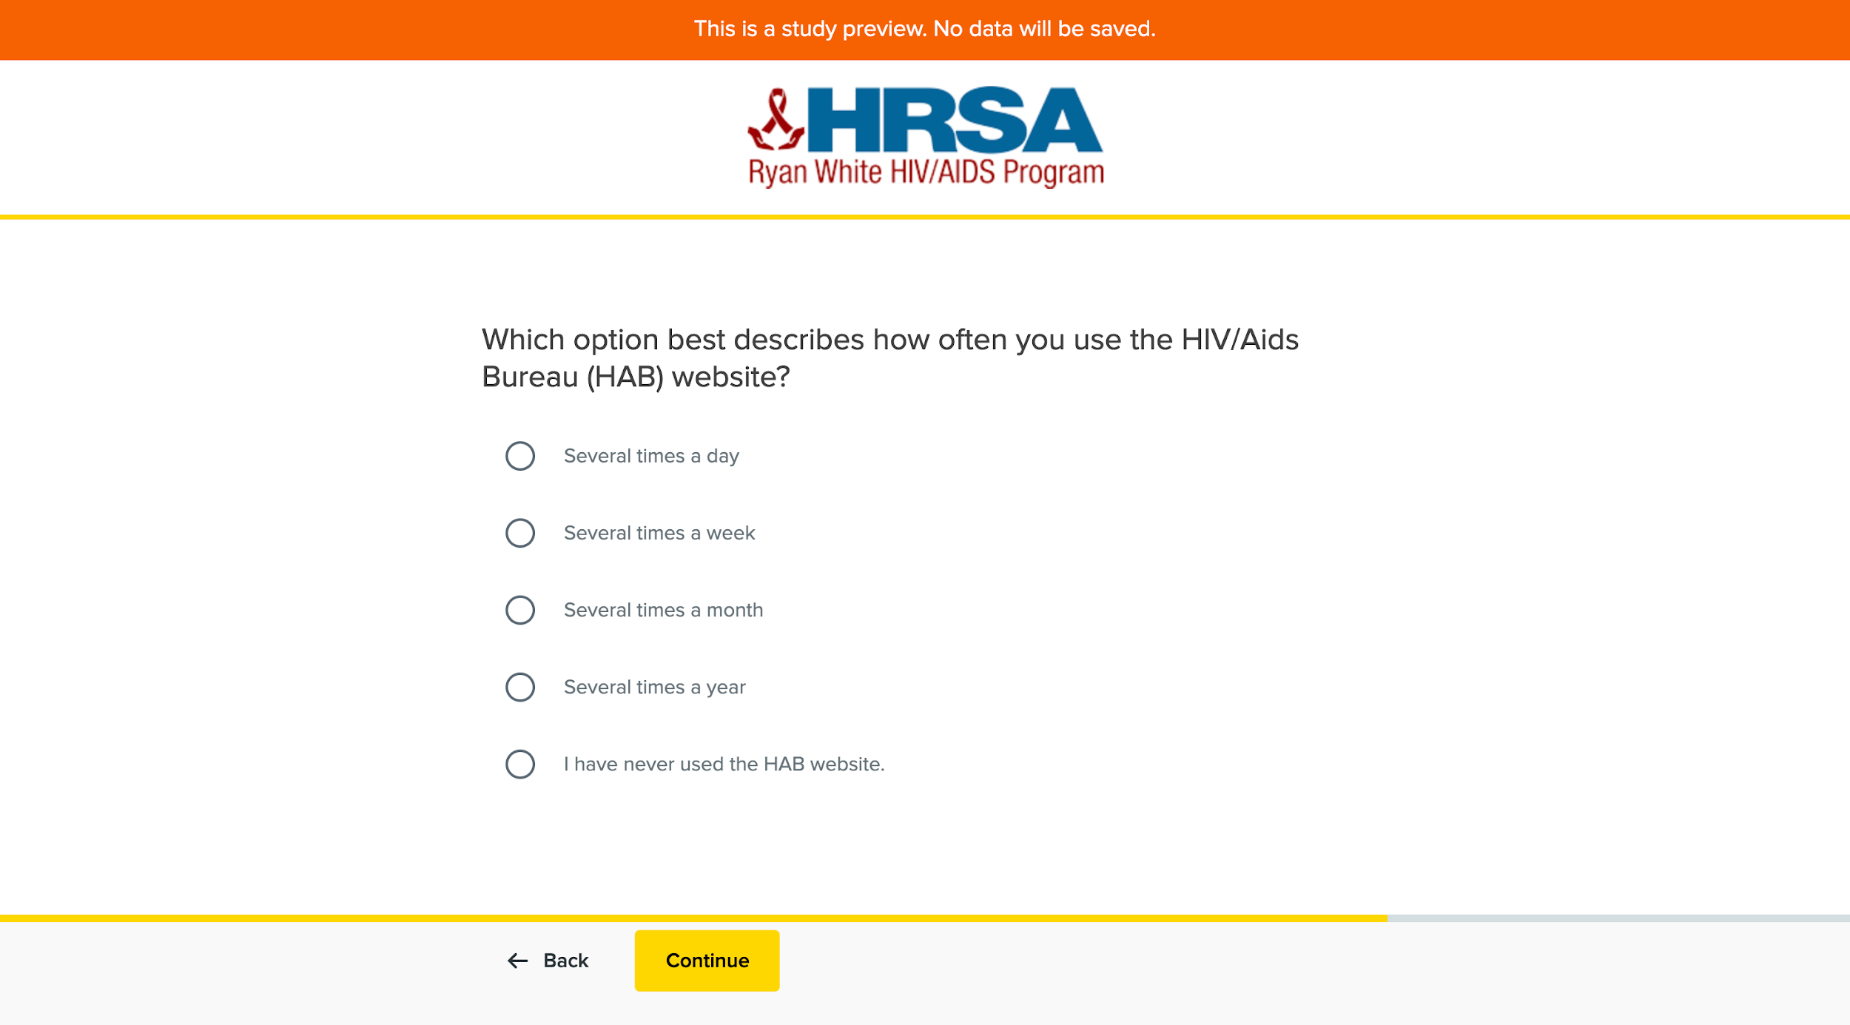
Screenshot 5: Pre-Test Question 3
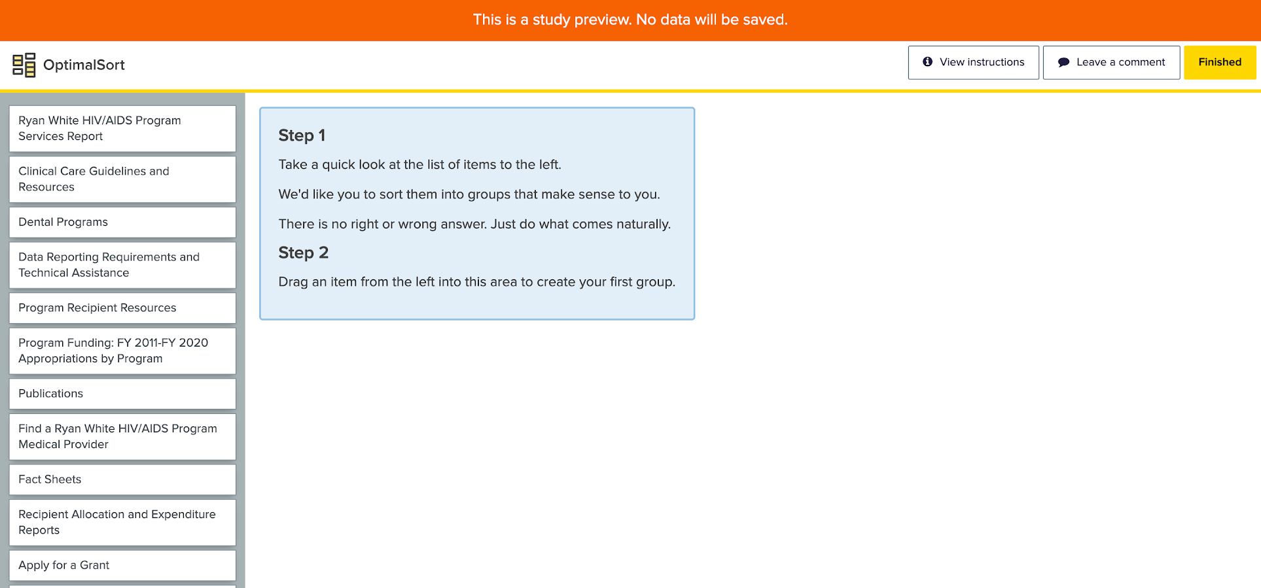
Screenshot 6: Test Screen and Part 1 of Instructions
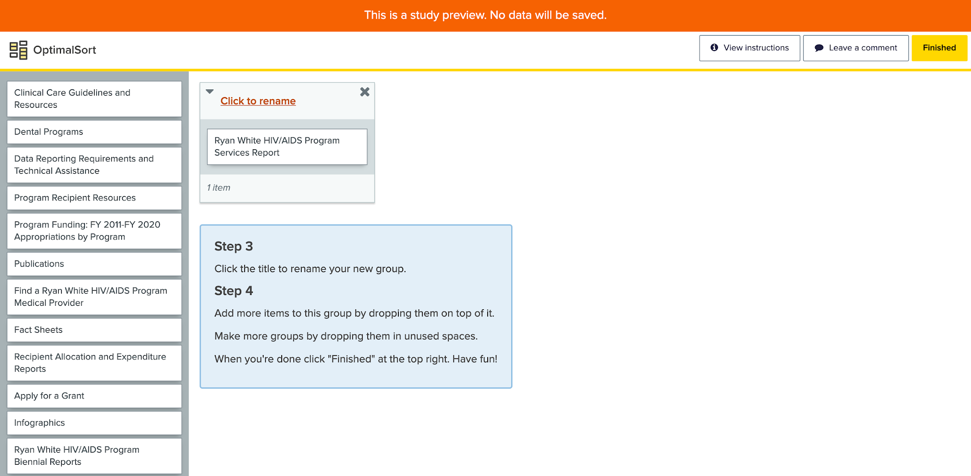
Screenshot 7: Test Screen and Part 2 of Instructions
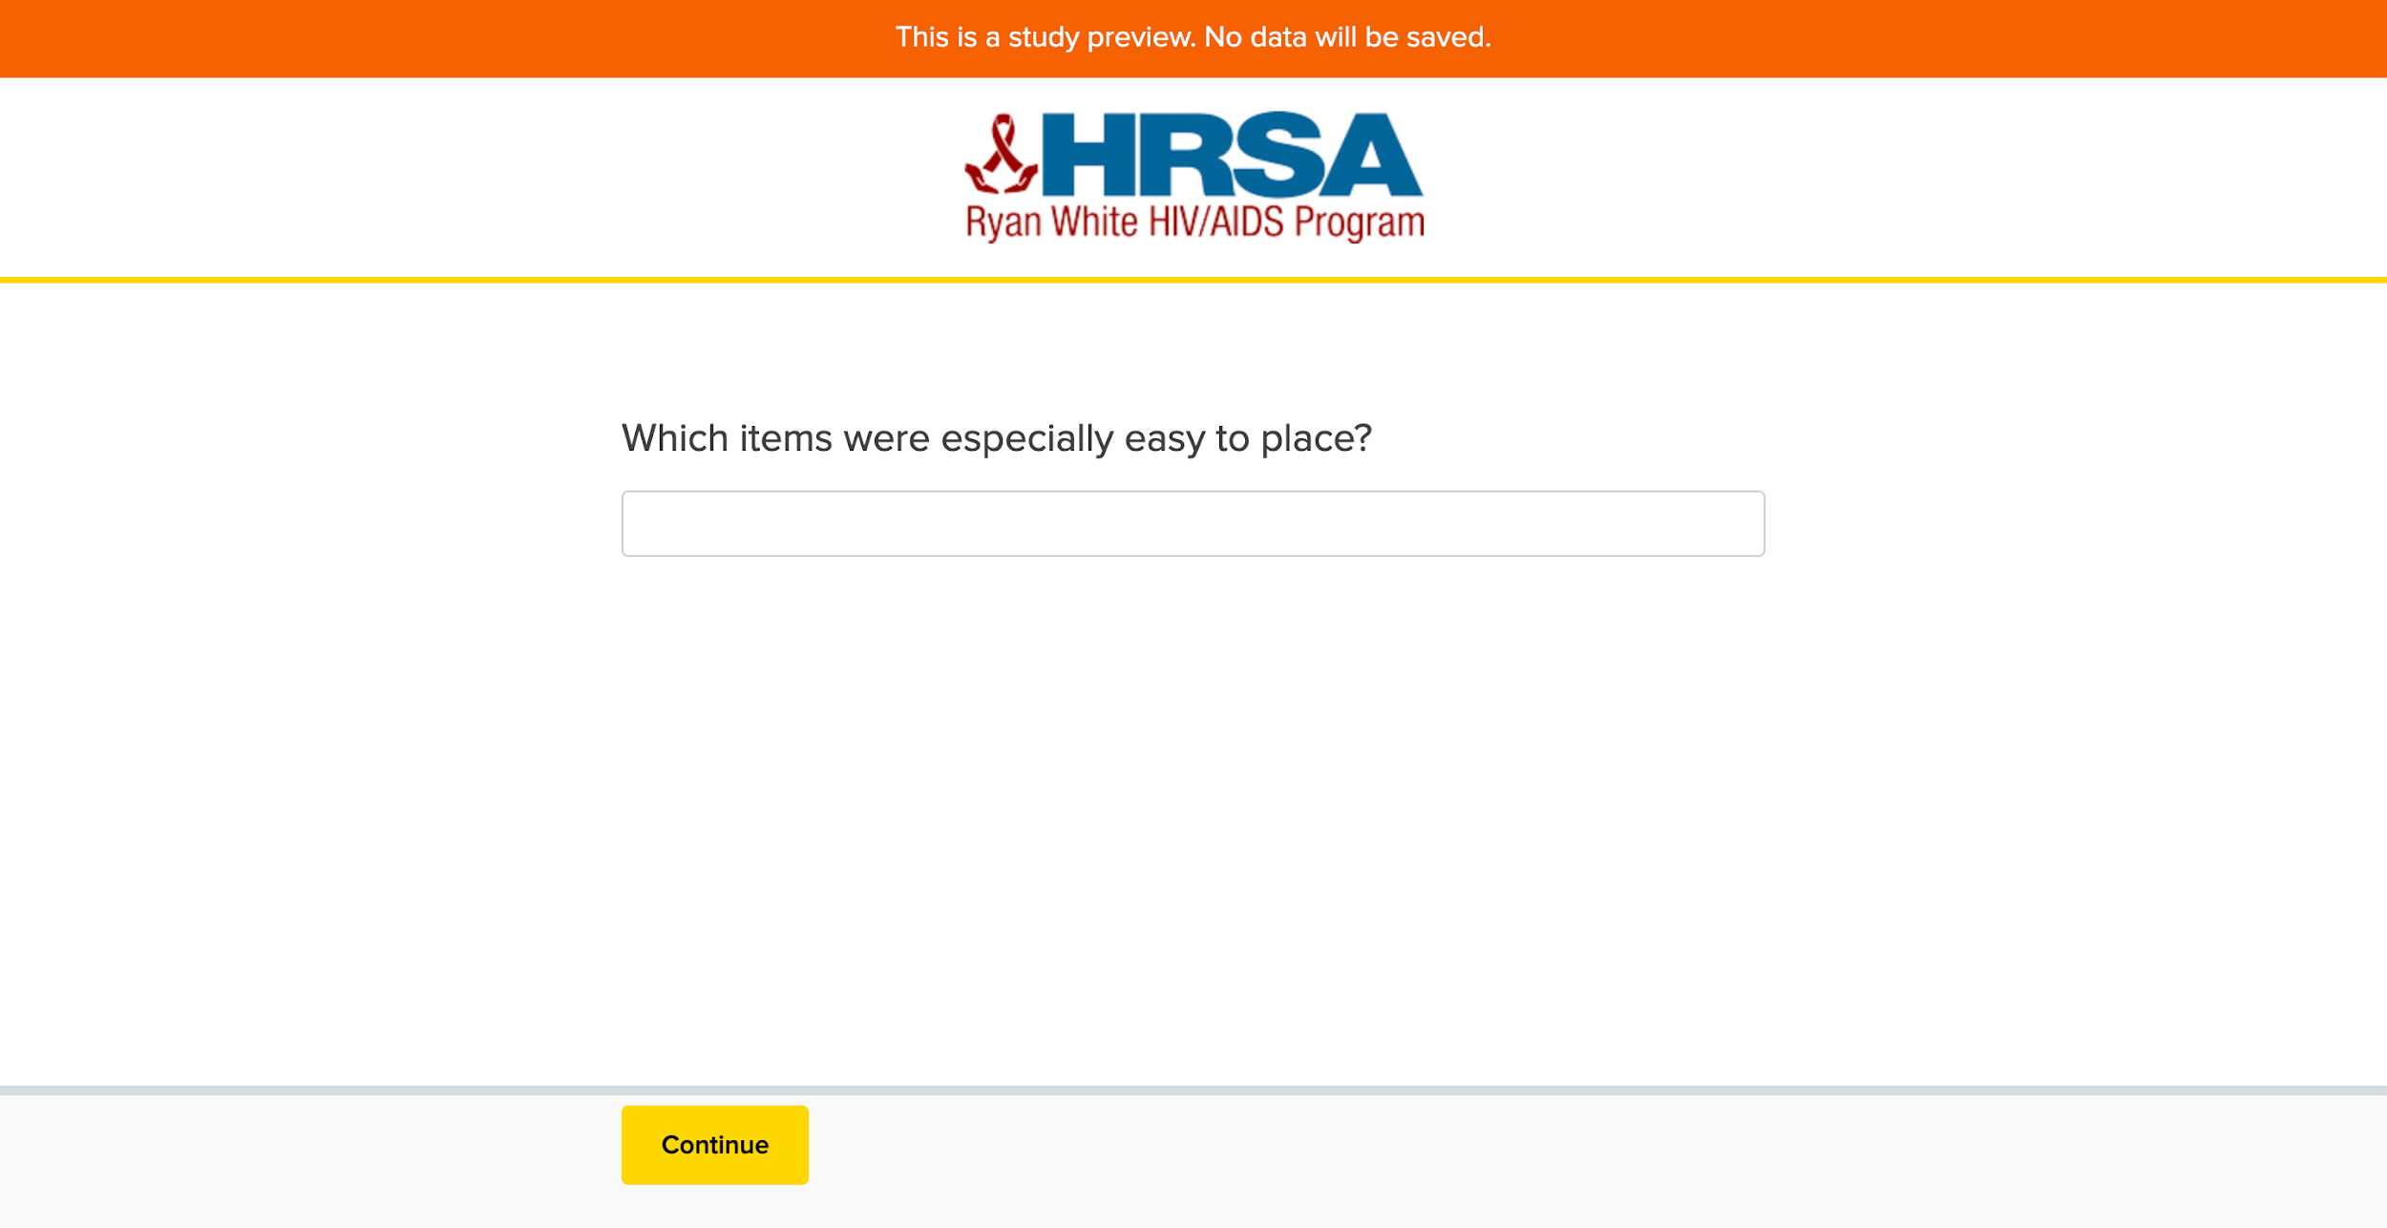
Screenshot 8: Post-Test Question 1
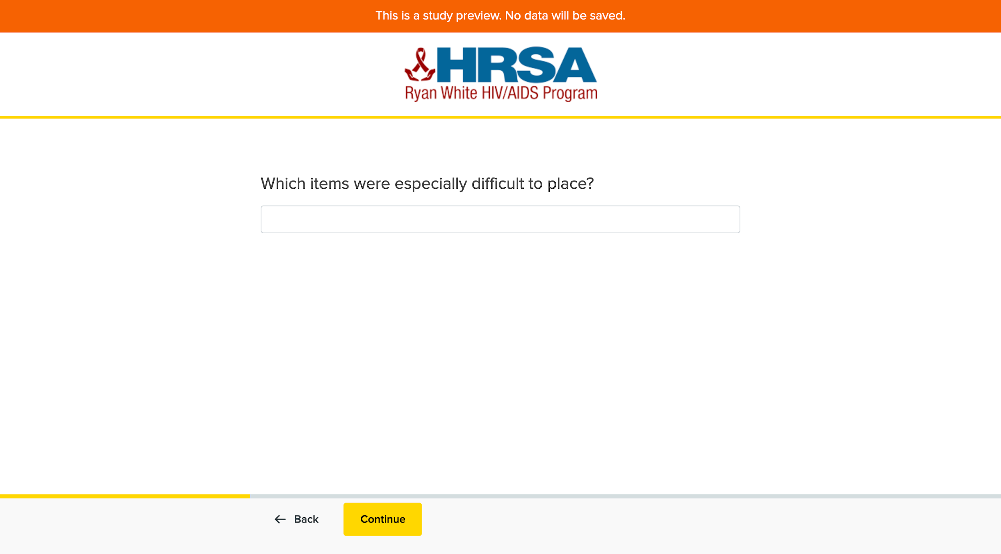
Screenshot 9: Post-Test Question 2
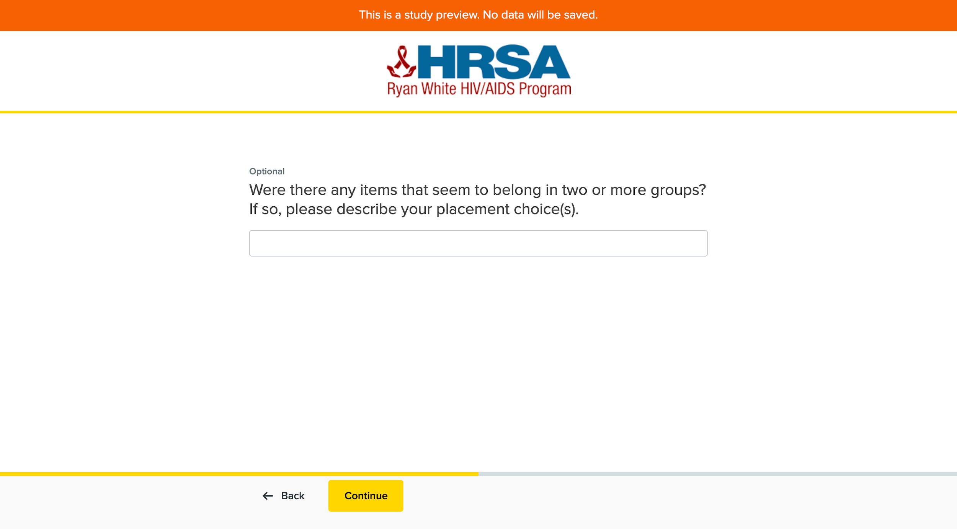
Screenshot 10: Post-Test Question 3
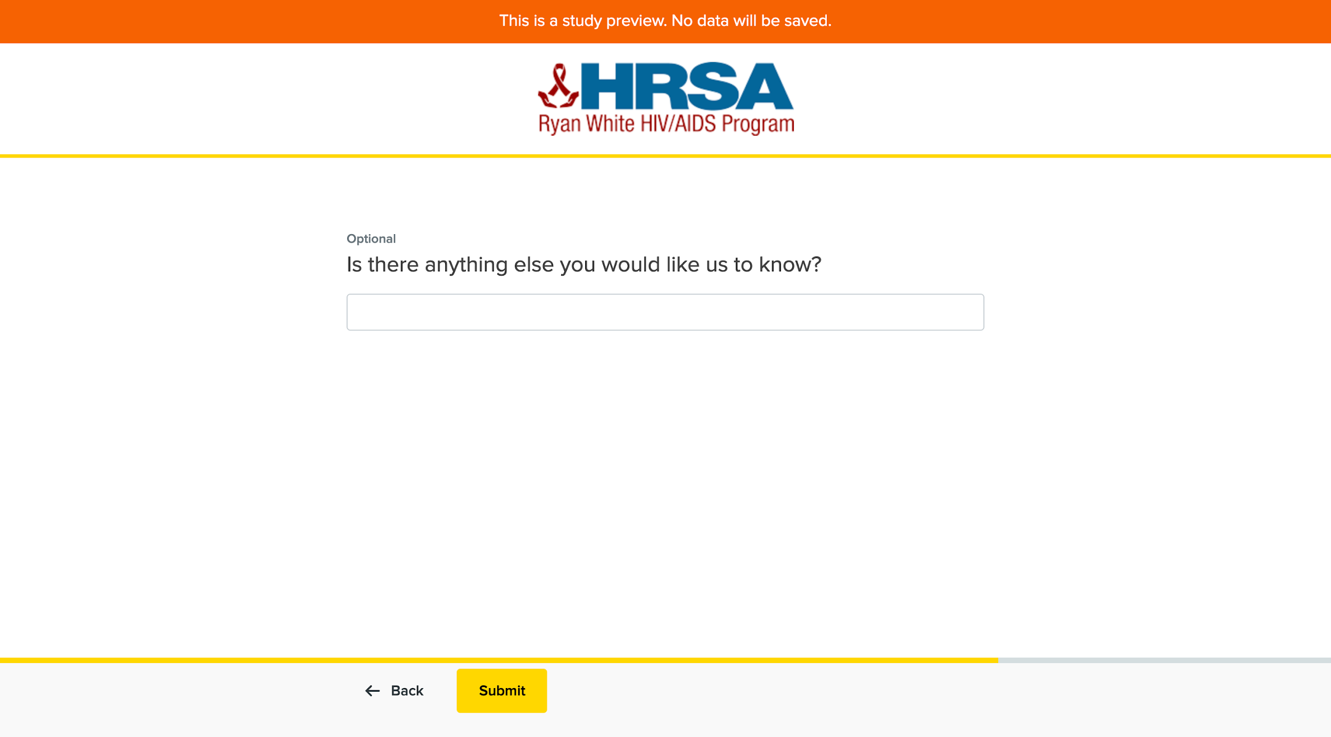
Screenshot 11: Post-Test Question 4
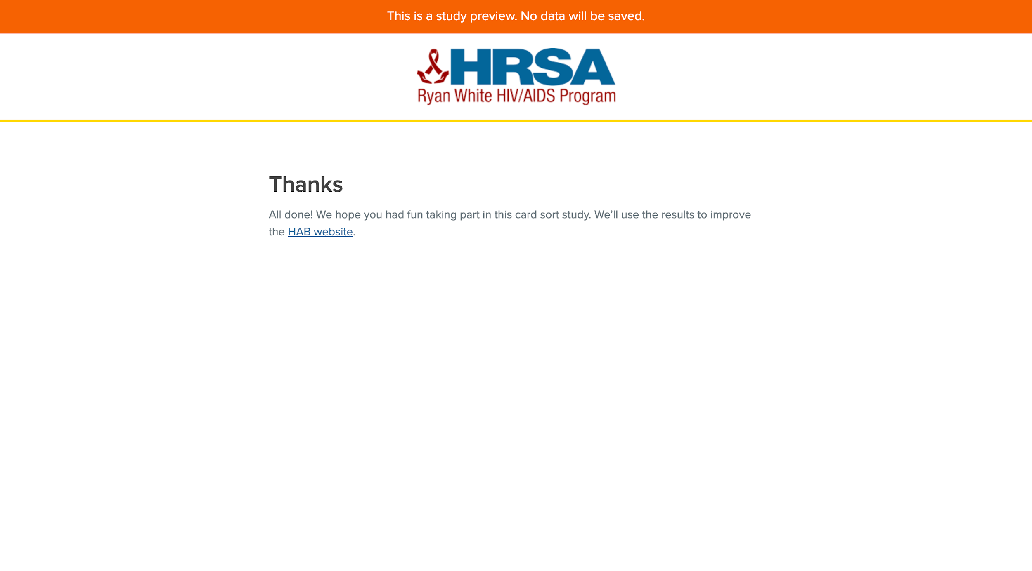
Screenshot 12: Completed Test Screen

