Form Approved
OMB No. 0990-0379
Exp. Date 08/31/2023

HRSA FORHP Website:

Card Sort Test Script (Survey Instrument)

Introduction
Thank you for participating in HRSA’s Federal Office of Rural Health Policy (FORHP) website study.
This activity will take you between 15 to 20 minutes to complete.
Your response will help us understand how to organize and improve the content on our website to make it more useful for you.
According to the Paperwork Reduction Act of 1995, no persons are required to respond to a collection of information unless it displays a valid OMB control number. The valid OMB control number for this information collection is 0990-0379. The time required to complete this information collection is estimated to average 30 minutes per response, including the time to review instructions, search existing data resources, gather the data needed, and complete and review the information collection. If you have comments concerning the accuracy of the time estimate(s) or suggestions for improving this form, please write to: U.S. Department of Health & Human Services, OS/OCIO/PRA, 200 Independence Ave., S.W., Suite 336-E, Washington D.C. 20201, Attention: PRA Reports Clearance Officer

Pre-Survey Questionnaire
Please answer the following questions to help us understand how you use the Federal Office of Rural Health Policy (FORHP) website, and what content is most important to you.

- With which of these do you identify?
Select all that apply: (multi-select) (Required)
  - Current Awardee
  - Prospective Awardee
  - Former Awardee
  - State Government Agency
  - Federal Government Agency
  - Congressional Staff
  - FORHP Staff
  - Philanthropic Organization, or other Non-Government organization
  - Other FORHP-Funded Stakeholder, e.g. Technical Assistance Provider, Program Evaluator, etc.
  - Other: (Text field: “If other, please specify”)
- What kind(s) of Federal Office of Rural Health Policy (FORHP) content are you likely to seek?
Select all that apply: (multi-select) (Required)
- News and Announcements
- Upcoming and Recent Funding Opportunities
- General Information about FORHP Programs
- Information on POCs for FORHP
- Rural Health Policies and Policy Updates
- Rural Health-Related Resources
- History and Organization of FORHP
- Definition of “Rural”
- Is my community rural?
- Other: (Text field: “If other, please specify”)
- Which option best describes how often you use the Federal Office of Rural Health Policy (FORHP) website? (single select) (Required)
  - Several times a day
  - Several times a week
  - Several times a month
  - Several times a year
  - I have never used the FORHP website.

Instructions

Step 1
- Take a quick look at the list of items to the left.
- Sort them into groups that make sense to you.
- There’s no right or wrong answer. Just do what comes naturally.

Step 2
- Drag an item from the left into this area to create your first group.

Step 3
- Click the title to rename your new group.

Step 4
- Add more items to this group by dropping them on top of it.
- You can also move items from one group to another if you decide it’s a better fit.
- Make more groups by dropping them in unused spaces.
- When you're done click "Finished” at the top right. Have fun!

Cards
The study will feature cards with labels from the following list. Participants will view all cards from this list in a random order. Group labels will not be provided given the approach of an open card sort.
- FORHP Mission
- History of FORHP
- Rural Relevant Research Findings
- Rural Health Policies
- Stabilizing Hospital Finance
- Definition of Rural
- Rural Residency Opportunities
- State Office of Rural Health Grants
- Rural Hospital Flexibility Grants
- Critical Access Hospital Assistance
- Medicare Rural Hospital Flexibility Program Information
- Medicare Beneficiary Quality Improvement Project
- Available Grants
- Major Issues Impacting Rural Health
- Grant Programs to Improve Rural Community Health
- Outreach Programs
- Grants Program for Opioid Addiction
- Public Health Services Act
- Access to Maternity and Obstetrics in Rural Areas
- Support for Miners
- Cancer
- Health Issues of Miners
- Help with Substance Use Disorder
- Rural Access Hospital Programs
- Federally Qualified Health Assistance
- National Rural Health Day
- Funding Awards
- Community Health Workers
- National Advisory Committee on Rural Health & Human Services
- Fact Sheet
- Telehealth
- Neo Natal Abstinence Syndrome
- Coronavirus
- Rural Health Information Hub
- Rural Health Research Gateway
- Rural Community Health Gateway
- Rural Health Resource Guide
- Support for Rural Tribal Communities
- Resources for Applying for FORHP Grants
- Resources for Managing FORHP Grants
- Rural Veterans’ Healthcare
- Vulnerable Rural Hospital Support
- Quality Measures for Rural Hospitals
- Rural Health Equity
- Rural Chronic Disease Prevention/Management
- Rural Health Networks
- Telehealth Grant Programs
- Telehealth Resource Centers
- Rural Health Center COVID-19 Testing Program
- Rural Hospital Closures

Post-Survey Questionnaire
- Which items were especially easy to place? (Required)
- Which items were especially difficult to place? (Required)
- Were there any items that seem to belong in two or more groups? If so, please describe your placement choice(s). (Optional)
- Was there anything that seemed to be missing? (Optional)
- Is there anything else you would like us to know? (Optional)

Thanks
All done, awesome! We hope you had fun taking part in this card sort study. We’ll use the results to improve the FORHP website.

OptimalSort Screenshots
Note: These screenshots display the script presented previously, how they will look in the survey tool.
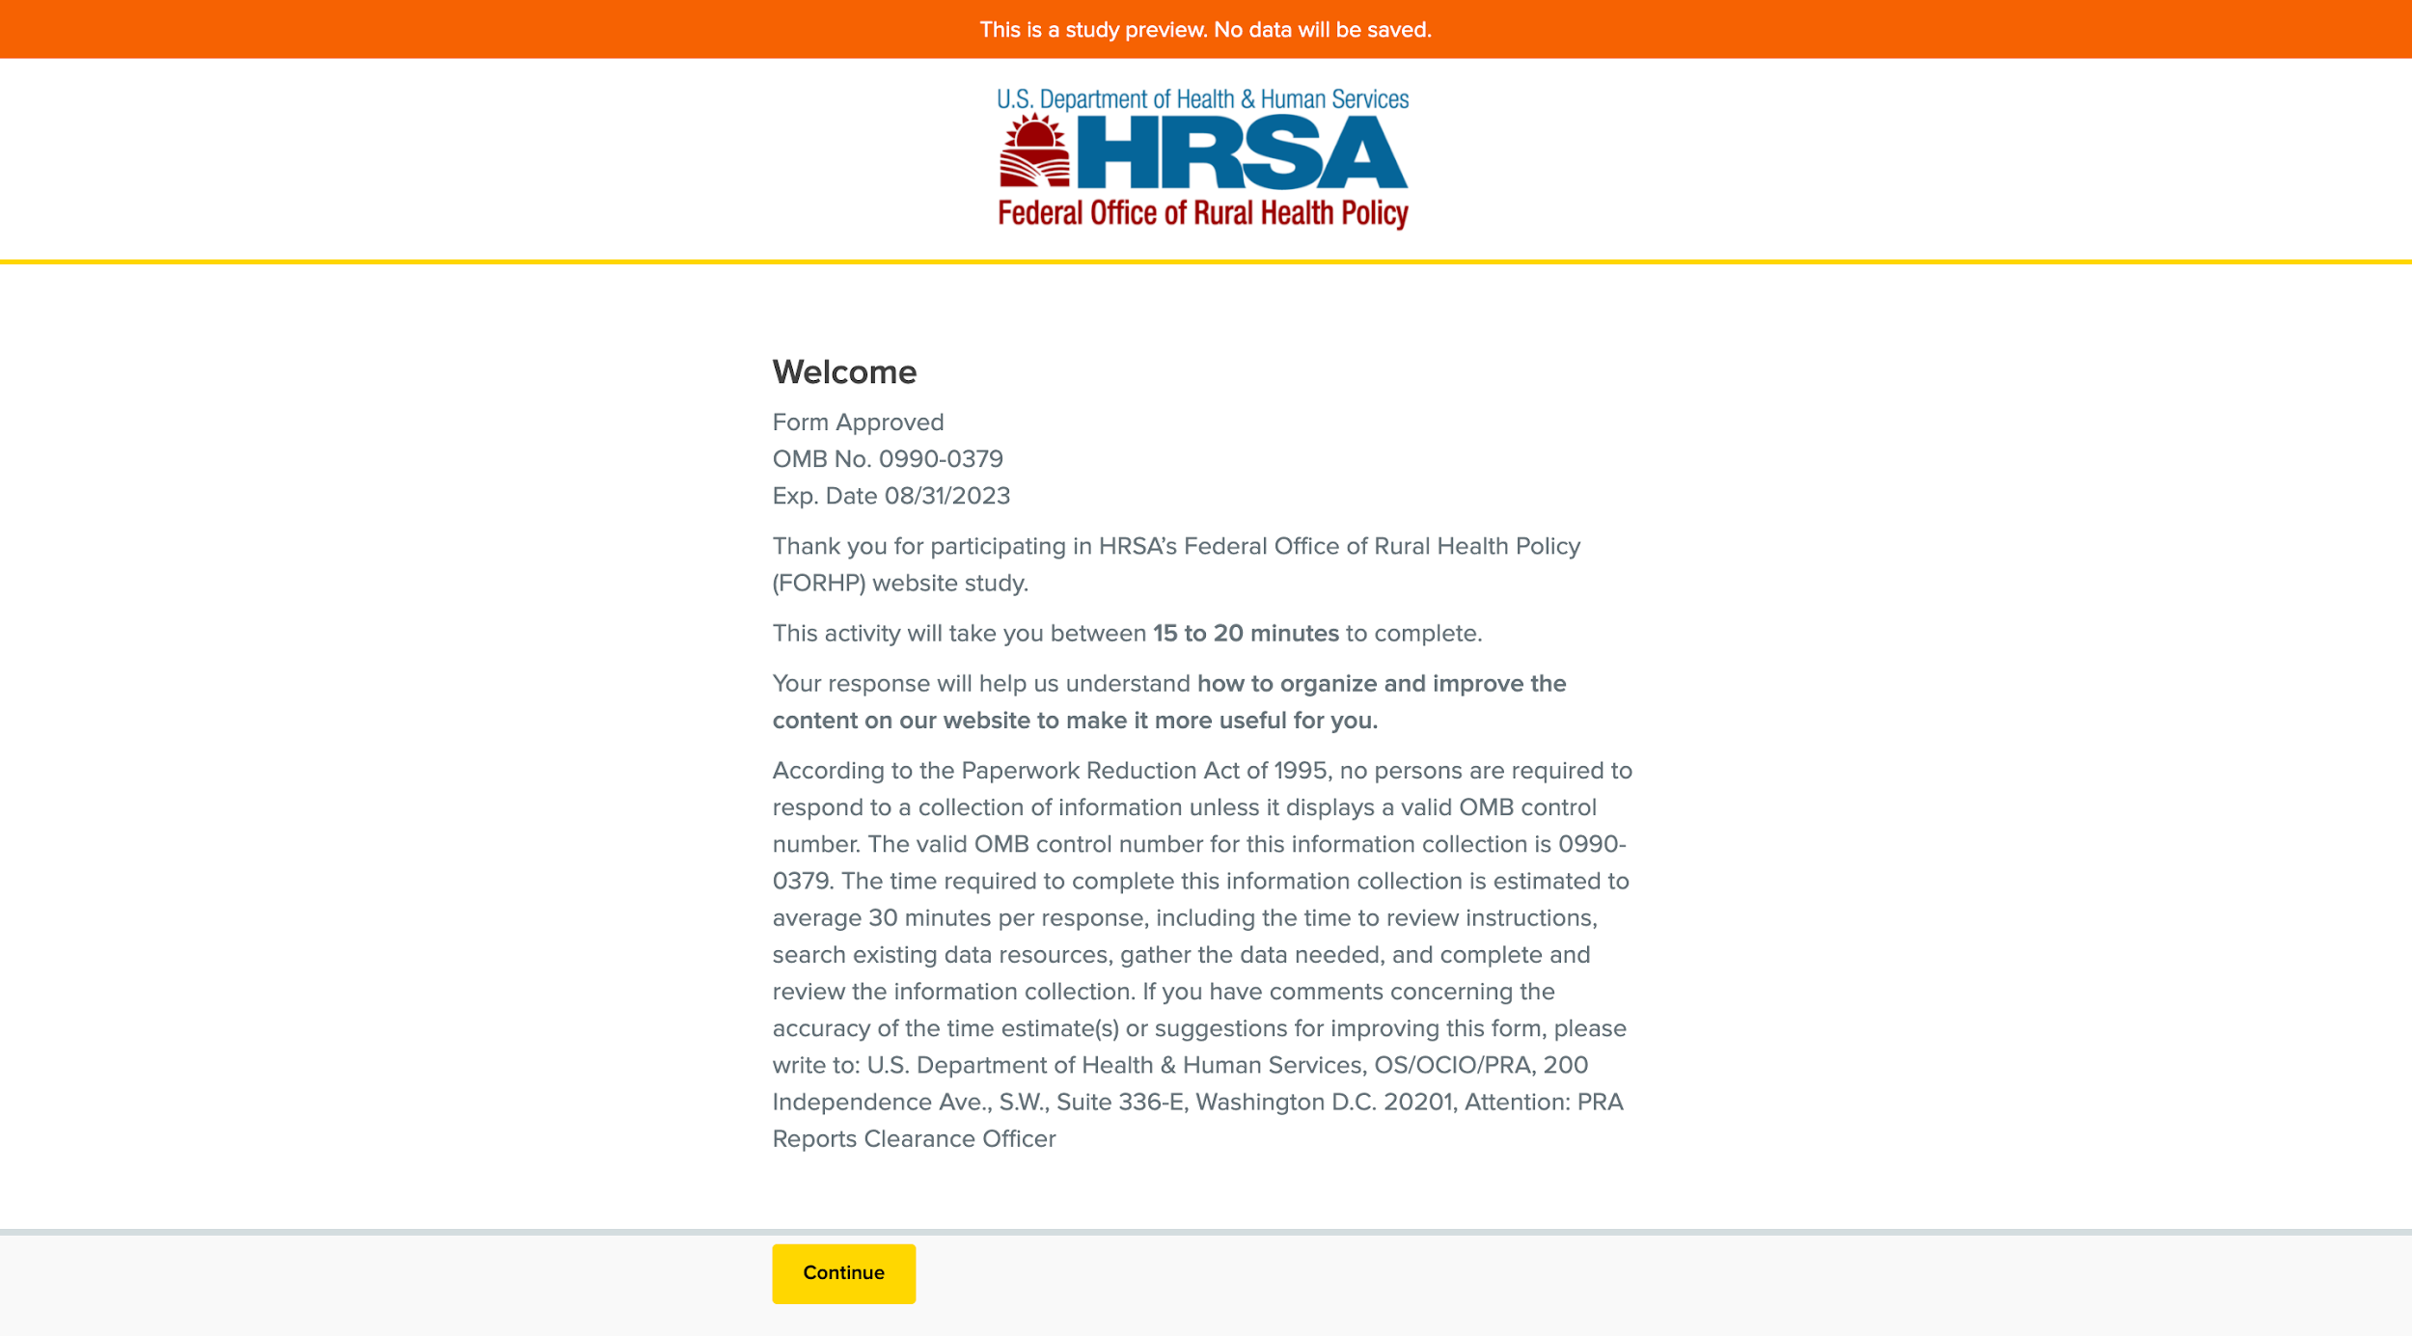
Screenshot 1: Welcome Message and PRA Statement
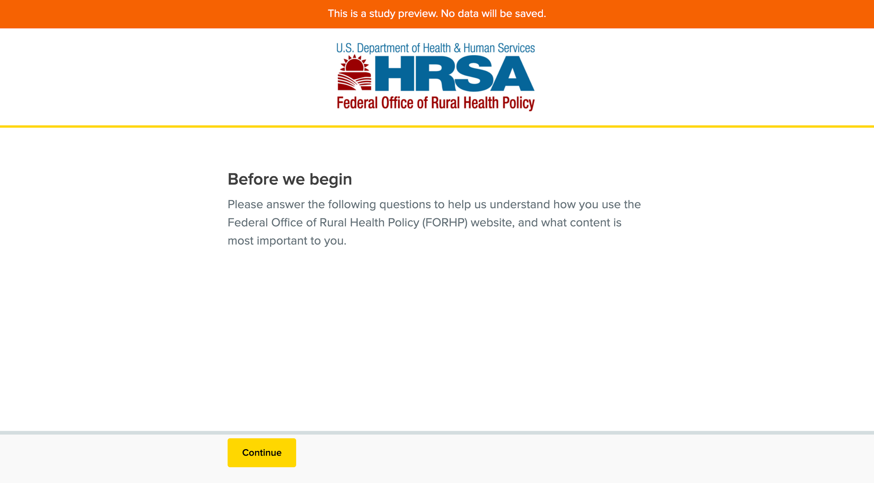
Screenshot 2: Pre-Test Questions Introduction
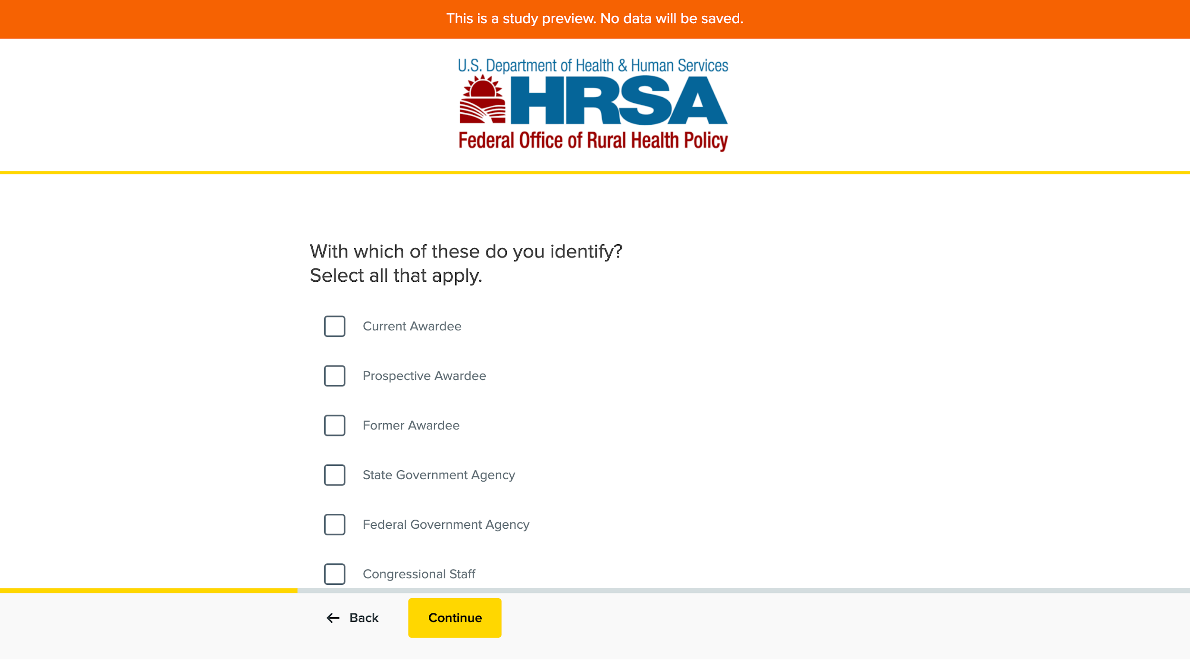
Screenshot 3: Pre-Test Question 1
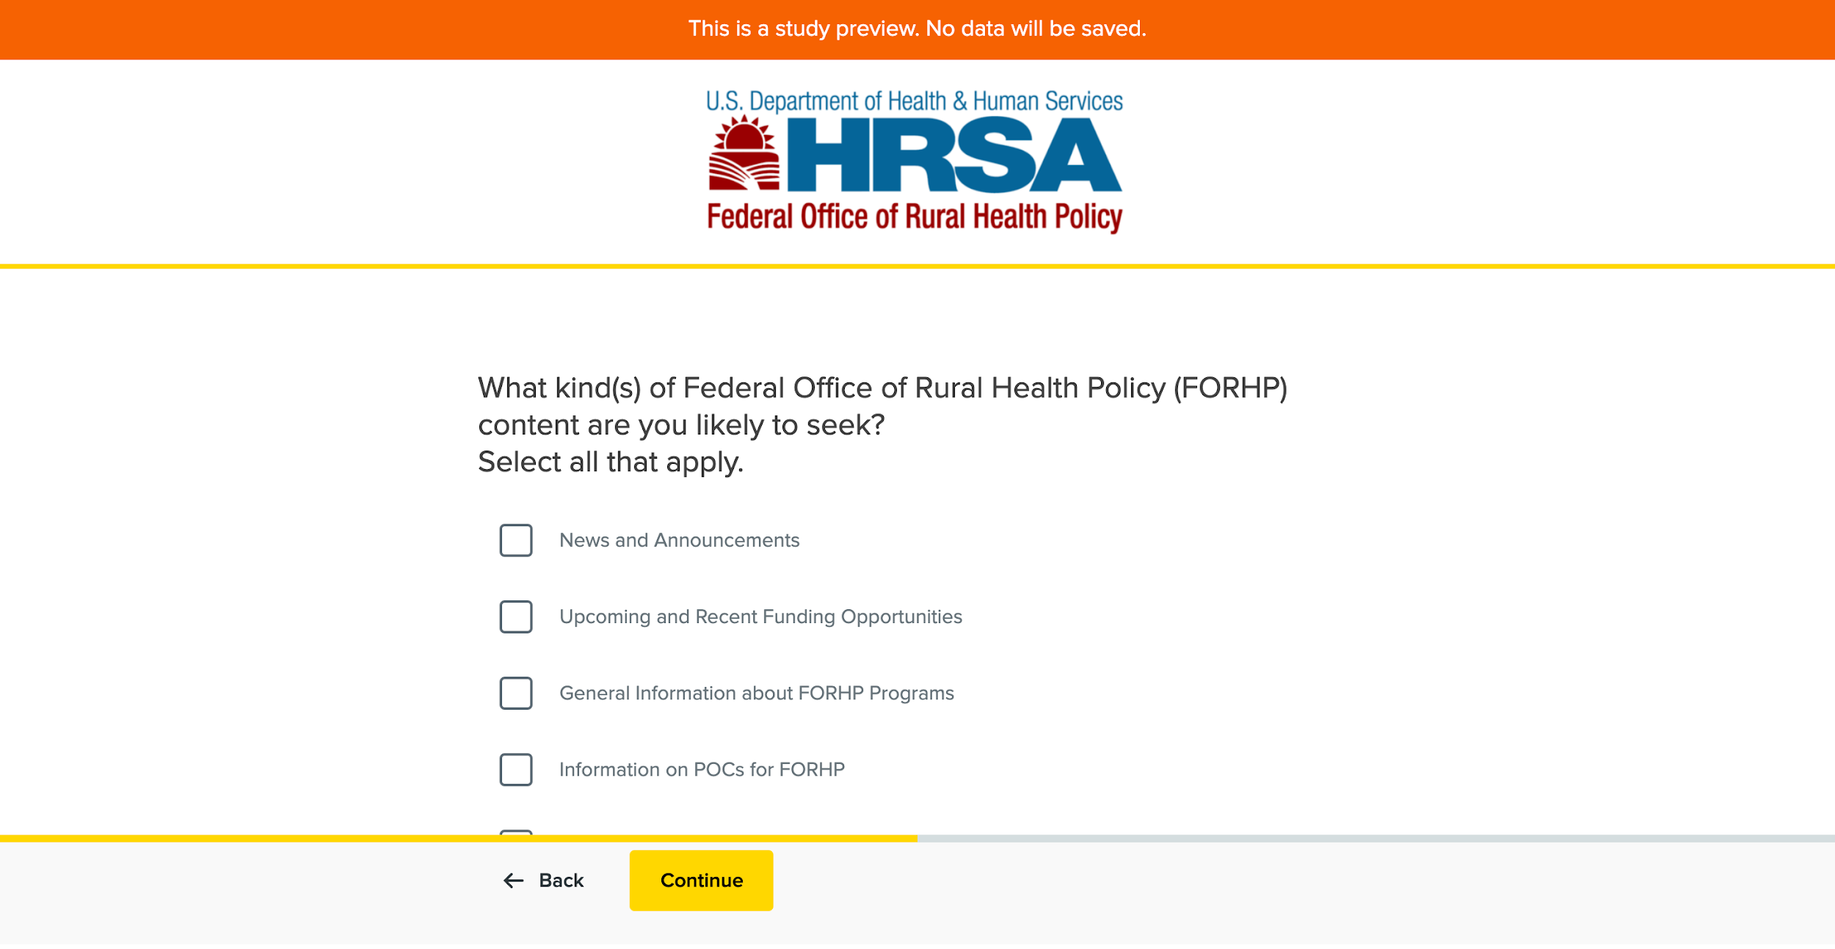
Screenshot 4: Pre-Test Question 2
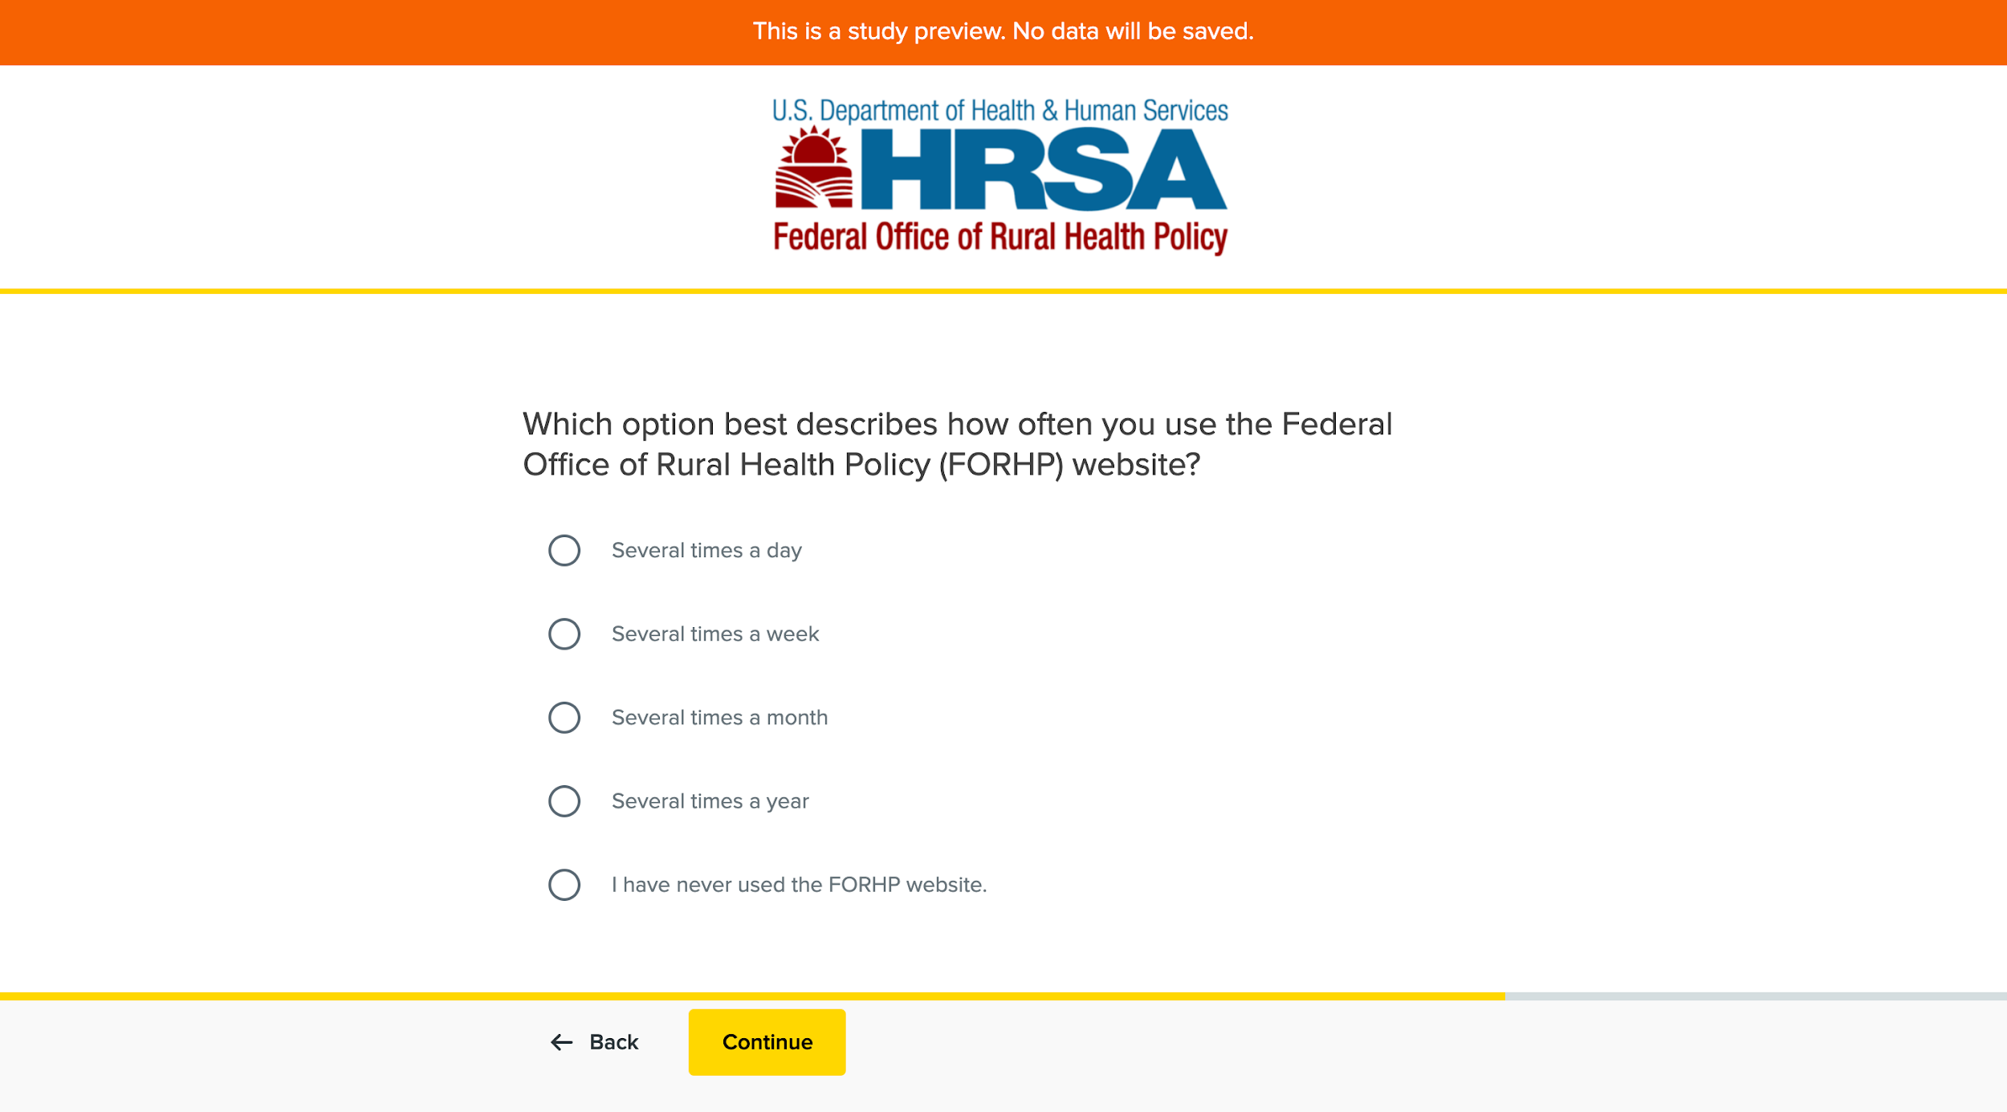
Screenshot 5: Pre-Test Question 3
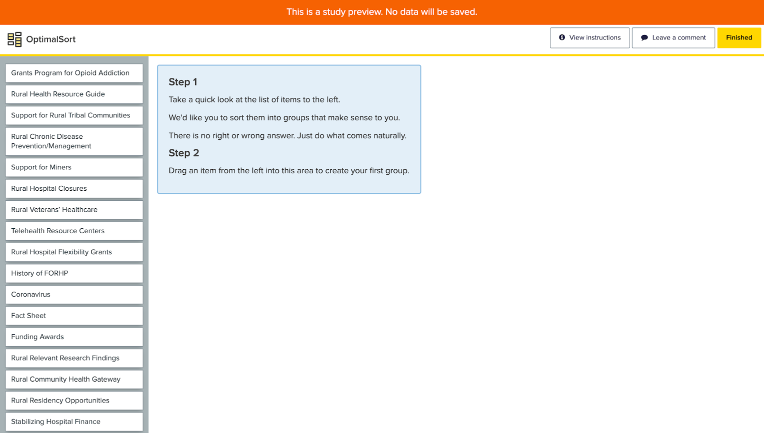
Screenshot 6: Test Screen and Part 1 of Instructions
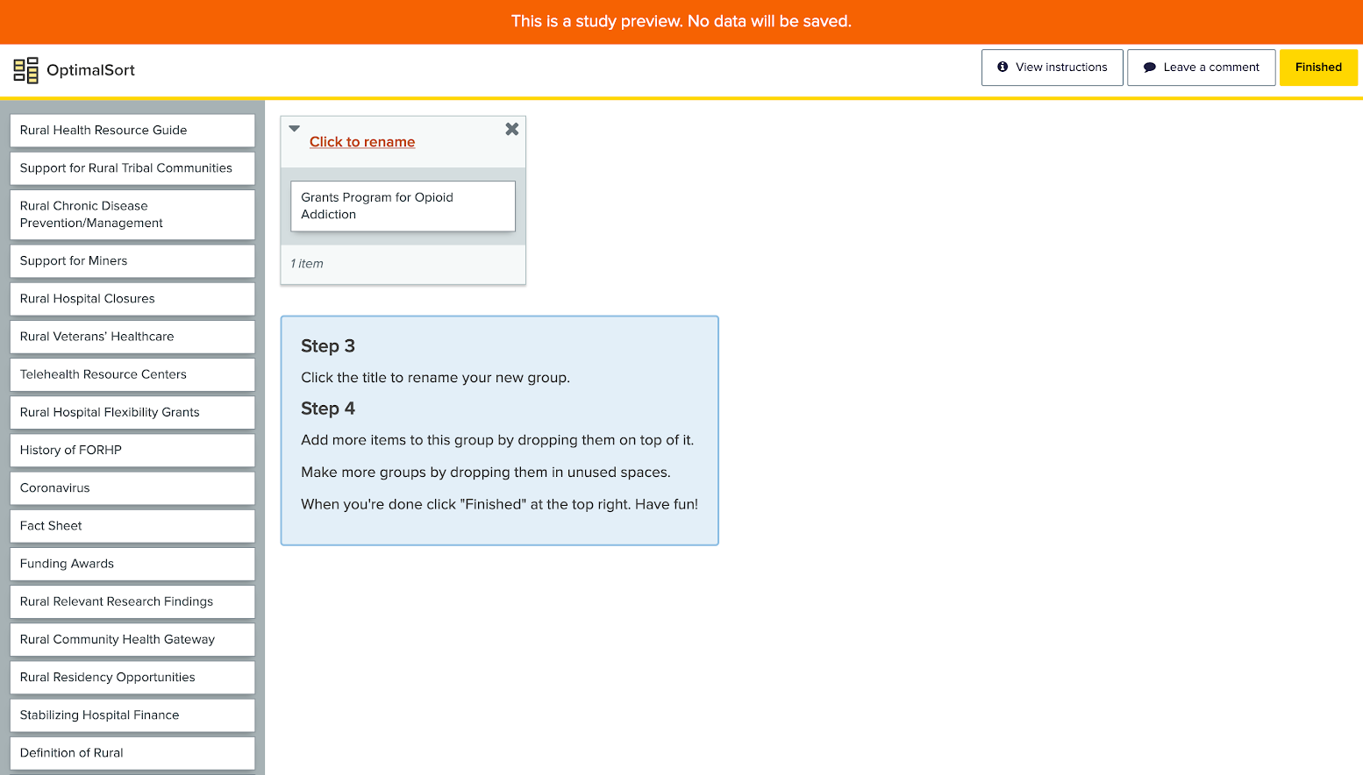
Screenshot 7: Test Screen and Part 2 of Instructions
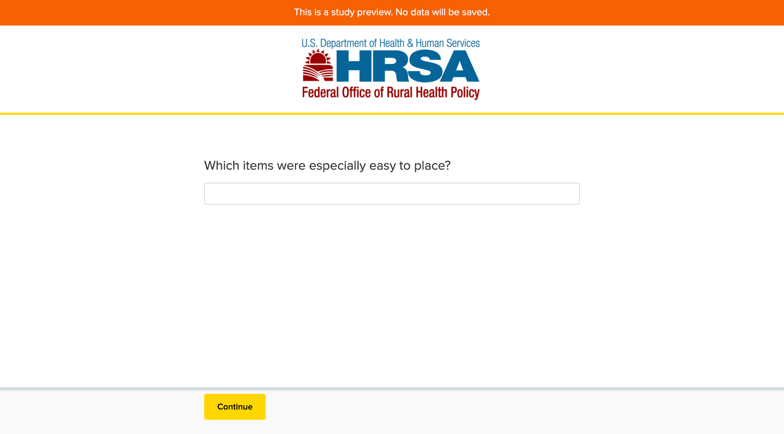
Screenshot 8: Post-Test Question 1
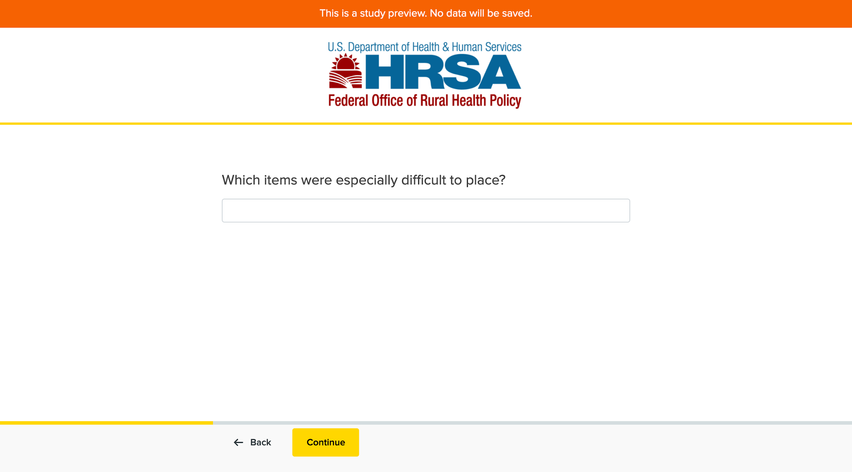
Screenshot 9: Post-Test Question 2
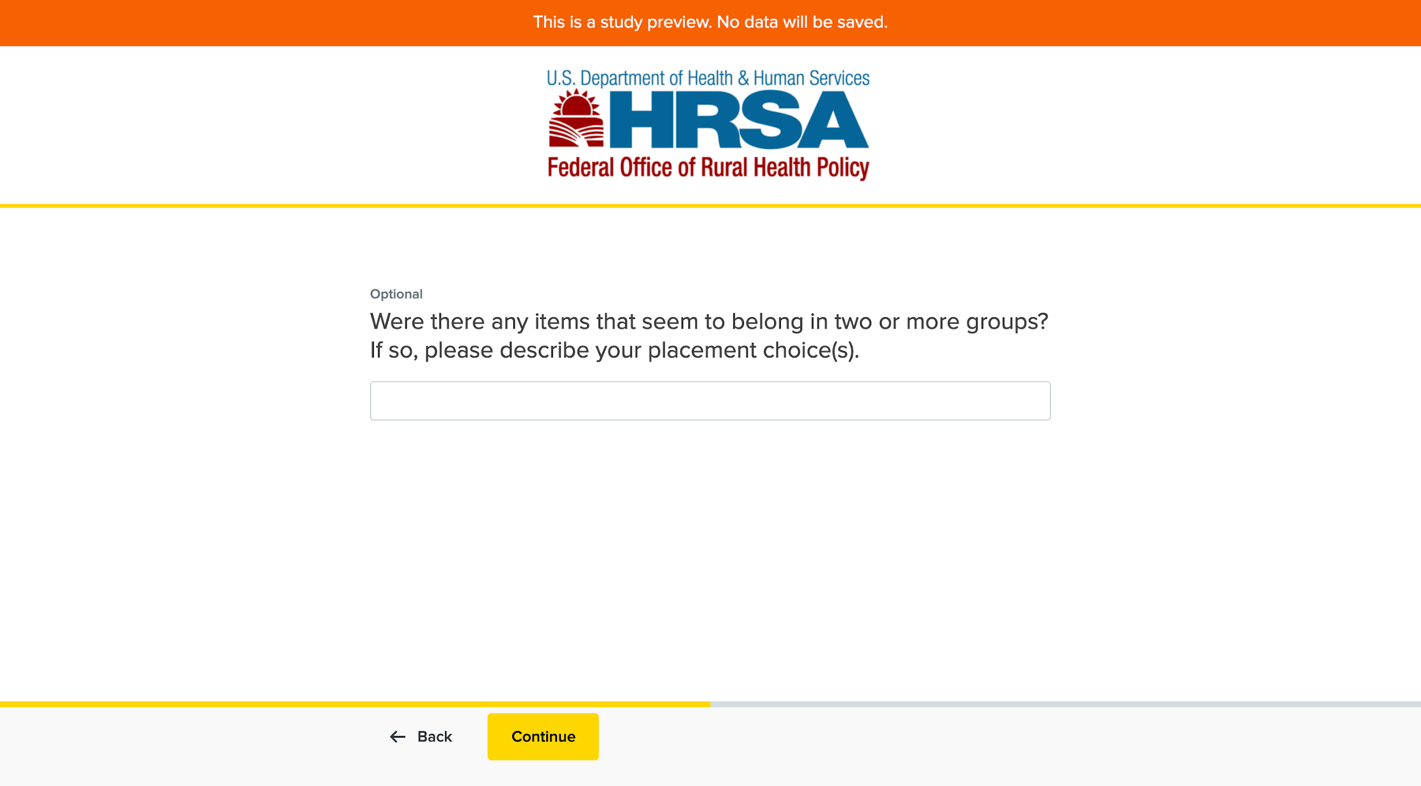
Screenshot 10: Post-Test Question 3
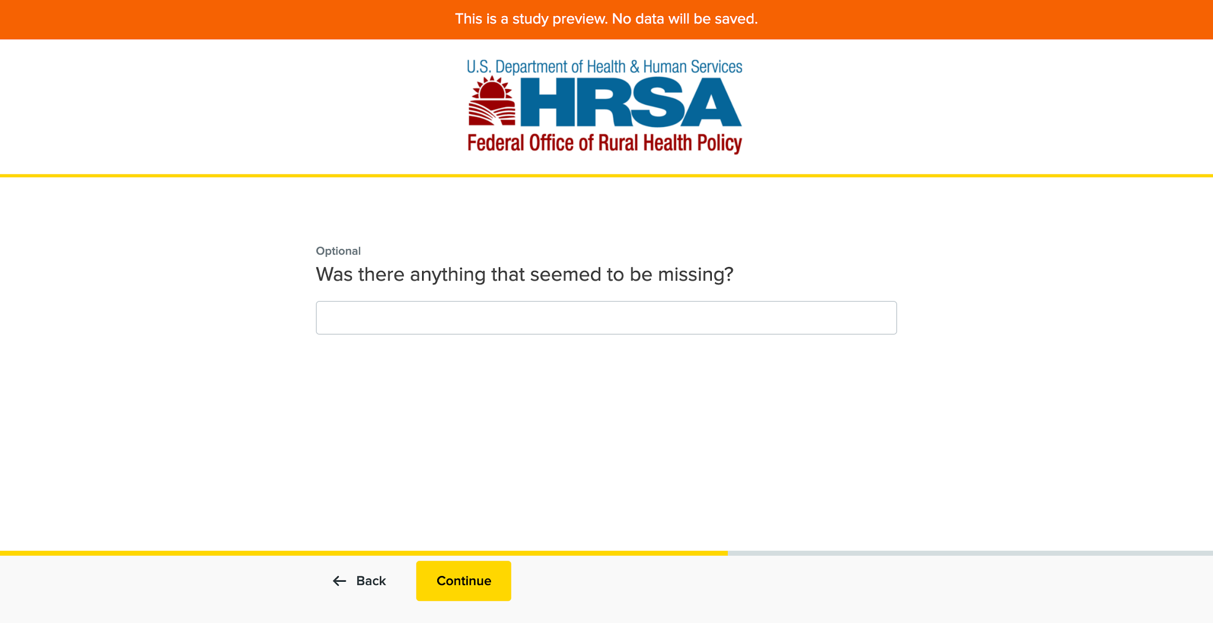
Screenshot 11: Post-Test Question 4
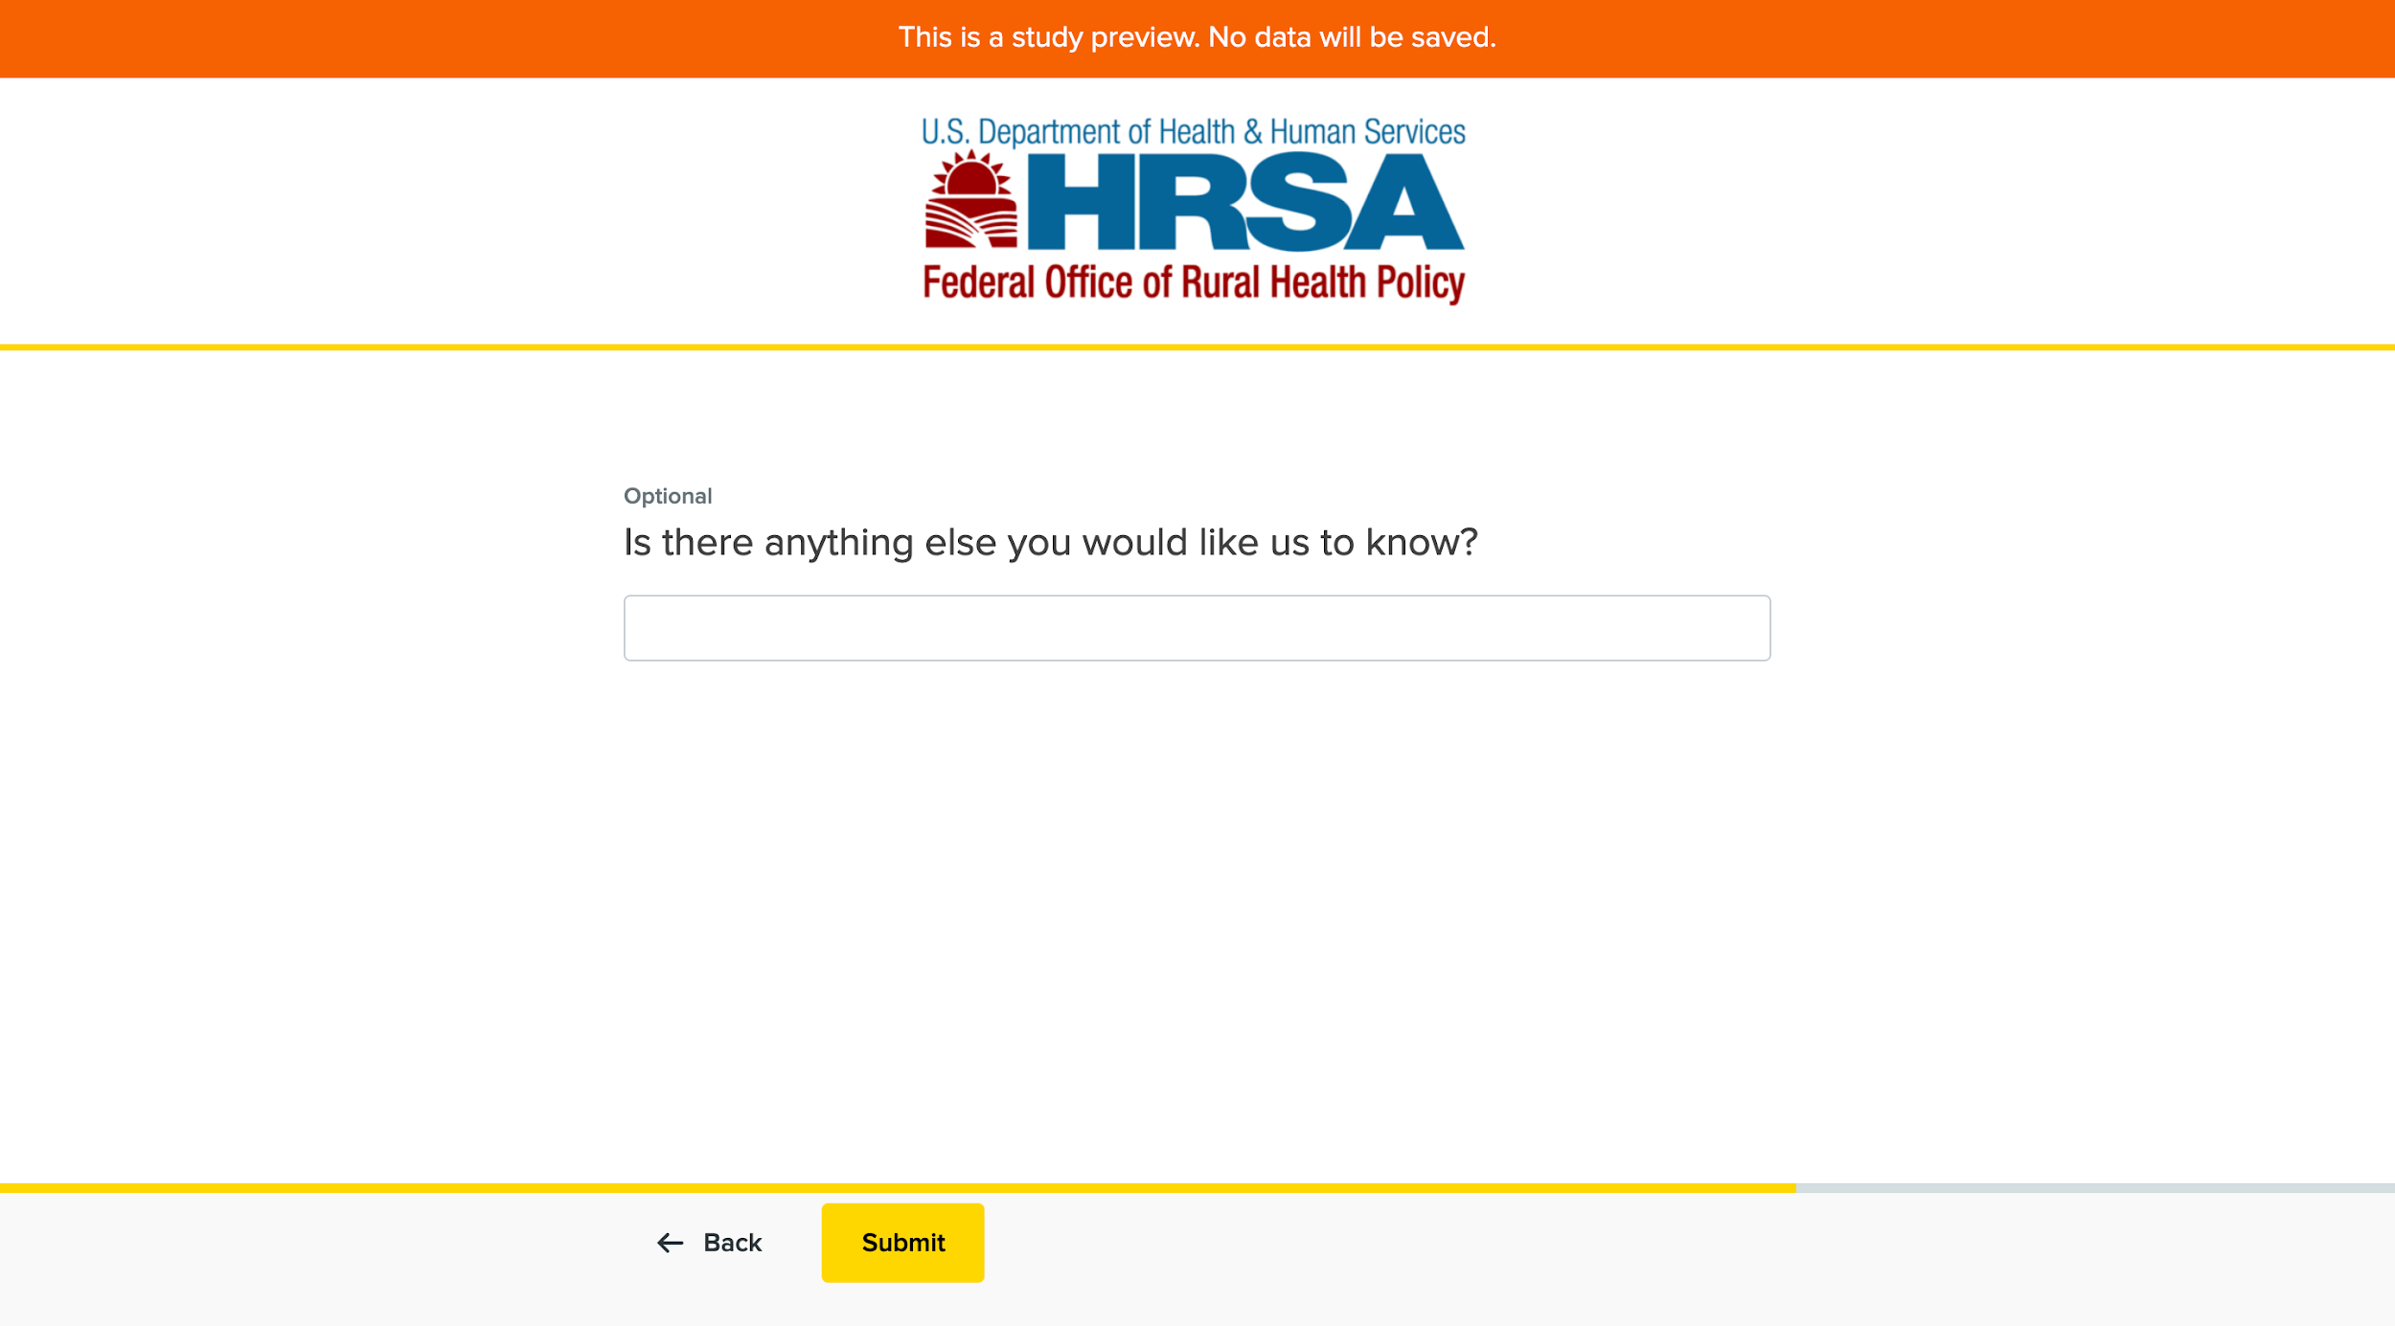
Screenshot 12: Post-Test Question 5
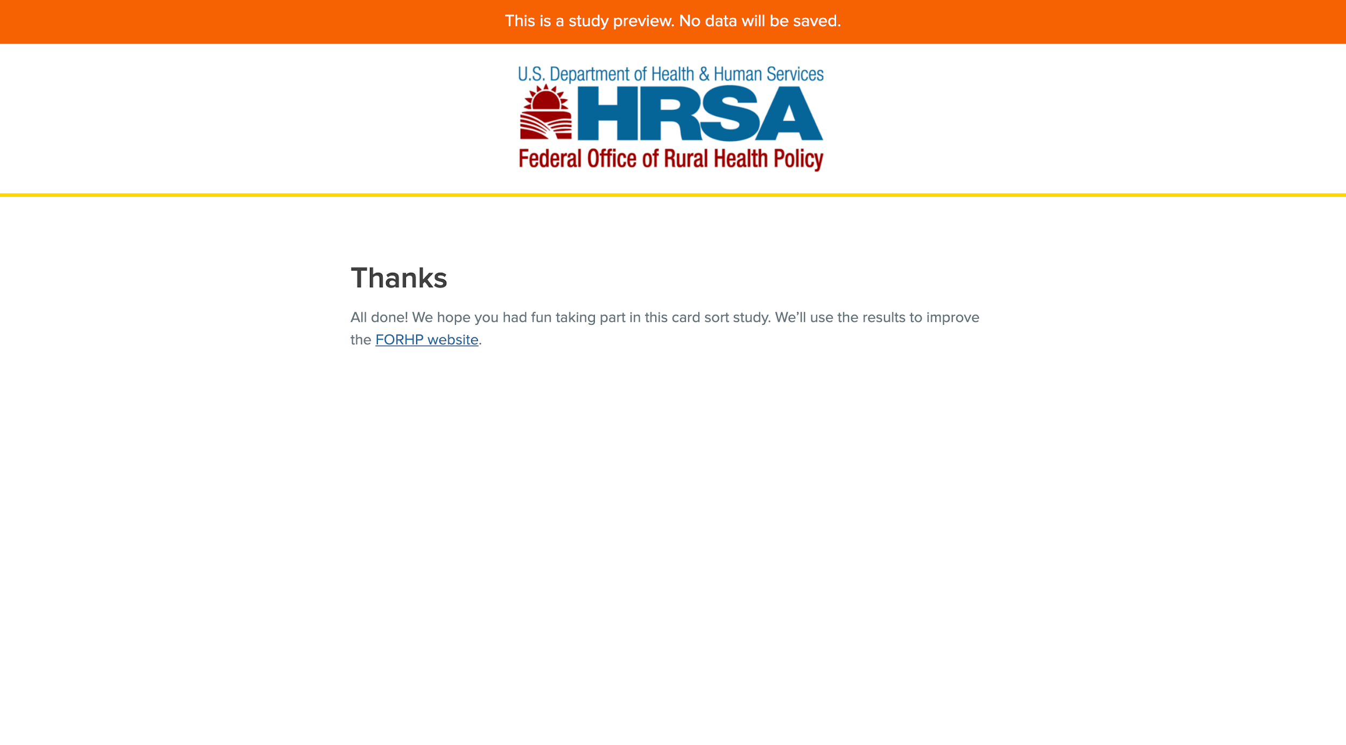
Screenshot 13: Completed Test Screen

