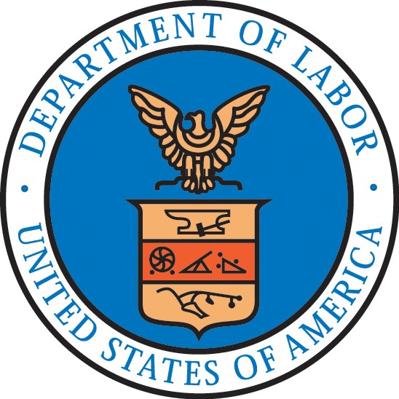

IMPORTANT: In accordance with 20 CFR 653.500, all employers seeking U.S. workers to perform agricultural services or labor on a temporary, less than year-round basis through the Agricultural Recruitment System for U.S. Workers, must submit a completed job clearance order (Form ETA-790) to the State Workforce Agency (SWA) for placement on its intrastate and interstate job clearance systems. Employers submitting a job order in connection with an H-2A Application for Temporary Employment Certification (Form ETA-9142A) must complete the Form ETA-790 and attach a completed 790A. All other employers submitting agricultural clearance orders must complete the Form ETA-790 and attach a completed 790B. Employers and authorized preparers must read the general instructions carefully, complete ALL required fields/items containing an asterisk ( * ), and any fields/items where a response is conditional as indicated by the section ( § ) symbol.

- Clearance Order Information

FOR STATE WORKFORCE AGENCY (SWA) USE ONLY
Questions 1 through 17
1. Clearance Order Number * | 2. Clearance Order Issue Date * |  |  |  | 3. Clearance Order Expiration Date *
4. SOC Occupation Code * | 5. SOC Occupation Title *
SWA Order Holding Office Contact Information
6. Contact’s last (family) name * |  | 7. First (given) name * |  |  |  | 8. Middle name(s) §
9. Contact’s job title *
10. Address 1 *
11. Address 2 (suite/floor and number) §
12. City * |  |  |  | 13. State * |  | 14. Postal code *
15. Telephone number * | 16. Extension § |  | 17. E-Mail address *

- Employer Contact Information

1. Legal Business Name *
2. Trade Name/Doing Business As (DBA), if applicable §
3. Contact’s last (family) name * |  | 4. First (given) name * |  |  | 5. Middle name(s) §
6. Contact’s job title *
7. Address 1 *
8. Address 2 (apartment/suite/floor and number) §
9. City * |  |  |  | 10. State * | 11. Postal code *
12. Telephone number * | 13. Extension § |  | 14. Business e-mail address *
15. Federal Employer Identification Number (FEIN from IRS) * |  |  |  | 16. NAICS Code *

- Type of Clearance Order

1. Indicate the type of agricultural clearance order being placed with the SWA for recruitment of U.S. workers. (choose only one) * | - 790A (H-2A clearance order)  - 790B (regular clearance order)

ForInstructions. General ETA-790A, Form see please information, statement burden public
Public Burden Statement (1205-0466)
Persons are not required to respond to this collection of information unless it displays a currently valid OMB control number. Public reporting burden for this collection of information is estimated to average .03 hours per response for all information collection requirements, including the time for reviewing instructions, searching existing data sources, gathering and maintaining the data needed, and completing, reviewing, and submitting the collection of information. The obligation to respond to this data collection is required to obtain/retain benefits (44 U.S.C. 3501, Immigration and Nationality Act, 8 U.S.C. 1101, et seq.). Send comments regarding this burden estimate or any other aspect of this collection of information, including suggestions for reducing this burden, to the U.S. Department of Labor, Employment and Training Administration, Office of Foreign Labor Certification, 200 Constitution Ave., NW, N-5311Suite PPII 12-200, Washington, DC, 20210. (Paperwork Reduction Project OMB 1205- 0466). DO NOT send the completed application to this address.

