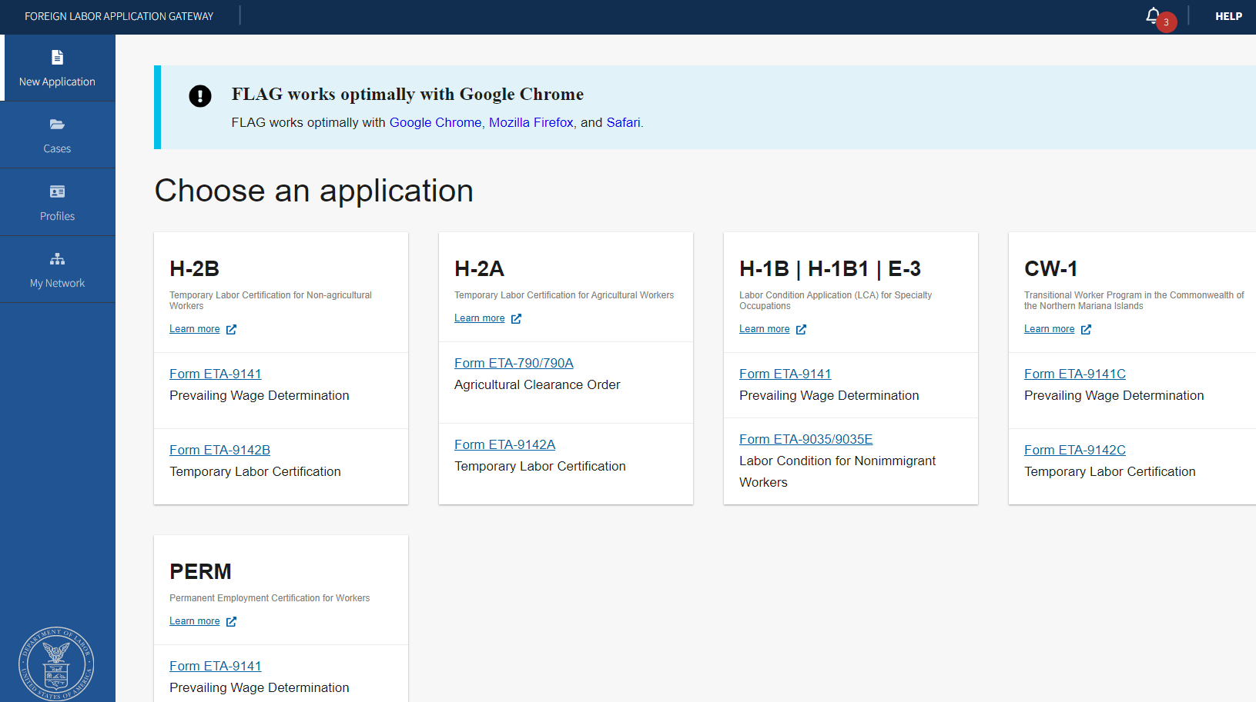 Figure 1: Home Screen to choose an application for Form ETA-790/790A
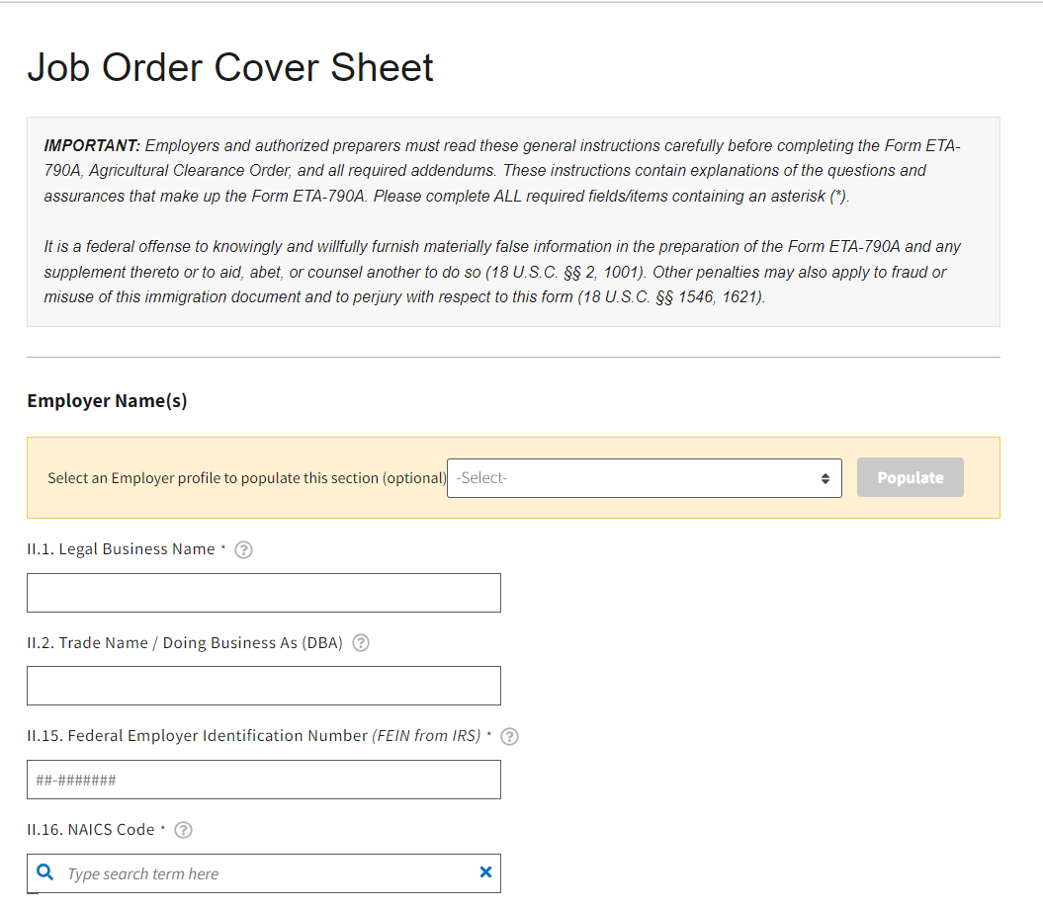
Figure 2: Job Order Cover Sheet Employer Name

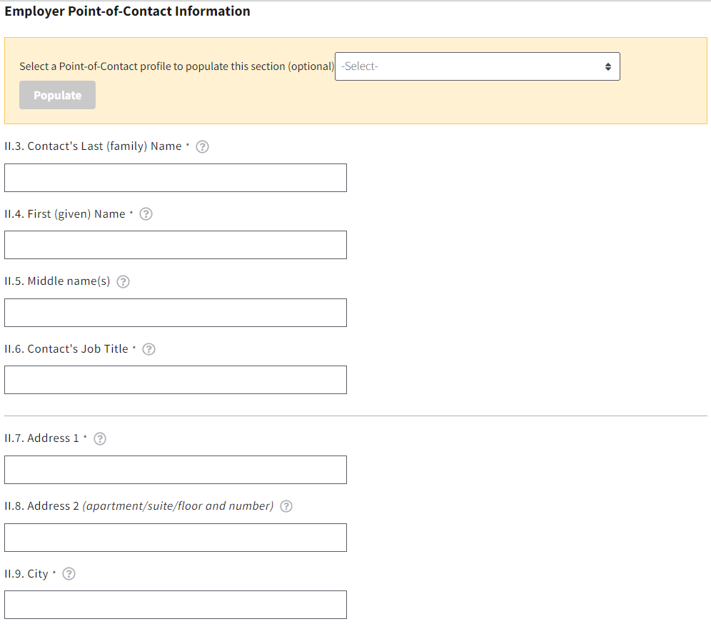
Figure 3: Job Order Cover Sheet Employer Point of Contact

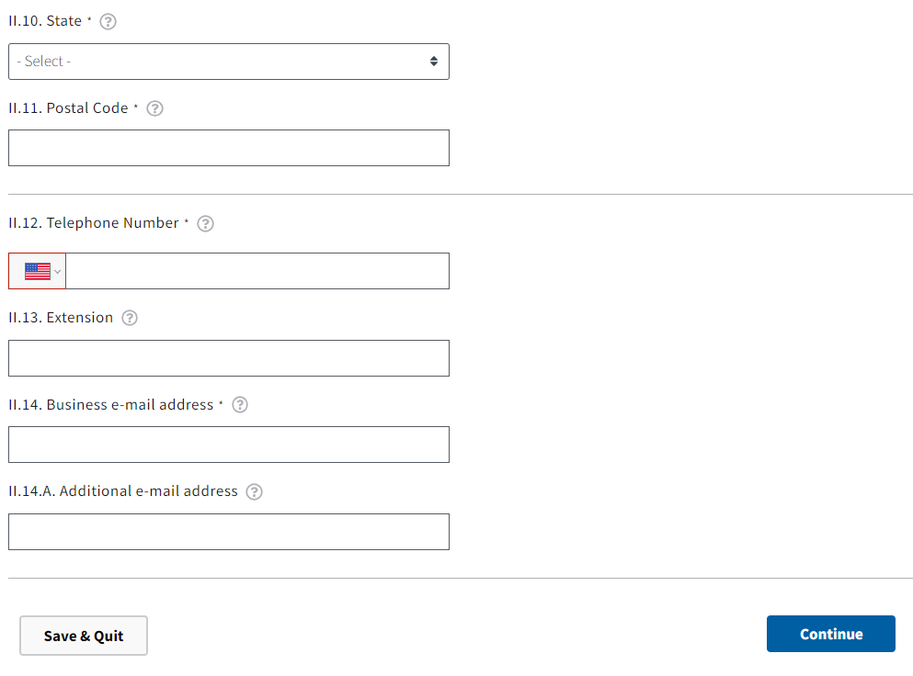
Figure 4: Job Order Cover Sheet Employer Point of Contact cont.

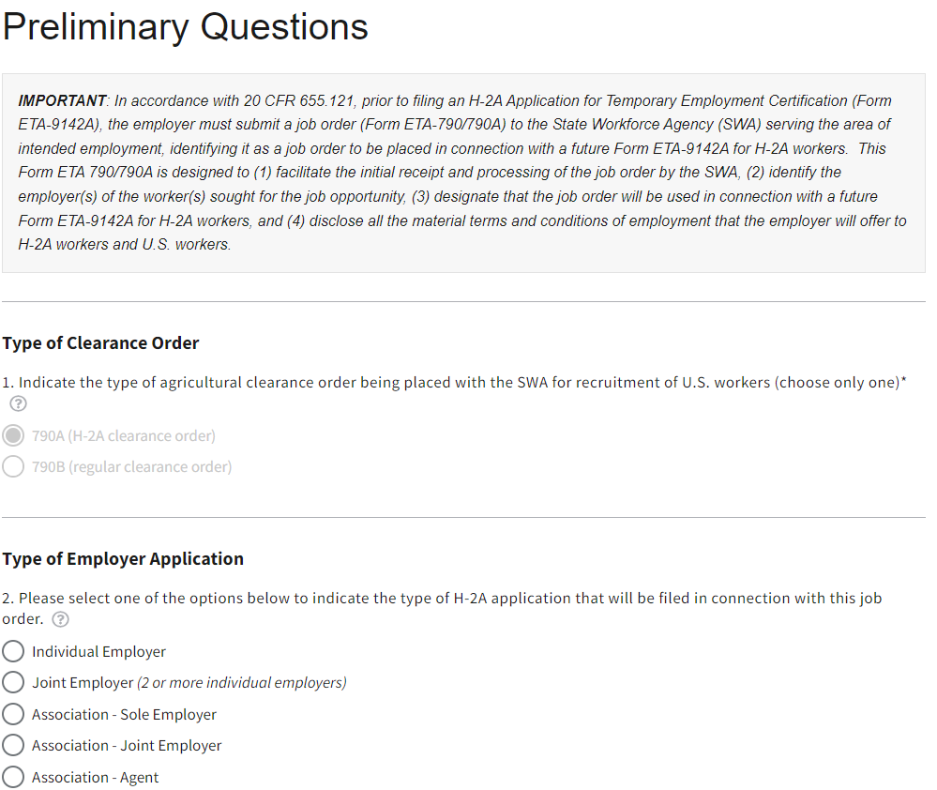
Figure 5: Job Order Preliminary Questions

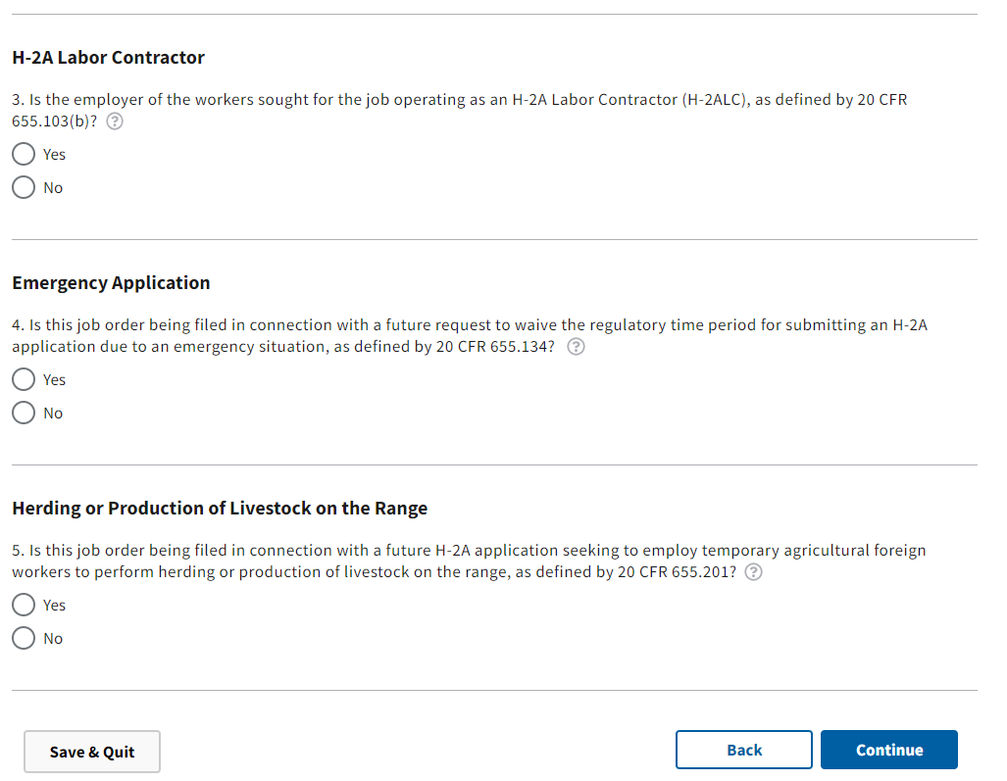
Figure 6: Job Order Preliminary Questions cont.

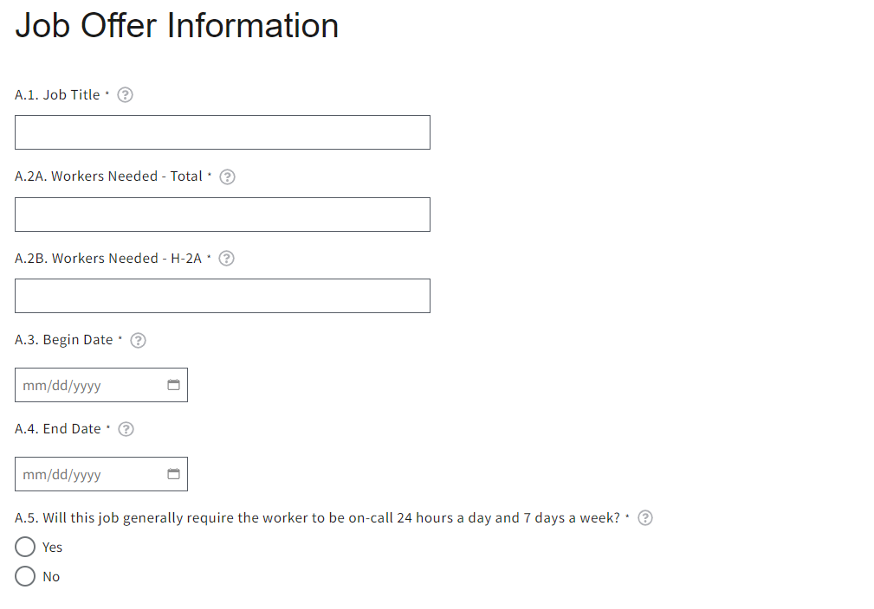
Figure 7: Form Section A Job Offer Information

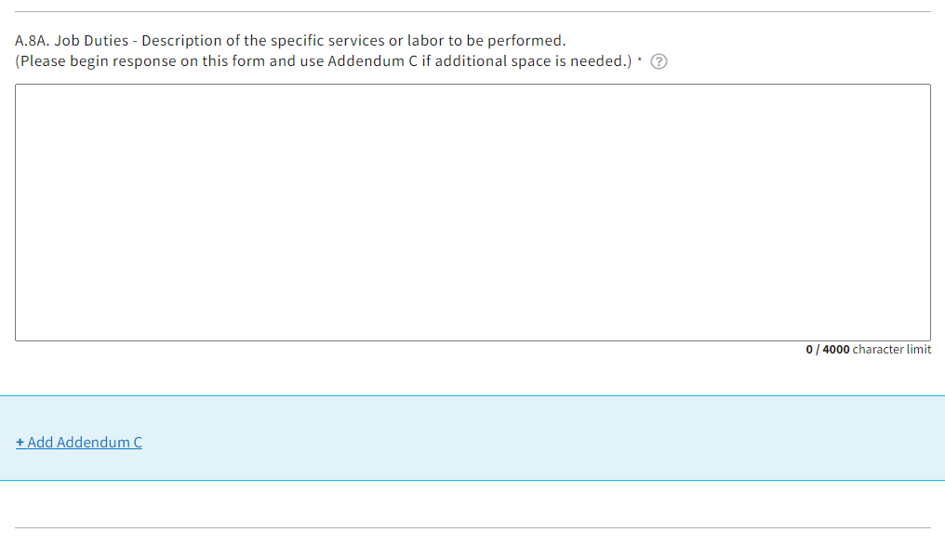
Figure 8: Form Section A Job Offer Information cont.

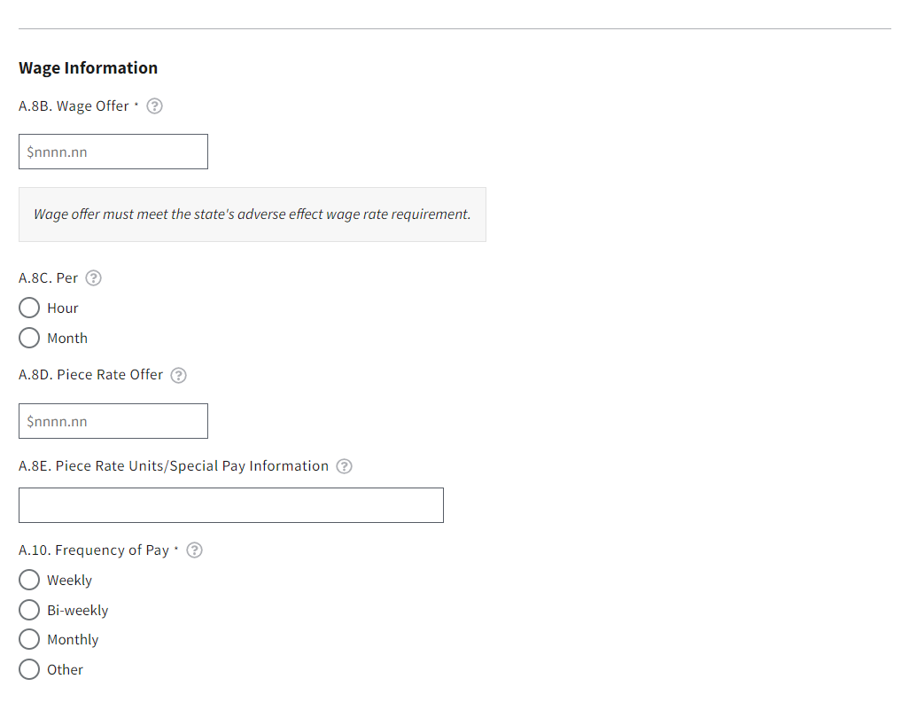
Figure 9: Form Section A Job Offer Information cont.

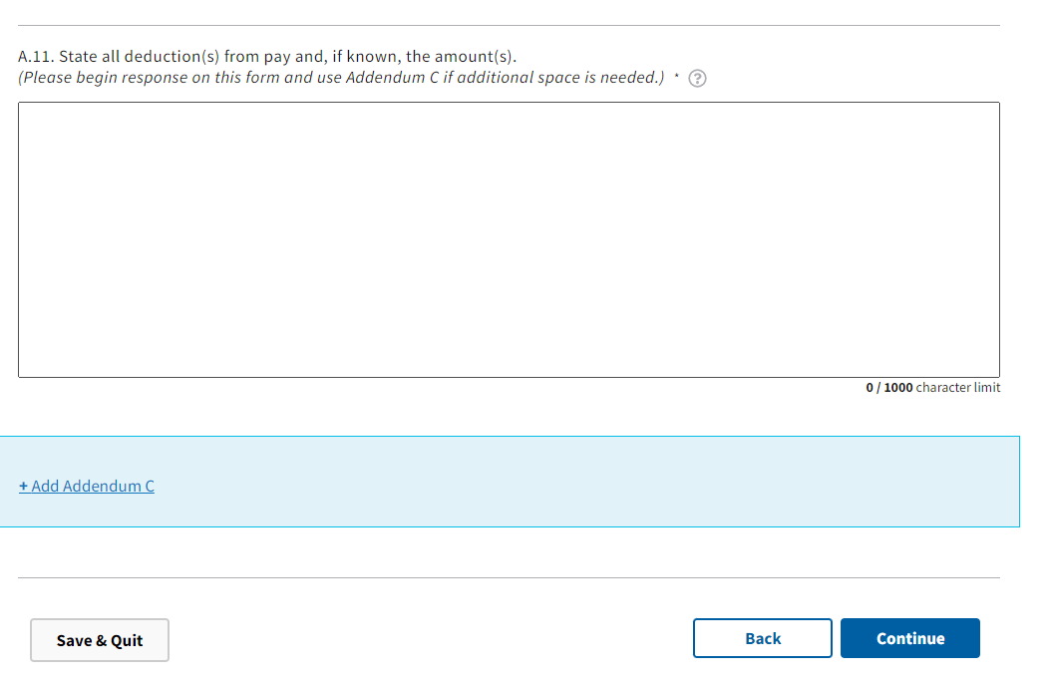
Figure 10: Form Section A Job Offer Information cont.

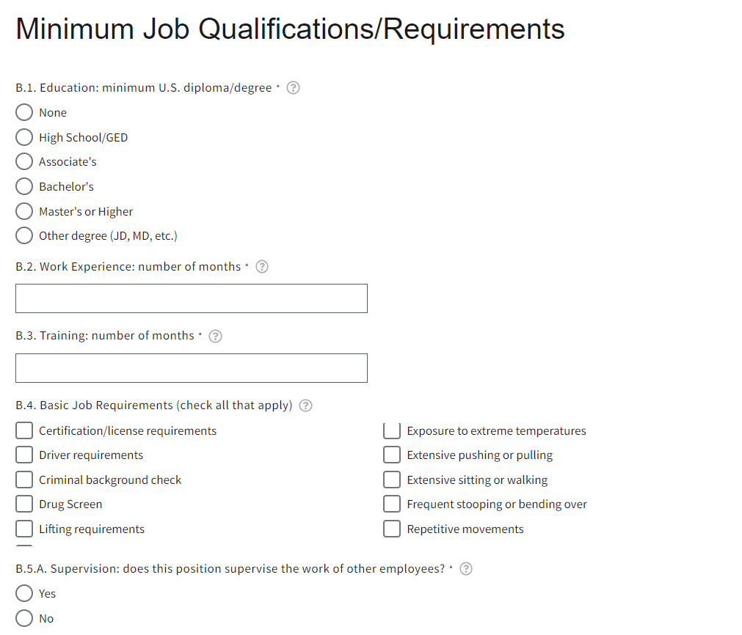
Figure 11: Form Section B Minimum Job Qualifications

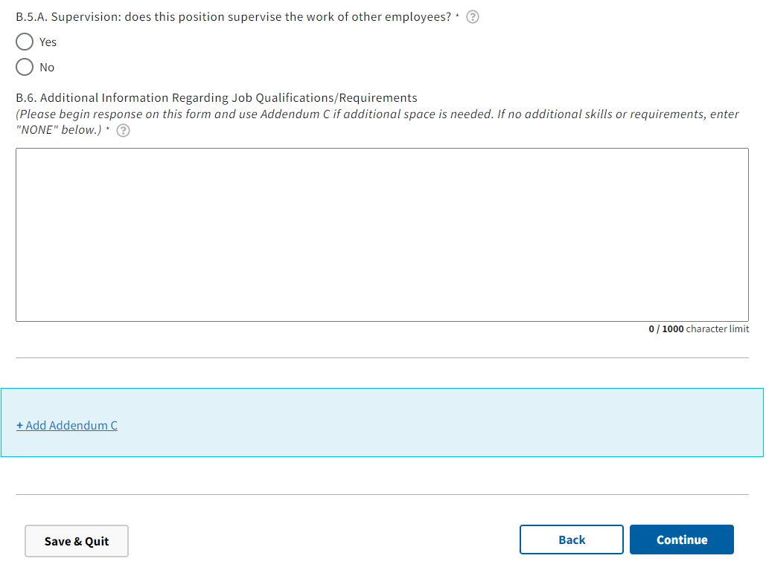
Figure 12: Form Section B Minimum Job Qualifications cont.

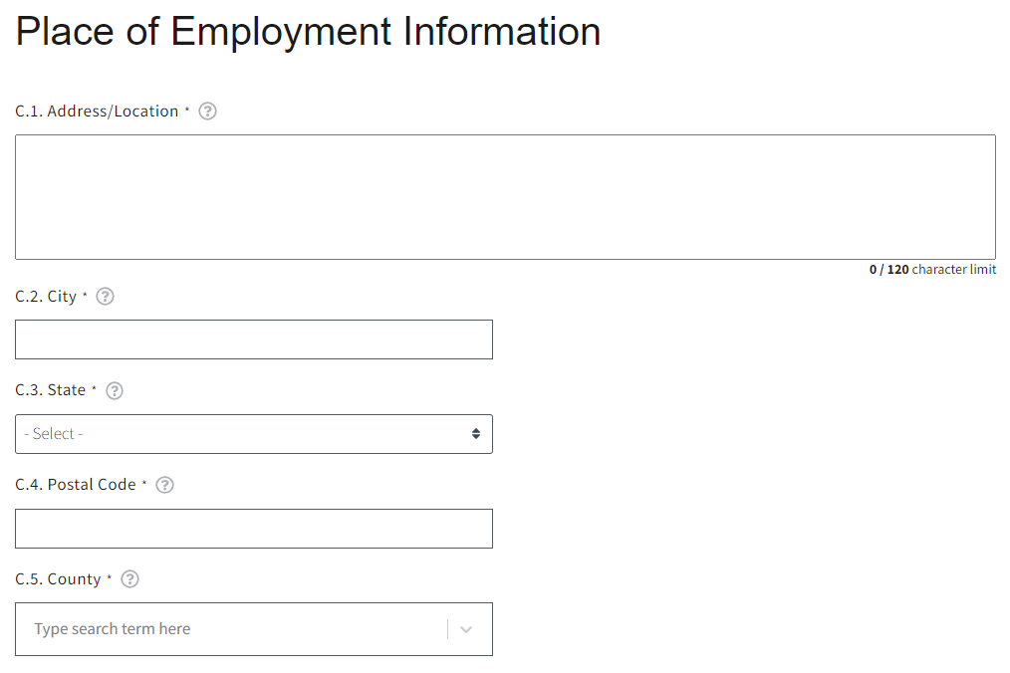
Figure 13: Form Section C Place of Employment Information

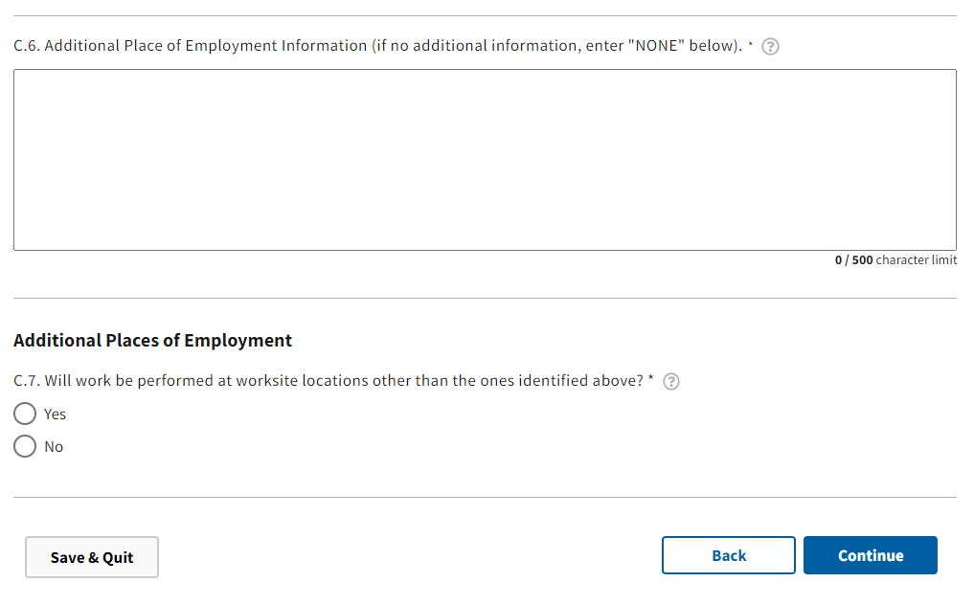
Figure 14: Form Section C Place of Employment Information cont.

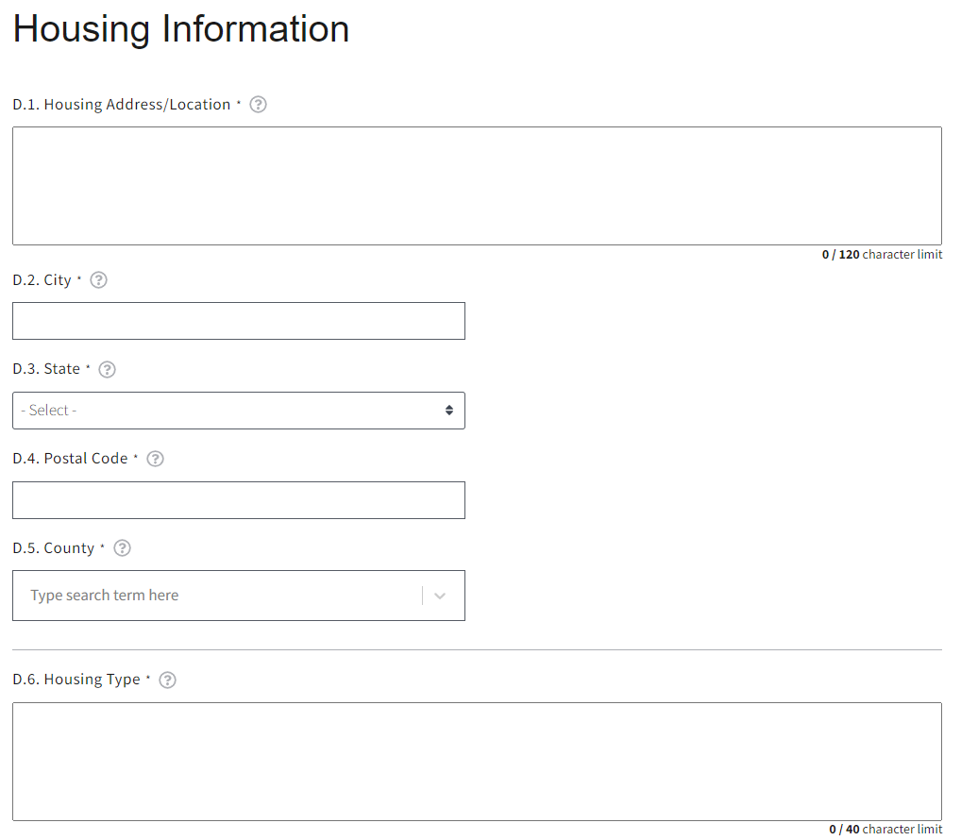
Figure 15: Form Section D Housing Information
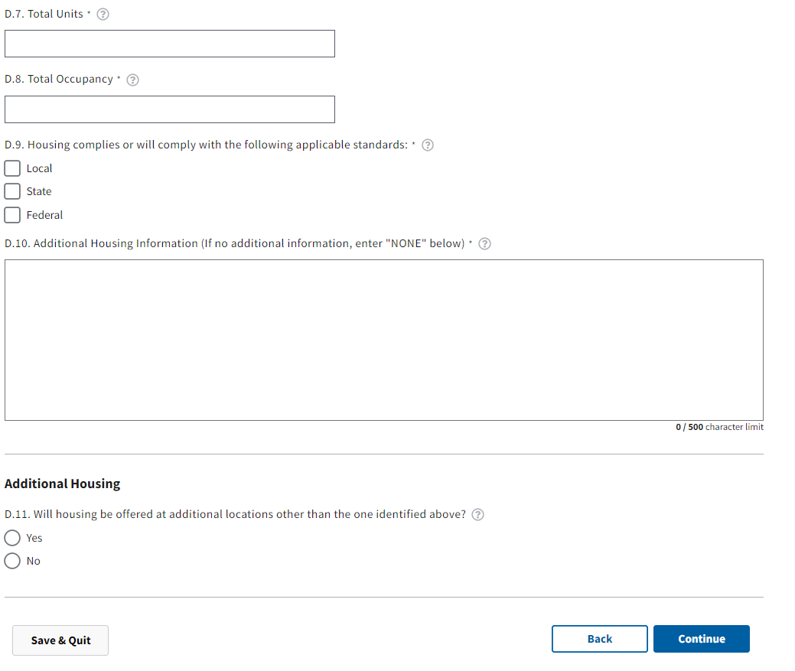
Figure 16: Form Section D Housing Information cont.

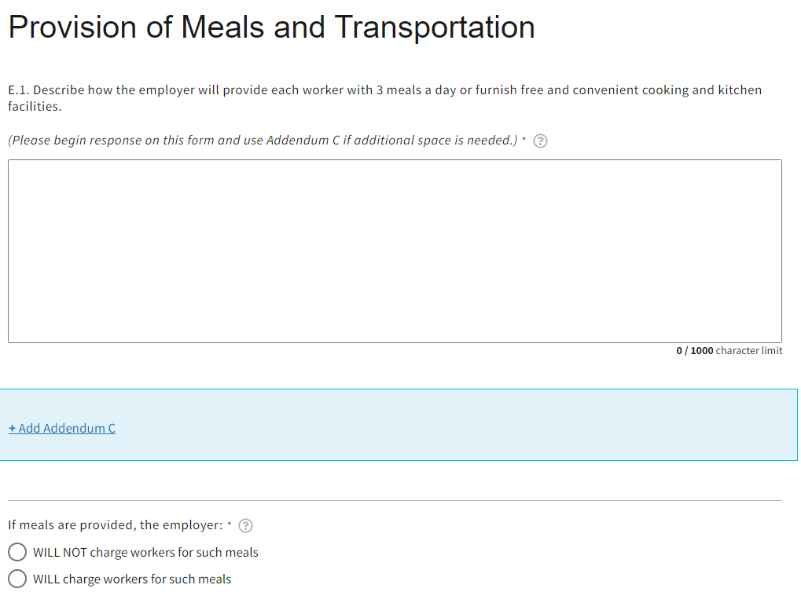
Figure 17: Form Sections E & F Provision of Meals and Transportation

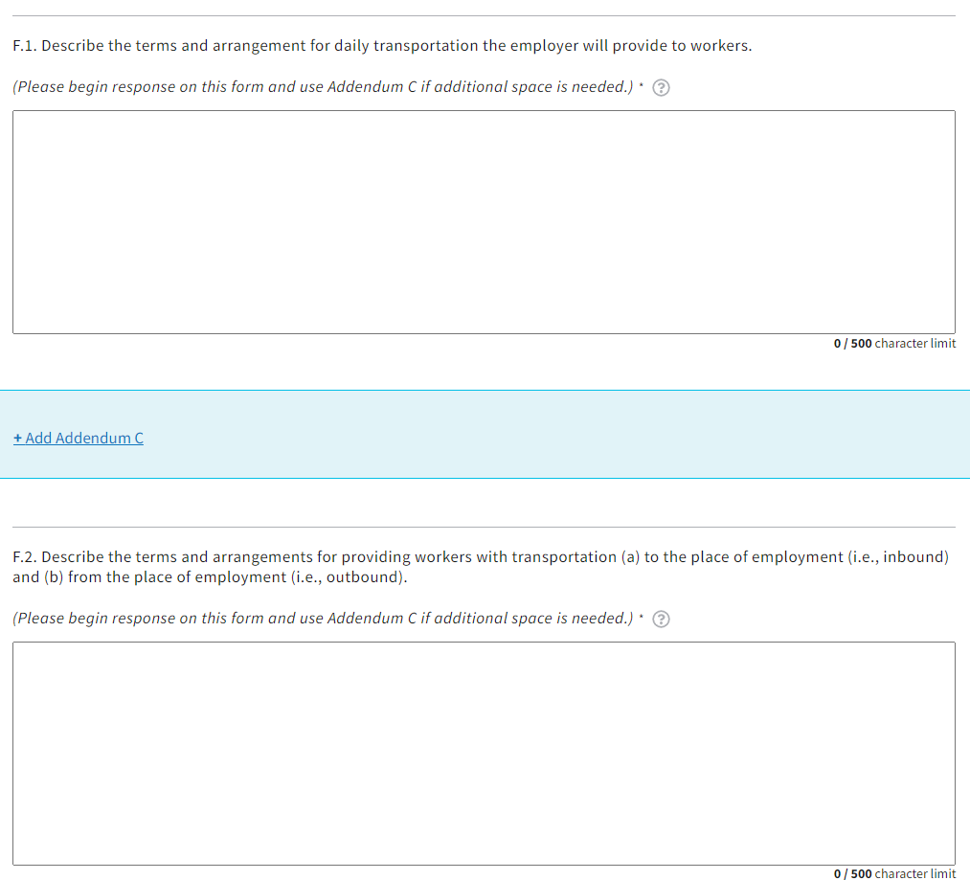
Figure 18: Form Sections E & F Provision of Meals and Transportation cont.

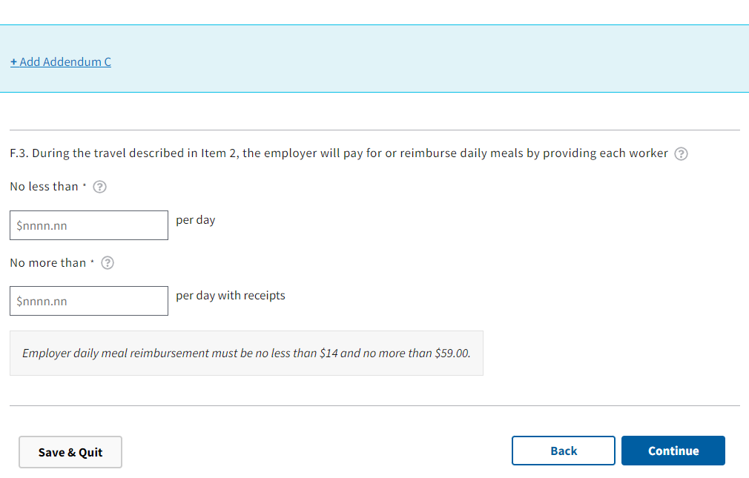
Figure 19: Form Sections E & F Provision of Meals and Transportation cont.
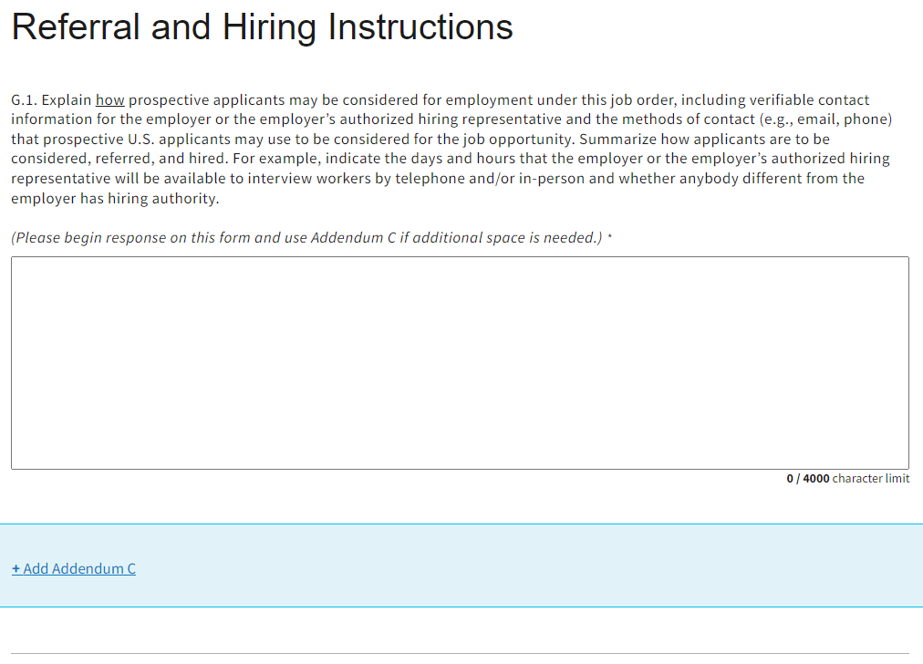
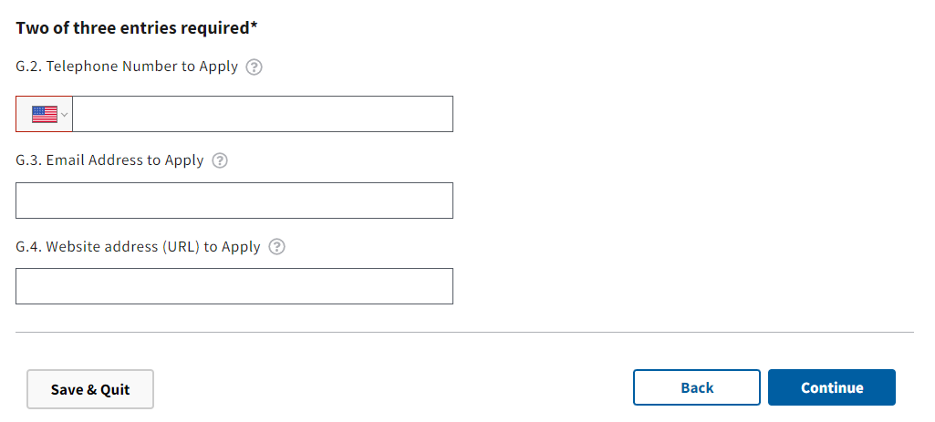
Figure 20: Form Section G Referral and Hiring Instructions
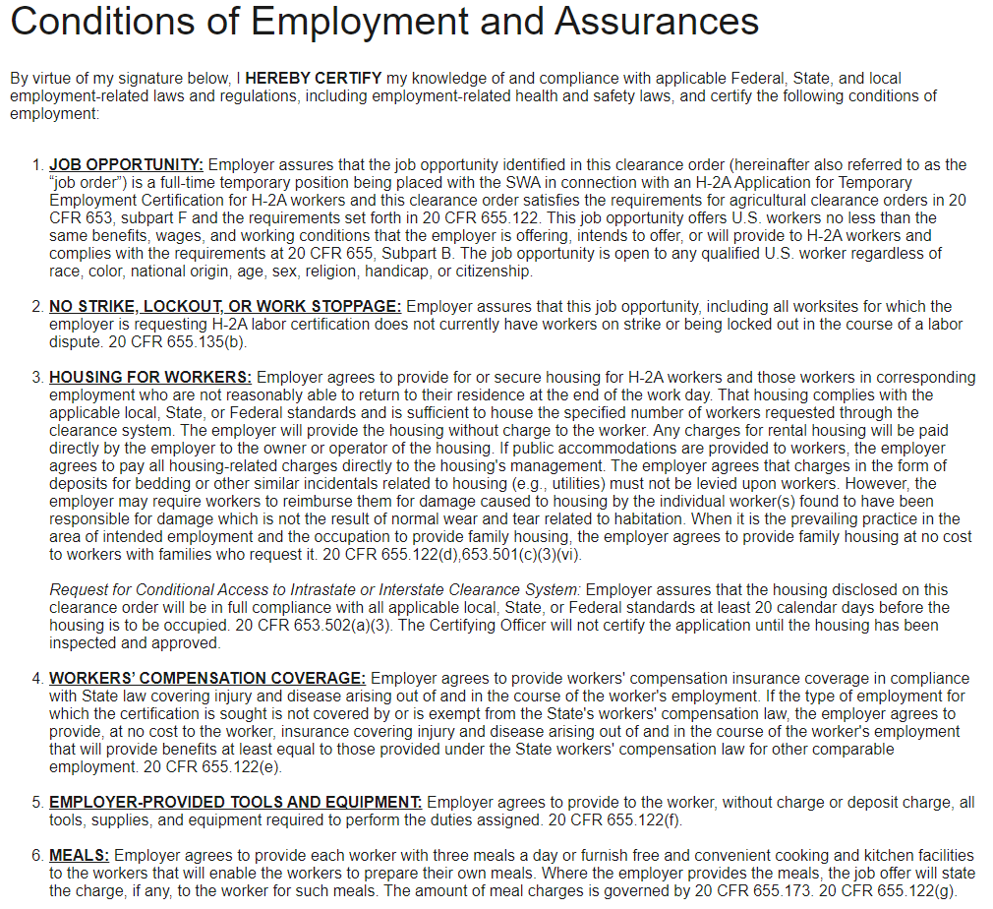
Figure 21: Form Section I Conditions of Employment and Assurances

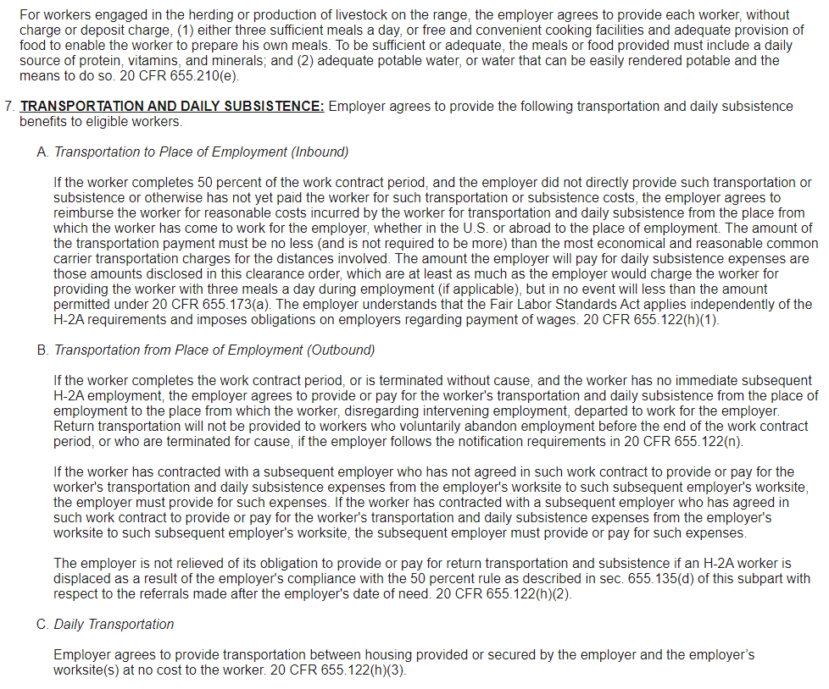
Figure 22: Form Section I Conditions of Employment and Assurances cont.

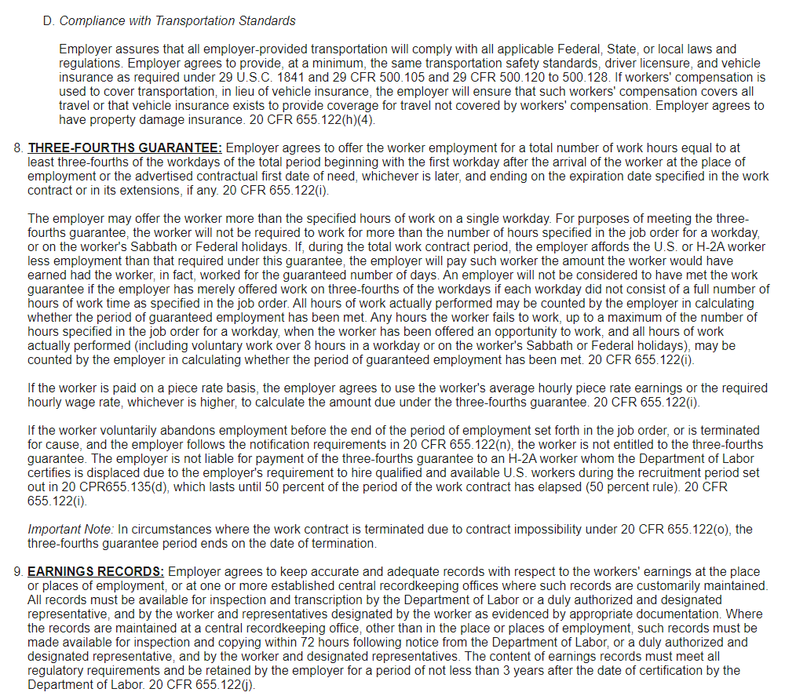
Figure 23: Form Section I Conditions of Employment and Assurances cont.

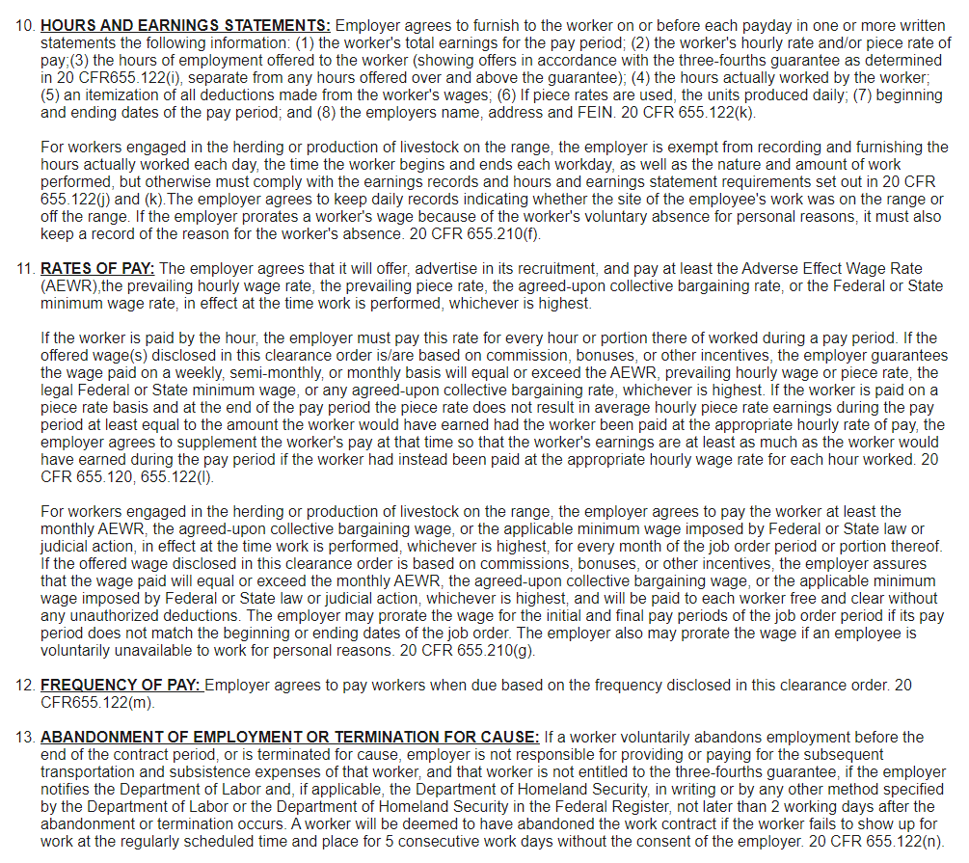
Figure 24: Form Section I Conditions of Employment and Assurances cont.

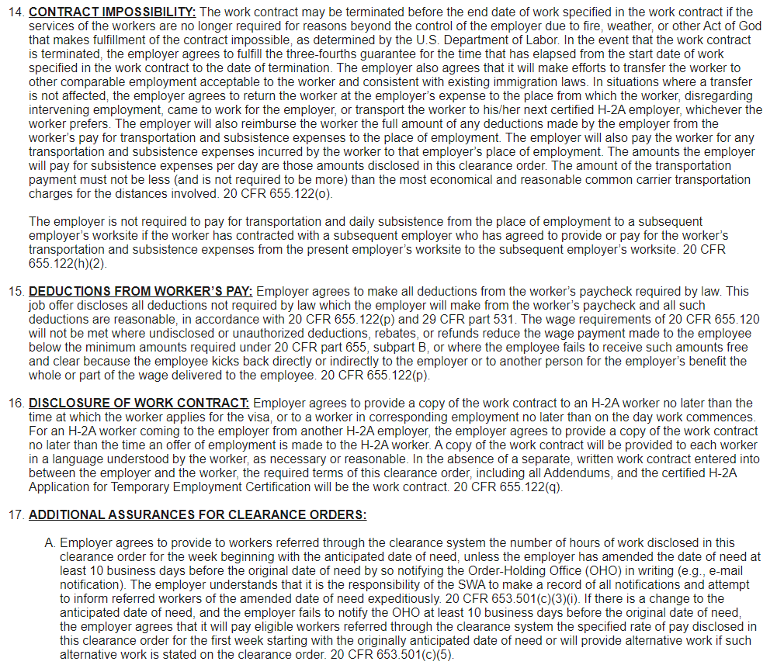
Figure 25: Form Section I Conditions of Employment and Assurances cont.

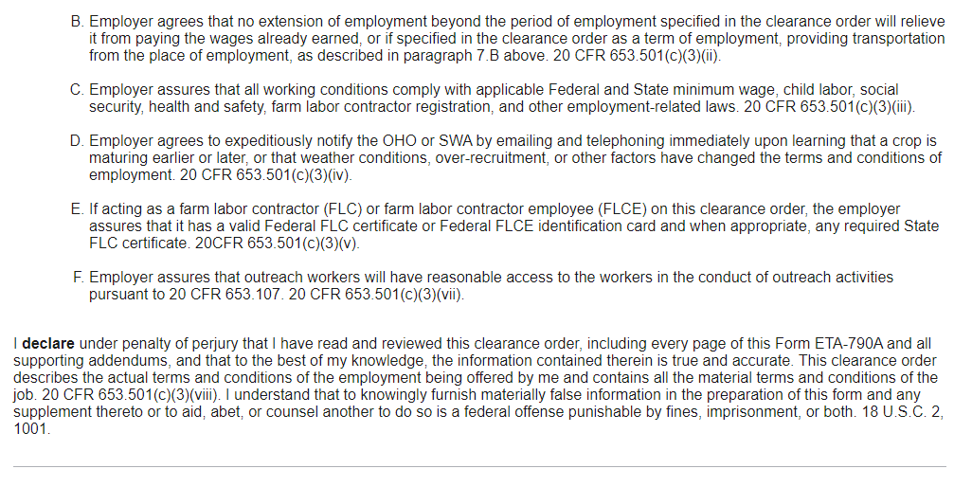
Figure 26: Form Section I Conditions of Employment and Assurances cont.

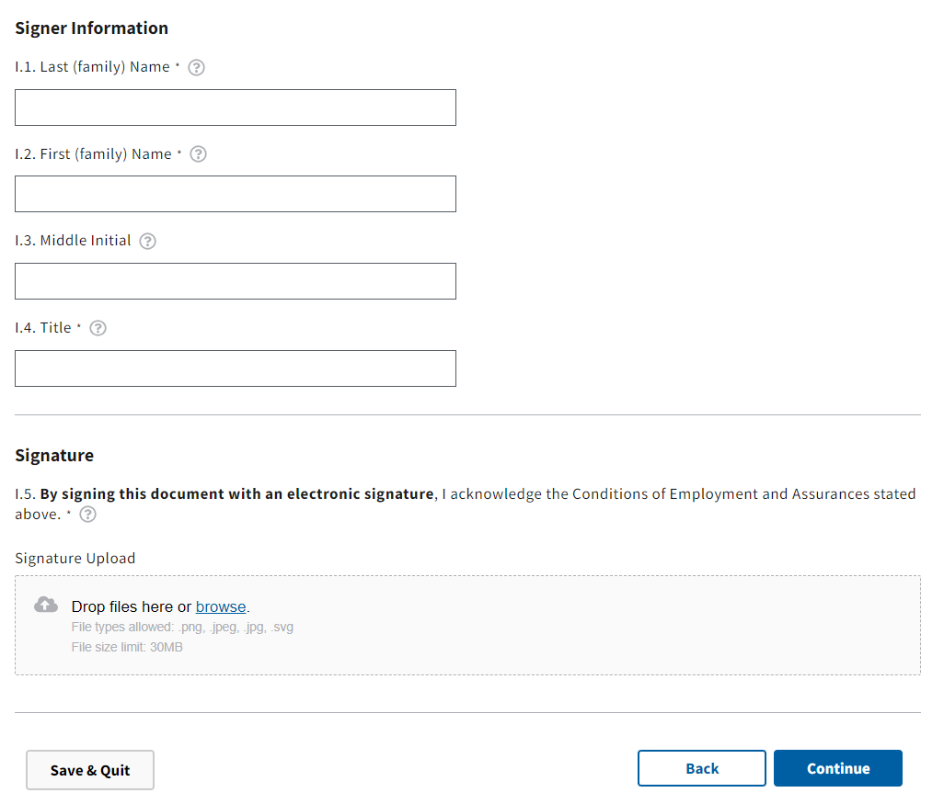
Figure 26: Form Section I Conditions of Employment and Assurances cont.

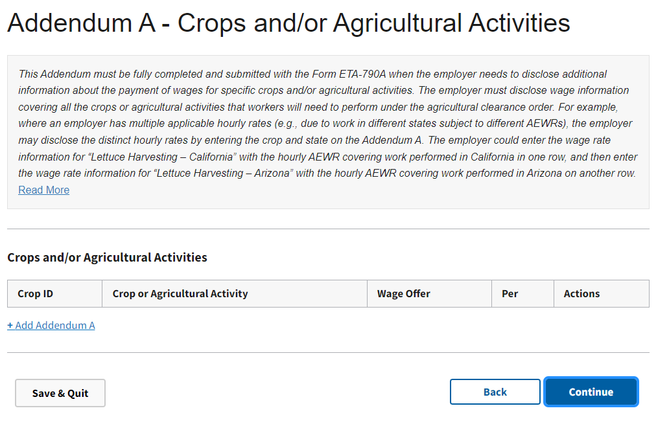
Figure 27: Form Addendum A – Additional Crops and/ or Agricultural Activities

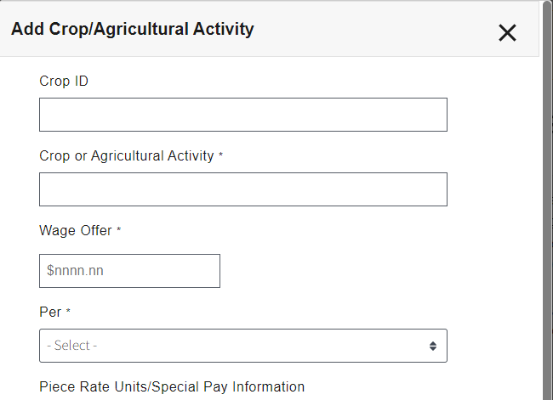
Figure 28: Form Addendum A – Additional Crops and/ or Agricultural Activities

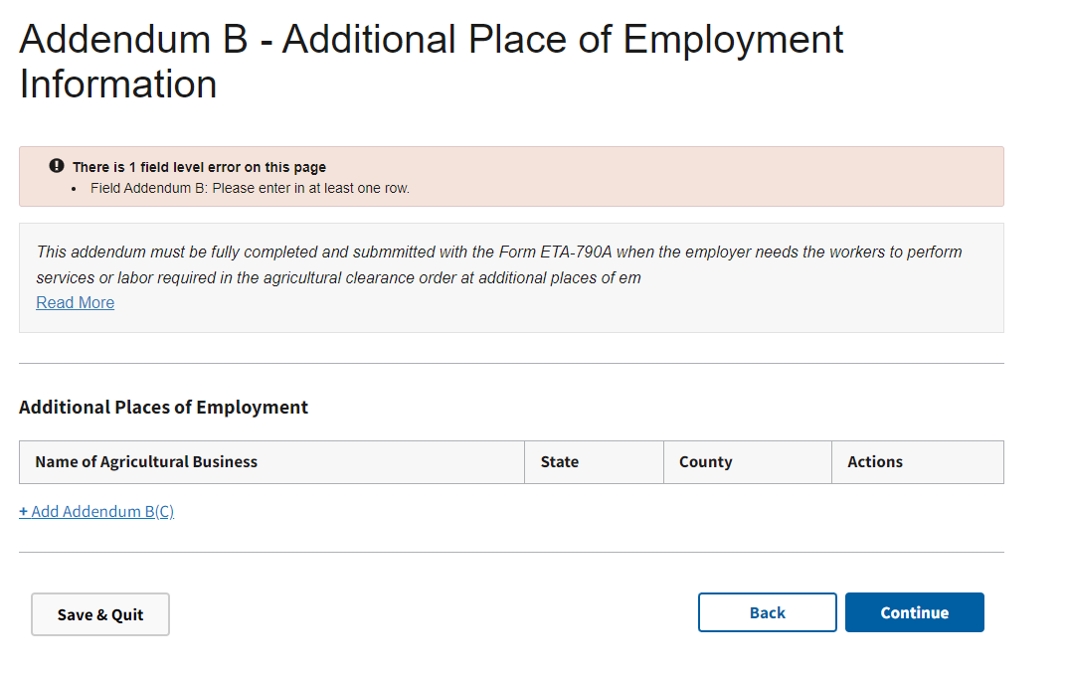
Figure 28: Form Addendum B – Additional Place of Employment Information

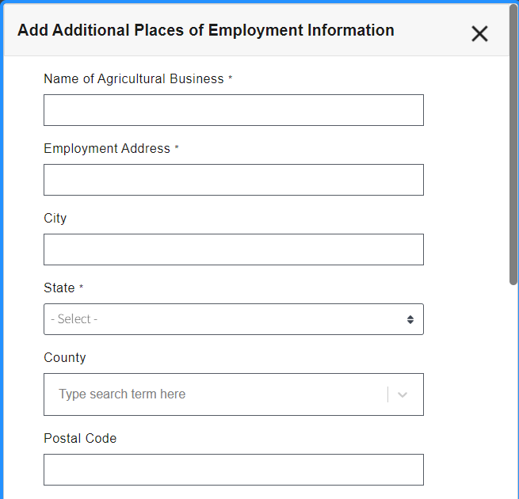
Figure 29: Form Addendum B – Additional Place of Employment Information cont.

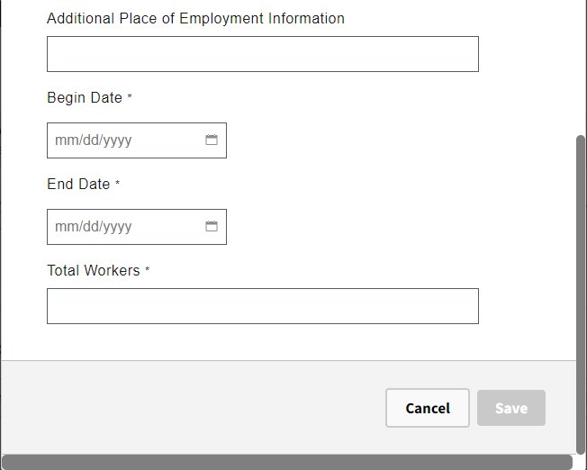
Figure 30: Form Addendum B – Additional Place of Employment Information cont.

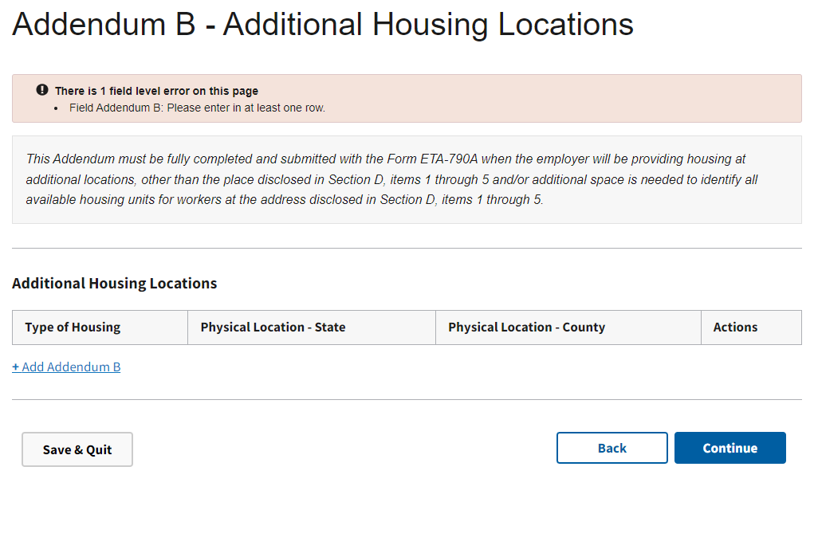
Figure 31: Form Addendum B – Additional Housing Information

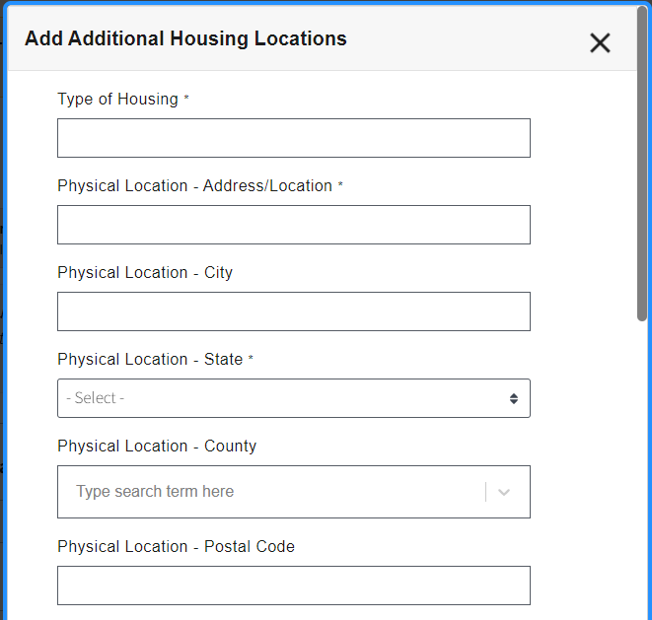
Figure 32: Form Addendum B – Additional Housing Information cont.

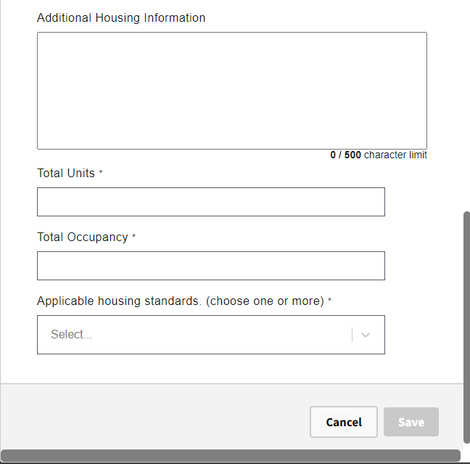
Figure 33: Form Addendum B – Additional Housing Information cont.

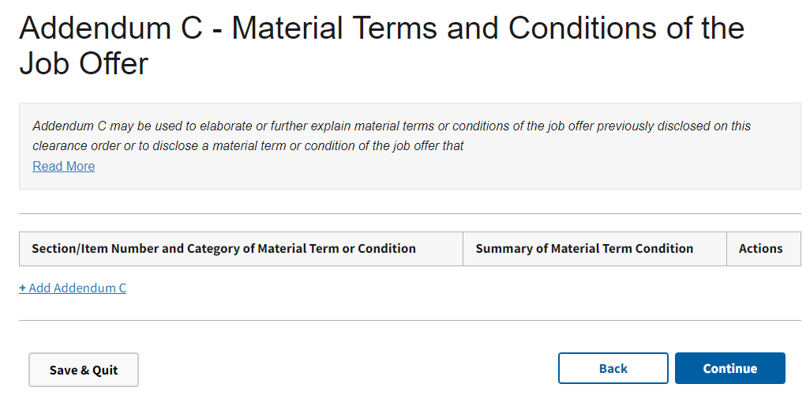
Figure 34: Form Addendum C – Material Terms and Conditions of the Job Offer

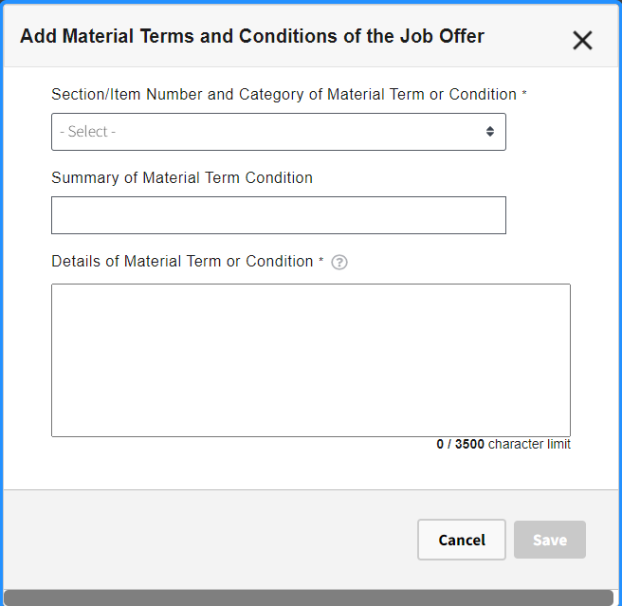
Figure 35: Form Addendum C – Material Terms and Conditions of the Job Offer cont.
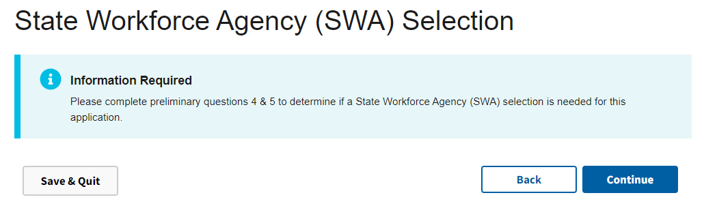
Figure 36: State Workforce Agency (SWA) Selection
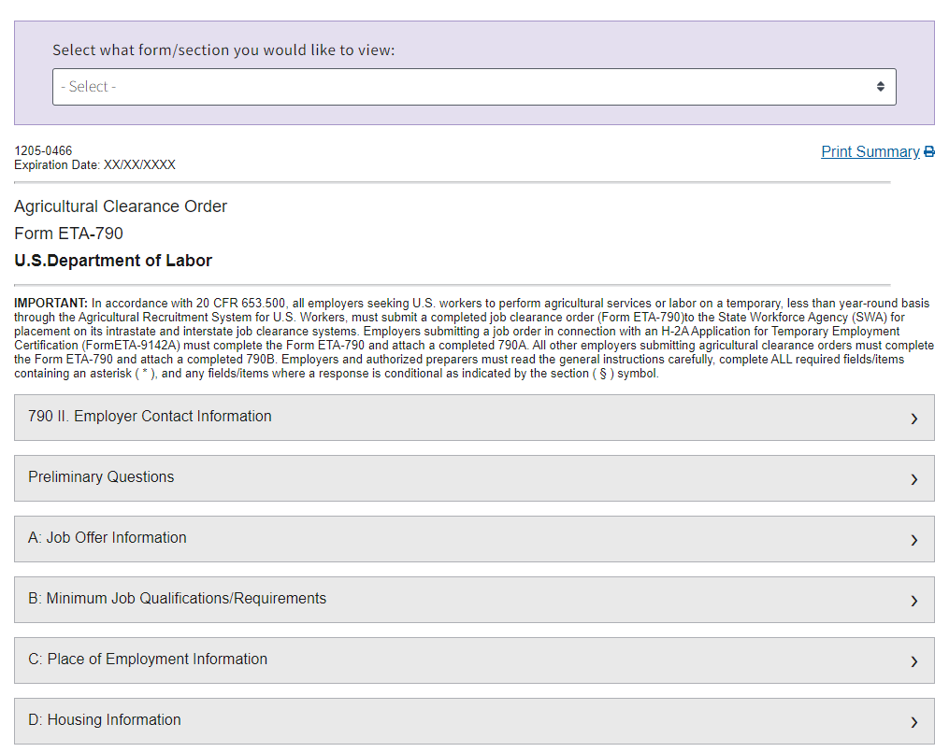
Figure 37: Review and Submit Section

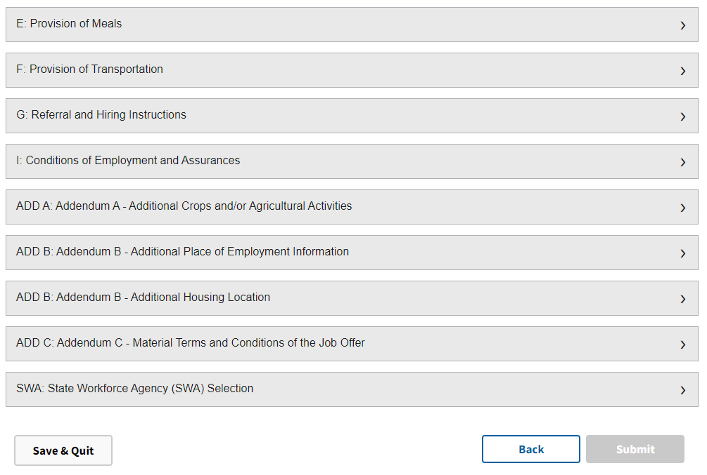
Figure 38: Review and Submit Section cont.

