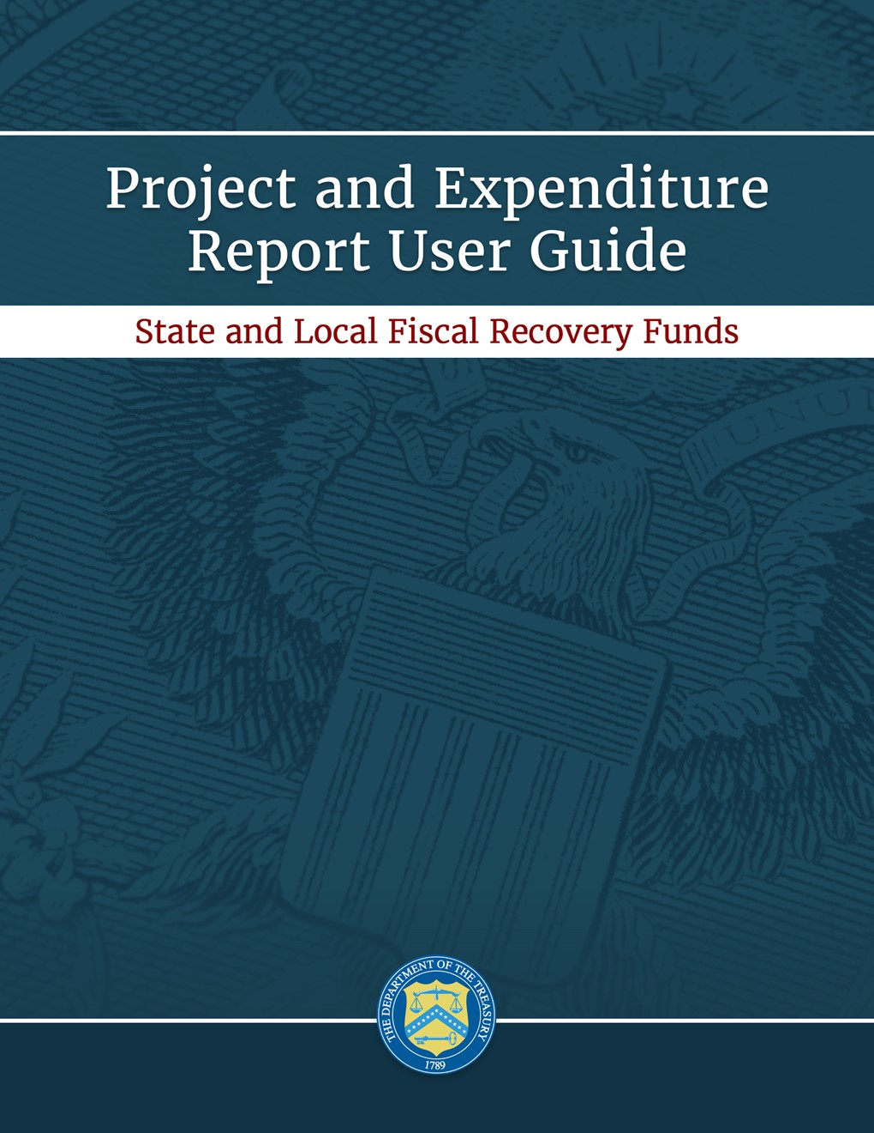30f

***April 1, 2022***

***Version: 2***

***January XX, 2022***

***Version 1***

***XXX***

***Version: 1.0***

***August 9, 2021***

***Version: 1.0***

OMB Control Number: 1505-0271

OMB Expiration Date: 02/28/2022[1]

PAPERWORK REDUCTION ACT NOTICE

The information collected will be used for the U.S. Government to process requests for support. The estimated burden associated with this collection of information is 6 hours per response. Comments concerning the accuracy of this burden estimate and suggestions for reducing this burden should be directed to the Office of Privacy, Transparency and Records, Department of the Treasury, 1500 Pennsylvania Ave., N.W., Washington, D.C. 20220. DO NOT send the form to this address. An agency may not conduct or sponsor, and a person is not required to respond to, a collection of information unless it displays a valid control number assigned by OMB.

**Table of Contents**

Section I. Reporting Basics 1

Section II. Navigation and Logistics 3

Section III. Reporting Requirements 9

Section IV. Project and Expenditure Report 14

Appendix A – Designating SLFRF Points of Contact by SLFRF Account Administrators 50

Appendix B – Bulk File Upload Overview 57

Appendix C – Expenditure Categories and Template Mapping 76

Appendix D – SLFRF Expenditure Category Programmatic Data and Other Information 80

Appendix E - Expenditure Categories 95

Appendix F – List of Sectors 100

Appendix G – Project Demographic Distribution Information 101

Appendix H – Capital Expenditures for Non-Infrastructure Projects 104

Appendix I – Frequently Asked Questions 106

**List of Figures**

Figure 1 Landing Page 3

[Figure 2 Navigation Bar 4](https://my.treas.gov/collab/orp/State%20and%20Local%20Fiscal%20Recovery%20Fund%20Documents/Reporting/P&E%20User%20Guide/PE%20Report%20User%20Guide.APRIL.04.01.22.docx#_Toc99640181)

Figure 3 Introduction and Bulk Upload Templates Screen 5

Figure 4 Sample Bulk Upload Icon 5

Figure 5 Successful Bulk Upload Example 6

Figure 6 Blank Required Data Error 6

Figure 7 Invalid Data Error 7

Figure 8 Duplicate Data Error 7

Figure 9 Non-Existent Reference Error 7

Figure 10 Manual Validation Text Box 8

[Figure 11 Screenshot of Unsubmit Button 8](https://my.treas.gov/collab/orp/State%20and%20Local%20Fiscal%20Recovery%20Fund%20Documents/Reporting/P&E%20User%20Guide/PE%20Report%20User%20Guide.APRIL.04.01.22.docx#_Toc99640190)

Figure 12 Relationship between Expenditure Categories and Multiple Projects 12

Figure 13 Recipient Information 15

Figure 14 Point of Contact List 15

Figure 15 Budget Approval and Obligation 16

Figure 16 SAM.gov question 16

Figure 17 Additional SAM.gov questions (1) 16

Figure 18 Additional SAM.gov questions (2) 17

Figure 19 Record of Highest Paid Officer 17

Figure 20 No Projects Available Option 18

Figure 21 My Projects Screen Example 20

Figure 22 Project and Expenditure Category Group Screen 21

Figure 23 Project Expenditure Category 21

Figure 24 Bulk Upload for EC 1.1 21

Figure 25 Project Entry Screen 23

Figure 26 Update Previously Reported Projects 24

Figure 27 Manual Entry for EC 3.1 25

Figure 28 Programmatic Data for EC 3.1 25

Figure 29 Project Demographic Distribution Questions 26

Figure 30 Public Health - Negative Economic Impact Questions 26

Figure 31 Capital Expenditure Questions 27

Figure 32 Evidenced-based questions 27

Figure 33 Premium Pay Additional Questions 28

Figure 34 Programmatic Data for Infrastructure Projects EC 5.1-5.18 30

Figure 35 Programmatic data for Broadband Projects EC 5.19-5.21 30

Figure 36 Additional Questions if Response to Davis Bacon Certification is "No" 32

Figure 37 Additional Questions if Response to Certifications of Labor Agreements is "No" 33

Figure 38 Additional Certification Questions 33

Figure 39 Revenue Replacement Screen - Electing Standard Allowance 34

Figure 40 Revenue Loss Using Formula 35

Figure 41 Edit and Delete Project Screen 36

Figure 42 Subrecipient/Beneficiaries Bulk Upload Icon 39

Figure 43 Manually Create a Subrecipient or Beneficiary 39

Figure 44 Sam.gov Questions for Subrecipients, Contractors or Beneficiaries 40

Figure 45 Additional SAM.gov questions for Subrecipients, Contractors, and Beneficiaries 40

Figure 46 Five Highest Paid Officers for Subrecipients, Contractors or Beneficiaries 41

Figure 47 Subrecipients or Beneficiaries Entered 41

Figure 48 Subaward Bulk Upload (1) 42

Figure 49 Subaward Bulk Upload (2) 42

Figure 50 Subaward Reporting 43

Figure 51 Subaward Entered 43

Figure 52 Expenditures >$50,000 45

Figure 53 Aggregated Expenditures for Awards Less than $50,000 45

Figure 54 Payments to Individuals 46

Figure 55 Tax Offset Provision Screen 47

Figure 56 Project Overview Status with Errors 47

Figure 57 Project Overview Status with No Errors 48

Figure 58 Official Certification 48

Figure 59 Submission Verification 48

Figure 60 Submission Verification with Additional Language 49

Figure 61 State, Local and Tribal Support Landing Page 50

Figure 62 My Compliance Reports 51

Figure 63 Account 51

Figure 64 Account Name 51

Figure 65 Landing Page 52

Figure 66 Certification 52

Figure 67 Official Certification of Authorization 53

Figure 68 Designation Form 53

Figure 69 Designation of Account Administrator, Point of Contact of Reporting and Authorized Representative for Reporting 53

Figure 70 Designation Form 55

Figure 71 Bulk Upload Pop Up 59

Figure 72 File uploaded message 59

Figure 73 File added to Bulk Upload portal 59

Figure 74 Listing of Bulk Upload Errors 60

Figure 75 Bulk Upload Creation 60

# **Reporting Basics**

## **Overview**

This document provides information on using Treasury’s Portal to submit the required Coronavirus State and Local Fiscal Recovery Funds (SLFRF) Project and Expenditure (P&E) reports for the April 2022 submission deadline. It is a supplement to the Compliance and Reporting Guidance ([Reporting Guidance](https://home.treasury.gov/system/files/136/SLFRF-Compliance-and-Reporting-Guidance.pdf)), which contains relevant information and guidance on the reporting requirements.

Additionally, you should visit Treasury’s [SLFRF home page](https://home.treasury.gov/policy-issues/coronavirus/assistance-for-state-local-and-tribal-governments/state-and-local-fiscal-recovery-funds/recipient-compliance-and-reporting-responsibilities) for the latest guidance and updates on programmatic and reporting topics, as well as information on Treasury’s [final rule](https://www.govinfo.gov/content/pkg/FR-2022-01-27/pdf/2022-00292.pdf), which takes effect on April 1, 2022. Recipients and stakeholders are also encouraged to consult the [Overview of the Final Rule](https://home.treasury.gov/system/files/136/SLFRF-Final-Rule-Overview.pdf), which provides a summary of Final Rule provisions for informational purposes, and to visit the Final Rule section below for more details.

Each SLFRF recipient is required to submit periodic reports with current performance and/or financial information including background information about the SLFRF projects that are the subjects of the reports; and financial information with details about obligations, expenditures, direct payments, and subawards.

If you have any questions about the SLFRF program’s reporting requirements, please contact us by email to [SLFRP@treasury.gov](mailto:slfrp@treasury.gov).

## **What is Covered in this User Guide?**

This User Guide contains detailed guidance and instructions for SLFRF recipients in using Treasury’s Portal for submitting the Project and Expenditure reports. All recipients must submit the required reports via Treasury’s Portal.This guide is not comprehensive and is meant to be used in conjunction with the documents mentioned above.

This User Guide provides detailed instructions to help recipients enter and submit the following:

* Project data
* Subrecipient/Beneficiary/Contractor data
* Subaward/Direct Payment data
* Expenditure data
* Project and Expenditure Bulk Upload Templates

## **Designating Staff for Key Roles in Managing SLFRF Reports User Designations**

## SLFRF recipients are required to designate staff or officials for the following three roles in managing reports for their SLFRF award. Recipients must make the required designations prior to accessing Treasury’s Portal. The required roles are as follows:

* **Account Administrator** for the SLFRF award has the administrative role of maintaining the names and contact information of the designated individuals for SLFRF reporting. The Account Administrator is also responsible for working within your organization to determine its designees for the roles of Point of Contact for Reporting and Authorized Representative for Reporting and providing their names and contact information via Treasury’s Portal. Finally, the Account Administrator is responsible for making any changes or updates to the user roles as needed over the award period. We recommend that the Account Administrator identify an individual to serve in his/her place in the event of staff changes.
* **Point of Contact for Reporting** is the primary contact for receiving official Treasury notifications about reporting on the SLFRF award, including alerts about upcoming reporting, requirements, and deadlines. The Point of Contact for Reporting is responsible for completing the SLFRF reports.
* **Authorized Representative for Reporting** is responsible for certifying and submitting official reports on behalf of the SLFRF recipient. Treasury will accept reports or other official communications only when submitted by the Authorized Representative for Reporting. The Authorized Representative for Reporting is also responsible for communications with Treasury on such matters as extension requests and amendments of previously submitted reports. The official reports may include special reports, quarterly or annual reports, interim reports, and final reports.

**For Accounts registered through Login.gov**

Treasury Portal at <https://portal.treasury.gov/compliance/s/>

**For Accounts registered through ID.me**

Treasury Portal at

<https://portal.treasury.gov/cares/s/slt>/s/slt

Some key items to note:

* Each designated individual must register with either Login.gov or ID.me for gaining access to Treasury’s Portal.
* If you have not previously registered an account, you should register through Login.gov following this [link](https://secure.login.gov/?request_id=d0f31cbe-842e-4599-a420-6d1ed7e32e79). This [link](https://home.treasury.gov/system/files/136/Login.gov-User-Guide.pdf) includes further instructions. The following links provide additional information:
  + <https://login.gov/create-an-account/>
  + <https://login.gov/help/get-started/create-your-account/>
* **Note:** if you are a Non-Entitlement Unit of Local Government (NEU), you should register using the Login.gov process linked above.
* Users who have previously registered through ID.me may continue to access Treasury’s Portal through that method. This [link](https://home.treasury.gov/system/files/136/TreasuryPortalRegInstructions.pdf) includes further instructions.
* An individual may be designated for multiple roles. For example, the individual designated as the Point of Contact for Reporting may also be designated as the Authorized Representative for Reporting.
* The recipient may designate one individual for all three roles.
* Multiple individuals can be designated for each role.
* An organization may make changes and updates to the list of designation individuals whenever needed. These changes must be processed by the Account Administrator.
* The designated individuals’ names and contact information will be pre-populated in the “Recipient Profile” portion of the recipient’s SLFRF reports, and recipients will be able to update the information, if necessary.

Recipients should refer to Appendix A for guidance on designating individuals for the three roles. Treasury also posted a series of webinars with guidance, as noted below:

* [Account Creation and Login](https://www.youtube.com/watch?v=MS7EAO2uCs0) - creation of account in Treasury’s Portal through ID.me or Login.gov
* [User Roles](https://www.youtube.com/watch?v=w7vbi94rVDI) - assignment and updates of user roles in Treasury’s Portal

Please contact [SLFRP@treasury.gov](mailto:SLFRP@treasury.gov) for additional information on procedures for registering an account.

# **Navigation and Logistics**

## **Login to Landing Page and Portal Navigation**

After logging into Treasury’s Portal, the landing page (see Figure 1) will appear listing Treasury’s Office of Recovery Programs-administered program(s) for which your organization may be eligible.

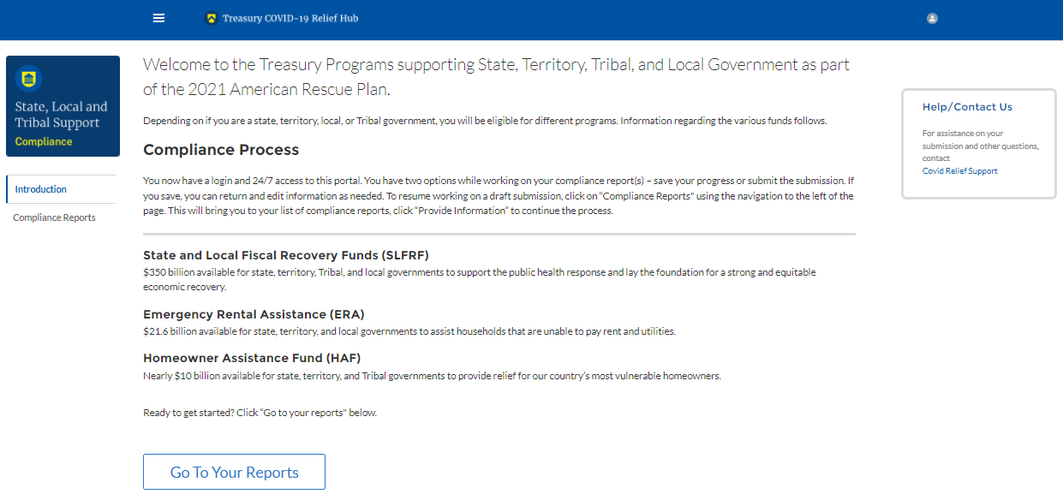

Figure Landing Page

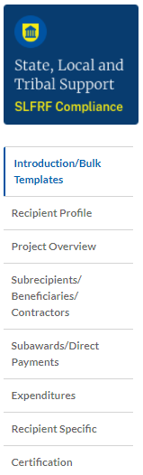From the landing page, select *Go to Your Reports* or *Compliance Reports* on the left side panel to be taken to a list of options for the programs you have access to under the Report Selection section.

At this time, you may select the SLFRF Project and Expenditures report.

Each listed report constitutes a link to that specific report’s online forms. Selecting a report from the landing page will open the first in a series of screens.

To begin completing a specific report, click on *Provide Information* for the given report. Refer to the [Reporting Guidance](https://home.treasury.gov/system/files/136/SLFRF-Compliance-and-Reporting-Guidance.pdf) for details about each type of required report for submittal.

The Navigation Bar (see Figure 2) on the left of Treasury’s Portal will allow you to freely move between screens.

## **Helpful Tips/Shortcuts for Submitting Data to Treasury’s Portal**

Treasury’s Portal leads you through a series of online forms that, when completed, will fulfill your reporting obligations. While navigating through Treasury’s Portal and submitting required information, users will have the option of manually entering data directly into Treasury’s Portal or providing information via a bulk upload file that includes all relevant information in a Treasury approved process and format.

Figure Navigation Bar

1. **Bulk File Upload Files**

Recipients can use the bulk upload function for providing required information in the modules listed here:

* Project Overview
* Subrecipients/Beneficiaries/Contractors
* Subawards/Direct Payments
* Expenditures

When using the bulk upload, recipients must provide the required information in specified formats and use the Treasury approved templates for each respective bulk upload. Recipients can download the templates separately or as a single zip file from selections available at the bottom of the Introduction and Bulk Upload Templates screen (Figure 3). In addition, individual templates are available from relevant screens throughout the portal.

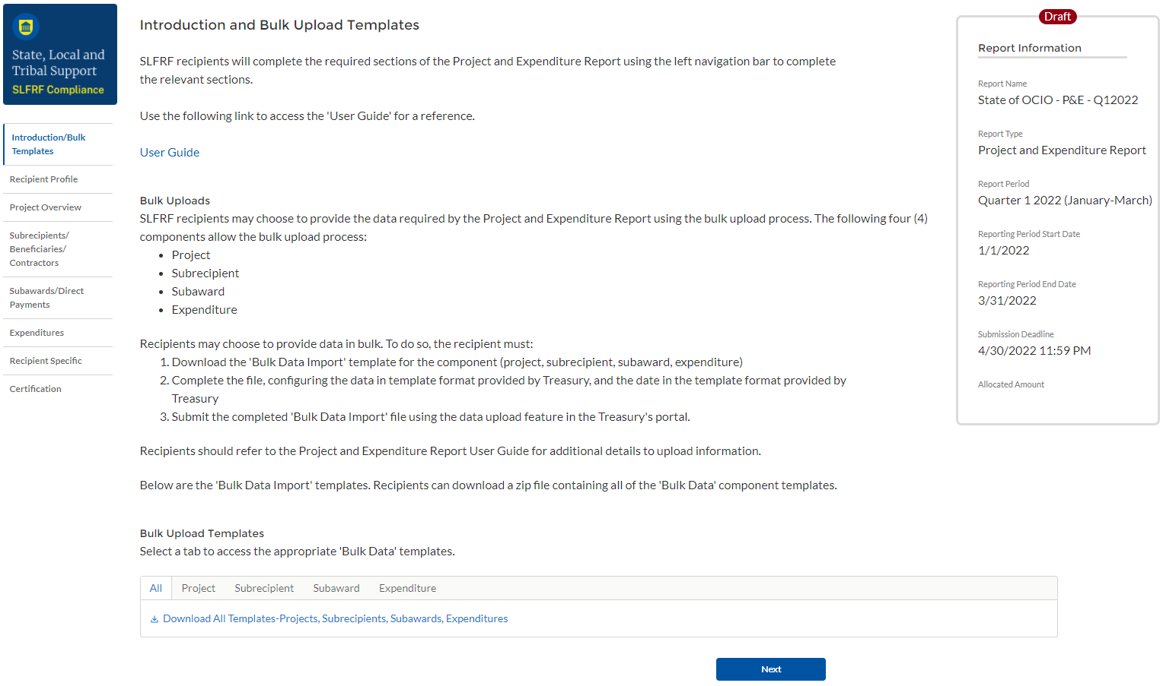

Figure Introduction and Bulk Upload Templates Screen

Please see Appendix B – Bulk File Upload Overview for complete guidance on using this important function.

Modules accepting bulk upload files are clearly marked in Treasury’s Portal and identified in later sections of this User Guide. The template for each upload file is available on the “Introduction/Bulk Templates” module for download and in the subsequent data entry modules (see Figure 4).

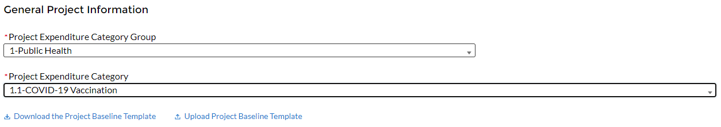

Figure Sample Bulk Upload Icon

All bulk file templates download in the .xls format, but these files must be converted to .csv format to properly upload. When you click the upload button you will be directed to an upload screen. You can either choose to add files or drag and drop files to initiate the bulk upload (see Figure 5). Refer to Appendix B for additional instructions to submit bulk upload files.

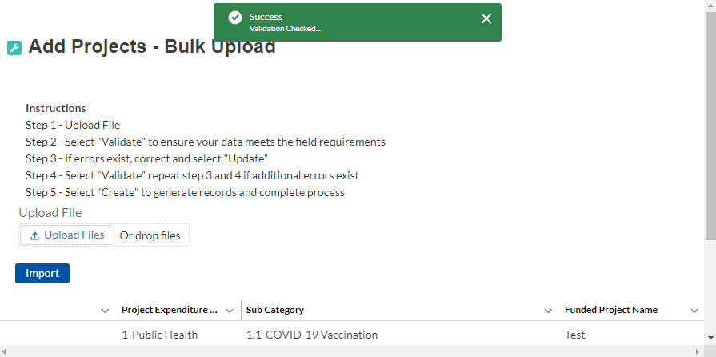

Figure Successful Bulk Upload Example

Treasury’s Portal will reject the file if an incorrect template, data format, or file format other than .csv is used for upload (see Figure 5). Treasury’s Portal will display an error message on screen if the bulk data upload file contains errors. If you receive an error message, you will need to correct the errors either in the bulk upload file or on screen and re-submit the corrected version.

There are four common Bulk File Upload errors as described below:

* **Blank Required Data:** When a required field is left blank within your bulk upload file, the specific bulk upload file row and cell number will be provided on the screen. In the example below, the user left “Name” blank and the error is located in Column X, Row 8 (see Figure 6).

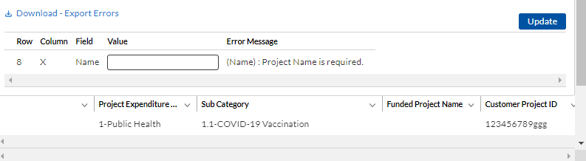

Figure Blank Required Data Error

* **Invalid Data:** Invalid data includes any type of data (numeric or text) that does not meet the requirements set forth in the Help Text within each bulk upload template. In the example below, the user made an error pertaining to the “Completion Status” and the error is located in Column F, Row 8 (see Figure 7).

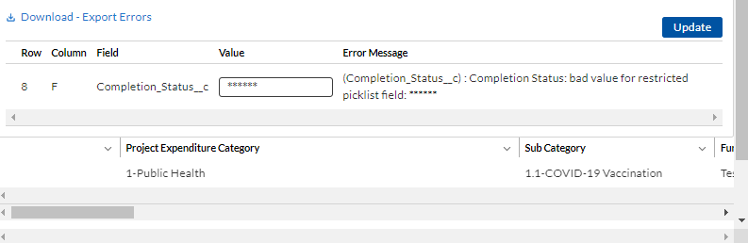

Figure Invalid Data Error

* **Duplicate Data**: Duplicate data includes any type of data (numeric or text) that is repeated in the same column when the Help Text within a bulk upload template requires a unique entry. For example, unique numbers should be provided for the project identification number. In the example below, the user made an error pertaining to the “Project Identification Number” and the error is in Column E, Row 8 (see Figure 8).

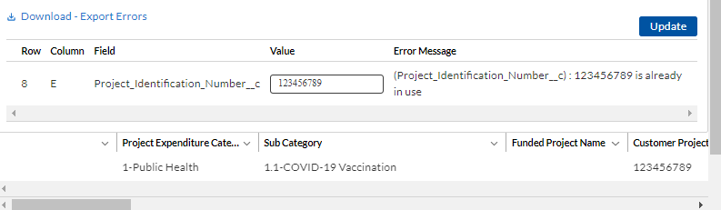

Figure Duplicate Data Error

* **Non-existent Reference**: This instance would include uploading data that references other records that do not yet exist or have not been previously uploaded into Treasury’s Portal. For example, uploading a subaward template that is filled out correctly, but references subrecipient identification (ID) records that have not been uploaded to the Subrecipient/Beneficiaries/Contractors module. This will result in an error and any pre-requisite data must be uploaded first in order for the reference to work. In this example the non-existent data is the Project ID Number field located in Column D, Row 8 (see Figure 9).

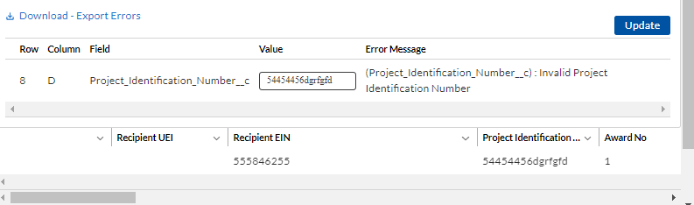

Figure Non-Existent Reference Error

1. **Manual Data Entry**

Manual data entry requires you to provide inputs as instructed on the screen. Manual inputs are described in detail below for each section of this user guide.

**Note:** An asterisk ( * ) indicates a required field. Entry into the field is required before you can save or proceed to the next screen.

Your inputs will be subject to validation by Treasury’s Portal to ensure that the data provided is consistent with expected format or description (e.g., entering “one hundred” instead of 100). If a given data entry fails a validation rule, Treasury’s Portal will display an error for you to address.

You will not be able to submit manually entered data that does not satisfy the data validation rules.

1. **Narrative Boxes**

When filling out detailed narratives, you are encouraged to type out responses in a word processing application (such as Microsoft Word) to minimize grammatical errors, track word count, and concisely answer all required narrative details. You can then copy and paste the final written narratives directly into the text boxes.

The text boxes (see Figure 10) can be expanded by clicking and dragging the icon in the bottom-right corner.



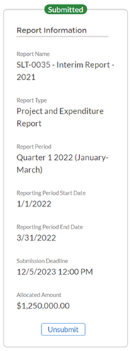Figure Manual Validation Text Box

1. **Corrections and Resubmissions**

Figure Screenshot of Unsubmit Button

In the event a file is uploaded, or information is entered into Treasury’s Portal, the information will be accepted by Treasury’s Portal as a record.

After a recipient’s submission has been certified and submitted in the system by the Authorized Representative for Reporting, it can be corrected in the Portal by selecting the *Unsubmit* button. Recipients may unsubmit, then resubmit, their Project and Expenditure Report any time before the reporting deadline (see Figure 11).

# **Reporting Requirements**

## **Reporting Requirements by Recipient**

For the SLFRF program, reporting requirements vary by recipient type, as shown in the table below. Detailed instructions for completion and submission of each report are covered in Part 2 of the [Reporting Guidance](https://home.treasury.gov/system/files/136/SLFRF-Compliance-and-Reporting-Guidance.pdf).

|  |  |  |  |  |
| --- | --- | --- | --- | --- |
| **Tier** | **Recipient** | **Interim Report** | **Project and Expenditure Report** | **Recovery Plan Performance Report** |
| 1 | States, U.S. territories, metropolitan cities and counties with a population that exceeds 250,000 residents | By August 31, 2021 or 60 days after receiving funding if funding was received by October 15, with expenditures by category.  *Note: NEUs were not required to submit an Interim Report* | By January 31, 2022, and then 30 days after the end of each quarter thereafter  *Note: NEUs were not required to submit a Project and Expenditure Report on January 31, 2022. The first reporting date for NEUs will be April 30, 2022.* | By August 31, 2021 or 60 days after receiving funding, and annually thereafter by July 31 |
| 2 | Metropolitan cities and counties with a population below 250,000 residents that are allocated more than $10 million in SLFRF funding, and NEUs that are allocated more than $10 million in SLFRF funding. |  |
| 3 | Tribal Governments that are allocated more than $30 million in SLFRF funding |
| 4 | Tribal Governments that are allocated less than $30 million in SLFRF funding | By April 30, 2022, and then annually thereafter |
| 5 | Metropolitan cities and  counties with a  population below  250,000 residents that  are allocated less than  $10 million in SLFRF  funding, and NEUs that  are allocated less than  $10 million in SLFRF  Funding |

Note: Based on the period of performance, reports will be collected through April 30, 2027.

The total SLFRF allocations across all sources for a given jurisdiction will be used to identify that jurisdiction’s Reporting Tier, beginning in April 2022. Treasury may reach out to jurisdictions to update Reporting Tiers.

## **Project and Expenditure Report Requirements**

1. **Quarterly Reporting**

The following recipients are required to submit quarterly Project and Expenditure Reports:

* States and U.S. territories
* Metropolitan cities and counties with a population that exceeds 250,000 residents
* Metropolitan cities and counties with a population below 250,000 residents that are allocated more than $10 million in SLFRF funding
* NEUs that are allocated more than $10 million in SLFRF funding
* Tribal Governments that are allocated more than $30 million in SLFRF funding

For recipients who are completing their first quarterly reporting in the April 2022 cycle, their first Project and Expenditure Report will cover the period from March 3, 2021 to March 31, 2022 and must be submitted to Treasury by April 30, 2022

The subsequent quarterly reports will cover one calendar quarter and must be submitted to Treasury by the last day of the month following the end of the period covered. Quarterly reports are not due concurrently with applicable annual reports.

1. **Annual Reporting**

The following recipients are required to submit annual Project and Expenditure Reports:

* Tribal Governments that are allocated less than $30 million in SLFRF funding
* Metropolitan cities and counties with a population below 250,000 residents that are allocated less than $10 million in SLFRF funding
* NEUs that are allocated less than $10 million in SLFRF funding.

For these recipients, the initial Project and Expenditure Report will cover the period from March 3, 2021 to March 31, 2022 and must be submitted to Treasury by April 30, 2022. The subsequent annual reports will cover one calendar year and must be submitted to Treasury by April 30 each year.

## **Key Concepts for Reporting**

The following concept structure applies to all report types:

1. **Expenditure Categories**

* For each project, recipients will be asked to select the appropriate Expenditure Category based on the scope of the project (as described in Appendix 1 of the Reporting Guidance). Projects should be scoped to align to a single Expenditure Category.
* The Expenditure Categories are important not only for tracking projects and expenditures, but also because for certain Expenditure Categories you will need to provide additional programmatic data. You will see them referred to regularly throughout the Reporting Guidance and in this User Guide with “EC” followed by a number.
* The 83 Expenditure Categories provide a flexible method to categorize projects. Each Expenditure Category could include many different programs and activities.
* Appendix C includes the full list of the 83 Expenditure Categories[2], which refers to the detailed level. For instance, EC 1 is the Project EC Group “Public Health,” and EC 1.1 is the Project EC “COVID-19 Vaccination.”
* Each recipient is required to report **obligations** and **expenditures** by project according to the corresponding Expenditure Category (EC). As noted in the Reporting Guidance, there are a wide range of eligible uses of the SLFRF funds, and Treasury must be able to track how funds are used by recipients for oversight and transparency purposes. In addition, States, U.S. territories, and metropolitan cities and counties with a population over 250,000 also need to provide the **adopted budget** for each project.
* An obligation is an order placed for property and services, contracts and subawards made, and similar transactions that require payment.
* An expenditure is the amount that has been incurred as a liability of the entity (the service has been rendered or the good has been delivered to the entity).
* The adopted budget is the budget adopted for each project by a recipient associated with SLFRF funds. Recipients will enter the Adopted Budget based on information that exists currently in the recipient’s financial systems and the recipient’s established budget process. Treasury understands that recipients may use different budget processes. For example, a recipient may consider a project budgeted once a legislature has appropriated funds; whereas another recipient may consider a project budgeted at the moment the funds have been obligated.
* Treasury is not approving or pre-approving projects or budgets. Treasury will use this information to better understand the intended impact, identify opportunities for further engagement, and understand the recipient’s progress in program implementation. Treasury is also collecting additional descriptive information about the budget process to better understand the context of recipients’ budget processes.

1. **Projects**

* A project is defined as a grouping of closely related activities that together are intended to achieve a specific goal or are directed toward a common purpose.
* These activities can include new or existing services, funded in whole or in part by the SLFRF award.
* Within this broad definition, recipients have flexibility to define their projects in a way that provides the greatest clarity on the work which will be performed.
* Each project must align to only **one** Expenditure Category. Projects break down an Expenditure Category into more detail.
* Recipients are required to define projects at a sufficient level of granularity to be able to do any programmatic reporting that is required.
* For each Expenditure Category recipients use funding for, one or more projects may be reported.
* For each project, recipients will need to track obligations and expenditures, as well as subrecipients and any subawards made.

Figure 12 depicts the relationship between EC and multiple projects.

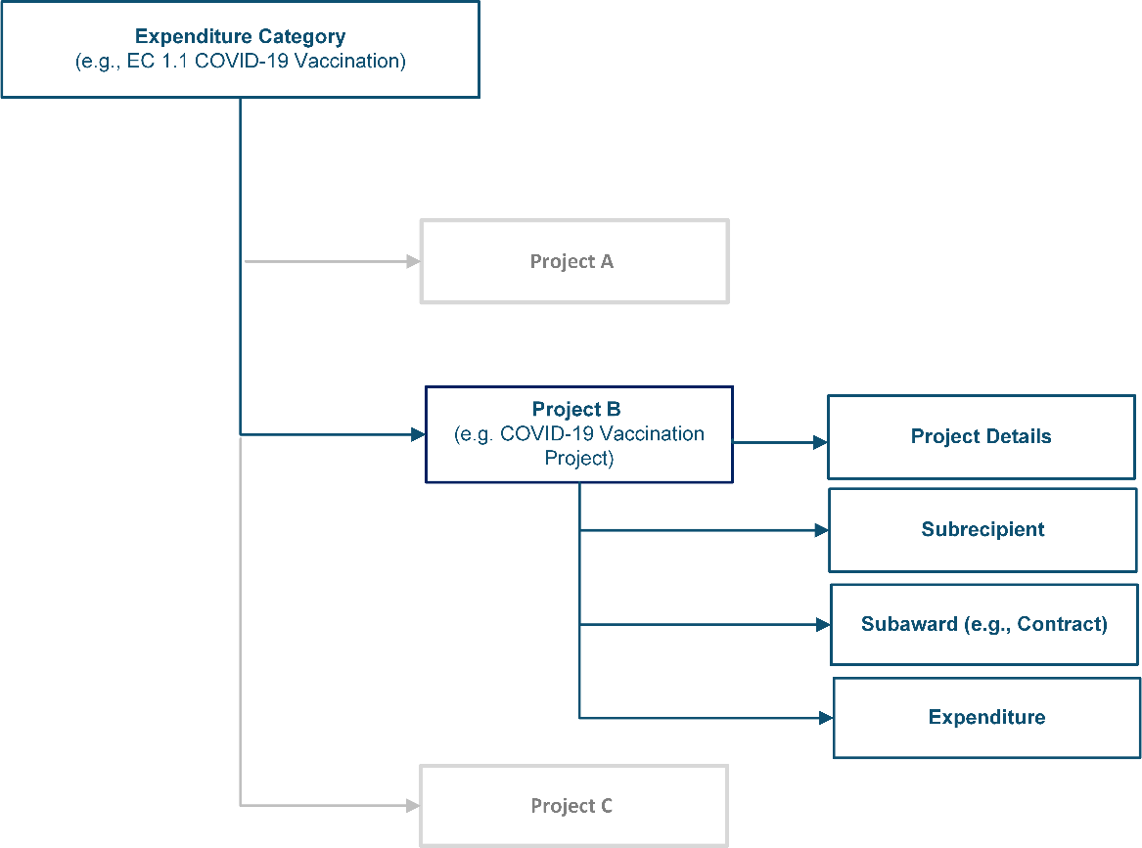

Figure Relationship between Expenditure Categories and Multiple Projects

1. **Relationships Between Project Components**

When entering project information, it is important to understand how the separate components of information relate to each other. Treasury’s Portal for compliance reporting is organized by modules, each of which is a project component: project entry, subrecipient entry, subaward entry, and expenditure entry. Each of these modules are linked to prior modules. Initial entry of information should follow these steps to reduce errors or data issues. After initial entry of information, users can go directly to any module to update and edit information throughout the life of the project.

* Step 1: The first step in entering a new project is specifying the Expenditure Category (EC). While all ECs require entry of a baseline set of details, additional fields will appear in this module and in others depending on program requirements as described in the Reporting Guidance and this User Guide. Examples of fields collected include, but are not limited to, project name, project identification (ID), total obligations, total expenditures, earned and expended program income, status of completion, and project description.
* Step 2: Enter subrecipient/beneficiary/contractor information. This information includes subrecipient/beneficiary/contractor name, unique entity identifier (UEI), tax identification number (TIN), entity type, address, and email.
* Step 3: Enter subaward or direct payment information. Entering a subaward or direct payment will require on-screen selection of a previously entered project and subrecipient/beneficiary/contractor. This aligns subaward funding to the project and the EC. Other information collected in this module includes subaward number, place of performance address, subaward amount, period of performance start and end dates, and a description of the subaward and its underlying eligible use.
* Step 4: Enter expenditures. Expenditures are entered in one of three categories: (1) Expenditures[3] Greater Than or Equal to $50,000, (2) Aggregate Expenditures Less Than $50,000, and (3) Payments to Individuals.
  + Expenditures for Awards Greater Than or Equal to $50,000: Entering expenditures for awards greater than or equal to $50,000 will require on-screen selection of a previously entered subaward number, which will auto-populate the project and subaward information details. Other information collected for this type of award includes expenditure start and end dates, and expenditure amount.
  + Aggregate Expenditures Less Than $50,000: Entering expenditures for awards less than $50,000 will require on-screen selection of a previously enter project. Other information collected for this type of expenditure include subaward type, total period obligation amount and total period expenditure amount.
  + Payments to Individuals: Entering expenditures for awards categorized as payments to individuals will require on-screen selection of a previously enter project. Other information collected for this type of expenditure include subaward type, total period obligation amount and total period expenditure amount.

# **Project and Expenditure Report**

The Project and Expenditure Report provides information on projects funded, expenditures, and contracts and subawards greater than or equal to $50,000, and other information required from recipients. Multiple modules or “screens” will help recipients navigate through the Project and Expenditure Report in Treasury’s Portal as follows:

1. Introduction/Bulk Templates
2. Recipient Profile
3. Project Overview
4. Subrecipients/Beneficiaries/Contractors
5. Subawards/Direct Payments
6. Expenditures
7. Recipient Specific
8. Certification

The following sections describe the reporting steps and information to be collected in each module.

## **Recipient Profile**

Upon login, you will be directed to the recipient information page, which is intended to verify relevant information in Treasury’s Portal. On this screen, you will review and confirm key information on your organization, and input information required for the Project and Expenditure Report. Recipient Profile information for States, U.S. territories, counties, cities and Tribal governments will be pre-populated from the SLFRF Application file. NEU information will be populated based on the information States collected from the NEUs and provided to Treasury.

## Review and confirm your Recipient Profile prepopulated from your SLFRF Application file or for NEUs, information provided by your State (see Figure 13).

## Verify the names and contact information for individuals the recipient has designated for key reporting roles for the SLFRF program displayed on the screen (see Figure 14).

## Refer to the instructions in Appendix A if there are updates are associated with reporting roles or contact [SLFRP@treasury.gov](mailto:SLFRP@treasury.gov).

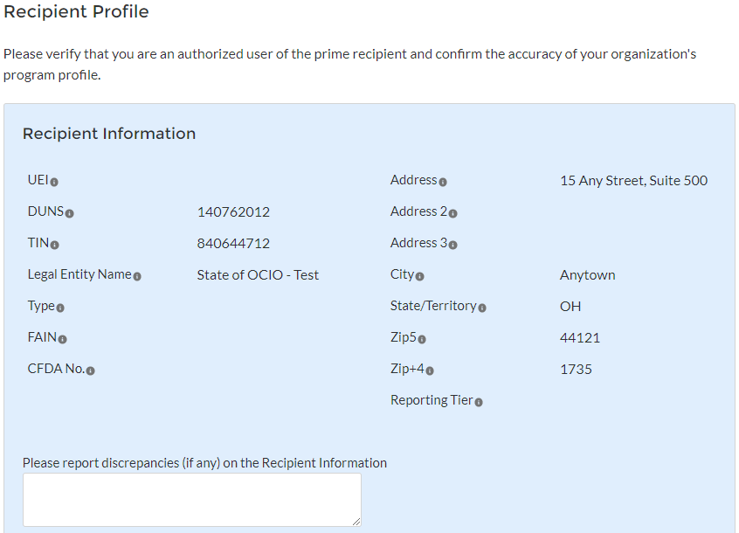

Figure Recipient Information

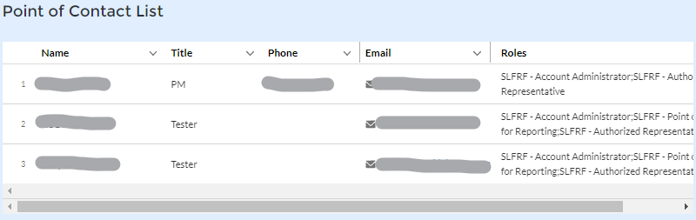

Figure Point of Contact List

## If changes are needed to the information displayed on the screen, use the textbox (see Figure 13).

## *For States, U.S. territories, and metropolitan cities and counties with a population over 250,000*, provide the answers to the following two questions (see Figure 15):

* Who approves the budget in your jurisdiction? Select from the picklist as follows: Legislature; Executive; Legislature & Executive; Other.
  + If Other, specify who approves the budget. Please include information about the role or function, not an individual’s name.
* Is your budget considered executed at the point of obligation? Select “Yes” or “No”. Please note that if you select “Yes” and your budget is considered executed at the point of obligation, then your adopted budget and total dollar value of obligations for each project would be the same.

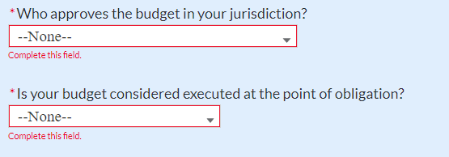

Figure Budget Approval and Obligation

## Treasury requires descriptive information about budget processes to support analysis of adopted budget information. Treasury is collecting adopted budget information to better understand the intended impact of recipient projects, identify opportunities for further engagement, and understand the recipient’s progress in program implementation. Treasury is requesting this descriptive information to inform these efforts.

Treasury is not approving or pre-approving projects or budgets. Treasury also recognizes that recipients may adjust project budgets over time, and recipients will have the ability to reflect these changes in future reporting.

## Complete the SAM.gov Registration and Executive Compensation information.

### Use the picklist (see Figure 16) to confirm your entity’s SAM.gov status and Executive Compensation reporting eligibility questions.

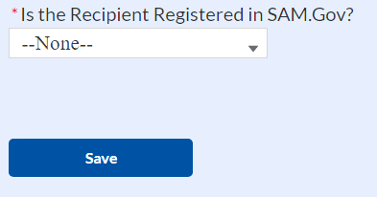

Figure SAM.gov question

### If you are registered in SAM.gov, select “Yes” from the picklist and move on to Step 7 below.

### If you are not registered in SAM.gov, select “No” from the picklist. Two additional questions will populate the space below (see Figure 17).

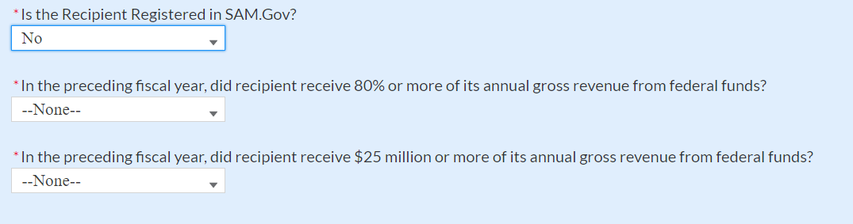

Figure Additional SAM.gov questions (1)

### If the recipient received 80% or more of its annual gross revenue from federal funds (including federal financial assistance and federal procurement contracts and subcontracts) AND the recipient received $25 million or more of its annual gross revenue from federal funds (including federal financial assistance and federal procurement contracts and subcontracts), an additional question will appear (see Figure 18). If the answer is “No” to any of these two questions, move on to step 7 below.

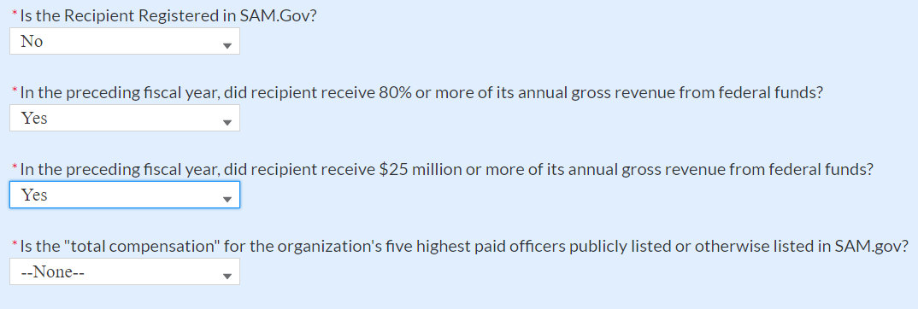

Figure Additional SAM.gov questions (2)

### Select “Yes” if the total compensation for the recipient’s five highest paid officers is publicly listed or otherwise listed in SAM.gov and move on to Step 7 below.

### Select “No” if the total compensation for the recipient’s five highest paid officers is not publicly listed or otherwise listed in SAM.gov. Enter the name(s) of the officer(s) in the chart that will appear (see Figure 19) and the total compensation received by each. If fewer than five (5) officers exist, enter “N/A” and $0 in the empty field(s).

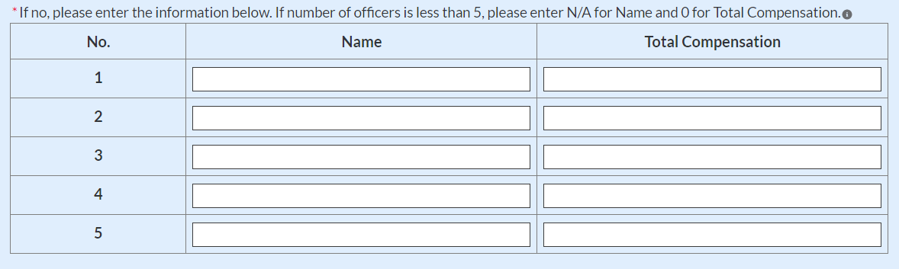

Figure Record of Highest Paid Officer

## Once all fields have been reviewed and verified, click the *Save* button to save your progress, then click the *Next* button to proceed to the following screen.

## 

## **Project Overview**

Recipients are required to enter all projects funded through SLFRF funds as part of their Project and Expenditure Report. Once projects are entered, they are viewable on the Project Overview screen and can be updated in future reporting periods.

1. **Key Considerations**

There are a couple of things to keep in mind when planning and executing your project inventory entry:

* **No Projects Available Option**: If your jurisdiction has not yet identified any projects to report, please know that Treasury encourages you to identify projects as soon as possible for your jurisdiction’s uses of SLFRF funds.

In the event recipients have no projects available for entry, an option has been included on the Project Overview screen to allow recipients to indicate this status to Treasury in lieu of adding projects. Selecting this option will require providing a written explanation and may result in additional compliance follow-up from Treasury.  Note: this option will not appear if projects are already entered in the system.

To utilize this option, on the Project Overview screen (See Figure 20):

1. For the question “Does your jurisdiction have projects to report as of this reporting period?”, select “My jurisdiction has projects to report” or “My jurisdiction does NOT have projects to report”.
2. If no projects will be reported, provide a narrative describing the reason(s) your jurisdiction does not have approved projects at this time in the text field provided.

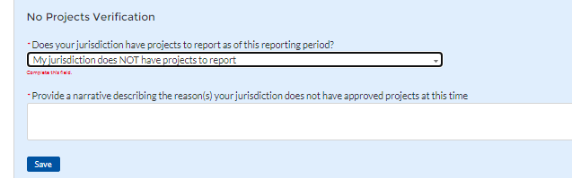

Figure No Projects Available Option

* **Manual versus Bulk Upload Entry:** There are two ways to enter project information – manual data entry and bulk upload. Bulk upload templates are specific to the project’s expenditure category group. Recipients may upload information for multiple projects within the same expenditure category group template simultaneously. Appendix B provides step by step instructions for using the bulk upload option.

Due to the different data collected across expenditure categories, you cannot use the same bulk upload template from one expenditure category group to another.

* **Non-Infrastructure and Infrastructure Projects Programmatic Data:** Treasury requests various programmatic data or impact measures for projects in several non-infrastructure (i.e., projects in EC 1 – 3) and infrastructure projects (i.e., projects in EC 5). The programmatic data can be provided via manual project entry or via bulk upload templates. Appendix B provides step by step instructions for using the bulk upload option for projects with programmatic data. Appendix D provides additional detail on the programmatic data requested by EC. Treasury recognizes that some programmatic data may not be available until a project starts.
* **Infrastructure Projects with expected total cost over $10M:** Information for infrastructure projects with expected total cost over $10 million must be entered manually at this time in Treasury’s Portal. Appendix D provides additional detail on the programmatic data requested by EC.

When creating infrastructure projects via bulk upload, you will be required to re-open those project records to manually complete fields related to costs over $10M.

Recipients should refer to Appendix C when planning your project inventory entry, as it includes a table identifying which ECs require the programmatic data. The table also maps each EC to its appropriate bulk upload template.

All projects, regardless of Expenditure Category, require a set of “standard” data fields. Some of these fields, such as project name and project ID, are static and do not change across reporting periods. Other fields, such as status of completion and total obligations, will change across reporting periods.

1. **Project Overview Screen Layout**

## On the Project Overview Screen, recipients can view previously established projects and enter new projects (see Figure 21). The screen displays the total number of projects. The screen also displays the following for each project entered: project name, project identification number (ID), adopted budget (if applicable), total obligations, total expenditures, expenditure category, project status, subaward status, and expenditure status. To go directly to a project to edit or add information, click the colored status button for that project.

 For Project Status, the green check icon indicates all required fields have been answered, including programmatic data. For Subaward Status and Expenditure Status, this status indicates that at least one subaward or expenditure entry has been made.

 For Project Status, the yellow pencil icon indicates certain required fields have not been answered and require confirmation. For Subaward Status and Expenditure Status, the status indicates that the sum of all obligation or expenditure amounts associated with the project included at the subaward and expenditure level do not equal that project’s total obligations or expenditures.

 For Project Status, the red pencil icon indicates that not all required fields have been answered. For Subaward Status and Expenditure Status, this indicates that no subaward or expenditure entries have been made.

|  |
| --- |
| **Required April 2022 Reporting Confirmation** |
| An expanded set of Expenditure Categories was introduced in the updated [Reporting Guidance](https://home.treasury.gov/system/files/136/SLFRF-Compliance-and-Reporting-Guidance.pdf) to reflect the broader flexibility introduced by the final rule. Appendix E includes the new Expenditure Categories, as well as a reference to the previous Expenditure Categories used for reporting under the interim final rule for ease of comparison.  If you are a recipient who submitted a Project and Expenditure Report in January 2022, you will have the opportunity to update the previously selected Expenditure Category, if appropriate, as well as providing answers to the applicable programmatic data. For simplicity, in the event a previously reported Expenditure Category changed numbers, no longer exists, or requires entering programming data, the Project Overview screen will mark those items with a yellow pencil icon.  Refer to section **2(d)** for additional details to update projects. |

To add a new project from this screen, click the *Add New Project* button. You may need to refresh your browser screen to see your previous new entries.

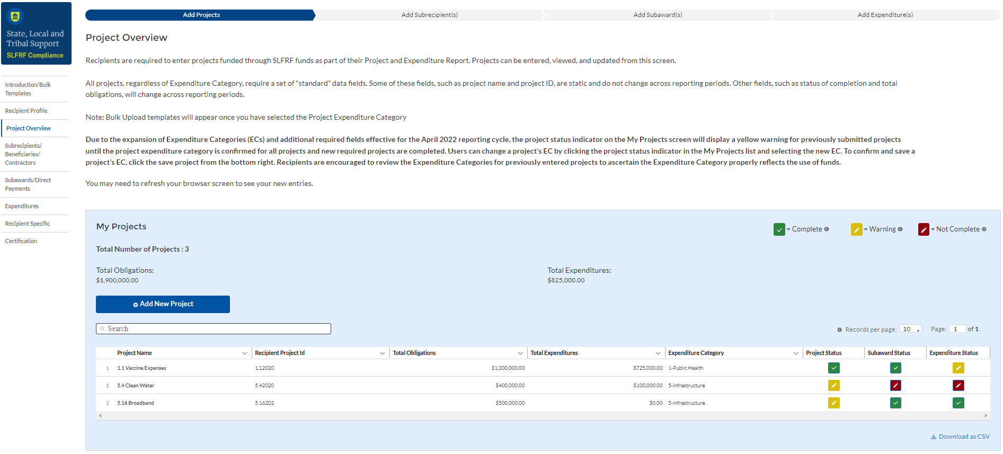

Figure My Projects Screen Example

## **Add new project manually**

## Select the Project Expenditure Category Group and Project Expenditure Category from the picklists. Selection of Expenditure Category drives the template through which you will manually enter the project data (see Figures 22 through 25). To view all of the ECs, scrolling may be necessary.

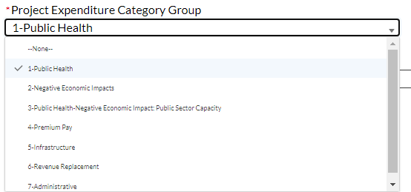

Figure Project and Expenditure Category Group Screen

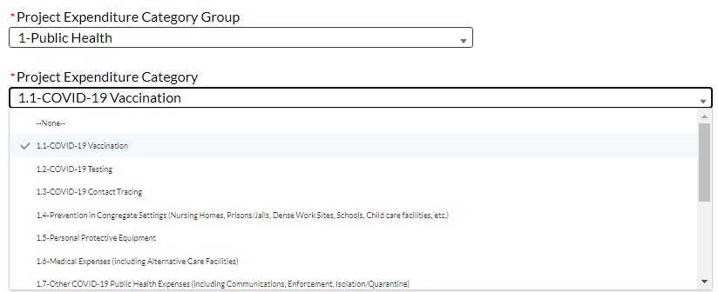

Figure Project Expenditure Category

## Note that once you select values from the Project Expenditure Category Group and the Project Expenditure Category picklists, the bulk download and upload links will appear (see Figure 24). As you are entering the information manually, go to step 3.

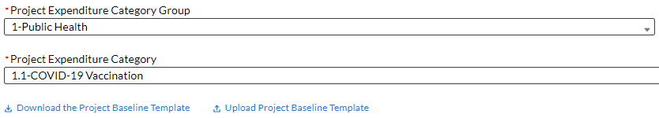

Figure Bulk Upload for EC 1.1

1. Enter the project name.
2. Enter the unique recipient identification number you assigned to the project. Do not use duplicate project numbers for multiple projects.
3. Select the completion status of the project from the drop-down list. Options are:

## Not started

## Completed less than 50%

## Completed 50% or more

## Completed

1. *For States, U.S territories and metropolitan cities and counties with population over 250,000, e*nter the adopted budget for the project*.*
   * Note that if you selected that your budget is considered at the point of obligation, adopted budget and total dollar value of obligations for each project would be the same
2. Enter the total dollar value of current period obligations for this project. If funds have not been obligated during the current reporting period, enter “0”.

* Note – Recipients should ensure that Current Period Obligations are less than or equal to Cumulative Obligations for each project. Treasury’s Portal will otherwise return an error.

1. Enter the total dollar value of cumulative obligations for this project. If funds have not been obligated for this project, enter "0".
2. Enter the total dollar value of current reporting period expenditures for this project. If expenditures have not been made during the current reporting period, enter “0”.

* Note – Recipients should ensure that Current Period Expenditures are less than or equal to Cumulative Expenditures for each project. Treasury’s Portal will otherwise return an error.

1. Enter the total dollar value of cumulative expenditures for this project. If expenditures have yet to be made for this project, enter "0".

* Note – Recipients should ensure that Cumulative Expenditures are less than or equal to Cumulative Obligations for each project. Treasury’s Portal will otherwise return an error.

## Provide a description for the project between 50 to 250 words. Each project description should be 3-5 sentences with an overview of the project, which includes a description of the project’s purpose, the population being served, the desired outcome from the project, and how this outcome is being measured (along with any current data on progress towards the desired outcome).

## If the project earns income or has expended that income, enter the total dollar value of program income earned and program income expended in the fields of the same name, respectively. This field is optional.

## If the project is in an EC which requires additional programmatic data, additional fields will display on the screen. Please see Section IV.e below for more information on providing programmatic data and Appendix D for more information on the programmatic indicators themselves.

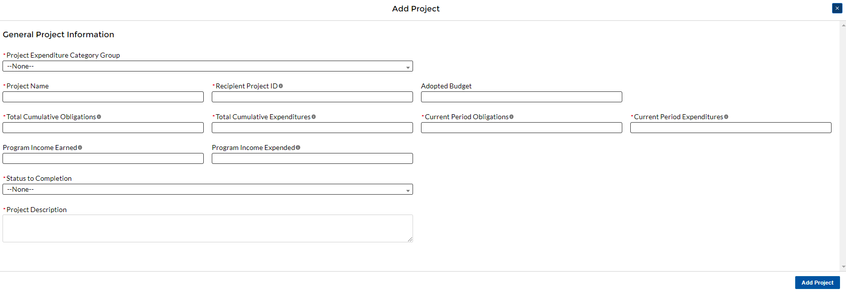

Figure Project Entry Screen

1. Once all of the above information is entered, click the *Add Project* button, then click the *Next* button to proceed to the following screen or you can stay on this screen and continue adding projects to your project inventory.
2. **Update previously reported projects**

Certain data fields may be updated in Treasury’s Portal. In addition, for the April 2022 reporting deadline, if projects were previously reported under an Expenditure Category that changed or no longer exists, or additional programmatic data is needed, the Project Profile screen will show a yellow pencil icon. Recipients need to confirm the information for these projects. Recipients are also encouraged to validate all the previously reported entries to ascertain that they properly reflect the Expenditure Categories established under the final rule and the project aligned to them (refer to Appendix E). Recipients should:

* 1. Click on the project icon on the Project Profile screen.
  2. Once the project information displays, confirm the information on the screen, including the Project Expenditure Category Status and the Project Expenditure Category.
  3. Provide answers to the programmatic data relevant to the EC, if applicable.
  4. Click *Confirm Project* (see Figure 26).

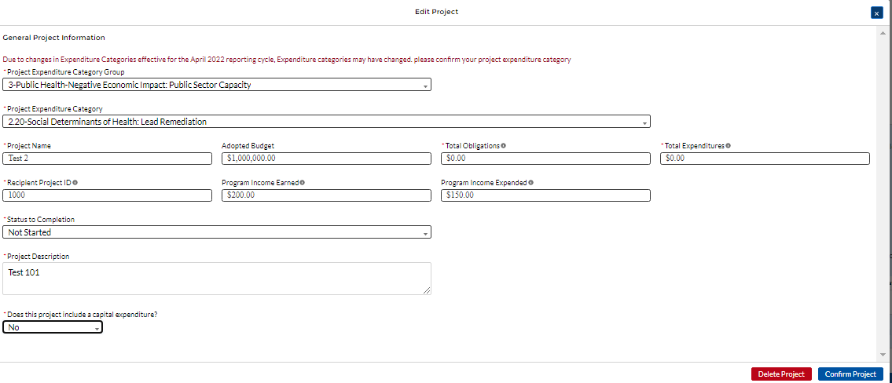

Figure Update Previously Reported Projects

## **Provide Programmatic Data for Projects**

Overview

As noted above, projects in several ECs require programmatic data in addition to the standard project information covered above and as described in Part B.3.i and B.3.j of the Reporting Guidance. Appendix D provides additional detail on the measures and information required, by Expenditure Category. This information should be provided at the project-level (e.g., disaggregated by project if the recipient has multiple projects in a single EC).

Programmatic data can be provided via the manual project entry process described above, or in some cases via bulk upload using the Expenditure Category-specific templates, described in Section IV.g and Appendix B.

For example, to manually enter a new project in Expenditure Category 3.1 (see Figure 27) Public Sector Workforce: Payroll and Benefits for Public Health, Public Safety, or Human Services, the recipient should:

1. Follow steps 1 – 12 in Section IV.c.1 above.
2. Answer the question “Does this project include a capital expenditure?” (Y/N) (see Figure 28)
3. Provide answers to the Public Health and Negative Economic Impact questions (see Figure 28)
4. Populate the programmatic data field for “Number of government FTEs responding to COVID-19 supported under this authority” (see Figure 28).
5. Once all of the above information is entered, click *Add Project*.
6. Click the *Next* button to proceed to the following screen.

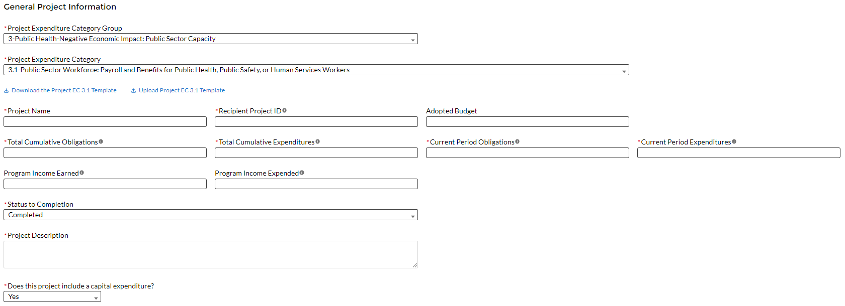

Figure Manual Entry for EC 3.1

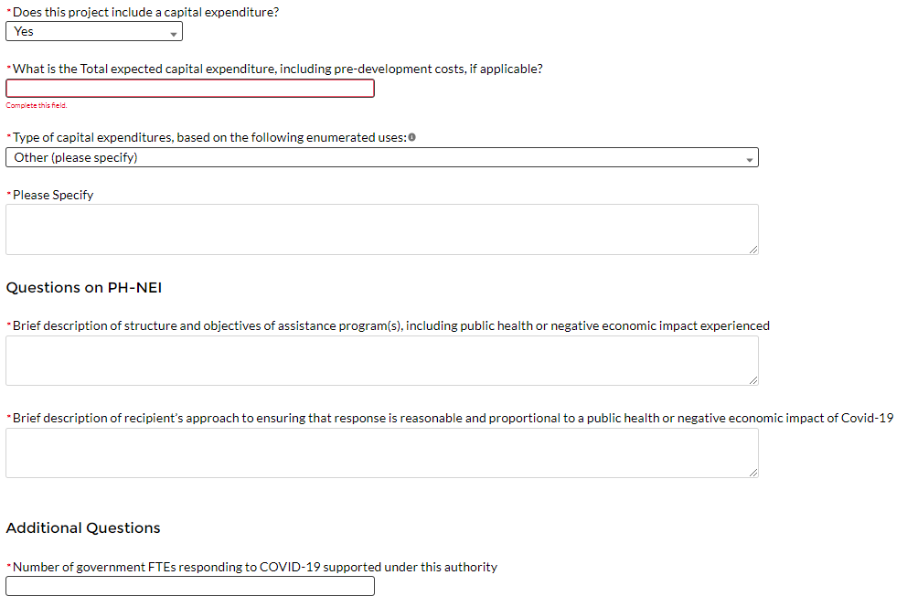

Figure Programmatic Data for EC 3.1

If entering projects via bulk upload, recipients should populate the programmatic data columns contained in the appropriate EC’s bulk upload template. Appendix C provides a helpful table mapping each Expenditure Category to the bulk upload template recipients should use if inputting or updating projects via the bulk upload method.

Additional Information Regarding Certain Programmatic Data

In addition to programmatic data or impact measures for projects for specific Expenditure Categories as noted in Appendix D, Treasury requests information for the following Expenditure Categories:

## Project Demographic Distribution (applicable to Public Health and Negative Economic Impact ECs: EC 1.1-2.37) - recipients must report whether certain types of projects are targeted to impacted and disproportionately impacted communities. Recipients will be asked to respond to the following (see Figure 29):

* What Impacted and/or Disproportionally Impacted population does this project primarily serve? Please select the population primarily served, based on list included in Appendix G.
* If this project primarily serves more than one Impacted and/or Disproportionately Impacted population, please select up to two additional populations served, based on list included in Appendix G**.** If the project does not serve more than one Impacted and/or Disproportionately Impacted population, click “None”.
* If a project primarily serves an Impacted and/or Disproportionately Impacted population under an “Other” category, add the relevant information in the narrative.

## 

Figure Project Demographic Distribution Questions

## Public Health and Negative Economic Impact: For projects reported under the Project Expenditure Categories EC1: Public Health, EC2: Negative Economic Impact and EC3: Public Health-Negative Economic Impact: Public Sector Capacity, provide:

## Brief description of structure and objectives of assistance program(s), including public health or negative economic impact experienced

## Brief description of how a recipient’s response is related and reasonably proportional to a public health or negative economic impact of COVID-19 (see Figure 30)

## Between these two fields above, recipients should provide enough information to identify the type of enumerated eligible use being provided within the EC (e.g., kinship care support services), the public health or economic impact experienced, who the program and/or service is being provided to, and what services are being provided (e.g., respite resources). For enumerated eligible uses (other than certain capital expenditures, as discussed below), recipients are not required to provide substantive documentation that the response is related and reasonably proportional in the Project and Expenditure Report.

Figure Public Health - Negative Economic Impact Questions

## Capital Expenditures: For projects reported under the Project Expenditure Categories EC1: Public Health, EC2: Negative Economic Impact and EC3: Public Health-Negative Economic Impact: Public Sector Capacity, provide answers to the following questions (refer to Figure 31):

## Does this project include a capital expenditure?

## If “Yes”:

## What is the total expected cost of the capital expenditure, including pre-development costs, if applicable?

## Type of capital expenditure, based on the following enumerated uses (as noted in Appendix H)

## If the answer is “No”, include a zero for the expected total cost of the capital expenditure

## For recipients (other than Tribal governments) investing in projects with total expected capital expenditures for an enumerated eligible use of $10 million or more, as well as projects with total expected capital expenditures for an “other” use of $1 million or more, provide a written justification. (This field is optional in April 2022; required in July 2022)

## For projects with total expected cost of the capital expenditures of over $10 million, provide the Davis Bacon and labor reporting as outlined for infrastructure projects on pages 24, 26, and 27 of the Reporting Guidance. (This field is optional in April 2022; required in July 2022)

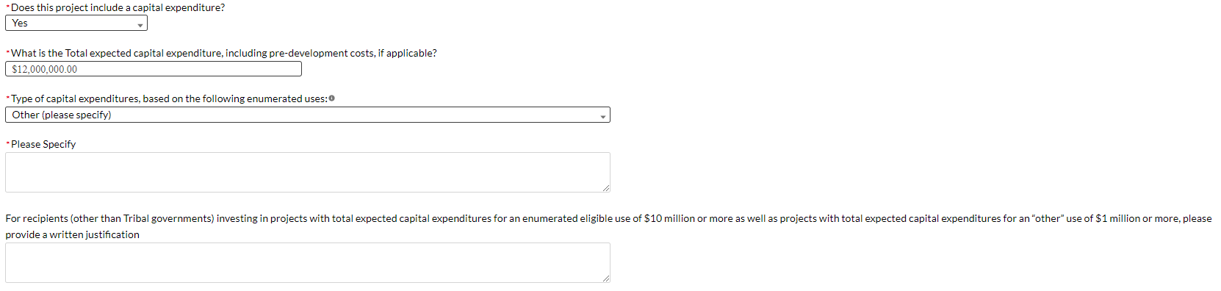

Figure Capital Expenditure Questions

1. Evidenced-based questions (*only applicable to States, U.S. Territories, and metropolitan cities and* *counties with population over 250,000)***:** For relevant ECs identified in Appendix C with an asterisk (“*”), provide the following information in regards to use of evidence. Appendix 2 of the Reporting Guidance provides further details. See Figure 32.
   * Identify the dollar amount of the total project spending that is allocated towards evidence-based interventions.
   * Is a program evaluation of the project being conducted?

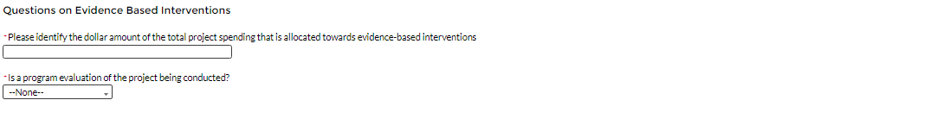

Figure Evidenced-based questions

## Premium Pay (EC 4.1 and EC 4.2): If EC 4.1 or 4.2 is selected as the project expenditure category, recipients will need to provide additional data, as reflected in Figure 33:

* Sectors Designated as Essential Critical Infrastructure
* Number of workers to be served
* Premium Pay Narrative
* Number of workers to be served with premium pay in K-12 schools

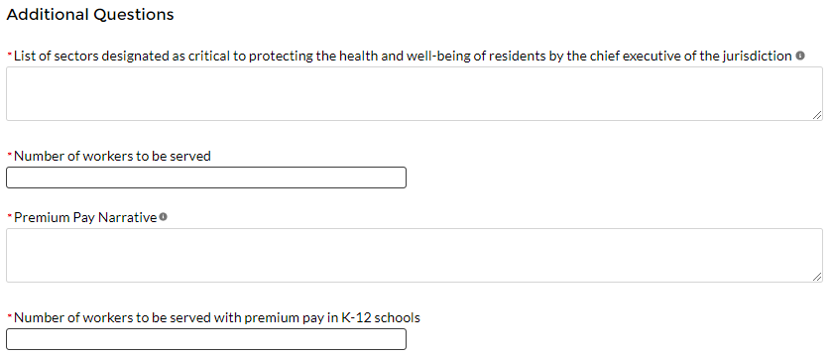

Figure Premium Pay Additional Questions

**Note -** Recipients that are either creating or supporting a Premium Pay program should reference the final rule and the Overview of the Final Rule for information regarding this eligible use.

* **Sectors designated as essential critical infrastructure sectors:** Recipients should refer to the list of sectors below when providing information for this question. Recipients may also refer to this list of sectors on the Subaward screens (see section IV.g) to answer the question: *Employer sector for all subawards to third-party employers (i.e., employers other than the State, local, or Tribal government).* If a recipient selects “other”, please describe the additional non-public sector that the recipient’s chief executive (or equivalent) designated consistent with the requirements of the final rule.

| **Sectors Designated as Essential Critical Infrastructure Sectors** |
| --- |
| Any work performed by an employee of a State, local, or Tribal government |
| Behavioral health work |
| Biomedical Research |
| Dental care work |
| Educational work, school nutrition work, and other work required to operate a school facility |
| Election’s work |
| Emergency response |
| Family or childcare |
| Grocery stores, restaurants, food production, and food delivery |
| Health care |
| Home- and community-based health care or assistance with activities of daily living |
| Laundry work |
| Maintenance work |
| Medical testing and diagnostics |
| Pharmacy |
| Public health work |
| Sanitation, disinfection, and cleaning work |
| Social services work |
| Solid waste or hazardous materials management, response, and cleanup work |
| Transportation and warehousing |
| Vital services to Tribes |
| Work at hotel and commercial lodging facilities that are used for COVID-19 mitigation and containment |
| Work in a mortuary |
| Work in critical clinical research, development, and testing necessary for COVID-19 response |
| Work requiring physical interaction with patients |
| Other |

* **Premium Pay Narrative:** Recipients must submit a written justification to Treasury describing how the premium pay or grant is responsive to eligible workers performing essential work during the public health emergency for groups of workers that do not meet one of the two criteria below:

1. Eligible worker receiving premium pay is earning (with the premium included) at or below 150 percent of their residing state or county’s average annual wage for all occupations, as defined by the Bureau of Labor Statistics Occupational Employment and Wage Statistics, whichever is higher, on an annual basis; or
2. Eligible worker receiving premium pay is not exempt from the Fair Labor Standards Act overtime provisions.

## Infrastructure Projects Programmatic Data (EC 5): Programmatic data is requested for Infrastructure projects in addition to data uploaded by bulk template.

For Water and sewer projects (EC 5.1-5.18): Recipients will provide information associated with water and sewer projects (see Figure 34), under EC 5.1 through 5.18 when the project starts. Recipients are not required to provide the information if the project has not started. When the “Status of Completion” field is marked “Not Started”, the additional questions required for water and sewer projects will not display. Recipients should consider this guidance when entering the following data:

* Projected/actual construction start date
* Projected/actual initiation of operations date
* Location Type
* Location Details
* Public Water System (PWS) ID Number
* National Pollutant Discharge Elimination System (NPDES) Permit Number
* Median Household Income of service area
* Lowest Quintile Income of the service area
  + For median income and lowest quintile income of Census Tracts and other geographic areas, recipients should refer to the most recent American Community Survey 5-year estimates available through the Census website.

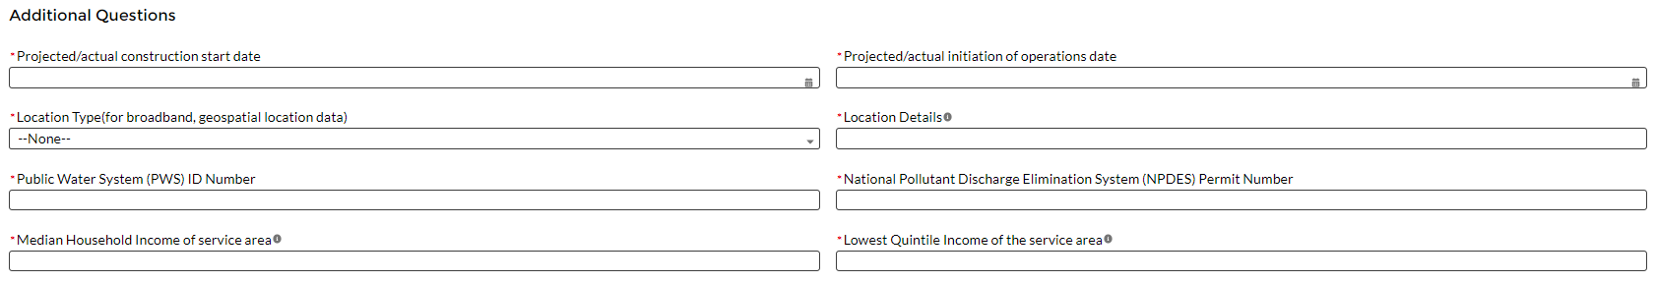

Figure Programmatic Data for Infrastructure Projects EC 5.1-5.18

For broadband projects (EC 5.19-5.21): Recipients will provide information associated with broadband projects when the project starts. Recipients are not required to provide the information if the project has not started. When the “Status of Completion” field is marked “Not Started”, the additional questions required for broadband projects will not show up. Recipients should consider this guidance when entering the following data (see Figure 35):

* Projected/actual construction start date
* Projected/actual initiation of operations date
* Location
  + Recipients will be asked to indicate whether they have a broadband location file to upload for the project. If they indicate yes, recipients will be able to upload a file to the reporting portal.
  + Broadband location files should provide the latitude/longitude for each location served by a project. Further guidance will be provided for the July 2022 reporting cycle on the format of this data, along with other items that recipients will be required to report.
  + Recipients are required to upload a broadband location file unless they have not engaged in detailed location planning of their broadband project.
* Is the project designed to meet or exceed symmetrical 100 Mbps download and upload speeds?
  + If the project is not designed to reliably meet or exceed symmetrical 100 Mbps download and upload speeds, explain why not, and
  + Confirm that the project is designed to, upon completion, meet or exceed 100 Mbps download speed and between at least 20 Mbps and 100 Mbps upload speed, and be scalable to a minimum of 100 Mbps download speed and 100 Mbps upload speed.

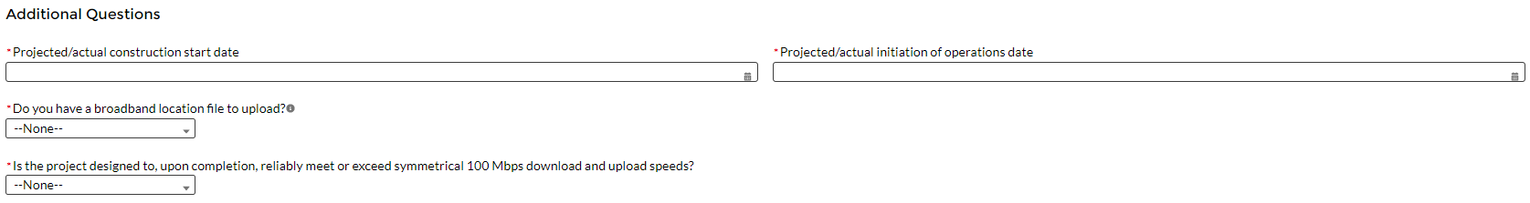

Figure Programmatic data for Broadband Projects EC 5.19-5.21

## Infrastructure Projects with total expected costs over $10M: Recipients entering infrastructure projects with total expected costs over $10 million are required to respond to four questions manually. If you expect a project to exceed $10 million over its lifetime, it is strongly recommended to complete the reporting in advance to avoid future retroactive reporting burden and project-associated expenses.

Recipients are required to provide the following additional information:

1. Davis-Bacon Act Certification (see Figures 36):
   1. Select “Yes” or “No” response to Certification question for Davis-Bacon Act: *Do you intend to certify that “all laborers and mechanics employed by contractors and subcontractors in the performance of the project are paid wages at rates not less than those prevailing, as determined by the U.S. Secretary of Labor in accordance with subchapter IV of chapter 31 of title 40, United States Code (commonly known as the “Davis-Bacon Act”), for the corresponding classes of laborers and mechanics employed on projects of a character similar to the contract work in the civil subdivision of the State (or the District of Columbia) in which the work is to be performed, or by the appropriate state entity pursuant to a corollary state prevailing-wage-in-construction law (commonly known as “baby Davis-Bacon Acts”)?*
   2. If response is “No”, enter the following information in the revealed questions:
      1. The number of employees of contractors and sub-contractors working on the project;
      2. The number of employees on the project hired directly;
      3. The number of employees on the project hired through a third party;
      4. The wages and benefits of workers on the project by classification; and
      5. Whether those wages are at rates less than those prevailing.[4]

PLEASE NOTE: Selecting "*Yes*" to a)1) means that you intend to certify that all contractors and subcontractors are paying prevailing wages and fringe benefits to all laborers and mechanics on the project.

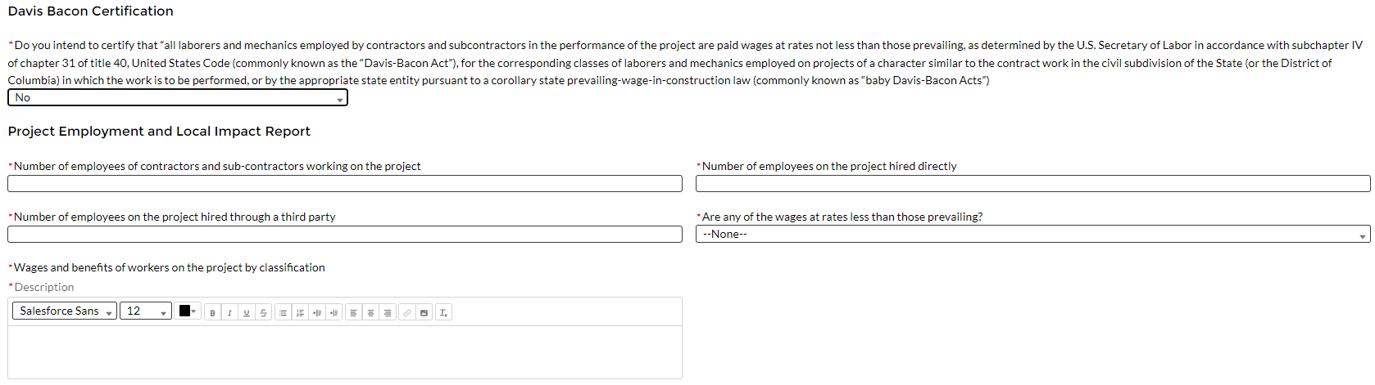

Figure Additional Questions if Response to Davis Bacon Certification is "No"

1. Certification of Labor Agreements (Figures 37):
   1. Select “Yes” or “No” response to Certification question for existence of project labor agreement: *Do you intend to certify that “the indicated project includes a project labor agreement, meaning a pre-hire collective bargaining agreement consistent with section 8(f) of the National Labor Relations Act (29 U.S.C. 158(f))?*
   2. If response is “No”, enter the following information about a project continuity plan in the pop-up window:
      1. How the recipient will ensure the project has ready access to a sufficient supply of appropriately skilled and unskilled labor to ensure high-quality construction throughout the life of the project, including a description of any required professional certifications and/or in-house training?;
      2. How the recipient will minimize risks of labor disputes and disruptions that would jeopardize timeliness and cost-effectiveness of the project?;
      3. How the recipient will provide a safe and healthy workplace that avoids delays and costs associated with workplace illnesses, injuries, and fatalities, including descriptions of safety training, certification, and/or licensure requirements for all relevant workers (e.g., OSHA 10, OSHA 30)?;
      4. Whether workers on the project will receive wages and benefits that will secure an appropriately skilled workforce in the context of the local or regional labor market?; and
      5. Whether the project has completed a project labor agreement.

PLEASE NOTE: Selecting "*Yes*" to b)1) means that you intend to or are using an 8(f) pre-hire agreement on your project.

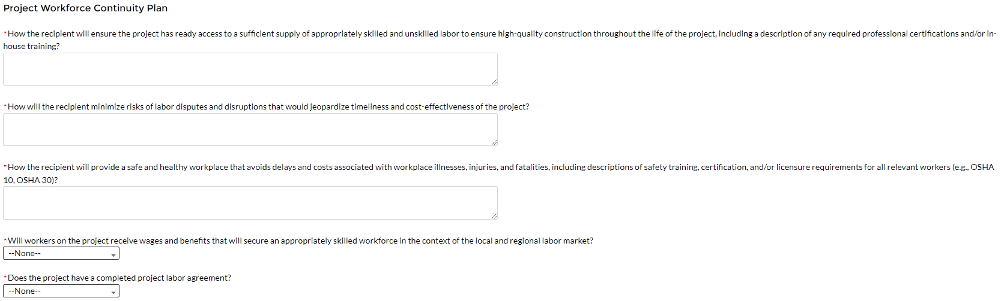

Figure Additional Questions if Response to Certifications of Labor Agreements is "No"

1. Whether the project prioritizes local hires (see Figure 38).
2. Whether the project has a Community Benefit Agreement, with a description of any such agreement (see Figure 38).

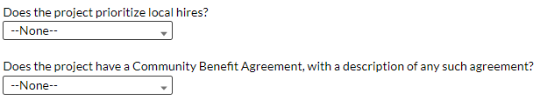

Figure Additional Certification Questions

## Revenue Replacement: Recipients will have the option to update or provide information associated with revenue replacement not previously provided as part of prior submissions. Information previously provided as part of the Interim Report (if provided) or Project and Expenditure Report (if provided) will display in this screen.

As outlined in the final rule, recipients will have the option to make a one-time decision to either calculate revenue loss according to the formula outlined in the final rule or elect a “Standard Allowance” of up to $10 million, not to exceed the award allocation, to spend on government services throughout the period of performance. **Recipients must make this one-time decision during the April 2022 reporting deadline.**

Standard Allowance

For recipients electing the “Standard Allowance”, Treasury will presume that up to $10 million, not to exceed the award allocation, in revenue has been lost due to the public health emergency and recipients are permitted to use that amount to fund “government services”. Please note that electing the standard allowance does not change a recipient’s total allocation.

Treasury’s Portal will allow all recipients to elect to use this standard allowance instead of calculating lost revenue using the formula. Refer to Figure 39. The following questions will display in the screen for all recipients, including those with total allocations of $10 million or less.

* Is your jurisdiction electing to use the standard allowance of up to $10 million, not to exceed your total award allocation, for identifying revenue loss? Yes/No (Please note electing the standard allowance does not change your total allocation).

If “Yes” is selected, recipients will enter further information to indicate to Treasury the amount of revenue loss the recipient is electing under the standard allowance, as noted in Figure 39.[5]

When entering the amount of revenue loss a recipient is electing under the standard allowance, recipients should note the following:

* If a recipient’s total allocation is $10 million or greater, the recipient may enter in the amount of revenue loss the recipient is electing up to $10 million.
* If a recipient’s total allocation is less than $10 million, the recipient may enter in the amount of revenue loss the recipient is electing up to your total allocation.

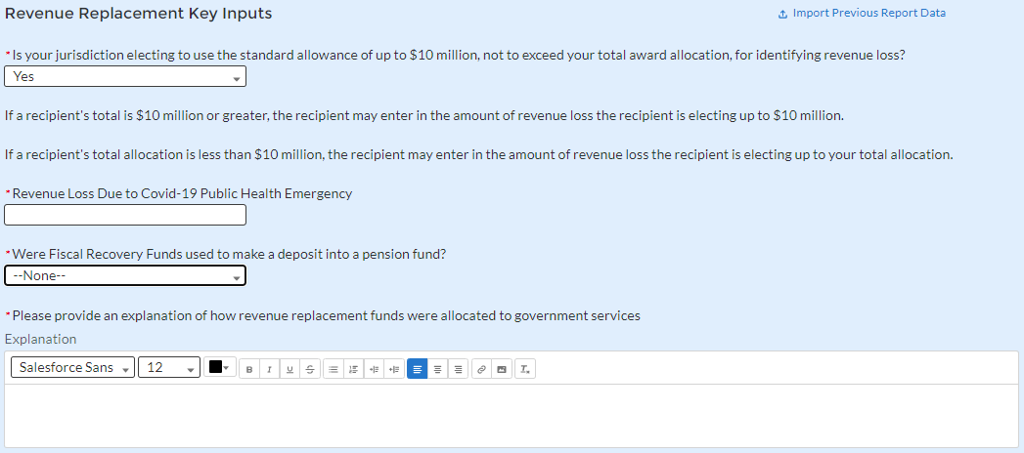

Figure Revenue Replacement Screen - Electing Standard Allowance

Calculating revenue loss according to the formula

For recipients calculating revenue loss according to the formula, note that the final rule permits recipients to choose whether to use calendar or fiscal year calculation dates. Recipients must use the same calculation time frame (calendar or fiscal year) throughout the award period. For the April 2022 reporting period, recipients will complete the revenue loss fields for 2020 and 2021 (if information is available), respectively. Figure 40 provides the screen recipients will complete for each year. Recipient will navigate to each year by clicking on the years.

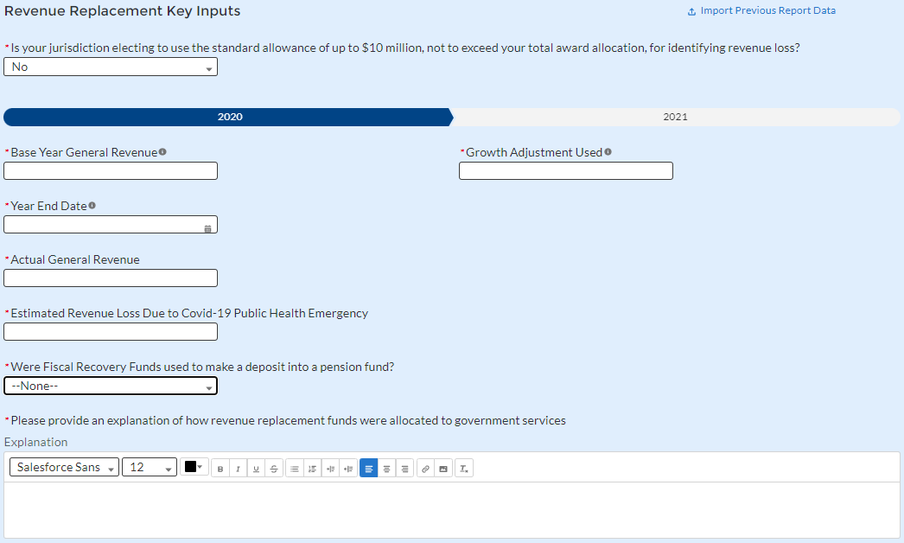

Figure Revenue Loss Using Formula

Summary

Based on the recipient’s election, certain information will display in Treasury’s Portal which the recipient will need to complete, as noted in the table below:

| **Data** | **If Using Standard Allowance** | **If not Using Standard Allowance**  **2020 and 2021 Information** |
| --- | --- | --- |
| Base Year Revenue | N/A | Required |
| Fiscal Year End Date | N/A | Required |
| Growth Adjustment Used | N/A | Required |
| Actual General Revenue[6] | N/A | Required |
| Revenue Loss | Required | Required |
| Select whether Fiscal Recovery Funds were used to a make a deposit into a pension fund. Please note that no recipients except for Tribal governments may use Fiscal Recovery Funds to make a deposit to a pension fund | Required | Required |
| Provide an explanation of how revenue replacement funds were allocated to government services | Required | Required |

1. **Edit or delete projects before submission**

Projects entered into the system can be edited or deleted before final submission. To edit a project, open the project from the My Projects screen. To delete a project, use the *Delete Project* Button. See Figure 41. If a report is already submitted, users will need to un-submit the report to edit or delete a project record, until the due date of the report.

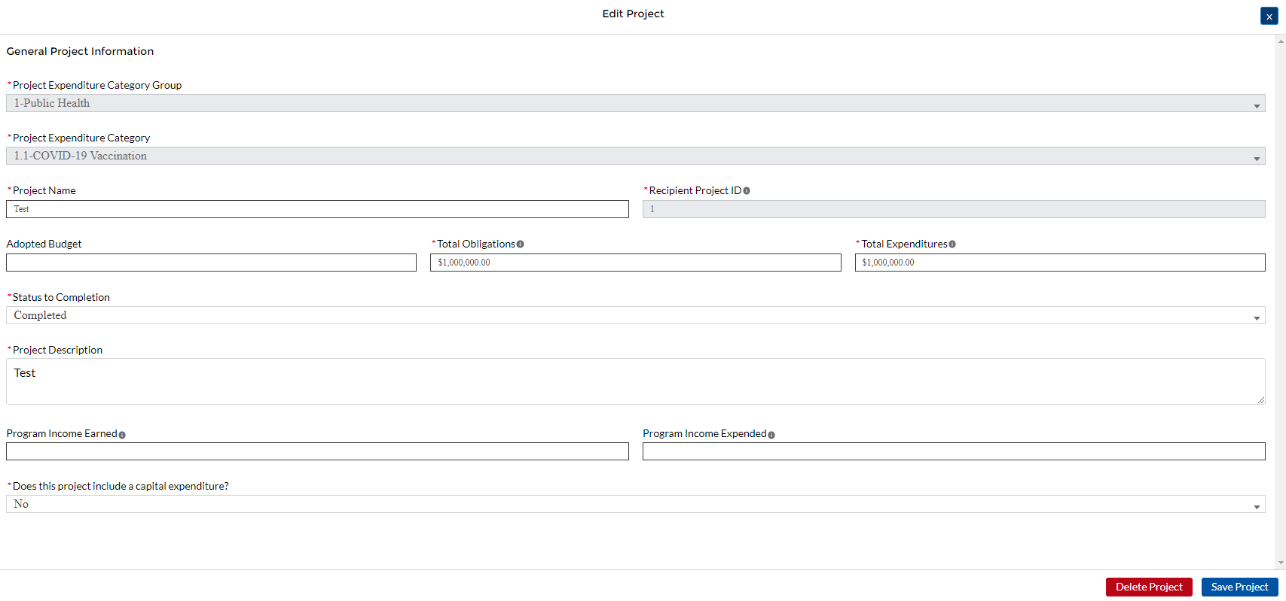

Figure Edit and Delete Project Screen

## **Enter projects using the bulk upload method:**

## Recipients have the option to provide project information via bulk upload, in lieu of manual entry for some or all of their projects. Please note, bulk upload templates are specific to the EC the project best aligns to. The table in Appendix C provides a mapping of project ECs to their appropriate bulk upload template.

1. Fill the downloaded template with information specific to each project’s EC, as follows. Projects within the same EC or set of ECs covered by a given template can be uploaded together. For example, all projects in EC 1.8, 2.29- 2.33 can be entered together on the Project Bulk Upload for Project EC 1.8, 2.29-2.33 Template. Optional fields are denoted by (*). “Column” below refers to the applicable area in the bulk upload file.

* Column B: Select the Project Expenditure Category Group
* Column C: Select the Project Expenditure Category
* Column D: Enter the Project Name
* Column E: Enter the unique project identification number assigned by the State or U.S. Territory to the project. Do not use duplicate project numbers for multiple projects
* Column F: Select the completion status of the project
* Column G: Enter the total dollar value of the adopted budget for this project * *(**only applicable to States, U.S. Territories, and metropolitan cities and* *counties with population over 250,000)*
* Column H: Enter the total dollar value of obligations for this project. If no amounts are obligated, enter “0”
* Column I: Enter the total dollar value of expenditures for this project. If no expenditures have been incurred, enter “0”
* Column J: Enter the current period value of obligations. If no new amounts were obligated, enter “0”
* Column K: Enter the current period value of expenditures. If no expenditures were incurred during the period, enter “0”
* Column L: For projects in EC 1, EC 2, or EC 3, enter a yes or no response to the question, does this project include a capital expenditure?
* Column M: If yes, what is the total expected cost of the capital expenditure?
* Column N: Enter the capital expenditure type based on list
* Column O: If “Other” was selected in Column N for Capital Expenditure Type, provide more details
* Column P: Enter the narrative for the capital expenditure
* Column Q: Enter a description of the project
* Column R: Enter the amount of program income earned
* Column S: Enter the amount of program income expended
* Column T: Enter the Project Demographic Distribution Primarily Populations Served
* Column U: If selecting a population needing specification, enter that specific population
* Column V: Enter the Project Demographic Distribution Secondary Populations Served, if applicable
* Column W: If selecting a population needing specification, enter that specific population
* Column X: Enter the Project Demographic Distribution Additional Populations Served
* Column Y: If selecting a population needing specification, enter that specific population
* Column Z: Enter a brief description of structure and objectives of assistance program(s), including public health or negative economic impact experienced
* Column AA: Enter a brief description of recipient’s approach to ensuring that response is reasonable and proportional to a public health or negative economic impact of Covid-19, as described in the final rule
* Column AB: Enter the number of small businesses served (by program if recipient establishes multiple separate small businesses assistance programs)

1. Upload the Project Entry and Status template, in this case the template for EC 1.8, 2.29-2.33, separately as a .csv file by using the respective *Upload* button on the screen or dropping the files in this view.

### Once all of the above information is entered, click *Add Project*. Click the *Next* button to proceed to the following screen.

## Refer to Appendix B for additional information related to the bulk file upload process

## **Subrecipients, Beneficiaries, or Contractors**

The Subrecipients, Beneficiaries, or Contractor Profile documents the information about each subrecipient, contractor or beneficiary that has received at least one Subaward or Direct Payment obligation of federal funding greater than or equal to $50,000 to execute projects supporting the SLFRF program. Please note that projects entered under EC 6.1 Provision of Government Services are not required to enter Subrecipient, Subaward, or Expenditures (for a subaward) information for the April 2022 reporting cycle.

In addition, individual persons receiving direct payment of federal funds are not required to be reported in this module. They should be reported in aggregate under the Payments to Individuals section of the Expenditures module.

The Subrecipients, Beneficiaries and Contractors module allows users to enter data manually or leverage the bulk file upload capability. For bulk-upload instructions specific to this submodule, see Appendix B. You can download the bulk file template for use in submitting the required data via bulk upload. When ready to submit the data, use the upload button (see Figure 42).



Figure Subrecipient/Beneficiaries Bulk Upload Icon

**Note:** When using the bulk file upload capability, the Subrecipient bulk upload must be completed prior to beginning the data entry for the Subawards module.

If you choose to individually enter records, follow the instructions below.

### Enter the Entity Type you are creating a record for. This can be either Subrecipient, Contractor, or Beneficiary.

### Enter the relevant Subrecipient, Beneficiary, or Contractor information in each of the required fields (see Figure 43). Recipients must enter at least one of the following two identifiers for a subrecipient: UEI (Unique Entity Identifier), or TIN.

### Note: Recipients should be aware that the federal government has transitioned from the use of DUNS starting in April 2022. Active SAM.gov registrants will have their UEI assigned and viewable within SAM.gov.

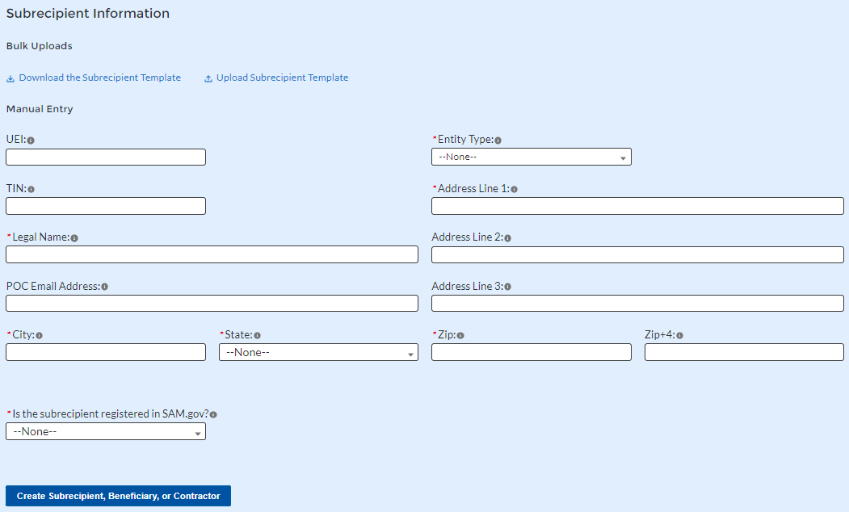

Figure Manually Create a Subrecipient or Beneficiary

### If the subrecipient is not registered in SAM.Gov, select “No” from the picklist. Two additional questions will populate the space below (see Figure 44).

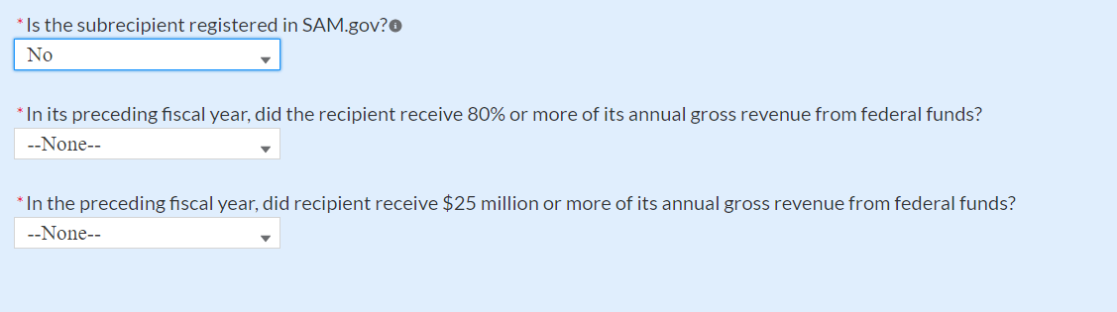

Figure Sam.gov Questions for Subrecipients, Contractors or Beneficiaries

1. If the subrecipient’s five most highly compensated executives received 80% or more of its annual gross revenue from Federal procurement contracts (and subcontracts) and Federal financial assistance subject to the Transparency Act, as defined at [2 CFR 170.320](https://www.ecfr.gov/current/title-2/section-170.320) (and subawards), AND received $25 million or more of its annual gross revenue from Federal procurement contracts (and subcontracts) and Federal financial assistance subject to the Transparency Act, as defined at [2 CFR 170.320](https://www.ecfr.gov/current/title-2/section-170.320) (and subawards), an additional question will appear (see Figure 45).

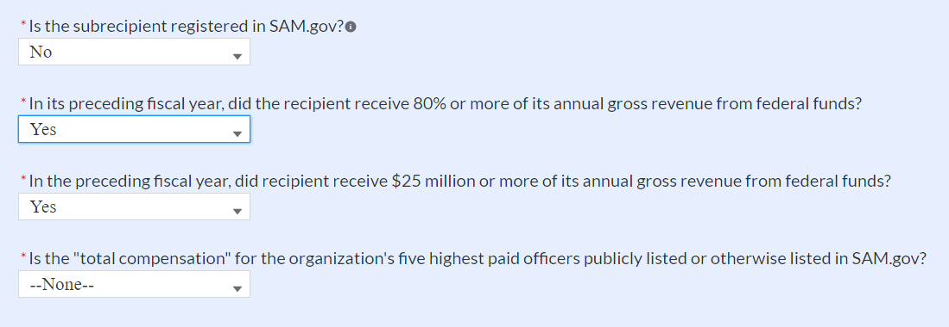

Figure Additional SAM.gov questions for Subrecipients, Contractors, and Beneficiaries

1. Select “Yes” if the total compensation for the recipient five highest paid officers is publicly listed or otherwise listed in SAM.Gov and move on to step 7 below.
2. Select “No” if the total compensation for the recipient five highest paid officers is not publicly listed or otherwise listed in SAM.Gov. Enter the name(s) of the officer(s) in the chart that will appear (see Figure 46) and the total compensation received by each. If fewer than five (5) officers exist, enter “N/A” and $0 in the empty field(s).

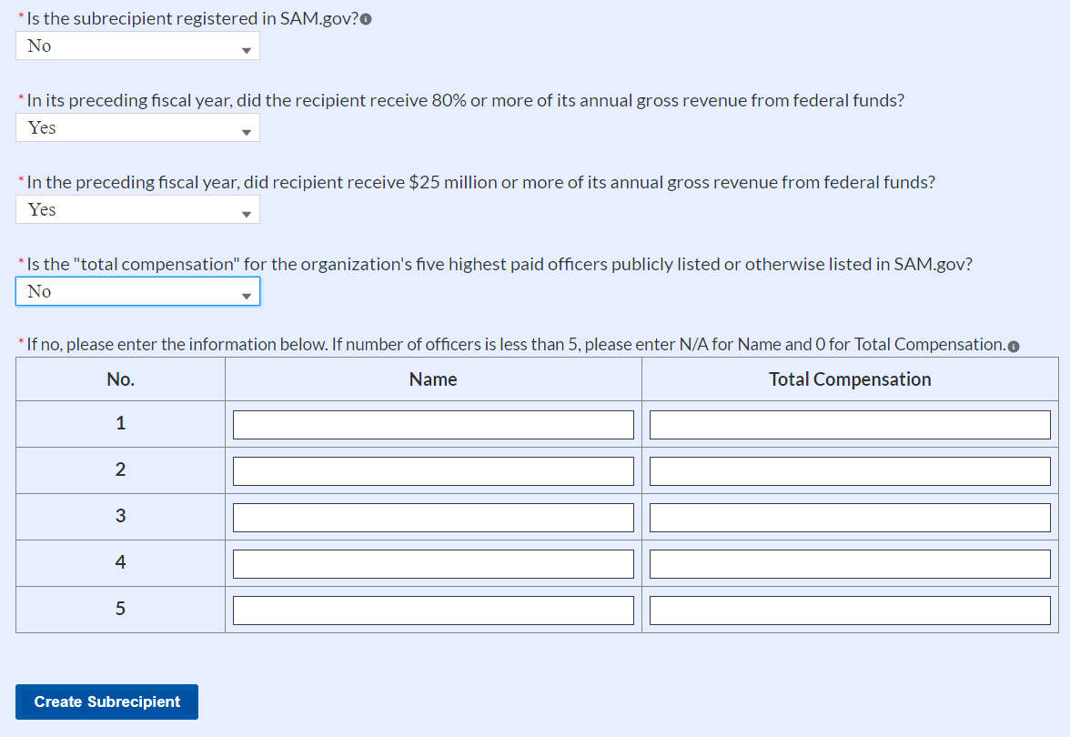

Figure Five Highest Paid Officers for Subrecipients, Contractors or Beneficiaries

### At the bottom of the page, click the *Create Subrecipient* icon to complete the Subrecipient record and return to Subrecipient screen.

1. Subrecipients, Contractors, or Beneficiaries entered into the system are shown at the bottom portion of the screen (see Figure 47).

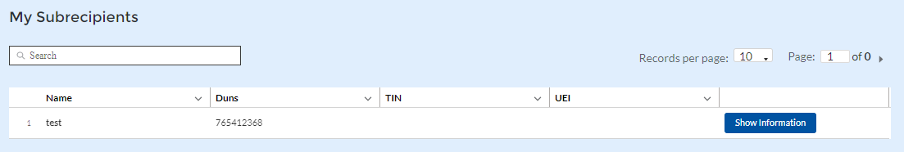

Figure Subrecipients or Beneficiaries Entered

## **Subawards or Direct Payments**

## The Subawards or Direct Payments section allows recipients to enter the required information regarding Subawards or Direct Payment of federal funding greater than or equal to $50,000 for all direct payments, subawards, and contracts made by your organization under SLFRF. Please note that projects entered under EC 6.1 Provision of Government Services and EC 6.2 Non-federal match for other Federal Programs are not required to enter Subrecipient, Subaward, or Expenditures (for a subaward) information for the April 2022 reporting cycle.

The Subawards or Direct Payments module allows users to enter data manually or leverage the bulk file upload capability. For bulk-upload instructions specific to this submodule, see Appendix B. You can download the bulk template using the provided link in Treasury’s Portal before using the upload button (see Figures 48 and 49).



Figure Subaward Bulk Upload (1)

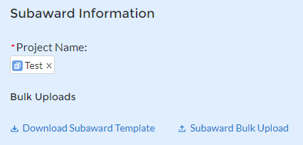

Figure Subaward Bulk Upload (2)

**Note:** Subaward bulk upload can only be completed after Project and Subrecipient bulk entries are completed.

If you choose to individually enter records, follow the instructions below.

### Enter the following fields pertaining to the Subawards or Direct Payments (see Figure 50):

### Project Name from picklist

### Subrecipient or Direct Payment Recipient Name from the picklist

### Subaward Number

### Subaward type

### Subaward Amount (Obligation)

### Subaward Date

### Period of Performance Start

### Period of Performance End

### Brief description of Subaward and its underlying eligible use

### Place of Performance Address, City, State, Zip

### Brief description of Subaward and its underlying eligible use

### Select the Subaward Type from the drop-down picklist:

### Contract: Purchase order

### Contract: Delivery order

### Contract: Blanket Purchase Agreement

### Contract: Definitive contract

### Grant: Lump sum Payment(s)

### Grant: Reimbursable

### Loan - Maturity prior to 12/31/26 with planned forgiveness

### Loan - Maturity prior to 12/31/26 without planned forgiveness

### Loan - Maturity past 12/31/26 with planned forgiveness

### Loan - Maturity past 12/31/26 without planned forgiveness

* + Direct Payment
  + Transfer: Lump Sum Payment(s)
  + Transfer: Reimbursable

Note for loans: Loan maturity date will be required.

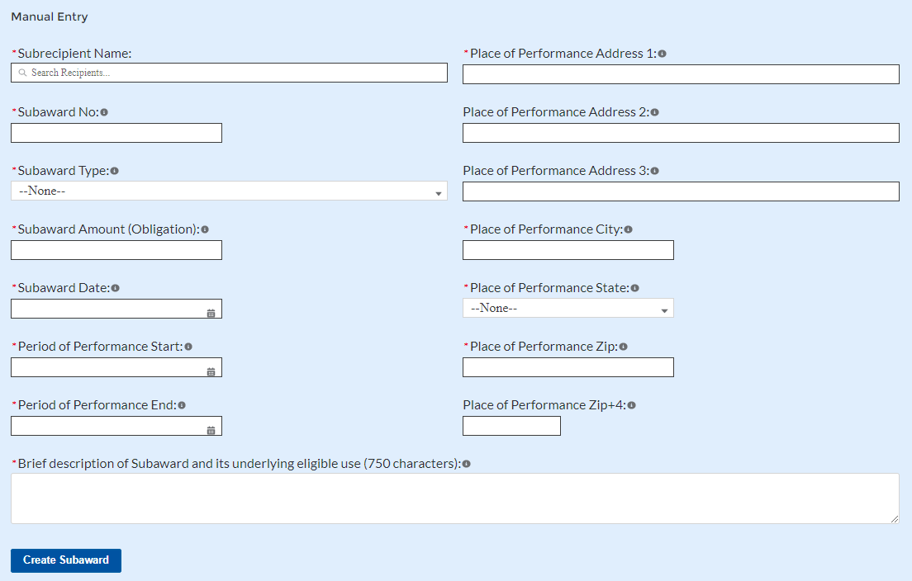

Figure Subaward Reporting

### Click *Create Subaward* to establish the Subaward record. Repeat Steps 1 through 3 to create additional Subaward records.

1. Subawards entered into the system are shown at the bottom portion of the screen (see Figure 51).

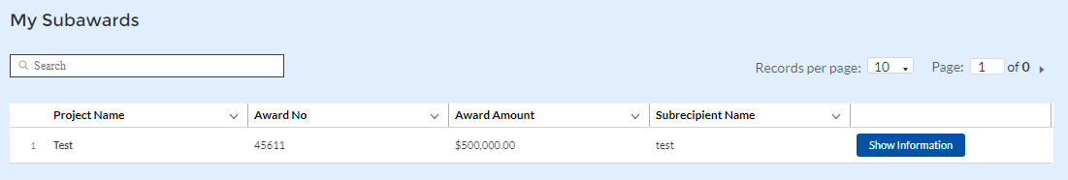

Figure Subaward Entered

## **Expenditures**

In the Expenditures tab, recipients will provide information for each contract, grant awarded, loan issued, transfer made to other government entities, or direct payment greater than or equal to $50,000. Additionally, aggregate reporting is required for contracts, grants, transfers made to other government entities, loans, and direct payments that are less than $50,000.

As mentioned above, obligations and expenditures made directly to individuals, regardless of dollar amount, should be included in aggregate reporting.

If aggregated expenditures linked to a project equal the total Expenditures reported for that project, the Subaward status box on the My Projects screen is changed to ‘Complete’. Please note that projects entered under EC 6.1 Provision of Government Services and EC 6.2 Non-federal match for other Federal Programs are not required to enter Subrecipient, Subaward, or Expenditures (for a subaward) information for the April 2022 reporting cycle.

The Expenditures reporting module allows users to enter data manually or leverage the bulk file upload capability. For bulk-upload instructions specific to this submodule, see Appendix B.

If you do not use the bulk upload function, follow the steps listed below.

### To report new expenditures under a specific subaward, enter the subaward number. The Project Name associated with the subaward will auto populate.

### Enter the following:

### Expenditure Start Date

### Expenditure End Date

### Expenditure Amount

### Enter narrative for Administrative Costs, if applicable.

### Click the *Create Expenditure* button to submit the record. Repeat Steps 1 through 3 to report additional sub-award expenditures. Proceed to the next segment once all sub-award expenditures are reported.

1. **Expenditures for Awards Greater Than or Equal To $50,000**

For expenditures for awards greater than or equal to $50,000, fill out the “Expenditures for Awards > $50,000” box (see Figure 52). Project name and subaward will be selected to link each expenditure to the appropriate entries. Note that the Project name is automatically identified based on the associated Subaward No. entered. Once the information has been entered, click the *Create Expenditure* button on the bottom left of the box.

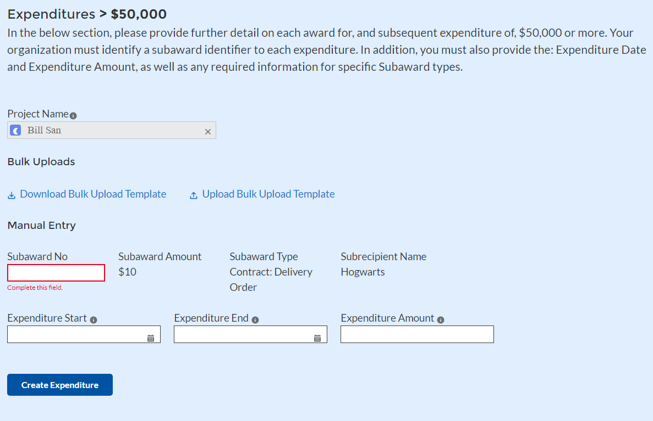

Figure Expenditures >$50,000

Alternatively, the Expenditures for Awards greater than $50,000 bulk upload template (Figure 53) may be used and uploaded with the relevant information.

1. **Aggregate Expenditures for Awards Less than $50,000**

For expenditures for awards less than $50,000, fill out the “Aggregate Expenditures < $50,000” box (see Figure 53). Select the project name from the picklist, enter the subaward type, total period obligation amount, and total period expenditure amount. Once the information has been entered, click the *Create Expenditure* button on the bottom left of the box. Note that no Subaward is necessary for Aggregate Expenditures for awards less than $50,000.

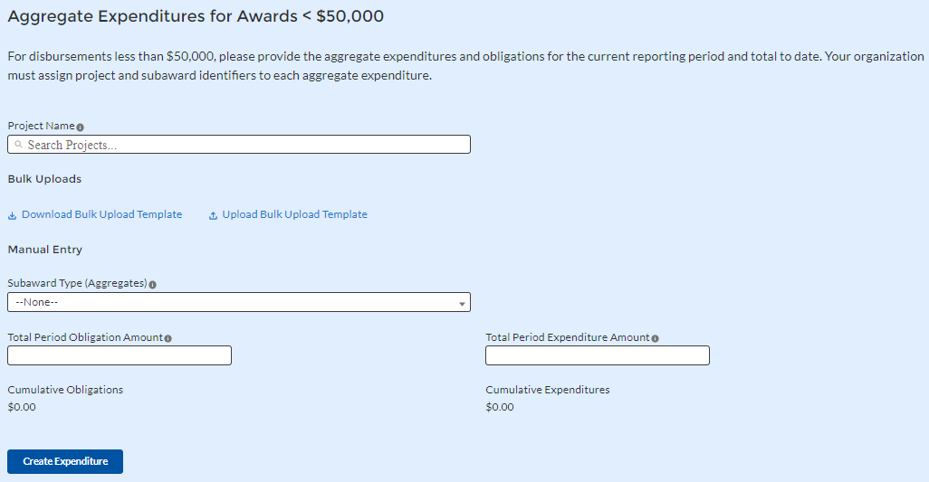

Figure Aggregated Expenditures for Awards Less than $50,000

Aggregate subaward types available for selection are as follows.

* Aggregate of Contracts Awarded
* Aggregate of Grants Awarded
* Aggregate of Loans Issued
* Aggregate of Transfers
* Aggregate of Direct Payments

Alternatively, the Aggregate Expenditures for Awards less than $50,000 bulk upload template may be used and uploaded with the relevant information.

1. **Payments to Individuals**

For disbursements to individuals, recipients should complete the “Payments to Individuals” box (see Figure 54) with expenditure information. Once this information has been entered, click the *Create Expenditure* button on the bottom left of the box.

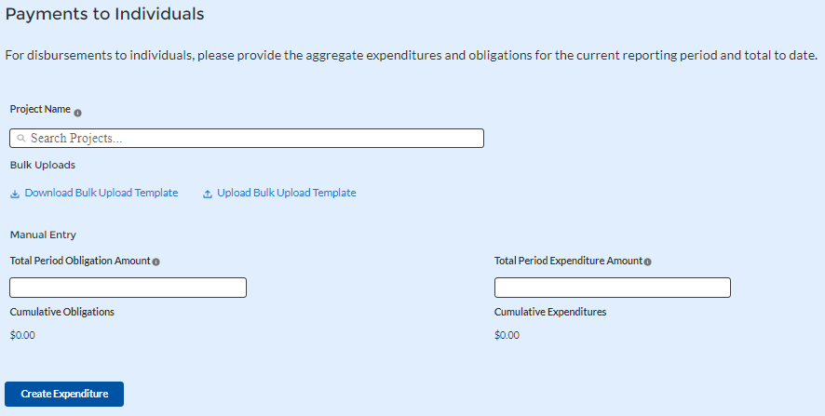

Figure Payments to Individuals

Alternatively, the Payments to Individuals bulk upload template (Figure 54) may be used and uploaded with the relevant information. Note the need to manually identify the Project Name as no Subaward is necessary for Payments to Individuals.

Once entries are complete, click the *Next* button on the bottom right of the page. This will bring recipients to the Report tab.

## **Tax Offset Provision (Only for States and U.S. Territories)**

Baseline revenue or revenue-increasing covered changes information is not required at this time. State and U.S territory recipients should provide the amount of revenue-reducing covered changes covering the periods of date of award through July 31, 2021, and separately, August 1, 2021 through December 31, 2021. (See Figure 55).

See Section C (11) of the [Reporting Guidance](https://home.treasury.gov/system/files/136/SLFRF_Treasury-Portal-Recipient-Reporting-User-Guide.pdf) for additional information.

Additional guidance and reporting fields will be forthcoming for the tax offset provision in subsequent reporting periods, which is expected to require reporting for prior periods as well as current period.

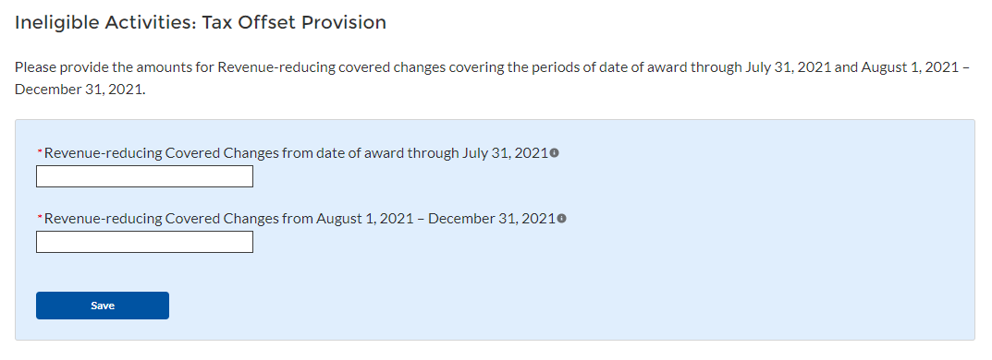

Figure Tax Offset Provision Screen

1. **Official Certification**

On this screen, the Authorized Representative for Reporting (ARR) will be asked to certify information pertaining to the Project and Expenditure Report. By certifying this submission, the ARR is confirming that all reported information is accurate and approved for submission (see Figures 56 and 57).

Users who are not designated as an ARR will not be able to certify and submit.

1. On the Certification screen, validate that the review section project overview status is free of system identified errors. Figure 56 indicates that an error has been identified with the expenditure status. Figure 57 shows a clean status, and the system will allow submission of the report.

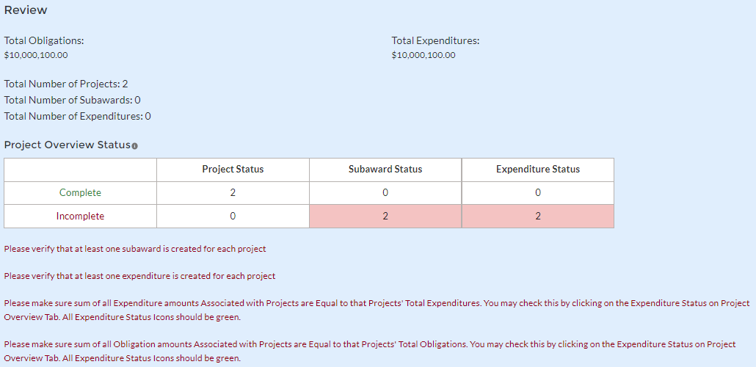

Figure Project Overview Status with Errors

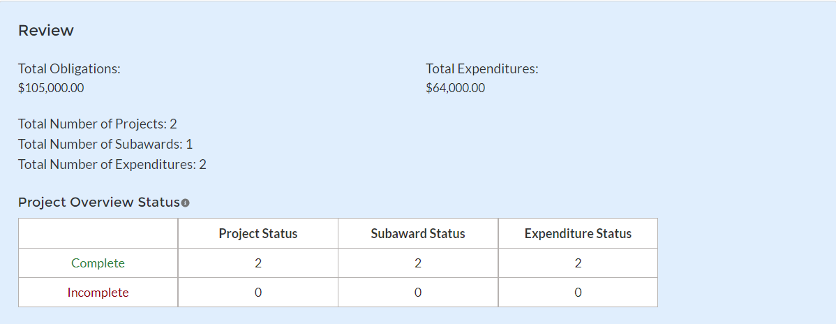

Figure Project Overview Status with No Errors

1. The ARR’s Name, Title, Telephone Number, and E-Mail Address will be presented on screen for review.
2. Allow the Certifying Official to review all prior screens and entries to verify accuracy of the inputted record.

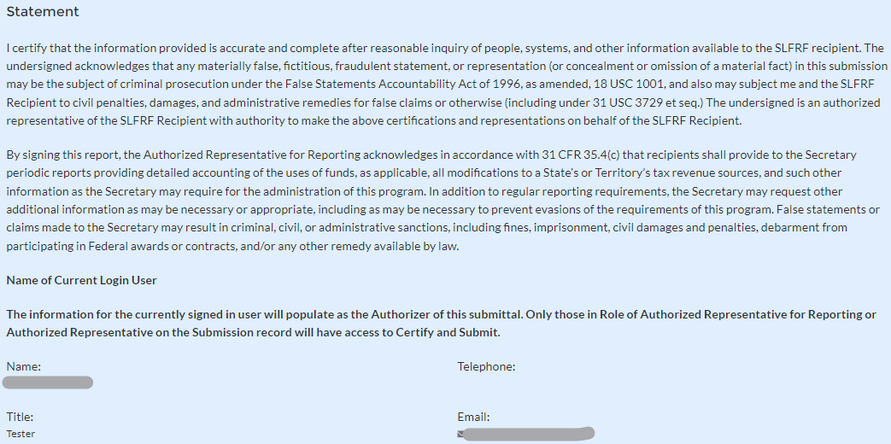

Figure Official Certification

### Verify information included in Figure 59 and confirm that the values presented are as expected based on the information included or uploaded in previous screens.

### When certifying and submitting the report, a confirmation box will appear asking if the recipient is sure it wants to submit (see Figure 60).

### 

Figure Submission Verification

1. A confirmation box may also appear with additional certification language depending on the programmatic data inputs in the user’s report. Figure 60 shows an example of project-dependent certification language.

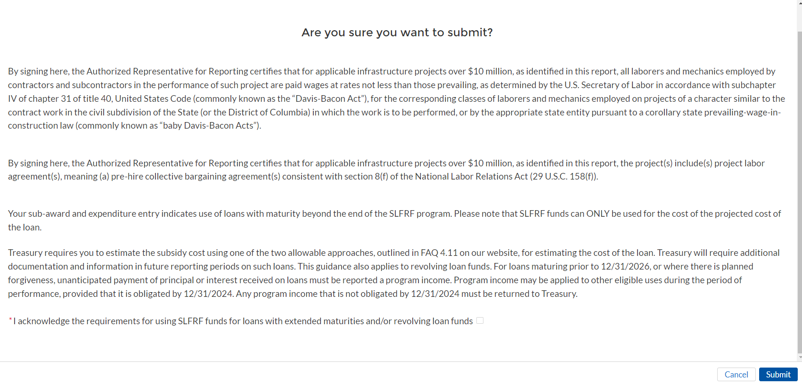

Figure Submission Verification with Additional Language

### Once all of the information is validated, click the *Submit* button to complete the entry.

# **Appendix A – Designating SLFRF Points of Contact by SLFRF Account Administrators**

This section provides a brief instruction for SLFRF Account Administrators on accessing Treasury’s Portal to provide the names and contact information of officials to be designated as your organization’s points of contact for the SLFRF award(s). The following pages provide step-by-step guidance. See FAQ Section B for commonly asked questions/answers on this topic.

Note- the screens noted below may be subject to change.

**Section A: Instructions**

**Step 1**  
You must be registered in the ID.me or Login.gov system to access Treasury’s Portal. If you have questions about registering in ID.me or Login.gov, please email SLFRP@treasury.gov.

**Step 2**  
Once you are registered in ID.me or Login.gov, click on the link in the email you received requesting the POC designations. If you do not have the email link, please email us via SLFRP@Treasury.gov and we will provide the link.

**Step 3**   
The link will take you to the Treasury Portal “State, Local, and Tribal Support” landing page as shown below. Once on that page, click on the *Go to Your Reports* button at the bottom left of the screen, as indicated in by the red box below.

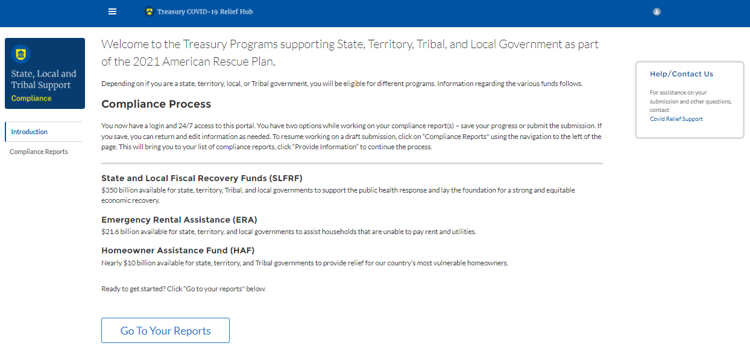

Figure State, Local and Tribal Support Landing Page

**Step 4**The green *Go to Your Report* button will take you to the Submissions and Compliance page as shown below. Once on that page, click on the three-line navigation icon at the top left of the screen. The red box indicates the icon.

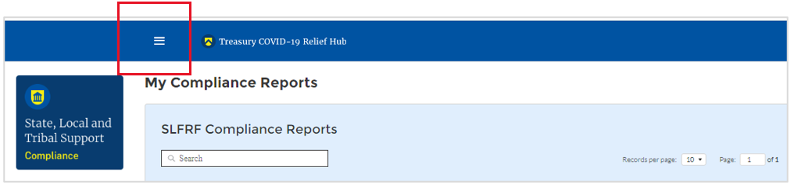

Figure My Compliance Reports

**Step 5**After clicking on the three-line navigation icon, a drop-down menu will appear on the top left of the screen as shown below. Please click on “Account” from the drop-down menu, as shown by the red box below.

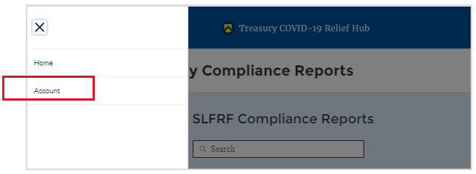

Figure Account

**Step 6**   
Next you will see the screen below. Under the “Account Name” heading, click on the name of your organization (as shown by the red box).

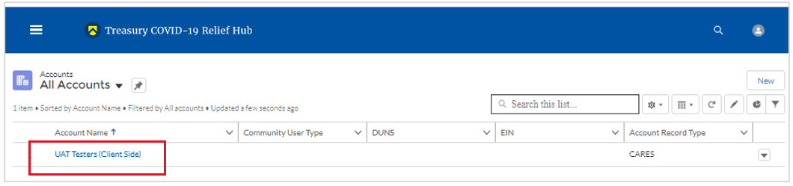

Figure Account Name

**Step 7**  
By clicking the name of your organization, Treasury’s portal will open to allow you to provide names and contact information on your organization’s designees for the SLFRF reports, as shown below. The landing page provides basic information about the designations. Please see section B for more details about the roles and responsibilities for each or the three roles.  
  
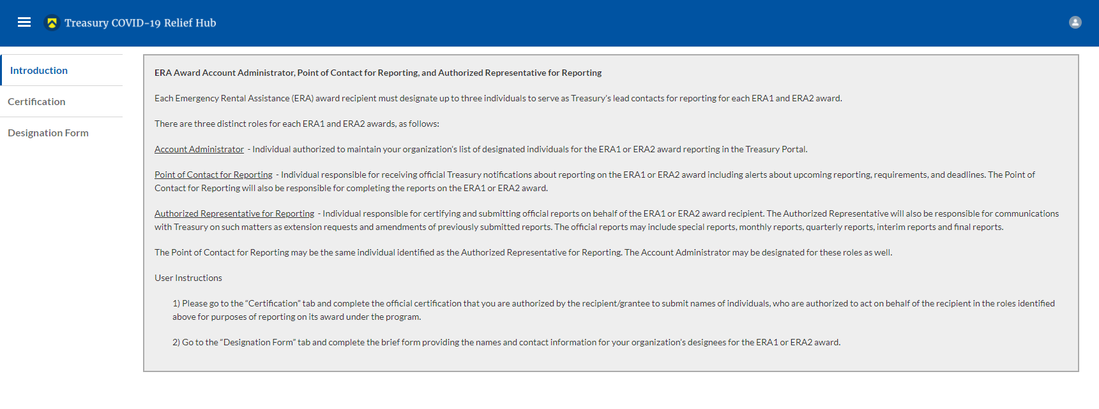

Figure Landing Page

**Step 8**When you are ready to key in the names of the designated individuals, click on the *Certification* button on the left navigation bar, as noted in the red box shown below.

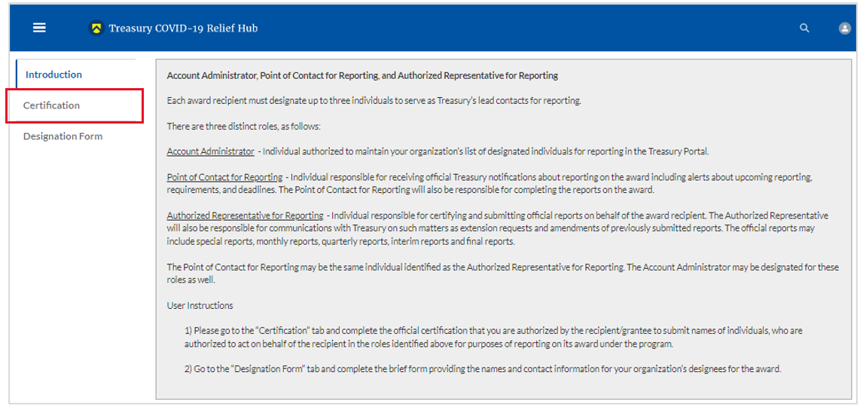

Figure Certification

**Step 9**On the “Official Certification of Authorization” screen, you should type in your name to indicate you are authorized to submit the names of the designated individuals. Once you enter your name, click on the *Submit b*utton.

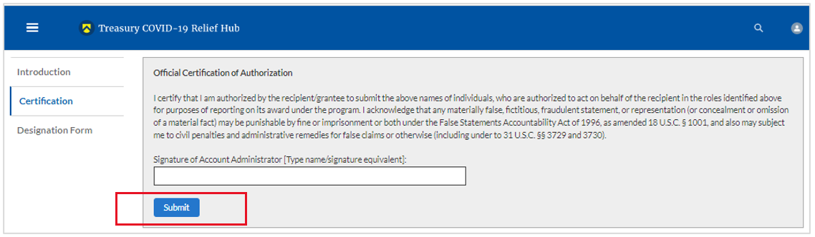

Figure Official Certification of Authorization

**Step 10**Next, click on the *Designation Form* button on the left navigation bar, as noted by the red box shown below.

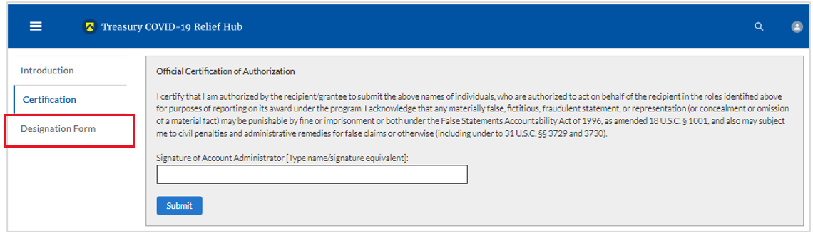

Figure Designation Form

**Step 11**Clicking on the *Designation Form* button will open the “Designation of Account Administrator, Point of Contact for Reporting, and Authorized Representative for Reporting” screen shown below.

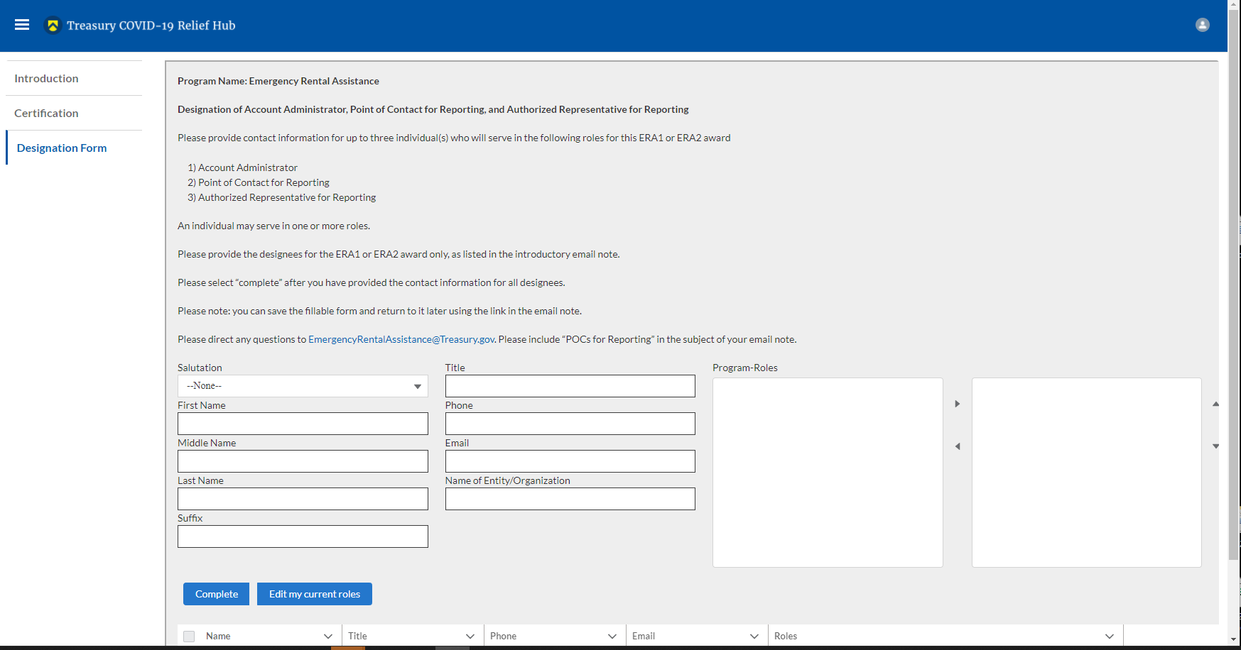

Figure Designation of Account Administrator, Point of Contact of Reporting and Authorized Representative for Reporting

You can use the Designation Form to enter the names and contact information for each of the three designations for each of you SLFRF allocations.

The roles for the SLFRF allocations are displayed as follows:

* SLFRF – Account Administrator
* SLFRF – Point of Contact for Reporting
* SLFRF – Authorized Representative for Reporting

The Designation Form screen shows nine data fields for entering key information about the individual being designated. These include:

* Salutation (optional)
* First Name
* Middle Name (optional)
* Last Name
* Suffix (optional)
* Title
* Phone
* Email
* Name of Entity/Organization (Recipient entity)

Note: The screen will display a list at the bottom of the screen with the names and contact information of individuals (if any) who have previously been designated for any of the three roles. This list will be important in maintaining and updating your organization’s designees in the future.

1. **Designation of the Account Administrator**

Remember, we have temporarily authorized you as the SLFRF – Account Administrator. There is no need to re-enter your name and contact information if you plan to continue in that role. If you need to designate someone else as the SLFRF Account Administrator,

* Find your name at the bottom of the screen.
* Hit the blue *Edit* button located to right of your name.
* Enter the name and contact information of the new SLFRF Account Administrator.
* Hit the blue *Complete* button.

1. **Designation of Point of Contact for Reporting and Authorized Representative for Reporting**

* Enter the next designee’s name and contact information.
* After entering their name and required contact information, select the Program Role(s) for which he/she is being designated.
* Once the role is selected, click on the small arrow to the right of the role, which will move the role to the box on the right.
* Click on the *Complete* button at the bottom of the screen.
* Follow the same process for each of the remaining designees.
* When you have entered all three designations, please press the *Complete* button.
* As a final step, go to the icon on the upper right of the screen as shown below to exit the system.

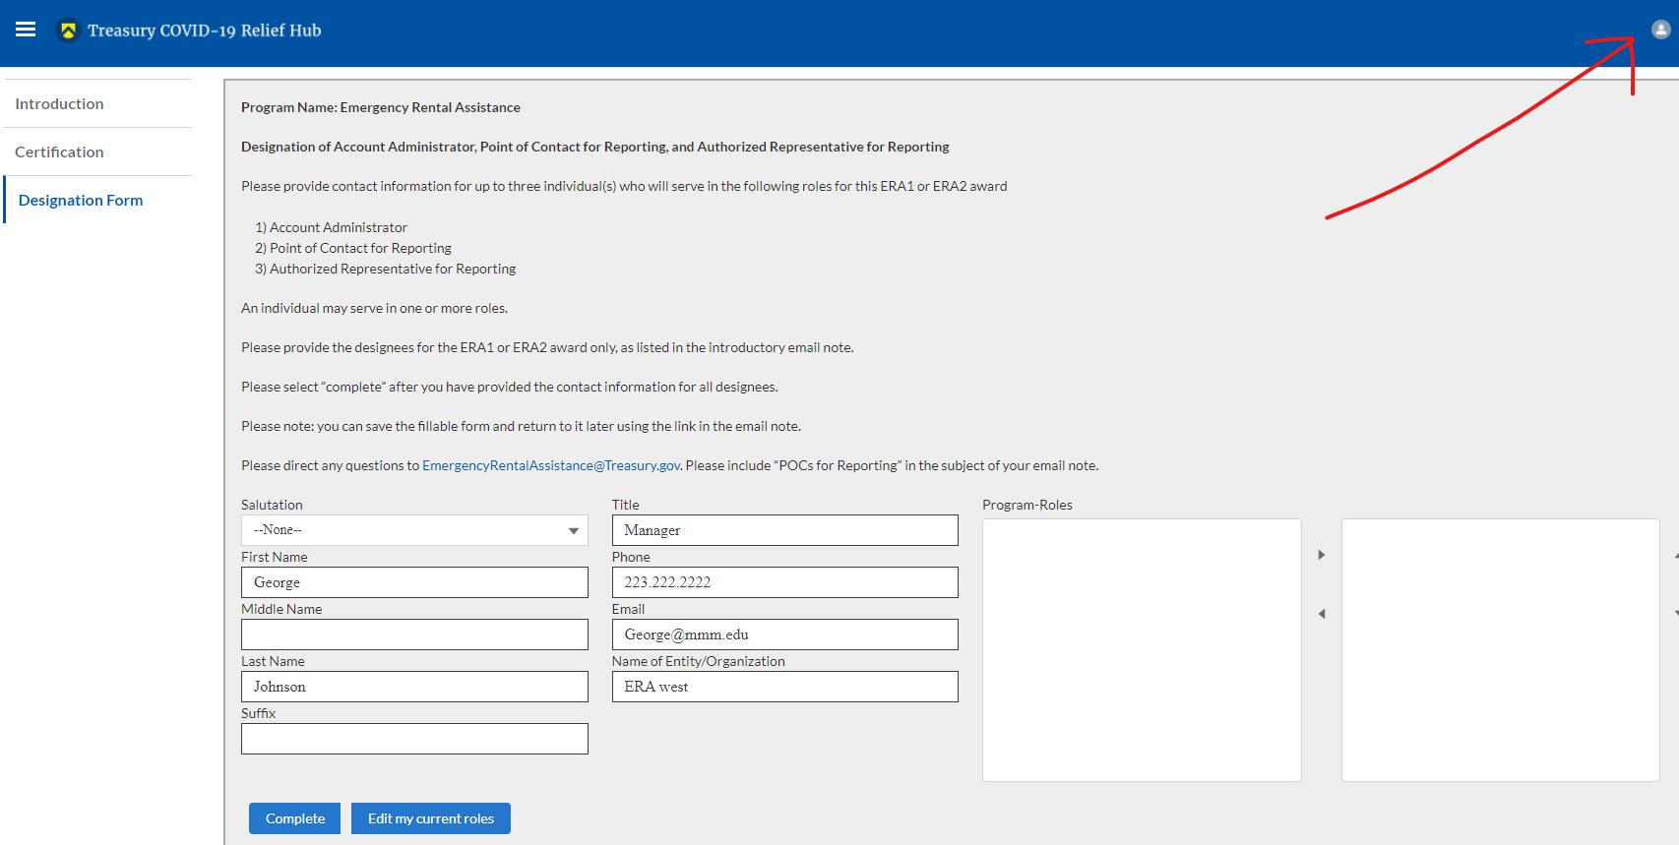

Figure Designation Form

**Section B: Questions and Answers**

**Who is authorized to designate the Account Administrator, the Point of Contact for Reporting, and the Authorized Representative for Reporting for my organization’s SLFRF’s award?**

Treasury requests that each SLFRF should follow its own decision-making procedures in making the three designations for each award.

**What is the deadline for making the designation?**

Treasury requests that users of Treasury’s portal make the three designations as soon as possible to enable your organization to submit required reports.

**What are the responsibilities for each of the three designated roles?**

## The required roles are as follows:

* **Account Administrator** for the SLFRF award has the administrative role of maintaining the names and contact information of the designated individuals for SLFRF reporting. The Account Administrator is also responsible for working within your organization to determine its designees for the roles of Point of Contact for Reporting and Authorized Representative for Reporting and providing their names and contact information via Treasury’s Portal. The Account Administrator can also view and submit reports. Finally, the Account Administrator is responsible for making any changes or updates as needed over the award period. We recommend that the Account Administrator identify an individual to serve in his/her place in the event of staff changes.
* **Point of Contact for Reporting** is the primary contact for receiving official Treasury notifications about reporting on the SLFRF award, including alerts about upcoming reporting, requirements, and deadlines. The Point of Contact for Reporting is responsible for completing the SLFRF reports but cannot certify and submit these reports.
* **Authorized Representative for Reporting** is responsible for certifying and submitting official reports on behalf of the SLFRF award recipient. Treasury will accept reports or other official communications only when submitted by the Authorized Representative for Reporting. The Authorized Representative for Reporting is also responsible for communications with Treasury on such matters as extension requests and amendments of previously submitted reports. The official reports may include special reports, monthly reports, quarterly reports, interim reports, and final reports.

**May my organization designate one individual for multiple roles?**Yes, an individual may be designated for multiple roles. For example, the individual designated as the Account Administrator can also be designated as the Authorized Representative for Reporting or Point of Contact for Reporting. It is also acceptable for an organization to designate one individual for all three roles however it should also adhere to any applicable rules on personnel checks and balances.

**May my organization designate more than one individual per role?**Yes, you may designate more than one person per each role but are encouraged to limit the number of users assigned to each role.

**May my organization change the designations from time to time?**Yes, an organization may make changes and updates to the list of designation individuals whenever needed.

**Must each of the designated individuals register for using Treasury’s Portal?**Yes, everyone designated for any of the roles must register with ID.me or Login.gov before they will be given access to Treasury’s portal. Please contact us at the email address below for more information and guidance on registering with ID.me or Login.gov. If you are already registered with ID.me, you do not have to register to Login.gov to access your reports.

**Additional Questions or Additional Assistance?**If you have additional questions about accessing or using Treasury’s portal to provide the designees’ names and contact information, please send us an email via [SLFRP@treasury.gov](mailto:SLRFP@treasury.gov).

# **Appendix B – Bulk File Upload Overview**

1. **Purpose**

This Appendix provides an overview of the SLFRF bulk file upload process. The six (6) bulk file upload templates listed below are presented in the order in which they should be populated and submitted to the SLFRF Treasury Portal. The data requirements for each template can be found in subsequent sections of this Appendix.

1. Project Baseline Template (*Note: This template will be used for Expenditure Categories 1.1-1.7, 1.10, 1.11-1.14, 2.9-2.13, 2.15-2.23, 2.28, 2.35, 2.37, 3.3-3.5, 7.1-7.2)*
2. Subrecipient Template
3. Subaward Template
4. Expenditures GT $50,000 Template
5. Aggregate Expenditures LT $50,000 Template
6. Payments to Individuals Template
7. **Expenditure Category (EC) Templates**

Expenditure Categories (EC) which require additional programmatic data and other information are listed below. The reporting requirements for each EC can be found in Appendix D.

1. Project Baseline Template
2. Project EC 1.8, 2.29-2.33 Template
3. Project EC 1.9, 2.34 Template
4. Project EC 2.36 Template
5. Project EC 2.1-2.8 Template
6. Project EC 2.14, 2.24-2.27 Template
7. Project EC 3.1 Template
8. Project EC 3.2 Template
9. Project EC 4.1-4.2 Template
10. Project EC 5.1-5.18 Template
11. Project EC 5.19-5.21 Template
12. **Template Description**

Each of the bulk file upload templates contains instructions on how to populate the respective fields within each file. When adding content to each template, please follow the “Help” text, which will provide what is and isn’t permitted for each cell. Each Module in the web application provides a link to download the template. All templates have the same structure as described below:

Row 1: Template Version

Row 2: Template Name

Row 3: Instructions: Brief description of the template constraints.

Row 4: Field IDs: Column identifiers

Row 5: Required or Optional: This field specifies if the field is optional or required. When the column is required, and a recipient does not provide the required data, the system will not accept any record or allow the file to be uploaded. NOTE: Due to system constraints, some required fields that are conditional based on the Expenditure Category are marked as optional in the bulk upload templates.

Row 6: Field Name: Brief description of each Field or Column

Row 7: Field Help Text: Provides a description of the column. There are 2 types of fields, 1). an open value either text or numbers and 2). A predefined list of pick list values:

* Open Value: Any text or number. Text for State name or a Number that represents amounts. Most text types are free formats, the only expectation is for Dates, each column that represents a date describes the accepted format. For any number field, it is not required to add “,” to represent thousands or it is not required to add “$” to represent currency. Only add decimal “.” when needed.
* Pick List: A Predefined list of values that is accepted by the system. When the column is a pick list, row 7 provides the list of options that the system accepts. End users should “copy and paste” the valid value for each record. If the respondent provides a value that is not in the predefined pick list, the system will not accept the file. Responses should not contain double quotes

Row 8: Data that recipient submits. Row 8 is where recipients insert specific data to submit. The system accepts 1 or many rows.

*The following is special guidance for each row or set of rows:*

1. Do not change the content of rows 1 to 7.
2. Rows 4 to 7 provide metadata of each data element or column of the information that recipients will provide.
3. Add your data beginning in row 8, column B.
4. **Bulk Upload Process**

The upload process includes the following steps:

1. Download the template from the link provided in the web application section of the module.
2. Open the template in Microsoft Excel.
3. Add your data starting with row 8, column B of the applicable template.
4. When you finish adding your data for row 8, repeat on additional rows as required.
5. Save the template as a .CSV file and change the name of the file if needed.
6. Click the Bulk Upload link to open the Bulk Upload box (see Figure 71).

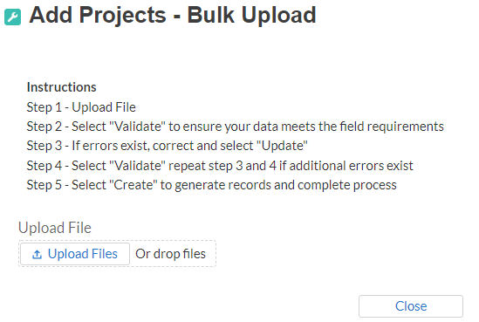

Figure Bulk Upload Pop Up

1. Attach your saved .CSV file by clicking on “Upload Files”, alternatively you can drag the file to the designated area.
2. A message will appear confirming that your file is uploaded (see Figure 72). Click “Done”.

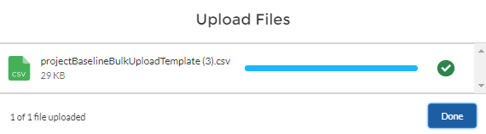

Figure File uploaded message

1. Your file will be listed at the bottom of the bulk upload window (see Figure 73).

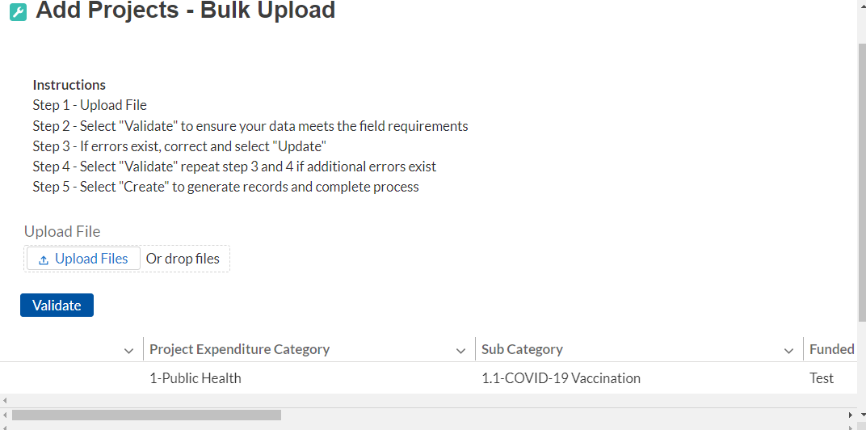

Figure File added to Bulk Upload portal

1. Click “Validate” to have the system verify that your bulk upload does not have errors.
2. If the system validation finds errors in your bulk upload, it will return the screen with the list of the errors (see Figure 74). From here, you can either update on the screen by manually typing in your corrections in the Value column, or you may restart the process with a corrected bulk upload file.

In cases when it may be preferable to work from a master list of errors, click the *Download – Export Errors* link, highlighted in red box, to download a spreadsheet detailing all errors in the bulk upload file. Once your errors are corrected, click “update”. The system will once again check your upload for errors.

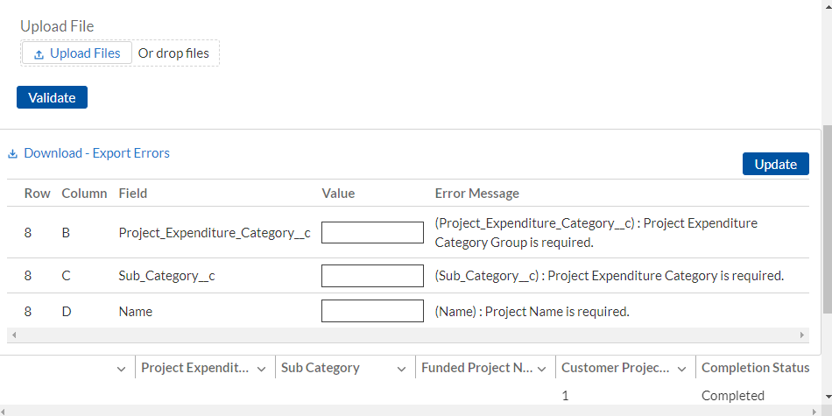

Figure Listing of Bulk Upload Errors

1. If the system validates that your bulk upload has no errors, it will return the same screen as Figure 75 with instead the option to “Create” (see Figure 75). Click the “Create” button.

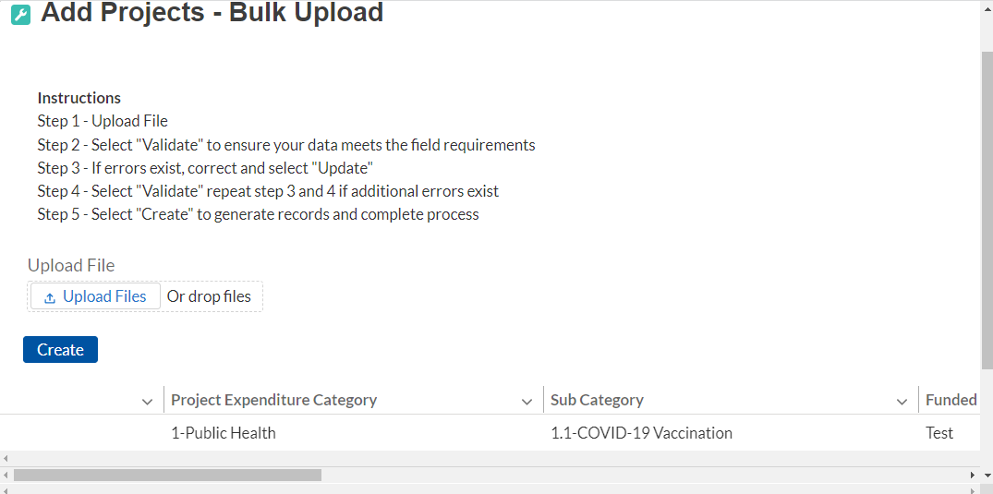

Figure Bulk Upload Creation

1. Once created, your records will show at the bottom of the relevant screen.
2. **Bulk Upload Creation Steps**

The collective bulk file upload process is contingent upon end-users following the below steps to ensure successful submission.

**Note:**  All data submitted via the bulk upload functionality must be submitted as a .CSV file.

1. **CSV Guidance**

Refer to the following link for descriptions of the CSV format.

<https://en.wikipedia.org/wiki/Comma-separated_values>

1. **Specific CSV characteristics**

* The date format is: MM/DD/YYYY. Example:
  1. 06/22/2021
* All currency values are numeric. It is not required to add “,” for thousand or millions.
* All currency values should not contain a “$” sign. The file will be rejected if a “$” is included in the data entry.
* Once you’ve saved the excel spreadsheet as a .csv file, do not re-open the file. Re-opening the file will cause excel to possible revert to an .xls type file and leading zeros or other issues may occur,

1. **Upload Template Description**

Each data element and/or column in the CSV files is described below:

* Index No: Reference number for the data element. For internal use only.
* Defined term: Column Short description.
* Definition: Column long description or definition.
* CSV Column Name: The column header name that must be used in the CSV file.
* Required: Indicates if the column is required or not required.
* List Value: The content of the column is from a list of predefined values. This is valid for some of the columns. The list is provided for all cases. Most of the cases is N/A which means that the type is ether String or Numeric.
* Data type: Specify the data type of the column. The options are: Numeric, Text, Date and Pick List.
* Max Length: Indicates the maximum length in characters that is allowed for each column.

1. **Project Baseline Template**

The downloadable templates provide all information required to create the upload files. The following table highlights the data elements required to complete the Project Baseline Template. Expenditure categories not covered by the Project Baseline Template have a devoted template as described in Appendix C. NOTE: Each bulk file upload template, including the Project Baseline Template, will have unique requirements which determine if data fields are required, optional, or conditional. Additional guidance can be found within the Help Text for all bulk file upload templates.

| **Defined Term** | **Definition** | **Required/**  **Optional/**  **Conditional** | **List Values** | **Data Type** | **Max  Length** |
| --- | --- | --- | --- | --- | --- |
| Project Expenditure Category Group | Per guidance, this field represents the predefined project expenditure category | Required | "1-Public Health"  "2-Negative Economic Impacts"  "3-Public Health-Negative Economic Impact: Public Sector Capacity"  "7-Administrative and Other" | Picklist (see permissible values in previous column | n/a |
| Project Expenditure Category | Per guidance, this field represents and is aligned to the project expenditure category | Required | Refer to “Expenditure Categories covered by the Project Baseline Template” table below | Picklist (see permissible values in previous column | n/a |
| Project Name | Name of the project. | Required | n/a | String | 80 |
| Project Identification Number (Assigned by recipient) | Identification number assigned to project by recipient. | Required | n/a | Alphanumeric | 20 |
| Status of Completion | Completion status of the project. | Required | "Not started", "Completed less than 50%", "Completed 50% or more", "Completed" | Picklist (see permissible values in previous column | n/a |
| Adopted Budget | Amount of the adopted budget for this project | Required for Tier 1 recipients  Optional for other Tier recipients | n/a | Currency | 12,2 |
| Total Cumulative Obligations | Total dollar value of obligations for this project. | Required | n/a | Currency | 12,2 |
| Total Cumulative Expenditures | Total dollar value of expenditures for this project. | Required | n/a | Currency | 12,2 |
| Current Period Obligations | Total dollar value of obligations for this current reporting period | Required | n/a | Currency | 12,2 |
| Current Period Expenditures | Total dollar value of expenditures for this current reporting period | Required | n/a | Currency | 12,2 |
| Does this project include a capital expenditure? | Does this project include a capital expenditure | Required | Yes  No | Picklist (see permissible values in previous column) | n/a |
| If yes, what is the total expected capital expenditure? | If you answered “yes” to the previous question, enter the total dollar value of the expected capital expenditure  Note: If the total expected capital expenditure is greater than $10M, then labor certifications are required. | Conditional  Required if you answered “Yes” to the previous question | n/a | Currency | 12,2 |
| Capital Expenditure Type | Type of Capital Expenditure | Conditional  Required if you answered "Yes" for the "Does this project include a capital expenditure" question | See Appendix H for the list of Capital Expenditure Types | Picklist (see permissible values in previous column) | n/a |
| Other Capital Expenditure Explanation | If you selected "Other (please specify)" for the Capital Expenditure Type, please provide more details. | Conditional  Required if your answer to the previous question was “Other (please specify)” | n/a | String | 255 |
| Capital Expenditure Narrative | For recipients (other than Tribal governments) investing in projects with total expected capital expenditures for an enumerated eligible use of $10 million or more, as well as projects with total expected capital expenditures for an "other" use of $1 million or more, please provide a written justification. | Conditional  Required if you answered "Yes" for the "Does this project include a capital expenditure" question | n/a | String | 1500 |
| Project Description | Brief description of the project. | Required | n/a | String | 1,500 |
| Program Income Earned | The amount of Federal program income earned. | Optional | n/a | Currency | 12,2 |
| Program Income Expended | The amount of program income that was used to cover eligible project costs. | Optional | n/a | Currency | 12,2 |
| Project Demographic Distribution - Primarily Populations Served | Impacted and/or Disproportionally Impacted populations served by this project. | Required | See Appendix G for Project Demographic Distribution populations | Picklist (see permissible values in previous column) | n/a |
| Project Demographic Distribution – Primary Populations Served Explanation | If the selected demographic includes 'specify' please provide a brief explanation | Conditional  Required if the selected demographic in the previous question includes 'specify' | n/a | String | 250 |
| Project Demographic Distribution - Additional Populations Served | Impacted and/or Disproportionally Impacted populations served by this project. | Optional | See Appendix G for Project Demographic Distribution populations | Picklist (see permissible values in previous column) | n/a |
| Project Demographic Distribution – Secondary Populations Served Explanation | If the selected demographic includes 'specify' please provide a brief explanation | Conditional | n/a | String | 250 |
| Project Demographic Distribution - Additional Populations Served | Impacted and/or Disproportionally Impacted populations served by this project. | Optional | See Appendix G for Project Demographic Distribution populations | Picklist (see permissible values in previous column) | n/a |
| Project Demographic Distribution – Tertiary Populations Served Explanation | If the selected demographic includes 'specify' please provide a brief explanation | Conditional | n/a | String | 250 |
| Structure and objectives of assistance program | Description of structure and objectives of assistance program(s), including public health or negative economic impact experienced | Required | n/a | String | 250 |
| Recipient’s approach | Description of recipient’s approach to ensuring that response is reasonable and proportional to a public health or negative economic impact of Covid-19, as described in the final rule | Required | n/a | String | 250 |

| **Expenditure Categories covered by the Project Baseline Template** |
| --- |
| 1.1 COVID-19 Vaccination |
| 1.2 COVID-19 Testing |
| 1.3 COVID-19 Contact Tracing |
| 1.4 Prevention in Congregate Settings (Nursing Homes, Prisons/Jails, Dense Work Sites, Schools, etc.) |
| 1.5 Personal Protective Equipment |
| 1.6 Medical Expenses (including Alternative Care Facilities) |
| 1.7 Other COVID-19 Public Health Expenses (including Communications, Enforcement, Isolation/Quarantine) |
| 1.10 COVID-19 Aid to Impacted Industries |
| 1.11 Community Violence Interventions |
| 1.12 Mental Health Services |
| 1.13 Substance Use Services |
| 1.14 Other Public Health Services |
| 2.9 Unemployment Benefits or Cash Assistance to Unemployed Workers |
| 2.10 Assistance to Unemployed or Underemployed Workers (e.g. job training, subsidized employment, employment supports or incentives) |
| 2.11 Healthy Childhood Environments: Child Care |
| 2.12 Healthy Childhood Environments: Home Visiting |
| 2.13 Healthy Childhood Environments: Services to Foster Youth or Families Involved in Child Welfare System |
| 2.15 Long-term Housing Security: Affordable Housing |
| 2.16 Long-term Housing Security: Services for Unhoused Persons |
| 2.17 Housing Support: Housing Vouchers and Relocation Assistance for Disproportionately Impacted Communities |
| 2.18 Housing Support: Other Housing Assistance |
| 2.19 Social Determinants of Health: Community Health Workers or Benefits Navigators |
| 2.20 Social Determinants of Health: Lead Remediation |
| 2.21 Medical Facilities for Disproportionately Impacted Communities |
| 2.22 Strong Healthy Communities: Neighborhood Features that Promote Health and Safety |
| 2.23 Strong Healthy Communities: Demolition and Rehabilitation of Properties |
| 2.28 Contributions to UI Trust Funds |
| 2.35 Aid to Tourism Travel and Hospitality |
| 2.37 Economic Impact Assistance: Other |
| 3.3 Public Sector Workforce: Other |
| 3.4 Public Sector Capacity: Effective Service Delivery |
| 3.5 Public Sector Capacity: Administrative Needs |
| 7.1 Administrative Expenses |
| 7.2 Transfers to Other Units of Government |

1. **Subrecipient Template**

The downloadable templates provide all information required to create the upload files. The following table highlights the data elements required to complete the Subrecipient Template.

| **Defined Term** | **Definition** | **Required** | **List Values** | **Data Type** | **Max  Length** |
| --- | --- | --- | --- | --- | --- |
| Subrecipient UEI | The Sub-recipient's Unique Entity Identifier (UEI) created in SAM.gov.  NOTE:  Sub-recipients must provide one of the following numbers:  -UEI, or  -TIN | Optional | n/a | Alpha-numeric | 12 |
| Subrecipient TIN | The Subrecipient's Internal Revenue Service (IRS) Taxpayer Identification Number  NOTE:  Sub-recipients must provide one of the following numbers:  -UEI, or  -TIN | Optional | n/a | Numeric | 9 |
| Subrecipient Name | The name of the Subrecipient. | Required | n/a | String | 80 |
| Entity Type | Indicators for types of entities | Required | -Subrecipient  -Contractor  -Beneficiary | Picklist (see permissible values in previous column) | n/a |
| POC Email Address | The email address of the primary point-of-contact for the Subrecipient. | Optional | n/a | String | 40 |
| Address Line 1 | First line of the Subrecipient's address. | Required | n/a | String | 150 |
| Address Line 2 | Second line of the Subrecipient's address. | Optional | n/a | String | 150 |
| Address Line 3 | Third line of the Subrecipient's address. | Optional | n/a | String | 150 |
| City Name | Name of the city in which the Subrecipient is located. | Required | n/a | String | 40 |
| State Code | United States Postal Service (USPS) two-letter abbreviation for the state or territory in which the Subrecipient is located. | Required | (AL, AK, AS, AZ, AR, CA, CO, CT, DE, DC, FM, FL, GA, GU, HI, ID, IL, IN, IA, KS, KY, LA, ME, MH, MD, MA, MI, MN, MS, MO, MT, NE, NV, NH, NJ, NM, NY, NC, ND, MP, OH, OK, OR, PW, PA, PR, RI, SC, SD, TN, TX, UT, VT, VI, VA, WA, WV, WI, WY) | String | 2 |
| Zip5 | United States ZIP code (five digits) associated with the Subrecipient's address. | Required | n/a | Numeric | 5 |
| Zip4 | Zip Plus4 (four digits) identifying where the predominant performance of the subaward will be accomplished. | Optional | n/a | Numeric | 4 |
| Subrecipient SAM.gov Registration | Confirmation that the Subrecipient is registered in SAM.gov | Required | Yes/No | Picklist (see permissible values in previous column) | n/a |
| In its preceding fiscal year, did recipient receive 80% or more of its annual gross revenue from federal funds? | Confirmation that the proportion of the Subrecipient's federal funding-to-total annual gross revenue for the preceding fiscal year is at least 80% | Conditional  Required if you answered “No” to the previous question | Yes/No | Picklist (see permissible values in previous column) | n/a |
| In the preceding fiscal year, did recipient receive $25 million or more of its annual gross revenue from federal funds? | Confirmation that the Subrecipient's total annual gross revenue from federal funding across all programs for the preceding fiscal year is greater than $25 million. | Conditional  Required if you answered “No” to the “Subrecipient SAM.gov registration”  question | Yes/No | Picklist (see permissible values in previous column) | n/a |
| Is the "total compensation" for the organization's five highest paid officers publicly listed or otherwise listed in SAM.gov? | Confirmation that qualifying Subrecipient's publicly identify their top five highest compensated executives or have it listed in their SAM.gov profile, if No please provide names and compensation for top 5 executives. | Conditional  Required if you answered “Yes” to both previous questions | Yes/No | Picklist (see permissible values in previous column) | n/a |
| Executive Name (1) | The legal name belonging to one of the five highest paid executives, officers, or employees of the Subrecipient. | Conditional  Required If you answered “No” to the previous question | n/a | String | 100 |
| Total Compensation Executive (1) | The Total Compensation, as defined in 2 CFR part 170.330, earned by the five highest paid executives, officers, or employees of the Subrecipient. | Conditional  Required If you answered “No” to the “Is the total compensation for the organization's five highest paid officers publicly listed or otherwise listed in SAM.gov?” question | n/a | Currency | 12,2 |
| Executive Name (2) | The legal name belonging to one of the five highest paid executives, officers, or employees of the Subrecipient. | Conditional  Required If you answered “No” to the “Is the total compensation for the organization's five highest paid officers publicly listed or otherwise listed in SAM.gov?” question | n/a | String | 100 |
| Total Compensation Executive (2) | The Total Compensation, as defined in 2 CFR part 170.330, earned by the five highest paid executives, officers, or employees of the Subrecipient. | Conditional  Required If you answered “No” to the “Is the total compensation for the organization's five highest paid officers publicly listed or otherwise listed in SAM.gov?” question | n/a | Currency | 12,2 |
| Executive Name (3) | The legal name belonging to one of the five highest paid executives, officers, or employees of the Subrecipient. | Conditional  Required If you answered “No” to the “Is the total compensation for the organization's five highest paid officers publicly listed or otherwise listed in SAM.gov?” question | n/a | String | 100 |
| Total Compensation (3) | The Total Compensation, as defined in 2 CFR part 170.330, earned by the five highest paid executives, officers, or employees of the Subrecipient. | Conditional  Required If you answered “No” to the “Is the total compensation for the organization's five highest paid officers publicly listed or otherwise listed in SAM.gov?” question | n/a | Currency | 12,2 |
| Executive Name (4) | The legal name belonging to one of the five highest paid executives, officers, or employees of the Subrecipient. | Conditional  Required If you answered “No” to the “Is the total compensation for the organization's five highest paid officers publicly listed or otherwise listed in SAM.gov?” question | n/a | String | 100 |
| Total Compensation (4) | The Total Compensation, as defined in 2 CFR part 170.330, earned by the five highest paid executives, officers, or employees of the Subrecipient. | Conditional  Required If you answered “No” to the “Is the total compensation for the organization's five highest paid officers publicly listed or otherwise listed in SAM.gov?” question | n/a | Currency | 12,2 |
| Executive Name (5) | The legal name belonging to one of the five highest paid executives, officers, or employees of the Subrecipient. | Conditional  Required If you answered “No” to the “Is the total compensation for the organization's five highest paid officers publicly listed or otherwise listed in SAM.gov?” question | n/a | String | 100 |
| Total Compensation  Executive (5) | The Total Compensation, as defined in 2 CFR part 170.330, earned by the five highest paid executives, officers, or employees of the Subrecipient. | Conditional  Required If you answered “No” to the “Is the total compensation for the organization's five highest paid officers publicly listed or otherwise listed in SAM.gov?” question | n/a | Currency | 12,2 |

1. **Subaward Template**

The downloadable templates provide all information required to create the upload files. The following table highlights the data elements required to complete the Subaward Template.

| **Defined Term** | **Definition** | **Required** | **List Values** | **Data Type** | **Max  Length** |
| --- | --- | --- | --- | --- | --- |
| Subrecipient UEI | The Sub-recipient's Unique Entity Identifier (UEI) created in SAM.gov.  NOTE:  Sub-recipients must provide one of the following numbers:  -UEI, or  -TIN | Optional | n/a | Alpha-numeric | 12 |
| Subrecipient TIN | The Subrecipient's Internal Revenue Service (IRS) Taxpayer Identification Number  NOTE:  Sub-recipients must provide one of the following numbers:  -UEI, or  -TIN | Optional | n/a | Numeric | 9 |
| Recipient Project Id | Recipient Project ID associated with this Sub Award. This is your unique Project Identification Number. | Required | n/a | Numeric | 20 |
| Subaward No. | Recipient's internal account number for the grant, contract, transfer, or direct payment. This can be the account number, or any other unique identifying number assigned by the Recipient to the award. This number is strictly for the Recipient's recordkeeping. | Required | n/a | String | 20 |
| Subaward Type | The type of Subaward. | Required | "Contract: Purchase Order"  "Contract: Delivery Order"  "Contract: Blanket Purchase Agreement"  "Contract: Definitive Contract"  "Grant: Lump Sum Payment(s)"  "Grant: Reimbursable"  "Direct Payment"  "Transfer: Lump Sum Payment(s)"  "Transfer: Reimbursable"  "Loan - maturity prior to 12/31/26 with planned forgiveness"  "Loan - maturity prior to 12/31/26 without planned forgiveness"  "Loan - maturity past 12/31/26 with planned forgiveness"  "Loan - maturity past 12/31/26 without planned forgiveness" | Picklist (see permissible values in previous column) | 30 |
| Subaward Amount (Obligation) | Total amount of SLFRF funds obligated by the Recipient to a Subrecipient under a given Subaward. | Required | n/a | Currency | 12,2 |
| Subaward Award Date | The date the Recipient obligated funds to a Subrecipient. | Required | n/a | Date | 8 |
| Primary Sector | Select Primary Sector from picklist. | Conditional | Refer to Sectors Designated as Essential Critical Infrastructure Sectors table below | Picklist (see permissible values in previous column) | 30 |
| If Other | Explanation if the Primary Sector is “Other” | Conditional  Required if previous question answer is "Other" | n/a | String | 100 |
| Period of Performance Start | The date on which efforts begin or the Subaward is otherwise effective. | Required | n/a | Date | 8 |
| Period of Performance End | The date on which all effort is completed or the Subaward is otherwise ended. | Required | n/a | Date | 8 |
| Place of Performance Address 1 | First line of the address where the predominant performance of the Subaward will be accomplished. | Required | n/a | String | 120 |
| Place of Performance Address 2 | Second line of the address where the predominant performance of the Subaward will be accomplished. | Optional | n/a | String | 120 |
| Place of Performance Address 3 | Third line of the address where the predominant performance of the Subaward will be accomplished. | Optional | n/a | String | 120 |
| Place of Performance City | The name of the city where the predominant performance of the Subaward will be accomplished. | Required | n/a | String | 40 |
| Place of Performance State Code | United States Postal Service (USPS) two-letter abbreviation for the state or territory indicating where the predominant performance of the Subaward will be accomplished. | Required | (AL, AK, AS, AZ, AR, CA, CO, CT, DE, DC, FM, FL, GA, GU, HI, ID, IL, IN, IA, KS, KY, LA, ME, MH, MD, MA, MI, MN, MS, MO, MT, NE, NV, NH, NJ, NM, NY, NC, ND, MP, OH, OK, OR, PW, PA, PR, RI, SC, SD, TN, TX, UT, VT, VI, VA, WA, WV, WI, WY) | String | 2 |
| Place of Performance Zip | United States ZIP code (five digits) identifying where the predominant performance of the subaward will be accomplished. | Required | n/a | Numeric | 5 |
| Place of Performance Zip4 | United States ZIP code (four digits) identifying where the predominant performance of the Subaward will be accomplished. | Optional | n/a | Numeric | 4 |
| Purpose of Funds | Recipients must submit a written justification to Treasury describing how the premium pay or grant is responsive to workers performing essential work during the public health emergency unless the worker or groups of workers receiving premium pay meet one of two criteria: (1) the eligible worker(s) receiving premium pay earn (with the premium included) below 150 percent of their residing state or county’s average annual wage for all occupations, as defined by the Bureau of Labor Statistics Occupational Employment and Wage Statistics; or (2) the eligible worker(s) receiving premium pay is not exempt from the Fair Labor Standards Act overtime provisions. | Required | n/a | Sting | 3000 |
| Subaward Description | A description of the overall purpose and expected outputs and outcomes or results of the funded subaward, including significant deliverables and, if appropriate, associated units of measure. The purpose and outcomes or results should be stated in terms that allow an understanding that the subaward constitutes an eligible use of funds. | Required | n/a | String | 750 |

| **Sectors Designated as Essential Critical Infrastructure Sectors** |
| --- |
| Any work performed by an employee of a State, local, or Tribal government |
| Behavioral health work |
| Biomedical Research |
| Dental care work |
| Educational work, school nutrition work, and other work required to operate a school facility |
| Election’s work |
| Emergency response |
| Family or childcare |
| Grocery stores, restaurants, food production, and food delivery |
| Health care |
| Home- and community-based health care or assistance with activities of daily living |
| Laundry work |
| Maintenance work |
| Medical testing and diagnostics |
| Pharmacy |
| Public health work |
| Sanitation, disinfection, and cleaning work |
| Social services work |
| Solid waste or hazardous materials management, response, and cleanup work |
| Transportation and warehousing |
| Vital services to Tribes |
| Work at hotel and commercial lodging facilities that are used for COVID-19 mitigation and containment |
| Work in a mortuary |
| Work in critical clinical research, development, and testing necessary for COVID-19 response |
| Work requiring physical interaction with patients |
| Other |

1. **Expenditures for Awards Greater Than $50,000 Template**

The downloadable templates provide all information required to create the upload files. The following table highlights the data elements required to complete the Expenditures GT $50,000 Template.

| **Defined Term** | **Definition** | **Required** | **List Values** | **Data Type** | **Max  Length** |
| --- | --- | --- | --- | --- | --- |
| Subaward Number | Subaward number that allows the Recipient to associate Expenditure records to Subaward records. Enter Subaward Number. Subaward Number is not required if Expenditure Category is "Administrative Cost". | Required | n/a | Numeric | 20 |
| Expenditure Start Date | Start date for the range of time when the expenditure(s) occurred. | Required | n/a | Date | 8 |
| Expenditure End Date | End date for the range of time when the expenditure(s) occurred | Required | n/a | Date | 8 |
| Expenditure Amount | Total amount of SLFRF dollars on the Subaward. | Required | n/a | Currency | 12,2 |

1. **Aggregate Expenditures for Awards Less Than $50,000 Template**

The downloadable templates provide all information required to create the upload files. The following table highlights the data elements required to complete the Aggregate Expenditures LT $50,000 Template.

| **Defined Term** | **Definition** | **Required** | **List Values** | **Data Type** | **Max  Length** |
| --- | --- | --- | --- | --- | --- |
| Recipient Project Id | Recipient Project ID that allows the Recipient to associate Expenditure records to Project records. | Required | n/a | Numeric | 20 |
| Subaward Type Aggregates SLFRF | The Subaward Type that had obligation or expenditure/payment activity during the reporting period. | Required | "Aggregate of Contracts Awarded "  "Aggregate of Grants Awarded "  "Aggregate of Loans Issued "  "Aggregate of Transfers "  "Aggregate of Direct Payments " | Picklist (see permissible values in previous column) | 100 |
| Total Period Obligation Amount (Aggregates) | Sum of sub-award amounts/obligations during the most recent period for this Sub-Award Type (Aggregates). | Required | n/a | Currency | 12,2 |
| Total Period Expenditure Amount (Aggregates) | Sum of Expenditures or Payments during the most recent period for this Sub-Award Type (Aggregates). | Required | n/a | Currency | 12,2 |

1. **Payments to Individuals Template**

The downloadable templates provide all information required to create the upload files. The following table highlights the data elements required to complete the Payments to Individuals Template.

| **Defined Term** | **Definition** | **Required** | **List Values** | **Data Type** | **Max  Length** |
| --- | --- | --- | --- | --- | --- |
| Recipient Project Id | Recipient Project ID that allows the Recipient to associate Expenditure records to Project records. | Required | n/a | Numeric | 20 |
| Total Period Obligation Amount (Aggregates) | Sum of sub-award amounts/obligations during the most recent period for this Sub-Award Type (Aggregates). | Required | n/a | Currency | 12,2 |
| Total Period Expenditure Amount (Aggregates) | Sum of Expenditures or Payments during the most recent period for this Sub-Award Type (Aggregates). | Required | n/a | Currency | 12,2 |

# **Appendix C – Expenditure Categories and Template Mapping**

## The Expenditure Categories (EC) listed below must be used to categorize each project as

## noted in the [Reporting Guidance](https://home.treasury.gov/system/files/136/SLFRF-Compliance-and-Reporting-Guidance.pdf). The term “Expenditure Category” refers to the detailed level (e.g., 1.1 COVID-10 Vaccination). When referred to at the summary level (e.g., EC 1) it includes all Expenditure Categories within that summary level.

For the table below, the following legend applies.

*Denotes areas where recipients must identify the amount of the total funds that are allocated to evidence-based interventions (see Use of Evidence section above for details). Please note the evidence-based questions are only applicable to States, U.S. Territories, and metropolitan cities and counties with population over 250,000.

^Denotes areas where recipients must report on whether projects are primarily serving disproportionately impacted communities (see Project Demographic Distribution section above for details)

The Programmatic Data column indicates which Expenditure Categories have associated programmatic data, in addition to the project standard information. More information on each EC’s programmatic data is contained in Appendix C and in the [Reporting Guidance](https://home.treasury.gov/system/files/136/SLFRF-Compliance-and-Reporting-Guidance.pdf).

| **Category** | | **Programmatic**  **Data?** | **Bulk Upload Template** |
| --- | --- | --- | --- |
| 1 Expenditure Category: Public Health | | | |
| 1.1 | COVID-19 Vaccination^ | No | Project Baseline Template |
| 1.2 | COVID-19 Testing^ | No | Project Baseline Template |
| 1.3 | COVID-19 Contact Tracing^ | No | Project Baseline Template |
| 1.4 | Prevention in Congregate Settings (Nursing Homes, Prisons/Jails, Dense Work Sites, Schools, Child care facilities, etc.)*^ | No | Project Baseline Template |
| 1.5 | Personal Protective Equipment^ | No | Project Baseline Template |
| 1.6 | Medical Expenses (including Alternative Care Facilities)^ | No | Project Baseline Template |
| 1.7 | Other COVID-19 Public Health Expenses (including Communications, Enforcement, Isolation/Quarantine)^ | No | Project Baseline Template |
| 1.8 | COVID-19 Assistance to Small Businesses^ | Yes | Template for 1.8, 2.29-2.33 |
| 1.9 | COVID 19 Assistance to Non-Profits^ | Yes | Template for 1.9, 2.34 |
| 1.10 | COVID-19 Aid to Impacted Industries^ | No | Project Baseline Template |
| 1.11 | Community Violence Interventions*^ | No | Project Baseline Template |
| 1.12 | Mental Health Services*^ | No | Project Baseline Template |
| 1.13 | Substance Use Services*^ | No | Project Baseline Template |
| 1.14 | Other Public Health Services^ | No | Project Baseline Template |
| 2 Expenditure Category: Negative Economic Impacts | | | |
| 2.1 | Household Assistance: Food Programs*^ | Yes | Template for 2.1 – 2.8 |
| 2.2 | Household Assistance: Rent, Mortgage, and Utility Aid*^ | Yes | Template for 2.1 – 2.8 |
| 2.3 | Household Assistance: Cash Transfers*^ | Yes | Template for 2.1 – 2.8 |
| 2.4 | Household Assistance: Internet Access Programs*^ | Yes | Template for 2.1 – 2.8 |
| 2.5 | Household Assistance: Paid Sick and Medical Leave^ | Yes | Template for 2.1 – 2.8 |
| 2.6 | Household Assistance: Health Insurance*^ | Yes | Template for 2.1 – 2.8 |
| 2.7 | Household Assistance: Services for Un/Unbanked*^ | Yes | Template for 2.1 – 2.8 |
| 2.8 | Household Assistance: Survivor's Benefits^ | Yes | Template for 2.1 – 2.8 |
| 2.9 | Unemployment Benefits or Cash Assistance to Unemployed Workers*^ | No | Project Baseline Template |
| 2.10 | Assistance to Unemployed or Underemployed Workers (e.g., job training, subsidized employment, employment supports or incentives) *^ | No | Project Baseline Template |
| 2.11 | Healthy Childhood Environments: Child Care*^ | No | Project Baseline Template |
| 2.12 | Healthy Childhood Environments: Home Visiting*^ | No | Project Baseline Template |
| 2.13 | Healthy Childhood Environments: Services to Foster Youth or Families Involved in Child Welfare System*^ | No | Project Baseline Template |
| 2.14 | Healthy Childhood Environments: Early Learning*^ | Yes | Template for 2.14, 2.24-2.27 |
| 2.15 | Long-term Housing Security: Affordable Housing*^ | No | Project Baseline Template |
| 2.16 | Long-term Housing Security: Services for Unhoused Persons*^ | No | Project Baseline Template |
| 2.17 | Housing Support: Housing Vouchers and Relocation Assistance for Disproportionately Impacted Communities*^ | No | Project Baseline Template |
| 2.18 | Housing Support: Other Housing Assistance*^ | No | Project Baseline Template |
| 2.19 | Social Determinants of Health: Community Health Workers or Benefits Navigators*^ | No | Project Baseline Template |
| 2.20 | Social Determinants of Health: Lead Remediation*^ | No | Project Baseline Template |
| 2.21 | Medical Facilities for Disproportionately Impacted Communities^ | No | Project Baseline Template |
| 2.22 | Strong Healthy Communities: Neighborhood Features that Promote Health and Safety^ | No | Project Baseline Template |
| 2.23 | Strong Healthy Communities: Demolition and Rehabilitation of Properties^ | No | Project Baseline Template |
| 2.24 | Addressing Educational Disparities: Aid to High-Poverty Districts^ | Yes | Template for 2.14, 2.24-2.27 |
| 2.25 | Addressing Educational Disparities: Academic, Social, and Emotional Services*^ | Yes | Template for 2.14, 2.24-2.27 |
| 2.26 | Addressing Educational Disparities: Mental Health Services*^ | Yes | Template for 2.14, 2.24-2.27 |
| 2.27 | Addressing Impacts of Lost Instructional Time^ | Yes | Template for 2.14, 2.24-2.27 |
| 2.28 | Contributions to UI Trust Funds^ | No | Project Baseline Template |
| 2.29 | Loans or Grants to Mitigate Financial Hardship^ | Yes | Template for 1.8, 2.29-2.33 |
| 2.30 | Technical Assistance, Counseling, or Business Planning*^ | Yes | Template for 1.8, 2.29-2.33 |
| 2.31 | Rehabilitation of Commercial Properties or Other Improvements^ | Yes | Template for 1.8, 2.29-2.33 |
| 2.32 | Business Incubators and Start-Up or Expansion Assistance*^ | Yes | Template for 1.8, 2.29-2.33 |
| 2.33 | Enhanced Support to Microbusinesses*^ | Yes | Template for 1.8, 2.29-2.33 |
| 2.34 | Assistance to Impacted Nonprofit Organizations (Impacted or Disproportionately Impacted)^ | Yes | Template for 1.9, 2.34 |
| 2.35 | Aid to Tourism, Travel, or Hospitality^ | No | Project Baseline Template |
| 2.36 | Aid to Other Impacted Industries^ | Yes | Template for 2.36 |
| 2.37 | Economic Impact Assistance: Other*^ | No | Project Baseline Template |
| 3 Expenditure Category: Services to Disproportionately Impacted Communities | | | |
| 3.1 | Public Sector Workforce: Payroll and Benefits for Public Health, Public Safety, or Human Services Workers^ | Yes | Template for EC 3.1 |
| 3.2 | Public Sector Workforce: Rehiring Public Sector Staff^ | Yes | Template for EC 3.2 |
| 3.3 | Public Sector Workforce: Other^ | No | Project Baseline Template |
| 3.4 | Public Sector Capacity: Effective Service Delivery^ | No | Project Baseline Template |
| 3.5 | Public Sector Capacity: Administrative Needs^ | No | Project Baseline Template |
| 4 Expenditure Category: Premium Pay | | | |
| 4.1 | Public Sector Employees | Yes | Template for EC 4.1 – 4.2 |
| 4.2 | Private Sector: Grants to other employers | Yes | Template for EC 4.1 – 4.2 |
| 5 Expenditure Category: Infrastructure | | | |
| 5.1 | Clean Water: Centralized Wastewater Treatment | Yes | Template for EC 5.1 – 5.18 |
| 5.2 | Clean Water: Centralized Wastewater Collection and Conveyance | Yes | Template for EC 5.1 – 5.18 |
| 5.3 | Clean Water: Decentralized Wastewater | Yes | Template for EC 5.1 – 5.18 |
| 5.4 | Clean Water: Combined Sewer Overflows | Yes | Template for EC 5.1 – 5.18 |
| 5.5 | Clean Water: Other Sewer Infrastructure | Yes | Template for EC 5.1 – 5.18 |
| 5.6 | Clean Water: Stormwater | Yes | Template for EC 5.1 – 5.18 |
| 5.7 | Clean Water: Energy Conservation | Yes | Template for EC 5.1 – 5.18 |
| 5.8 | Clean Water: Water Conservation | Yes | Template for EC 5.1 – 5.18 |
| 5.9 | Clean Water: Nonpoint Source | Yes | Template for EC 5.1 – 5.18 |
| 5.10 | Drinking water: Treatment | Yes | Template for EC 5.1 – 5.18 |
| 5.11 | Drinking water: Transmission & Distribution | Yes | Template for EC 5.1 – 5.18 |
| 5.12 | Drinking water: Lead Remediation, including in Schools and Daycares | Yes | Template for EC 5.1 – 5.18 |
| 5.13 | Drinking water: Source | Yes | Template for EC 5.1 – 5.18 |
| 5.14 | Drinking water: Storage | Yes | Template for EC 5.1 – 5.18 |
| 5.15 | Drinking water: Other water infrastructure | Yes | Template for EC 5.1 – 5.18 |
| 5.16 | Water and Sewer: Private Wells | Yes | Template for EC 5.1 – 5.18 |
| 5.17 | Water and Sewer: IIJA Bureau of Reclamation Match | Yes | Template for EC 5.1 – 5.18 |
| 5.18 | Water and Sewer: Other | Yes | Template for EC 5.1 – 5.18 |
| 5.19 | Broadband: “Last Mile” projects | Yes | Template for EC 5.19-5.21 |
| 5.20 | Broadband: IIJA Match | Yes | Template for EC 5.19-5.21 |
| 5.21 | Broadband: Other projects | Yes | Template for EC 5.19-5.21 |
| 6 Expenditure Category: Revenue Replacement | | | |
| 6.1 | Provision of Government Services | N/A | N/A |
| 6.2 | Non-federal match for other Federal Programs | N/A | N/A |
| 7 Administrative and Other | | | |
| 7.1 | Administrative Expenses | No | Project Baseline Template |
| 7.2 | Transfers to Other Units of Government | No | Project Baseline Template |

# **Appendix D – SLFRF Expenditure Category Programmatic Data and Other Information**

The downloadable templates contain information required to create the upload files to include required/optional fields, help text, and permissible data types.

The following table highlights the standard data elements required for the Project Bulk Upload for Baseline Projects. Refer to Appendix C for the Expenditure Categories that this template applies to.

*Project Bulk Upload for Project Baseline Template Table*

| **Defined Term** | **Definition** | **Required/**  **Optional** | **List Values** | **Data Type** | **Max  Length** |
| --- | --- | --- | --- | --- | --- |
| Project Expenditure Category Group | Per guidance, this field represents the predefined project expenditure category | Required | "1-Public Health"  "2-Negative Economic Impacts"  "3-Public Health-Negative Economic Impact: Public Sector Capacity"  "7-Administrative and Other" | Picklist (see permissible values in previous column | n/a |
| Project Expenditure Category | Per guidance, this field represents and is aligned to the project expenditure category | Required | Refer to “Expenditure Categories covered by the Project Baseline Template” table in Appendix B | Picklist (see permissible values in previous column | n/a |
| Project Name | Name of the project. | Required | n/a | String | 80 |
| Project Identification Number (Assigned by recipient) | Identification number assigned to project by recipient. | Required | n/a | Alphanumeric | 20 |
| Status of Completion | Completion status of the project. | Required | "Not started", "Completed less than 50%", "Completed 50% or more", "Completed" | Picklist (see permissible values in previous column | n/a |
| Adopted Budget | Amount of the adopted budget for this project | Required for Tier 1 recipients  Optional for other Tier recipients | n/a | Currency | 12,2 |
| Total Cumulative Obligations | Total dollar value of obligations for this project. | Required | n/a | Currency | 12,2 |
| Total Cumulative Expenditures | Total dollar value of expenditures for this project. | Required | n/a | Currency | 12,2 |
| Current Period Obligations | Total dollar value of obligations for this current reporting period | Required | n/a | Currency | 12,2 |
| Current Period Expenditures | Total dollar value of expenditures for this current reporting period | Required | n/a | Currency | 12,2 |
| Does this project include a capital expenditure? | Does this project include a capital expenditure | Required | Yes  No | Picklist (see permissible values in previous column) | n/a |
| If yes, what is the total expected capital expenditure? | If you answered “yes” to the previous question, enter the total dollar value of the expected capital expenditure  Note: If the total expected capital expenditure is greater than $10M, then labor certifications are required. | Conditional  Required if you answered “Yes” to the previous question | n/a | Currency | 12,2 |
| Capital Expenditure Type | Type of Capital Expenditure | Conditional  Required if you answered "Yes" for the "Does this project include a capital expenditure" question | See Appendix H for the list of Capital Expenditure Types | Picklist (see permissible values in previous column) | n/a |
| Other Capital Expenditure Explanation | If you selected "Other (please specify)" for the Capital Expenditure Type, please provide more details. | Conditional  Required if the answer to the question above was “Other (please specify)” | n/a | String | 255 |
| Capital Expenditure Narrative | For recipients (other than Tribal governments) investing in projects with total expected capital expenditures for an enumerated eligible use of $10 million or more, as well as projects with total expected capital expenditures for an "other" use of $1 million or more, please provide a written justification. | Conditional  Required if you answered "Yes" for the "Does this project include a capital expenditure" question | n/a | String | 1500 |
| Project Description | Brief description of the project. | Required | n/a | String | 1,500 |
| Program Income Earned | The amount of Federal program income earned. | Optional | n/a | Currency | 12,2 |
| Program Income Expended | The amount of program income that was used to cover eligible project costs. | Optional | n/a | Currency | 12,2 |
| Project Demographic Distribution - Primarily Populations Served | Impacted and/or Disproportionally Impacted populations served by this project. | Required | See Appendix G for Project Demographic Distribution populations | Picklist (see permissible values in previous column) | n/a |
| Project Demographic Distribution – Primary Populations Served Explanation | If the selected demographic includes 'specify' please provide a brief explanation | Conditional  Required if the selected demographic in the previous question includes 'specify' | n/a | String | 250 |
| Project Demographic Distribution - Additional Populations Served | Impacted and/or Disproportionally Impacted populations served by this project. | Optional | See Appendix G for Project Demographic Distribution populations | Picklist (see permissible values in previous column) | n/a |
| Project Demographic Distribution – Secondary Populations Served Explanation | If the selected demographic includes 'specify' please provide a brief explanation | Conditional | n/a | String | 250 |
| Project Demographic Distribution - Additional Populations Served | Impacted and/or Disproportionally Impacted populations served by this project. | Optional | See Appendix G for Project Demographic Distribution populations | Picklist (see permissible values in previous column) | n/a |
| Project Demographic Distribution – Tertiary Populations Served Explanation | If the selected demographic includes 'specify' please provide a brief explanation | Conditional | n/a | String | 250 |
| Structure and objectives of assistance program | Description of structure and objectives of assistance program(s), including public health or negative economic impact experienced | Required | n/a | String | 250 |
| Recipient’s approach | Description of recipient’s approach to ensuring that response is reasonable and proportional to a public health or negative economic impact of Covid-19, as described in the final rule | Required | n/a | String | 250 |

**EC 1.1 – 1.7, 1.10**

There is no additional programmatic data required for the following ECs:

* EC 1.1 COVID-19 Vaccination
* EC 1.2 COVID-19 Testing
* EC 1.3 Contact Tracing
* EC 1.4 Prevention in Congregate Settings (Nursing Homes, Prisons/Jails, Dense Work Sites, Schools, Childcare facilities, etc.)
* EC 1.5 Personal Protective Equipment
* EC 1.6 Medical Expenses (including Alternative Care Facilities)
* EC 1.7 Other COVID-19 Public Health Expenses (including Communications, Enforcement, Isolation/Quarantine)
* EC 1.10 COVID-19 Aid to Impacted Industries

**EC 1.8, 2.29 - 2.33**

There is additional programmatic data required for EC 1.8, 2.29 - 2.33 that can be provided via bulk upload file or manual entry. The EC1.8, 2.29-2.33 Bulk File Upload Template contains guidance to create the upload files to include data instructions, required/optional fields, help text, and permissible data types.

* EC 1.8 COVID-19 Assistance to Small Businesses
* EC 2.29 Loans or Grants to Mitigate Financial Hardship
* EC 2.30 Technical Assistance, Counseling, or Business Planning
* EC 2.31 Rehabilitation of Commercial Properties or Other Improvements
* EC 2.32 Business Incubators and Start-Up or Expansion Assistance
* EC 2.33 Enhanced Support to Microbusinesses

In addition to the project base information noted in the Project Bulk Upload for Base Projects table above, additional data to provide is as follows:

| **Defined Term** | **Definition** | **Required or**  **Optional** | **List Values** | **Data Type** | **Max  Length** |
| --- | --- | --- | --- | --- | --- |
| Number of small businesses served | Number of small businesses served (by program if recipient establishes multiple separate small businesses assistance programs) | Required | n/a | Numeric | 10 |

**EC 1.9, 2.34**

There is additional programmatic data required for EC 1.9, 2.34 that can be provided via bulk upload file or manual entry. The EC 1.9, 2.34 Bulk File Upload Template contains guidance to create the upload files to include data instructions, required/optional fields, help text, and permissible data types.

* EC 1.9 COVID 19 Assistance to Non-Profits
* EC 2.34 Assistance to Impacted Nonprofit Organizations (Impacted or Disproportionately Impacted)

In addition to the project base information noted in the Project Bulk Upload for Base Projects table above, additional data to provide is as follows:

| **Defined Term** | **Definition** | **Required or**  **Optional** | **List Values** | **Data Type** | **Max  Length** |
| --- | --- | --- | --- | --- | --- |
| Non-Profits Served | Number of Non-Profits served (by program if recipient establishes multiple separate non-profit assistance programs) | Required | n/a | Numeric | 10 |

**EC 1.11 – 1.14**

There is no additional programmatic data required for the following ECs:

* EC 1.11 Community Violence Interventions
* EC 1.12 Mental Health Services
* EC 1.13 Substance Use Services
* EC 1.14 Other Public Health Services

**EC 2.1 – 2.8**

There is additional programmatic data required for EC 2.1 – 2.8 that can be provided via bulk upload file or manual entry. The EC 2.1-2.8 Bulk File Upload Template contains guidance to create the upload files and to include data instructions, required/optional fields, help text, and permissible data types.

* EC 2.1 Household Assistance: Food Programs
* EC 2.2 Household Assistance: Rent, Mortgage, and Utility Aid
* EC 2.3 Household Assistance: Cash Transfers
* EC 2.4 Household Assistance: Internet Access Programs
* EC 2.5 Household Assistance: Paid Sick and Medical Leave
* EC 2.6 Household Assistance: Health Insurance
* EC 2.7 Household Assistance: Services for Un/Unbanked
* EC 2.8 Household Assistance: Survivor's Benefits

In addition to the project base information noted in the Project Bulk Upload for Base Projects table above, additional data to provide is as follows:

| **Defined Term** | **Definition** | **Required or**  **Optional** | **List Values** | **Data Type** | **Max  Length** |
| --- | --- | --- | --- | --- | --- |
| Number Households Served | Number of households served (by program if recipient establishes multiple separate household assistance programs) | Required | n/a | Numeric | 10 |

**EC 2.9 – 2.13**

There is no additional programmatic data required for the following ECs:

* EC 2.9 Unemployment Benefits or Cash Assistance to Unemployed Workers
* EC 2.10 Assistance to Unemployed or Underemployed Workers (e.g., job training, subsidized employment, employment supports or incentives)
* EC 2.11 Healthy Childhood Environments: Child Care
* EC 2.12 Healthy Childhood Environments: Home Visiting
* EC 2.13 Healthy Childhood Environments: Services to Foster Youth or Families Involved in Child Welfare System

**EC 2.14, 2.24 - 2.27**

There is additional programmatic data required for EC 2.14, 2.24 - 2.27 that can be provided via bulk upload file or manual entry. The EC 2.14, 2.24-2.27 Bulk File Upload Template contains guidance to create the upload files and to include data instructions, required/optional fields, help text, and permissible data types.

* EC 2.14 Healthy Childhood Environments: Early Learning
* EC 2.24 Addressing Educational Disparities: Aid to High-Poverty Districts
* EC 2.25 Addressing Educational Disparities: Academic, Social, and Emotional Services
* EC 2.26 Addressing Educational Disparities: Mental Health Services
* EC 2.27 Addressing Impacts of Lost Instructional Time

In addition to the project base information noted in the Project Bulk Upload for Base Projects table above, additional data to provide is as follows:

| **Defined Term** | **Definition** | **Required or**  **Optional** | **List Values** | **Data Type** | **Max  Length** |
| --- | --- | --- | --- | --- | --- |
| The National Center for Education Statistics (“NCES”) School ID or NCES District ID. | The National Center for Education Statistics (“NCES”) School ID or NCES District ID. Separate IDs with commas for multiple entries. | Required | n/a | Numeric | 750 |

**Policy Information**

When providing the National Center for Education Statistics (“NCES”) School ID or NCES District ID, please list the School District if all schools within the school district received some funds. If not all schools within the school district received funds, please list the School ID of the schools that received funds. These can allow evaluators to link data from the NCES to look at school-level demographics and, eventually, student performance. For more information on NCES identification numbers see https://nces.ed.gov/ccd/districtsearch/ (districts) and https://nces.ed.gov/ccd/schoolsearch/ (schools).

**EC 2.15 – 2.23, 2.28, 2.35, 2.37**

There is no additional programmatic data required for the following ECs:

* EC 2.15 Long-term Housing Security: Affordable Housing
* EC 2.16 Long-term Housing Security: Services for Unhoused Persons
* EC 2.17 Housing Support: Housing Vouchers and Relocation Assistance for Disproportionately Impacted Communities
* EC 2.18 Housing Support: Other Housing Assistance
* EC 2.19 Social Determinants of Health: Community Health Workers or Benefits Navigators
* EC 2.20 Social Determinants of Health: Lead Remediation
* EC 2.21 Medical Facilities for Disproportionately Impacted Communities
* EC 2.22 Strong Healthy Communities: Neighborhood Features that Promote Health and Safety
* EC 2.23 Strong Healthy Communities: Demolition and Rehabilitation of Properties
* EC 2.28 Contributions to UI Trust funds
* EC 2.35 Aid to Tourism Travel or Hospitality
* EC 2.37 Economic Impact Assistance: Other

**EC 2.36**

There is additional programmatic data required for EC 2.36 that can be provided via bulk upload file or manual entry. The EC 2.36 Bulk File Upload Template contains guidance to create the upload files to include data instructions, required/optional fields, help text, and permissible data types.

* EC 2.36 Aid to Other Impacted Industries

In addition to the project base information noted in the Project Bulk Upload for Base Projects table above, additional data to provide is as follows:

| **Defined Term** | **Definition** | **Required or**  **Optional** | **List Values** | **Data Type** | **Max  Length** |
| --- | --- | --- | --- | --- | --- |
| Industry other than tourism Narrative | If aid is provided to industries other than travel, tourism, and hospitality (EC 2.36), please describe if the industry experienced at least 8 percent employment loss from pre-pandemic levels, or the industry is experiencing comparable or worse economic impacts as the national tourism, travel, and hospitality industries as of the date of the Final Rule, and rationale for providing aide to the industry | Required | n/a | Text | 250 |

**EC 3.1**

There is additional programmatic data required for EC 3.1 that can be provided via bulk upload file or manual entry. The EC 3.1 Template contains guidance to create the upload files to include data instructions, required/optional fields, help text, and permissible data types.

* 3.1 Public Sector Workforce: Payroll and Benefits for Public Health, Public Safety, or Human Services Workers

In addition to the project base information noted in the Project Bulk Upload for Base Projects table above, additional data to provide is as follows:

| **Defined Term** | **Definition** | **Required or**  **Optional** | **List Values** | **Data Type** | **Max  Length** |
| --- | --- | --- | --- | --- | --- |
| Number of government FTE responding to COVID-19 supported under this authority | Number of government FTE responding to COVID-19 supported under this authority | Required | n/a | Numeric | 6 |

**EC 3.2**

There is additional programmatic data required for EC 3.2 that can be provided via bulk upload file or manual entry. The EC 3.2 Bulk File Upload Template contains guidance to create the upload files to include data instructions, required/optional fields, help text, and permissible data types.

* 3.2 Public Sector Workforce: Rehiring Public Sector Staff

In addition to the project base information noted in the Project Bulk Upload for Base Projects table above, additional data to provide is as follows:

| **Defined Term** | **Definition** | **Required or**  **Optional** | **List Values** | **Data Type** | **Max  Length** |
| --- | --- | --- | --- | --- | --- |
| Number of FTEs rehired by governments under this authority | Number of FTEs rehired by governments under this authority | Required | n/a | Numeric | 6 |

**EC 3.3 – 3.5**

There is no additional programmatic data required for the following ECs:

* EC 3.3 Public Sector Workforce: Other
* EC 3.4 Public Sector Capacity: Effective Service Delivery
* EC 3.5 Public Sector Capacity: Administrative Needs

**EC 4.1–4.2 (Premium Pay)**

There is additional programmatic data required for EC 4.1 – 4.2 that can be provided via bulk upload file or manual entry. The EC 4.1-4.2 Bulk File Upload Template contains guidance to create the upload files to include data instructions, required/optional fields, help text, and permissible data types.

* EC 4.1 Public Sector Employees
* EC 4.2 Private Sector: Grants to other employers

In addition to the project base information noted in the Project Bulk Upload for Base Projects table above, additional data to provide is as follows:

| **Defined Term** | **Definition** | **Required or**  **Optional** | **List Values** | **Data Type** | **Max  Length** |
| --- | --- | --- | --- | --- | --- |
| Sectors designated as essential critical infrastructure sectors | List of sectors designated as essential critical infrastructure sector | Required | Valid entries for Sectors designated as essential critical infrastructure sectors. (See Appendix E) | String | 1500 |
| Number of workers to be served | Number of workers to be served | Required | n/a | Numeric | 7 |
| Premium Pay Narrative | For groups of workers that do not meet one of the two criteria below, submit a written justification to Treasury describing how the premium pay or grant is responsive to workers performing essential work during the public health emergency unless the worker or groups of workers receiving premium pay meet one of two criteria: (1) the eligible worker(s) receiving premium pay earn (with the premium included) below 150 percent of their residing state or county’s average annual wage for all occupations, as defined by the Bureau of Labor Statistics Occupational Employment and Wage Statistics; or (2) the eligible worker(s) receiving premium pay is not exempt from the Fair Labor Standards Act overtime provisions. | Required | n/a | String | 3000 |
| K-12 Workers Served | Number of workers to be served with premium pay in K-12 schools | Required | n/a | Numeric | 10 |

In addition, please see [Section IV.d.1](#_Premium_Pay_(EC) Step 5 and Appendix E for additional information needed on sub-awards supporting projects in these Expenditure Categories.

**Note-** Recipients that are either creating or supporting a Premium Pay program should reference the final rule and the Overview of the Final Rule for information regarding this eligible use.

**EC 5.1–5.18**

There is additional programmatic data required for EC 5.1 – 5.18 that can be provided via bulk upload file or manual entry. There is also additional programmatic data required for all projects that can only be entered via manual entry. The EC 5.1-5.18 Bulk File Upload Template contains guidance to create the upload files to include data instructions, required/optional fields, help text, and permissible data.

* 5.1-Clean Water: Centralized wastewater treatment
* 5.2-Clean Water: Centralized wastewater collection and conveyance
* 5.3 Clean Water: Decentralized wastewater
* 5.4 Clean Water: Combined sewer overflows
* 5.5 Clean Water: Other sewer infrastructure
* 5.6 Clean Water: Stormwater
* 5.7 Clean Water: Energy conservation
* 5.8 Clean Water: Water conservation
* 5.9 Clean Water: Nonpoint source
* 5.10 Drinking water: Treatment
* 5.11 Drinking water: Transmission & distribution
* 5.12 Drinking water: Lead Remediation, including in Schools and Daycares
* 5.13 Drinking water: Source
* 5.14 Drinking water: Storage
* 5.15 Drinking water: Other water infrastructure
* 5.16 Water and Sewer: Private Wells
* 5.17 Water and Sewer: IIJA Bureau of Reclamation Match
* 5.18 Water and Sewer: Other

In addition to the project base information noted in the Project Bulk Upload for Base Projects table above, additional data to provide is as follows:

| **Defined Term** | **Definition** | **Required or**  **Optional** | **List Values** | **Data Type** | **Max  Length** |
| --- | --- | --- | --- | --- | --- |
| Projected/actual construction start date | Projected/actual construction start date | Conditional  REQUIRED if the project has started.  NOT REQUIRED if you selected "Not Started" for the "Status to Completion" question. | n/a | Date | 10 |
| Projected/actual initiation of operations date | Projected/actual initiation of operations date | Conditional  REQUIRED if the project has started.  NOT REQUIRED if you selected "Not Started" for the "Status to Completion" question. | n/a | Date | 10 |
| Location Type | Location Type (for broadband, geospatial location data) | Conditional  REQUIRED if the project has started.  NOT REQUIRED if you selected "Not Started" for the "Status to Completion" question. | -Latitude / longitude (WGS84 or NAD83 geographic coordinate system)  -Address  -Address Range  -Road Segment | Picklist | n/a |
| Location Details | Location Details (for broadband, geospatial location data) | Conditional  REQUIRED if the project has started.  NOT REQUIRED if you selected "Not Started" for the "Status to Completion" question. | n/a | text | 100 |
| NPDES Number | National Pollutant Discharge Elimination System (NPDES) Permit Number (if applicable; for projects aligned with the Clean Water State Revolving Fund) | Conditional  REQUIRED if the project has started.  NOT REQUIRED if you selected "Not Started" for the "Status to Completion" question. | n/a | text | 50 |
| PWS ID Number | Public Water System (PWS) ID number (if applicable; for projects aligned with the Drinking Water State Revolving Fund) | Conditional  REQUIRED if the project has started.  NOT REQUIRED if you selected "Not Started" for the "Status to Completion" question. | n/a | text | 50 |
| Median Household Income of service area | Median Household Income of service area | Conditional  REQUIRED if the project has started.  NOT REQUIRED if you selected "Not Started" for the "Status to Completion" question. | n/a | currency | 12,2 |
| Lowest Quintile Income of the service area | Lowest Quintile Income of the service area | Conditional  REQUIRED if the project has started.  NOT REQUIRED if you selected "Not Started" for the "Status to Completion" question. | n/a | currency | 12,2 |

**Note-** Recipients should use the following definitions when evaluating information:

* Median Household Income of service area
* Lowest Quintile Income of the service area
  + For median income and lowest quintile income of Census Tracts and other geographic areas, recipients should refer to the most recent American Community Survey 5-year estimates available through the Census website.

After the bulk upload of EC 5.1 – 5.18 infrastructure project information, manual entry of additional programmatic data will be required in Treasury’s Portal.

**EC 5.19–5.21**

There is additional programmatic data required for EC 5.19 – 5.21 that can be provided via bulk upload file or manual entry. There is also additional programmatic data required for all projects that can only be entered via manual entry. The EC 5.19-5.21 Bulk File Upload Template contains guidance to create the upload files to include data instructions, required/optional fields, help text, and permissible data.

* 5.19 Broadband: “Last Mile” projects
* 5.20 Broadband: IIJA Match
* 5.21 Broadband: Other projects

| **Defined Term** | **Definition** | **Required or**  **Optional** | **List Values** | **Data Type** | **Max  Length** |
| --- | --- | --- | --- | --- | --- |
| Projected/actual construction start date | Projected/actual construction start date | Conditional  REQUIRED if the project has started.  NOT REQUIRED if you selected "Not Started" for the "Status to Completion" question. | n/a | Date | 10 |
| Projected/actual initiation of operations date | Projected/actual initiation of operations date | Conditional  REQUIRED if the project has started.  NOT REQUIRED if you selected "Not Started" for the "Status to Completion" question. | n/a | Date | 10 |
| Download and Upload Speeds 1 | Confirm that the project is designed to, upon completion, reliably meet or exceed symmetrical 100 Mbps download and upload speeds. | Conditional  REQUIRED if the project has started.  NOT REQUIRED if you selected "Not Started" for the "Status to Completion" question. | Yes/No | Picklist | N/A |
| Download and Upload Speeds 2 | If the project is not designed to reliably meet or exceed symmetrical 100 Mbps download and upload speeds, explain why not, | Conditional  REQUIRED if the project has started.  NOT REQUIRED if you selected "Not Started" for the "Status to Completion" question. | N/A | Text | N/A |
| Download and Upload Speeds 3 | Confirm that the project is designed to, upon completion, meet or exceed symmetrical 100 Mbps download speed and between at least 20 Mbps and 100 Mbps upload speed, and be scalable to a minimum of 100 Mbps download speed and 100 Mbps upload speed. | Conditional  REQUIRED if the project has started.  NOT REQUIRED if you selected "Not Started" for the "Status to Completion" question. | Yes/No | Picklist | N/A |

After the bulk upload of EC 5.19 – 5.21 infrastructure project information, manual entry of additional programmatic data will be required in Treasury’s Portal.

## **Additional manual entry for all infrastructure projects**

* 1. Location
  2. For projects over $10 million in expected total cost
     1. Complete Davis-Bacon certification or provide the following:
        + Number of employees of contractors and sub-contractors working on the project (number)
        + Number of employees on the project hired directly (number)
        + Number of employees on the project hired through a third party (number)
        + Wages and benefits of workers on the project by classification (rich text field)
        + Are any of the wages at rates less than those prevailing? (Y/N)
     2. Complete certification for labor agreements or provide the following:
        + How will the recipient ensure the project has ready access to a sufficient supply of appropriately skilled and unskilled labor to ensure high-quality construction throughout the life of the project, including a description of any required professional certifications and/or in-house training? (text box)
        + How will the recipient minimize risks of labor disputes and disruptions that would jeopardize timeliness and cost-effectiveness of the project? (text box)
        + How will the recipient provide a safe and healthy workplace that avoids delays and costs associated with workplace illnesses, injuries, and fatalities, including descriptions of safety training, certification, and/or licensure requirements for all relevant workers (e.g., OSHA 10, OSHA 30);”? (text box)
        + Will workers on the project receive wages and benefits that will secure an appropriately skilled workforce in the context of the local and regional labor market? (Y/N)
        + Does the project have a completed project labor agreement? (Y/N)
     3. Respond to the question, Does the project prioritize local hires? (Y/N)
     4. Respond to the question, Does the project have a Community Benefit Agreement, with a description of any such agreement? (Y/N)

## **Additional manual entry for Broadband Projects Expenditure Categories (5.19 – 5.21):**

* 1. For broadband projects, there will be a field for upload of a geo location data file, including latitude and longitude.

**EC 6.1 and 6.2**

There is no additional programmatic data required for EC 6.1 Revenue Replacement or EC 6.2 Non-federal match for other Federal Programs and there is no bulk upload template option. For EC 6.2, recipients should note the program name and assistance listing of the other federal program that is being matched in the project description.

In addition, note that obligations and expenditures reported under EC 6.1 and EC 6.2 do not need to have subrecipients, subawards, or expenditures separately reported. Entry screens for EC 6.1 and 6.2 will have the following fields greyed out and unavailable for entry: Subrecipient module, Subaward Module, Expenditure Module.

**EC 7.1 – 7.2**

There is no additional programmatic data required for the following ECs:

* EC 7.1 Administrative Expenses
* EC 7.2 Transfers to Other Units of Government

# **Appendix E - Expenditure Categories**

Treasury’s final rule provides greater flexibility and simplicity for recipients to fight the pandemic and support families and businesses struggling with its impacts, maintain vital services amid revenue shortfalls, and build a strong, resilient, and equitable recovery. As such, recipients will report on a broader set of eligible uses and associated Expenditure Categories (EC), starting with the April 2022 Project and Expenditure Report. The table below includes the new Expenditure Categories, as well as a reference to previous Expenditure Categories used for reporting under the interim final rule.

The Expenditure Categories (EC) listed below must be used to categorize each project. The term “Expenditure Category” refers to the detailed level (e.g., 1.1 COVID-19 Vaccination). When referred to as a category (e.g., EC 1) it includes all Expenditure Categories within that level.

*Denotes areas where recipients must identify the amount of the total funds that are allocated to evidence-based interventions (see Use of Evidence section above for details). Please note the evidence-based questions are only applicable to States, U.S. Territories, and metropolitan cities and counties with population over 250,000.

^Denotes areas where recipients must report on whether projects are primarily serving disproportionately impacted communities (see Project Demographic Distribution section above for details)

| **Expenditure Category** | **EC[7]** | **Previous EC[8]** |
| --- | --- | --- |
| **1: Public Health** | | |
| **COVID-19 Mitigation & Prevention** | | |
| COVID-19 Vaccination^ | 1.1 | 1.1 |
| COVID-19 Testing^ | 1.2 | 1.2 |
| COVID-19 Contact Tracing^ | 1.3 | 1.3 |
| Prevention in Congregate Settings (Nursing Homes, Prisons/Jails, Dense Work Sites, Schools, Child care facilities, etc.)*^ | 1.4 | 1.4 |
| Personal Protective Equipment^ | 1.5 | 1.5 |
| Medical Expenses (including Alternative Care Facilities)^ | 1.6 | 1.6 |
| Other COVID-19 Public Health Expenses (including Communications, Enforcement, Isolation/Quarantine)^ | 1.7 | 1.8 |
| COVID-19 Assistance to Small Businesses^ | 1.8 | - |
| COVID 19 Assistance to Non-Profits^ | 1.9 | - |
| COVID-19 Aid to Impacted Industries^ | 1.10 | - |
| **Community Violence Interventions** | | |
| Community Violence Interventions*^ | 1.11 | 3.16 |
| **Behavioral Health** | | |
| Mental Health Services*^ | 1.12 | 1.10 |
| Substance Use Services*^ | 1.13 | 1.11 |
| **Other** | | |
| Other Public Health Services^ | 1.14 | 1.12 |
| Capital Investments or Physical Plant Changes to Public Facilities that respond to the COVID-19 public health emergency | - | 1.7 |
| **2: Negative Economic Impacts** | | |
| **Assistance to Households** | | |
| Household Assistance: Food Programs*^ | 2.1 | 2.1 |
| Household Assistance: Rent, Mortgage, and Utility Aid*^ | 2.2 | 2.2 |
| Household Assistance: Cash Transfers*^ | 2.3 | 2.3 |
| Household Assistance: Internet Access Programs*^ | 2.4 | 2.4 |
| Household Assistance: Paid Sick and Medical Leave^ | 2.5 | - |
| Household Assistance: Health Insurance*^ | 2.6 | - |
| Household Assistance: Services for Un/Unbanked*^ | 2.7 | - |
| Household Assistance: Survivor's Benefits^ | 2.8 | - |
| Unemployment Benefits or Cash Assistance to Unemployed Workers*^ | 2.9 | 2.6 |
| Assistance to Unemployed or Underemployed Workers (e.g. job training, subsidized employment, employment supports or incentives)*^ | 2.10 | 2.7 |
| Healthy Childhood Environments: Child Care*^ | 2.11 | 3.6 |
| Healthy Childhood Environments: Home Visiting*^ | 2.12 | 3.7 |
| Healthy Childhood Environments: Services to Foster Youth or Families Involved in Child Welfare System*^ | 2.13 | 3.8 |
| Healthy Childhood Environments: Early Learning*^ | 2.14 | 3.1 |
| Long-term Housing Security: Affordable Housing*^ | 2.15 | 3.10 |
| Long-term Housing Security: Services for Unhoused Persons*^ | 2.16 | 3.11 |
| Housing Support: Housing Vouchers and Relocation Assistance for Disproportionately Impacted Communities*^ | 2.17 | - |
| Housing Support: Other Housing Assistance*^ | 2.18 | 3.12 |
| Social Determinants of Health: Community Health Workers or Benefits Navigators*^ | 2.19 | 3.14 |
| Social Determinants of Health: Lead Remediation*^ | 2.20 | 3.15 |
| Medical Facilities for Disproportionately Impacted Communities^ | 2.21 | - |
| Strong Healthy Communities: Neighborhood Features that Promote Health and Safety^ | 2.22 | - |
| Strong Healthy Communities: Demolition and Rehabilitation of Properties^ | 2.23 | - |
| Addressing Educational Disparities: Aid to High-Poverty Districts^ | 2.24 | 3.2 |
| Addressing Educational Disparities: Academic, Social, and Emotional Services*^ | 2.25 | 3.3 |
| Addressing Educational Disparities: Mental Health Services*^ | 2.26 | 3.4 |
| Addressing Impacts of Lost Instructional Time^ | 2.27 | - |
| Contributions to UI Trust Funds^ | 2.28 | 2.8 |
| **Assistance to Small Businesses** | | |
| Loans or Grants to Mitigate Financial Hardship^ | 2.29 | 2.9 |
| Technical Assistance, Counseling, or Business Planning*^ | 2.30 |  |
| Rehabilitation of Commercial Properties or Other Improvements^ | 2.31 | - |
| Business Incubators and Start-Up or Expansion Assistance*^ | 2.32 |  |
| Enhanced Support to Microbusinesses*^ | 2.33 |  |
| **Assistance to Non-Profits** | | |
| Assistance to Impacted Nonprofit Organizations (Impacted or Disproportionately Impacted)^ | 2.34 | 2.10 |
| **Aid to Impacted Industries** | | |
| Aid to Tourism, Travel, or Hospitality^ | 2.35 | 2.11 |
| Aid to Other Impacted Industries^ | 2.36 | 2.12 |
| **Other** | | |
| Economic Impact Assistance: Other*^ | 2.37 | 2.13 |
| Household Assistance: Eviction Prevention*^ | - | 2.5 |
| Education Assistance: Other*^ | - | 3.5 |
| Healthy Childhood Environments: Other*^ | - | 3.9 |
| Social Determinants of Health: Other*^ | - | 3.13 |
| **3: Public Health-Negative Economic Impact: Public Sector Capacity** | | |
| **General Provisions** | | |
| Public Sector Workforce: Payroll and Benefits for Public Health, Public Safety, or Human Services Workers | 3.1 | 1.9 |
| Public Sector Workforce: Rehiring Public Sector Staff | 3.2 | 2.14 |
| Public Sector Workforce: Other | 3.3 | - |
| Public Sector Capacity: Effective Service Delivery | 3.4 | 7.2 |
| Public Sector Capacity: Administrative Needs | 3.5 | - |
| **4: Premium Pay** | | |
| Public Sector Employees | 4.1 | 4.1 |
| Private Sector: Grants to Other Employers | 4.2 | 4.2 |
| **5: Infrastructure** | | |
| **Water and Sewer** | | |
| Clean Water: Centralized Wastewater Treatment | 5.1 | 5.1 |
| Clean Water: Centralized Wastewater Collection and Conveyance | 5.2 | 5.2 |
| Clean Water: Decentralized Wastewater | 5.3 | 5.3 |
| Clean Water: Combined Sewer Overflows | 5.4 | 5.4 |
| Clean Water: Other Sewer Infrastructure | 5.5 | 5.5 |
| Clean Water: Stormwater | 5.6 | 5.6 |
| Clean Water: Energy Conservation | 5.7 | 5.7 |
| Clean Water: Water Conservation | 5.8 | 5.8 |
| Clean Water: Nonpoint Source | 5.9 | 5.9 |
| Drinking water: Treatment | 5.10 | 5.10 |
| Drinking water: Transmission & Distribution | 5.11 | 5.11 |
| Drinking water: Lead Remediation, including in Schools and Daycares | 5.12 | 5.12 |
| Drinking water: Source | 5.13 | 5.13 |
| Drinking water: Storage | 5.14 | 5.14 |
| Drinking water: Other water infrastructure | 5.15 | 5.15 |
| Water and Sewer: Private Wells | 5.16 | - |
| Water and Sewer: IIJA Bureau of Reclamation Match | 5.17 | - |
| Water and Sewer: Other | 5.18 | - |
| **Broadband** | | |
| Broadband: “Last Mile” projects | 5.19 | 5.16 |
| Broadband: IIJA Match | 5.20 | - |
| Broadband: Other projects | 5.21 | 5.17 |
| **6: Revenue Replacement** | | |
| Provision of Government Services | 6.1 | 6.1 |
| Non-federal Match for Other Federal Programs | 6.2 | - |
| **7: Administrative** | | |
| Administrative Expenses | 7.1 | 7.1 |
| Transfers to Other Units of Government | 7.2 | 7.3 |
| Transfers to Non-entitlement Units (States and territories only) | - | 7.4 |

Treasury has prepared the additional guidance below to support recipients in implementing the new expenditure categories. This table includes only those previous expenditure categories that are changing under the new structure, aligned with the final rule.

| **January 2022 Expenditure Categories** | **April 2022 Guidance** |
| --- | --- |
| **1: Public Health** | |
| 1.7 Capital Investments or Physical Plant Changes to Public Facilities that respond to the COVID-19 public health emergency | EC removed, capital expenditures can be designated in any relevant PH-NEI EC (e.g., new hospital wing would be tracked under EC 1.4) |
| 1.8 Other COVID-19 Public Health Expenses (including Communications, Enforcement, Isolation/Quarantine) | EC is 1.7 |
| 1.9 Payroll Costs for Public Health, Safety, and Other Public Sector Staff Responding to COVID-19 | EC is 3.1 |
| 1.10 Mental Health Services* | EC is 1.12 |
| 1.11 Substance Use Services* | EC is 1.13 |
| 1.12 Other Public Health Services | EC is 1.14 |
| **2: Negative Economic Impacts** | |
| 2.5 Household Assistance: Eviction Prevention | EC is now included as part of 2.2 |
| 2.6 Unemployment Benefits or Cash Assistance to Unemployed Workers* | EC is 2.9 |
| 2.7 Job Training Assistance (e.g., Sectoral job-training, Subsidized Employment, Employment Supports or Incentives)*^ | EC is 2.10 |
| 2.8 Contributions to UI Trust Funds | EC is 2.28 |
| 2.9 Small Business Economic Assistance (General)*^ | If public-health related (e.g., providing rapid tests for small businesses), EC is 1.8; if related to negative economic impact eligible use (e.g., grants, technical assistance, rehabilitation, incubators, or microbusinesses), EC is 2.29-2.33 |
| 2.10 Aid to Nonprofit Organizations* | If public-health related (e.g., providing rapid tests for non-profits), EC is 1.9; if related to negative economic impact (e.g., grants to stabilize non-profit budget), EC is 2.34 |
| 2.11 Aid to Tourism, Travel, or Hospitality | EC is 2.35 |
| 2.12 Aid to Other Impacted Industries | EC is 2.36 |
| 2.13 Other Economic Support*^ | EC is 2.37, re-named Other Economic Impact |
| 2.14 Rehiring Public Sector Staff | EC is 3.2 |
| **3: Services to Disproportionately Impacted Communities** | |
| 3.1 Education Assistance: Early Learning*^ | EC is 2.14 |
| 3.2 Education Assistance: Aid to High-Poverty Districts ^ | EC is 2.24 |
| 3.3 Education Assistance: Academic Services*^ | EC is 2.25, social and emotional services will now be tracked under this EC |
| 3.4 Education Assistance: Social, Emotional, and Mental Health Services*^ | EC is 2.26, if social and emotional services, EC is 2.25; |
| 3.5 Education Assistance: Other*^ | EC is 2.37, collected under Other Economic Impact |
| 3.6 Healthy Childhood Environments: Child Care*^ | EC is 2.11 |
| 3.7 Healthy Childhood Environments: Home Visiting*^ | EC is 2.12 |
| 3.8 Healthy Childhood Environments: Services to Foster Youth or Families Involved in Child Welfare System*^ | EC is 2.13 |
| 3.9 Healthy Childhood Environments: Other*^ | EC is 2.37, collected under Other Economic Impact |
| 3.10 Housing Support: Affordable Housing*^ | EC is 2.15 |
| 3.11 Housing Support: Services for Unhoused Persons*^ | EC is 2.16 |
| 3.12 Housing Support: Other Housing Assistance*^ | EC is 2.18 |
| 3.13 Social Determinants of Health: Other*^ | EC is 2.37, collected under Other Economic Impact |
| 3.14 Social Determinants of Health: Community Health Workers or Benefits Navigators*^ | EC is 2.19 |
| 3.15 Social Determinants of Health: Lead Remediation^ | EC is 2.20 |
| 3.16 Social Determinants of Health: Community Violence Interventions*^ | EC is 1.11 |
| **5: Infrastructure** | |
| 5.16 Broadband: “Last Mile” projects | EC is 5.19 |
| 5.17 Broadband: Other projects | EC is 5.20 |
| **7: Administrative** | |
| 7.2 Evaluation and Data Analysis | EC is 3.4 and has been renamed Effective Service Delivery |
| 7.3 Transfers to Other Units of Government | EC is 7.2 |
| 7.4 Transfers to Non-entitlement Units (States and territories only) | To be separately reported as part of NEU/Non-UGLG module. Refer to Part 2 Section D. |

# 

# **Appendix F – List of Sectors**

When entering information for project subawards, selection of a Primary Sector is required for subawards tied to projects in Expenditure Categories:

* 4.1 Premium Pay: Public Sector Employees; and
* 4.2 Premium Pay: Private Sector: Grants to other employers.

A primary sector is defined as the sector targeted by the work performed under the sub-award. It is not required for other expenditure categories. The table below lists primary sectors available in the system for selection. If the primary sector is not listed, select “Other” and clarify in the manual entry box.

|  |
| --- |
| **Sectors Designated as Essential Critical Infrastructure Sectors** |
| Any work performed by an employee of a State, local, or Tribal government |
| Behavioral health work |
| Biomedical Research |
| Dental care work |
| Educational work, school nutrition work, and other work required to operate a school facility |
| Elections work |
| Emergency response |
| Family or childcare |
| Grocery stores, restaurants, food production, and food delivery |
| Health care |
| Home- and community-based health care or assistance with activities of daily living |
| Laundry work |
| Maintenance work |
| Medical testing and diagnostics |
| Pharmacy |
| Public health work |
| Sanitation, disinfection, and cleaning work |
| Social services work |
| Solid waste or hazardous materials management, response, and cleanup work |
| Transportation and warehousing |
| Vital services to Tribes |
| Work at hotel and commercial lodging facilities that are used for COVID-19 mitigation and containment |
| Work in a mortuary |
| Work in critical clinical research, development, and testing necessary for COVID-19 response |
| Work requiring physical interaction with patients |
| Other |

# **Appendix G – Project Demographic Distribution Information**

For ECs 1.1 – 2.37 applicable to Public Health and Negative Economic Impacts, recipients must report whether projects are targeted to impacted and disproportionately impacted communities. Recipients will be asked to respond to the following:

1. What Impacted and/or Disproportionally Impacted population does this project primarily serve? Please select the population primarily served.
2. If this project primarily serves more than one Impacted and/or Disproportionately Impacted population, please select up to two additional populations served.

For this question the following options are available.

|  | **Impacted** | **Disproportionately Impacted** |
| --- | --- | --- |
| Public Health | * General Public |  |
| Assistance to Households | * Low- or-moderate income households or communities[9] * Households that experienced unemployment * Households that experienced increased food or housing insecurity * Households that qualify for certain federal programs[10] * For services to address lost instructional time in K-12 schools: any students that lost access to in-person instruction for a significant period of time * Other households or populations that experienced a negative economic impact of the pandemic other than those listed above (please specify) | * Low-income households and communities[11] * Households and populations residing in Qualified Census Tracts * Households that qualify for certain federal benefits[12] * Households receiving services provided by Tribal governments * Households residing in the U.S. territories or receiving services from these governments * For services to address educational   disparities, Title I eligible schools[13]   * Other households or populations   that experienced a disproportionate  negative economic impact of the  pandemic other than those listed  above (please specify) |
| Assistance to Small Businesses | * Small businesses that experienced a negative economic impact of the pandemic * Classes of small businesses designated as negatively economically impacted by the pandemic (please specify) | * Small businesses operating in Qualified Census Tracts * Small businesses operated by Tribal governments or on Tribal lands * Small businesses operating in the U.S. territories * Other small businesses disproportionately impacted by the pandemic (please specify) |
| Assistance to Non-Profits | * Non-Profits that experienced a negative economic impact of the pandemic * Classes of non-profits designated as negatively economically impacted by the pandemic (please specify) | * Non-profits operating in Qualified Census Tracts * Non-profits operated by Tribal governments or on Tribal lands * Non-profits operating in the U.S. territories * Other non-profits disproportionately impacted by the pandemic (please specify) |
| Aid to Impacted Industries | * Travel, tourism, or hospitality sectors (including Tribal development districts) * Industry outside the travel, tourism, or hospitality sectors that experienced a negative economic impact of the pandemic (please specify) | N/A |

The following table lists the options for indicating impacted and disproportionally impacted populations and shows how these selections will appear as a picklist in the portal and in the bulk templates.

| **Impacted Population** | **As Shown in Portal and Bulk Template** |
| --- | --- |
| Impacted General Public | 1 Imp General Public |
| Impacted Low or moderate income households or populations | 2 Imp Low or moderate income HHs or populations |
| Impacted Households that experienced unemployment | 3 Imp HHs that experienced unemployment |
| Impacted Households that experienced increased food or housing insecurity | 4 Imp HHs that experienced increased food or housing insecurity |
| Impacted Households that qualify for certain federal programs | 5 Imp HHs that qualify for certain federal programs |
| Impacted For services to address lost instructional time in K-12 schools any students that lost access to in-person instruction for a significant period of time | 6 Imp For services to address lost instructional time in K-12 schools |
| Impacted Other households or populations that experienced a negative economic impact of the pandemic other than those listed above (please specify) | 7 Imp Other HHs or populations that experienced a negative economic specify |
| Impacted Small businesses that experienced a negative economic impact of the pandemic | 8 Imp SBs that experienced a negative economic impact |
| Impacted Classes of small businesses designated as negatively economically impacted by the pandemic (please specify) | 9 Imp Classes of SBs designated as negatively economically impacted |
| Impacted Non-Profits that experienced a negative economic impact of the pandemic | 10 Imp NPs that experienced a negative economic impact |
| Impacted Classes of non-profits designated as negatively economically impacted by the pandemic (please specify) | 11 Imp Classes of NPs designated as negatively economically impacted specify s |
| Impacted Travel tourism or hospitality sectors (including Tribal development districts) | 12 Imp Travel tourism or hospitality sectors |
| Impacted Industry outside the travel tourism or hospitality sectors that experienced a negative economic impact of the pandemic (please specify) | 13 Imp Industry outside the travel tourism or hospitality sectors specify |
| **Disproportionately Impacted Population** | **As Shown in Portal and Bulk Template** |
| Disproportionately Impacted Low income households and populations | 14 Dis Imp Low income HHs and populations |
| Disproportionately Impacted Households and populations residing in Qualified Census Tracts | 15 Dis Imp HHs and populations residing in Qualified Census Tracts |
| Disproportionately Impacted Households that qualify for certain federal programs | 16 Dis Imp HHs that qualify for certain federal programs |
| Disproportionately Impacted Households receiving services provided by Tribal governments | 17 Dis Imp HHs receiving services provided by Tribal governments |
| Disproportionately Impacted Households residing in the U.S. territories or receiving services from these governments | 18 Dis Imp HHs residing in the U.S. territories or receiving services |
| Disproportionately Impacted For services to address educational disparities, Title I eligible schools | 19 Dis Imp For services to address educational disparities Title I eligible |
| Disproportionately Impacted Other households or populations that experienced a disproportionate negative economic impact of the pandemic other than those listed above (please specify) | 20 Dis Imp Other HHs or populations that experienced a disproportionate specify |
| Disproportionately Impacted Small businesses operating in Qualified Census Tracts | 21 Dis Imp SBs operating in Qualified Census Tracts |
| Disproportionately Impacted Small businesses operated by Tribal governments or on Tribal lands | 22 Dis Imp SBs operated by Tribal governments or on Tribal lands |
| Disproportionately Impacted Small businesses operating in the U.S. territories | 23 Dis Imp SBs operating in the U.S. territories |
| Disproportionately Impacted Other small businesses disproportionately impacted by the pandemic (please specify) | 24 Dis Imp Other SBs Dis Imp by the pandemic specify |
| Disproportionately Impacted Non-profits operating in Qualified Census Tracts | 25 Dis Imp NPs operating in Qualified Census Tracts |
| Disproportionately Impacted Non-profits operated by Tribal governments or on Tribal lands | 26 Dis Imp NPs operated by Tribal governments or on Tribal lands |
| Disproportionately Impacted Non-profits operating in the U.S. territories | 27 Dis Imp NPs operating in the U.S. territories |
| Disproportionately Impacted Other non-profits disproportionately impacted by the pandemic (please specify) | 28 Dis Imp Other NPs Dis Imp by the pandemic specify |

# **Appendix H – Capital Expenditures for Non-Infrastructure Projects**

For ECs 1, 2, and 3 applicable to Public Health and Negative Economic Impacts, recipients must report the capital expenditure type for those projects obligating $10 million or more in funds to the capital expenditure portion of the project. Picklist items are listed below. The underlined portion of each item will be the portion selectable in the portal and the bulk upload template.

FIELD: Type of capital expenditure, based on the following enumerated uses:

* + - Acquisition of equipment for COVID-19 prevention and treatment, including ventilators, ambulances, and other medical or emergency services equipment
    - Adaptations to congregate living facilities, including skilled nursing facilities, other long-term care facilities, incarceration settings, homeless shelters, residential foster care facilities, residential behavioral health treatment, and other group living facilities, as well as public facilities and schools (excluding construction of new facilities for the purpose of mitigating spread of COVID-19 in the facility)
    - Affordable housing, supportive housing, or recovery housing development
    - Behavioral health facilities and equipment (e.g., inpatient or outpatient mental health or substance use treatment facilities, crisis centers, diversion centers)
    - Childcare, daycare, and early learning facilities
    - COVID-19 testing sites and laboratories, and acquisition of related equipment
    - COVID-19 vaccination sites
    - Devices and equipment that assist households in accessing the internet (e.g., tablets, computers, or routers)
    - Emergency operations centers and acquisition of emergency response equipment (e.g., emergency response radio systems)
    - Food banks and other facilities primarily dedicated to addressing food insecurity
    - Improvements to existing facilities to remediate lead contaminants (e.g., removal of lead paint)
    - Installation and improvement of ventilation systems in congregate settings, health facilities, or other public facilities
    - Job and workforce training centers
    - Medical equipment and facilities designed to address disparities in public health outcomes (includes primary care clinics, hospitals, or integrations of health services into other settings)
    - Medical facilities generally dedicated to COVID-19 treatment and mitigation (e.g., emergency rooms, intensive care units, telemedicine capabilities for COVID-19 related treatment)
    - Mitigation measures in small businesses, nonprofits, and impacted industries (e.g., developing outdoor spaces)
    - Parks, green spaces, recreational facilities, sidewalks, pedestrian safety features like crosswalks, streetlights, neighborhood cleanup, and other projects to revitalize public spaces
    - Public health data systems, including technology infrastructure
    - Rehabilitations, renovation, remediation, cleanup, or conversions of vacant or abandoned properties
    - Schools and other educational facilities or equipment to address educational disparities
    - Technology and equipment to allow law enforcement to efficiently and effectively respond to the rise in gun violence resulting from the pandemic
    - Technology and tools to effectively develop, execute, and evaluate government programs
    - Technology infrastructure to adapt government operations to the pandemic (e.g., video-conferencing software, improvements to case management systems or data sharing resources), reduce government backlogs, or meet increased maintenance needs
    - Temporary medical facilities and other measures to increase COVID-19 treatment capacity, including related construction costs
    - Transitional shelters (e.g., temporary residences for people experiencing homelessness)
    - Other (please specify)

# **Appendix I – Frequently Asked Questions**

* 1. **What records must be kept by governments receiving funds?**

Financial records and supporting documents related to the award must be retained for a period of five years after all funds have been expended or returned to Treasury, whichever is later. This includes those which demonstrate the award funds were used for eligible purposes in accordance with sections 602(c) and 603(c) of the Social Security Act, Treasury’s regulations implementing those sections, and Treasury’s related guidance.

* 1. **What reporting will be required, and when will the first report be due?[14]**

Recipients will be required to submit an interim report, project and expenditure reports, and annual Recovery Plan Performance Reports as specified below, regarding their utilization of Coronavirus State and Local Fiscal Recovery Funds.

Interim reports: States (defined to include the District of Columbia), territories, metropolitan cities, counties, and Tribal governments were required to submit one interim report. The interim report was required to include a recipient’s expenditures by category at the summary level and for states, information related to distributions to non-entitlement units of local government were also required to be included in the interim report. The interim report covered activity from the date of award to July 31, 2021 and were due to Treasury by August 31, 2021 or 60 days after receiving funding if funding was received by October 15, 2021. Non-entitlement units of local government were not required to submit an interim report.

Project and Expenditure reports: State (defined to include the District of Columbia), territorial, metropolitan city, county, and Tribal governments will be required to submit project and expenditure reports. This report will include financial data, information on contracts and subawards greater than or equal to $50,000, types of projects funded, and other information regarding a recipient’s utilization of award funds.

Reports will be required quarterly for the following recipients:

* States and U.S. territories
* Tribal governments that are allocated more than $30 million in SLFRF funding
* Metropolitan cities and counties with a population that exceeds 250,000
* Metropolitan cities and counties with a population below 250,000 that were allocated more than $10 million in SLFRF funding and NEUs that are allocated more than $10 million in SLFRF funding

The initial project and expenditure report for quarterly recipients was due January 31, 2022 and covered the period of March 3, 2021 to December 31, 2021. The subsequent quarterly reports will cover one calendar quarter and must be submitted to Treasury within 30 days after the end of each calendar quarter.

Reports will be required annually for the following recipients:

* Tribal governments that are allocated less than $30 million in SLFRF funding
* Metropolitan cities and counties with a population below 250,000 that are allocated less than $10 million in SLFRF funding and NEUs that are allocated less than $10 million in SLFRF funding

The initial project and expenditure report for annual filers is due April 30, 2022 and will cover the period of March 3, 2021 to March 31, 2022. The subsequent annual reports must be submitted to Treasury by April 30 each year.

The reports will include the same general data as those submitted by recipients of the Coronavirus Relief Fund, with some modifications to expenditure categories and the addition of data elements related to specific eligible uses.

Recovery Plan Performance Reports: States (defined to include the District of Columbia), territories, and metropolitan cities and counties with a population that exceeds 250,000 residents will also be required to submit an annual Recovery Plan Performance Report to Treasury. This report will include descriptions of the projects funded and information on the performance indicators and objectives of each award, helping local residents understand how their governments are using the substantial resources provided by Coronavirus State and Local Fiscal Recovery Funds program. The initial Recovery Plan Performance Report covered activity from date of award to July 31, 2021 and was due to Treasury by August 31, 2021 or 60 days after receiving funding. Thereafter, the Recovery Plan Performance Reports will cover a 12-month period and recipients will be required to submit the report to Treasury within 30 days after the end of the 12-month period. The second Recovery Plan Performance Report will cover the period from July 1, 2021 to June 30, 2022 and must be submitted to Treasury by July 31, 2022. Each annual Recovery Plan Performance Report must be posted on the public-facing website of the recipient. Local governments with fewer than 250,000 residents, Tribal governments, and non-entitlement units of local government are not required to develop a Recovery Plan Performance Report.

Please see the [Compliance and Reporting Guidance](https://home.treasury.gov/system/files/136/SLFRF-Compliance-and-Reporting-Guidance.pdf) for more information.

* 1. **Once a recipient has identified a reduction in revenue, how will Treasury track use of funds for the provision of government services?**

The ARPA establishes four categories of eligible uses and further restrictions on the use of funds to ensure that Fiscal Recovery Funds are used within the four eligible use categories.  The final rule implements these restrictions, including the scope of the eligible use categories and further restrictions on states or territories using SLFRF funds to offset a reduction in a recipient’s net tax revenue resulting from changes in state or territory law and deposits into pension funds for recipients other than Tribal governments.

Consistent with the broad latitude provided to recipients to use funds for government services to the extent of the reduction in revenue due to the pandemic, recipients will be required to submit a description of services provided.  These services can include a broad range of services but may not be used directly for pension deposits (except for Tribal governments), contributions to reserve funds, or debt service.  Recipients may use sources of funding other than Fiscal Recovery Funds to make deposits to pension funds, contribute to reserve funds, and pay debt service, including during the period of performance for the Fiscal Recovery Fund award.

For recipients using Fiscal Recovery Funds to provide government services to the extent of reduction in revenue due to the pandemic, the description of government services reported to Treasury may be narrative or in another form, and recipients are encouraged to report based on their existing budget processes and to minimize administrative burden. For example, a recipient with $100 in revenue replacement funds available could indicate that $50 were used for personnel costs and $50 were used for pay-go building of sidewalk infrastructure.

In the Project and Expenditure report, recipients using revenue loss funds for the provision of governments services may report projects under Expenditure Category 6.1. Recipients using revenue loss funds for non-federal match may report projects under Expenditure Category 6.2. Recipients using revenue loss funds for non-federal match should include the Program Name and Assistance Listing of the other federal program that is being matched in the project description.

In addition to describing the government services provided to the extent of reduction in revenue, all recipients other than Tribal governments will also be required to indicate that Fiscal Recovery Funds are not used directly to make a deposit in a pension fund. Further, recipients subject to the tax offset provision will be required to provide information necessary to implement this provision.  Treasury does not anticipate requiring other types of reporting or recordkeeping on spending in pensions, debt service, or contributions to reserve funds.

These requirements are further detailed in the guidance on reporting requirements for the Fiscal Recovery Funds available [here](https://home.treasury.gov/system/files/136/SLFRF-Compliance-and-Reporting-Guidance.pdf).

* 1. **What is the Assistance Listing and Catalog of Federal Domestic Assistance (CFDA) number for the program?**

The [Assistance Listing](https://sam.gov/fal/7cecfdef62dc42729a3fdcd449bd62b8/view) for the Coronavirus State and Local Fiscal Recovery Funds (CSLFRF) was published May 28, 2021 on SAM.gov. This includes the final Assistance Listing number for the program, 21.027.

The assistance listing includes helpful information including program purpose, statutory authority, eligibility requirements, and compliance requirements for recipients. The Assistance Listing number is the unique 5-digit code for each type of federal assistance, and can be used to search for program information, including funding opportunities, spending on usaspending.gov, or audit results through the Federal Audit Clearinghouse.

To expedite payments and meet statutory timelines, Treasury issued initial payments under an existing Assistance Listing number. If you have already received funds or captured the initial Assistance Listing number in your records, please update your systems and reporting to reflect the final Assistance Listing number 21.027. **Recipients must use the final Assistance Listing number for all financial accounting, audits, subawards, and associated program reporting requirements.**

To ensure public trust, Treasury expects all recipients to serve as strong stewards of these funds. This includes ensuring funds are used for intended purposes and recipients have in place effective financial management, internal controls, and reporting for transparency and accountability.

Please see the [final rule](https://www.govinfo.gov/content/pkg/FR-2022-01-27/pdf/2022-00292.pdf) and the [Compliance and Reporting Guidance](https://home.treasury.gov/system/files/136/SLFRF-Compliance-and-Reporting-Guidance.pdf) for more information.

* 1. **If a recipient has not received funding as of October 15, 2021 but received funding before the end of December 31, 2021, what are the reporting requirements?**

Treasury recognizes that recipients will need sufficient time to gather the information and determine how to allocate funds in accordance with the interim final rule. As such, recipients that have received funding between October 16, 2021 and December 31, 2021 were not required to submit an Interim Report.

However, recipients in this circumstance are subject to quarterly reporting (those in Reporting Tiers 1, 2, or 3) were required to submit a Project and Expenditure Report by January 31, 2022.

Recipients that are not subject to quarterly reporting will be required to submit a Project and Expenditure Report by April 30, 2022.

Recipients must submit a Recovery Plan (if applicable) within 60 days of receiving funding.

* 1. **Does the $10 million threshold for metropolitan cities and counties with population less than 250,000 and the $30 million threshold for tribes apply to funds received or the total allocation?**

The reporting threshold is based on the total allocation expected under the SLFRF program, not the funds received by the recipient as of the time of reporting. Recipient reporting tiers will be displayed in the reporting portal. If you believe there is an error with the reporting tier or application of the $10 million (for metropolitan cities and counties with a population below 250,000 residents) or $30 million (for tribes) thresholds, please email [SLFRP@treasury.gov](mailto:slfrp@treasury.gov).

* 1. **How should a recipient report funds if funds were received as multiple entity types (e.g., a county and an NEU, or county and a city)?**

When receiving funds as multiple entity types, a recipient’s total SLFRF allocations across all sources will be used to identify that recipient’s reporting tier.

A recipient’s reporting tier will be available for review in the Treasury’s Portal and on the Treasury website prior to the reporting deadline. If you believe there is an error in your reporting tier or allocation amount, please email [SLFRP@treasury.gov](mailto:slfrp@treasury.gov).

* 1. **The guidance covering submission of the Recovery Plan indicates that in addition to submitting a PDF version of the Recovery Plan recipients must also upload a project inventory file and input other programmatic data. Is this no longer required?**

Treasury has delayed the collection of this information in Treasury’s Portal in order to streamline reporting and lessen the reporting burden for recipients. Recipients are still required to upload a PDF version of their Recovery Plan by August 31, or 60 days after receiving funding. Recipients are encouraged to use the suggested template posted in the

[www.treasury.gov/SLFRPReporting](http://www.treasury.gov/SLFRPReporting) website when preparing the Recovery Plan template. Some data from the Recovery Plan will be phased in to be submitted with the Project and Expenditure report.

* 1. **How should recipients report if the population threshold changes during the reporting period?**

The population threshold is determined by Treasury at award date and will not change during the reporting period. A recipient’s reporting tier will be available for review in the reporting portal.

* 1. **How do Recipients identify what Reporting Tier they are in?**

A list of all SLFRF Recipients and their corresponding Reporting Tiers is published on the Treasury website [www.Treasury.gov/SLFRPReporting](http://www.Treasury.gov/SLFRPReporting)

In addition, Recipients will be able to find their Reporting Tier after logging into the Treasury Reporting Portal and selecting the Project and Expenditure Report record. The Reporting Tier will be displayed as part of the Recipient Profile.

* 1. **Can records be edited or updated after submission? How do I report changes?**

Interim Report: No changes will be allowed after the initial submission. Any updates will be captured when the first Project and Expenditure Report is submitted.

Project and Expenditure Report: Recipients will have an opportunity to reopen and provide edits to their submitted Project and Expenditure Reports anytime before the reporting deadline. Recipients will then be required to re-certify and submit the report again to properly reflect any edits made.

Recovery Plan: Similarly, Recipients will be allowed to reopen and provide an update of their submitted Recovery Plan report record anytime before the reporting deadline. They should also provide concurrent updates to the publicly posted version.

Recipients will then be required to re-certify and submit the report again to properly reflect any edits made.

* 1. **How do recipients correct or edit pre-populated information or project information in Treasury’s Portal?**

In the event that information presented in Treasury’s Portal requires correction, recipients should email [SLFRP@treasury.gov](mailto:slfrp@treasury.gov) and provide the necessary edits.

* 1. **Is there any possibility of extension for the reporting deadlines for individual recipients?**

Generally, no. The data submitted by recipients will be used internally for oversight purposes and to fulfill Treasury’s transparency and legal obligations. Late submissions undermine the efficiency and timeliness of these processes. Recipient submissions after the reporting deadline will be considered as late, and recipients will be asked to provide a date by which the delayed reporting will be submitted so that Treasury can plan for incorporating the data. Treasury’s own reporting may highlight those recipients whose reports were not received by the deadline. If there are any changes to the overall reporting deadlines, they will be communicated to the relevant impacted recipients.

* 1. **Is there a penalty for not submitting timely reports?**

A record of late reporting could lead to a finding of non-compliance, which could result in development of a corrective action plan, or other consequences.

* 1. **What is meant by Date of Award?**

The Date of Award is the day the recipient certifies the funding.

* 1. **When are recipients subject to the quarterly reporting?**

Recipients are required to provide quarterly reporting if they are in Reporting Tiers 1, 2, or 3 (see Section III.b). If applicable, reporting will start in the period funds were received and certified and will be required for all quarters thereafter.

Please note, submission of the April 2022 Project and Expenditure report is required for all recipients, including those reporting quarterly and annually.

* 1. **How should interest or principal received from loans made with SLFRF Funds be treated?**

The Project and Expenditure Report will include fields for reporting on program income at the Project level. Interest received on loans made with SLFRF funds should be tracked as program income (See 2 CFR § 200.1 *Program income*). Any program income that comes in by December 31, 2024 can be recycled by the recipients on eligible projects.

* 1. **Will there be a way to capture and tally a total award amount that includes program income for ensuring all funds are spent or that any funds that need to be returned are?**

Yes, since Program Income is being collected, Treasury will use the information reported to determine total allowable obligations and expenditures. That information will be made

available in the Treasury portal for Recipients as part of future enhancements. Please

note, interest earned on advances of federal funds is not considered program income and is not subject to these reporting requirements. (See 2 CFR § 200.1 *Program income.*)

* 1. **Are Recipients required to collect a DUNs number for each of their subrecipients?**

As of April 2022, the Dun & Bradstreet D‑U‑N‑S number is no longer the official identifier for doing business with the U.S. Government. All recipients and each of their subrecipients are required to obtain through SAM.gov registration, a Unique Entity Identifier (UEI) number.

Recipients should encourage as many of their subrecipients to obtain a UEI number as possible.

To accommodate Recipients during this transition period, if there are subrecipients who do not yet have a UEI number, and/or have challenges in obtaining one, the April 2022 Project and Expenditure Report form will accept for each subrecipient **one of the following two identifiers:**

* + Taxpayer Identification Number (TIN)
  + Unique Entity Identifier (UEI)

* 1. **Who are beneficiaries and are recipients required to report for them?**

A subrecipient is an entity that receives a subaward to carry out a project funded by Fiscal Recovery Funds on behalf of a recipient. Individuals or entities that are direct beneficiaries of a project funded by Fiscal Recovery Funds are not considered subrecipients. Households, communities, small businesses, nonprofits, and impacted industries are all potential beneficiaries of projects carried out with SLFRF funds.

The terms and conditions of Federal awards flow down to subawards to subrecipients, requiring subrecipients to comply with all requirements of recipients such as the treatment of eligible uses of funds, procurement, and reporting requirements.

Beneficiaries are not subject to the requirements placed on subrecipients in the Uniform Guidance, including audit pursuant to the Single Audit Act and 2 CFR Part 200, Subpart F or subrecipient reporting requirements.

The distinction between a subrecipient and a beneficiary, therefore, is contingent upon the rationale for why a recipient is providing funds to the individual or entity. If the recipient is providing funds to the individual or entity for the purpose of carrying out a SLFRF program or project on behalf of the recipient, the individual or entity is acting as a subrecipient. Acting as a subrecipient, the individual or entity is subject to subrecipient monitoring and reporting requirements. Conversely, if the recipient is providing funds to the individual or entity for the purpose of directly benefitting the individual or entity as a result of experiencing a public health impact or negative economic impact, the individual or entity is acting as a beneficiary. Acting as a beneficiary, the individual or entity is not subject to subrecipient monitoring and reporting requirements.

Similar to reporting under the Coronavirus Relief Fund (CRF), information on both beneficiaries and subrecipients will be collected in a single form in the Project and Expenditure Report.

* 1. **Do recipients who have projects under Expenditure Category 6.1 "Provision of Government Services" need to report on Subrecipients, Subawards, and Expenditures?**

Recipients who have projects categorized under EC 6.1 "Provision of Government Services" are not required at this time to report on the subrecipients, subawards, and expenditures (for subawards or in aggregate) for those projects for the April 2022 reporting cycle.

* 1. **How should a Recipient report the Subaward's "Place of Performance" address if the work was performed over a broad area and no specific address is available?**

For the Subaward module, if a specific address is not available for a Subaward, you can enter the corresponding Subrecipient's address or the nearest headquarters of your jurisdiction in the required address fields.

* 1. **Do jurisdictions need to have committed or dedicated funding received by the August 31, 2021 deadline or 60 days after receiving funding for the initial Recovery Plan?**

No. Funding does not need to be committed or dedicated by the time the initial Recovery Plan is submitted. The Recovery Plan should include planned uses of funds and projects to the extent known at the time the Recovery Plan is submitted. Updates can be provided in subsequent Recovery Plans and Project and Expenditure reports.

* 1. **Will the data recipients submit be made publicly available?**

Yes, Treasury will make the data submitted by recipients publicly available. The content and timing of release is still under development. Treasury encourages recipients to make their data directly available through their own websites. Tier 1 recipients, States, territories, and metropolitan cities and counties with a population greater than 250,000, are reminded that they need to post the Recovery Plan on their public website by the date the report is transmitted to Treasury.

* 1. **What reporting is required if no SLFRF funding was used for the activities covered by the Required Performance Indicators noted in Part 2 C.2. of the Reporting Guidance related to the Recovery Plan?**

A recipient only needs to report on mandatory performance indicators if funds were used for that purpose / Expenditure Category.

**Revision Log**

|  |  |  |
| --- | --- | --- |
| **Version** | **Date Published** | **Summary of changes** |
| 1.0 | January 7, 2022 | Initial publication |
| 1.1 | January 24, 2022 | * Added language around use of “No Projects Available” * Updated language around bulk uploads, including edits to Appendix B |
| 2.0 | April 1, 2022 | * Updated to reflect changes to the final rule |



1. Under OMB review to extend the expiration date
2. Included in Appendix 1 of the Reporting Guidance
3. Expenditures includes contracts, grants, loans, transfers, or direct payments.
4. As determined by the U.S. Secretary of Labor in accordance with subchapter IV of chapter 31 of title 40, United States Code (commonly known as the “Davis-Bacon Act”), for the corresponding classes of laborers and mechanics employed on projects of a character similar to the contract work in the civil subdivision of the State (or the District of Columbia) in which the work is to be performed.
5. In many instances, a recipient with a total allocation below $10 million may choose to use its full allocation as revenue loss funds. For example, a recipient with a $9 million allocation may elect the standard allowance and use $9 million for the revenue loss eligible use category.

   In other instances, a recipient with an allocation below $10 million may choose to attribute less than its full award to revenue loss. For example, a recipient with a $9 million allocation may have obligated or expended funds for a project under another eligible use category (e.g., COVID-19 Vaccination) before the $10 million standard allowance was announced by Treasury. In that case, the recipient could report the project under the COVID-19 Vaccination eligible use category, and then choose to attribute the rest of its allocation to the revenue loss standard allowance. Alternatively, this recipient could recategorize its previously obligated funds under the revenue loss eligible use category (EC 6.1) to account for them all under revenue loss.

   Recipients with allocations greater than $10 million may also determine to use the full $10 million as revenue loss, or there may be similar considerations that cause the recipient to take less than the $10 million standard allowance.
6. As discussed in the final rule, following the April 1 effective date of the final rule, recipients who calculate revenue loss will be required to account for the impact of tax decreasing or increasing changes in their actual general revenue calculation.
7. Under the final rule to be used starting with April 2022 reports
8. Under the interim final rule to be used in Interim Report and January 2022 Project and Expenditure Report
9. Low or moderate-income households and communities are those with (i) income at or below 300 percent of the Federal Poverty Guidelines for the size of the household based on the most recently published poverty guidelines by the Department of Health and Human Services (HHS) or (ii) income at or below 65 percent of the Area Median Income for the county and size of household based on the most recently published data by the Department of Housing and Urban Development (HUD).
10. For Impacted households, these programs are Children’s Health Insurance Program (“CHIP”); Childcare Subsidies through the Child Care and Development Fund (“CCDF”) Program; Medicaid; National Housing Trust Fund (“HTF”), for affordable housing programs only; Home Investment Partnerships Program (“HOME”), for affordable housing programs only.
11. Low-income households and communities are those with (i) income at or below 185 percent of the Federal Poverty Guidelines for the size of the household based on the most recently published poverty guidelines by HHS or (ii) income at or below 40 percent of Area Median Income for its county and size of household based on the most recently published data by HUD.
12. For Disproportionately Impacted households, these programs are Temporary Assistance for Needy Families (“TANF”), Supplemental Nutrition Assistance Program (“SNAP”), Free- and Reduced-Price Lunch (“NSLP”) and/or School Breakfast (“SBP”) programs, Medicare Part D Low-Income Subsidies, Supplemental Security Income (“SSI”), Head Start, Special Supplemental Nutrition Program for Women, Infants, and Children (“WIC”), Section 8 Vouchers, Low-Income Home Energy Assistance Program (“LIHEAP”), and Pell Grants.
13. For educational services and other efforts to address educational disparities, Treasury will recognize Title I eligible schools as disproportionately impacted and responsive services that support the school generally or support the whole school service as eligible. “Title I eligible schools” means schools eligible to receive services under section 1113 of Title I, Part A of the Elementary and Secondary Education Act of 1965, as amended (20 U.S.C. 6313), including schools served under section 1113(b)(1)(C) of that Act.
14. This question was updated on November 15, 2021