together.gov Screenshots

June 9, 2022

Contents

Step 1 2

Step 2a: 3

Step 2b 5

Step 2c 7

Step 3a 9

Step 3b 10

# Step 1

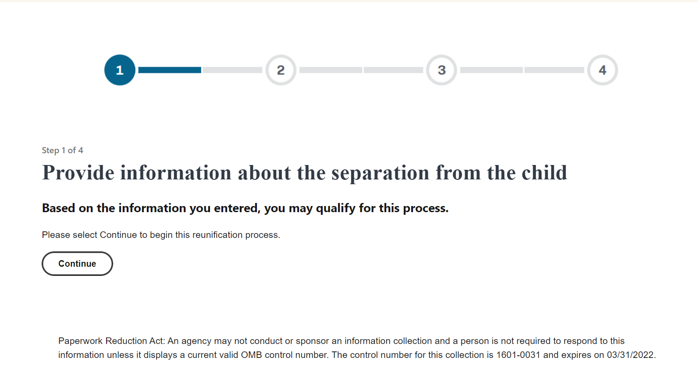

# Step 2a:

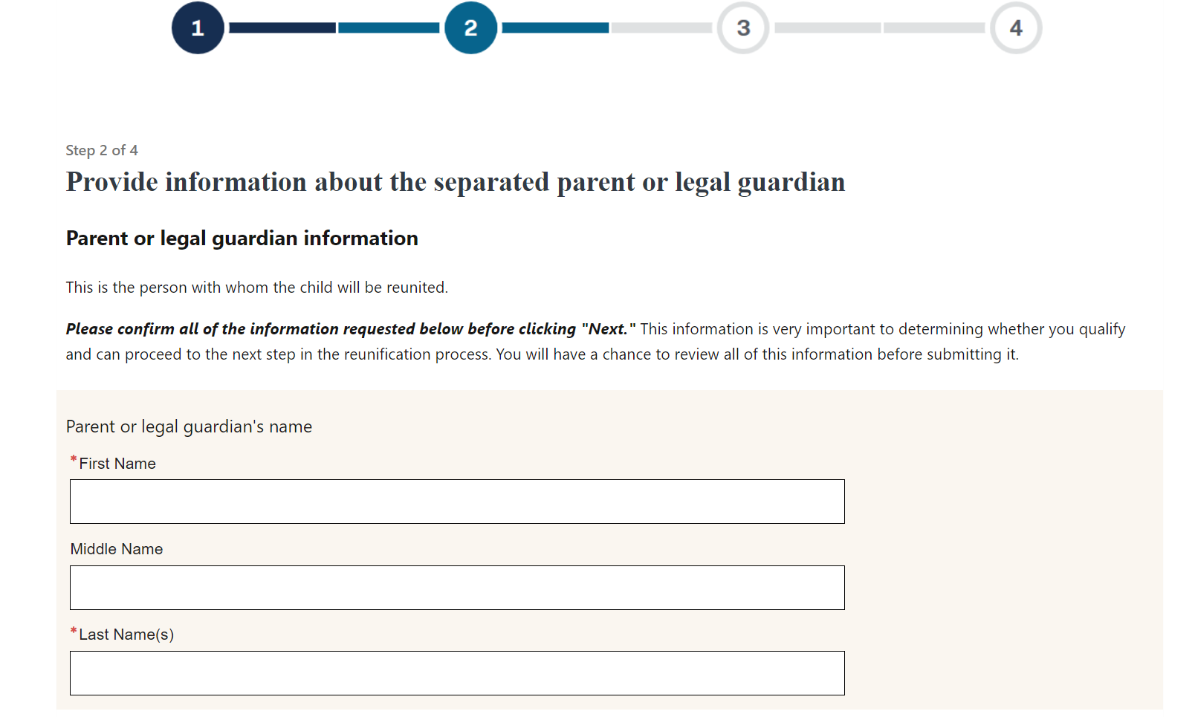

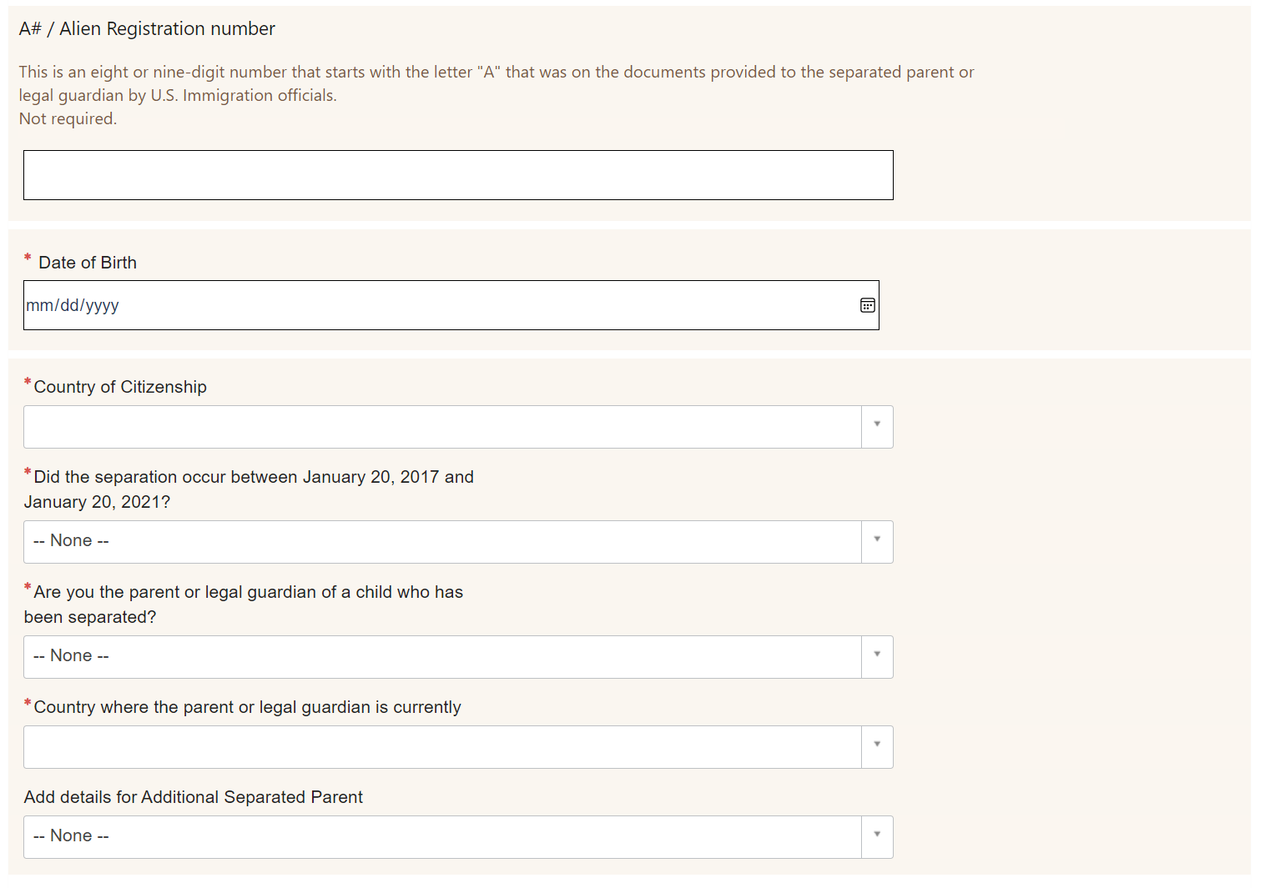

# Step 2b

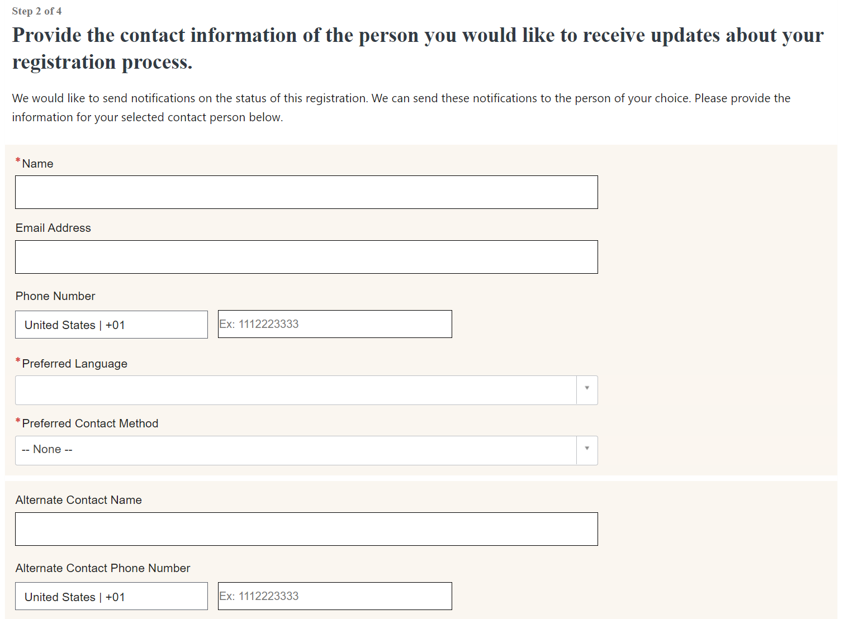

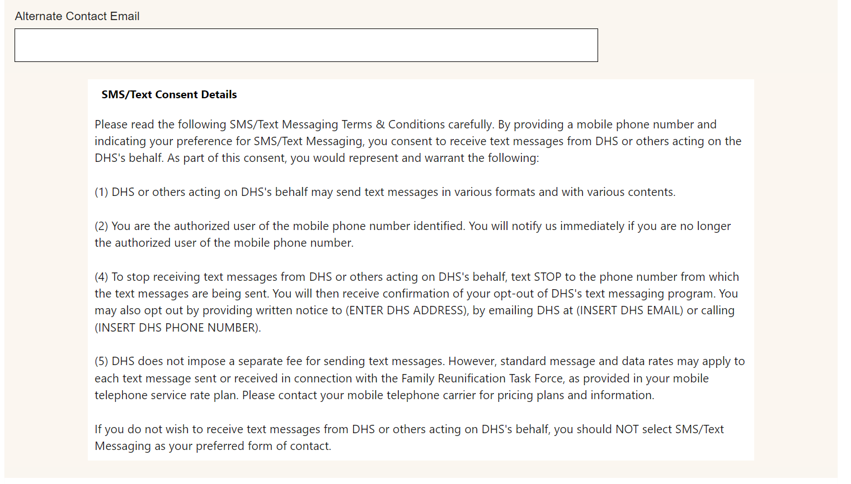

# Step 2c

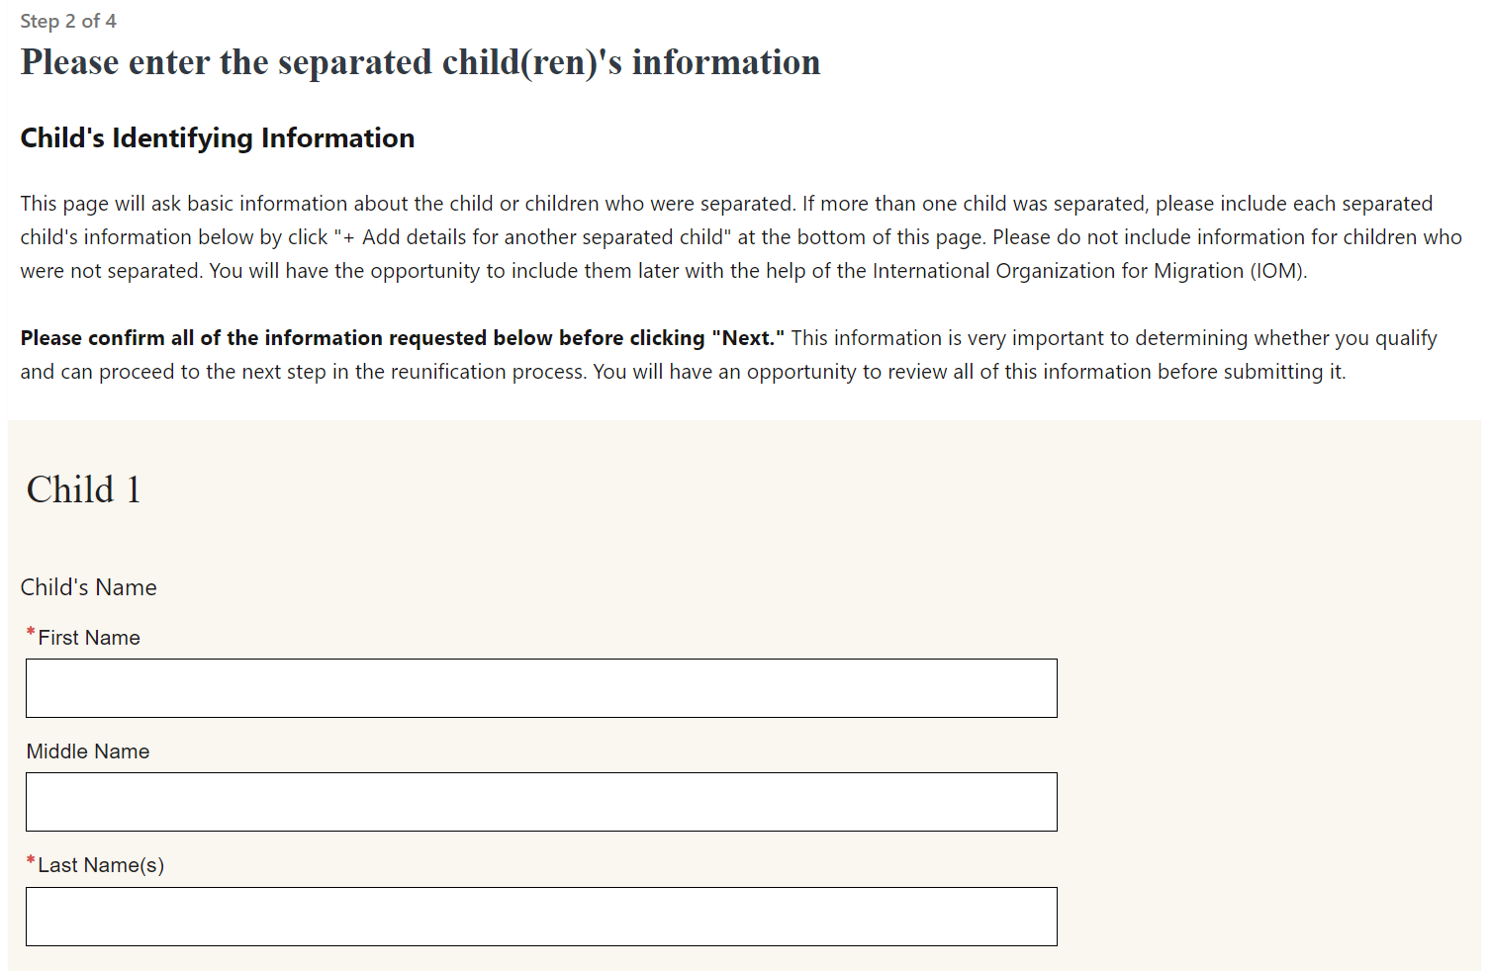

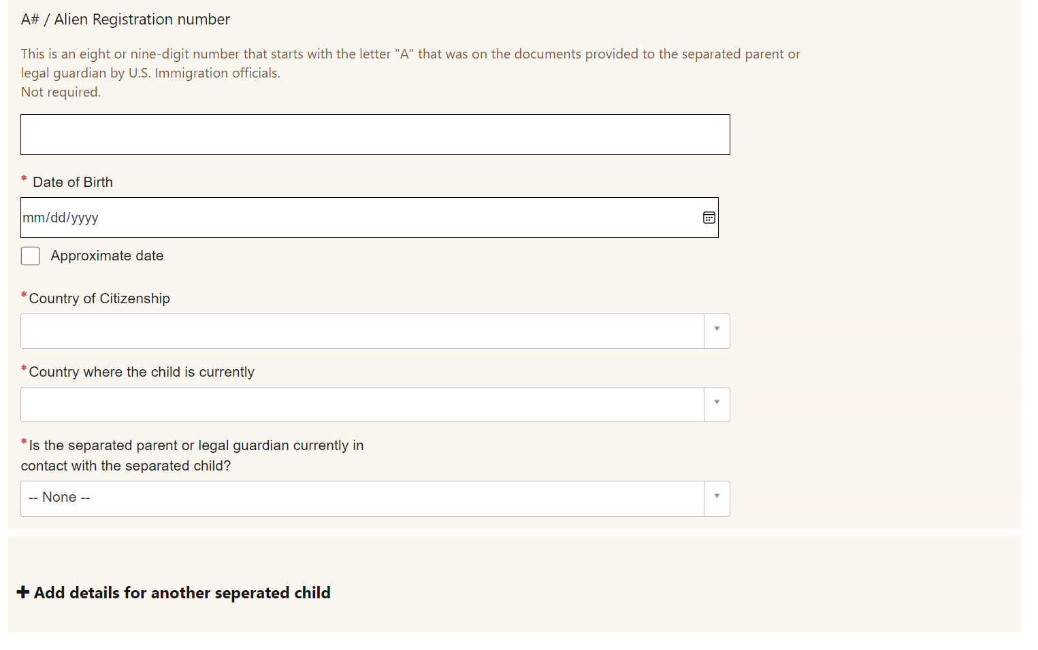

# Step 3a

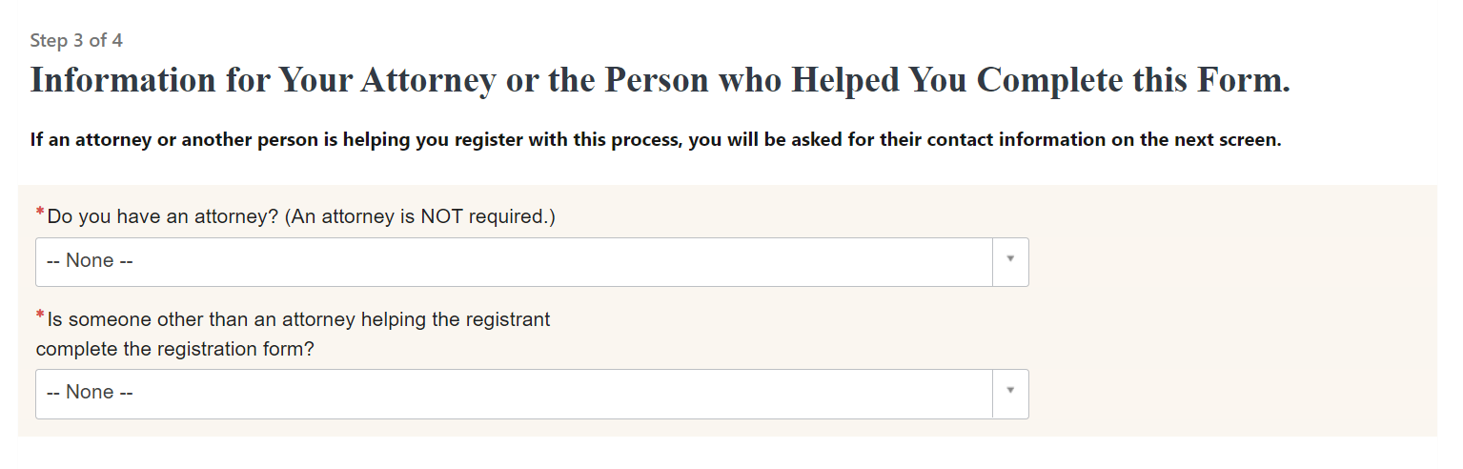

# Step 3b

