Early Childhood Longitudinal Study, Kindergarten Class of 2023-24 (ECLS-K:2024)

**Kindergarten and First-Grade Field Test Data Collection, National Sampling, and National Recruitment**

**OMB# 1850-0750 v.25**

**Attachment A-1**

**K-1 Field Test Respondent Materials**

**National Center for Education Statistics**

**U.S. Department of Education**

**August 2021**

**revised November 2021**

**revised December 2021**

**revised May 2022**

ECLS Study Overview Field Test 1

School District Recruitment Letter Field Test 5

ECLS Coronavirus Protocols Overview Fall 2022 – Field Test 8

School District Nonresponse Letter Field Test 10

School Recruitment Letter Field Test 12

Recruitment Follow–up Letter for Pending/Refusal Schools Field Test 15

Recruitment Email Template for Difficult-to-Reach Principals Field Test 17

Recruitment Email Template School Staff Considering Participation Field Test 19

Recruitment Email Template Follow–up to Address Concerns Field Test 21

Recruitment Email Template Follow–up after Cooperation Achieved Field Test 22

Follow–up Letter for Participating but Difficult to Contact Schools Field Test 23

Spring Email for School Coordinators Field Test 25

School Coordinator Responsibilities Checklist Field Test 27

Summer Email for School Coordinators Field Test 30

School Coordinator Email Announcing E–filing Field Test 31

Instructions for School Coordinators to E–file Child List Field Test 32

Email Providing MyECLS PIN to School Coordinators, School Administrators, and Teachers Field Test 34

Email Providing Secondary MyECLS PIN to School Administrators Field Test 35

School Coordinator Email: Child Information Form Availability Field Test 36

School Coordinator Email: Request to Notify Participants Field Test 37

School Coordinator Guide for Encouraging Participation Field Test 38

School Administrator Notification Email Field Test 40

Teacher Notification Email Field Test 41

Parent Notification Email Field Test 42

Parent Notification Email (Spanish) Field Test 43

School Coordinator Study Activities Package Cover Letter Field Test 44

School Administrator Welcome Letter Field Test 46

Teacher Fact Sheet Field Test 52

Parent Welcome Letter Field Test 54

Parent Welcome Letter (Spanish) Field Test 56

Parent Welcome Letter (Mandarin) Field Test 58

Parent Fact Sheet Field Test 60

Parent Fact Sheet (Spanish) Field Test 62

Explicit Consent Form for Parents Field Test 65

Explicit Consent Form for Parents (Spanish) Field Test 66

Explicit Consent Form for Parents (Mandarin) Field Test 67

Implicit Consent Form for Parents Field Test 68

Implicit Consent Form for Parents (Spanish) Field Test 69

Implicit Consent Form for Parents (Mandarin) Field Test 70

Postcard Providing MyECLS PIN to Parents Field Test 71

Postcard Providing MyECLS PIN to Parents (Spanish) Field Test 72

First Consent and Survey Completion Reminder Email for School Coordinators Field Test 74

First Consent and Survey Completion Reminder Email for Parents (attached to first SC email) Field Test 76

First Consent and Survey Completion Reminder Email for Parents (attached to first SC email; Spanish) Field Test 78

First Consent and Survey Completion Reminder Text Message for Parents (attached to first SC email) Field Test 80

First Consent and Survey Completion Reminder Text Message for Parents (attached to first SC email; Spanish) Field Test 81

First Survey Completion Reminder Email for Teachers and School Administrator (attached to first SC email) Field Test 82

Second Consent and Survey Completion Reminder Email for School Coordinators Field Test 84

Second Consent and Survey Completion Reminder Email for Parents (attached to second SC email) Field Test 85

Second Consent and Survey Completion Reminder Email for Parents (attached to second SC email; Spanish) Field Test 86

Second Consent and Survey Completion Reminder Text Message for Parents (attached to second SC email) Field Test 87

Second Consent and Survey Completion Reminder Text Message for Parents (attached to second SC email; Spanish) Field Test 88

Second Survey Completion Reminder Email for Teachers and School Administrator (attached to second SC email) Field Test 89

Third Survey Completion Reminder Email for School Coordinators Field Test 90

Third Survey Completion Reminder Email for Parents (attached to third SC email) Field Test 91

Third Survey Completion Reminder Email for Parents (attached to third SC email; Spanish) Field Test 92

Third Survey Reminder Text Message for Parents (attached to third SC email) Field Test 93

Third Survey Reminder Text Message for Parents (attached to third SC email; Spanish) Field Test 94

Third Survey Completion Reminder Email for Teachers and School Administrator (attached to third SC email) Field Test 95

Fourth Survey Completion Reminder Email for School Coordinators Field Test 96

Fourth Survey Completion Reminder Email for Parents (attached to fourth SC email) Field Test 97

Fourth Survey Completion Reminder Email for Parents (attached to fourth SC email; Spanish) Field Test 98

Fourth Survey Completion Reminder Text for Parents (attached to fourth SC email) Field Test 99

Fourth Survey Completion Reminder Text for Parents (attached to fourth SC email; Spanish) Field Test 100

Fourth Survey Completion Reminder Email for Teachers and School Administrator (attached to fourth SC email) Field Test 101

School, School Administrator, School Coordinator, and Teacher Thank You Letter Field Test 102

Thank You Email for School Coordinators Field Test 103

Thank You Email for Parents Field Test 104

Thank You Email for Parents (Spanish) Field Test 105

Notification of Feedback Questions for School Coordinator Field Test 106

Notification of Feedback Questions for School Administrator, Teachers, and Parents Field Test 107

Notification of Feedback Questions for School Administrator, Teachers, and Parents (Spanish) Field Test 108

Certification of Contribution Field Test 109

Study Letterhead Field Test 110

Updated ECLS Coronavirus Protocols Overview Field Test 111

# ECLS Study Overview Field Test

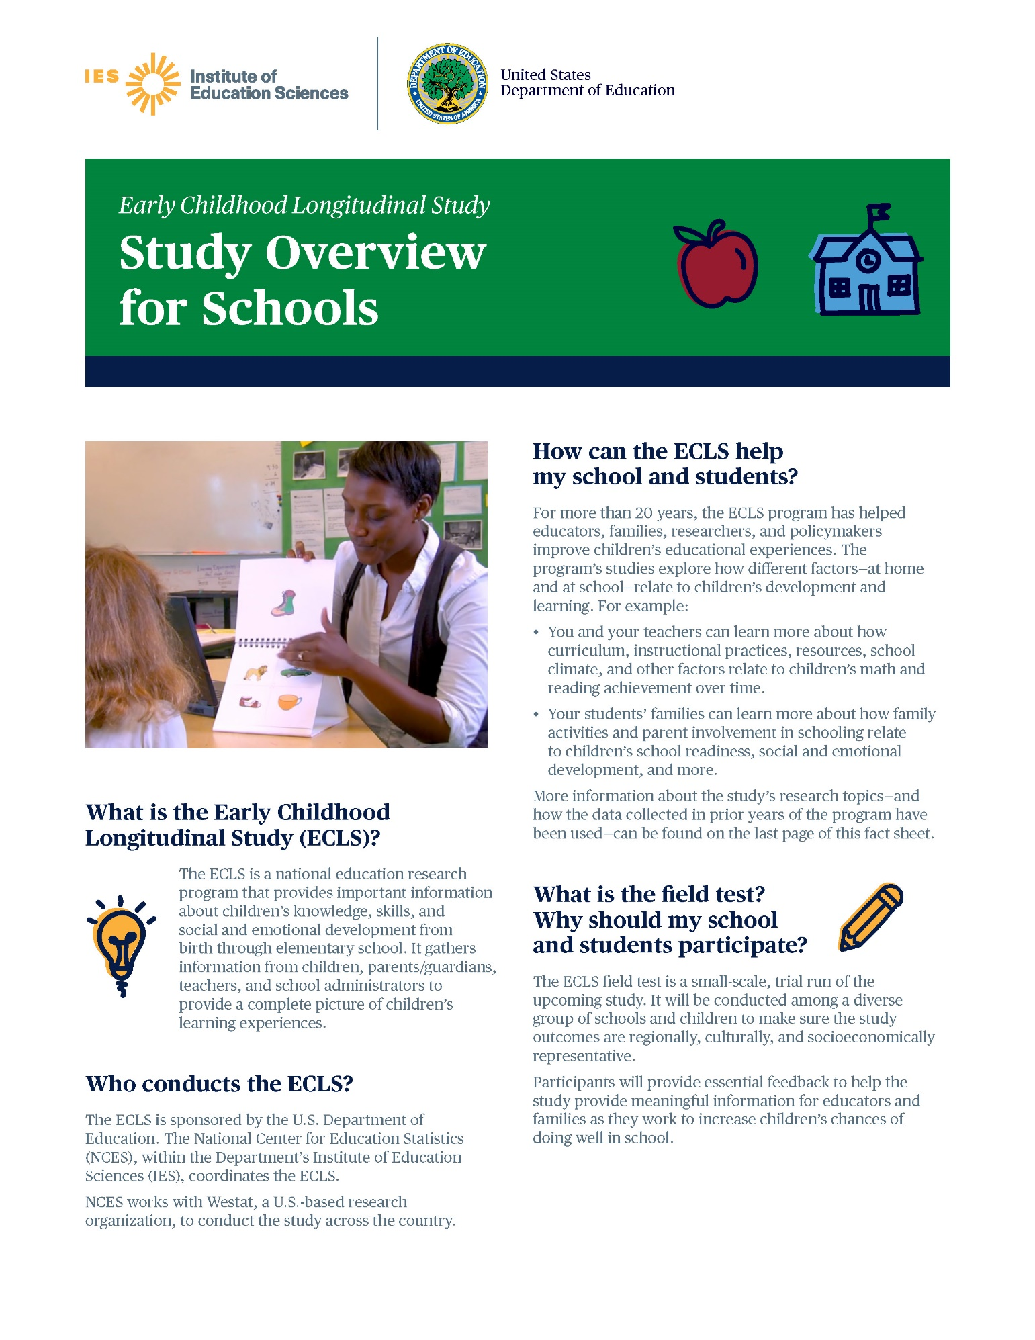

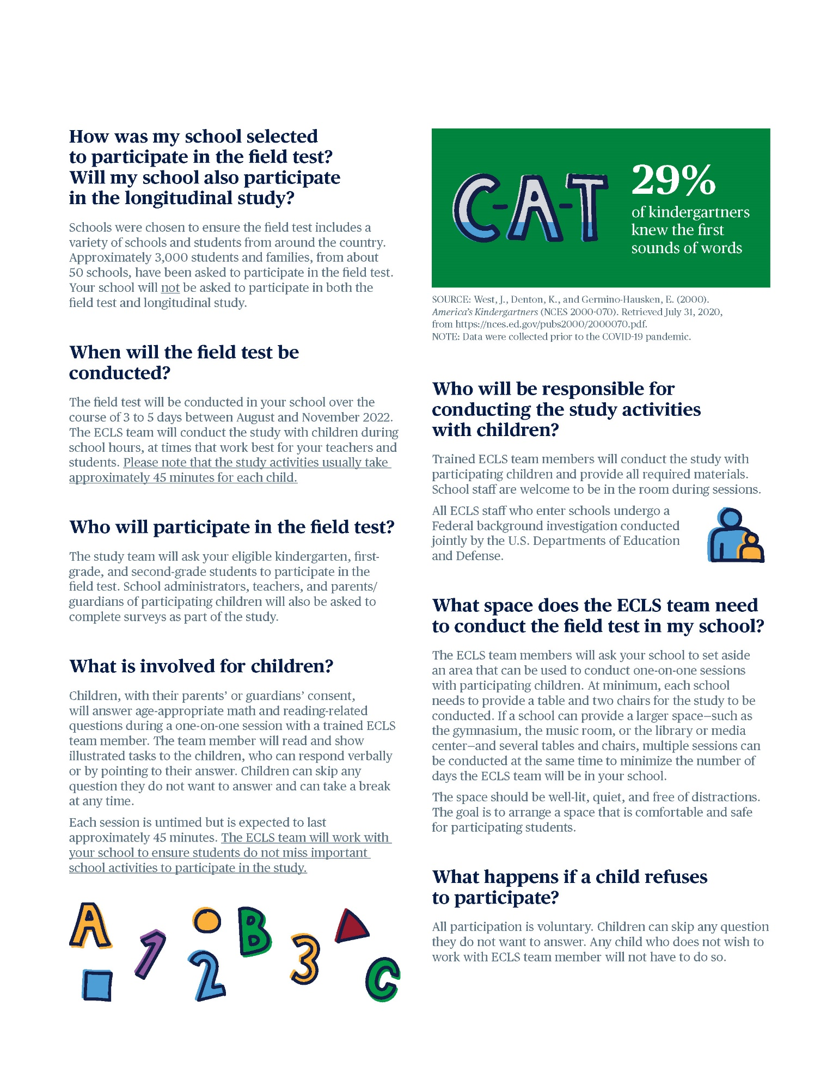

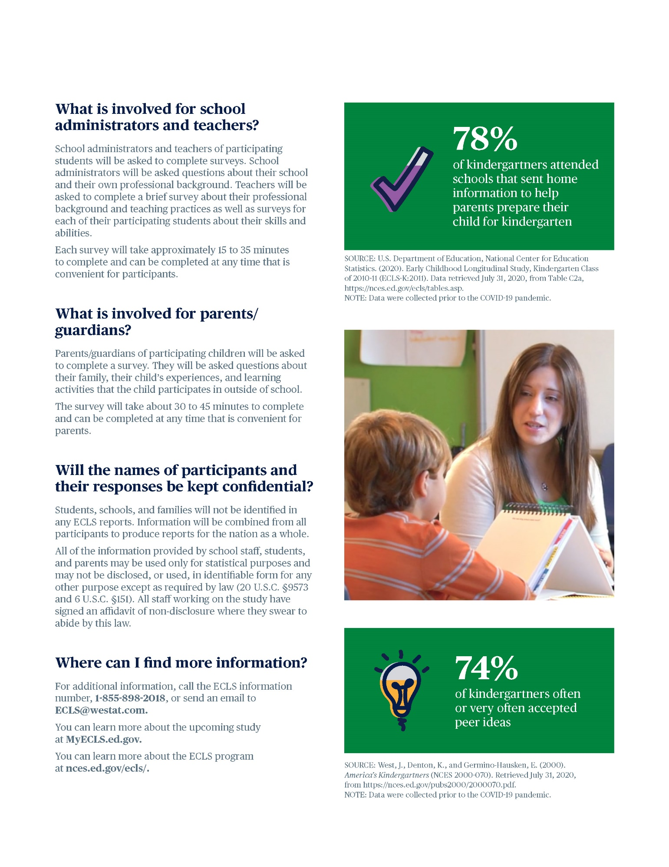

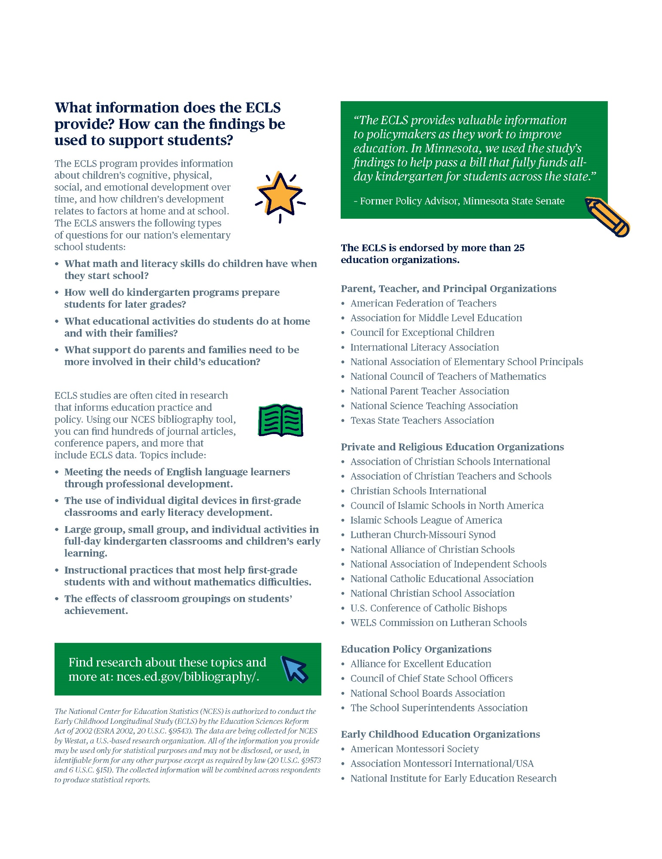

# School District Recruitment Letter Field Test

[DATE]

[TITLE] [NAME FIRST] [NAME LAST]

[TITLE/DEPARTMENT]

[SCHOOL DISTRICT]

[ADDRESS 1]

[CITY], [STATE] [ZIP CODE]

Dear [TITLE] [NAME LAST]:

The U.S. Department of Education is preparing to work with a new cohort of elementary-aged students for a national education research study called the **Early Childhood Longitudinal Study (ECLS)**. This study will help improve educational experiences and outcomes for all students in the United States. In order to inform the national data collections, a field test of study activities is planned for the **fall of 2022.** The enclosed Study Overview provides more details about the study and what is involved for the participants.

The current ECLS is the fourth cohort in the series of early childhood longitudinal studies that make up the ECLS research program. For more than 20 years, the ECLS program has helped educators, families, researchers, and policymakers better understand and improve children’s educational experiences from birth through elementary school. For more details about the ECLS program, visit nces.ed.gov/ecls.

[IF CORONAVIRUS NEEDS TO BE ADDRESSED] As we make plans for the fall 2022 data collection, the COVID-19 pandemic continues to pose significant challenges for state agencies, districts, and schools, while also affecting us all personally.As the situation with the pandemic evolves, please know that we recognize these challenges and are implementing processes and procedures to protect the health and safety of students, school staff, and the ECLS staff. We will follow recommended guidance from health experts and work closely with our state, district, and school partners to determine how to best proceed with the study in schools.The enclosed COVID-19 Protocols Overview provides more details about the safety measures that are currently planned.

The ECLS field test study activities will include one-on-one child assessments conducted by trained ECLS staff and self-administered web surveys completed by school administrators, teachers, and parents of sampled children. The ECLS field test will be conducted among a diverse group of schools and children to ensure that the study outcomes are regionally, culturally, and socioeconomically representative. Participants will provide essential feedback that will inform the national data collection.

**Some schools in your district have been randomly selected to participate in the field test phase of the ECLS in fall 2022, and I am writing to ask for your district’s support of the study and the selected schools’ participation.** While the study is voluntary, by permitting our staff to contact selected schools in your district to discuss participation and encouraging those schools to participate, you will help ensure a successful data collection.

Study staff will be contacting you soon to discuss the participation of the selected schools in your district, as well as any special approval processes that may be required, such as research applications or district-specific consent forms. <To help ensure that our study clearance request packages are properly developed and submitted for your district’s formal review process, I am asking you to designate a staff person who can serve as our central point of contact.>

The following school(s) in your district will be contacted to discuss participation. If allowed by your district, these schools, as well as school staff, teachers, and parents, will be provided with monetary tokens of appreciation in recognition of the time spent participating in the study.

<LIST SAMPLED SCHOOLS>

The ECLS is conducted by the National Center for Education Statistics (NCES), within the U.S. Department of Education’s Institute of Education Sciences (IES). NCES is working with Westat, a U.S.-based research organization, to conduct this voluntary study. Additional specific study information is available on the ECLS website, MyECLS.ed.gov. If you have questions or need assistance, please call 1-855-898-2018 or email ECLS@westat.com. You may also reach the ECLS Study Director, Jill McCarroll, at 202-304-2920 or jill.mccarroll@ed.gov.

Thank you for your time and support of this important national education research study.

Sincerely,

[Name]

[Associate Commissioner or other title]

National Center for Education Statistics, Institute of Education Sciences

U.S. Department of Education

Enclosure:

ECLS Study Overview

[COVID-19 Protocols Overview Fall 2022]

The National Center for Education Statistics (NCES) was established in 1867 to collect and provide to Congress and the public information on the condition of the education system in the United States. NCES, part of the U.S. Department of Education’s Institute of Education Sciences (IES), is the sole Federal statistical agency responsible for meeting Congressional mandates to collect, analyze, and report information on the condition of education in the United States.

NCES needs the support of all involved in the education process to complete the studies it conducts related to Congressional mandates for information about education in the country as a whole. The longitudinal studies including those in the ECLS program collect nationally representative data from students and from their families, teachers, schools, and school systems. These data provide rich information that can be used to study how students’ backgrounds and school experiences are related to education and life outcomes. The studies are comprehensive in approach, covering an expansive array of research and policy issues central to the future of education.

NCES has produced some of the most widely used and cited longitudinal studies on education in the United States. All data collections conducted by NCES are reviewed and approved by the Federal Office of Management and Budget (OMB) to ensure minimal burden on the part of the public and to prevent duplicate data collections by multiple Federal agencies. NCES data are used not only by government agencies but also by policy institutes and researchers at leading universities from across the country. NCES also produces resources for teachers and families. For example, the nces.ed.gov/nceskids website is a resource to learn more about education in the United States and to play fun educational games.

**ECLS Tokens of Appreciation**

If district policy permits, each school community will receive the following to recognize the time spent participating in the ECLS field test:

* Each school will receive $10 per participating student.
* School administrators will receive $25 to thank them for completing a web survey.
* School coordinators, who will act as a liaison between the school and the study, will receive $65 to assist with study activities.
* Participating teachers will receive $20 for a survey they complete about themselves and $7 for each survey they complete for participating students.
* School administrators, school coordinators, and teachers will also receive a Certificate of Contribution from the U.S. Department of Education.
* For schools that require explicit parent consent for children’s participation and that have obtained 100 percent returned forms, regardless of whether consent is provided, the study will also sponsor a food event at the school.
* Participating families will receive <a $15 prepaid Mastercard® and> a pad of sticky notes with the U.S. Department of Education logo as a thank you for completing a web-based survey.

*The National Center for Education Statistics (NCES) is authorized to conduct the Early Childhood Longitudinal Study (ECLS) by the Education Sciences Reform Act of 2002 (ESRA 2002, 20 U.S.C. §9543). The data are being collected for NCES by Westat, a U.S.-based research organization. All of the information you provide may be used only for statistical purposes and may not be disclosed, or used, in identifiable form for any other purpose except as required by law (20 U.S.C. §9573 and 6 U.S.C. §151). The collected information will be combined across respondents to produce statistical reports.*

# ECLS Coronavirus Protocols Overview Fall 2022 – Field Test

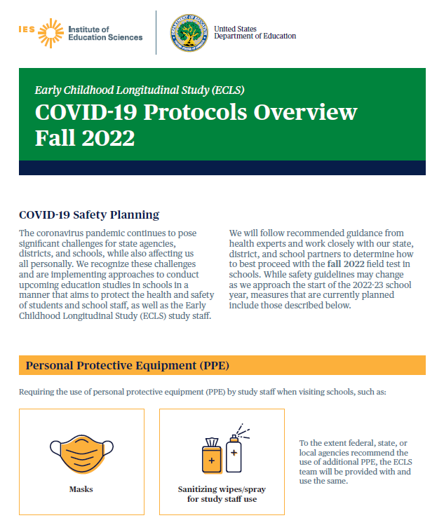

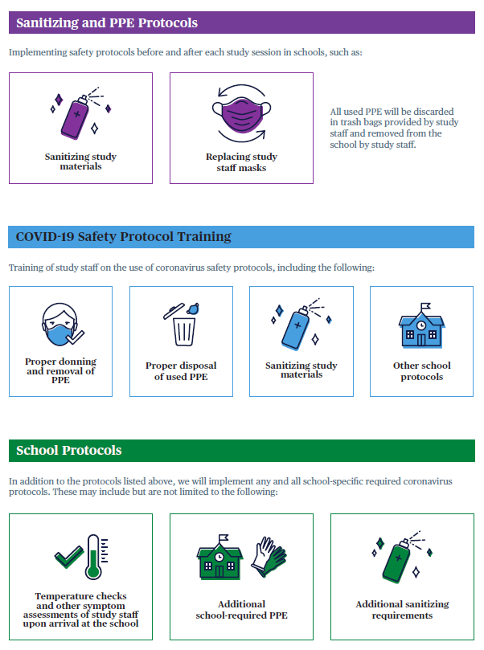

# School District Nonresponse Letter Field Test

[DATE]

[TITLE] [NAME FIRST] [NAME LAST]

[TITLE/DEPARTMENT]

[SCHOOL DISTRICT]

[ADDRESS 1]

[CITY], [STATE] [ZIP CODE]

Dear [TITLE] [NAME LAST]:

We recently contacted your district about the U.S. Department of Education’s **Early Childhood Longitudinal Study (ECLS)**. I am contacting you again to consider lending your support to the study and allowing your district’s sampled schools to participate in the study in the fall of 2022.

[IF CORONAVIRUS NEEDS TO BE ADDRESSED] As we make plans for the fall 2022 data collection, the COVID-19 pandemic continues to pose significant challenges for state agencies, districts, and schools, while also affecting us all personally. As the situation with the pandemic evolves, please know that we recognize these challenges and are implementing processes and procedures to protect the health and safety of students, school staff, and the ECLS staff. We will follow recommended guidance from health experts and work closely with our state, district, and school partners to determine how to best proceed with the study in schools. The enclosed COVID-19 Protocols Overview provides more details about the safety measures that are currently planned.

**About the ECLS research program:** Over its rich 20-year history, the ECLS program’s studies have been important sources of data for researchers and policymakers to use in order to address key issues related to children’s development and learning including literacy in the home; school support of families; the teaching of reading and mathematics; and the associations between physical exercise, childhood obesity, and well-being. Researchers using ECLS data have published their findings widely in scientific journals, and the popular press has reported on these findings. The results from these research studies are available for districts, schools, and the general public to read about on the ECLS program’s website, nces.ed.gov/ecls.

<INSERT INFOGRAPHIC HERE: EITHER USE OF TECHNOLOGY, SCHOOL SUPPORT OF FAMILIES, AND/OR MATERIALS SENT HOME.>

**Why it is important to participate:** We need the support of all involved in the education process to collect nationally representative data from children and from their families, teachers, and schools. We will not be able to understand the current experiences and skills of children without a sample of schools that includes a diverse group of children and teachers in the United States today. This can lead to misleading research conclusions and misinformed policy decisions.

**What is involved for the selected schools, staff, and families:** We are asking the selected schools to participate in the field test phase of the ECLS, which will be conducted among a variety of schools and children to ensure that the study outcomes are regionally, culturally, and socioeconomically representative. Participants will provide essential feedback that will inform the national data collection.

* Age-appropriate and engaging assessments in mathematics and reading will be conducted with children by trained ECLS staff and will be scheduled at a time convenient for the school, between August and November 2022. Most children will be out of the classroom for approximately 45 minutes. Teachers do not need to be present during the sessions.
* School administrators will be asked to complete web surveys about their background and the school environment. Teachers of the participating children will be asked to complete web surveys about their background, the school environment, their classrooms, and skills of the sampled children. If allowed by district policy, school administrators and teachers will receive a monetary token of appreciation as a recognition of their time and effort. They, along with school coordinators, will also receive a Certificate of Contribution from the U.S. Department of Education.
* For schools that require explicit parent consent for children’s participation and that have obtained 100 percent returned forms, regardless of whether consent is provided, the study will also sponsor a food event at the school.
* Parents of the sampled children will be asked to complete a web survey about their child’s home environment, health, early care and education, and skills. Parents will receive <a $15 prepaid Mastercard® and> a pad of sticky notes with the U.S. Department of Education logo for their time.

The ECLS is conducted by the National Center for Education Statistics (NCES), within the U.S. Department of Education’s Institute of Education Sciences (IES). NCES is working with Westat, a U.S.-based research organization, to conduct this voluntary study.

A Westat representative of the ECLS will call you soon to discuss your decision. For additional information, please reach out to the ECLS team at ECLS@westat.com or 1-855-898-2018, or visit the study website at MyECLS.ed.gov. To contact the ECLS Study Director, Jill McCarroll, please call 202-304-2920 or email jill.mccarroll@ed.gov. Thank you for your time and consideration.

Sincerely,

[Name]

[Associate Commissioner or other title]

National Center for Education Statistics, Institute of Education Sciences

U.S. Department of Education

Enclosure:

ECLS Study Overview

[COVID-19 Protocols Overview Fall 2022]

*The National Center for Education Statistics (NCES) is authorized to conduct the Early Childhood Longitudinal Study (ECLS) by the Education Sciences Reform Act of 2002 (ESRA 2002, 20 U.S.C. §9543). The data are being collected for NCES by Westat, a U.S.-based research organization. All of the information you provide may be used only for statistical purposes and may not be disclosed, or used, in identifiable form for any other purpose except as required by law (20 U.S.C. §9573 and 6 U.S.C. §151). The collected information will be combined across respondents to produce statistical reports.*

# School Recruitment Letter Field Test

<Date>

<Addressee’s Name

School

Address

Address 2

City, State, ZIP>

Dear <School Administrator>:

Your school has been chosen by the U.S. Department of Education to participate in a field test for the upcoming **Early Childhood Longitudinal Study, or the ECLS, happening in the fall of 2022**. <District approver’s name at your district’s office/Your district office> has been notified about this study and is aware that you are being contacted and asked to participate. The enclosed Study Overview provides more details about the study and what is involved for the participants.

The current ECLS is the fourth cohort in the series of early childhood longitudinal studies that make up the ECLS program. For more than 20 years, the ECLS program has helped educators, families, researchers, and policymakers better understand and improve children’s educational experiences from birth through elementary school. The program provides valuable information about children’s learning and development. For more details about the ECLS program, visit nces.ed.gov/ecls.

[IF CORONAVIRUS NEEDS TO BE ADDRESSED] As we make plans for the fall 2022 data collection, the COVID-19 pandemic continues to pose significant challenges for state agencies, districts, and schools, while also affecting us all personally. As the situation with the pandemic evolves, please know that we recognize these challenges and are implementing processes and procedures to protect the health and safety of students, school staff, and the ECLS staff. We will follow recommended guidance from health experts and work closely with you to determine how to best proceed with the study in your school. The enclosed COVID-19 Protocols Overview provides more details about the safety measures that are currently planned.

I encourage you and your school to participate in the field test phase of the study. While participation is voluntary, the selected schools, students, and families need to be included to ensure that the study outcomes are regionally, culturally, and socioeconomically representative. Participants will provide essential feedback that will inform the national data collection.

* The field test will be conducted in the fall of 2022 in approximately 50 selected schools.
* Selected kindergarten, first-grade, and second-grade children will be asked to complete age-appropriate and engaging math and reading assessments with a trained ECLS team member. The child sessions will be scheduled at a time convenient for the school. Each child session is untimed but is expected to take approximately 45 minutes for most children. Your teachers will not need to take time away from their students for study activities and we will work with them to minimize classroom disruptions.
* You, as well as the parents and teachers of the selected students, will be asked to complete web surveys.
* <For your time and effort, we will provide you, your school, the school’s coordinator to the study, <and>teachers<, and parents> a monetary token of appreciation. More details are provided on the back of this letter.>

The ECLS is conducted by the National Center for Education Statistics (NCES), within the U.S. Department of Education’s Institute of Education Sciences (IES). We have partnered with Westat, a U.S.-based research organization, to carry out the study in participating schools.

A study representative will contact you about the study within the next few days. In the meantime, if you have questions or need assistance, please call the ECLS team at 1-855-898-2018 or email ECLS@westat.com. Additional specific study information is available on the ECLS website, MyECLS.ed.gov.

Thank you for your support of this important program!

Sincerely,

[Name][Associate Commissioner or other title]

National Center for Education Statistics, Institute of Education Sciences

U.S. Department of Education

Enclosure:

ECLS Study Overview

[COVID-19 Protocols Overview Fall 2022]

Your school community will receive the following to recognize the time spent participating in the study:

* <You will receive $25 to complete a school administrator survey.
* Your school will receive $10 per participating student.
* Your school coordinator, who will act as a liaison between your school and the study, will receive $65.
* Participating teachers will receive $20 for a survey they complete about themselves and $7 for each survey they complete for participating students.>
* School administrators, school coordinators, and teachers will <also> receive a Certificate of Contribution from the U.S. Department of Education.
* For schools that require explicit parent consent for children’s participation and that have obtained 100 percent returned forms, regardless of whether consent is provided, the study will also sponsor a food event at the school.
* Parents will receive <a $15 prepaid Mastercard® and> a pad of sticky notes with the U.S. Department of Education logo as a thank you for completing a web survey.

*The National Center for Education Statistics (NCES) is authorized to conduct the Early Childhood Longitudinal Study (ECLS) by the Education Sciences Reform Act of 2002 (ESRA 2002, 20 U.S.C. §9543). The data are being collected for NCES by Westat, a U.S.-based research organization. All of the information you provide may be used only for statistical purposes and may not be disclosed, or used, in identifiable form for any other purpose except as required by law (20 U.S.C. §9573 and 6 U.S.C. §151). The collected information will be combined across respondents to produce statistical reports.*

# Recruitment Follow–up Letter for Pending/Refusal Schools Field Test

[DATE]

[TITLE] [NAME FIRST] [NAME LAST]

[TITLE/DEPARTMENT]

[SCHOOL DISTRICT]

[ADDRESS 1]

[CITY], [STATE] [ZIP CODE]

Dear [TITLE] [NAME LAST]:

We recently contacted your school about the U.S. Department of Education’s **Early Childhood Longitudinal Study (ECLS)**. I am contacting you again to consider lending your support to the study and allowing your school to participate in the study in the fall of 2022.

[IF CORONAVIRUS NEEDS TO BE ADDRESSED] As we make plans for the fall 2022 data collection, the COVID-19 pandemic continues to pose significant challenges for state agencies, districts, and schools, while also affecting us all personally. As the situation with the pandemic evolves, please know that we recognize these challenges and are implementing processes and procedures to protect the health and safety of students, school staff, and the ECLS staff. We will follow recommended guidance from health experts and work closely with you to determine how to best proceed with the study in your school. The enclosed COVID-19 Protocols Overview provides more details about the safety measures that are currently planned.

**About the ECLS research program:** Over its rich 20-year history, the ECLS program’s studies have been important sources of data for researchers and policymakers to use in order to address key issues related to children’s development and learning including literacy in the home; school support for families; the teaching of reading and mathematics; and the associations between physical exercise, childhood obesity, and well-being. Researchers using ECLS data have published their findings widely in scientific journals, and the popular press has reported on these findings. The results from these studies are available for districts, schools, and the general public to read about on the ECLS program’s website, nces.ed.gov/ecls.

<INSERT INFOGRAPHIC HERE: EITHER USE OF TECHNOLOGY, SCHOOL SUPPORT OF FAMILIES, AND/OR MATERIALS SENT HOME.>

**Why it is important to participate:** We need the support of all involved in the education process to collect nationally representative data from children and from their families, teachers, and schools. We will not be able to understand the current experiences and skills of children without a sample of schools that includes a diverse group of children and teachers in the United States today. This can lead to misleading research conclusions and misinformed policy decisions. The enclosed Study Overview provides more details about the study and what is involved for the participants.

**What is involved for the selected schools, staff, and families:** We are asking the selected schools to participate in the field test phase of the ECLS, which will be conducted among a variety of schools and children to ensure that the study outcomes are regionally, culturally, and socioeconomically representative. Participants will provide essential feedback that will inform the national data collection.

* Age-appropriate and engaging assessments in mathematics and reading will be conducted with children by trained ECLS staff and will be scheduled at a time convenient for the school between August and November 2022. Most children will be out of the classroom for approximately 45 minutes. Teachers do not need to be present during the sessions and we will work with them to minimize classroom disruptions.
* School administrators will be asked to complete web surveys about their background and the school environment. Teachers of the participating children will be asked to complete web surveys about their background, the school environment, their classrooms, and skills of the sampled children. <Monetary tokens of appreciation will be distributed as a recognition of time and effort spent.> School administrators, school coordinators, and teachers will <also> receive a Certificate of Contribution from the U.S. Department of Education. For schools that require explicit parent consent for children’s participation and that have obtained 100 percent returned forms, regardless of whether consent is provided, the study will also sponsor a food event (such as a pizza or ice cream party) at the school.
* Parents of the sampled children will be asked to complete a web survey about their child’s home environment, health, early care and education, and skills. Parents will receive <a $15 prepaid Mastercard® and> a pad of sticky notes with the U.S. Department of Education logo for their time.

The ECLS is conducted by the National Center for Education Statistics (NCES), within the U.S. Department of Education’s Institute of Education Sciences (IES). NCES is working with Westat, a U.S.-based research organization, to conduct this voluntary study. A Westat representative of ECLS will call you soon to discuss your decision. For additional information, please reach out to the ECLS team at ECLS@westat.com or 1-855-898-2018, or visit the ECLS project-specific website at MyECLS.ed.gov. Thank you for your time and consideration.

Sincerely,

[Name][Associate Commissioner or other title]

National Center for Education Statistics, Institute of Education Sciences

U.S. Department of Education

Enclosure:

ECLS Study Overview

[COVID-19 Protocols Overview Fall 2022]

*The National Center for Education Statistics (NCES) is authorized to conduct the Early Childhood Longitudinal Study (ECLS) by the Education Sciences Reform Act of 2002 (ESRA 2002, 20 U.S.C. §9543). The data are being collected for NCES by Westat, a U.S.-based research organization. All of the information you provide may be used only for statistical purposes and may not be disclosed, or used, in identifiable form for any other purpose except as required by law (20 U.S.C. §9573 and 6 U.S.C. §151). The collected information will be combined across respondents to produce statistical reports.*

# Recruitment Email Template for Difficult-to-Reach Principals Field Test

SUBJECT: Participation in the U.S. Department of Education’s ECLS

Dear [SCHOOL ADMIN NAME]:

My name is [RECRUITER NAME] and I have recently been trying to reach you to discuss the U.S. Department of Education’s **Early Childhood Longitudinal Study (ECLS), happening in the fall of 2022**. [Your [SECRETARY / ADMINISTRATIVE ASSISTANT / RECEPTIONIST] has been very gracious in receiving my calls and suggested I use email to contact you.] [IF DISTRICT APPROVAL OBTAINED: I spoke with [NAME], [TITLE] of [DISTRICT/DIOCESE NAME], about your school’s selection for the ECLS field test. [He/She] approved my contacting you directly.]

[IF CORONAVIRUS NEEDS TO BE ADDRESSED] As we make plans for the fall 2022 data collection, the COVID-19 pandemic continues to pose significant challenges for state agencies, districts, and schools, while also affecting us all personally. As the situation with the pandemic evolves, please know that we recognize these challenges and are implementing processes and procedures to protect the health and safety of students, school staff, and the ECLS staff. We will follow recommended guidance from health experts and work closely with you to determine how to best proceed with the study in your school.

**Why is it Important for My School to Participate?**

* Your school was selected because of a variety of factors, including geographic location, school size, and the makeup of the school population you serve.
* We are asking the selected schools to participate in the field test phase of the ECLS, which will be conducted among a diverse group of schools and children to ensure that the study outcomes are regionally, culturally, and socioeconomically representative. Participants will provide essential feedback.
* We need representation from all types of schools in the United States―public, religiously-affiliated private schools, and private schools without religious affiliation.

**What is Involved for the Selected Schools, Staff, and Families?**

* Selected kindergarten, first-grade, and second-grade children participate in an engaging, one-on-one assessment in reading and math. Each child session is untimed but should take about 45 minutes for most children.
* Local ECLS staff will administer each child’s session and the study will provide all materials for the school visits. Teachers do not need to be present and we will work with them to minimize disruptions to their classrooms.
* You are asked to complete a web survey on school characteristics and your background. The teachers of sampled children are asked to complete web surveys about their experiences, classroom characteristics, and the selected children. The parents of sampled children are asked to complete web surveys about their household and the child.

**What Else Should I Know about the Study?**

* [IF INCENTIVES ARE ALLOWED:] There is no monetary cost involved―in fact, the school, the school’s coordinator to the study, teachers, and parents will all receive a monetary token of appreciation for participation.
* School, child, teacher, and parent names will not be published in any reports nor will individual child assessment scores be reported.
* All ECLS staff who enter schools undergo a Federal background investigation conducted jointly by the U.S. Departments of Education and Defense and have signed a pledge of confidentiality.

**What is the Next Step?**

Please identify a convenient time when we can discuss your ECLS participation. If you would rather appoint another staff member to serve as the contact, I would be glad to work with that person to make arrangements.

**Need More Information about the Study?**

Refer to the attached ECLS Study Overview or visit the study website, [MyECLS](http://MyECLS.ed.gov). If you have questions, please feel free to contact me directly.

Sincerely,

[NAME], ECLS Representative

[PHONE NUMBER]

**One reason why the ECLS program is so important? It helps us understand more about schools, teachers, and students across the United States.**

<INSERT INFOGRAPHIC HERE: EITHER USE OF TECHNOLOGY, SCHOOL SUPPORT OF FAMILIES, AND/OR MATERIALS SENT HOME.>

*Attachment*

ECLS Study Overview

[COVID-19 Protocols Overview Fall 2022]

The ECLS is conducted by the National Center for Education Statistics (NCES), within the U.S. Department of Education’s Institute of Education Sciences (IES).

*The National Center for Education Statistics (NCES) is authorized to conduct the Early Childhood Longitudinal Study (ECLS) by the Education Sciences Reform Act of 2002 (ESRA 2002, 20 U.S.C. §9543). The data are being collected for NCES by Westat, a U.S.-based research organization. All of the information you provide may be used only for statistical purposes and may not be disclosed, or used, in identifiable form for any other purpose except as required by law (20 U.S.C. §9573 and 6 U.S.C. §151). The collected information will be combined across respondents to produce statistical reports.*

# Recruitment Email Template School Staff Considering Participation Field Test

SUBJECT: Participation in the U.S. Department of Education’s ECLS

Dear [SCHOOL ADMIN NAME]:

Thank you for taking your valuable time to speak with me today concerning the participation of [SCHOOL NAME] in the U.S. Department of Education’s **Early Childhood Longitudinal Study (ECLS), happening in the fall of 2022**. As you will be speaking with [your teachers/your board] about the study, I am including a brief overview of what is involved as well as attaching an ECLS Study Overview for you to pass along. As we discussed, your staff’s time involvement is limited, but their support is vital.

[IF CORONAVIRUS NEEDS TO BE ADDRESSED] As we make plans for the fall 2022 data collection, the COVID-19 pandemic continues to pose significant challenges for state agencies, districts, and schools, while also affecting us all personally. As the situation with the pandemic evolves, please know that we recognize these challenges and are implementing processes and procedures to protect the health and safety of students, school staff, and the ECLS staff. We will follow recommended guidance from health experts and work closely with you to determine how to best proceed with the study in your school.

**Why is it Important for My School to Participate?**

* Your school was selected because of a variety of factors, including geographic location, school size, and the makeup of the school population you serve.
* We are asking the selected schools to participate in the field test phase of the ECLS, which will be conducted among a diverse group of schools and children to ensure that the study outcomes are regionally, culturally, and socioeconomically representative. Participants will provide essential feedback to help improve the national data collection.
* We need representation from all types of schools in the United States―public, religiously-affiliated private schools, and private schools without religious affiliation.

**What is Involved for the Selected Schools, Staff, and Families?**

* Selected kindergarten, first-grade, and second-grade children participate in an engaging, one-on-one assessment in reading and math. Each child session is untimed but should take about 45 minutes for most children.
* Local ECLS staff will administer each child’s session and the study will provide all materials for the school visits. Teachers do not need to be present and we will work with them to minimize disruptions to their classrooms.
* The school administrator is asked to complete a web survey on school characteristics and his or her background. The teachers of sampled children are asked to complete web surveys about their experiences, classroom characteristics, and the selected children. The parents of sampled children are asked to complete web surveys about their household and the child.

**What Else Should I Know about the Study?**

* [IF INCENTIVES ARE ALLOWED:] There is no monetary cost involved―in fact, the school, the school’s coordinator to the study, teachers, and parents will all receive a monetary token of appreciation for participation.
* School, child, teacher, and parent names will not be published in any reports nor will individual child assessment scores be reported.
* All ECLS staff who enter schools undergo a Federal background investigation conducted jointly by the U.S. Departments of Education and Defense and have signed a pledge of confidentiality.

**Need More Information about the Study?**

Refer to the attached ECLS Study Overview or visit the study website, [MyECLS](http://MyECLS.ed.gov). If you have questions, please feel free to contact me directly.

**What is the Next Step?**

I will contact you on [DATE] to obtain additional school information, including the contact information for the person you designate to help with study arrangements.

Sincerely,

[NAME], ECLS Representative

[PHONE NUMBER]

**One reason why the ECLS program is so important? It helps us understand more about schools, teachers, and students across the United States.**

<INSERT INFOGRAPHIC HERE: EITHER USE OF TECHNOLOGY, SCHOOL SUPPORT OF FAMILIES, AND/OR MATERIALS SENT HOME.>

*Attachment*

ECLS Study Overview

[COVID-19 Protocols Overview Fall 2022]

The ECLS is conducted by the National Center for Education Statistics (NCES), within the U.S. Department of Education’s Institute of Education Sciences (IES).

*The National Center for Education Statistics (NCES) is authorized to conduct the Early Childhood Longitudinal Study (ECLS) by the Education Sciences Reform Act of 2002 (ESRA 2002, 20 U.S.C. §9543). The data are being collected for NCES by Westat, a U.S.-based research organization. All of the information you provide may be used only for statistical purposes and may not be disclosed, or used, in identifiable form for any other purpose except as required by law (20 U.S.C. §9573 and 6 U.S.C. §151). The collected information will be combined across respondents to produce statistical reports.*

# Recruitment Email Template Follow–up to Address Concerns Field Test

SUBJECT: Participation in the U.S. Department of Education’s ECLS

Dear [SCHOOL ADMIN NAME]:

Thank you so much for taking the time to speak with me today. I am writing to summarize some of the details of our discussion and to provide more information about [CONCERN].

[DETAILED RESPONSE TO CONCERN]

For more than 20 years, the ECLS program has helped educators, families, researchers, and policymakers better understand and improve children’s educational experiences from birth through elementary school. This is [SCHOOL NAME]’s opportunity to contribute to the interests of the broader educational community, while also contributing to research that can help your particular school, teachers, and students.

**One reason why the ECLS program is so important? It helps us understand more about schools, teachers, and students across the United States.**

<INSERT INFOGRAPHIC HERE: EITHER USE OF TECHNOLOGY, SCHOOL SUPPORT OF FAMILIES, AND/OR MATERIALS SENT HOME.>

Please visit the study website [MyECLS](http://MyECLS.ed.gov) for more information or contact me with any questions you may have. I will call you again in a few days and look forward to working with you.

Sincerely,

[NAME], ECLS Representative

[PHONE NUMBER]

The ECLS is conducted by the National Center for Education Statistics (NCES), within the U.S. Department of Education’s Institute of Education Sciences (IES).

*The National Center for Education Statistics (NCES) is authorized to conduct the Early Childhood Longitudinal Study (ECLS) by the Education Sciences Reform Act of 2002 (ESRA 2002, 20 U.S.C. §9543). The data are being collected for NCES by Westat, a U.S.-based research organization. All of the information you provide may be used only for statistical purposes and may not be disclosed, or used, in identifiable form for any other purpose except as required by law (20 U.S.C. §9573 and 6 U.S.C. §151). The collected information will be combined across respondents to produce statistical reports.*

# Recruitment Email Template Follow–up after Cooperation Achieved Field Test

SUBJECT: Participation in the U.S. Department of Education’s ECLS

Dear [SCHOOL ADMIN NAME]:

Thank you for taking your valuable time to speak with me today concerning the participation of [SCHOOL NAME] in the U.S. Department of Education’s **Early Childhood Longitudinal Study (ECLS)**. I am so pleased that your school will assist us in gathering important information that will be used to improve education for our nation’s students. As we discussed, your staff’s time involvement is limited, but their support is vital. To summarize our discussion today:

[SUMMARY OF DISCUSSION]

I look forward to working with you and your staff. I will contact [SCHOOL COORDINATOR NAME] on [DATE OR TIMEFRAME] to discuss the fall study activities and to make preliminary arrangements. In the meantime, please feel free to contact me with questions, or visit the study website [MyECLS](http://MyECLS.ed.gov) for more information about next steps.

[IF CORONAVIRUS NEEDS TO BE ADDRESSED] As the situation with the COVID-19 pandemic evolves, please know that we recognize these challenges and are implementing processes and procedures to protect the health and safety of students, school staff, and the ECLS staff. We will follow recommended guidance from health experts and work closely with you to determine how to best proceed with the study in your school.

Sincerely,

[NAME], ECLS Representative

[PHONE NUMBER]

The ECLS is conducted by the National Center for Education Statistics (NCES), within the U.S. Department of Education’s Institute of Education Sciences (IES).

*The National Center for Education Statistics (NCES) is authorized to conduct the Early Childhood Longitudinal Study (ECLS) by the Education Sciences Reform Act of 2002 (ESRA 2002, 20 U.S.C. §9543). The data are being collected for NCES by Westat, a U.S.-based research organization. All of the information you provide may be used only for statistical purposes and may not be disclosed, or used, in identifiable form for any other purpose except as required by law (20 U.S.C. §9573 and 6 U.S.C. §151). The collected information will be combined across respondents to produce statistical reports.*

# Follow–up Letter for Participating but Difficult to Contact Schools Field Test

[DATE]

[TITLE] [NAME FIRST] [NAME LAST]

[TITLE/DEPARTMENT]

[SCHOOL DISTRICT]

[ADDRESS 1]

[CITY], [STATE] [ZIP CODE]

Dear [TITLE] [NAME LAST]:

We recently contacted you about a new cohort of the U.S. Department of Education’s **Early Childhood Longitudinal Study (ECLS)**. As the ECLS Project Director for Westat, the U.S.-based research organization conducting the field test phase of this study on behalf of the National Center for Education Statistics (NCES), I want to thank you for agreeing to participate in the ECLS.

As the data collection period draws closer, it is critical that we <confirm the ECLS study visit dates for your school / receive the child list for sampling>. Your school represents other schools in the U.S. that have a student body like yours and it is so important that we field test the study activities to ensure the study outcomes are regionally, culturally, and socioeconomically representative for the national data collection. As a reminder:

* We will schedule the fall school visit at a time convenient for your school, between August and November 2022. Local ECLS staff will administer each child’s session. Teachers do not need to be present and we will work with them to minimize classroom disruptions. The burden on your school staff is minimal.
* We will work with your school staff to schedule the child sessions at convenient times to minimize the amount of class time that children miss. Most children will be out of the classroom for approximately 45 minutes.
* <In recognition of the school staff’s time and effort, your school will receive $10 per participating kindergarten, first-grade, and second-grade child. School administrators will receive $25 for completing the school survey. Your school’s ECLS school coordinator, who will act as a liaison between your school and the study, will receive $65, and teachers will receive $20 for completing the teacher background survey and an additional $7 for each survey about a study child that they complete.> School administrators, school coordinators, and teachers will <also> receive a Certificate of Contribution from the U.S. Department of Education. < For schools that require explicit parent consent for children’s participation and that have obtained 100 percent returned forms, regardless of whether consent is provided, the study will also sponsor a food event (such as a pizza or ice cream party) at the school.> Parents asked to complete the survey will receive <a $15 prepaid Mastercard® and> a pad of sticky notes with the U.S. Department of Education logo.

[IF CORONAVIRUS NEEDS TO BE ADDRESSED]: As the situation with the COVID-19 pandemic evolves, please know that we recognize these challenges and are implementing processes and procedures to protect the health and safety of students, school staff, and the ECLS staff. We will follow recommended guidance from health experts and work closely with you to determine how to best proceed with the study in your school.

**The ECLS team wants to make your school’s participation as easy and efficient as possible.** We are available to help review your calendar to find a time to visit your school to conduct the study activities and can aid in compiling and submitting the child list that we need in order to select students for the study. Please reach out to your ECLS representative, <team leader name>, at <email address>. You can also contact the ECLS team at 1–855–898–2018 or ECLS@westat.com with any questions. There are detailed tips for completing the study activities on the ECLS website, MyECLS.ed.gov.

Thank you for your time and consideration.

Sincerely,

Elizabeth Bissett

Project Director, ECLS

Westat

**One reason the ECLS program is so important? It helps us understand more about schools, teachers, and students across the United States.**

<INSERT INFOGRAPHIC HERE: EITHER USE OF TECHNOLOGY, SCHOOL SUPPORT OF FAMILIES, AND/OR MATERIALS SENT HOME.>

*The National Center for Education Statistics (NCES) is authorized to conduct the Early Childhood Longitudinal Study (ECLS) by the Education Sciences Reform Act of 2002 (ESRA 2002, 20 U.S.C. §9543). The data are being collected for NCES by Westat, a U.S.-based research organization. All of the information you provide may be used only for statistical purposes and may not be disclosed, or used, in identifiable form for any other purpose except as required by law (20 U.S.C. §9573 and 6 U.S.C. §151). The collected information will be combined across respondents to produce statistical reports.*

# Spring Email for School Coordinators Field Test

SUBJECT: Early Childhood Longitudinal Study (ECLS) Study Participation

Dear <SC NAME>:

As you may be aware, <SCHOOL NAME> is participating in the fall 2022 field test phase of the U.S. Department of Education’s **Early Childhood Longitudinal Study (ECLS)** and you have been named to serve as the school’s liaison with the ECLS staff who will work with your school. For over 20 years, the ECLS program’s studies have been important sources of data to address key issues including those related to children’s development and learning including literacy in the home; the teaching of reading and mathematics; and the associations between physical exercise, childhood obesity, and well-being.

ECLS study staff will be visiting your school in the fall of 2022 to conduct the field test study activities. It is so important that we conduct this trial run of the ECLS study activities to ensure that the national study outcomes are regionally, culturally, and socioeconomically representative.

[IF CORONAVIRUS NEEDS TO BE ADDRESSED] As the situation with the COVID-19 pandemic evolves, please know that we recognize these challenges and are implementing processes and procedures to protect the health and safety of students, school staff, and the ECLS staff. We will follow recommended guidance from health experts and work closely with you to determine how to best proceed with the study in your school.

**What Will You be Asked to Do?**

* At the beginning of the 2022–23 school year, you will be asked to provide a list of kindergarten, first-grade, and second-grade children at your school. From this list, the ECLS team will select children to participate in the study.
* Once the children are selected for the study, an ECLS representative will call you to discuss the study activities that need completion prior to our visit to your school, including the most efficient method of contacting parents and gaining consent for their child’s participation, working with selected children’s teachers to invite them to complete web surveys, and the logistics for our visit to your school.
* We will work with you to schedule the child sessions at convenient times to minimize the amount of class time that children miss. The sessions are conducted by trained ECLS staff, so there is nothing that you or their teachers need to do to administer them. You will be asked to provide logistical support during the days ECLS staff are visiting your school.
* You may be asked to follow-up with teachers and parents to ask them to complete their web surveys.
* <To thank you for your help, you will receive $65.> You will <also> receive a Certificate of Contribution from the U.S. Department of Education. <For schools that return 100 percent of their parental consent forms, regardless of whether consent is provided, the study will also sponsor a food event (such as a pizza or ice cream party) at the school.>

**Need More Information about the Study?**

* Refer to the attached ECLS Study Overview and School Coordinator Responsibilities Checklist.
* The study website [MyECLS](http://MyECLS.ed.gov) contains more details about the study and additional findings from previous ECLS studies.

**Questions or Need Help?**

* The U.S. Department of Education is working with Westat, a U.S.-based research organization, to conduct the study. Please contact the ECLS team at ECLS@westat.com or call 1-855-898-2018.

Thank you and have a wonderful summer,

The ECLS Project Staff

*Attachments*

ECLS Study Overview

School Coordinator Responsibilities Checklist

[COVID-19 Protocols Overview Fall 2022]

The ECLS is conducted by the National Center for Education Statistics (NCES), within the U.S. Department of Education’s Institute of Education Sciences (IES).

*The National Center for Education Statistics (NCES) is authorized to conduct the Early Childhood Longitudinal Study (ECLS) by the Education Sciences Reform Act of 2002 (ESRA 2002, 20 U.S.C. §9543). The data are being collected for NCES by Westat, a U.S.-based research organization. All of the information you provide may be used only for statistical purposes and may not be disclosed, or used, in identifiable form for any other purpose except as required by law (20 U.S.C. §9573 and 6 U.S.C. §151). The collected information will be combined across respondents to produce statistical reports.*

# School Coordinator Responsibilities Checklist Field Test

U.S. Department of Education

Early Childhood Longitudinal Study (ECLS)

School Coordinator Responsibilities Checklist

*Overview*

As the school coordinator, your efforts and support are crucial to the success of the ECLS. Thank you in advance for your help preparing for this important study!

*In late August or early September 2022, you will be responsible for:*

* **Preparing and submitting the child list to MyECLS.ed.gov.**

The child list should include all kindergarten (including those in transitional kindergartens and pre-first grade classrooms), first–grade, and second–grade students in your school who speak English well enough to understand the assessment directions; are not excluded from standardized assessments based on their IEP; and who do not require assessment in Braille, Sign Language, or Large Print. Include each child’s month and year of birth, grade, and sex, and indicate whether each child is Asian, Native Hawaiian, or Other Pacific Islander.* The list will be used by ECLS staff to select the children, and their parents and teachers, to participate in the ECLS. Please submit this list electronically; instructions are posted on the MyECLS.ed.gov website on the “Submit Child List” page. It is very important that the list is prepared carefully and accurately.

* Please identify any child who is Asian, Native Hawaiian, or Other Pacific Islander, even if the child is also another race/ethnicity. Note that this is the only race/ethnicity information needed for statistical sampling. Other information on race/ethnicity will be collected only for selected children at a later time.

* **Determining consent requirements and updating MyECLS.ed.gov.**

There are two types of parental consent used for the ECLS: implicit consent and explicit consent. Details about consent are displayed on the “School Information” page of the MyECLS website. The Parent Portal on the ECLS website allows parents to provide consent electronically for their children to participate. The ECLS team can also provide paper consent forms as necessary. Please confirm which type of consent is required for child participation in the ECLS in your school and how paper consent forms (if being used for any parents in your school) will be distributed; we will update MyECLS with the consent requirements.

*Leading up to the visit to your school, you will be responsible for:*

* **Collecting and confirming child and teacher information.**

After the children are selected for participation, you will receive an email informing you that the Child Tracking Form is available to download from the MyECLS website. This formallows you to compile child and teacher information in advance of the study activities call with an ECLS representative.

* **Participating in a study activities call with an ECLS representative.**

The ECLS representative assigned to your school will contact you to go over the status of the preliminary tasks, discuss child and teacher participation, and work with you to arrange logistics for the school visit such as arranging a room for the child sessions and determining where ECLS staff should park when they arrive at the school. The representative can field any questions you may have about any of the ECLS procedures.

* **Receiving and checking the ECLS study activities package.**

You will receive a FedEx package with the following materials:

* School Administrator packet,
* Parent packets,
* Teacher packets, and
* A cover letter with a list of included materials.

The parent and teacher materials include welcome letters with instructions for using the MyECLS website to complete study activities, informational fact sheets, and the monetary tokens of appreciation (if allowed by the school and district). Parent packets will also contain unique PINs to access the MyECLS website. PINs for school administrators and teachers will be emailed to them directly. If your school has chosen to use paper consent forms, the parent packets will also contain a consent form. Please ensure that there are parent and teacher packets for each selected child.

* **Notifying parents and teachers and distributing survey information.**

You are responsible for distributing the parent and teacher packets that will be included in the study activities package. In the event that you believe certain selected children are not eligible to participate or if a parent or teacher refuses to participate, be sure to let the ECLS representative know.

You will receive email templates for you to send to selected school staff and parents to notify them about the ECLS. When emailing school administrators, teachers, and parents, please help us to maintain confidentiality by not revealing the names of study participants. We encourage you to send individual emails or, if you choose to send a group email, please be sure to blind-copy recipients so that they cannot see the names and email addresses of others included on the message.

* **Encouraging consent and participation from parents and school staff and updating status on MyECLS.ed.gov.**

The success of the study relies on children, parents, teachers, and the school administrator. Please encourage them to participate and notify the ECLS representative as soon as possible about any problems affecting participation in your school. You can check the completion of surveys on the School, Teacher, and Parent Information pages in the MyECLS website.

[IF CORONAVIRUS NEEDS TO BE ADDRESSED] As the situation with the COVID-19 pandemic evolves, please reassure parents that we are employing study processes and procedures aimed to protect the health and safety of students and school staff. We will follow recommended guidance from health experts and work closely with the school to determine how to best proceed safely with the study in your school.

It is also very important that you update consent information on the Parent Information page of the website, particularly for parents providing consent through the return of paper forms. The ECLS representative assigned to your school will follow up with you on consent progress prior to and on the school visit days.

Please check the MyECLS website regularly throughout the study period to determine which parents and teachers need prompting to complete their surveys.

* **Reserving space for the child sessions.**

Three to five study team members will need approximately 4 consecutive days to assess all participating students. Please reserve space for the ECLS team to conduct the sessions with children. The sessions can take place in one large room with separate tables or in smaller rooms that accommodate only one or two pairs of ECLS study staff member and child. The space should be well-lit, quiet, free of distractions, and have two chairs and a table for each member of the study team. The goal is to arrange a space that is comfortable and safe for participating children. Internet access is not required.

*On the ECLS school visit days, you will be responsible for:*

* **Working with the ECLS team and providing support, as needed.**

Please plan to meet with the ECLS team before the first child session each day the ECLS study team is in your school in order to walk through the plan for the day. Show the reserved location to the team and make sure that they are introduced to all relevant staff members and, if possible, to the children involved in the study. You should also make sure that the procedure for getting children to and from class is clear. As the school coordinator, you are asked to assist the team as needed and help resolve any unforeseen issues. If you are unable to meet with the team on any of the school visit days, please designate an alternate staff member to take your place. Please deliver to the ECLS representative any paper parent consent forms that you have collected.

* **Debriefing with the ECLS representative and returning completed paper surveys.**

At the end of each day ECLS staff are in your school, please plan to meet with the ECLS representative for 5–10 minutes to debrief about the day’s activities. The ECLS representative will provide you with any paper surveys that have been requested for you to distribute to school staff. Please return any surveys that were completed on paper by school staff.

*After the ECLS school visit, you will be responsible for:*

* **Storing the tracking forms and ECLS team materials in the ECLS Storage envelope until December 31, 2022.**

Please securely store the Child Tracking Form, Child Information Sheet, and Child Sign–out sheets until December 31, 2022 in the red storage envelope provided by the ECLS representative. After that date, the materials should be shredded.

Thank you for your help with the ECLS study activities!

*The National Center for Education Statistics (NCES) is authorized to conduct the Early Childhood Longitudinal Study (ECLS) by the Education Sciences Reform Act of 2002 (ESRA 2002, 20 U.S.C. §9543). The data are being collected for NCES by Westat, a U.S.-based research organization. All of the information you provide may be used only for statistical purposes and may not be disclosed, or used, in identifiable form for any other purpose except as required by law (20 U.S.C. §9573 and 6 U.S.C. §151). The collected information will be combined across respondents to produce statistical reports.*

# Summer Email for School Coordinators Field Test

SUBJECT: Upcoming ECLS Study Activities in Your School

Dear <SC NAME>:

Thank you again for agreeing to take part in the U.S. Department of Education’s important study, the Early Childhood Longitudinal Study (ECLS).

**We look forward to visiting your school from <SCHOOL VISIT START DATE> through <SCHOOL VISIT END DATE> to complete the planned study activities. Please contact us at 1-855-898-2018 or** [**ECLS@westat.com**](mailto:ECLS@westat.com) **if these dates no longer work for your school.**

**What’s next?**

* This fall you will receive an email with directions for providing a list of all of the kindergarten, first-grade, and second-grade students in your school. The list will be uploaded to the study’s secure website so that we can select children to participate in the study activities.
* We will call you on **<STUDY ACTIVITIES CALL DATE>** to discuss the study arrangements in more detail.

**Need more information about the study?**

* Refer to the attached ECLS Study Overview and School Coordinator Responsibilities Checklist.
* Visit the ECLS website at [MyECLS](http://MyECLS.ed.gov).

[IF THE CORONAVIRUS PANDEMIC NEEDS TO BE ADDRESSED] We recognize the ongoing challenges associated with the COVID-19 pandemic and are implementing procedures to protect the health and safety of students, school staff, and the ECLS staff. We will follow recommended guidance from health experts and work closely with you to determine how to best proceed with the study in your school.

We look forward to working with you and your school! As a reminder, to thank you for your help, you will receive <$65 and> a Certificate of Contribution from the U.S. Department of Education. < Your school will also receive $10 per participating child.>

Thank you and have a wonderful rest of your summer,

The ECLS Team

*Attachments*

ECLS Study Overview

School Coordinator Responsibilities Checklist

The ECLS is conducted by the National Center for Education Statistics (NCES), within the U.S. Department of Education’s Institute of Education Sciences (IES).

*The National Center for Education Statistics (NCES) is authorized to conduct the Early Childhood Longitudinal Study (ECLS) by the Education Sciences Reform Act of 2002 (ESRA 2002, 20 U.S.C. §9543). The data are being collected for NCES by Westat, a U.S.-based research organization. All of the information you provide may be used only for statistical purposes and may not be disclosed, or used, in identifiable form for any other purpose except as required by law (20 U.S.C. §9573 and 6 U.S.C. §151). The collected information will be combined across respondents to produce statistical reports.*

# School Coordinator Email Announcing E–filing Field Test

SUBJECT: Action Required: Time to Submit your ECLS Child List!

Dear <SC NAME>:

Thank you again for supporting the Early Childhood Longitudinal Study (ECLS) at your school! We are excited to be working with you.

In order to select children to participate in the ECLS, we need a list of **all** eligible kindergarten (including transitional kindergarten and pre-first grade), first-grade, and second-grade students at your school. Detailed instructions about how to submit your list are included in the attached document, “ECLS E-Filing Instructions.”

**Please upload the child list on the study’s secure website,** [**MyECLS**](http://MyECLS.ed.gov)**. For security purposes, your PIN to access the website will be sent shortly in a separate email.**

Please submit this list as soon as possible so we can move forward with the study activities. This will allow selected children, their teachers, and their parents/guardians to be notified about the study well in advance of our visit to your school.

As a reminder, to thank you for your help, you will receive <$65 and> a Certificate of Contribution. <Your school will also receive $10 per participating student.>

If you have any questions about the instructions, please contact the ECLS team at ECLS@westat.com or call 1-855-898-2018. We will be in touch again soon to prepare for the school visit.

Sincerely,

The ECLS Team

*Attachment*

ECLS E-Filing Instructions

The ECLS is conducted by the National Center for Education Statistics (NCES), within the U.S. Department of Education’s Institute of Education Sciences (IES).

*The National Center for Education Statistics (NCES) is authorized to conduct the Early Childhood Longitudinal Study (ECLS) by the Education Sciences Reform Act of 2002 (ESRA 2002, 20 U.S.C. §9543). The data are being collected for NCES by Westat, a U.S.-based research organization. All of the information you provide may be used only for statistical purposes and may not be disclosed, or used, in identifiable form for any other purpose except as required by law (20 U.S.C. §9573 and 6 U.S.C. §151). The collected information will be combined across respondents to produce statistical reports.*

# Instructions for School Coordinators to E–file Child List Field Test

**Four Steps for Preparing an Electronic Child List (E-File)**

**Step 1: Identify ALL children at your school who meet the eligibility criteria listed below**

* Currently enrolled in kindergarten (including transitional kindergarten[1] and pre-first[2] classrooms), first grade, or second grade. Please include students from all classes that make up these grades.
* Speak English well enough to understand the assessment directions.
* Are not excluded from standardized assessments based on their IEP.
* Do not require assessment in Braille, Sign Language, or Large Print.

**Step 2: Download the Excel template from the Submit Child List page on the MyECLS website (MyECLS.ed.gov). Save the Excel spreadsheet template to your computer.**

**Step 3: In the downloaded spreadsheet template, list each of the eligible children along with their grade and demographic information (see Figure 1 below for an example)**

Using the electronic listing form template provided on the MyECLS.ed.gov website, list children in your school who are eligible for the ECLS along with their demographic information.

* Child first name
* Child middle name (not required; leave blank if no middle name)
* Child last name
* Month of birth (M or MM; must be submitted in numeric format, not text)
* Year of birth (YYYY)
* Grade (K, 1, or 2)
* Sex (F = Female; M = Male)
* Is the child Asian, Native Hawaiian, or Other Pacific Islander? (Y = Yes, N = No)*

* Please identify any child who is Asian, Native Hawaiian, or Other Pacific Islander, even if the child is also another race/ethnicity. Note that this is the only race/ethnicity information needed for statistical sampling. Other information on race/ethnicity will be collected only for selected children at a later time.

**Figure 1**: **Example of Electronic Child List**

|  |  |  |  |  |  |  |  |
| --- | --- | --- | --- | --- | --- | --- | --- |
| **Child First Name** | **Child Middle Name** | **Child Last Name** | **Month of Birth** | **Year of Birth** | **Grade** | **Sex** | **Asian, Native Hawaiian, or Other Pacific Islander?** |
| Ted | Brian | Brooks | 5 | 2018 | K | M | N |
| Jeffrey |  | Jenkins | 3 | 2018 | K | M | N |
| Rose | Ann | Matthews | 8 | 2017 | 1 | F | Y |
| José |  | Rodriguez | 5 | 2016 | 2 | M | N |

**(continue onto back page)**

**Step 4: Upload your completed Child List spreadsheet by selecting the Upload Child List button on the Submit Child List page on the MyECLS website. Navigate to your saved spreadsheet and select Open.**

**If at any point you have any difficulties with this process, please do not hesitate to contact the ECLS Team for assistance at 1-855-898-2018 or send an email to ECLS@westat.com.**

*The National Center for Education Statistics (NCES) is authorized to conduct the Early Childhood Longitudinal Study (ECLS) by the Education Sciences Reform Act of 2002 (ESRA 2002, 20 U.S.C. §9543). The data are being collected for NCES by Westat, a U.S.-based research organization. All of the information you provide may be used only for statistical purposes and may not be disclosed, or used, in identifiable form for any other purpose except as required by law (20 U.S.C. §9573 and 6 U.S.C. §151). The collected information will be combined across respondents to produce statistical reports.*

# Email Providing MyECLS PIN to School Coordinators, School Administrators, and Teachers Field Test

SUBJECT: Important ECLS Information

Dear <SC/SA/TEACHER NAME>:

Please use this PIN to access the secure study website.

**PIN:** **<PIN>**

When you first log in to the website using your PIN, you will be prompted to enter your email address and create a password to securely access the website in the future. You will no longer need this PIN once you have created a password.

Your password must be at least 8 characters in length and must contain a combination of 3 of the following 4 types:

* upper case letters
* lower case letters
* numbers
* special characters.

If you need technical assistance at any time, please contact the ECLS team at 1-855-898-2018 or ECLS@westat.com.

Sincerely,

The ECLS Team

The ECLS is conducted by the National Center for Education Statistics (NCES), within the U.S. Department of Education’s Institute of Education Sciences (IES).

*The National Center for Education Statistics (NCES) is authorized to conduct the Early Childhood Longitudinal Study (ECLS) by the Education Sciences Reform Act of 2002 (ESRA 2002, 20 U.S.C. §9543). The data are being collected for NCES by Westat, a U.S.-based research organization. All of the information you provide may be used only for statistical purposes and may not be disclosed, or used, in identifiable form for any other purpose except as required by law (20 U.S.C. §9573 and 6 U.S.C. §151). The collected information will be combined across respondents to produce statistical reports.*

# Email Providing Secondary MyECLS PIN to School Administrators Field Test

SUBJECT: ECLS Secondary Log in Details

Dear <SA NAME>:

If you have designated a school staff member to help you complete some sections of the School Administrator Survey, please forward this **secondary PIN** to that person. This PIN will allow that person to have limited access to the secure study website.

**SECONDARY PIN:** **<PIN>**

When your designee first logs in to the website using this PIN, he or she will be prompted to enter his or her email address and create a password to securely access the website in the future. The designee will no longer need this PIN after creating a password.

The designee’s password must be at least 8 characters in length and must contain a combination of 3 of the following 4 types:

* upper case letters
* lower case letters
* numbers
* special characters.

If you need technical assistance at any time, please contact the ECLS team at 1-855-898-2018 or ECLS@westat.com.

Sincerely,

The ECLS Team

The ECLS is conducted by the National Center for Education Statistics (NCES), within the U.S. Department of Education’s Institute of Education Sciences (IES).

*The National Center for Education Statistics (NCES) is authorized to conduct the Early Childhood Longitudinal Study (ECLS) by the Education Sciences Reform Act of 2002 (ESRA 2002, 20 U.S.C. §9543). The data are being collected for NCES by Westat, a U.S.-based research organization. All of the information you provide may be used only for statistical purposes and may not be disclosed, or used, in identifiable form for any other purpose except as required by law (20 U.S.C. §9573 and 6 U.S.C. §151). The collected information will be combined across respondents to produce statistical reports.*

# School Coordinator Email: Child Information Form Availability Field Test

SUBJECT: Action Required: Student Information Needed for ECLS

Dear <SC NAME>:

Thank you very much for submitting your list of students who are eligible for the ECLS. Your school’s sample for the study can now be found on [MyECLS](http://MyECLS.ed.gov).

Your ECLS representative will call you on **<STUDY ACTIVITIES CALL DATE>**. In preparation for this call, please do the following:

* Download or print the **Child Information Form** from the Documents page of [MyECLS](http://MyECLS.ed.gov) and complete the primary teacher, home language, and accommodation information for each sampled child. Instructions for completing the form are on the website.
* Review the School Information page on [MyECLS](http://MyECLS.ed.gov) and note any needed changes to communicate to the ECLS representative during your call.
* Reserve space for the child assessment sessions from <SCHOOL VISIT START DATE> through <SCHOOL VISIT END DATE>. The ideal location would be one large room like the gymnasium, music room, or library or media center, where several sessions could be conducted simultaneously. The space should be well-lit, quiet, and have two chairs and a table for each member of the ECLS team.

If you have any questions about these instructions, or if you need to change the dates for the school visit that are noted above, please contact the ECLS team at ECLS@westat.com or call 1-855-898-2018.

Sincerely,

The ECLS Team

The ECLS is conducted by the National Center for Education Statistics (NCES), within the U.S. Department of Education’s Institute of Education Sciences (IES).

*The National Center for Education Statistics (NCES) is authorized to conduct the Early Childhood Longitudinal Study (ECLS) by the Education Sciences Reform Act of 2002 (ESRA 2002, 20 U.S.C. §9543). The data are being collected for NCES by Westat, a U.S.-based research organization. All of the information you provide may be used only for statistical purposes and may not be disclosed, or used, in identifiable form for any other purpose except as required by law (20 U.S.C. §9573 and 6 U.S.C. §151). The collected information will be combined across respondents to produce statistical reports.*

# School Coordinator Email: Request to Notify Participants Field Test

SUBJECT: Action Required: Time to Notify Participants!

Dear <SC NAME>:

Thank you very much for taking the time to talk to your ECLS representative.

As discussed, your study activities package is on the way. Please be on the lookout for it. The package includes welcome letters and study materials for you, your school administrator, teachers, and parents of sampled children. <The package also includes our monetary tokens of appreciation for you and the participants.>

**Before your package arrives, please notify participants about the study. Emails are attached for you to use.**

* When sending notification emails, please help us to maintain confidentiality by not revealing the names of study participants. We encourage you to send individual emails. If you choose to send a group email, please be sure to blind-copy recipients so that they cannot see the names and email addresses of others included on the message.

**When the package arrives, your next steps are as follows:**

* Check that you have received a parent packet and a teacher packet for each selected child and that the materials in the parent and teacher packets are complete. Information on the expected content of each package can be found in the cover letter sent with the package.
* Distribute the packets to the selected school administrator, teachers, and parents. The package cover letter will contain more detailed instructions for doing so.
* If you haven’t done so already, please reserve space for the ECLS team to conduct the child assessment sessions with participating children.

If you do not receive your package in the next week or if you have any questions, please contact the ECLS team at ECLS@westat.com or call 1-855-898-2018.

Sincerely,

The ECLS Team

*Attachments*

School Administrator Notification Email

Teacher Notification Email

Parent Notification Email

The ECLS is conducted by the National Center for Education Statistics (NCES), within the U.S. Department of Education’s Institute of Education Sciences (IES).

*The National Center for Education Statistics (NCES) is authorized to conduct the Early Childhood Longitudinal Study (ECLS) by the Education Sciences Reform Act of 2002 (ESRA 2002, 20 U.S.C. §9543). The data are being collected for NCES by Westat, a U.S.-based research organization. All of the information you provide may be used only for statistical purposes and may not be disclosed, or used, in identifiable form for any other purpose except as required by law (20 U.S.C. §9573 and 6 U.S.C. §151). The collected information will be combined across respondents to produce statistical reports.*

# School Coordinator Guide for Encouraging Participation Field Test

Guide for Encouraging Participation in the ECLS

The following suggestions are helpful ideas for how you can encourage participation and ensure a successful study administration in your school. Remember, results from the Early Childhood Longitudinal Study (ECLS) will provide information about children’s cognitive skills, their social and emotional development over time, and how their development relates to factors at home and at school. **The upcoming study will be particularly meaningful, as it will provide important information about the experiences of children whose early lives were shaped by the COVID-19 pandemic.**

* The success of the study relies on the participation of children, parents, and teachers, as well as your assistance in securing their participation.
* It is important that selected children participate in the ECLS because they represent many other children like them across the country.
* Teachers provide information about the knowledge and skills of participating children to create a clearer picture of what our nation’s elementary-school-aged children know and can do.
* Parents contribute vital information about children’s home, early care, and preschool experiences, which helps us understand how those experiences are related to children’s skills as they enter school.

**Notify** selected children’s parents, teachers, and the school administrator about the study before you distribute their participation packets. Providing advanced notice increases the likelihood that they will pay attention to the printed materials. We have provided emails for you to use to complete this task.

When emailing school administrators, teachers, and parents, please help us to maintain confidentiality by not revealing the names of study participants. We encourage you to send individual emails. If you choose to send a group email, please be sure to blind-copy recipients so that they cannot see the names and email addresses of others included on the message.

**Remind** the school administrator, teachers, and parents on a regular basis that the last day for completing their surveys is November 30, 2022. We will provide email and text messages for you to use. Email reminders are especially helpful because participants can immediately access MyECLS and the web survey from a link provided in the messages. Again, please send individual emails or blind-copy recipients.

**Support** school administrators, teachers, and parents by answering questions, as appropriate, about their participation in the study. Consider offering a time and space for parents to complete the surveys at your school, especially for those who may not have convenient access to the Internet or a computer.

**Emphasize** the importance of the study and their contribution to it when communicating with parents and teachers. Talking points are provided on the back of this document.

**Remember** that the ECLS team is here to help! If you have any questions or concerns, please contact your ECLS representative directly, call 1-855-898-2018, or send an email to ECLS@westat.com.

<[IF THE CORONAVIRUS PANDEMIC NEEDS TO BE ADDRESSED] As we make plans for the fall 2022 data collection, the COVID-19 pandemic continues to pose significant challenges for state agencies, districts, and schools, while also affecting us all personally. As the situation with the pandemic evolves, please know that we recognize these challenges and are implementing procedures to protect the health and safety of students, school staff, and the ECLS staff. We will follow recommended guidance from health experts and work closely with you to determine how to best proceed with the study in your school.>

**Talking Points for Parents**

* It is important that every selected child participates in the ECLS because he or she represents many other children like him or her across the country. Together, the participating children will demonstrate what children in the United States know and can do in elementary school.
* By completing the online parent survey, you will help the study provide results about the relationship between children’s early learning experiences and their skills in school.
* It will take you only 30-45 minutes to complete the online parent survey.
* It is important to be honest and accurate to ensure that the ECLS can provide valuable results.
* Educators and policymakers can use the results of the ECLS to make informed decisions about how to improve education for future generations.
* Results from studies like this help the U.S. Department of Education better support our teachers and families. For example, the website nces.ed.gov/nceskids was created as a place to learn more about recent developments in education and as a source of fun, educational games.

**Talking Points for Teachers**

* By completing the web surveys, you help ensure that the ECLS can provide a more complete picture of what our country’s elementary-school–aged children know and can do in the early grades.
* It will take approximately 25 minutes to complete the teacher survey and approximately 15 minutes to complete each child-level survey.
* Teachers will receive a Certificate of Contribution from the U.S. Department of Education.
* If district or school policy allows, to thank you for their time and effort, teachers will receive $20 for the teacher background survey plus an additional $7 for each child–level survey.
* Educators and policymakers can use the ECLS results to make informed decisions about how to improve education for future generations.
* Results from studies like this help the U.S. Department of Education better support our teachers and families. For example, the website nces.ed.gov/nceskids was created as a place to learn more about recent developments in education and as a source of fun, educational games.

*The National Center for Education Statistics (NCES) is authorized to conduct the Early Childhood Longitudinal Study (ECLS) by the Education Sciences Reform Act of 2002 (ESRA 2002, 20 U.S.C. §9543). The data are being collected for NCES by Westat, a U.S.-based research organization. All of the information you provide may be used only for statistical purposes and may not be disclosed, or used, in identifiable form for any other purpose except as required by law (20 U.S.C. §9573 and 6 U.S.C. §151). The collected information will be combined across respondents to produce statistical reports.*

# School Administrator Notification Email Field Test

SUBJECT: Participation in the U.S. Department of Education’s ECLS

Dear Colleague:

As you know, our school has accepted an invitation from the U.S. Department of Education to participate in the **Early Childhood Longitudinal Study (ECLS)** field test. We are one of about 50 schools across the United States that will participate.

As part of this study, school administrators are asked to complete a web survey about their school. Information you provide, combined with information from our teachers and students, their parents/ guardians, and other school administrators like you, will help ensure that the study outcomes are regionally, culturally, and socioeconomically representative for the national data collection.

I will soon provide you with a packet of study information. The study is voluntary, but I encourage you to participate. <To thank you for your help, your packet will also contain a check for $25.> At the conclusion of the study, you will <also> receive a Certificate of Contribution from the U.S. Department of Education. < For schools like ours that require explicit parent consent for children’s participation, if we hear from all parents of selected children about whether their child can participate, even if parents decline, the study will also sponsor a food event (such as a pizza or ice cream party) at our school.>

Please log on to the study website, MyECLS, to complete your survey. You will be emailed a PIN to access the secure portion of this website in a separate email sent directly from the ECLS project team at Westat, the U.S.-based research organization that will be collecting the data. Please complete your survey by **November 30, 2022**.

If you have questions, you may contact me directly, or feel free to contact the ECLS team at ECLS@westat.com or 1-855-898-2018 or visit the ECLS website at [MyECLS](http://MyECLS.ed.gov).

Thank you for your time and for supporting this important study.

Sincerely,

<School Coordinator name>

The ECLS is conducted by the National Center for Education Statistics (NCES), within the U.S. Department of Education’s Institute of Education Sciences (IES).

*The National Center for Education Statistics (NCES) is authorized to conduct the Early Childhood Longitudinal Study (ECLS) by the Education Sciences Reform Act of 2002 (ESRA 2002, 20 U.S.C. §9543). The data are being collected for NCES by Westat, a U.S.-based research organization. All of the information you provide may be used only for statistical purposes and may not be disclosed, or used, in identifiable form for any other purpose except as required by law (20 U.S.C. §9573 and 6 U.S.C. §151). The collected information will be combined across respondents to produce statistical reports.*

# Teacher Notification Email Field Test

SUBJECT: Participation in the U.S. Department of Education’s ECLS

Dear Colleague:

Our school is proud to be one of about 50 schools across the United States that has accepted an invitation from the U.S. Department of Education to participate in the **Early Childhood Longitudinal Study (ECLS)** field test. Results from the ECLS provide parents/guardians, teachers, and policymakers with valuable information that can be used to improve children’s elementary education and experiences.

**What you need to know:**

* Some or all of your students have been selected to participate in the ECLS. Each participating student will take part in an assessment that is expected to take about 45 minutes. The study activities are conducted by trained ECLS staff, so there is nothing that you will need to do to administer the sessions. ECLS staff will work with your school to make sure children participate in the study activities at convenient times.
* You will be asked to complete brief web surveys about yourself and participating students. <You will receive a check for $20 for the survey on your background as well as $7 for each survey about a participating child that you are asked to complete.> At the conclusion of the study, you will <also> receive a Certificate of Contribution from the U.S. Department of Education. Please complete your surveys by **November 30, 2022**.
* Parents are also asked to complete a web survey for their child to provide important contextual data on children’s home learning environments.
* The child assessment sessions will take place from <START SCHOOL VISIT DATE> to <END SCHOOL VISIT DATE>.
* The study is voluntary, but I encourage you to participate. <Our school will receive $10 per participating child.> < For schools like ours that require explicit parent consent for children’s participation, if we hear from all parents of selected children about whether their child can participate, even if parents decline, the study will also sponsor a food event (such as a pizza or ice cream party) at our school.>

I will soon provide you with a packet of study information. In the meantime, if you have questions, you may contact me directly, or feel free to contact the ECLS team at ECLS@westat.com or 1-855-898-2018 or visit the ECLS website at [MyECLS](http://MyECLS.ed.gov). If any parents ask you about the study, please encourage them to participate and direct them to me if they have any questions or concerns.

Thank you for your time and for supporting this important study.

Sincerely,

<School Coordinator name>

The ECLS is conducted by the National Center for Education Statistics (NCES), within the U.S. Department of Education’s Institute of Education Sciences (IES).

*The National Center for Education Statistics (NCES) is authorized to conduct the Early Childhood Longitudinal Study (ECLS) by the Education Sciences Reform Act of 2002 (ESRA 2002, 20 U.S.C. §9543). The data are being collected for NCES by Westat, a U.S.-based research organization. All of the information you provide may be used only for statistical purposes and may not be disclosed, or used, in identifiable form for any other purpose except as required by law (20 U.S.C. §9573 and 6 U.S.C. §151). The collected information will be combined across respondents to produce statistical reports.*

# Parent Notification Email Field Test

SUBJECT: Participation in the U.S. Department of Education’s ECLS

Dear Parent/Guardian:

Our school is proud to be one of about 50 schools across the United States that has accepted an invitation from the U.S. Department of Education to participate in the **Early Childhood Longitudinal Study (ECLS)**. Results from the study will provide parents/guardians, teachers, and policymakers with valuable information that can be used to improve children’s elementary education and experiences.

**What you need to know:**

* Your child and other students in kindergarten, first grade, and second grade have been selected to participate.
* Children will answer age-appropriate math and reading-related questions during an approximately 45-minute one-on-one session with a trained ECLS staff member. ECLS staff will work with teachers to make sure children do not miss important lessons or activities.
* You will be asked to complete a brief web survey to provide a more complete picture of your child’s learning and development. Please complete your survey by **November 30, 2022**.
* ECLS staff will visit our school from <START SCHOOL VISIT DATE> to <END SCHOOL VISIT DATE>.
* The study is voluntary, but I encourage you to participate. <You will receive a monetary token of appreciation for participating<; our school will too>.> <If we hear from all parents of selected children about whether their child can participate, even if they say “no” to participating, the study will also sponsor a food event (such as a pizza or ice cream party) at the school for our students.>

I will be sending an ECLS information packet home with your child this week. Please watch for it. You can also learn more about the study here: [MyECLS](http://MyECLS.ed.gov).

Our school supports the goals of this valuable study, and we are hopeful that every selected teacher, parent, and child from our school will participate.

If you have questions, you may contact me directly, or feel free to contact the ECLS team at ECLS@westat.com or 1-855-898-2018.

Sincerely,

<School Coordinator name>

The ECLS is conducted by the National Center for Education Statistics (NCES), within the U.S. Department of Education’s Institute of Education Sciences (IES).

*The National Center for Education Statistics (NCES) is authorized to conduct the Early Childhood Longitudinal Study (ECLS) by the Education Sciences Reform Act of 2002 (ESRA 2002, 20 U.S.C. §9543). The data are being collected for NCES by Westat, a U.S.-based research organization. All of the information you provide may be used only for statistical purposes and may not be disclosed, or used, in identifiable form for any other purpose except as required by law (20 U.S.C. §9573 and 6 U.S.C. §151). The collected information will be combined across respondents to produce statistical reports.*

# Parent Notification Email (Spanish) Field Test

SUBJECT: Participación en el estudio ECLS del Departamento de Educación de los EE.UU.

Estimado(a) padre o madre/tutor(a) o guardián(a) legal:

Nuestra escuela se enorgullece de ser una de aproximadamente 50 escuelas en los Estados Unidos que han aceptado una invitación del Departamento de Educación de los EE.UU. para participar en el **Estudio Longitudinal de la Primera Infancia** (**ECLS** por sus siglas en inglés). Los resultados del estudio proporcionarán a los padres y madres (o tutores/guardianes legales), a los maestros y a los legisladores información valiosa que puede ser usada para mejorar la educación elemental y las experiencias de los niños.

**Qué necesita saber:**

* Su niño(a) y otros estudiantes de *kindergarten*, primer grado y segundo grado han sido seleccionados para participar.
* Los niños contestarán preguntas relacionadas con matemáticas y lectura apropiadas para su edad durante una sesión individual de aproximadamente 45 minutos con un miembro entrenado del equipo ECLS. El personal de ECLS trabajará con los maestros para asegurar que los niños no pierdan importantes lecciones o actividades.
* A usted se le pedirá que complete una breve encuesta por Internet para proporcionar una imagen más completa del aprendizaje y desarrollo de su niño(a). Por favor complete su encuesta antes del **30 de noviembre de 2022**.
* El personal de ECLS visitará nuestra escuela desde el <START SCHOOL VISIT DATE> hasta el <END SCHOOL VISIT DATE>.
* El estudio es voluntario, pero nos gustaría que participe. <Como muestra de nuestro agradecimiento usted recibirá un pago por su participación<; nuestra escuela también lo recibirá >.> <Si todos los padres o madres nos comunican si sus niños pueden participar, aunque nos digan que “no” pueden participar, el estudio también patrocinará un evento con comida en la escuela para nuestros estudiantes (como una fiesta de pizza o helados).>

Enviaré un paquete de información de ECLS a casa con su niño(a) esta semana. Por favor esté atento(a). También puede obtener más información sobre el estudio aquí: [MyECLS](http://MyECLS.ed.gov).

Nuestra escuela apoya los objetivos de este valioso estudio, y esperamos que todos los maestros, padres y niños seleccionados de nuestra escuela participen.

Si tiene alguna pregunta, puede comunicarse conmigo directamente, o también no dude en comunicarse con el equipo de ECLS a la dirección electrónica ECLS@westat.com o al teléfono 1-855-898-2018.

Atentamente,

<School Coordinator name>

El ECLS lo está llevando a cabo el Centro Nacional para Estadísticas de Educación (NCES por sus siglas en inglés), dentro del Instituto de Ciencias de la Educación (IES por sus siglas en inglés), del Departamento de Educación de los EE.UU.

*El Centro Nacional para Estadísticas de Educación (NCES) está autorizado a hacer el Estudio Longitudinal de la Primera Infancia (ECLS por sus siglas en inglés) por el Acta de Reforma de las Ciencias de la Educación de 2002 (ESRA 2002, 20 U.S.C. §9543). La firma Westat, una organización que realiza estudios y está basada en los Estados Unidos, está recopilando los datos para NCES. Toda la información que usted proporcione podrá usarse solamente para propósitos estadísticos y no podrá divulgarse ni usarse de manera que permita identificar a los participantes para ningún otro propósito, salvo que lo requiera la ley (20 U.S.C. §9573 y 6 U.S.C. §151). Se combinará la información recopilada de todos los participantes para producir reportes estadísticos.*

# School Coordinator Study Activities Package Cover Letter Field Test

[DATE]

[SC NAME]

[SCHOOL NAME]

[ADDRESS]

[CITY], [STATE] [ZIP CODE]

Dear <SC NAME>:

Thank you again for agreeing to serve as the school coordinator for the U.S. Department of Education’s Early Childhood Longitudinal Study (ECLS). Enclosed is the Study Activities Package, which includes materials for you, as well as packets for you to distribute to your school administrator, teachers, and parents.

**Contents of this Package:**

* For you, the school coordinator, there is <a check for $65 to thank you for your time and effort and> a guide for encouraging the participation of school administrators, teachers, and parents.
* A School Administrator Packet containing a welcome letter <, a check for $25,> an ECLS Study Overview, and a school administrator survey worksheet. School administrators will receive an email from the ECLS team with a PIN to access the secure section of the MyECLS website.
* Teacher Packets for the primary and special education teachers of selected children, each containing a welcome letter <, a check for $20 for each teacher-level survey plus $7 for each child-level survey,> and an ECLS teacher fact sheet. Teachers will also receive their PIN numbers via email from the ECLS team.
* Parent Packets for parents of sampled children, each containing a welcome letter, <a $15 prepaid Mastercard®,> a pad of sticky notes with the U.S. Department of Education logo, <a consent form for their child’s participation,> a sealed postcard with a PIN to access the secure section of the MyECLS website, and the ECLS parent fact sheet.

**Instructions:**

* **Ensure** that you have received a parent packet and a teacher packet for each selected child.
* **Notify** selected teachers, parents, and the school administrator that you will be distributing study packets to them, if you have not already done so. Use the emails that were attached to the notification email that you recently received.

*When emailing school administrators, teachers, and parents, please help us to maintain confidentiality by not revealing the names of study participants. We encourage you to send individual emails. If you choose to send a group email, please be sure to blind-copy recipients so that they cannot see the names and email addresses of others included on the message.*

* **Distribute** the packets to the school administrator and to selected teachers and parents.
* **Encourage** the school administrator, teachers, and parents to participate by using the strategies outlined in the enclosed guide. We will also provide you with reminder emails and text messages for this purpose.
* **Reserve space** for the ECLS child assessment sessions, if you have not already done so.

**The success of the study relies on the participation of children, teachers, and parents.** Please notify your ECLS representative as soon as possible about any problems affecting participation in your school. The ECLS team will be happy to assist you in following-up with teachers and parents about the completion of the surveys.

If you have any questions about these instructions, please do not hesitate to contact the ECLS team at ECLS@westat.com or call 1-855-898-2018.

Sincerely,

The ECLS Team

*Enclosures*

<A check for $65>

Guide for Encouraging Participation

School Administrator Packet

Teacher Packets

Parent Packets

*The National Center for Education Statistics (NCES) is authorized to conduct the Early Childhood Longitudinal Study (ECLS) by the Education Sciences Reform Act of 2002 (ESRA 2002, 20 U.S.C. §9543). The data are being collected for NCES by Westat, a U.S.-based research organization. All of the information you provide may be used only for statistical purposes and may not be disclosed, or used, in identifiable form for any other purpose except as required by law (20 U.S.C. §9573 and 6 U.S.C. §151).* *The collected information will be combined across respondents to produce statistical reports.*

# School Administrator Welcome Letter Field Test

<Date>

Dear School Administrator:

As you know, your school has agreed to participate in the U.S. Department of Education’s field test for the **Early Childhood Longitudinal Study, or the ECLS**. For more than 20 years, the ECLS program has helped improve education for children from birth through elementary school. Results from the ECLS can be used to support students’ learning and development. The ECLS helps answer the following types of questions:

* What math and literacy skills do children have when they start school?
* What educational activities do students do at home and with their families?
* What support do parents and families need to be more involved in their child’s education?

The upcoming study will be particularly meaningful, as it will provide important information about the experiences of children whose early lives were shaped by the COVID-19 pandemic.

**What do I need to know?**

Westat, the U.S-based research organization collecting the data, will be working with your school coordinator to coordinate the study activities. Participation is voluntary, but I encourage you to take part in this important program.

* Child assessments will be conducted in your school this fall, over the course of 3 to 5 days. The activities will focus on students’ literacy and math skills, and accommodations are available to ensure every sampled student can participate as appropriate.
* The study activities are conducted by trained ECLS staff, so there is nothing that the children’s teachers need to do to administer the sessions. ECLS staff will work with your school to make sure children participate in the study activities at convenient times.
* We are asking school administrators, teachers, and parents of participating students to complete web surveys.
* <For your time and effort, we are providing you, your school, the school’s coordinator to the study, <and>teachers<, and parents> a monetary token of appreciation. Please find your $25 enclosed.> You will <also> receive a Certificate of Contribution from the U.S. Department of Education to thank you for participating in the ECLS.
* Details about the study can be found in the fact sheet that I provided with this letter. More study information, including a short video, is available at MyECLS.ed.gov, accessible from the QR code below.

**What do I need to do?**

Please log on to the study website (MyECLS.ed.gov) and complete your survey by **November 30, 2022**.

* When you first log on to the website, enter the unique PIN that will be emailed to you directly from Westat.
* After you enter the unique PIN, enter your email address and a password to log on in the future. The log on process will keep your data secure each time you visit the website.

Enclosed is a worksheet that provides more details on the content of the school administrator survey. After reviewing the survey content, you may decide to ask another school staff person to complete some of the survey sections on your behalf. A separate email with a second, unique PIN to access the secure section of the MyECLS website and the survey will be sent to you. If you have identified someone else to answer sections of the school administrator survey, please forward the email with the second PIN to that person. He or she should not be given your unique PIN, as that will allow him or her to access portions of the survey that should be completed only by you.

You can find more study information in the enclosed Study Overview. If you have any questions, please contact the ECLS team at ECLS@westat.com or call 1-855-898-2018. Thank you for your participation in the ECLS.

Sincerely,

Elizabeth Bissett

Project Director, ECLS

Westat

Enclosures

ECLS Study Overview

School Administrator Survey Worksheet

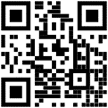

*The National Center for Education Statistics (NCES) is authorized to conduct the Early Childhood Longitudinal Study (ECLS) by the Education Sciences Reform Act of 2002 (ESRA 2002, 20 U.S.C. §9543). The data are being collected for NCES by Westat, a U.S.-based research organization. All of the information you provide may be used only for statistical purposes and may not be disclosed, or used, in identifiable form for any other purpose except as required by law (20 U.S.C. §9573 and 6 U.S.C. §151). The collected information will be combined across respondents to produce statistical reports.*

**School Administrator Survey Worksheet  
Field Test**

**ECLS School Administrator Survey Worksheet**

The ECLS school administrator web survey is designed to be completed by the principals/school administrators at participating schools. The survey includes a broad range of questions about the school setting, policies and practices at both the school level and in specific grades, as well as questions about the principal and the teaching staff. The survey is divided into eight separate sections, described below.

**The ECLS anticipates that some school administrators will need help from other school staff to complete some of the sections.** Each school administrator will receive a unique PIN to log in to the MyECLS website to complete the web survey. If you need help completing any of the sections, we have provided you with a second PIN that should be given to your designee to log on to the study website. For security purposes, **please do not share your PIN with anyone**.

**Instructions for Completing the School Administrator Survey**

* Review the survey section descriptions below to determine if you will need to ask a knowledgeable staff member (your designee) to complete any of the sections on your behalf. You can also ask your designee to complete only portions of sections, as needed. All sections **except for Section H** can be completed by your designee, if you choose to delegate them. Section H is about you and must be completed by you; it is accessible on the MyECLS website only with your PIN.
  + The survey asks for details that might require you to review your school’s records. For this reason, it may be easier to complete the survey while at school.
  + The individual survey sections can be completed in any order. The survey sections can be completed all at once or over the course of multiple sessions. Each section can be completed entirely by you or your designee, or by both of you.
* Log on to the study website, MyECLS.ed.gov, and enter your PIN. On your first visit, you will be asked to enter your email address and a password to ensure the security of your data.
  + If you would like someone else to answer certain sections of the survey, please provide him or her with the second PIN and instructions for logging on to the site.
  + While the survey may be completed on any device, we recommend using your desktop or laptop computer. Some of the questions are easier to read on a larger screen.
* After logging on to the MyECLS website, indicate who will complete each of the survey sections. For sections A through G, you can indicate yourself, a designee, or both. This will make it clear to your designee the sections that he or she is asked to complete.

**Survey Section Descriptions**

* **Section A – School Characteristics** asks for basic school information and enrollment, a demographic breakdown of your student population, and information about your school’s participation in the USDA–reimbursable breakfast and lunch programs. The types of questions include the average daily attendance; the percentage of students in various racial/ethnic groups, with special needs, and eligible for select programs; and the number of children qualified to receive federally-reimbursable meals served.
* **Section B – School Facilities and Resources** covers your school’s facilities, including the availability of dedicated rooms, such as a cafeteria or music room, as well as the use of computers.
* **Section C – School-Family-Community Connections** asks for information about the school’s interaction with parents, the neighborhood where the school is located, safety and emergency procedures, and problems that may be occurring within your school. Specific questions include the availability of programs or services for parents, methods used to communicate with parents, instances of crime in the surrounding community and within the school, and the frequency of emergency drill practice.
* **Section D – School Policies and Practices** asks about practices and policies related to student promotion and retention, suspensions, and benchmarks for student success in various subject areas. Specific questions include the implementation of student-focused special programs, and the number of students assigned suspensions by gender and race/ethnicity.
* **Section** **E – School Programs for Particular Populations** covers information about the school’s programs for various populations, including homeless students, English language learners, students with disabilities, and students in special education. Types of questions include the percentage of students who are English language learners (in the school and in kindergarten), and the percentage of kindergartners with IEPs or receiving special/additional instruction.
* **Section F – Federal Programs** asks questions pertaining to public schools including the use of Title I and Title III funds, actions taken in response to the need for improvement, and state assessments. Administrators from private schools will be asked one question in this section and then will be skipped out of the remainder of the questions in Section F.
* **Section G – Staffing and Teacher Characteristics** covers the characteristics of staff at your school, including the number of staff members in various capacities, the primary roles of various staff members, and the demographics of your school staff.
* **Section H – School Administrator Characteristics** asks questions about you, the designated school administrator, including your educational background, training, and time spent on various tasks. This section **must** be completed by you, the school administrator (principal).

*The National Center for Education Statistics (NCES) is authorized to conduct the Early Childhood Longitudinal Study (ECLS) by the Education Sciences Reform Act of 2002 (ESRA 2002, 20 U.S.C. §9543). The data are being collected for NCES by Westat, a U.S.-based research organization. All of the information you provide may be used only for statistical purposes and may not be disclosed, or used, in identifiable form for any other purpose except as required by law (20 U.S.C. §9573 and 6 U.S.C. §151).* *The collected information will be combined across respondents to produce statistical reports.*

**Teacher Welcome Letter  
Field Test**

<Date>

Dear Teacher:

I am proud to tell you that the U.S. Department of Education has chosen our school and students to participate in an exciting study called the **Early Childhood Longitudinal Study, or the ECLS**. For more than 20 years, the ECLS has helped improve education for children from birth through elementary school. We can use results from the ECLS to support students’ learning and development. The study helps answer the following types of questions:

* What math and literacy skills do children have when they start school?
* What educational activities do students do at home and with their families?
* What support do parents and families need to be more involved in their child’s education?

The upcoming study will be particularly meaningful, as it will provide important information about the experiences of children whose early lives were shaped by the COVID-19 pandemic.

**What do I need to know?**

You, your students, and their families have been selected to participate in the ECLS field test, which is a trial run for the national study. Participation is voluntary, but I encourage you to take part in this important part of the study.

1. Your students will be asked to do engaging age-appropriate activities during a one-on-one session with an ECLS team member. The activities will focus on students’ literacy and math skills, and accommodations are available to ensure every sampled student can participate as appropriate. The session will last about 45 minutes for most children and the ECLS team will work with you to make sure children participate in the study activities at convenient times.
   * Visit our study website at MyECLS.ed.gov (accessible via the QR code) to watch a video that includes brief examples of ECLS child assessment sessions. Children who participated in previous ECLS sessions report enjoying the activities and the individual attention.
2. You will be asked to complete web surveys about you and your classroom, as well as about the participating children. You will not conduct the student assessment sessions, but you can observe them if you like.
3. Parents of participating children will also be asked to complete a web survey. The study uses procedures to include all families, for example phone surveys for those without internet access and translated materials or interpreters for those who speak a non-English language. Parents are also welcome to observe the study sessions with students.
4. <You and our school will receive a monetary token of appreciation to recognize the time spent participating in the study. Please find your check enclosed.> At the conclusion of the study, you will <also> receive a Certificate of Contribution from the U.S. Department of Education. <Participating families will also receive a monetary token of appreciation.>
5. The information you provide will be kept secure and combined with information from other teachers, students, parents/guardians, and school administrators participating in the study.
6. The ECLS is endorsed by more than 25 education organizations.

**What do I need to do?**

Please log on to MyECLS.ed.gov and complete your surveys by November 30, 2022.

* You will receive your unique PIN in a few days, if you haven’t already. An email with the PIN will come from the ECLS team at Westat, the company conducting the study for the U.S. Department of Education’s National Center for Education Statistics within the Institute of Education Sciences.
* Surveys may be completed at your convenience and do not have to be done all at once.

You can find more information in the fact sheet I provided. If you have any questions, please contact the ECLS team at ECLS@westat.com or call 1-855-898-2018. You can also learn more at MyECLS.ed.gov, accessible via the QR code.

Thank you in advance for participating!

Sincerely,

<School Coordinator name>

Enclosure

ECLS teacher fact sheet

*The National Center for Education Statistics (NCES) is authorized to conduct the Early Childhood Longitudinal Study (ECLS) by the Education Sciences Reform Act of 2002 (ESRA 2002, 20 U.S.C. §9543). The data are being collected for NCES by Westat, a U.S.-based research organization. All of the information you provide may be used only for statistical purposes and may not be disclosed, or used, in identifiable form for any other purpose except as required by law (20 U.S.C. §9573 and 6 U.S.C. §151). The collected information will be combined across respondents to produce statistical reports.*

# Teacher Fact Sheet Field Test

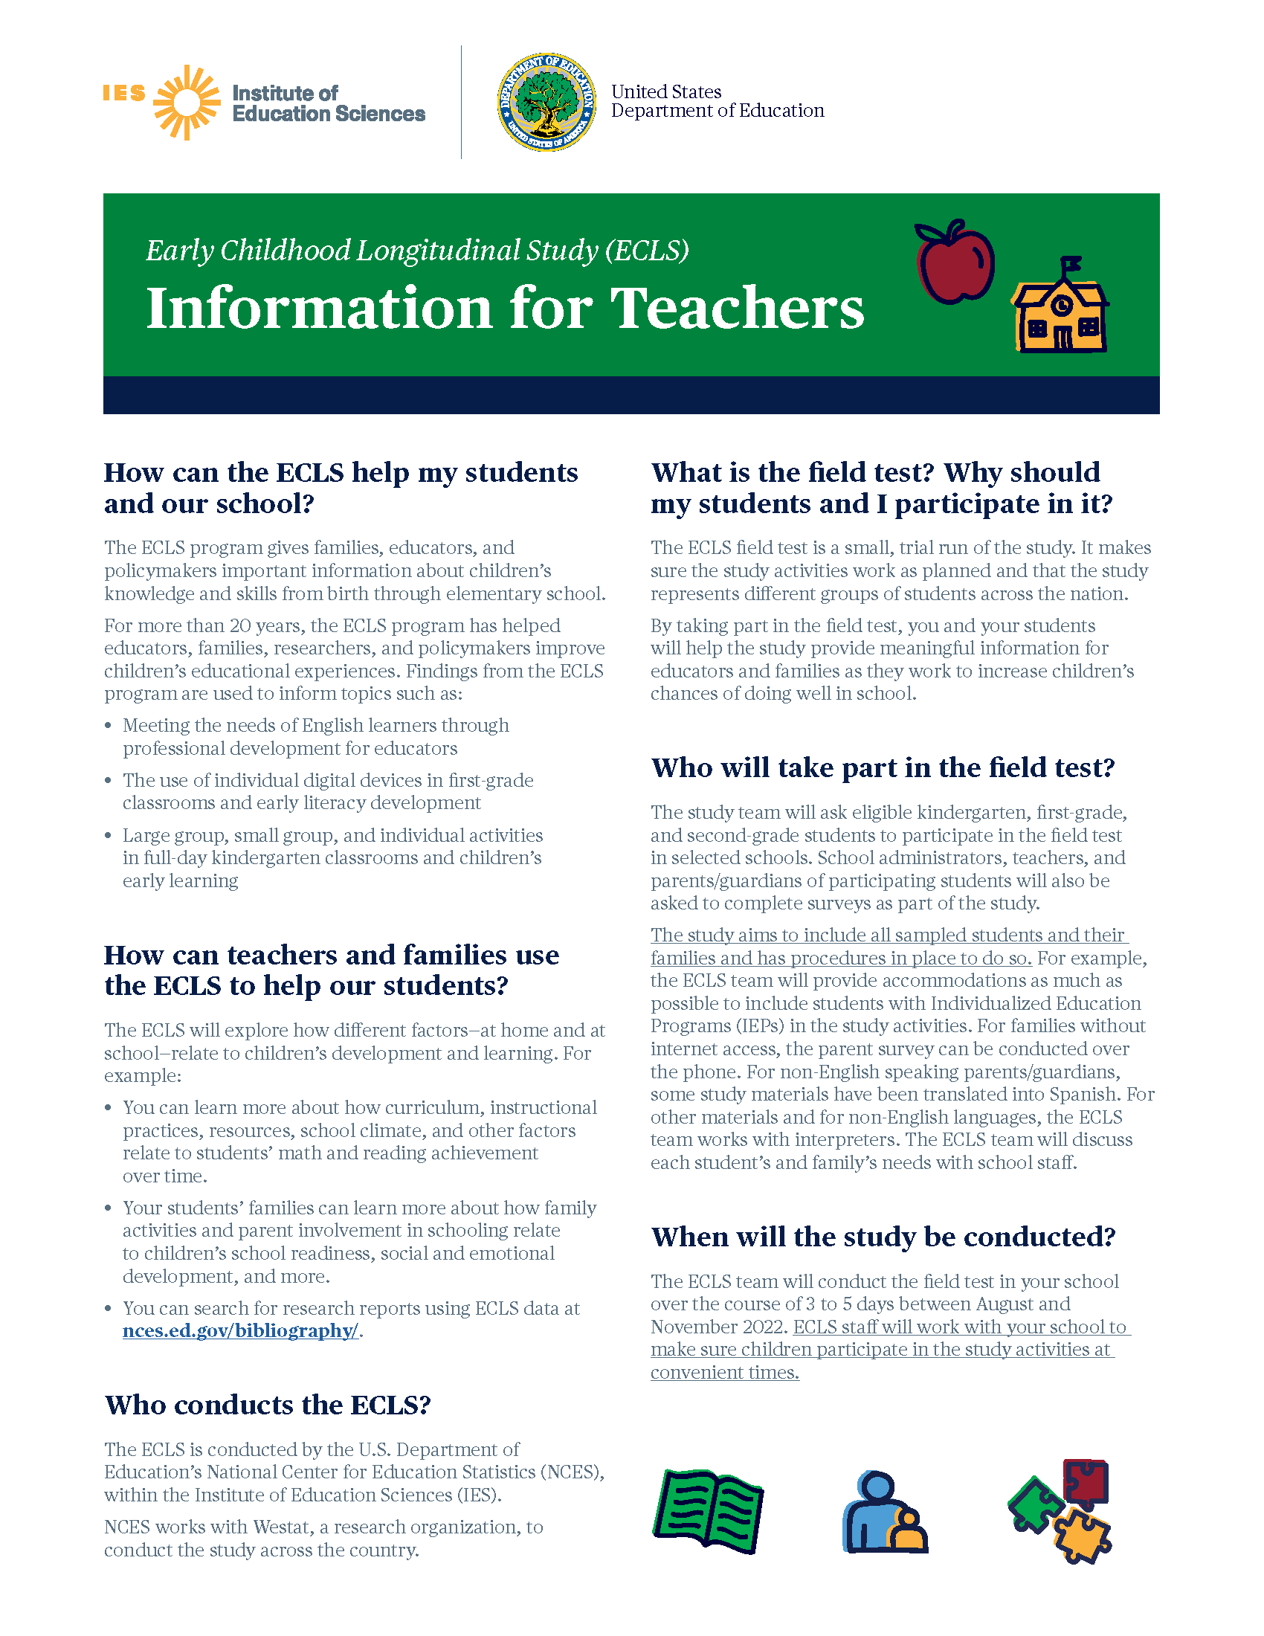

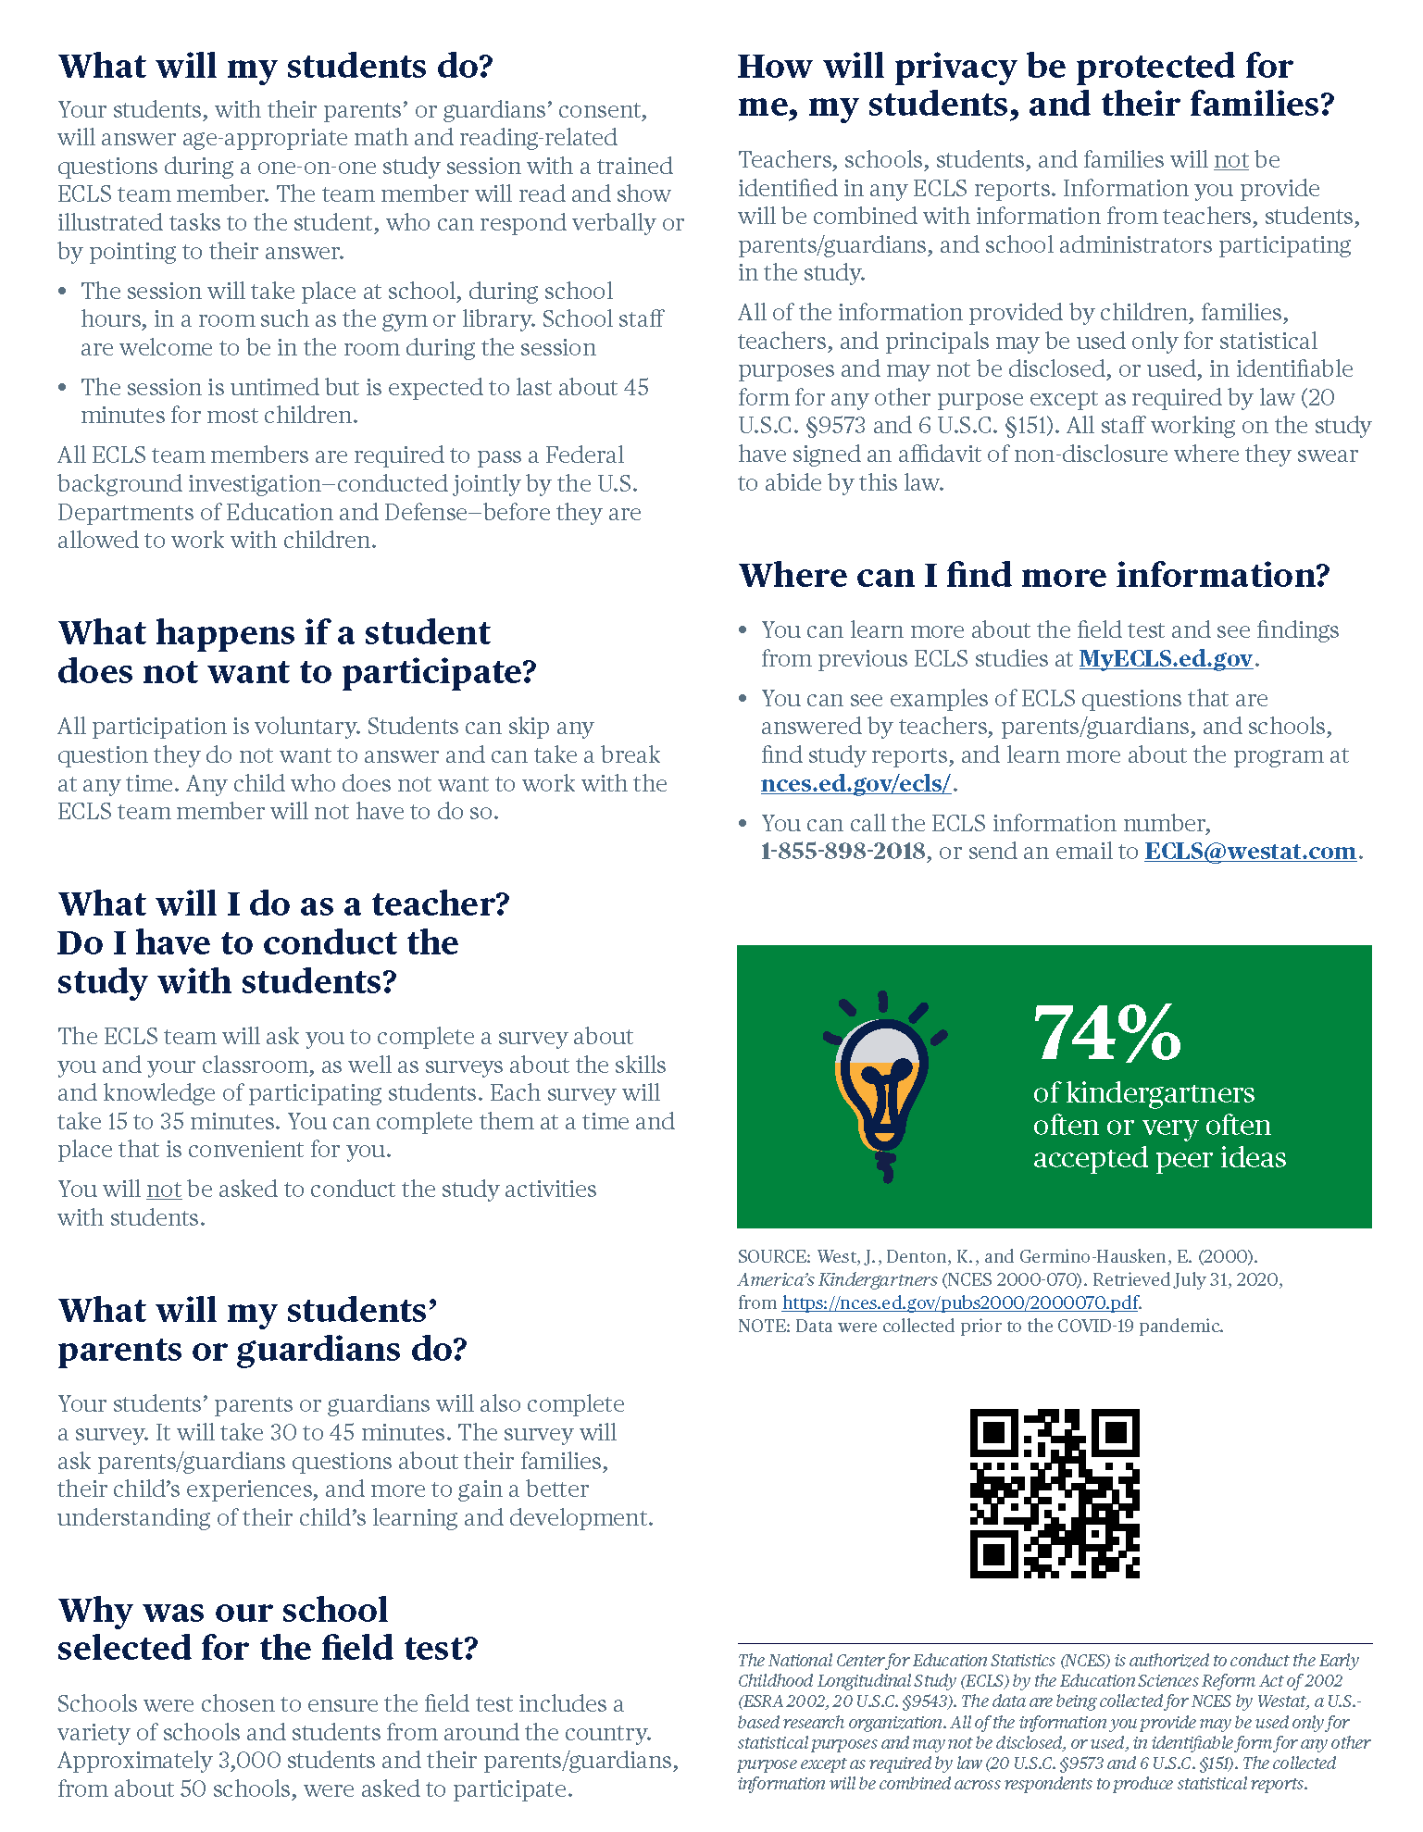

# Parent Welcome Letter Field Test

<Date>

Dear Parent/Guardian:

I am proud to tell you that the U.S. Department of Education has chosen our school and students to participate in an exciting study. The study is called the **Early Childhood Longitudinal Study**, or the **ECLS**. For more than 20 years, the ECLS has helped to answer the following types of questions:

* How well do kindergarten programs prepare students for later grades?
* What educational activities do students do at home and with their families?
* What support do parents and families need to be more involved in their child’s education?

The upcoming study will be particularly meaningful, as it will provide important information about the experiences of children whose early lives were shaped by the COVID-19 pandemic.

**What do I need to know?**

Your child and family have been selected to participate in the ECLS field test, which is a trial run for the national study. Participation is voluntary, but I encourage you to take part in this important part of the study.

* Your child will be asked to do engaging, age-appropriate activities during a one-on-one session with an ECLS team member. The activities will focus on students’ reading and math skills, and school staff and parents are welcome to be in the room during the session. The session will last about 45 minutes for most children and the ECLS team will work with teachers to make sure children do not miss important lessons or activities.
  + Visit our study website at MyECLS.ed.gov to watch a video that includes brief examples of ECLS child assessment sessions. Children who participated in previous ECLS sessions report enjoying the activities and the individual attention.
* You will be asked to complete a web survey. It can be completed at your convenience and does not have to be done all at once. To thank you for participating in the study, enclosed is a <$15 prepaid Mastercard® and a> pad of sticky notes with the U.S. Department of Education logo.
* Your child’s teacher will also be asked to complete web surveys about his or her teaching background, classroom lessons and activities, and the selected children he or she teaches. The study activities are conducted by trained ECLS staff, so there is nothing that the children’s teachers need to do to administer the sessions.
* <Our school will receive $10 per participating child and teachers will also receive a monetary token of appreciation.> <If we hear from all parents of selected children about whether their child can participate, even if they say “no” to participating, the ECLS will also sponsor a food event (such as a pizza or ice cream party) for children at the school.>
* The ECLS is endorsed by more than 25 education organizations.

**What do I need to do?**

Please log on to MyECLS.ed.gov to <provide permission for your child to participate in the study as soon as possible and> complete your survey by November 30, 2022.

* Your PIN to log on to the website is in the sealed postcard provided in this packet. <After you enter the unique PIN, your $15 prepaid card will be activated, whether or not you complete the survey.>

The ECLS is conducted by the National Center for Education Statistics (NCES), within the U.S. Department of Education’s Institute of Education Sciences (IES). NCES is working with Westat, a research organization, to conduct this voluntary study. If you have any questions, please contact the ECLS team at ECLS@westat.com or call 1-855-898-2018.

Thank you for participating in this important study!

Sincerely,

Visit MyECLS.ed.gov

<School Coordinator name>

Enclosure

ECLS parent fact sheet

*The National Center for Education Statistics (NCES) is authorized to conduct the Early Childhood Longitudinal Study (ECLS) by the Education Sciences Reform Act of 2002 (ESRA 2002, 20 U.S.C. §9543). The data are being collected for NCES by Westat, a U.S.-based research organization. All of the information you provide may be used only for statistical purposes and may not be disclosed, or used, in identifiable form for any other purpose except as required by law (20 U.S.C. §9573 and 6 U.S.C. §151). The collected information will be combined across respondents to produce statistical reports.*

# Parent Welcome Letter (Spanish) Field Test

<Date>

Estimado(a) padre o madre/tutor(a) o guardián(a) legal:

Me enorgullece comunicarle que el Departamento de Educación de los EE.UU. ha elegido a nuestra escuela y a nuestros estudiantes para participar en un estudio muy interesante. El estudio se llama el **Estudio Longitudinal de la Primera Infancia**, o **ECLS** por sus siglas en inglés. Durante más de 20 años, el ECLS ha ayudado a responder a los siguientes tipos de preguntas:

* ¿En qué medida los programas de *kindergarten* preparan a los estudiantes para los cursos posteriores?
* ¿Qué actividades educativas realizan los estudiantes en casa y con sus familias?
* ¿Qué apoyo necesitan los padres y las familias para participar más en la educación de sus hijos?

El próximo estudio será especialmente significativo, ya que proporcionará información importante sobre las experiencias de los niños cuyas vidas tempranas se vieron afectadas por la pandemia de COVID-19.

**¿Qué necesito saber?**

Su niño(a) y su familia han sido seleccionados para participar en la prueba de campo del ECLS, la cual es un ensayo para el estudio nacional. La participación es voluntaria, pero nos gustaría que tome parte en esta importante parte del estudio.

* Se le pedirá a su niño(a) que haga actividades interesantes y apropiadas para su edad durante una sesión individual con un miembro del equipo ECLS. Las actividades se centrarán en las habilidades de lectura y matemáticas de los estudiantes, y el personal escolar y los padres serán bienvenidos en el salón durante la sesión. La sesión durará unos 45 minutos para la mayoría de los niños y el equipo de ECLS trabajará con los maestros para asegurar que los niños no pierdan importantes lecciones o actividades.
  + Visite la página de Internet del estudio en MyECLS.ed.gov para ver un video que incluye breves ejemplos de sesiones infantiles del ECLS en curso. Los niños que participaron en sesiones anteriores de ECLS dijeron que disfrutaron de las actividades y de la atención individual.
* A usted se le pedirá que complete una encuesta por Internet. Usted puede completarla a su conveniencia y no tiene que hacerlo de una sola vez. Para agradecerle por participar en el estudio, le estamos enviando junto con esta carta <una tarjeta prepagada Mastercard® de $15 y> un bloc de notas adhesivas (*sticky notes*) con el logo del Departamento de Educación de los EE UU.
* También se le pedirá al maestro de su niño(a) que complete encuestas por Internet sobre sus antecedentes docentes, sobre lecciones y actividades de su salón de clases, y sobre los niños y niñas seleccionados entre sus estudiantes.
* <Nuestra escuela recibirá $10 por cada niño que participe y los maestros también recibirán un pago como muestra de agradecimiento.> < Si todos los padres o madres nos comunican si sus niños pueden participar, aunque nos digan que “no” pueden participar, el estudio también patrocinará un evento con comida en la escuela para nuestros estudiantes (como una fiesta de pizza o helados).>
* El ECLS está respaldado por más de 25 organizaciones educativas.

**¿Qué necesito hacer?**

Por favor, ingrese a MyECLS.ed.gov para <dar permiso para que su niño(a) participe en el estudio lo más pronto posible y> completar su encuesta antes del 30 de noviembre de 2022.

* Su PIN para ingresar al sitio web se encuentra en la tarjeta postal sellada proporcionada en este paquete. <Después que usted ponga el PIN único, su tarjeta prepagada de $15 se activará, ya sea que usted complete o no la encuesta.>

El ECLS lo está llevando a cabo el Centro Nacional para Estadísticas de Educación (NCES por sus siglas en inglés), dentro del Instituto de Ciencias de la Educación (IES por sus siglas en inglés), del Departamento de Educación de los EE.UU. NCES está trabajando con Westat, una firma que realiza estudios de investigación, para realizar este estudio voluntario. Si tiene alguna pregunta, por favor comuníquese con el equipo de ECLS a la dirección electrónica ECLS@westat.com o al teléfono 1-855-898-2018.

¡Gracias de antemano por su participación en este importante estudio!

Atentamente,

<School Coordinator name>

Anexo

Hoja información de ECLS para padres y madres/tutores o guardianes legales



*El Centro Nacional para Estadísticas de Educación (NCES) está autorizado a hacer el Estudio Longitudinal de la Primera Infancia (ECLS por sus siglas en inglés) por el Acta de Reforma de las Ciencias de la Educación de 2002 (ESRA 2002, 20 U.S.C. §9543). La firma Westat, una organización que realiza estudios y está basada en los Estados Unidos, está recopilando los datos para NCES. Toda la información que usted proporcione podrá usarse solamente para propósitos estadísticos y no podrá divulgarse ni usarse de manera que permita identificar a los participantes para ningún otro propósito, salvo que lo requiera la ley (20 U.S.C. §9573 y 6 U.S.C. §151). Se combinará la información recopilada de todos los participantes para producir reportes estadísticos.*

# Parent Welcome Letter (Mandarin) Field Test

<Date>

亲爱的家长/监护人，

美国教育部选中了我们的学校和学生来参与一项令人振奋的研究，这项研究称为**幼儿纵向研究**，或简称为**ECLS**。20多年来，这项研究帮助了我们回答下面各类问题：

1. 幼儿园课程对学生们如可为以后的年级作准备？
2. 学生们在家里与家人一起进行哪写教育活动？
3. 父母和家庭需要哪些支持才会更多地参与孩子的教育？

即将进行的研究将特别有意义，因为它将提供重要信息，有关幼年生活受到COVID-19大流行影响的儿童的经历。

**我需要知道些什么？**

您的孩子和家庭被选中参加ECLS实地测试，这是即将进行的全国数据收集的试验测试。这项研究属自愿性，但我鼓励你们参加这个重要的项目。

* 在与 ECLS 团队成员一对一的测试中，您的孩子会被要求做一些具参与性、适合年龄的数学和阅读相关活动。对于大多数儿童来说，测试时间大约是 45 分钟，ECLS 团队也会和教师配合来尽量减少儿童错过上课时间。
  + 请访问我们的学习网站MyECLS.ed.gov (可以用我们提供的二维码进入) 观看一个视频 里面有一个ECLS儿童正在进行测试中的简短范例。参加过以往 ECLS活动的儿童表示喜欢测试里的活动并享受个别的关注。
* 您将会被要求填写一份网络调查问卷，可以在您方便的时候完成，不比一次完成。为酬谢您参加这项研究，您会收到一张<在您登入研究调查网站之后则会被激活的15元美金Mastercard®万事达卡和>一叠带有美国教育部徽标的便条。
* 您的孩子的老师也将被要求填写关于他或她的教学背景、教室和从我们学校挑选的每个孩子的网络调查问卷。
* <每个参与的孩子会让我们学校收到10 美元， 教师也将收到感谢金。> <如果所有家长都交回同意书，不论家长是否同意学生参与研究，该研究还会赞助学校的孩子们举办一个食品活动（如比萨饼或冰淇淋派对）。>
* ECLS得到超过25个教育组织认可。

**我需要做什么？**

请登录网站MyECLS.ed.gov， <尽快同意您的孩子参与研究并>，完成您的调查问卷。 家长/监护人调查问卷将于 2022 年 11 月 30 日截止收件。

1. 这包袋子里的密封明信片中有您的个人身份识别码 （PIN），以登录网站。<在您输入您的为您而设的个人身份识别码后，无论您是否完成问卷调查，您的15美元Mastercard®万事达卡都会被激活。>

ECLS 由美国教育部教育科学研究所 （IES） 内的国家教育统计中心 （NCES） 执行。NCES正与研究机构 Westat 合作进行这一项自愿性的研究。如果您有任何问题，请发电子邮件至 ECLS@westat.com 或致电 1-855-898-2018 联系 ECLS 团队。

感谢您参与这项重要的研究！我对您、我们的学生、及我们的学校参与这项目感到骄傲1

<学校协调员姓名>

敬上，

附件

ECLS 家长说明单

|  |
| --- |
| 国家教育统计中心（NCES）根据2002年《教育科学改革法》（ESRA，2002，20 U.S.C.§9543）授权展开幼儿纵向研究。这些数据是由美国研究机构 Westat 为 NCES 收集的。您提供的所有信息除非是法律要求，仅能用于统计目的，不得以可识别的形式披露或使用于任何其他目的（20 U.S.C. §9573 和 6 U.S.C. §151）。所收集的信息将与其他答复者合并，以编制统计报告。 |



# Parent Fact Sheet Field Test

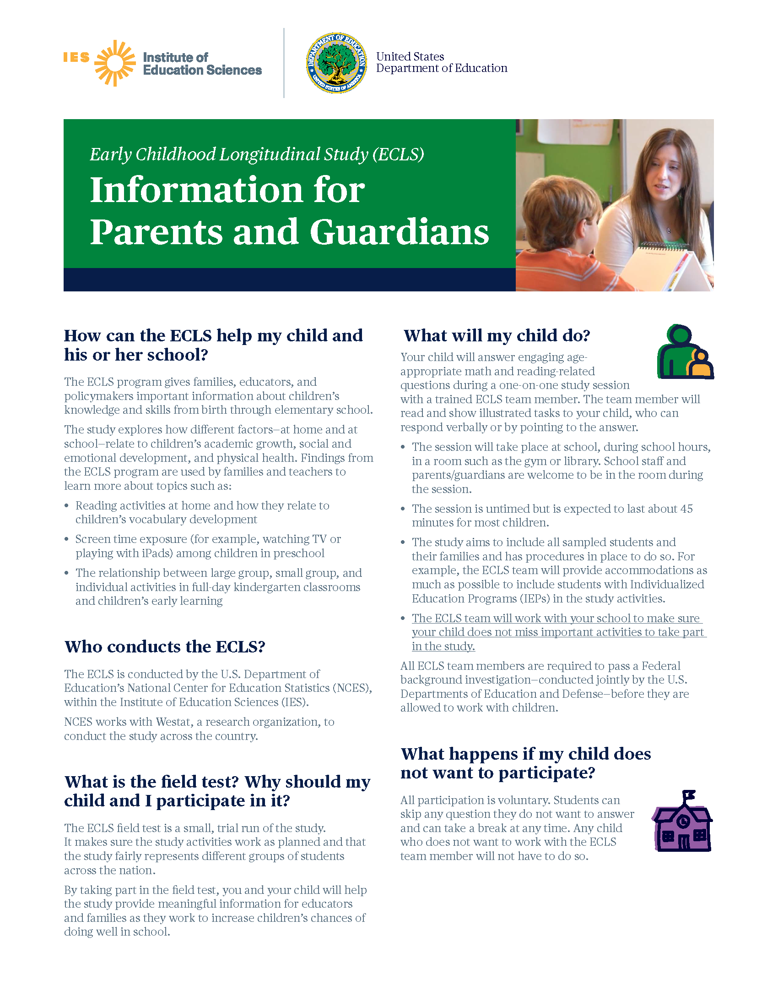

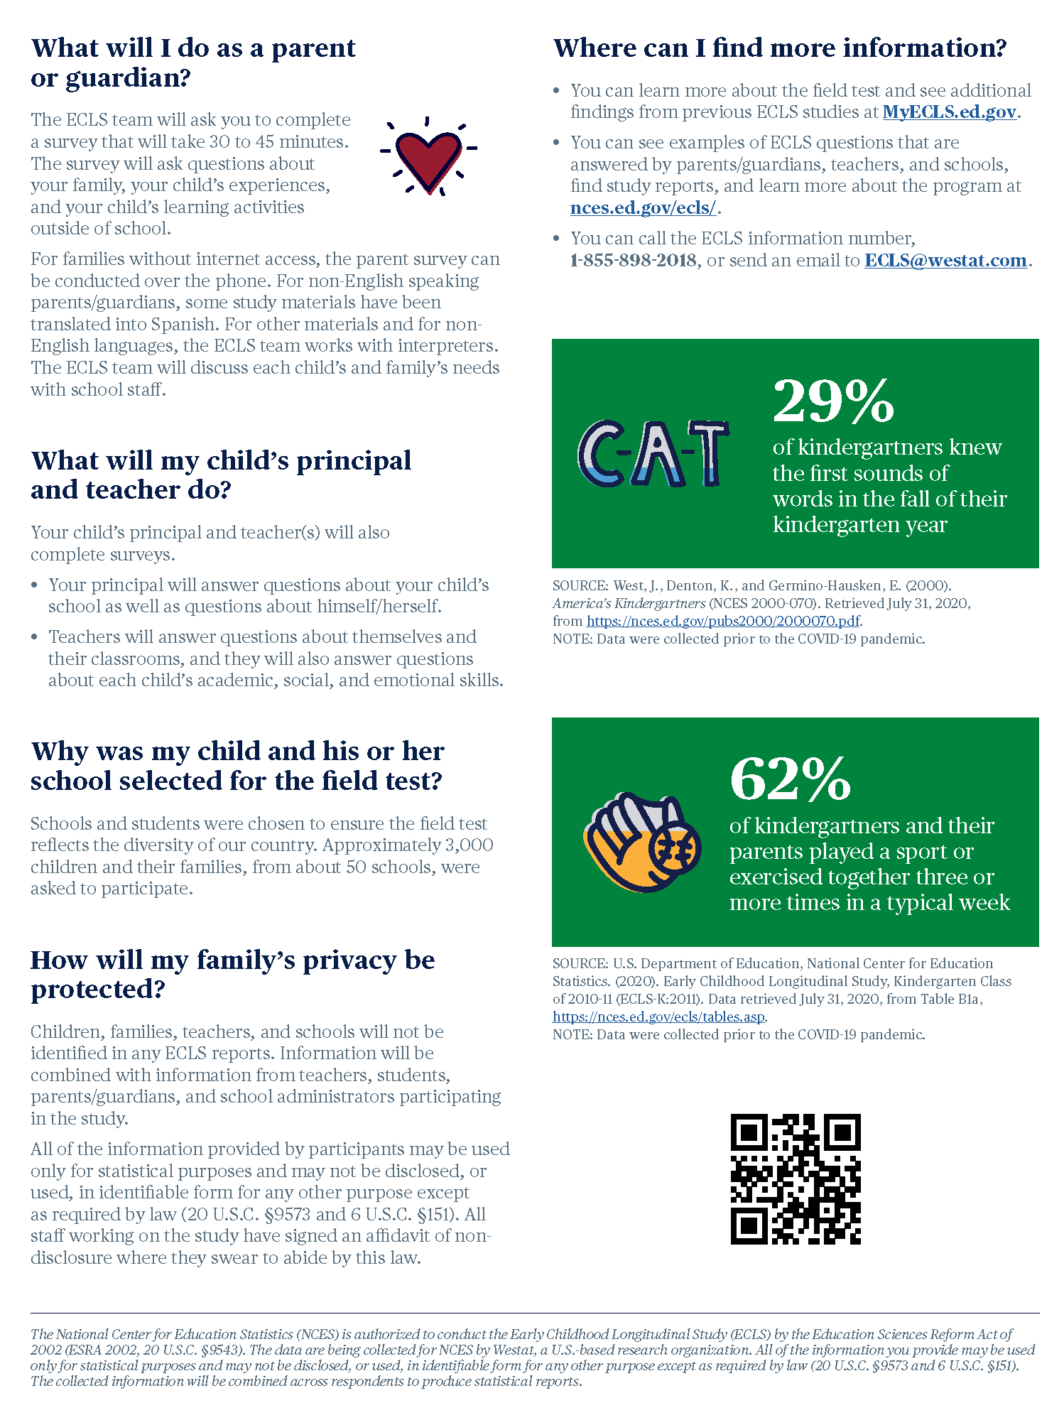

# Parent Fact Sheet (Spanish) Field Test

Estudio Longitudinal de la Primera Infancia (ECLS)

Información para padres, madres y tutores o guardianes legales

**¿Cómo puede el estudio ECLS ayudar a mi niño(a) y a su escuela?**

El programa ECLS brinda a las familias, a los educadores y a los legisladores información importante sobre los conocimientos y habilidades de los niños desde su nacimiento y durante la escuela elemental.

El ECLS explora cómo los diferentes factores --en el hogar y en la escuela-- se relacionan con el crecimiento académico, desarrollo social y emocional, y salud física de los niños. Familias y maestros usan resultados del programa ECLS para aprender más acerca de temas como:

* Actividades de lectura en el hogar y la manera en que se relacionan con el desarrollo del vocabulario de los niños.
* Tiempo frente a la pantalla (por ejemplo, viendo la televisión o jugando con iPads) entre los niños en educación preescolar.
* La relación entre actividades en un grupo grande, en un grupo pequeño e individuales en los salones de *kindergarten* de día completo y el aprendizaje temprano de los niños.

**¿Quién lleva a cabo el ECLS?**

El estudio ECLS es llevado a cabo por el Centro Nacional para Estadísticas de Educación (NCES por sus siglas en inglés) del Departamento de Educación de los Estados Unidos, el cual está dentro del Instituto de Ciencias de la Educación (IES por sus siglas en inglés).

NCES trabaja con Westat, una firma que realiza estudios de investigación para llevar a cabo el estudio en todo el país.

**¿Qué es la prueba de campo? ¿Por qué deberíamos mi niño(a) y yo participar en la prueba?**La prueba de campo de ECLS es un pequeño ensayo del estudio. El mismo asegura que las actividades del estudio funcionen según lo planeado y que el estudio represente de manera justa a diferentes grupos de estudiantes en todo el país.

Al participar en la prueba de campo, usted y su niño(a) contribuirán a que el estudio brinde información significativa a educadores y a familias a medida que se esfuerzan por aumentar las probabilidades de que a los niños les vaya bien en la escuela.

**¿Qué hará mi niño(a)?**

Su niño(a) responderá preguntas relacionadas con matemáticas y lectura, interesantes y apropiadas para su edad, durante una sesión individual con un miembro entrenado del equipo ECLS. El miembro del equipo leerá y mostrará las tareas ilustradas a su niño(a), y él/ella podrá responder verbalmente o señalando la respuesta.

* La sesión se llevará a cabo en la escuela, durante el horario escolar, en un salón como el gimnasio o la biblioteca. El personal escolar y los padres/tutores legales serán bienvenidos en el salón durante la sesión.
* La sesión no tiene límite de tiempo, pero se espera que dure aproximadamente 45 minutos para la mayoría de los niños.
* El estudio intenta incluir a todos los estudiantes seleccionados y a sus familias y ha establecido procedimientos para lograrlo. Por ejemplo, en lo posible, el equipo de ECLS proporcionará acomodaciones para incluir en las actividades del estudio a estudiantes con Programas de Educación Individualizada (IEPs).
* El equipo de ECLS trabajará con su escuela para asegurar que su niño(a) no se pierda actividades importantes para participar en el estudio.

A todos los miembros del equipo de ECLS se les requiere pasar una investigación federal de antecedentes penales que llevan a cabo conjuntamente el Departamento de Educación y el Departamento de Defensa de los EE.UU., antes de permitirles trabajar con niños.

**¿Qué sucede si mi niño(a) no quiere participar?**

Toda la participación es voluntaria. Los estudiantes pueden no contestar cualquier pregunta que no quieran responder y pueden tomar un descanso en cualquier momento. Cualquier niño(a) que no quiera trabajar con el miembro del equipo de ECLS no tendrá que hacerlo.

**¿Qué haré como padre/madre o tutor(a)/guardián(a) legal?**

El equipo de ECLS le pedirá que complete una encuesta que durará de 30 a 45 minutos. La encuesta tendrá preguntas sobre su familia, las experiencias de su niño(a) y sus actividades de aprendizaje fuera de la escuela.

Para familias sin acceso a Internet, la encuesta para padres y madres puede hacerse por teléfono. Para padres o madres/tutores o guardianes legales que no hablan inglés, algunos de los materiales del estudio han sido traducidos al español. Para otros materiales y para otros idiomas que no sean inglés, el equipo de ECLS trabaja con intérpretes. El equipo de ECLS hablará sobre las necesidades de cada niño(a) y su familia con el personal escolar.

**¿Qué harán el director y el maestro de mi niño(a)?**El director y el maestro (o los maestros) de su niño(a) también completarán encuestas.

* El director responderá preguntas sobre la escuela de su niño(a), así como preguntas sobre sí mismo(a).
* Los maestros responderán preguntas sobre sí mismos y sus salones de clases, y también responderán preguntas sobre las habilidades académicas, sociales y emocionales de cada niño(a).

**¿Por qué mi niño(a) y su escuela fueron seleccionados para la prueba de campo?**

Las escuelas y los estudiantes fueron elegidos para asegurar que la prueba de campo refleje la diversidad de nuestro país. Aproximadamente 3,000 niños y sus familias, de unas 50 escuelas, fueron invitados a participar.

**¿Cómo se protegerá la privacidad de mi familia?**

Los niños, las familias, los maestros y las escuelas no se identificarán en ningún reporte de ECLS. La información se combinará con información de maestros, estudiantes, padres o madres/tutores o guardianes legales, y administradores escolares que participen en el estudio.

Toda la información que proporcionen los participantes podrá usarse solamente para propósitos estadísticos y no podrá divulgarse ni usarse de manera que permita identificar a los participantes para ningún otro propósito, salvo que lo requiera la ley (20 U.S.C. §9573 y 6 U.S.C. §151). Todo el personal que trabaja en el estudio ha firmado una declaración de no divulgación, donde juran cumplir con esta ley.

**¿Dónde puedo encontrar más información?**

* Puede obtener más información sobre la prueba de campo y ver más resultados de estudios anteriores de ECLS en **MyECLS.ed.gov**.
* Puede ver ejemplos de preguntas de ECLS que responden los padres o madres/tutores o guardianes legales, los maestros y las escuelas, encontrar reportes del estudio, e informarse más sobre el programa en **nces.ed.gov/ecls/**.
* Puede llamar por teléfono al número de información de ECLS, 1-855-898-2018, o puede enviar un correo electrónico a la dirección electrónica **ECLS@westat.com**.

|  |  |
| --- | --- |
| C-A-T | **29%**  de los niños de *kindergarten* sabía los primeros sonidos de las palabras en el otoño de su año de *kindergarten* |

FUENTE: West, J., Denton, K., and Germino-Hausken, E. (2000).

*America’s Kindergartners* (NCES 2000-070). Datos extraídos el 31 de julio de 2020,

de [https://nces.ed.gov/pubs2000/2000070.pdf](https://secure-web.cisco.com/10hRc91bJt5iYRjbTUoPgT5NthzN7WOe0f41thYRpSC4My0iiXMcG_wW712TVMA-Zdl_OYTMyzUYGvXh9PJ_qmotd061T3IxD9Pp356yK8EtkUgpOfXp-Vdq9knV-3B-X18vPg2FAxC5v6DT805-pX_-7NogAWpiweQU8RSnpcUiykfkzmIcNuGnom6P21sugsmUhael_9F6S6RmPJ2nJqHcsEtJX6XdQRXGNjghE6fxbLdj-TTTs-Aiv-pVd003T/https%3A%2F%2Fnces.ed.gov%2Fpubs2000%2F2000070.pdf). NOTA: Los datos se recopilaron antes de la pandemia de COVID-19.

|  |
| --- |
| **62%**  de los niños de *kindergarten* y sus padres jugaban un deporte o hacían ejercicio juntos tres o más veces en una semana normal |

FUENTE: Departamento de Educación de los Estados Unidos, Centro Nacional para Estadísticas de Educación (2020). Estudio Longitudinal de la Primera Infancia, Clase de *Kindergarten* de 2010-11 (ECLS-K:2011). Datos extraídos el 31 de julio de 2020 de la tabla B1a, <https://nces.ed.gov/ecls/tables.asp> NOTA: Los datos se recopilaron antes de la pandemia de COVID-19.

*El Centro Nacional para Estadísticas de Educación (NCES) está autorizado a hacer el Estudio Longitudinal de la Primera Infancia (ECLS por sus siglas en inglés) por el Acta de Reforma de las Ciencias de la Educación de 2002 (ESRA 2002, 20 U.S.C. §9543). La firma Westat, una organización que realiza estudios y está basada en los Estados Unidos, está recopilando los datos para NCES. Toda la información que usted proporcione podrá usarse solamente para propósitos estadísticos y no podrá divulgarse ni usarse de manera que permita identificar a los participantes para ningún otro propósito, salvo que lo requiera la ley (20 U.S.C. §9573 y 6 U.S.C. §151). Se combinará la información recopilada de todos los participantes para producir reportes estadísticos.*

# Explicit Consent Form for Parents Field Test

**The Early Childhood Longitudinal Study (ECLS)**

**Parent/Guardian Consent Form**

Your child’s school has agreed to participate in the U.S. Department of Education's **Early Childhood Longitudinal Study (ECLS)**, a nationwide study of elementary-aged children and their schools, teachers, and parents/guardians. We would like to invite you and your child to join others from your school in participating in this important study.

The study will take place in your child’s school. It is expected that most children will take about 45 minutes to complete the activities, which consist of engaging age- and grade-appropriate reading and math items. Your child will complete the study activities with an ECLS team member who has undergone a Federal background investigation. Children may decline to answer any of the questions they do not wish to answer, and their responses will not be associated with their names or provided to school staff. School staff, including teachers, are welcome to observe the sessions.

If you have any questions, please refer to the enclosed materials and do not hesitate to email the ECLS team at ECLS@westat.com or call 1-855-898-2018.

**PLEASE CHECK ONE:**

Yes, I give permission for my child to participate in the ECLS. I have read this permission form and understand what my child is being asked to do.

No, I do not give permission for my child to participate in the ECLS.

**PLEASE SIGN YOUR NAME BELOW:**

Date of signature: / /

(Signature of parent or guardian)

PLEASE PRINT:

Child name:

School name:

Parent name:

Parent telephone:

Parent email:

|  |  |  |  |  |  |  |  |  |
| --- | --- | --- | --- | --- | --- | --- | --- | --- |
| FOR OFFICE/TL USE ONLY: Child ID: |  |  |  |  |  |  |  | C |

# Explicit Consent Form for Parents (Spanish) Field Test

**Estudio Longitudinal de la Primera Infancia (ECLS)**

**Formulario de Consentimiento para padres/madres/tutores o guardianes legales**

La escuela de su niño(a) ha aceptado participar en el **Estudio Longitudinal de la Primera Infancia** (**ECLS** por sus siglas en inglés)del Departamento de Educación de los EE.UU., un estudio nacional de los niños en edad de educación elemental y sus escuelas, maestros y padres/madres/tutores o guardianes legales. Nos gustaría invitarlos a usted y a su niño(a) a unirse a otras personas de su escuela para participar en este importante estudio.

El estudio tendrá lugar en la escuela de su niño(a). Se espera que la mayoría de los niños pase unos 45 minutos completando las actividades, las cuales consisten en preguntas interesantes de lectura y matemáticas, apropiadas para su edad y grado escolar. Su niño(a) completará las actividades de estudio con un miembro del equipo de ECLS, que ha pasado por una investigación de antecedentes penales a nivel federal. Los niños pueden negarse a responder a cualquiera de las preguntas que no deseen contestar, y sus respuestas no se asociarán con sus nombres ni se proporcionarán al personal de la escuela. El personal de la escuela, incluyendo a los maestros, tendrán permitido observar las sesiones.

Si tiene alguna pregunta, por favor consulte los materiales incluidos y no dude en enviar un correo electrónico al equipo de ECLS a la dirección electrónica ECLS@westat.com o al teléfono 1-855-898-2018.

**POR FAVOR MARQUE UNA OPCIÓN:**

Sí, doy permiso para que mi niño(a) participe en el estudio ECLS. He leído este formulario de consentimiento y entiendo lo que se le pide a mi niño(a) que haga.

No, no doy mi permiso para que mi niño(a) participe en ECLS.

**POR FAVOR FIRME A CONTINUACIÓN:**

____________________________________________ Fecha en que firma: ______/_______/_________

(Firma del padre o madre/tutor(a) o guardián(a) legal)

POR FAVOR ESCRIBA CON LETRA DE IMPRENTA:

Nombre del niño(a):

Nombre de la escuela:

Nombre del padre o madre/tutor(a) o guardián(a) legal:

Teléfono del padre o madre/tutor(a) o guardián(a) legal:

Correo electrónico del padre o madre/tutor(a) o guardián(a)legal:

|  |  |  |  |  |  |  |  |  |
| --- | --- | --- | --- | --- | --- | --- | --- | --- |
| FOR OFFICE/TL USE ONLY: Child ID: |  |  |  |  |  |  |  | C |

# Explicit Consent Form for Parents (Mandarin) Field Test

**幼儿纵向研究(ECLS)**

**家长/监护人同意书**

您孩子的学校已经同意参加美国教育部的**幼儿纵向研究（ECLS）**，这是一项对象是全国小学儿童及其学校、教师和家长/监护人的研究。我们想邀请您和您的孩子加入您学校的其他人，参加这一项重要的研究。

这项研究将在您孩子的学校进行。预计大多数儿童需要大约45分钟来完成活动，其中包括参与适合孩子年龄和年级的阅读和数学项目。您的孩子将与经过联邦背景调查的ECLS团队成员完成学习活动。儿童可以拒绝回答任何他们不想回答的问题，他们的回答将不被注上姓名，也不得提供给学校工作人员。欢迎学校职员、包括教师，来观摩测试过程。

如果您有任何问题，请参阅随附的材料，并随时发送电子邮件至ECLS@westat.com给ECLS团队或致电 1-855-898-2018。

**请勾选其中一项：**

是的，我允许我的孩子参加 ECLS。.我已经阅读了这份同意书，并理解我的孩子会被要求做些么。

不， 我不允许我的孩子参加 ECLS。

**请在下方签名：**

签名日期： ______/_______/_________

（家长或监护人签名）

请用正体书写：

孩子姓名：

学校名称：

家长姓名：

家长电话号码：

家长电子邮件：

|  |  |  |  |  |  |  |  |  |
| --- | --- | --- | --- | --- | --- | --- | --- | --- |
| FOR OFFICE/TL USE ONLY: Child ID: |  |  |  |  |  |  |  | C |

# Implicit Consent Form for Parents Field Test

**The Early Childhood Longitudinal Study (ECLS)**

**Parent/Guardian Consent Form**

Your child’s school has agreed to participate in the U.S. Department of Education's **Early Childhood Longitudinal Study (ECLS)**, a nationwide study of elementary-aged children and their schools, teachers, and parents/guardians. We would like to invite you and your child to join others from your school in participating in this important study.

The study will take place in your child’s school. It is expected that most children will take about 45 minutes to complete the activities, which consist of engaging age- and grade-appropriate reading and math items. Your child will complete the study activities with an ECLS team member who has undergone a Federal background investigation. Children may decline to answer any of the questions they do not wish to answer, and their responses will not be associated with their names or provided to school staff. School staff, including teachers, are welcome to observe the sessions.

If you have any questions, please refer to the enclosed materials and do not hesitate to email the ECLS team at ECLS@westat.com or call 1-855-898-2018.

**If you give permission for your child to participate in the ECLS, you do not need to return this form.**

**If you do not give permission for your child to participate in the ECLS, please check the box below, and sign and return this form to your child’s school as soon as possible.**

No, I do not give permission for my child to participate in the ECLS.

Date of signature: / /

(Signature of parent or guardian)

PLEASE PRINT:

Child name:

School name:

Parent name:

Parent telephone:

Parent email:

|  |  |  |  |  |  |  |  |  |
| --- | --- | --- | --- | --- | --- | --- | --- | --- |
| FOR OFFICE/TL USE ONLY: Child ID: |  |  |  |  |  |  |  | C |

# Implicit Consent Form for Parents (Spanish) Field Test

**Estudio Longitudinal de la Primera Infancia (ECLS)**

**Formulario de Consentimiento para padres/madres/tutores o guardianes legales**

La escuela de su niño(a) ha aceptado participar en el **Estudio Longitudinal de la Primera Infancia** (**ECLS** por sus siglas en inglés) del Departamento de Educación de los EE.UU., un estudio nacional de los niños en edad de educación elemental y sus escuelas, maestros y padres/madres/tutores o guardianes legales. Nos gustaría invitarlos a usted y a su niño(a) a unirse a otras personas de su escuela para participar en este importante estudio.

El estudio tendrá lugar en la escuela de su niño(a). Se espera que la mayoría de los niños pase unos 45 minutos completando las actividades, las cuales consisten en preguntas interesantes de lectura y matemáticas, apropiadas para su edad y grado escolar. Su niño(a) completará las actividades de estudio con un miembro del equipo de ECLS, que ha pasado por una investigación de antecedentes penales a nivel federal. Los niños pueden negarse a responder a cualquiera de las preguntas que no deseen contestar, y sus respuestas no se asociarán con sus nombres ni se proporcionarán al personal de la escuela. El personal de la escuela, incluyendo a los maestros, tendrán permitido observar las sesiones.

Si tiene alguna pregunta, por favor consulte los materiales incluidos y no dude en enviar un correo electrónico al equipo de ECLS a la dirección electrónica ECLS@westat.com o al teléfono 1-855-898-2018.

**Si usted da permiso para que su niño(a) participe en ECLS, no es necesario que devuelva este formulario.**

**Si usted no da su permiso para que su niño(a) participe en ECLS, por favor marque el cuadrito de abajo, firme y devuelva este formulario a la escuela de su niño(a) lo más pronto posible.**

No, no doy mi permiso para que mi niño(a) participe en el estudio ECLS.

____________________________________________ Fecha en que firma: ______/_______/_________

(Firma del padre o madre/tutor(a) o guardián(a) legal)

POR FAVOR ESCRIBA CON LETRA DE IMPRENTA:

Nombre del niño(a):

Nombre de la escuela:

Nombre del padre o madre/tutor(a) o guardián(a) legal:

Teléfono del padre o madre/tutor(a) o guardián(a) legal:

Correo electrónico del padre o madre/tutor(a) o guardián(a) legal:

|  |  |  |  |  |  |  |  |  |
| --- | --- | --- | --- | --- | --- | --- | --- | --- |
| FOR OFFICE/TL USE ONLY: Child ID: |  |  |  |  |  |  |  | C |

# Implicit Consent Form for Parents (Mandarin) Field Test

**幼儿纵向研究(ECLS)**

**家长/监护人同意书**

您孩子的学校已经同意参加美国教育部的幼儿纵向研究（ECLS），这是一项对象是全国小学儿童及其学校、教师和家长/监护人的研究。我们想邀请您和您的孩子加入您学校的其他人，参加这一项重要的研究。

这项研究将在您孩子的学校进行。预计大多数儿童需要大约45分钟来完成活动，其中包括参与适合孩子年龄和年级的阅读和数学项目。您的孩子将与经过联邦背景调查的ECLS团队成员完成学习活动。儿童可以拒绝回答任何他们不想回答的问题，他们的回答将不被注上姓名，也不得提供给学校工作人员。欢迎学校职员、包括教师，来观摩测试过程。

如果您有任何问题，请参阅随附的材料，并随时发送电子邮件至ECLS@westat.com给ECLS团队或致电 1-855-898-2018。

**如果您允许孩子参加 ECLS，则无需交回此同意书。**

**如果您不允许孩子参加 ECLS，请勾选下面的选框、签名并尽快将此同意书交回您的孩子的学校。**

No, I 不 ， 我不允许我的孩子参加 ECLS。

**请在下方签名：**

签名日期： ______/_______/_________

（家长或监护人签名）

请用正体书写：

孩子姓名：

学校名称：

家长姓名：

家长电话号码：

家长电子邮件：

|  |  |  |  |  |  |  |  |  |
| --- | --- | --- | --- | --- | --- | --- | --- | --- |
| FOR OFFICE/TL USE ONLY: Child ID: |  |  |  |  |  |  |  | C |

# Postcard Providing MyECLS PIN to Parents Field Test

FRONT COVER LABELED WITH PARENT ID AND NAME

INSIDE:

Please use this PIN to log on to the secure study website <and activate your $15 prepaid Mastercard®>.

**PIN:** **<PIN>**

When you first log in to the website using your PIN, you will be asked to enter your email address and create a password.

Your password must be at least 8 characters in length and include 3 of the following 4 types of characters:

* upper case letters
* lower case letters
* numbers
* special characters.

If you need help, please call 1-855-898-2018 or send an email to ECLS@westat.com.

Sincerely,

The ECLS Team

The ECLS is conducted by the National Center for Education Statistics (NCES), within the U.S. Department of Education’s Institute of Education Sciences (IES).

*The National Center for Education Statistics (NCES) is authorized to conduct the Early Childhood Longitudinal Study (ECLS) by the Education Sciences Reform Act of 2002 (ESRA 2002, 20 U.S.C. §9543). The data are being collected for NCES by Westat, a U.S.-based research organization. All of the information you provide may be used only for statistical purposes and may not be disclosed, or used, in identifiable form for any other purpose except as required by law (20 U.S.C. §9573 and 6 U.S.C. §151). The collected information will be combined across respondents to produce statistical reports.*

# Postcard Providing MyECLS PIN to Parents (Spanish) Field Test

FRONT COVER LABELED WITH PARENT ID AND NAME

INSIDE:

Por favor use este PIN para ingresar a la página de Internet segura del estudio <y activar su tarjeta prepagada Mastercard® de $15>.

**PIN:** **<PIN>**

La primera vez que ingrese a la página de Internet usando su PIN, se le pedirá que ponga su correo electrónico y deberá crear una contraseña.

Su contraseña deberá tener al menos 8 caracteres de longitud y deberá incluir 3 de los siguientes 4 tipos de caracteres:

* letras mayúsculas
* letras minúsculas
* números
* caracteres especiales.

Si necesita ayuda, por favor llame al 1-855-898-2018 o envíe un correo electrónico a ECLS@westat.com.

Atentamente,

El equipo de ECLS

El ECLS lo está llevando a cabo el Centro Nacional para Estadísticas de Educación (NCES por sus siglas en inglés), dentro del Instituto de Ciencias de la Educación (IES por sus siglas en inglés), del Departamento de Educación de los EE.UU.

*El Centro Nacional para Estadísticas de Educación (NCES) está autorizado a hacer el Estudio Longitudinal de la Primera Infancia (ECLS por sus siglas en inglés) por el Acta de Reforma de las Ciencias de la Educación de 2002 (ESRA 2002, 20 U.S.C. §9543). La firma Westat, una organización que realiza estudios y está basada en los Estados Unidos, está recopilando los datos para NCES. Toda la información que usted proporcione podrá usarse solamente para propósitos estadísticos y no podrá divulgarse ni usarse de manera que permita identificar a los participantes para ningún otro propósito, salvo que lo requiera la ley (20 U.S.C. §9573 y 6 U.S.C. §151). Se combinará la información recopilada de todos los participantes para producir reportes estadísticos.*

Please use this PIN to log on to the secure study website <and activate your $15 prepaid Mastercard®>.

**PIN:** **<PIN>**

When you first log in to the website using your PIN, you will be asked to enter your email address and create a password.

Your password must be at least 8 characters in length and include 3 of the following 4 types of characters:

* upper case letters
* lower case letters
* numbers
* special characters.

If you need help, please call 1-855-898-2018 or send an email to ECLS@westat.com.

Sincerely,

The ECLS Team

The ECLS is conducted by the National Center for Education Statistics (NCES), within the U.S. Department of Education’s Institute of Education Sciences (IES).

*The National Center for Education Statistics (NCES) is authorized to conduct the Early Childhood Longitudinal Study (ECLS) by the Education Sciences Reform Act of 2002 (ESRA 2002, 20 U.S.C. §9543). The data are being collected for NCES by Westat, a U.S.-based research organization. All of the information you provide may be used only for statistical purposes and may not be disclosed, or used, in identifiable form for any other purpose except as required by law (20 U.S.C. §9573 and 6 U.S.C. §151). The collected information will be combined across respondents to produce statistical reports.*

# First Consent and Survey Completion Reminder Email for School Coordinators Field Test

Subject: Reminder: ECLS Consent and Survey Completion Check-In

Dear <School Coordinator name>:

Thank you for your work to ensure the ECLS study’s success in your school! It is now time to check on the surveys that are being completed by parents, teachers, and the school administrator, as well as the return of consent forms.

**Where to monitor the status of consent forms and surveys:**

* Visit MyECLS to review the return of parental consent forms and completed surveys. If you have received paper consent forms, then you will need to update the consent information in the system. Electronic consent status will be automatically updated by our system.

**How to follow up with parents and school staff:**

* <DISPLAY FOR SCHOOLS WITH EXPLICIT CONSENT: Focus first on parental consent.
  + On MyECLS, note the parents who have not yet provided consent for their child to participate. It is critical we get permission to assess as many children as possible from your school.
  + You may also consider following up with parents who opted their child out of participation. Providing additional information may help them better understand the importance of participating in the study.>

<DISPLAY FOR SCHOOLS WITH IMPLICIT CONSENT:

On MyECLS, check to see if any parents have declined their child’s participation and consider contacting these parents to provide more details about the study. It is critical we get permission to assess as many children as possible from your school. Providing additional information may help convince them about the importance of participating in the study.>

* Review the completion status of the parent and school staff surveys. Note those parents and school staff who have not yet completed their surveys.
* Use the materials attached to this email to contact parents and school staff and remind them to complete the consent forms and/or surveys. *When emailing school administrators, teachers, and parents, please help us to maintain confidentiality by not revealing the names of study participants. We encourage you to send individual emails. If you choose to send a group email, please be sure to blind-copy recipients so that they cannot see the names and email addresses of others included on the message.*

**We are here to help!**

* Please email or call your ECLS representative to discuss how we can help make the study a success in your school.
* You can also contact the ECLS team at ECLS@westat.com or call 1-855-898-2018.

Thank you again for all you are doing to support the ECLS.

Sincerely,

The ECLS Team

*Attachments:*

Consent and Survey Reminder Email and Text Message for Parents

Survey Reminder Email for Teachers and School Administrator

Guide for Encouraging Participation

The ECLS is conducted by the National Center for Education Statistics (NCES), within the U.S. Department of Education’s Institute of Education Sciences (IES).

*The National Center for Education Statistics (NCES) is authorized to conduct the Early Childhood Longitudinal Study (ECLS) by the Education Sciences Reform Act of 2002 (ESRA 2002, 20 U.S.C. §9543). The data are being collected for NCES by Westat, a U.S.-based research organization. All of the information you provide may be used only for statistical purposes and may not be disclosed, or used, in identifiable form for any other purpose except as required by law (20 U.S.C. §9573 and 6 U.S.C. §151). The collected information will be combined across respondents to produce statistical reports.*

# First Consent and Survey Completion Reminder Email for Parents (attached to first SC email) Field Test

Subject: Reminder to complete your ECLS <consent form and> survey!

Dear Parent/Guardian:

Thank you for reviewing the materials I sent home about the Early Childhood Longitudinal Study (ECLS), conducted by the U.S. Department of Education. Our school supports this study, and we hope that every selected teacher, parent, and child from our school will participate.

**What are parents being asked do?**

* <Provide consent for your child’s participation. Without your consent, your child will not be able to participate in the study activities.>
* Complete a survey about your child and your family. If you have already completed the survey, thank you!

If you have not, note that the survey can be completed whenever is convenient for you. It does not need to be completed all at once. The information you provide will be combined with information from all other participants. Students, schools, and families will not be identified, nor will study data be shared with your child’s school.

A <prepaid Mastercard® card worth $15 upon activation and a> pad of sticky notes with the U.S. Department of Education logo <was/were> also included in the package to thank you for your time completing the survey. <Our school will receive $10 per participating child and participating teachers will also receive a monetary token of appreciation.>

**How to <provide consent and> complete the survey:**

* Visit the MyECLS website.
  + For your first visit, you will be asked to enter a PIN. Your unique PIN was enclosed in the study materials I recently sent home. If you cannot find the PIN, please contact the ECLS helpdesk at ECLS@westat.com or call 1-855-898-2018.
* The website contains a link to <provide consent and to> the survey you are being asked to complete. <Please log on to the website and provide your consent for your child’s participation as soon as possible.> Complete the survey before Wednesday, November 30.

**How to get more information about the study:**

* The letter and fact sheet that I sent home recently include a brief overview of the study.
* The MyECLS website has more information, including a video that shows part of child activity sessions in action, and findings from previous ECLS studies.

**Questions or need help?**

* The U.S. Department of Education is working with Westat, a U.S.-based research organization, to conduct the study. Please contact the ECLS team at ECLS@westat.com or call 1-855-898-2018.

You can also contact me if you have any questions about the study activities for you or your child.

Sincerely,

<School Coordinator name>

**Why is the ECLS program so important? It helps us understand more about schools, teachers, and students across the United States.**

<INSERT INFOGRAPHIC HERE: EITHER USE OF TECHNOLOGY, SCHOOL SUPPORT OF FAMILIES, MATERIALS SENT HOME, BARRIERS TO PARTICIPATION, CHILDREN GOING TO SCHOOL, AND/OR COMMON ACTIVITIES FOR NEW FAMILIES.>

The ECLS is conducted by the National Center for Education Statistics (NCES), within the U.S. Department of Education’s Institute of Education Sciences (IES).

*The National Center for Education Statistics (NCES) is authorized to conduct the Early Childhood Longitudinal Study (ECLS) by the Education Sciences Reform Act of 2002 (ESRA 2002, 20 U.S.C. §9543). The data are being collected for NCES by Westat, a U.S.-based research organization. All of the information you provide may be used only for statistical purposes and may not be disclosed, or used, in identifiable form for any other purpose except as required by law (20 U.S.C. §9573 and 6 U.S.C. §151). The collected information will be combined across respondents to produce statistical reports.*

# First Consent and Survey Completion Reminder Email for Parents (attached to first SC email; Spanish) Field Test

Subject: ¡Recuerde completar su <formulario de consentimiento y> encuesta de ECLS!

Estimado(a) padre o madre/tutor(a) o guardián(a) legal:

Gracias por revisar los materiales que le envié a casa acerca del Estudio Longitudinal de la Primera Infancia (ECLS), que está llevando a cabo el Departamento de Educación de los EE.UU. Nuestra escuela apoya este estudio y esperamos que todos los maestros, padres y niños seleccionados de nuestra escuela participen.

**¿Qué se les pide a los padres o madres que hagan?**

* <Proporcionar consentimiento para la participación de su niño(a). Sin su consentimiento, su niño(a) no podrá participar en las actividades del estudio.>
* Completar una encuesta sobre su niño(a) y su familia. Si usted ya ha completado la encuesta, ¡se lo agradecemos! Si no lo ha hecho, sepa que la encuesta se puede completar cuando a usted le resulte conveniente. No es necesario que la complete toda de una vez. La información que usted proporcione se combinará con información de todos los demás participantes. Los estudiantes, las escuelas y las familias no serán identificados y los datos del estudio no se compartirán con la escuela de su niño(a).

Un(a) <tarjeta prepagada Mastercard® card con un valor de $15 una vez activada y> bloc de notas adhesivas (*sticky notes)* con el logo del Departamento de Educación de los EE.UU. se <incluyó/incluyeron> también en el paquete para agradecerle a usted por el tiempo dedicado a contestar la encuesta. <Nuestra escuela recibirá $10 por cada niño(a) que participe y los maestros que participen también recibirán un pago como muestra de agradecimiento.>

**Cómo <dar su consentimiento y> completar la encuesta:**

* Visite la página de Internet MyECLS.
  + Para su primera visita, se le pedirá que ponga un PIN. Su PIN único se incluyó con los materiales del estudio que le envié recientemente a casa. Si no encuentra el PIN, por favor comuníquese con la línea de ayuda de ECLS escribiendo a la dirección electrónica ECLS@westat.com o llamando por teléfono al 1-855-898-2018.
* La página de Internet contiene un enlace para <dar su consentimiento y para> la encuesta que se le pide que complete. <Por favor ingrese a la página de Internet y dé su consentimiento para la participación de su niño(a) lo más pronto posible.> Complete la encuesta antes del miércoles, 30 de noviembre.

**Cómo obtener más información sobre el estudio:**

* La carta y la hoja información que envié a su casa recientemente incluyen una breve descripción general del estudio.
* La página de Internet MyECLS tiene más información, incluyendo un video que muestra parte de una sesión de actividades de un niño en curso y resultados de estudios anteriores de ECLS.

**¿Tiene preguntas o necesita ayuda?**

* El Departamento de Educación de los EE.UU. está trabajando con Westat, una firma que realiza estudios de investigación y está basada en los EE.UU., para realizar el estudio. Por favor comuníquese con el equipo de ECLS escribiendo a la dirección electrónica ECLS@westat.com o llamando al teléfono al 1-855-898-2018.

También puede contactarme si tiene alguna pregunta sobre las actividades del estudio para usted o para su niño(a).

Atentamente,

<School Coordinator name>

**¿Por qué es tan importante el programa ECLS? Nos ayuda a entender más sobre las escuelas, los maestros y los estudiantes en los Estados Unidos.**

<INSERT INFOGRAPHIC HERE: EITHER USE OF TECHNOLOGY, SCHOOL SUPPORT OF FAMILIES, MATERIALS SENT HOME, BARRIERS TO PARTICIPATION, CHILDREN GOING TO SCHOOL, AND/OR COMMON ACTIVITIES FOR NEW FAMILIES.>

El ECLS lo está llevando a cabo el Centro Nacional para Estadísticas de Educación (NCES por sus siglas en inglés), dentro del Instituto de Ciencias de la Educación (IES por sus siglas en inglés), del Departamento de Educación de los EE.UU.

*El Centro Nacional para Estadísticas de Educación (NCES) está autorizado a hacer el Estudio Longitudinal de la Primera Infancia (ECLS por sus siglas en inglés) por el Acta de Reforma de las Ciencias de la Educación de 2002 (ESRA 2002, 20 U.S.C. §9543). La firma Westat, una organización que realiza estudios y está basada en los Estados Unidos, está recopilando los datos para NCES. Toda la información que usted proporcione podrá usarse solamente para propósitos estadísticos y no podrá divulgarse ni usarse de manera que permita identificar a los participantes para ningún otro propósito, salvo que lo requiera la ley (20 U.S.C. §9573 y 6 U.S.C. §151). Se combinará la información recopilada de todos los participantes para producir reportes estadísticos.*

# First Consent and Survey Completion Reminder Text Message for Parents (attached to first SC email) Field Test

Hello! The U.S. Department of Education’s Early Childhood Longitudinal Study (ECLS) will start in our school on <school visit date>. Please <provide consent for your child to participate><,> < and> complete the parent survey<, and activate your $15 prepaid Mastercard®> on the MyECLS website. An information packet and email from <School Coordinator name> have directions. Please call the ECLS team at 1-855-898-2018 with questions. Thank you!

# First Consent and Survey Completion Reminder Text Message for Parents (attached to first SC email; Spanish) Field Test

¡Hola! El Estudio Longitudinal de la Primera Infancia (ECLS) del Departamento de Educación de los EE.UU. comenzará en nuestra escuela el <school visit date>. Por favor, <dé su consentimiento para que su niño(a) participe><,> < y> complete la encuesta de padres y madres <, y active su tarjeta Mastercard® prepagada> en la página de MyECLS en Internet. Las instrucciones están en un paquete de información y un correo electrónico enviado por <School Coordinator name>. Si tiene preguntas, por favor comuníquese con el equipo de ECLS llamando al teléfono 1-855-898-2018. ¡Gracias!

# First Survey Completion Reminder Email for Teachers and School Administrator (attached to first SC email) Field Test

Subject: Reminder to complete your ECLS survey!

Dear Colleague:

I am reaching out to ask that you please complete your activities for the Early Childhood Longitudinal Study (ECLS), conducted by the U.S. Department of Education.

**What are school staff being asked to do?**

*Teachers:*

* Complete a survey about your background and classroom practices.
* Complete surveys about each of the selected children in your classroom.
* Introduce the ECLS team to your students when they arrive at our school on <school visit date>. All child assessment sessions will be conducted by the ECLS team.

*School administrators:*

* Complete a survey about your background and the school.

**How to complete the surveys:**

* Visit the MyECLS website.
  + For your first visit, you will be prompted to enter the unique PIN you were provided in an email a few weeks ago. If you cannot find the PIN, please contact the ECLS team at ECLS@westat.com or call 1-855-898-2018.
* The website contains links to each of the surveys you are being asked to complete. Please complete the survey(s) before **Wednesday, November 30**. Note that the surveys can be completed at your convenience and do not have to be done all at once.
* <To thank you for your help, your packet contained a monetary token of appreciation.> At the conclusion of the study, you will <also> receive a Certificate of Contribution from the U.S. Department of Education.

**How to get more information about the study:**

* The letter and fact sheet that you recently received include a brief overview of the study.
* The MyECLS website contains more information and findings from previous ECLS studies.

**Questions or need help?**

* The U.S. Department of Education is working with Westat, a U.S.-based research organization, to conduct the study. Please contact the ECLS team at ECLS@westat.com or call 1-855-898-2018.
* You can also reach out to me if you have any questions.
* If any parents ask you about the study, please encourage them to participate and direct them to me if they have any questions.

Sincerely,

<School Coordinator name>

**Why is the ECLS program so important? It helps us understand more about schools, teachers, and students across the United States.** <INSERT INFOGRAPHIC HERE: EITHER USE OF TECHNOLOGY, SCHOOL SUPPORT OF FAMILIES, AND/OR MATERIALS SENT HOME.>

The ECLS is conducted by the National Center for Education Statistics (NCES), within the U.S. Department of Education’s Institute of Education Sciences (IES).

*The National Center for Education Statistics (NCES) is authorized to conduct the Early Childhood Longitudinal Study (ECLS) by the Education Sciences Reform Act of 2002 (ESRA 2002, 20 U.S.C. §9543). The data are being collected for NCES by Westat, a U.S.-based research organization. All of the information you provide may be used only for statistical purposes and may not be disclosed, or used, in identifiable form for any other purpose except as required by law (20 U.S.C. §9573 and 6 U.S.C. §151). The collected information will be combined across respondents to produce statistical reports.*

# Second Consent and Survey Completion Reminder Email for School Coordinators Field Test

Subject: Reminder: ECLS <Consent and> Survey Completion Check-In

Dear <School Coordinator name>:

Thank you for all you are doing to make the ECLS a success! Now that a couple of weeks have gone by, it is time to check again on the status of the study <consent forms and> surveys.

**What do I need to do?**

* Review the MyECLS website to see which parents still need to complete their <consent forms and> surveys or that may have declined their child’s participation. Without parental consent to participate, we will not be able to include these children in the study.
* Check to see whether the school administrator and teachers have completed their surveys.
* Email the attached reminders to those parents and school staff who have not yet completed the survey <and/or provided their consent>. Text reminders for parents are also attached if you prefer to send texts. The last day for completing the surveys is **Wednesday, November 30**.

*When emailing school administrators, teachers, and parents, please help us to maintain confidentiality by not revealing the names of study participants. We encourage you to send individual emails. If you choose to send a group email, please be sure to blind-copy recipients so that they cannot see the names and email addresses of others included on the message.*

* Please continue to update MyECLS as appropriate (for example, with <consent status or> child-specific information).

Our ECLS team members want to assist you in these efforts. Please email or call your ECLS representative to discuss how we can help follow up with parents and school staff.

**Do your parents or school staff need help completing the survey?**

* Anyone who needs help can contact the ECLS team at ECLS@westat.com or 1-855-898-2018.

We want to hear from as many of your school staff and parents as possible! Thank you for helping us meet that goal.

Sincerely,

The ECLS Team

*Attachments:*

Consent and Survey Reminder Email and Text Message for Parents

Survey Reminder Email for Teachers and School Administrator

The ECLS is conducted by the National Center for Education Statistics (NCES), within the U.S. Department of Education’s Institute of Education Sciences (IES).

*The National Center for Education Statistics (NCES) is authorized to conduct the Early Childhood Longitudinal Study (ECLS) by the Education Sciences Reform Act of 2002 (ESRA 2002, 20 U.S.C. §9543). The data are being collected for NCES by Westat, a U.S.-based research organization. All of the information you provide may be used only for statistical purposes and may not be disclosed, or used, in identifiable form for any other purpose except as required by law (20 U.S.C. §9573 and 6 U.S.C. §151). The collected information will be combined across respondents to produce statistical reports.*

# Second Consent and Survey Completion Reminder Email for Parents (attached to second SC email) Field Test

Subject: Reminder to complete your ECLS <consent form and> survey!

Dear Parent/Guardian:

I appreciate your family’s participation in the U.S. Department of Education’s Early Childhood Longitudinal Study (ECLS)! With your help, the nation can learn more about what our country’s young students know and can do to better meet their needs in school.

**Don’t forget**:

1. Log on to the MyECLS website to <provide consent for your child’s participation and> complete the parent survey if you have not done so already.
2. Detailed information about the study was provided in the materials I sent home a couple of weeks ago along with <the $15 prepaid Mastercard® and> a pad of sticky notes with the U.S. Department of Education logo to thank you for your time and effort. <You can activate your prepaid card on MyECLS.>
3. As a reminder, the last day to complete your parent survey is **November 30**.

**Questions, need help, or forgot your log-in information?**

* Please email the ECLS team at ECLS@westat.com or call 1-855-898-2018.
* You can also reach out to me if you have any questions.

**Why is the ECLS program so important? It helps us understand more about schools, teachers, and students across the United States.**

<INSERT INFOGRAPHIC HERE: EITHER USE OF TECHNOLOGY, SCHOOL SUPPORT OF FAMILIES, MATERIALS SENT HOME, BARRIERS TO PARTICIPATION, CHILDREN GOING TO SCHOOL, AND/OR COMMON ACTIVITIES FOR NEW FAMILIES.>

You can find more findings from the previous ECLS studies, and other U.S. Department of Education surveys, on the MyECLS homepage.

Sincerely,

<School Coordinator name>

The ECLS is conducted by the National Center for Education Statistics (NCES), within the U.S. Department of Education’s Institute of Education Sciences (IES).

*The National Center for Education Statistics (NCES) is authorized to conduct the Early Childhood Longitudinal Study (ECLS) by the Education Sciences Reform Act of 2002 (ESRA 2002, 20 U.S.C. §9543). The data are being collected for NCES by Westat, a U.S.-based research organization. All of the information you provide may be used only for statistical purposes and may not be disclosed, or used, in identifiable form for any other purpose except as required by law (20 U.S.C. §9573 and 6 U.S.C. §151). The collected information will be combined across respondents to produce statistical reports.*

# Second Consent and Survey Completion Reminder Email for Parents (attached to second SC email; Spanish) Field Test

Subject: ¡Recuerde completar su <formulario de consentimiento y> encuesta de ECLS!

Estimado(a) padre o madre/tutor(a) o guardián(a) legal:

¡Agradezco la participación de su familia en el Estudio Longitudinal de la Primera Infancia (ECLS), del Departamento de Educación de los Estados Unidos. Con su ayuda, la nación podrá aprender más sobre qué saben y qué pueden hacer los estudiantes jóvenes de nuestro país para satisfacer mejor sus necesidades en la escuela.

**No olvide**:

1. Ingrese a la página de Internet MyECLS para <dar su consentimiento para la participación de su niño(a) y> completar la encuesta de padres y madres/tutores o guardianes legales, si aún no lo ha hecho.
2. Hay información detallada sobre el estudio en los materiales que envié a su casa hace un par de semanas junto con <la tarjeta prepagada Mastercard® de $15 y> un bloc de notas adhesivas (*sticky notes*) con el logo del Departamento de Educación de los EE.UU., para agradecerle por su tiempo y esfuerzo. <Usted puede activar su tarjeta prepagada en MyECLS.>
3. Le recuerdo que el último día para completar su encuesta es el **30 de noviembre**.

**¿Tiene preguntas, necesita ayuda u olvidó su información para ingresar a la página?**

* Por favor envíe un correo electrónico al equipo de ECLS a la dirección electrónica ECLS@westat.com o llame al teléfono 1-855-898-2018.
* También puede comunicarse conmigo si tiene alguna pregunta.

**¿Por qué es tan importante el programa ECLS? Nos ayuda a entender más sobre las escuelas, los maestros y los estudiantes en los Estados Unidos.**

<INSERT INFOGRAPHIC HERE: EITHER USE OF TECHNOLOGY, SCHOOL SUPPORT OF FAMILIES, MATERIALS SENT HOME, BARRIERS TO PARTICIPATION, CHILDREN GOING TO SCHOOL, AND/OR COMMON ACTIVITIES FOR NEW FAMILIES.>

Puede encontrar más resultados de los estudios anteriores de ECLS y de otras encuestas del Departamento de Educación de los EE.UU. en la página principal de MyECLS.

Atentamente,

<School Coordinator name>

El ECLS lo está llevando a cabo el Centro Nacional para Estadísticas de Educación (NCES por sus siglas en inglés), dentro del Instituto de Ciencias de la Educación (IES por sus siglas en inglés), del Departamento de Educación de los EE.UU.

*El Centro Nacional para Estadísticas de Educación (NCES) está autorizado a hacer el Estudio Longitudinal de la Primera Infancia (ECLS por sus siglas en inglés) por el Acta de Reforma de las Ciencias de la Educación de 2002 (ESRA 2002, 20 U.S.C. §9543). La firma Westat, una organización que realiza estudios y está basada en los Estados Unidos, está recopilando los datos para NCES. Toda la información que usted proporcione podrá usarse solamente para propósitos estadísticos y no podrá divulgarse ni usarse de manera que permita identificar a los participantes para ningún otro propósito, salvo que lo requiera la ley (20 U.S.C. §9573 y 6 U.S.C. §151). Se combinará la información recopilada de todos los participantes para producir reportes estadísticos.*

# Second Consent and Survey Completion Reminder Text Message for Parents (attached to second SC email) Field Test

Hello! Please don’t miss out on participating in the U.S. Department of Education’s Early Childhood Longitudinal Study (ECLS). The last day to complete your survey is November 30. Your information packet and email from <School Coordinator name> have directions on how to visit the MyECLS website to <activate your $15 prepaid Mastercard® and> <provide consent and> complete the survey. Please let us know if you have any questions or call the ECLS team at 1-855-898-2018.

# Second Consent and Survey Completion Reminder Text Message for Parents (attached to second SC email; Spanish) Field Test

¡Hola! Por favor no se pierda la oportunidad de participar en el Estudio Longitudinal de la Primera Infancia (ECLS) del Departamento de Educación de los EE.UU. El último día para completar su encuesta es el 30 de noviembre. Su paquete de información y un correo electrónico de <School Coordinator name> tienen instrucciones sobre cómo visitar la página de Internet MyECLS para <activar su tarjeta prepagada Mastercard® de $15 y> <dar su consentimiento y> completar la encuesta. Por favor díganos si tiene alguna pregunta o llame al equipo de ECLS al 1-855-898-2018.

# Second Survey Completion Reminder Email for Teachers and School Administrator (attached to second SC email) Field Test

Subject: Reminder to complete your ECLS survey!

Dear Colleague:

I appreciate your willingness to participate in the U.S. Department of Education’s Early Childhood Longitudinal Study (ECLS)! This is a friendly reminder to complete your web surveys.

**How to complete the surveys:**

* Visit the MyECLS website and enter the unique PIN you were provided in an email a few weeks ago. If you cannot find the email containing the PIN, please contact the ECLS helpdesk at ECLS@westat.com or call 1-855-898-2018.
* The website contains links to each of the surveys you are being asked to complete. Please log on to the website and complete the survey(s) by **Wednesday, November 30**.
* <To thank you for your help, you have received a monetary token of appreciation.> At the conclusion of the study, you will <also> receive a Certificate of Contribution from the U.S. Department of Education.

**Questions or need help?**

* Please contact the ECLS team at ECLS@westat.com or call 1-855-898-2018.
* You can also reach out to me if you have any questions.
* If parents ask you about the study, please encourage them to participate and direct them to me if they have any questions.

Thank you again!

Sincerely,

<School Coordinator name>

**Why is the ECLS program so important? It helps us understand more about schools, teachers, and students across the United States.**

<INSERT INFOGRAPHIC HERE: EITHER USE OF TECHNOLOGY, SCHOOL SUPPORT OF FAMILIES, AND/OR MATERIALS SENT HOME.>

The ECLS is conducted by the National Center for Education Statistics (NCES), within the U.S. Department of Education’s Institute of Education Sciences (IES).

*The National Center for Education Statistics (NCES) is authorized to conduct the Early Childhood Longitudinal Study (ECLS) by the Education Sciences Reform Act of 2002 (ESRA 2002, 20 U.S.C. §9543). The data are being collected for NCES by Westat, a U.S.-based research organization. All of the information you provide may be used only for statistical purposes and may not be disclosed, or used, in identifiable form for any other purpose except as required by law (20 U.S.C. §9573 and 6 U.S.C. §151). The collected information will be combined across respondents to produce statistical reports.*

# Third Survey Completion Reminder Email for School Coordinators Field Test

Subject: ECLS—Survey Completion Reminder

Dear <School Coordinator name>:

We do not have much longer until the ECLS ends. Please help us obtain as many complete surveys as possible from your school’s parents and staff.

**What do I need to do?**

* Review the MyECLS website to see which parents and school staff still need to complete their surveys.
* Email the attached reminders to those parents and school staff who have not yet completed the survey. Text reminders for parents are also attached if you prefer texting. The last day for completing the surveys is **Wednesday, November 30**.

*When emailing school administrators, teachers, and parents, please help us to maintain confidentiality by not revealing the names of study participants. We encourage you to send individual emails. If you choose to send a group email, please be sure to blind-copy recipients so that they cannot see the names and email addresses of others included on the message.*

Our ECLS team members want to assist you in these efforts. Please email or call your ECLS representative to discuss how we can help follow up with parents and school staff.

**Do parents or school staff need help completing the survey?**

1. Anyone who needs help can contact the ECLS team at ECLS@westat.com or 1-855-898-2018.

We want to hear from as many of your school staff and parents as possible! Thank you for helping us meet this goal.

Sincerely,

The ECLS Team

*Attachments:*

Survey Reminder Email and Text Message for Parents

Survey Reminder Email for Teachers and School Administrator

The ECLS is conducted by the National Center for Education Statistics (NCES), within the U.S. Department of Education’s Institute of Education Sciences (IES).

*The National Center for Education Statistics (NCES) is authorized to conduct the Early Childhood Longitudinal Study (ECLS) by the Education Sciences Reform Act of 2002 (ESRA 2002, 20 U.S.C. §9543). The data are being collected for NCES by Westat, a U.S.-based research organization. All of the information you provide may be used only for statistical purposes and may not be disclosed, or used, in identifiable form for any other purpose except as required by law (20 U.S.C. §9573 and 6 U.S.C. §151). The collected information will be combined across respondents to produce statistical reports.*

# Third Survey Completion Reminder Email for Parents (attached to third SC email) Field Test

Subject: ECLS parent survey data collection ending soon!

Dear Parent/Guardian:

Thanks again for participating in the U.S. Department of Education’s Early Childhood Longitudinal Study (ECLS)!

I know you are very busy, but I want to remind you that the last day for completing your parent survey is quickly approaching. **We would like to have all surveys completed by November 30.** Don’t let the opportunity to participate in this valuable study pass you by!

**To participate**: Log on to the MyECLS website to complete the parent survey if you have not done so already. Details about the study were provided in the materials I sent home several weeks ago along with a <prepaid Mastercard® worth $15 upon activation and a> pad of sticky notes with the U.S. Department of Education logo to thank you for your time and effort.

**Questions, need help, or forgot your log-in information?** Please email the ECLS team at ECLS@westat.com or call 1-855-898-2018. You can also reach out to me if you have any questions.

**Why is the ECLS program so important? It helps us understand more about schools, teachers, and students across the United States.**

<INSERT INFOGRAPHIC HERE: EITHER USE OF TECHNOLOGY, SCHOOL SUPPORT OF FAMILIES, MATERIALS SENT HOME, BARRIERS TO PARTICIPATION, CHILDREN GOING TO SCHOOL, AND/OR COMMON ACTIVITIES FOR NEW FAMILIES.>

Sincerely,

<School Coordinator name>

The ECLS is conducted by the National Center for Education Statistics (NCES), within the U.S. Department of Education’s Institute of Education Sciences (IES).

*The National Center for Education Statistics (NCES) is authorized to conduct the Early Childhood Longitudinal Study (ECLS) by the Education Sciences Reform Act of 2002 (ESRA 2002, 20 U.S.C. §9543). The data are being collected for NCES by Westat, a U.S.-based research organization. All of the information you provide may be used only for statistical purposes and may not be disclosed, or used, in identifiable form for any other purpose except as required by law (20 U.S.C. §9573 and 6 U.S.C. §151). The collected information will be combined across respondents to produce statistical reports.*

# Third Survey Completion Reminder Email for Parents (attached to third SC email; Spanish) Field Test

Subject: ¡Ya pronto termina la encuesta para padres de ECLS!

Estimado(a) padre o madre/tutor(a) o guardián(a) legal:

¡Gracias de nuevo por participar en el Estudio Longitudinal de la Primera Infancia (ECLS) del Departamento de Educación de los EE.UU.!

Sé que está muy ocupado(a), pero quiero recordarle que el último día para completar la encuesta de padres y madres/tutores o guardianes legales se acerca rápidamente. **Nos gustaría que todas las encuestas se completaran antes del 30 de noviembre.** ¡No deje pasar la oportunidad de participar en este estudio tan valioso!

**Para participar**: Ingrese a la página de Internet MyECLS para completar la encuesta, si aún no lo ha hecho. Se proporcionaron detalles sobre el estudio en los materiales que envié a su casa hace varias semanas junto con <una tarjeta prepagada Mastercard® con un valor de $15 una vez activada y> un bloc de notas adhesivas (*sticky notes*) con el logo del Departamento de Educación de los EE.UU. para agradecerle por su tiempo y esfuerzo.

**¿Tiene preguntas, necesita ayuda u olvidó su información para ingresar a la página?** Por favor envíe un correo electrónico al equipo de ECLS a la dirección ECLS@westat.com o llame al teléfono 1-855-898-2018. También puede comunicarse conmigo si tiene alguna pregunta.

**¿Por qué es tan importante el programa ECLS? Nos ayuda a entender más sobre**

**las escuelas, los maestros y los estudiantes en los Estados Unidos.**

<INSERT INFOGRAPHIC HERE: EITHER USE OF TECHNOLOGY, SCHOOL SUPPORT OF FAMILIES, MATERIALS SENT HOME, BARRIERS TO PARTICIPATION, CHILDREN GOING TO SCHOOL, AND/OR COMMON ACTIVITIES FOR NEW FAMILIES.>

Atentamente,

<School Coordinator name>

El ECLS lo está llevando a cabo el Centro Nacional para Estadísticas de Educación (NCES por sus siglas en inglés), dentro del Instituto de Ciencias de la Educación (IES), del Departamento de Educación de los EE.UU.

*El Centro Nacional para Estadísticas de Educación (NCES) está autorizado a hacer el Estudio Longitudinal de la Primera Infancia (ECLS por sus siglas en inglés) por el Acta de Reforma de las Ciencias de la Educación de 2002 (ESRA 2002, 20 U.S.C. §9543). La firma Westat, una organización que realiza estudios y está basada en los Estados Unidos, está recopilando los datos para NCES. Toda la información que usted proporcione podrá usarse solamente para propósitos estadísticos y no podrá divulgarse ni usarse de manera que permita identificar a los participantes para ningún otro propósito, salvo que lo requiera la ley (20 U.S.C. §9573 y 6 U.S.C. §151). Se combinará la información recopilada de todos los participantes para producir reportes estadísticos.*

# Third Survey Reminder Text Message for Parents (attached to third SC email) Field Test

We know you are very busy, but the last day for completing your Early Childhood Longitudinal Study (ECLS) survey is **November 30**. Please visit the MyECLS website to complete your survey, if you have not already done so. Please contact <School Coordinator name> or call the ECLS team at 1-855-898-2018 if you have any questions.

# Third Survey Reminder Text Message for Parents (attached to third SC email; Spanish) Field Test

Sabemos que está muy ocupado(a), pero el último día para completar su encuesta del Estudio Longitudinal de la Primera Infancia (ECLS) es el **30 de noviembre**. Por favor visite la página de Internet MyECLS para completar su encuesta, si aún no lo ha hecho. Si tiene alguna pregunta, por favor comuníquese con <School Coordinator name> o llame al equipo de ECLS al 1-855-898-2018.

# Third Survey Completion Reminder Email for Teachers and School Administrator (attached to third SC email) Field Test

Subject: ECLS survey collection ending soon!

Dear Colleague:

I know you are very busy, but I want to remind you that the last day for completing the ECLS survey(s) is quickly approaching. **We would like to have all surveys completed by November 30.** If you could find time to complete the survey, it would go a long way toward helping the study provide valuable information for parents, schools, researchers, and policymakers.

**How to complete the surveys:**

* Visit the MyECLS website to complete the survey(s) if you have not done so already. The website contains links to each of the surveys you are being asked to complete.
* <To thank you for your help, your packet received a monetary token of appreciation.> At the conclusion of the study, you will <also> receive a Certificate of Contribution from the U.S. Department of Education.

**Questions or need help?**

* Please contact the ECLS team at ECLS@westat.com or 1-855-898-2018.
* You can also reach out to me if you have any questions.
* If parents ask you about the study, please encourage them to participate and direct them to me if they have any questions.

Sincerely,

<School Coordinator name>

**Why is the ECLS program so important? It helps us understand more about schools, teachers, and students across the United States.** <INSERT INFOGRAPHIC HERE: EITHER USE OF TECHNOLOGY, SCHOOL SUPPORT OF FAMILIES, AND/OR MATERIALS SENT HOME.>

The ECLS is conducted by the National Center for Education Statistics (NCES), within the U.S. Department of Education’s Institute of Education Sciences (IES).

*The National Center for Education Statistics (NCES) is authorized to conduct the Early Childhood Longitudinal Study (ECLS) by the Education Sciences Reform Act of 2002 (ESRA 2002, 20 U.S.C. §9543). The data are being collected for NCES by Westat, a U.S.-based research organization. All of the information you provide may be used only for statistical purposes and may not be disclosed, or used, in identifiable form for any other purpose except as required by law (20 U.S.C. §9573 and 6 U.S.C. §151). The collected information will be combined across respondents to produce statistical reports.*

# Fourth Survey Completion Reminder Email for School Coordinators Field Test

Subject: ECLS—One Last Survey Reminder

Dear <School Coordinator name>:

Thank you for all you have done to make the ECLS a success in your school!

This is the final reminder to check on the completion of the parent and school staff surveys. If the school administrator, parents, and teachers still need to complete their surveys, please remind them that the last day is **Wednesday, November 30.**

Email and text message reminders are attached for you to send. *When emailing school administrators, teachers, and parents, please help us to maintain confidentiality by not revealing the names of study participants. We encourage you to send individual emails. If you choose to send a group email, please be sure to blind-copy recipients so that they cannot see the names and email addresses of others included on the message.*

If you have any questions, please contact the ECLS team at ECLS@westat.com or 1-855-898-2018.

Thank you!

Sincerely,

The ECLS Team

*Attachments*

Survey Reminder Emails and Text Messages for Parents

Survey Reminder Emails for Teachers

The ECLS is conducted by the National Center for Education Statistics (NCES), within the U.S. Department of Education’s Institute of Education Sciences (IES).

*The National Center for Education Statistics (NCES) is authorized to conduct the Early Childhood Longitudinal Study (ECLS) by the Education Sciences Reform Act of 2002 (ESRA 2002, 20 U.S.C. §9543). The data are being collected for NCES by Westat, a U.S.-based research organization. All of the information you provide may be used only for statistical purposes and may not be disclosed, or used, in identifiable form for any other purpose except as required by law (20 U.S.C. §9573 and 6 U.S.C. §151). The collected information will be combined across respondents to produce statistical reports.*

# Fourth Survey Completion Reminder Email for Parents (attached to fourth SC email) Field Test

Subject: ECLS—One Last Survey Reminder

Dear Parent/Guardian:

We are making every effort to finish strong for the U.S. Department of Education’s Early Childhood Longitudinal Study (ECLS)! **If you have not already completed your parent survey, please do so today.** The ECLS team is really counting on your participation!

**To participate**: Log on to the MyECLS website to complete the parent survey. Details about the study were provided in the materials I sent home several weeks ago along with a <prepaid Mastercard® worth $15 upon activation and a> pad of sticky notes with the U.S. Department of Education logo to thank you for your time and effort.

**Questions, need help, or forgot your log-in information?** For any questions, please email the ECLS team at ECLS@westat.com or call 1-855-898-2018. You can also reach out to me if you have any questions.

**Why is the ECLS program so important? It helps us understand more about schools, teachers, and students across the United States.**

<INSERT INFOGRAPHIC HERE: EITHER USE OF TECHNOLOGY, SCHOOL SUPPORT OF FAMILIES, MATERIALS SENT HOME, BARRIERS TO PARTICIPATION, CHILDREN GOING TO SCHOOL, AND/OR COMMON ACTIVITIES FOR NEW FAMILIES.>

Sincerely,

<School Coordinator name>

The ECLS is conducted by the National Center for Education Statistics (NCES), within the U.S. Department of Education’s Institute of Education Sciences (IES).

*The National Center for Education Statistics (NCES) is authorized to conduct the Early Childhood Longitudinal Study (ECLS) by the Education Sciences Reform Act of 2002 (ESRA 2002, 20 U.S.C. §9543). The data are being collected for NCES by Westat, a U.S.-based research organization. All of the information you provide may be used only for statistical purposes and may not be disclosed, or used, in identifiable form for any other purpose except as required by law (20 U.S.C. §9573 and 6 U.S.C. §151). The collected information will be combined across respondents to produce statistical reports.*

# Fourth Survey Completion Reminder Email for Parents (attached to fourth SC email; Spanish) Field Test

Subject: ECLS— Último recordatorio para la encuesta

Estimado(a) padre o madre/tutor(a) o guardián(a) legal:

¡Estamos haciendo todo lo posible para terminar con éxito el Estudio Longitudinal de la Primera Infancia (ECLS) del Departamento de Educación de los EE.UU.! **Si aún no ha completado su encuesta para padres y madres/tutores o guardianes legales, por favor hágalo hoy.** ¡El equipo de ECLS está contando de verdad con su participación!

**Para participar**: Ingrese a la página de Internet MyECLS para completar la encuesta. Se proporcionaron

detalles sobre el estudio en los materiales que envié a su casa hace varias semanas junto con <una tarjeta prepagada Mastercard® con un valor de $15 una vez activada y> un bloc de notas adhesivas (*sticky notes*) con el logo del Departamento de Educación de los EE.UU., para agradecerle por su tiempo y esfuerzo.

**¿Tiene preguntas, necesita ayuda u olvidó su información para ingresar a la página?** Para cualquier pregunta, por favor envíe un correo electrónico al equipo de ECLS a la dirección electrónica ECLS@westat.com o llame al teléfono 1-855-898-2018. También puede comunicarse conmigo si tiene alguna pregunta.

**¿Por qué es tan importante el programa ECLS? Nos ayuda a entender más sobre**

**las escuelas, los maestros y los estudiantes en los Estados Unidos.**

<INSERT INFOGRAPHIC HERE: EITHER USE OF TECHNOLOGY, SCHOOL SUPPORT OF FAMILIES, MATERIALS SENT HOME, BARRIERS TO PARTICIPATION, CHILDREN GOING TO SCHOOL, AND/OR COMMON ACTIVITIES FOR NEW FAMILIES.>

Atentamente,

<School Coordinator name>

El ECLS lo está llevando a cabo el Centro Nacional para Estadísticas de Educación (NCES por sus siglas en inglés), dentro del Instituto de Ciencias de la Educación (IES por sus siglas en inglés), del Departamento de Educación de los EE.UU.

*El Centro Nacional para Estadísticas de Educación (NCES) está autorizado a hacer el Estudio Longitudinal de la Primera Infancia (ECLS por sus siglas en inglés) por el Acta de Reforma de las Ciencias de la Educación de 2002 (ESRA 2002, 20 U.S.C. §9543). La firma Westat, una organización que realiza estudios y está basada en los Estados Unidos, está recopilando los datos para NCES. Toda la información que usted proporcione podrá usarse solamente para propósitos estadísticos y no podrá divulgarse ni usarse de manera que permita identificar a los participantes para ningún otro propósito, salvo que lo requiera la ley (20 U.S.C. §9573 y 6 U.S.C. §151). Se combinará la información recopilada de todos los participantes para producir reportes estadísticos.*

# Fourth Survey Completion Reminder Text for Parents (attached to fourth SC email) Field Test

We are making every effort to finish strong for the U.S. Department of Education’s Early Childhood Longitudinal Study (ECLS)! **If you have not already completed your parent survey, please do so today by visiting the** MyECLS website**.** We are really counting on your participation! Please contact <School Coordinator name> or call the ECLS team at 1-855-898-2018 if you have any questions. Thank you!

# Fourth Survey Completion Reminder Text for Parents (attached to fourth SC email; Spanish) Field Test

¡Estamos haciendo todo lo posible para terminar con éxito el Estudio Longitudinal de la Primera Infancia (ECLS) del Departamento de Educación de los EE.UU.! **Si aún no ha completado su encuesta para padres y madres/tutores o guardianes legales, por favor hágalo hoy visitando la** página de InternetMyECLS**.** ¡Estamos contando de verdad con su participación! Si tiene alguna pregunta, por favor comuníquese con <School Coordinator name> o llame al equipo de ECLS al 1-855-898-2018. ¡Gracias!

# Fourth Survey Completion Reminder Email for Teachers and School Administrator (attached to fourth SC email) Field Test

Subject: ECLS—One Last Survey Reminder

Dear Colleague:

We are making every effort to finish strong for the U.S. Department of Education’s Early Childhood Longitudinal Study (ECLS)! **If you have not already completed your survey(s), please do so today.** We are really counting on your participation!

**How to complete the surveys:**

* Visit the MyECLS website. The website contains links to each of the surveys you are being asked to complete. <To thank you for your help, you received a monetary token of appreciation.> At the conclusion of the study, you will <also> receive a Certificate of Contribution from the U.S. Department of Education.

**Questions or need help?**

* Please contact the ECLS team at ECLS@westat.com or call 1-855-898-2018.

You can also reach out to me if you have any questions.

Sincerely,

<School Coordinator name>

**Why is the ECLS program so important? It helps us understand more about schools, teachers, and students across the United States.**

<INSERT INFOGRAPHIC HERE: EITHER USE OF TECHNOLOGY, SCHOOL SUPPORT OF FAMILIES, AND/OR MATERIALS SENT HOME.>

The ECLS is conducted by the National Center for Education Statistics (NCES), within the U.S. Department of Education’s Institute of Education Sciences (IES).

*The National Center for Education Statistics (NCES) is authorized to conduct the Early Childhood Longitudinal Study (ECLS) by the Education Sciences Reform Act of 2002 (ESRA 2002, 20 U.S.C. §9543). The data are being collected for NCES by Westat, a U.S.-based research organization. All of the information you provide may be used only for statistical purposes and may not be disclosed, or used, in identifiable form for any other purpose except as required by law (20 U.S.C. §9573 and 6 U.S.C. §151). The collected information will be combined across respondents to produce statistical reports.*

# School, School Administrator, School Coordinator, and Teacher Thank You Letter Field Test

[DATE]

[TITLE] [NAME FIRST] [NAME LAST]

[TITLE/DEPARTMENT]

[SCHOOL DISTRICT]

[ADDRESS 1]

[CITY], [STATE] [ZIP CODE]

Dear <NAME>,

Thank you for participating in the U.S. Department of Education’s Early Childhood Longitudinal Study (ECLS). Enclosed is <a check for <INCENTIVE AMOUNT and>/a Certificate of Contribution> as a token of our appreciation for <your/your school’s> participation in this important study of education.

The study has been very successful because of the cooperation and participation of the children, parents, schools, school administrators, and teachers selected to take part. You can find further information about the study at nces.ed.gov/ecls/.

Thank you again for your support of the ECLS. If you have any questions or concerns, please contact the ECLS team at 1-855-898-2018 or ECLS@westat.com.

Sincerely,

The ECLS Team

*The National Center for Education Statistics (NCES) is authorized to conduct the Early Childhood Longitudinal Study (ECLS) by the Education Sciences Reform Act of 2002 (ESRA 2002, 20 U.S.C. §9543). The data are being collected for NCES by Westat, a U.S.-based research organization. All of the information you provide may be used only for statistical purposes and may not be disclosed, or used, in identifiable form for any other purpose except as required by law (20 U.S.C. §9573 and 6 U.S.C. §151). The collected information will be combined across respondents to produce statistical reports.*

# Thank You Email for School Coordinators Field Test

SUBJECT: Thank you from the ECLS!

Dear <SCHOOL COORDINATOR NAME>:

Thank you so very much for all your help in coordinating the Early Childhood Longitudinal Study (ECLS) in your school. We truly couldn’t have done it without you!

We hope you will give our thanks to the participating teachers, parents, and children. An email for parents is attached for you to distribute. Please help us to maintain confidentiality by sending these emails individually or, if sending a group email, be sure to blind-copy recipients so that they cannot see the names and email addresses of others included on the message. The school administrator and teachers have been sent a separate letter of thanks, along with their Certificate of Contribution.

You can find further information about the study at nces.ed.gov/ecls/. If you have any questions or concerns, please contact the ECLS team at 1-855-898-2018 or ECLS@westat.com.

Thank you again for your support of the ECLS.

Sincerely,

The ECLS Team

*Attachments*

Thank You Email Template for Parents

The ECLS is conducted by the National Center for Education Statistics (NCES), within the U.S. Department of Education’s Institute of Education Sciences (IES).

*The National Center for Education Statistics (NCES) is authorized to conduct the Early Childhood Longitudinal Study (ECLS) by the Education Sciences Reform Act of 2002 (ESRA 2002, 20 U.S.C. §9543). The data are being collected for NCES by Westat, a U.S.-based research organization. All of the information you provide may be used only for statistical purposes and may not be disclosed, or used, in identifiable form for any other purpose except as required by law (20 U.S.C. §9573 and 6 U.S.C. §151). The collected information will be combined across respondents to produce statistical reports.*

# Thank You Email for Parents Field Test

SUBJECT: Thank you for participating in the ECLS!

Dear Parents/Guardians:

On behalf of the U.S. Department of Education, our school, and our students, I want to thank you for participating in the Early Childhood Longitudinal Study (ECLS). The study results will help our nation learn more about what the country’s young students know and can do to better meet their needs in school.

You can find further information about the study at nces.ed.gov/ecls/. If you have any questions or concerns, please contact the ECLS team at 1-855-898-2018 or ECLS@westat.com.

Thank you again for your support of this important study!

Sincerely,

<SC Name>

The ECLS is conducted by the National Center for Education Statistics (NCES), within the U.S. Department of Education’s Institute of Education Sciences (IES).

*The National Center for Education Statistics (NCES) is authorized to conduct the Early Childhood Longitudinal Study (ECLS) by the Education Sciences Reform Act of 2002 (ESRA 2002, 20 U.S.C. §9543). The data are being collected for NCES by Westat, a U.S.-based research organization. All of the information you provide may be used only for statistical purposes and may not be disclosed, or used, in identifiable form for any other purpose except as required by law (20 U.S.C. §9573 and 6 U.S.C. §151). The collected information will be combined across respondents to produce statistical reports.*

# Thank You Email for Parents (Spanish) Field Test

SUBJECT: ¡Gracias por participar en el ECLS!

Estimados padres, madres y tutores/guardianes legales:

En nombre del Departamento de Educación de los EE.UU., de nuestra escuela y de nuestros estudiantes, quiero darle las gracias por participar en el Estudio Longitudinal de la Primera Infancia (ECLS). Los resultados del estudio ayudarán a nuestra nación a aprender más sobre qué saben y qué pueden hacer los estudiantes jóvenes de nuestro país para así poder satisfacer mejor sus necesidades en la escuela.

Puede encontrar más información sobre el estudio en nces.ed.gov/ecls/. Si tiene alguna pregunta o inquietud por favor comuníquese con el equipo de ECLS al número de teléfono 1-855-898-2018 o a la dirección electrónica ECLS@westat.com.

¡Gracias de nuevo por su apoyo a este importante estudio!

Atentamente,

<SC Name>

El ECLS lo está llevando a cabo el Centro Nacional para Estadísticas de Educación (NCES por sus siglas en inglés), dentro del Instituto de Ciencias de la Educación (IES por sus siglas en inglés), del Departamento de Educación de los EE.UU.

*El Centro Nacional para Estadísticas de Educación (NCES) está autorizado a hacer el Estudio Longitudinal de la Primera Infancia (ECLS por sus siglas en inglés) por el Acta de Reforma de las Ciencias de la Educación de 2002 (ESRA 2002, 20 U.S.C. §9543). La firma Westat, una organización que realiza estudios y está basada en los Estados Unidos, está recopilando los datos para NCES. Toda la información que usted proporcione podrá usarse solamente para propósitos estadísticos y no podrá divulgarse ni usarse de manera que permita identificar a los participantes para ningún otro propósito, salvo que lo requiera la ley (20 U.S.C. §9573 y 6 U.S.C. §151). Se combinará la información recopilada de todos los participantes para producir reportes estadísticos.*

# Notification of Feedback Questions for School Coordinator Field Test

SUBJECT: Please provide feedback on the ECLS experience

Dear <SCHOOL COORDINATOR NAME>:

Thank you very much for all your help in coordinating the ECLS team’s visit to your school to conduct the study activities. Our team enjoyed their visit and meeting you, the school staff, and of course the students!

Now that the school visit has concluded, we want to provide you, the school administrator, teachers, and parents the opportunity to provide feedback on the study experience. We welcome your honest feedback and suggestions so that we can improve the study procedures and activities for the work that will occur in schools across the country beginning in the fall of 2023. We are particularly interested in hearing your perspective on how the study was conducted in your school and on your role as the school coordinator for the ECLS.

**What do I need to do?**

* To provide your feedback, please log on to MyECLS. Once logged on, click on the arrow icon in the Feedback section at the bottom of the screen.
* Please send the attached email to your school administrator, as well as participating teachers and parents. To help us to maintain confidentiality, please send these emails individually. If sending a group email, be sure to blind-copy recipients so that they cannot see the names and email addresses of others included on the message.

Thank you again for your support of the ECLS.

Sincerely,

The ECLS Team

*Attachment*

Feedback Email for the School Administrator, Teachers, and Parents

The ECLS is conducted by the National Center for Education Statistics (NCES), within the U.S. Department of Education’s Institute of Education Sciences (IES).

*The National Center for Education Statistics (NCES) is authorized to conduct the Early Childhood Longitudinal Study (ECLS) by the Education Sciences Reform Act of 2002 (ESRA 2002, 20 U.S.C. §9543). The data are being collected for NCES by Westat, a U.S.-based research organization. All of the information you provide may be used only for statistical purposes and may not be disclosed, or used, in identifiable form for any other purpose except as required by law (20 U.S.C. §9573 and 6 U.S.C. §151). The collected information will be combined across respondents to produce statistical reports.*

# Notification of Feedback Questions for School Administrator, Teachers, and Parents Field Test

SUBJECT: Please provide feedback on the ECLS experience

Dear ECLS participant,

Thank you very much for participating in the ECLS. If you have not yet had a chance to complete your survey, please do so at your earliest convenience.

We welcome your feedback on the study activities. We are interested in hearing your perspective on how the study was conducted in your school and any feedback you would like to share on the ECLS surveys. Your honest opinions and suggestions can help us improve the study for future participants.

**To provide feedback**, please log on to MyECLS. Once logged on, click on the arrow icon in the Feedback section at the bottom of the screen.

If you need help, please contact the ECLS team at ECLS@westat.com or 1-855-898-2018.

Thank you again for your support of the ECLS.

Sincerely,

The ECLS Team

The ECLS is conducted by the National Center for Education Statistics (NCES), within the U.S. Department of Education’s Institute of Education Sciences (IES).

*The National Center for Education Statistics (NCES) is authorized to conduct the Early Childhood Longitudinal Study (ECLS) by the Education Sciences Reform Act of 2002 (ESRA 2002, 20 U.S.C. §9543). The data are being collected for NCES by Westat, a U.S.-based research organization. All of the information you provide may be used only for statistical purposes and may not be disclosed, or used, in identifiable form for any other purpose except as required by law (20 U.S.C. §9573 and 6 U.S.C. §151). The collected information will be combined across respondents to produce statistical reports.*

# Notification of Feedback Questions for School Administrator, Teachers, and Parents (Spanish) Field Test

SUBJECT: Por favor denos sus comentarios sobre su experiencia en ECLS

Estimado(a) participante de ECLS:

Muchas gracias por participar en el estudio ECLS. Si aún no ha tenido la oportunidad de completar su encuesta, por favor hágalo lo antes posible.

Sus comentarios sobre las actividades del estudio serán bienvenidos. Estamos interesados en conocer su punto de vista sobre la manera en que se llevó a cabo el estudio en su escuela y cualquier otro comentario que le gustaría compartir sobre las encuestas ECLS. Sus francas opiniones y sugerencias pueden ayudarnos a mejorar el estudio para futuros participantes.

**Para darnos sus opiniones,** por favor ingrese a MyECLS. Una vez que haya iniciado sesión, haga clic en el ícono con la flecha en la sección *Feedback* al pie de la pantalla.

Si necesita ayuda, por favor comuníquese con el equipo de ECLS a la dirección electrónica ECLS@westat.com o al 1-855-898-2018.

Gracias de nuevo por su apoyo al ECLS.

Atentamente,

El equipo de ECLS

El ECLS lo está llevando a cabo el Centro Nacional para Estadísticas de Educación (NCES por sus siglas en inglés), dentro del Instituto de Ciencias de la Educación (IES por sus siglas en inglés), del Departamento de Educación de los EE.UU.

*El Centro Nacional para Estadísticas de Educación (NCES) está autorizado a hacer el Estudio Longitudinal de la Primera Infancia (ECLS por sus siglas en inglés) por el Acta de Reforma de las Ciencias de la Educación de 2002 (ESRA 2002, 20 U.S.C. §9543). La firma Westat, una organización que realiza estudios y está basada en los Estados Unidos, está recopilando los datos para NCES. Toda la información que usted proporcione podrá usarse solamente para propósitos estadísticos y no podrá divulgarse ni usarse de manera que permita identificar a los participantes para ningún otro propósito, salvo que lo requiera la ley (20 U.S.C. §9573 y 6 U.S.C. §151). Se combinará la información recopilada de todos los participantes para producir reportes estadísticos.*

# Certification of Contribution Field Test

**PAGE WILL BE LANDSCAPE. TOP OF THE PAGE WILL CONTAIN THE U.S DEPARTMENT OF EDUCATION LOGO, AS ON THE STUDY LETTERHEAD. (See below for an example.) THE STUDY NAME WILL NOT BE USED.**



**[RESPONDENT NAME]**

**The United States Department of Education recognizes and thanks you for your contributions.**

**By participating in our education study, you have given back to your community and the national educational system. Your support will help educators, families, and researchers improve schools and classrooms for future generations of students in this country. Thank you again for your interest and help with our study!**

**__________________________**

[Name][Associate Commissioner or other title]

National Center for Education Statistics, Institute of Education Sciences

U.S. Department of Education

# Study Letterhead Field Test

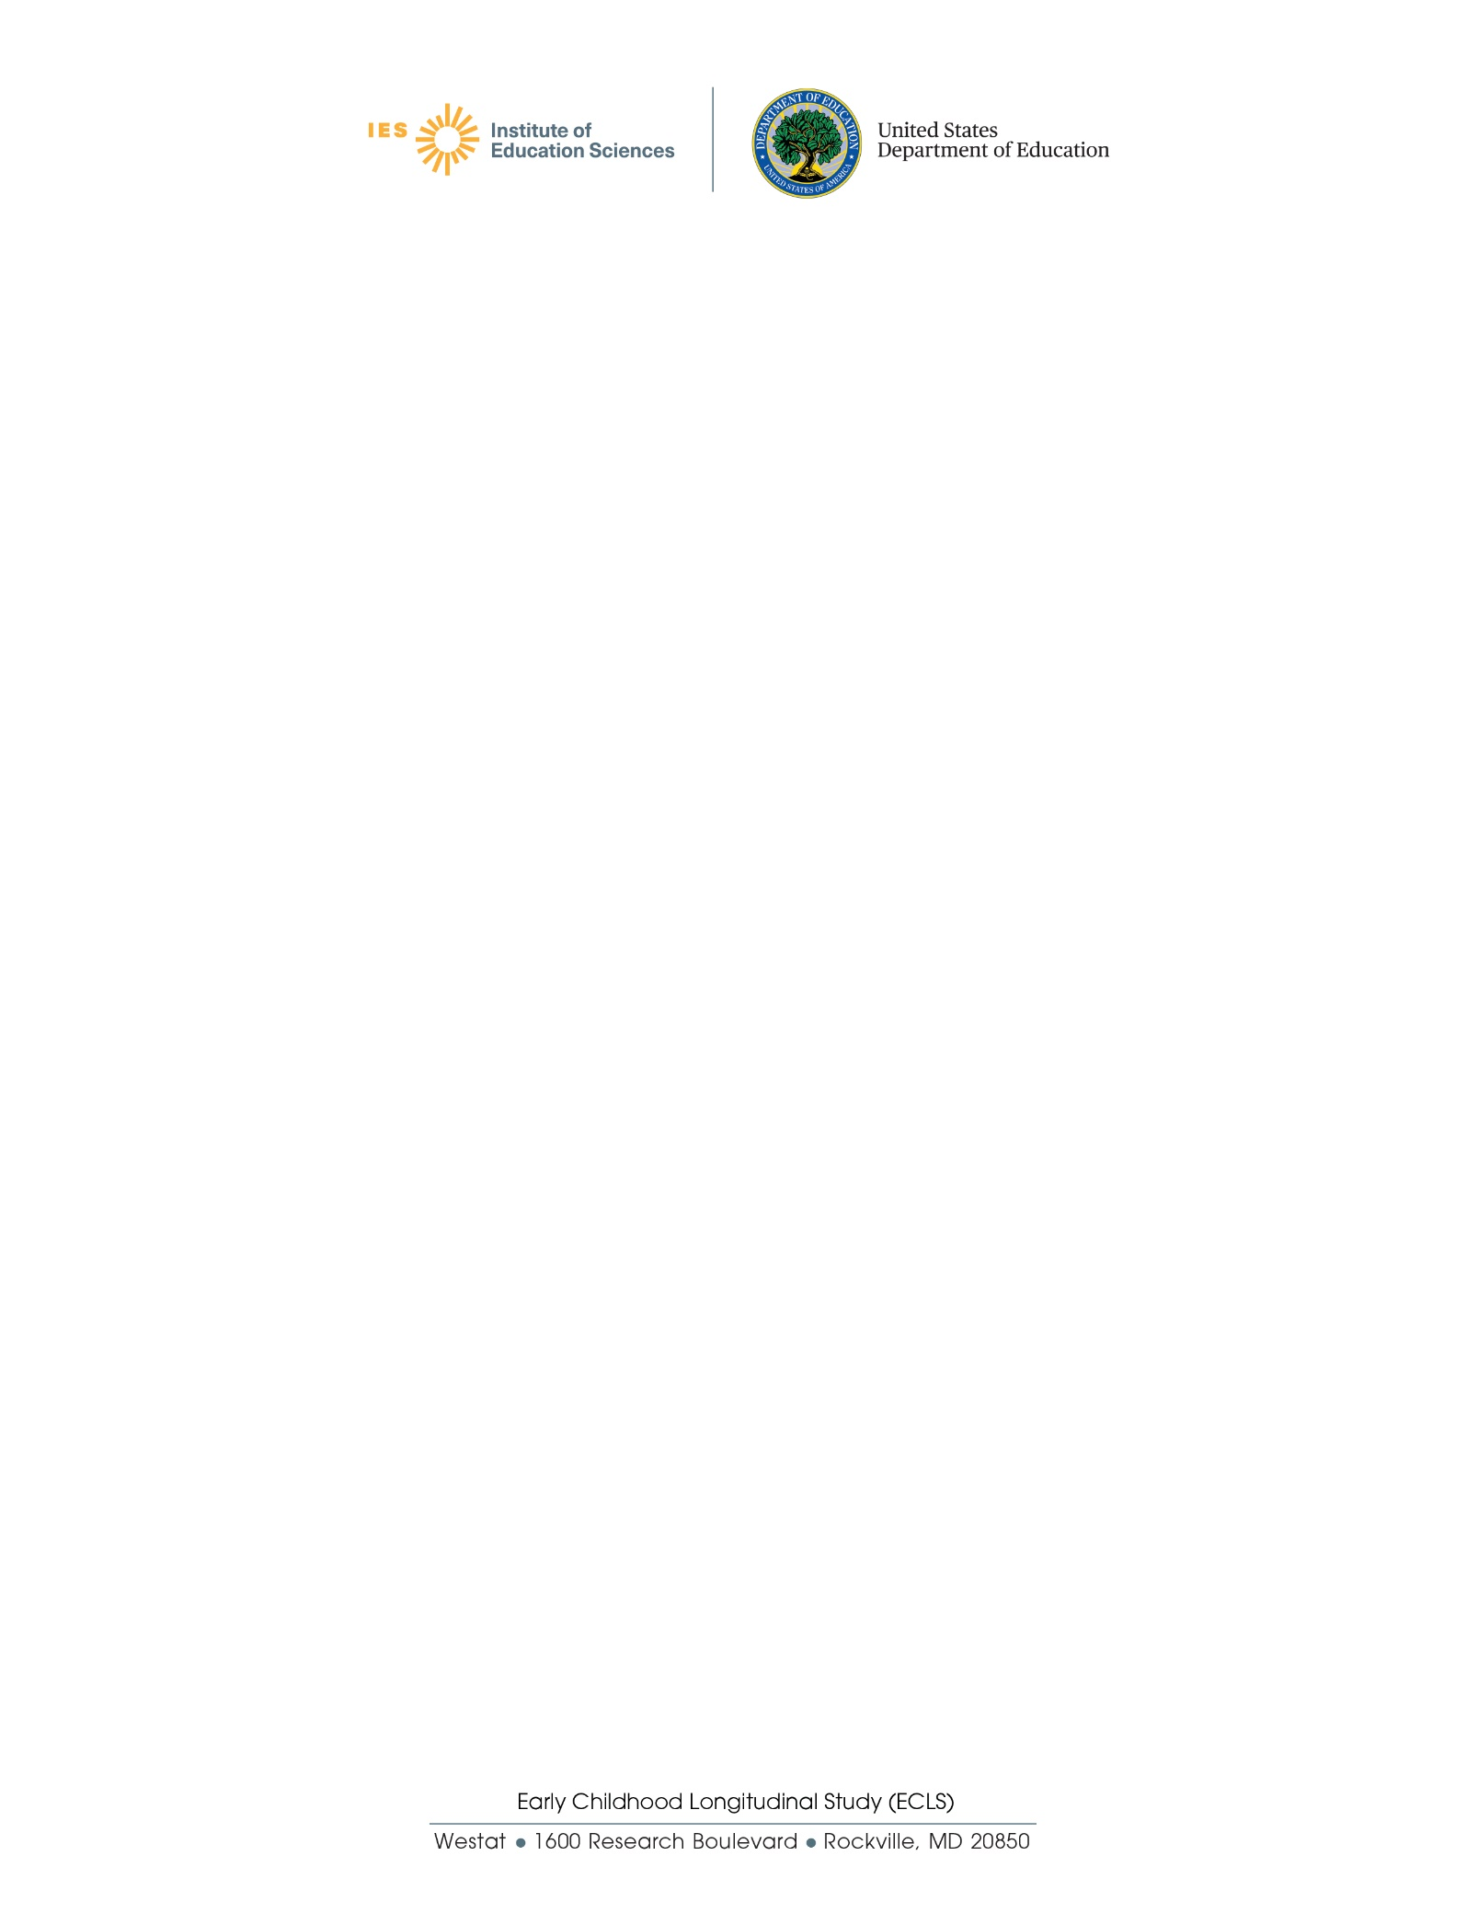

# Updated ECLS Coronavirus Protocols Overview Field Test

1. **Transitional Kindergarten Program**: A transitional kindergarten (TK) program is an extra year of school before kindergarten starts. It is different from preschool or prekindergarten. TK may be for children who are too young to start kindergarten or need more time to be ready for kindergarten. Schools have different names for these programs (e.g., early transitional kindergarten (ETK), readiness kindergarten, or a kindergarten equivalent in a classroom without grades or one with multiple grades), but all are types of kindergarten. The program may be in a public or private school and it may be a full- or part-day program and have regular and/or special education.
2. **Transitional First (or pre-first grade)**: A school program between kindergarten and the first grade. It is for children who have attended kindergarten, but need more time to be ready for the first grade.