Early Childhood Longitudinal Study, Kindergarten Class of 2023-24 (ECLS-K:2024)

Kindergarten and First-Grade Field Test Data Collection, National Sampling, and National Recruitment

OMB# 1850-0750 v.25

Attachment A-2
National Study Recruitment Respondent Materials

National Center for Education Statistics
U.S. Department of Education

August 2021
revised November 2021
revised December 2021
revised May 2022

Table of Contents
Section Page
State Recruitment Letter National Study 1
ECLS-K:2024 Study Overview National Study 2
School District Recruitment Letter National Study 6
School District Nonresponse Letter National Study 9
School Recruitment Letter National Study 11
Recruitment Follow-up Letter for Pending/Refusal Schools National Study 13
Recruitment Email Template for Difficult-to-Reach Principals National Study 15
Recruitment Email Template School Staff Considering Participation National Study 17
Recruitment Email Template Follow-up to Address Concerns National Study 19
Recruitment Email Template Follow-up after Cooperation Achieved National Study 20
Follow-up Letter for Participating but Difficult to Contact Schools National Study 21
Spring Email for School Coordinators National Study 23
School Coordinator Responsibilities Checklist National Study 25
Summer Email for School Coordinators National Study 28
Study Letterhead National Study 29

State Recruitment Letter
National Study
[DATE]
[TITLE] [NAME FIRST] [NAME LAST]
[STATE AGENCY NAME]
[ADDRESS 1]
[CITY], [STATE] [ZIP CODE]

Dear [TITLE] [NAME LAST]:
[This is a follow-up to the letter you received from me in {MONTH}.] The U.S. Department of Education is beginning its newest study of elementary-school-aged students called the Early Childhood Longitudinal Study, Kindergarten Class of 2023-24 (ECLS-K:2024). Schools in your state have been sampled for the national study.

Key details
- Participants will include children who are attending kindergarten during the 2023-24 school year, as well as their school administrators, teachers, and parents.
  - Activities include one-on-one child assessments conducted by trained ECLS-K:2024 staff and web surveys completed by school administrators, teachers, and parents. The enclosed Study Overview provides more detail about what is involved for participants.
- Study activities are currently planned to take place when sampled children are in kindergarten (fall 2023 and spring 2024), first grade (spring 2025), third grade (spring 2027), and fifth grade (spring 2029).
- Communications with sampled districts and schools will begin in August 2022.

Your support of this voluntary study—as well as active encouragement of district and school participation in your state—are invaluable. For more than 20 years, the ECLS program has helped educators, families, researchers, and policymakers improve children’s educational experiences. The ECLS-K:2024 will be particularly meaningful, as it will provide insights into the experiences of children whose early lives were shaped by the COVID-19 pandemic. The participation of selected schools is essential for ensuring the data accurately reflect the changing landscape of education for students in the United States.

More information about the ECLS-K:2024 is available on the NCES website, nces.ed.gov/ecls, as well as a website for study participants, MyECLS.ed.gov. If you have questions or need assistance, please call 1-855-898-2018 or email ECLS@westat.com. You may also reach the ECLS Study Director, Jill McCarroll, at 202-304-2920 or jill.mccarroll@ed.gov.

Thank you for your time and support.

Sincerely,
[Name]
[Commissioner or other title]
National Center for Education Statistics, Institute of Education Sciences
U.S. Department of Education

cc: State Testing Coordinator, State Early Childhood Education Coordinator

The ECLS-K:2024 is conducted by the National Center for Education Statistics (NCES), within the U.S. Department of Education’s Institute of Education Sciences (IES). NCES is working with Westat, a U.S.-based research organization, to conduct the study.

The National Center for Education Statistics (NCES) is authorized to conduct the Early Childhood Longitudinal Study (ECLS) by the Education Sciences Reform Act of 2002 (ESRA 2002, 20 U.S.C. §9543). The data are being collected for NCES by Westat, a U.S.–based research organization. All of the information you provide may be used only for statistical purposes and may not be disclosed, or used, in identifiable form for any other purpose except as required by law (20 U.S.C. §9573 and 6 U.S.C. §151). The collected information will be combined across respondents to produce statistical reports.

ECLS-K:2024 Study Overview
National Study
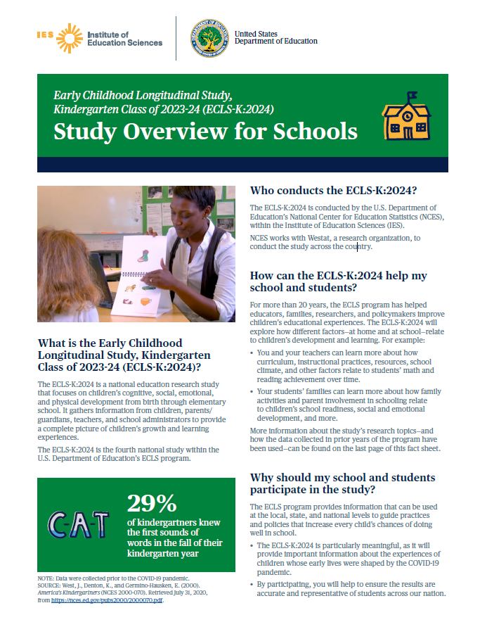
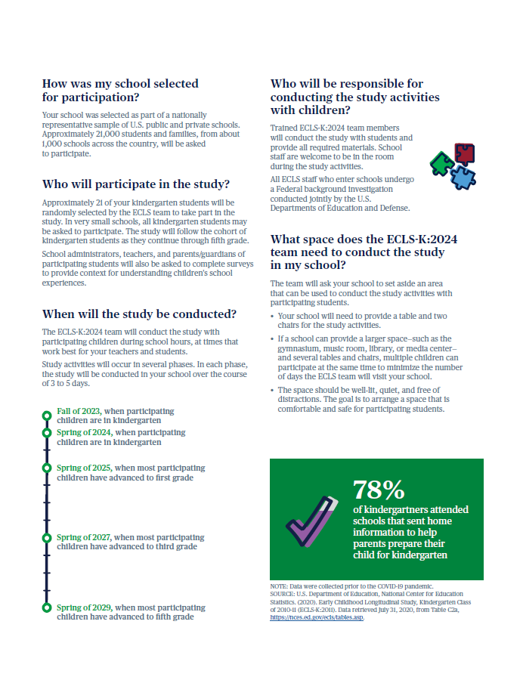

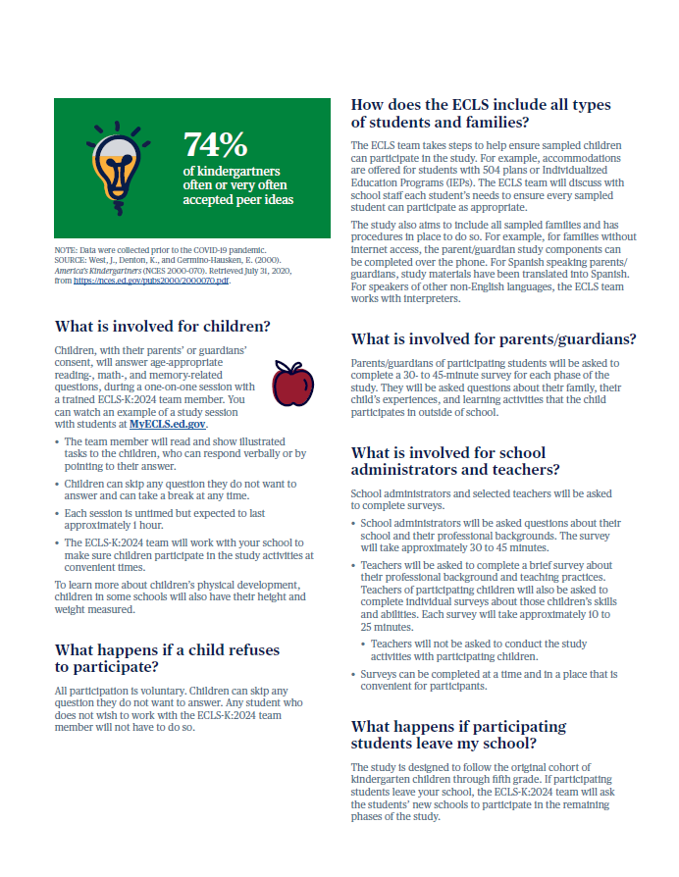

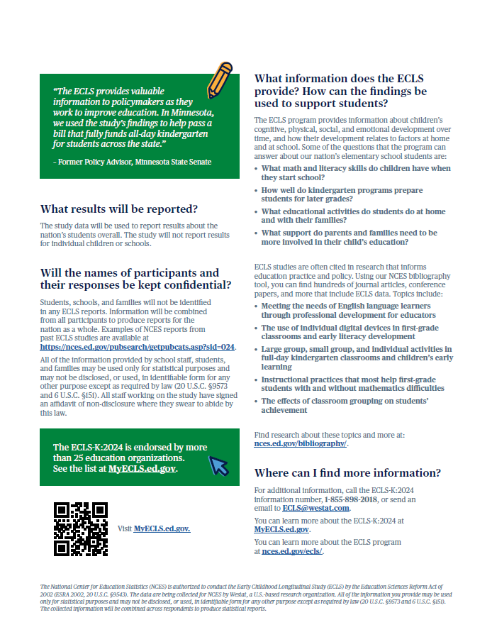

School District Recruitment Letter
National Study
[DATE]
[TITLE] [NAME FIRST] [NAME LAST]
[TITLE/DEPARTMENT]
[SCHOOL DISTRICT]
[ADDRESS 1]
[CITY], [STATE] [ZIP CODE]

Dear [TITLE] [NAME LAST]:

The U.S. Department of Education is beginning its newest study of elementary-school-aged students called Early Childhood Longitudinal Study, Kindergarten Class of 2023-24 (ECLS-K:2024). Some schools in your district have been selected to participate. I am writing to ask for your district’s support of this national study and the selected schools’ participation.

Key details
- The ECLS-K:2024 begins in the 2023-24 school year. Participants will include children in kindergarten that year as well as their school administrators, teachers, and parents.
  - Activities will include one-on-one child assessments conducted by trained ECLS-K:2024 staff and web surveys completed by school administrators, teachers, and parents. The enclosed Study Overview provides more detail about what is involved for the participants.
- Study activities are currently planned to take place when sampled children are in kindergarten (fall 2023 and spring 2024), first grade (spring 2025), third grade (spring 2027), and fifth grade (spring 2029).
- If allowed by your district, these schools, as well as school staff, will be provided with monetary tokens of appreciation in recognition of the time spent participating in the study. <Parents may also be eligible for monetary tokens of appreciation.>
- The ECLS is conducted by the National Center for Education Statistics (NCES), within the U.S. Department of Education’s Institute of Education Sciences (IES). We have partnered with Westat, a U.S.-based research organization, to carry out the study in participating schools.

Importance of participation
For more than 20 years, the ECLS program has helped educators, families, researchers, and policymakers improve children’s educational experiences. The ECLS-K:2024 will be particularly meaningful, as it will provide insights into the experiences of children whose early lives were shaped by the COVID-19 pandemic.

While the study is voluntary, by permitting our staff to contact selected schools and encouraging those schools to participate, you will help ensure the data continue to be useful. The participation of selected schools is essential for ensuring the data accurately reflect the changing landscape of education for students in the United States.

Next steps
Study staff will be contacting you soon about the participation of selected schools in your district. <To help ensure that our study clearance request packages are properly developed and submitted for your district’s formal review process, I ask you to designate a staff person who can serve as our central point of contact.>

The following school(s) in your district have been selected for the study using random statistical sampling procedures and would be contacted to discuss participation.
<LIST SAMPLED SCHOOLS>

(over)
More information about the ECLS-K:2024 is available on the NCES website, nces.ed.gov/ecls, as well as a website for study participants, MyECLS.ed.gov.

If you have questions or need assistance, please call 1-855-898-2018 or email ECLS@westat.com. You may also reach the ECLS Study Director, Jill McCarroll, at 202-304-2920 or jill.mccarroll@ed.gov.

Thank you for your time and for supporting this important national education research study.

Sincerely,

[Name]
[Commissioner or other title]
National Center for Education Statistics, Institute of Education Sciences
U.S. Department of Education

ECLS-K:2024 tokens of appreciation
If district policy permits, each school community will receive the following to recognize the time spent participating in the ECLS-K:2024:
- Each participating school will receive $300 at the conclusion of every spring phase of the study.
- School administrators will receive $25 during every spring phase of the study to thank them for completing a school administrator survey.
- School coordinators for the study will receive $65 in the fall of 2023. They will also receive $35 in the spring of 2024, as well as in each of the future spring phases.
- In each phase, teachers of sampled students will receive $20 for a survey they complete about themselves and $7 for each survey they complete for participating students.
- School administrators, school coordinators, and teachers will receive a Certificate of Contribution from the U.S. Department of Education.
- < For schools that require explicit parent consent for children’s participation, if we hear from all parents of selected children about whether their child can participate, even if parents decline, the study will also sponsor a food event (such as a pizza or ice cream party) at the school.> In each phase, participating families will receive <a $15 prepaid Mastercard® and> a pad of sticky notes with the U.S. Department of Education logo.

About the National Center for Education Statistics (NCES)
NCES was established in 1867 to collect and provide to Congress and the public information on the condition of the education system in the United States. NCES, part of the U.S. Department of Education’s Institute of Education Sciences (IES), is the sole Federal statistical agency responsible for meeting Congressional mandates to collect, analyze, and report information on the condition of education in the United States.

NCES needs the support of all involved in the education process to complete the studies it conducts related to these mandates for information about education in the country as a whole. The longitudinal studies, including those in the ECLS program, collect nationally representative data from students and from their families, teachers, schools, and school systems. These data provide rich information that can be used to study how students’ backgrounds and school experiences are related to education and life outcomes. The studies are comprehensive in approach, covering an expansive array of research and policy issues central to education.

NCES has produced some of the most widely used and cited longitudinal studies on education in the United States. NCES data are used not only by government agencies but also by policy institutes and researchers at leading universities from across the country. NCES also produces resources for teachers and families. For example, the nces.ed.gov/nceskids website is a resource for children to learn more about education in the United States and to play fun educational games.

All data collections conducted by NCES are reviewed and approved by the Federal Office of Management and Budget (OMB) to ensure minimal burden on the part of the public and to prevent duplicate data collections by multiple Federal agencies.

The ECLS-K:2024 is conducted by the National Center for Education Statistics (NCES), within the U.S. Department of Education’s Institute of Education Sciences (IES). NCES is working with Westat, a U.S.-based research organization, to conduct this voluntary study.

The National Center for Education Statistics (NCES) is authorized to conduct the Early Childhood Longitudinal Study (ECLS) by the Education Sciences Reform Act of 2002 (ESRA 2002, 20 U.S.C. §9543). The data are being collected for NCES by Westat, a U.S.-based research organization. All of the information you provide may be used only for statistical purposes and may not be disclosed, or used, in identifiable form for any other purpose except as required by law (20 U.S.C. §9573 and 6 U.S.C. §151). The collected information will be combined across respondents to produce statistical reports.

School District Nonresponse Letter
National Study
[DATE]
[TITLE] [NAME FIRST] [NAME LAST]
[TITLE/DEPARTMENT]
[SCHOOL DISTRICT]
[ADDRESS 1]
[CITY], [STATE] [ZIP CODE]
Dear [TITLE] [NAME LAST]:
We recently contacted your district about the U.S. Department of Education’s Early Childhood Longitudinal Study, Kindergarten Class of 2023-24 (ECLS-K:2024). I am contacting you again to ask that you consider lending your support to the study and allowing your district’s sampled schools to participate.
Key details
- The study activities begin in the 2023-24 school year. Participants will include children in kindergarten that year, as well as their school administrators, teachers, and parents.
- Current plans are for the study activities to take place when sampled children are in kindergarten (fall 2023 and spring 2024), first grade (spring 2025), third grade (spring 2027), and fifth grade (spring 2029). While we would like schools to participate for the entire study, we are not asking for a commitment to do so now.

Why is it important to participate?
- As with all ECLS studies, the ECLS-K:2024 will provide information that can be used at the local, state, and national levels to guide practice and policies that increase every child’s chances of doing well in school. By participating, your district will help ensure the data we provide accurately represent the experiences and skills of children whose early lives were shaped by the COVID-19 pandemic—in your district and across the United States.

What is involved for the selected schools, staff, and families?
- Children will participate in age-appropriate and engaging assessments during one-on-one sessions with trained ECLS-K:2024 staff. The sessions will be scheduled at a time convenient for the school. Most children will be out of the classroom for about 1 hour. Teachers do not need to be present during the sessions, though school staff and parents are welcome to observe.
- School administrators, teachers, and parents will be asked to complete web surveys.
- If allowed by district policy, schools, school administrators, and teachers will receive a monetary token of appreciation as a recognition of their time and effort. They, along with school coordinators, will also receive a Certificate of Contribution from the U.S. Department of Education. Families will receive <a $15 prepaid Mastercard® and> a pad of sticky notes with the U.S. Department of Education logo for their time.

The ECLS-K:2024 is conducted by the National Center for Education Statistics (NCES), within the U.S. Department of Education’s Institute of Education Sciences (IES). NCES is working with Westat, a U.S.-based research organization, to conduct this voluntary study.

A study representative will call you soon to discuss your decision. For additional information, please reach out to the ECLS-K:2024 team at ECLS@westat.com or 1-855-898-2018, or visit the ECLS-K:2024 website at MyECLS.ed.gov. To contact the ECLS Study Director, Jill McCarroll, please call 202-304-2920 or email jill.mccarroll@ed.gov.

Thank you for your time and consideration.

Sincerely,
[Name]
[Commissioner or other title]
National Center for Education Statistics, Institute of Education Sciences
U.S. Department of Education (over)
About the ECLS program
Over its rich 20-year history, the ECLS program’s studies have been important sources of data for educators, families, researchers, and policymakers to use in order to address key issues related to children’s development and learning, including literacy in the home; school support of families; the teaching of reading and mathematics; and the associations between physical exercise, childhood obesity, and well-being. Researchers using ECLS data have published their findings widely in scientific journals and the popular press has reported on these findings. The results from these research studies are available for districts, schools, and the general public to read about on the ECLS program’s website, nces.ed.gov/ecls.
<INSERT INFOGRAPHIC HERE: EITHER USE OF TECHNOLOGY, SCHOOL SUPPORT OF FAMILIES, AND/OR MATERIALS SENT HOME.>

The National Center for Education Statistics (NCES) is authorized to conduct the Early Childhood Longitudinal Study (ECLS) by the Education Sciences Reform Act of 2002 (ESRA 2002, 20 U.S.C. §9543). The data are being collected for NCES by Westat, a U.S.-based research organization. All of the information you provide may be used only for statistical purposes and may not be disclosed, or used, in identifiable form for any other purpose except as required by law (20 U.S.C. §9573 and 6 U.S.C. §151). The collected information will be combined across respondents to produce statistical reports.

School Recruitment Letter
National Study
<Date>

<Addressee’s Name
School
Address
Address 2
City, State, ZIP>

Dear <School Administrator>:
Your school has been chosen by the U.S. Department of Education to participate in the upcoming Early Childhood Longitudinal Study, Kindergarten Class of (2023-24 (ECLS-K:2024). <<District approver’s name> at your district’s office/Your district office> has been notified about this study and is aware that you are being asked to participate.

Key details
- The ECLS-K:2024 will begin in the 2023-24 school year.
- Participants in your school include approximately 21 kindergartners, as well as you, their teachers, and their parents.
  - Study activities for children include one-on-one, age-appropriate, and engaging child assessments in mathematics, reading, and memory skills. <Children’s height and weight will also be measured.> You, as well as parents and teachers, will be asked to complete web surveys. The enclosed Study Overview provides further details about the study and what is involved for participants.
- Current plans are for the study activities to take place when sampled children are in kindergarten (fall 2023 and spring 2024), first grade (spring 2025), third grade (spring 2027), and fifth grade (spring 2029).
- <For your time and effort, we will provide you, your school, the school’s coordinator to the study, <and > teachers<, and parents> a monetary token of appreciation. More details are provided on the back of this letter.>
- The ECLS is conducted by the National Center for Education Statistics (NCES), within the U.S. Department of Education’s Institute of Education Sciences (IES). We have partnered with Westat, a U.S.-based research organization, to carry out the study in participating schools.

Why is it important to participate?
For more than 20 years, the ECLS program has helped educators, families, researchers, and policymakers improve children’s educational experiences. While the study is voluntary, your participation is essential for ensuring the data can be used at the local, state, and national levels to guide practice and policies that increase every child’s chances of doing well in school. The ECLS-K:2024 will be particularly meaningful, as it will provide insights into the experiences of children whose early lives were shaped by the COVID-19 pandemic.

Questions?
A study representative will contact you about the study within the next few days. You can also contact the ECLS team at 1-855-898-2018 or ECLS@westat.com, or learn more at MyECLS.ed.gov.

I encourage you and your school to participate in the ECLS-K:2024.

Thank you for our support of this important study!
Sincerely,
[Name]
[Commissioner or other title]
National Center for Education Statistics, Institute of Education Sciences
U.S. Department of Education

(over)
<ECLS-K:2024 tokens of appreciation
Your school community will receive the following to recognize the time spent participating in the study:
- Each participating school will receive $300 at the conclusion of every spring phase of the study.
- School administrators will receive $25 during every spring phase of the study to thank them for completing a school administrator survey.
- School coordinators will receive $65 in the fall of 2023. They will also receive $35 in the spring of 2024, as well as in each of the future spring phases.
- In each phase, teachers of sampled students will receive $20 for a survey they complete about themselves and $7 for each survey they complete for participating students.
- School administrators, school coordinators, and teachers will <also> receive a Certificate of Contribution from the U.S. Department of Education.
- For schools that require explicit parent consent for children’s participation, if we hear from all parents of selected children about whether their child can participate, even if parents decline, the study will also sponsor a food event (such as a pizza or ice cream party) at the school.
- In every study phase, participating families will receive <a $15 prepaid Mastercard® and> a pad of sticky notes with the U.S. Department of Education logo.>

The ECLS-K:2024 is the fourth cohort in the series of early childhood longitudinal studies that make up the ECLS program. For more than 20 years, the ECLS program has helped educators, families, researchers, and policymakers better understand and improve children’s knowledge and skills from birth through elementary school. For more details about the ECLS program, visit nces.ed.gov/ecls.

The National Center for Education Statistics (NCES) is authorized to conduct the Early Childhood Longitudinal Study (ECLS) by the Education Sciences Reform Act of 2002 (ESRA 2002, 20 U.S.C. §9543). The data are being collected for NCES by Westat, a U.S.-based research organization. All of the information you provide may be used only for statistical purposes and may not be disclosed, or used, in identifiable form for any other purpose except as required by law (20 U.S.C. §9573 and 6 U.S.C. §151). The collected information will be combined across respondents to produce statistical reports.

Recruitment Follow-up Letter for Pending/Refusal Schools
National Study
[DATE]
[TITLE] [NAME FIRST] [NAME LAST]
[TITLE/DEPARTMENT]
[SCHOOL DISTRICT]
[ADDRESS 1]
[CITY], [STATE] [ZIP CODE]

Dear [TITLE] [NAME LAST]:

We recently contacted your school about the U.S. Department of Education’s Early Childhood Longitudinal Study, Kindergarten Class of 2023-24 (ECLS-K:2024). I am contacting you again to consider supporting the study and allowing your school to participate.

Why is it important to participate?
- As with all ECLS studies, the ECLS-K:2024 will provide information that can be used at the local, state, and national levels to guide practice and policies that increase every child’s chances of doing well in school. The ECLS-K:2024 will be particularly meaningful, as it will provide insights into the experiences of children whose early lives were shaped by the COVID-19 pandemic.
- While the study is voluntary, by participating your school will help ensure we represent the current experiences and skills of children in your district and across the United States.

What is involved for the selected schools, staff, and families?
- The ECLS-K:2024 will begin in the 2023-24 school year.
- Approximately 21 of your kindergartners will participate in one-on-one, age-appropriate, and engaging child assessments in mathematics, reading, and memory skills. The sessions will be conducted by trained ECLS-K:2024 staff. <Children’s height and weight will also be measured.>
  - Each child will participate in an approximately 1-hour session. Teachers do not need to be present during the sessions, though school staff and parents are welcome to observe. We will work with teachers to minimize classroom disruptions.
- School administrators, teachers, and parents will be asked to complete web surveys about their background and the skills and educational experiences of sampled children.
  - If allowed by district policy, school administrators and teachers will receive a monetary token of appreciation as a recognition of their time and effort.
  - Parents will receive <a $15 prepaid Mastercard® and> a pad of sticky notes with the U.S. Department of Education logo for their time.
- Current plans are for the study to take place during the fall of 2023 and spring of 2024, 2025, 2027, and 2029. While we would like schools to participate for the entire study, we are not asking for a commitment to do so now.

The ECLS-K:2024 is conducted by the National Center for Education Statistics (NCES), within the U.S. Department of Education’s Institute of Education Sciences (IES). NCES is working with Westat, a U.S.-based research organization, to conduct this study.

Questions?
A study representative will call you soon to discuss your decision. You may also contact the ECLS-K:2024 team at ECLS@westat.com or 1-855-898-2018, or learn more at MyECLS.ed.gov.

Thank you for your time and consideration.

Sincerely,
[Name]
[Commissioner or other title]
National Center for Education Statistics, Institute of Education Sciences
U.S. Department of Education

(over)
About the ECLS program
Over its rich 20-year history, the ECLS program’s studies have been important sources of data for educators, families, researchers, and policymakers to use in order to address key issues related to children’s development and learning, including literacy in the home; school support for families; the teaching of reading and mathematics; and the associations between physical exercise, childhood obesity, and well-being. Researchers using ECLS data have published their findings widely in scientific journals and the popular press has reported on these findings. The results from these studies are available for districts, schools, and the general public to read about on the ECLS program’s website, nces.ed.gov/ecls.

<INSERT INFOGRAPHIC HERE: EITHER USE OF TECHNOLOGY, SCHOOL SUPPORT OF FAMILIES, AND/OR MATERIALS SENT HOME.>

The National Center for Education Statistics (NCES) is authorized to conduct the Early Childhood Longitudinal Study (ECLS) by the Education Sciences Reform Act of 2002 (ESRA 2002, 20 U.S.C. §9543). The data are being collected for NCES by Westat, a U.S.-based research organization. All of the information you provide may be used only for statistical purposes and may not be disclosed, or used, in identifiable form for any other purpose except as required by law (20 U.S.C. §9573 and 6 U.S.C. §151). The collected information will be combined across respondents to produce statistical reports.

Recruitment Email Template for Difficult-to-Reach Principals
National Study

SUBJECT: Participation in the U.S. Department of Education’s ECLS

Dear [SCHOOL ADMIN NAME]:

My name is [RECRUITER NAME] and I have recently been trying to reach you to discuss the U.S. Department of Education’s Early Childhood Longitudinal Study, Kindergarten Class of 2023-24 (ECLS-K:2024). [Your [SECRETARY / ADMINISTRATIVE ASSISTANT / RECEPTIONIST] has been very gracious in receiving my calls and suggested I use email to contact you.] [IF DISTRICT APPROVAL OBTAINED: I spoke with [NAME], [TITLE] of [DISTRICT/DIOCESE NAME], about your school’s selection for the ECLS-K:2024. [He/She] approved my contacting you directly.]

Why is it important for my school to participate?
- The upcoming ECLS-K:2024 will be particularly meaningful, as it will provide important information about the experiences of children whose early lives were shaped by the COVID-19 pandemic. The findings can be used at the local, state, and national levels to guide practice and policies that support students.
- Your school was selected because of a variety of factors, including geographic location, school size, and the makeup of the school population you serve. While the study is voluntary, your participation is essential to ensure the data we provide accurately represent the experiences and skills of children across the United States.

What is involved for the selected schools, staff, and families?
- The study activities will begin in the 2023-24 school year. Current plans are for the study to take place when sampled children are in kindergarten (fall 2023 and spring 2024), first grade (spring 2025), third grade (spring 2027), and fifth grade (spring 2029). While we would like schools to participate for the entire study, we are not asking for a commitment to do so now.
- For each round of the study, sampled children will participate in one-on-one, age-appropriate, and engaging child assessments in mathematics, reading, and memory skills that last approximately 1 hour. The study will provide all materials and the sessions will be conducted by trained ECLS-K:2024 staff. Teachers do not need to be present, though school staff and parents are welcome to observe. We will work with teachers to minimize disruptions to their classrooms.
- You, as well as teachers and parents of sampled children, will be asked to complete web surveys.

What else should I know about the study?
- [IF INCENTIVES ARE ALLOWED:] There is no monetary cost involved―in fact, the school, the school’s coordinator for the study, <and> teachers<, and parents> will all receive a monetary token of appreciation for participation.
- School, child, teacher, and parent names will not be published in any reports nor will individual child assessment scores be reported.
- All ECLS-K:2024 staff who enter schools undergo a Federal background investigation conducted jointly by the U.S. Departments of Education and Defense and have signed a pledge of confidentiality.
What is the next step?
Please identify a convenient time when we can discuss your ECLS-K:2024 participation. If you would rather appoint another staff member to serve as the contact, I would be glad to work with that person to make arrangements.

Where can I find more information about the study?
Refer to the attached ECLS Study Overview or visit the study website, MyECLS. If you have questions, please feel free to contact me directly.

Sincerely,
[NAME], ECLS-K:2024 Representative
[PHONE NUMBER]

One reason why the ECLS-K:2024 is so important? It helps us understand more about schools, teachers, and students across the United States.
<INSERT INFOGRAPHIC HERE: EITHER USE OF TECHNOLOGY, SCHOOL SUPPORT OF FAMILIES, AND/OR MATERIALS SENT HOME.>

Attachment
ECLS Study Overview
The ECLS-K:2024 is conducted by the National Center for Education Statistics (NCES), within the U.S. Department of Education’s Institute of Education Sciences (IES).
The National Center for Education Statistics (NCES) is authorized to conduct the Early Childhood Longitudinal Study (ECLS) by the Education Sciences Reform Act of 2002 (ESRA 2002, 20 U.S.C. §9543). The data are being collected for NCES by Westat, a U.S.-based research organization. All of the information you provide may be used only for statistical purposes and may not be disclosed, or used, in identifiable form for any other purpose except as required by law (20 U.S.C. §9573 and 6 U.S.C. §151). The collected information will be combined across respondents to produce statistical reports.

Recruitment Email Template School Staff Considering Participation
National Study
SUBJECT: Participation in the U.S. Department of Education’s ECLS

Dear [SCHOOL ADMIN NAME]:
Thank you for taking time to speak with me today about the U.S. Department of Education’s Early Childhood Longitudinal Study, Kindergarten Class of 2023-24 (ECLS-K:2024). As you will be talking with [your teachers / your board] about the study, I am including a brief summary of what is involved, as well as attaching an ECLS Study Overview document for you to pass along. We recognize that your staff’s time is limited, and while the study is voluntary, we appreciate their support.

Why is it important for my school to participate?
- The upcoming ECLS-K:2024 will be particularly meaningful, as it will provide important information about the experiences of children whose early lives were shaped by the COVID-19 pandemic. The findings can be used at the local, state, and national levels to guide practice and policies that support students.
- Your school was selected because of a variety of factors, including geographic location, school size, and the makeup of the school population you serve.
• We need representation from all types of schools in the United States―public, religiously-affiliated private schools, and private schools without religious affiliation. Your participation is essential to ensure the data we provide accurately represent the experiences and skills of children across the United States.

What is involved for the selected schools, staff, and families?
- The study activities will begin in the 2023-24 school year. Current plans are for the study to take place when sampled children are in kindergarten (fall 2023 and spring 2024), first grade (spring 2025), third grade (spring 2027), and fifth grade (spring 2029).
- For each round of the study, sampled children will participate in one-on-one, age-appropriate, and engaging child assessments in mathematics, reading, and memory skills that last approximately 1 hour.
- The study will provide all materials for the school visits and sessions will be conducted by trained ECLS-K:2024 staff. Teachers do not need to be present, though school staff and parents are welcome to observe. We will work with teachers to minimize disruptions to their classrooms.
- You, as well as teachers and parents of sampled children, will be asked to complete web surveys.

What else should I know about the study?
- [IF INCENTIVES ARE ALLOWED:] There is no monetary cost involved―in fact, the school, the school’s coordinator to the study, <and teachers><teachers, and parents> will all receive a monetary token of appreciation for participation.
- School, child, teacher, and parent names will not be published in any reports nor will individual child assessment scores be reported.
- All ECLS-K:2024 staff who enter schools undergo a Federal background investigation conducted jointly by the U.S. Departments of Education and Defense and have signed a pledge of confidentiality.
Need more information about the study?
Refer to the attached ECLS Study Overview or visit the study website, MyECLS. If you have questions, please feel free to contact me directly.

What is the next step?
I will contact you on [DATE] to obtain additional school information, including the contact information for the person you designate to help with study arrangements.

Sincerely,
[NAME], ECLS-K:2024 Representative
[PHONE NUMBER]

One reason why the ECLS-K:2024 is so important? It helps us understand more about schools, teachers, and students across the United States.
<INSERT INFOGRAPHIC HERE: EITHER USE OF TECHNOLOGY, SCHOOL SUPPORT OF FAMILIES, AND/OR MATERIALS SENT HOME.>

Attachment
ECLS Study Overview
The ECLS-K:2024 is conducted by the National Center for Education Statistics (NCES), within the U.S. Department of Education’s Institute of Education Sciences (IES).
The National Center for Education Statistics (NCES) is authorized to conduct the Early Childhood Longitudinal Study (ECLS) by the Education Sciences Reform Act of 2002 (ESRA 2002, 20 U.S.C. §9543). The data are being collected for NCES by Westat, a U.S.-based research organization. All of the information you provide may be used only for statistical purposes and may not be disclosed, or used, in identifiable form for any other purpose except as required by law (20 U.S.C. §9573 and 6 U.S.C. §151). The collected information will be combined across respondents to produce statistical reports.

Recruitment Email Template Follow-up to Address Concerns
National Study
SUBJECT: Participation in the U.S. Department of Education’s ECLS

Dear [SCHOOL ADMIN NAME]:

Thank you so much for taking the time to speak with me today. I am writing to summarize some of the details of our discussion and to provide more information about [CONCERN].

[DETAILED RESPONSE TO CONCERN]

For more than 20 years, the ECLS program has helped educators, families, researchers, and policymakers better understand and improve children’s knowledge and skills from birth through elementary school. This is [SCHOOL NAME]’s opportunity to contribute to the interests of the broader educational community, while also contributing to research that can help your particular school, teachers, and students.

One reason why the ECLS-K:2024 is so important? It helps us understand more about schools, teachers, and students across the United States.
<INSERT INFOGRAPHIC HERE: EITHER USE OF TECHNOLOGY, SCHOOL SUPPORT OF FAMILIES, AND/OR MATERIALS SENT HOME.>

Please visit the study website MyECLS for more information or contact me with any questions you may have. I will call you again in a few days and look forward to working with you.

Sincerely,
[NAME], ECLS-K:2024 Representative
[PHONE NUMBER]

The ECLS-K:2024 is conducted by the National Center for Education Statistics (NCES), within the U.S. Department of Education’s Institute of Education Sciences (IES).

The National Center for Education Statistics (NCES) is authorized to conduct the Early Childhood Longitudinal Study (ECLS) by the Education Sciences Reform Act of 2002 (ESRA 2002, 20 U.S.C. §9543). The data are being collected for NCES by Westat, a U.S.-based research organization. All of the information you provide may be used only for statistical purposes and may not be disclosed, or used, in identifiable form for any other purpose except as required by law (20 U.S.C. §9573 and 6 U.S.C. §151). The collected information will be combined across respondents to produce statistical reports.

Recruitment Email Template Follow-up after Cooperation Achieved
National Study
SUBJECT: Participation in the U.S. Department of Education’s ECLS

Dear [SCHOOL ADMIN NAME]:

Thank you for taking time to speak with me today about the U.S. Department of Education’s Early Childhood Longitudinal Study, Kindergarten Class of 2023-24 (ECLS-K:2024). I am so pleased that your school will assist us in providing important information that will be used to improve education for our nation’s students. We recognize your staff’s time is limited, and we appreciate their support of the study.

To summarize our discussion today:

[SUMMARY OF DISCUSSION]

I look forward to working with you and your staff. I will contact [SCHOOL COORDINATOR NAME] on [DATE OR TIMEFRAME] to discuss the fall study activities and to make preliminary arrangements. In the meantime, please feel free to contact me with questions, or visit the study website MyECLS for more information about next steps.

Sincerely,
[NAME], ECLS-K:2024 Representative
[PHONE NUMBER]

The ECLS-K:2024 is conducted by the National Center for Education Statistics (NCES), within the U.S. Department of Education’s Institute of Education Sciences (IES).
The National Center for Education Statistics (NCES) is authorized to conduct the Early Childhood Longitudinal Study (ECLS) by the Education Sciences Reform Act of 2002 (ESRA 2002, 20 U.S.C. §9543). The data are being collected for NCES by Westat, a U.S.-based research organization. All of the information you provide may be used only for statistical purposes and may not be disclosed, or used, in identifiable form for any other purpose except as required by law (20 U.S.C. §9573 and 6 U.S.C. §151). The collected information will be combined across respondents to produce statistical reports.

Follow-up Letter for Participating but Difficult to Contact Schools
National Study

[DATE]
[TITLE] [NAME FIRST] [NAME LAST],
[TITLE/DEPARTMENT]
[SCHOOL DISTRICT]
[ADDRESS 1]
[CITY], [STATE] [ZIP CODE]

Dear [TITLE] [NAME LAST]:
We recently contacted you about the U.S. Department of Education’s Early Childhood Longitudinal Study, Kindergarten Class of 2023-24 (ECLS-K:2024). As the ECLS-K:2024 Project Director for Westat, the U.S.-based research organization conducting this study on behalf of the National Center for Education Statistics (NCES), I want to thank you for agreeing to participate.

As the study period draws closer, it is critical that we <confirm the ECLS-K:2024 visit dates for your school / receive the child list for sampling>. Your school represents hundreds of other schools in the U.S. that have a student body like yours. As a reminder:
- We will schedule the fall school visit at a time convenient for your school, between August and December 2023. Local ECLS staff will conduct each child’s session. Most children will be out of the classroom about 1 hour.
- We will work with your school staff and teachers to schedule the sessions at convenient times to minimize the amount of class time that children will miss. Teachers do not need to be present, though school staff and parents are welcome to observe. We will work with them to minimize classroom disruptions. The burden on your school staff is minimal.
- <Participants, including you and your teachers, will receive a monetary token of appreciation for completing the web surveys.> Parents asked to complete a web survey will receive <a $15 prepaid Mastercard and> a pad of sticky notes with the U.S. Department of Education logo.
The ECLS-K:2024 team wants to make your school’s participation as easy and efficient as possible. We are available to help review your calendar to find a time to visit your school to conduct the study activities and can aid in compiling and submitting the child list that we need in order to sample children for the study.

Please reach out to your ECLS-K:2024 representative, <team leader name>, at <email address>. You can also contact the ECLS-K:2024 team at 1-855-898-2018 or ECLS@westat.com with any questions. There are detailed tips for completing the study activities on the ECLS-K:2024 website, MyECLS.ed.gov.

Thank you for your time and consideration.

Sincerely,

Elizabeth Bissett
Project Director, ECLS-K:2024
Westat

One reason why the ECLS-K:2024 is so important? It helps us understand more about schools, teachers, and students across the United States.
<INSERT INFOGRAPHIC HERE: EITHER USE OF TECHNOLOGY, SCHOOL SUPPORT OF FAMILIES, AND/OR MATERIALS SENT HOME.>

The National Center for Education Statistics (NCES) is authorized to conduct the Early Childhood Longitudinal Study (ECLS) by the Education Sciences Reform Act of 2002 (ESRA 2002, 20 U.S.C. §9543). The data are being collected for NCES by Westat, a U.S.-based research organization. All of the information you provide may be used only for statistical purposes and may not be disclosed, or used, in identifiable form for any other purpose except as required by law (20 U.S.C. §9573 and 6 U.S.C. §151). The collected information will be combined across respondents to produce statistical reports.

Spring Email for School Coordinators
National Study
SUBJECT: Participation in the U.S. Department of Education’s ECLS

Dear <SC NAME>:

As you may be aware, <SCHOOL NAME> is participating in the U.S. Department of Education’s Early Childhood Longitudinal Study, Kindergarten Class of 2023-24 (ECLS-K:2024) and you have been named to serve as the school’s liaison with the ECLS staff who will work with your school.

The study activities will begin in the 2023-24 school year. Activities will include one-on-one child assessments and self-administered web surveys completed by school administrators, teachers, and parents of sampled children. Current plans are for the study to take place when sampled children are in kindergarten (fall 2023 and spring 2024), first grade (spring 2025), third grade (spring 2027), and fifth grade (spring 2029).

What will you be asked to do?
- At the beginning of the 2023-24 school year, you will be asked to provide a list of kindergarten children at your school. From this list, the ECLS-K:2024 team will select children to participate in the study using random statistical sampling procedures.
- Once the children are selected for the study, a study representative will call you to discuss the study activities that need completion prior to our visit to your school, including the most efficient method of contacting parents and gaining consent for their child’s participation, working with teachers to invite them to complete web surveys, and the logistics for the visit to your school.
- We will work with you to schedule the study sessions at convenient times to minimize the amount of class time that children miss. The sessions are conducted by trained ECLS-K:2024 staff, so there is nothing that you or their teachers need to do to administer them. You will only be asked to provide logistical support during the days study staff are visiting your school.
- You may be asked to follow-up with teachers and parents to ask them to complete their web surveys.<To thank you for your help, you will receive $65 this fall and $35 in each spring phase of the study.> You will <also> receive a Certificate of Contribution from the U.S. Department of Education. < For schools that require explicit parent consent for children’s participation, if we hear from all parents of selected children about whether their child can participate, even if parents decline, the study will also sponsor a food event (such as a pizza or ice cream party) at the school.>

Need more information about the study?
- Refer to the attached ECLS Study Overview and School Coordinator Responsibilities Checklist.
- The study website MyECLS contains more details and additional findings from previous ECLS studies.
Questions or Need Help?
- The U.S. Department of Education is working with our team at Westat, a U.S.-based research organization, to conduct the study. Please contact us at ECLS@westat.com or by calling 1-855-898-2018.
Thank you and have a wonderful summer,
The ECLS-K:2024 Project Staff

Attachments
ECLS Study Overview
School Coordinator Responsibilities Checklist
The ECLS-K:2024 is conducted by the National Center for Education Statistics (NCES), within the U.S. Department of Education’s Institute of Education Sciences (IES).
The National Center for Education Statistics (NCES) is authorized to conduct the Early Childhood Longitudinal Study (ECLS) by the Education Sciences Reform Act of 2002 (ESRA 2002, 20 U.S.C. §9543). The data are being collected for NCES by Westat, a U.S.-based research organization. All of the information you provide may be used only for statistical purposes and may not be disclosed, or used, in identifiable form for any other purpose except as required by law (20 U.S.C. §9573 and 6 U.S.C. §151). The collected information will be combined across respondents to produce statistical reports.

School Coordinator Responsibilities Checklist
National Study
U.S. Department of Education
Early Childhood Longitudinal Study, Kindergarten Class of 2023-24 (ECLS-K:2024)
School Coordinator Responsibilities Checklist – Fall 2023
Overview

As the school coordinator, your efforts and support are crucial to the success of the ECLS-K:2024. Thank you in advance for your help preparing for this important study!

In late August or early September 2023, you will be responsible for:

- Preparing and submitting the child list to MyECLS.ed.gov.
The child list should include all kindergarten students in your school, including those in transitional kindergartens and pre-first grade classrooms. Include each child’s month and year of birth, grade, sex, ethnicity, and race. The list will be used by ECLS staff to select the children, their parents, and teachers to participate in the ECLS-K:2024. Please submit this list electronically; instructions are posted on the MyECLS.ed.gov website on the “Submit Child List” page. It is very important that the list is prepared carefully and accurately.

- Determining consent requirements and updating MyECLS.ed.gov.
There are two types of parental consent used for the ECLS-K:2024: implicit consent and explicit consent. Details about consent are displayed on the “School Information” page of the MyECLS website. The Parent Portal on the MyECLS website allows parents to provide consent electronically for their children to participate. The ECLS team can also provide paper consent forms as necessary. Please confirm which type of consent is required for child participation in the ECLS-K:2024 in your school and how paper consent forms (if being used for any parents in your school) will be distributed; we will update MyECLS with the consent requirements.

Leading up to the visit to your school, you will be responsible for:

- Collecting and confirming child and teacher information.
After the children are selected for participation, you will receive an email when the Child Tracking Form is available to download from the MyECLS website. This form allows you to compile child and teacher information in advance of the study activities call with an ECLS-K:2024 representative.

- Participating in a study activities call with an ECLS-K:2024 representative.
The ECLS-K:2024 representative assigned to your school will contact you to go over the status of the preliminary tasks, discuss child and teacher participation, and work with you to arrange logistics for the school visit such as arranging a room for the child sessions and determining where ECLS-K:2024 staff will park when they arrive at the school. The representative can field any questions you may have about any of the ECLS-K:2024 procedures.

- Receiving and checking the ECLS-K:2024 study activities package.
You will receive a FedEx package with the following materials:
- Parent packets,
- Teacher packets, and
- A cover letter with a list of included materials.
The parent and teacher materials include welcome letters with instructions for using the MyECLS website to complete study activities, informational fact sheets, and the monetary tokens of appreciation for parents and teachers (if allowed by the school and district). Parent packets will also contain unique PINs to access the MyECLS website. (The PINs for teachers will be emailed to them directly.) If your school has chosen to use paper consent forms, the parent packets will also contain a consent form. Please ensure that there are parent and teacher envelopes for each selected child.

- Notifying parents and teachers and distributing survey information.
You are responsible for distributing the parent and teacher packets that will be included in the study activities package. In the event that a parent or teacher refuses to participate, be sure to let the ECLS-K:2024 representative know.

You will receive email templates for you to send to selected school staff and parents to notify them about the ECLS-K:2024. When emailing school administrators, teachers, and parents, please help us to maintain confidentiality by not revealing the names of study participants. We encourage you to send individual emails or, if you choose to send a group email, please be sure to blind-copy recipients so that they cannot see the names and email addresses of others included on the message.

- Encouraging consent and participation from parents and school staff and updating status on MyECLS.ed.gov.
The success of the study relies on children, parents, teachers, and the school administrator. Please encourage them to participate and notify the ECLS-K:2024 representative as soon as possible about any problems affecting participation in your school. You can check the completion of surveys on the School, Teacher, and Parent Information pages in the MyECLS website.

It is also very important that you update consent information on the Parent Information page of the website, particularly for parents providing consent through the return of paper forms. The ECLS-K:2024 representative assigned to your school will follow up with you on consent progress prior to and on the school visit days.

Please check the MyECLS website regularly throughout the study period to determine which parents and teachers need prompting to complete their surveys.

- Reserving space for the child sessions.
Three to five study team members will need approximately 3 consecutive days to assess all participating students. Please reserve space for the ECLS-K:2024 team to conduct the sessions with children. The sessions can take place in one large room with separate tables or in smaller rooms that accommodate only one or two pairs of ECLS study staff member and child. The space should be well-lit, quiet, free of distractions, and have two chairs and a table for each member of the study team. The goal is to arrange a space that is comfortable and safe for participating children. Internet access is not required.

On the ECLS school visit days, you will be responsible for:

- Working with the ECLS-K:2024 team and providing support, as needed.
Please plan to meet with the ECLS-K:2024 team before the first child session each day the ECLS study team is in your school in order to walk through the plan for the day. Show the reserved location to the team and make sure that they are introduced to all relevant staff members and, if possible, to the children involved in the study. You should also make sure that the procedure for getting children to and from class is clear. As the school coordinator, you are asked to assist the team as needed and help resolve any unforeseen issues. If you are unable to meet with the team on any of the school visit days, please designate an alternate staff member to take your place. Please deliver to the ECLS-K:2024 representative any paper parent consent forms that you have collected.

- Debriefing with the ECLS-K:2024 representative and returning completed paper surveys.
At the end of each day ECLS-K:2024 staff are in your school, please plan to meet with the study representative for 5-10 minutes to debrief about the day’s sessions. The ECLS-K:2024 representative will provide you with any paper surveys that have been requested for you to distribute to teachers. Please return any surveys that were completed on paper by teachers.

After the school visit, you will be responsible for:

- Storing the tracking forms and ECLS-K:2024 team materials in the storage envelope until June 30, 2024.
Please securely store the Child Tracking Form, Child Information Sheet, and Child Sign-out sheets until June 30, 2024 in the red storage envelope provided by the ECLS-K:2024 representative. After that date, the materials should be shredded.

Thank you for your help with the ECLS-K:2024 study activities!

The National Center for Education Statistics (NCES) is authorized to conduct the Early Childhood Longitudinal Study (ECLS) by the Education Sciences Reform Act of 2002 (ESRA 2002, 20 U.S.C. §9543). The data are being collected for NCES by Westat, a U.S.-based research organization. All of the information you provide may be used only for statistical purposes and may not be disclosed, or used, in identifiable form for any other purpose except as required by law (20 U.S.C. §9573 and 6 U.S.C. §151). The collected information will be combined across respondents to produce statistical reports.

Summer Email for School Coordinators
National Study
SUBJECT: Upcoming ECLS-K:2024 Study Activities in Your School

Dear <SC NAME>:

Thank you again for agreeing to take part in the U.S. Department of Education’s important study, the Early Childhood Longitudinal Study, Kindergarten Class of 2023-24 (ECLS-K:2024).

We look forward to visiting your school from <SCHOOL VISIT START DATE> through <SCHOOL VISIT END DATE> to complete the planned study activities. Please contact us at 1-855-898-2018 or ECLS@westat.com if those dates no longer work for your school.

What’s next?
- This fall, you will receive an email with directions for providing a list of all of the kindergarten children in your school so that we can select children to participate in the study. The list will be uploaded to the study’s secure website.
- We will call you on <STUDY ACTIVITIES CALL DATE> to discuss the study arrangements in more detail.

Need more information about the study?
- Refer to the attached ECLS Study Overview and School Coordinator Responsibilities Checklist.
- Visit the ECLS-K:2024 website at MyECLS.

We look forward to working with you and your school! As a reminder, to thank you for your help, you will receive <$65 and> a Certificate of Contribution from the U.S. Department of Education. <Your school will also receive $10 per participating child.>
Thank you and have a wonderful rest of your summer,
The ECLS-K:2024 Team
Attachments
ECLS Study Overview
School Coordinator Responsibilities Checklist

The ECLS-K:2024 is conducted by the National Center for Education Statistics (NCES), within the U.S. Department of Education’s Institute of Education Sciences (IES).
The National Center for Education Statistics (NCES) is authorized to conduct the Early Childhood Longitudinal Study (ECLS) by the Education Sciences Reform Act of 2002 (ESRA 2002, 20 U.S.C. §9543). The data are being collected for NCES by Westat, a U.S.-based research organization. All of the information you provide may be used only for statistical purposes and may not be disclosed, or used, in identifiable form for any other purpose except as required by law (20 U.S.C. §9573 and 6 U.S.C. §151). The collected information will be combined across respondents to produce statistical reports.

Study Letterhead
National Study

