U.S. DEPARTMENT OF ENERGY  Energy Information Administration Office of Oil, Gas and Coal Supply Statistics  Washington, DC 20585 | OMB Number: 1905-0057  Expiration Date: 8/31/2025 Product No.: 2022.2  Burden: 31 hours  hours

ANNUAL REPORT OF DOMESTIC OIL AND GAS RESERVES FORM EIA-23L

REPORT YEAR 2022
Table of Contents
Page
General Instructions 2
- Purpose 2
- Who Must Submit Form EIA-23L 2
- What Must Be Submitted 2
- When and Where to Submit 2
- Record Keeping Requirements 3
- Sanctions 3
- Disclosure of Information 3
- Reporting Standards 3
  - Proved Reserves 3
  - Report Year Production 4
  - Total Operated Basis 4
  - States and Geographic Subdivisions 4
  - Reporting Units 4
  - Prior Year's Filings 5
    - Properties Were Purchased or Acquired 5
    - Properties Were Sold or Transferred 5
  - EIA Secure File Transfer Information… 6
Specific Instructions 6
- Part 1 - Company and Contact Identification 6
- Part 2 - Parent Company Identification 6
- Part 3 - Company Approval and Comments 6
- Part 4 - Total Reserves and Production by State 7
- Part 5 - Shale Reserves and Production by State 8
- DEFINITIONS 8
Maps of Selected State Subdivisions 13
For Information or Assistance
Contact the EIA Support Team at
1-855-EIA-4USA (1-855-342-4872)
or send an email to eia4usa@eia.gov.

GENERAL INSTRUCTIONS

PURPOSE
The U S. Energy Information Administration (EIA) of the Department of Energy (DOE) seeks to gather and summarize credible and timely data regarding proved reserves and production of crude oil, natural gas, lease condensate, and other related matters with Form EIA-23L. The Government will use the resulting information to develop national and regional estimates of proved reserves of domestic crude oil, natural gas, and natural gas liquids and to facilitate national energy policy decisions.

WHO MUST SUBMIT FORM EIA-23L
It is not feasible to perform a complete census of all domestic oil and gas well operators (see Section N Definitions) every year. Instead, the U.S. Energy Information Administration selects a sample of operators from each producing area of the United States; (e.g., state, state subdivision, state waters, and Federal Offshore waters) for a report year (Report Year sample).

Each operator selected as part of the Report Year sample must file Form EIA-23L regardless of their total report year production levels.

Selection to the Report Year sample is determined by the total or gross (8/8ths) annual operated production rate within the producing area. Production refers to the total report year production from all oil and/or gas wells you operated on December 31, of the report year, including wells abandoned during the report year.

Each operating affiliate of a parent company must file its own Form EIA-23L. The parent company must file only if it is an operator itself.

Note that as defined, day-to-day physical operation of a well or wells does not alone qualify a person as the operator. Physical operation may occasionally be divorced from operatorship, such as in the instance of manipulation of swing wells by a gas pipeline company representative or the manipulation and maintenance of wells located on an offshore platform by the platform manager. While the operator's own personnel usually perform such duties, the key factor is that the operator is the person who makes management decisions regarding the well(s) in question on behalf of the owner(s).

If you are not certain whether you are the operator, contact the EIA Support Team at 1-855-EIA-4USA (1-855-342-4872) or send an email to eia4usa@eia.gov for assistance in making this determination. If you are not the operator of oil and/or gas wells on December 31, 2022 (perhaps a former operator or solely a working or royalty interest owner), you should complete and sign the Cover Page Parts 1 - 3 and return it to EIA along with a comment in Part 3, Question 11, stating when operations ceased and what became of the wells you previously operated.

WHAT MUST BE SUBMITTED
Production data and estimates of proved reserves of crude oil including lease condensate and natural gas are required of each operator selected.

Operators must file:
  - Cover Page, Parts 1 – 3, Company and Contact Information
  - Part 4, Total Liquids and Natural Gas operated proved reserves, production, and related data by state and/or state subdivision
  - Part 5, Shale Only Liquids and Natural Gas operated proved reserves, production, and related data by state and/or state subdivision

WHEN AND WHERE TO SUBMIT
The completed 2022 report forms must be submitted on or before April 14, 2023. Operators must file electronically using Secure File Transfer. See page 5 for information

EIA-23L forms and instructions are available on the EIA website.

RECORD KEEPING REQUIREMENTS
All records necessary to reconstruct the data on this form must be retained and available for a period of three (3) years from the filing due date.

SANCTIONS
The timely submission of Form EIA-23L by those required to report is mandatory under Title 15 U.S.C. §772(b), as amended. Failure to respond may result in a civil penalty of not more than $11,630 each day for each violation. The government may bring a civil action to prohibit reporting violations that may result in a temporary restraining order or a preliminary or permanent injunction without bond. In such civil action, the court may also issue mandatory injunctions commanding any person to comply with these reporting requirements.

DISCLOSURE OF INFORMATION
The annual production of crude oil, lease condensate, and natural gas reported on Form EIA-23L are considered public information. These data elements may be released in company-identifiable form and will not be protected from disclosure in identifiable form when releasing statistical aggregate information. All other information, including reserves, reported on Form EIA-23L will be protected and not disclosed to the public to the extent that it satisfies the criteria for exemption under the Freedom of Information Act (FOIA), 5 U.S.C. §552, the DOE regulations, 10 C.F.R. §1004.11, implementing the FOIA, and the Trade Secrets Act, 18 U.S.C. §1905.

The Federal Energy Administration Act requires the EIA to provide company-specific data to other Federal agencies when requested for official use. The information reported on this form may also be made available, upon request, to another component of the Department of Energy (DOE); to any Committee of Congress, the Government Accountability Office, or other Federal agencies authorized by law to receive such information. A court of competent jurisdiction may obtain this information in response to an order. The information may be used for any non-statistical purposes such as administrative, regulatory, law enforcement, or adjudicatory purposes.

Disclosure limitation procedures are applied to the protected statistical data published from EIA-23L report information to ensure that the risk of disclosure of identifiable information is very small.

Confidential information collected on Form EIA-23L will be provided to United States Department of Interior offices (the Bureau of Ocean Energy Management and the United States Geological Survey) for statistical purposes only, in conducting their resource estimation activities.

REPORTING STANDARDS

Proved Reserves
EIA recognizes that the judgment of geologists and petroleum engineers is required in the reserve estimation process, and that as a result, proved reserves are estimates rather than precise quantitative measurements.

Proved reserves of oil and gas as of December 31, 2022 are the estimated quantities of oil and/or gas, which geological and engineering data demonstrate with reasonable certainty to be recoverable in future years from known reservoirs under existing economic and operating conditions. (See Proved Reserves, Crude Oil; Proved Reserves, Natural Gas; and Proved Reserves, Lease Condensate, Section N Definitions.)

Existing economic and operating conditions include prices and costs as of the date the estimate is made. Prices include consideration of changes in existing prices provided only by contractual arrangements, but not on escalations based on estimated future conditions. The U.S. Securities and Exchange Commission (SEC) procedure for determining the prices underpinning their proved reserves estimates were revised in 2008 to make reserves estimates less sensitive to price fluctuations. The 2008 SEC rules were changed to allow companies to use an average of the 12 first-day-of-the-month prices as opposed to the price observed on December 31 of that year. Proved reserves reported to both EIA and the SEC should be estimated using the same prices. SEC and EIA estimates are not exactly the same, however; the SEC requires companies to report their owned reserves, and EIA requires companies to report their operated reserves (See Total Operated Basis, Section 3 below.)

Report Year Production
Production data are required from all operators. If the actual production data are not available at the time Form EIA-23L is prepared, estimate production. Note that amended reports are not required to correct preliminary production data in the prior year.

Report production for properties operated on Dec 31st of the report year. If any properties were acquired during the report year, production data from the acquired properties should be reported for the entire year. If any properties were sold during the report year, production data should not be reported for these properties.

Total Operated Basis
All data on Parts 4 and 5 are to be reported on an 8/8ths or Total Operated Basis. When reporting on this basis, production and reserves data for any properties on which operations were acquired during the report year should be reported for the entire year. If any properties were sold or transferred to a new operator during the report year, production and reserves data should not be reported for these properties. Report production and reserves data only for properties operated on Dec 31st of the report year.

EXAMPLES:

Of the total 8/8ths interest, respondent's share is 50 percent and the associated royalty share is 6.25 percent. Respondent operates property. Respondent reports 100 percent of proved reserves and production.

Of the total 8/8ths interest, respondent's share is zero but it operates the property (i.e., a contract operator). Respondent reports 100 percent of proved reserves and production.

States and Geographic Subdivisions
The state or state subdivision in which to report proved reserves and production data is determined by the location of the wells producing the oil and/or gas. If a field overlaps two or more states or state subdivisions, the proved reserves data must be subdivided into the appropriate geographic components. Refer to the Section: Maps of Selected Sate Subdivisions for the subdivision boundaries in the States of Alaska, California, Louisiana, New Mexico, and Texas.

Offshore proved reserves data are required separately for the state and federal domains. If an offshore field lies on or between disputed boundaries, include all data in the state offshore area.

Reporting Units
All volumes are to be reported in the appropriate reporting units as shown below. Entries should not have negative numbers. Use of up to 3 decimal places is permitted.

  - Crude Oil: All crude oil volumes are to be reported in thousands of barrels (MBbls) (42 U.S. gallons per barrel at atmospheric pressure corrected to 60° Fahrenheit) and excluding basic sediment and water.

  - Natural Gas: All natural gas volumes are to be reported in millions of cubic feet (MMCF) at 14.73 psia and 60° Fahrenheit, wet after lease separation.

It is recognized that the operator in many instances has no knowledge of the ultimate reduction of the gas stream produced from his properties, which may result from further downstream processing. The operator is requested to report volumes of natural gas, which remain after processing through lease and field separation facilities. Lease use and flared and vented gas are also considered production and should be included in the volumes reported.

The EIA obtains data from gas processing plants separately. Gas volumes reported on Form EIA-23L should not be corrected for liquids removed by these plants. If you do not know if a field facility through which your gas is processed is currently reporting data to the EIA or not, contact the EIA Support Team at 1-855-EIA-4USA (1-855-342-4872) or send an email to eia4usa@eia.gov to obtain information on those plants which report.
An unusual situation may occur when, for pressure maintenance, a field is injected with natural gas produced from another field. The total injected volume should be added to the proved gas reserves for that state/state subdivision, and a comment created that states the total injected volume during the report year.

  - Lease Condensate: All lease condensate volumes are to be combined with crude oil and reported in thousands of barrels (MBbls) (42 U.S. gallons per barrel, at atmospheric pressure corrected to 60° Fahrenheit) (see Crude Oil).

  - Rounding: Round liquid volumes 500 barrels and above up to ‘1’ MBbls, and less than 500 barrels down to ‘0’ MBbls. Round gas volumes 500 MCF and above up to ‘1’ MMCF, and less than 500 MCF down to ‘0’ MMCF.

  - Negative and Positive Volumes: All data are to be entered without plus (+) or minus (-) symbols. By definition, Sales, and Production all constitute reserve decreases and are entered without the minus symbol.

Prior Year's Filing

Properties Were Purchased or Acquired
If operations were transferred from another company to the respondent during the report year, then these reserves should be shown in Acquisitions, Parts 4 and 5 Columns (D & K). Reserves and production for the acquired properties should be reported for the entire year. Additionally, the acquisition should be noted in Part 1, Question 8 indicating the name of the previous operator, the state(s) where the properties are located, and the month in which operations were acquired.

Properties Were Sold or Transferred
If operations were transferred to another company during the report year, then these reserves should be shown in Sales, Parts 4 and 5 (columns C and J). Do not report any production for these properties. Additionally, the transfer or sale should be noted in Part 1, Question 7 indicating the name of the new operator, the state(s) where the properties are located, and the month in which operations were transferred. In the event the respondent no longer operates any properties in each state, then the Total Producing Reserves (columns F and M) and Total Non-Producing Reserves (columns G and N) would be zero.

EIA Secure File Transfer (SFT) Information
EIA is ensuring the security of your transactions by using the latest Internet security technology. The technology being used to protect your data is encryption which is the scrambling of data into a code that is unreadable to anyone who does not have the key that deciphers it. The secure hypertext transfer protocol (HTTPS) is a communications protocol designed to transfer this encrypted information between computers over the World Wide Web. All information is protected by 128-bit encryption to maintain the privacy and confidentiality of your data. The only thing you need to take advantage of strong encryption technology is a secure browser, one that supports 128-bit encryption.

To use the EIA HTTPS secure file transfer system:

- Click to open the SFT webpage
or type in this URL in your browser: https://signon.eia.doe.gov/upload/noticeoog.jsp

The EIA SFT Notice to Users page appears.

- Read and then click the Accept button.
The Secure File Transfer System page appears.
At the bottom of this page, in blue text, click on Instructions for Secure File Transfer.

If you have any trouble transferring your files, please call the EIA User Services Center 202-586-8959 or email them at User- Services-Center@eia.gov.

SPECIFIC INSTRUCTIONS

Part 1. Company and Contact Identification

Question 1. Is this a resubmission?
If you’re filing a revised report for this report year, check “Yes.”

Question 2. Enter you EIA Operator ID Number.
If you do not have a 6-digit operator ID number, contact the EIA Support Team at 1-855-EIA-4USA (1-855-342-4872) or send an email to eia4usa@eia.gov to obtain an ID.

Question 3. Enter your Company information associated with your EIA Operator ID number.
Enter the company name and address, and check the box if any of the name and address information has changed since the last report.

Question 4. Enter information for the primary contact at your Company responsible for completing the form.
Enter the person’s name, email address, phone number, and fax number. Check the box if any of the contact information has changed since the last report. This person should be familiar with the data provided and will be the person to whom inquiries will be directed, if necessary.

Question 5. Enter information for a secondary contact at your Company responsible for completing the form.
Check the appropriate box if any of the contact information has changed or there is no secondary contact person.

Question 6. Did your Company, or any subsidiaries or affiliates you are reporting for, operate any oil and gas properties at any time during report year 2022?
Check either the “Yes” or “No” box and move to the next question as instructed.

Question 7. In report year 2022, was your Company or any of its oil or gas properties sold, merged, or transferred to any other company(ies)?
Check the box with the best answer. If either of the “Yes” boxes were checked, enter the acquiring company’s name, the state where the properties are located, and the month of the sale or merger. Then proceed to Question 8.

Question 8. During report year 2022, did your Company acquire any oil and gas operating companies or any properties from other companies?
Check the box with the best answer. If either of the “Yes” boxes were checked, enter the company you acquired or the previous operator of the properties you acquired, the state where the properties are located, and the month of the acquisition or merger. Then proceed to Question 9.

Question 9. For report year 2022, are you completing this form for any subsidiary/affiliated companies?
Check either “Yes” or “No.” If “Yes” is checked, enter the company name(s) and EIA Operator ID(s) of the subsidiary/affiliated companies you are reporting for. Then proceed to Part 2, Question 10.

Part 2. Parent Company Identification

Question 10. Is there a parent company that exercises control over your Company?
Check either “Yes” or “No.” If “Yes” is checked, enter the company name and address, and check the box if any of the name and address information has changed since the last report.

Part 3. Company Approval and Comments

Question 11. Please enter any comments you have in the space below.
Enter any general comments you may have about this report.

Question 12. Enter the name and title of the company official authorized to approve the filing of this report. This is required before returning the form.
Enter the name and title of the person authorizing the submission of this report. Include the date this report was authorized.

Part 4 – Total Reserves and Production by State
All proved reserves, production, and reserve changes data on Part 4 are to be reported on a Total Operated Basis for each state, state subdivision, and area in which the respondent operated oil and/or gas wells on December 31, of the report year. (See Total Operated Basis, Section H, Item 3.)

Production data and estimates of proved reserves of crude oil and condensate combined, and total nonassociated and associated-dissolved natural gas combined are required of each operator. Production refers to the total report year production from all domestic oil and/or gas wells you operated on December 31 of that report year. Production data and proved reserve estimates are required by state and state subdivision from all operators filing Form EIA-23L that were selected as part of the Report Year sample.

Column (A): State, Subdivision, Area – The geographic State, State Subdivision, or offshore area where wells were operated during the report year. These columns are filled with designated States and State subdivisions. Respondents cannot enter data in Column A.

Column (B): Production (MBbls) – Annual gross production of crude oil and condensate extracted during the report year from wells you operated in units of thousands of barrels.

Column (C): Sales (MBbls) - If oil wells or properties were sold or transferred to another company during the report year, then the reserves you no longer operate should be reported as Sales. Enter the reserves for these properties as of the date of sale in units of thousands of barrels. Additionally, provide a Comment in column (O) indicating the name of the new operator and the month in which operations were transferred. (See Sales, Section N Definitions.)

Column (D): Acquisitions (MBbls) - If oil wells or properties were transferred from another company to the respondent during the report year, then these reserves should be reported as Acquisitions. Enter the reserves for the acquired properties as of the date of purchase or transfer. Include the annual production from the acquired wells in the volume of annual production in Column B. Additionally, provide a comment in column O indicating the name of the previous operator and the month in which operations were acquired. (See Acquisitions, Section N Definitions.)

Column (E): Extensions and Discoveries (MBbls) – If proved reserves of crude oil or condensate were added to this state, state subdivision, or area during the report year because of successful exploratory drilling, then these reserves should be reported as Extensions and Discoveries. Extensions are reserves additions that result from expanding the proved acreage of previously discovered reserves through additional drilling. Discoveries are the sum of new field discoveries, and new reservoir discoveries found in existing fields during a report year. (See Extensions and Discoveries, Section N Definitions)

Column (F) Total Producing Reserves (MBbls) - Enter the volumes of total proved, developed, producing reserves of crude oil and condensate combined as of December 31 of the Report Year in units of thousands of barrels.

Column (G) Total Non-Producing Reserves (MBbls) - Enter the volumes of total proved non-producing reserves of crude oil and condensate combined as of December 31 of the Report Year in units of thousands of barrels. This value includes proved, developed non-producing (PDNP) reserves and proved, undeveloped reserves (PUDs).

Column (I): Gas Production (MMCF) – Annual gross production of total natural gas (associated-dissolved and nonassociated natural gas combined) extracted during the report year from wells you operated in units of millions of cubic feet.

Column (J): Sales (MMCF) - If gas wells or properties were sold or transferred to another company during the report year, then the reserves you no longer operate should be reported as Sales. Enter the reserves for these properties as of the date of sale in units of millions of cubic feet. Additionally, provide a Comment in column (O) indicating the name of the new operator and the month in which operations were transferred. (See Sales, Section N Definitions)

Column (K): Acquisitions (MMCF) - If gas wells or properties were transferred from another company to the respondent during the report year, then these reserves should be reported as Acquisitions. Enter the reserves for the acquired properties as of the date of purchase or transfer. Include the annual production from the acquired gas wells in the volume of annual production in Column I. Additionally, provide a comment in column O indicating the name of the previous operator and the month in which operations were acquired. (See Acquisitions, Section N Definitions)

Column (L): Extensions and Discoveries (MMCF) – If proved reserves of natural gas were added to this state, state subdivision, or area during the report year because of successful exploratory drilling, then these reserves should be reported as Extensions and Discoveries. Extensions are reserves additions that result from expanding the proved acreage of previously discovered reserves through additional drilling. Discoveries are the sum of new field discoveries, and new reservoir discoveries found in existing fields during a report year. (See Extensions and Discoveries, Section N Definitions)

Column (M) Total Producing Reserves (MMCF) - Enter the volumes of total proved, developed, producing reserves of natural gas as of December 31 of the Report Year in units of millions of cubic feet.

Column (N) Total Non-Producing Reserves (MMCF) - Enter the volumes of total proved non-producing reserves of natural gas as of December 31 of the Report Year in units of millions of cubic feet. This value includes proved, developed non-producing (PDNP) reserves and proved, undeveloped reserves (PUDs).
Column (O) Comments (formerly Footnotes) - Comments at the end of the row provide necessary additional information for reported data items. EIA requests that a comment in column O be included for sales or acquisitions of properties during a Report year. Respondents should include a comment for any other reported item if this will enhance its clarity.

Part 5 – Shale Reserves and Production by State
The portion of Total Proved Reserves and Production that came from domestic U.S. shale reservoirs should be separately reported in Part 5, Shale Reserves and Production by State. The columns and reporting units of Part 5 mirror those of Part 4 – Total Proved Reserves and Production by State (above). The only difference (a fundamental one) is based on the geology of the producing formation. If the crude oil and condensate or natural gas came from a known shale reservoir, include it in Part 5. If the producing formation geology is not shale or is unknown, do not include it.
Column A in Part 5 includes the major shale play(s) to report in each state. Report production and proved reserves only for these plays.
For all volumes, the subset volume from Shale should be less than or equal to the total reported in the columns of Part 4 for the Report Year.

DEFINITIONS
These definitions have been formulated with reference to the particular purposes of Form EIA-23L. They are not necessarily synonymous with the same or similar terms used in DOE regulations and are not to be construed as definitions applicable for any purposes other than the collection and reporting of data on Form EIA-23L.

Acquisitions: The volumes of proved reserves of crude oil, natural gas, and/or lease condensate associated with properties that were purchased and/or transferred from another company to the respondent’s operatorship during the report year.

Affiliated (Associated) Company: An entity that is directly or indirectly owned, operated, or controlled by another entity. (See
Person and Control)

Control: The term control (including the terms controlling, controlled by, and under common control with) means the possession, direct or indirect, of the power to direct or cause the direction of the management and policies of a person, whether through the ownership of voting shares, by contract or otherwise. (See Person)

Crude Oil (excluding Lease Condensate): A mixture of hydrocarbons that exists primarily in the liquid phase in natural underground reservoirs and remains liquid at atmospheric pressure after passing through surface separating facilities. Such hydrocarbons as lease condensate and natural gasoline recovered as liquids from natural gas wells in lease or field separation facilities are excluded. Depending upon the characteristics of the crude stream, it may also include:
- small amounts of hydrocarbons that exist in gaseous phase in natural underground reservoirs but are liquid at atmospheric pressure after being recovered from oil well (casinghead) gas in lease separators and are subsequently commingled with the crude stream without being separately measured
- small amounts of non-hydrocarbons produced with the oil, such as sulfur and various metals.

Existing Economic and Operating Conditions: Prices and costs as of the date the estimate is made. Prices include consideration of changes in existing prices provided only by contractual arrangements, but not on escalations based on estimated future conditions.

Extensions and Discoveries: Additions to proved reserves that result from (1) extension of the proved acreage of previously discovered reserves through additional drilling in periods subsequent to discovery and (2) discovery of new fields with proved reserves or of new reservoirs of proved reserves in old fields.

Field: An area consisting of a single reservoir or multiple reservoirs all grouped on, or related to, the same individual geological structural feature and/or stratigraphic condition. There may be two or more reservoirs in a field that are separated vertically by intervening impervious strata or laterally by local geologic barriers or by both.

Field Area: A geographic area encompassing two or more pools that have a common gathering and metering system, the reserves of which are reported as a single unit. This concept applies primarily to the Appalachian region. (See Pool)

Field Separation Facility: Surface equipment designed to separate some combination of oil, water, and gas produced from one or more leases, and managed by the operator of one or more of these leases.

Lease Condensate: A mixture consisting primarily of pentanes and heavier hydrocarbons which is recovered as a liquid from natural gas in lease or field separation facilities. This excludes natural gas plant liquids, such as butane, propane, and ethane which are recovered at downstream natural gas processing plants or facilities. The output of natural gas processing plants is reported on Form EIA-64A, Annual Report of the Origin of Natural Gas Liquids Production and Form EIA-816, Monthly Natural Gas Liquids Report. (See Crude Oil)

Lease Separator: A facility installed at the surface for the purpose of separating gases from:
- produced crude oil and water at the temperature and pressure conditions of the separator, and/or
- that portion of the produced natural gas stream, which liquefies at the temperature and pressure conditions of the separator, or
- water from either oil or gas or both.

Natural Gas: A gaseous mixture of hydrocarbon compounds, the primary one being methane. The parameters for measurement are cubic feet at 60 degrees Fahrenheit and 14.73 pounds per square inch absolute (psia). This EIA report does not include landfill gas (biomass gas), synthetic natural gas, coke oven gas, or manufactured gas.

Wet natural gas: A mixture of hydrocarbon compounds and small quantities of various non-hydrocarbons existing in the gaseous phase or in solution with crude oil in porous rock formations at reservoir conditions. The principal hydrocarbons normally contained in the mixture are methane, ethane, propane, butane, and pentane. Typical non-hydrocarbon gases that may be present in reservoir natural gas are water vapor, carbon dioxide, hydrogen sulfide, nitrogen, and trace amounts of helium. Under reservoir conditions, natural gas and its associated liquefiable portions occur either in a single gaseous phase in the reservoir or in solution with crude oil and are not distinguishable at the time as separate substances. Note:
U.S. Securities and Exchange Commission and Financial Accounting Standards Board refer to this product as natural gas.

Associated-dissolved natural gas: Natural gas that occurs in crude oil reservoirs either as free gas (associated) or as gas in solution with crude oil (dissolved gas).

Non-associated natural gas: Natural gas that is not in contact with significant quantities of crude oil in the reservoir.

Dry natural gas: Natural gas that remains after:
- the liquefiable hydrocarbon portion has been removed from the gas stream (i.e., gas after lease, field and/or plant separation); and
- any volumes of non-hydrocarbon gases have been removed where they occur in sufficient quantity to reduce the gas
quality below minimum pipeline specifications (rendering it unmarketable).

Natural Gas Processing Plant: Facilities designed to recover natural gas liquids from a stream of natural gas that may or may not have passed through lease separators and/or field separation facilities. These facilities also control the quality of the natural gas stream to be marketed, e.g. removal of nonhydrocarbon gases. Cycling plants are classified as natural gas processing plants.

New Field: A field discovered during the report year.

New Field Discoveries: The volumes of proved reserves of crude oil, natural gas, and/or lease condensate discovered in new fields during the report year.

Nonproducing Reserves: Quantities of proved liquid or gaseous hydrocarbon reserves that have been identified, but which did not produce during the last report year regardless of the availability and/or operation of production, gathering or transportation facilities. This includes both proved undeveloped and proved developed nonproducing reserves.

Old Reservoir: A reservoir discovered prior to the report year.

Operator: The person or company responsible for the management and day-to-day operation of one or more crude oil and/or natural gas wells as of December 31, 2022. The operator is generally a working interest owner or a company under contract to the working interest owner(s). Wells included are those, which have proved reserves of crude oil, natural gas, and/or lease condensate in the reservoirs associated with them, whether or not they are producing. Wells sold or abandoned during 2022 are not considered operated as of December 31, 2022. (See Person, Proved Reserves of Crude Oil, Proved Reserves of Natural Gas, Proved Reserves of Lease Condensate, Report Year, and Reservoir)

Ownership: (See Working Interest Ownership Basis)

Parent Company: A firm that directly or indirectly controls another entity. (See Affiliated {Associated} Company and Control)

Pool: In general, a reservoir. In certain situations, a pool may consist of more than one reservoir. (See Field Area)

Production, Crude Oil: The volume of crude oil that was extracted from oil reservoirs during the report year. These volumes are determined through measurement of the volumes delivered from lease storage tanks or at the point of custody transfer, with adjustment for:
- net differences between opening and closing lease inventories
- basic sediment and water
- Crude oil used on the lease is considered production.

Production, Lease Condensate: The volume of lease condensate produced during the report year. Lease condensate volumes include only those volumes recovered from lease or field separation facilities. In the columns on Form EIA-23L, lease condensate should be combined with crude oil (See Lease Condensate)

Production, Natural Gas: The volume of natural gas withdrawn from reservoirs during the report year less:
- the volume returned to such reservoirs in cycling, repressuring of oil reservoirs and conservation operations
- the shrinkage resulting from the removal of lease condensate
- non-hydrocarbon gases where they occur in sufficient quantity to render the gas unmarketable.
Lease use and flared and vented gas are considered production and should be included in the volumes reported. Volumes of gas withdrawn from gas storage reservoirs and native gas, which has been transferred to the storage category, are not considered production.
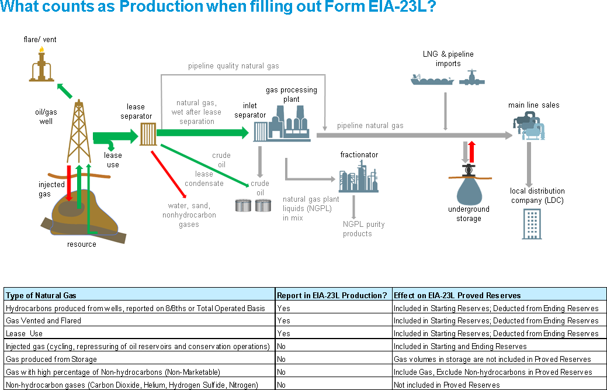

Prospect: An area of exploration or development in which hydrocarbons have been predicted to exist in economic quantity. A prospect is commonly an anomaly, such as a geologic structure or a seismic amplitude anomaly, which is recommended by exploration personnel for drilling a well. A single drilling location may also be called a prospect, but the term is more properly used in the context of exploration.

Proved Reserves, Crude Oil: Proved reserves of crude oil as of December 31 of the report year are the estimated volumes of all liquids defined as crude oil, which geological and engineering data demonstrate with reasonable certainty to be recoverable in future years from known reservoirs under existing economic and operating conditions.
Reservoirs are considered proved if economic producibility is supported by actual production or conclusive formation test (drill stem or wire line), or if economic producibility is supported by core analyses and/or electric or other log interpretations. The area of an oil reservoir considered proved includes:
- that portion delineated by drilling and defined by gas-oil and/or oil-water contacts, if any
- the immediately adjoining portions not yet drilled, but which can be reasonably judged as economically productive on the basis of available geological and engineering data.
In the absence of information on fluid contacts, the lowest known structural occurrence of hydrocarbons is considered to be the lower proved limit of the reservoir.

Volumes of crude oil placed in underground storage are not considered proved reserves.

Reserves of crude oil which can be produced economically through application of improved recovery techniques (such as fluid injection) are included in the proved classification when successful testing by a pilot project, or the operation of an installed program in the reservoir, provides support for the engineering analysis on which the project or program was based.

Estimates of proved crude oil reserves do not include the following:
- oil that may become available from known reservoirs in the future
- natural gas liquids (including lease condensate)
- oil, the recovery of which is subject to reasonable doubt because of uncertainty as to geology, reservoir characteristics, or economic factors
- oil that may occur in undrilled prospects
- oil that may be recovered from oil shales, coal, Gilsonite and other such sources.

It is not necessary that production, gathering or transportation facilities are installed or operative for a reservoir to be considered proved.

Proved Reserves, Lease Condensate: Proved reserves of lease condensate as of December 31 of the report year are the estimated volumes expected to be recovered in future years in conjunction with the production of proved reserves of natural gas based on the recovery efficiency of lease and/or field separation facilities currently installed. In the columns on Form EIA-23L, lease condensate should be combined with crude oil (See Lease Condensate and Proved Reserves of Natural Gas)

Proved Reserves, Natural Gas: Proved reserves of natural gas as of December 31 of the report year are the estimated volumes which analysis of geologic and engineering data demonstrates with reasonable certainty to be recoverable in future years from known reservoirs under existing economic and operating conditions. Reservoirs are considered proved if economic producibility is supported by actual production or conclusive formation test (drill stem or wire line), or if economic producibility is supported by core analyses and/or electric or other log interpretations.

The area of a gas reservoir considered proved includes:
- that portion delineated by drilling and defined by gas-oil and/or gas-water contacts, if any
- the immediately adjoining portions not yet drilled, but which can be reasonably judged as economically productive on the basis of available geological and engineering data.
In the absence of information on fluid contacts, the lowest known structural occurrence of hydrocarbons is considered to be the lower proved limit of the reservoir.

Volumes of natural gas placed in underground storage are not considered proved reserves.

For natural gas reserves, wet after lease separation, an appropriate reduction in the reservoir gas volume has been made to cover the removal of the liquefiable portions of the gas in lease and/or field separation facilities and the exclusion of nonhydrocarbon gases where they occur in sufficient quantity to render the gas unmarketable.

It is not necessary that production, gathering or transportation facilities are installed or operative for a reservoir to be considered proved. It is to be assumed that compression will be initiated if and when economically justified.

Reserves: (See Proved Reserves)

Reservoir: A porous and permeable underground formation containing an individual and separate natural accumulation of producible hydrocarbons (oil and/or gas) which is confined by impermeable rock or water barriers and is characterized by a single natural pressure system.

Sales: The volumes of proved reserves of crude oil, natural gas, and/or lease condensate associated with properties that were sold and/or transferred during the report year from the respondent’s operatorship to that of another company.

Subdivision: A prescribed portion of a given state or other geographical region defined in this publication for statistical reporting purposes.

Subsidiary Company: A company which is controlled through the ownership of voting stock or a corporate joint venture in which a corporation is owned by a small group of businesses as a separate and specific business or project for the mutual benefit of the members of the group. (See Control)

Report Year: The year to which data reported on this form pertains.

Total Operated Basis: The total reserves or production associated with the wells operated by an individual operator. This is also commonly known as the gross operated or 8/8ths basis.

Working Interest: Rights that permit the owner(s) to explore, develop, and operate a property. The working interest owner(s) bear(s) the costs of exploration, development, and operation of the property. In return for these investments, the owner(s) is (are) entitled to a share of the mineral production from the property or to a share of the proceeds from the property.

Working Interest Ownership: Working interest ownership is the respondent's working interest in a given property used to proportion the operating expenses. (See Working Interest).

MAPS OF SELECTED STATE SUBDIVISIONS

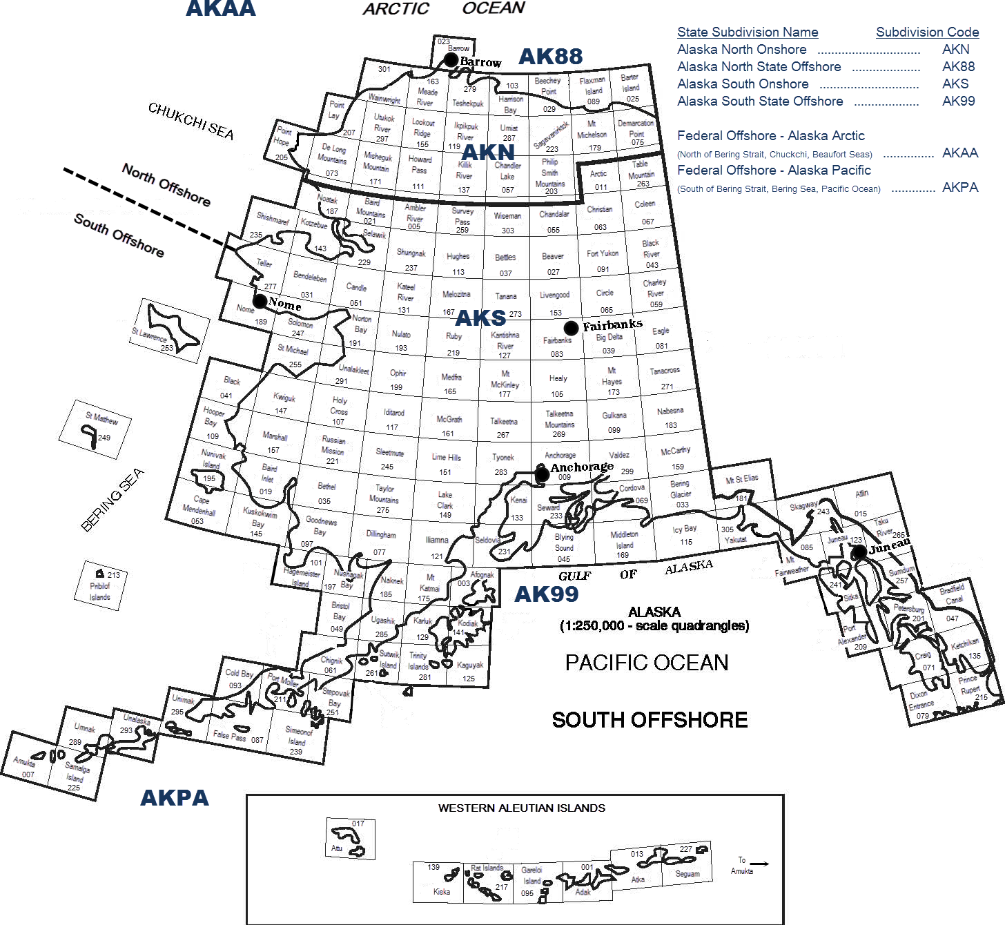

Alaska Subdivisions and U.S. Geological Survey Quadrangles
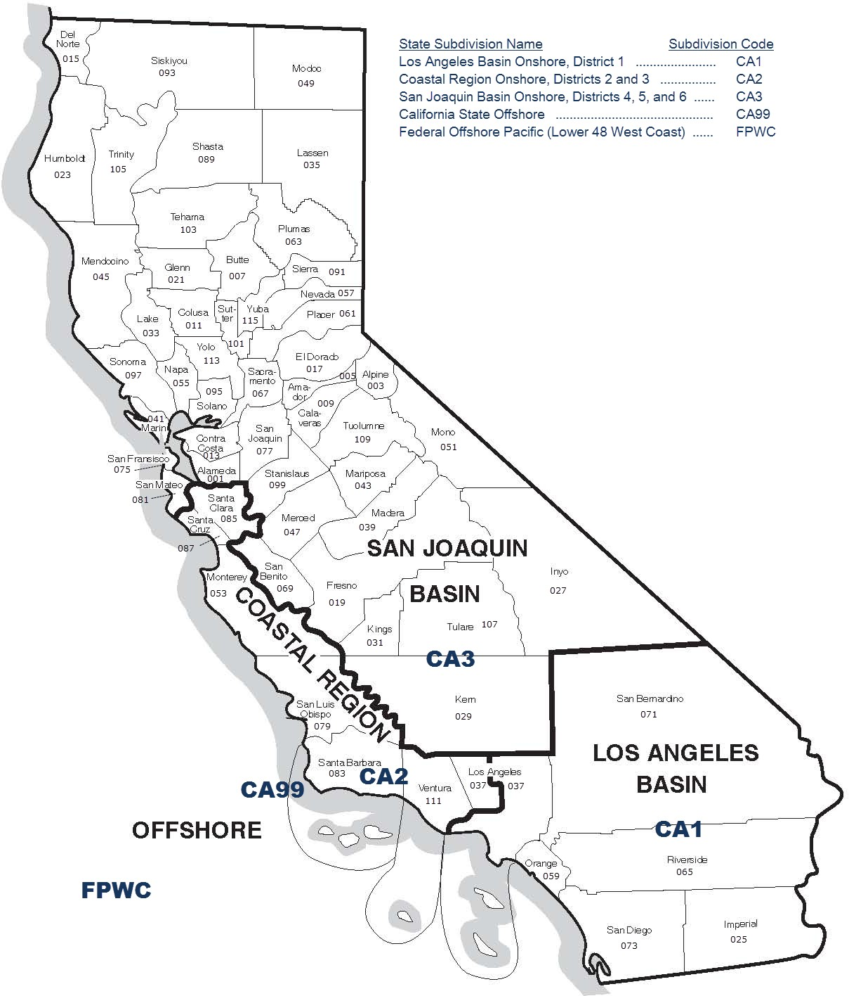

Source: Energy Information Administration, Office of Oil, Gas, and Coal Supply Statistics.

Subdivisions of California

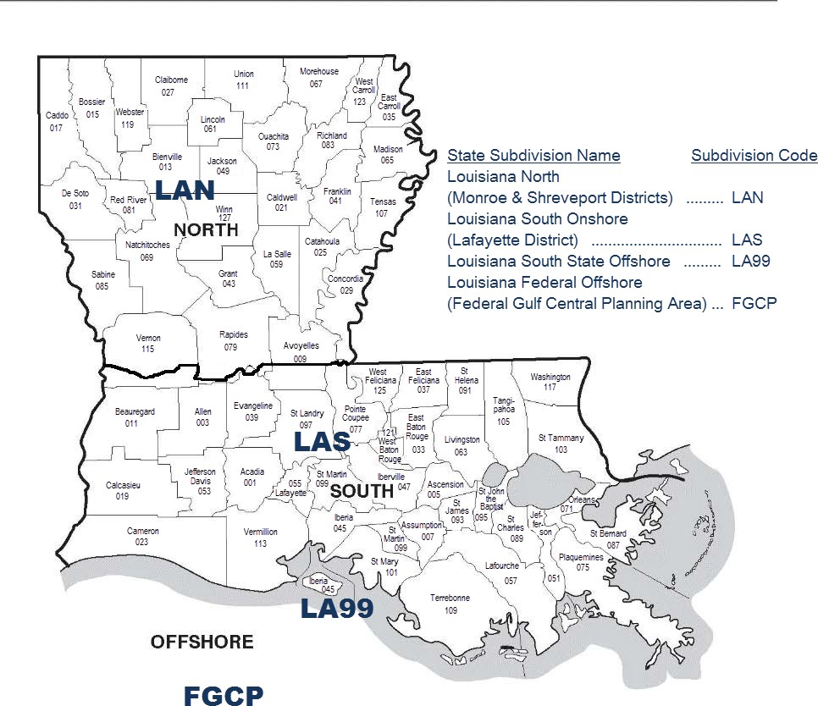

Source: Energy Information Administration, Office of Energy Statistics

Subdivisions of Louisiana

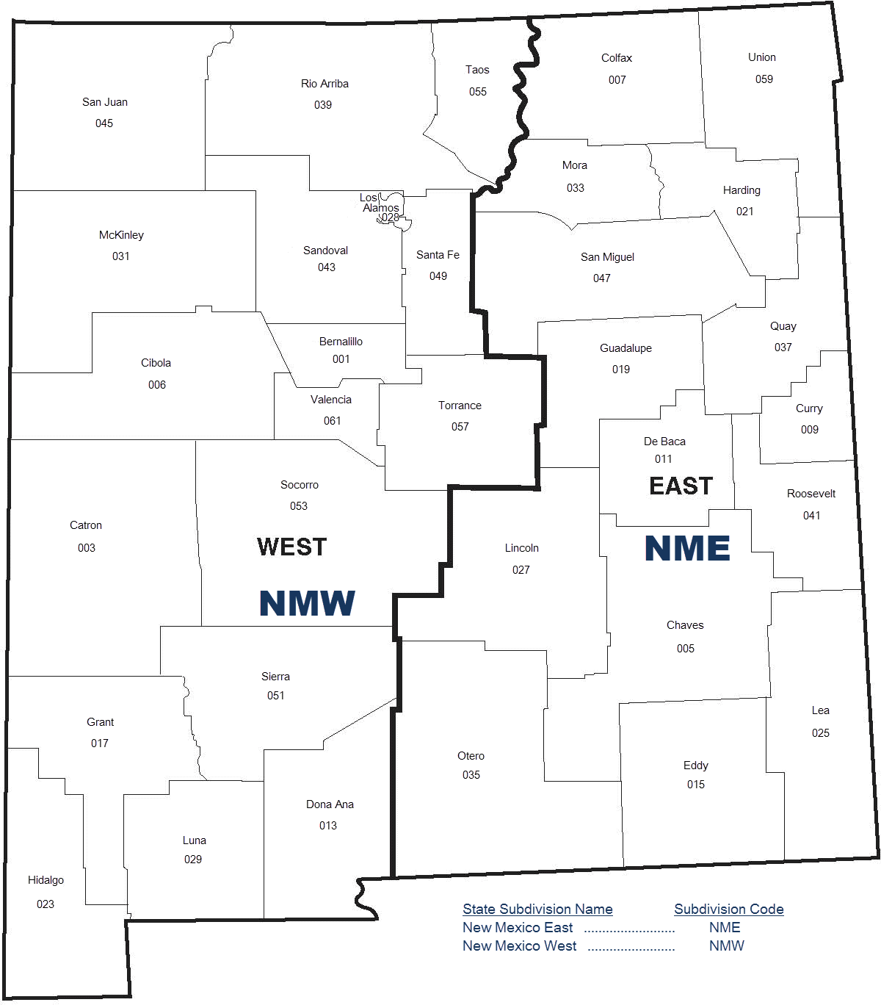

Source: Energy Information Administration, Office of Oil, Gas, and Coal Supply Statistics

Subdivisions of New Mexico

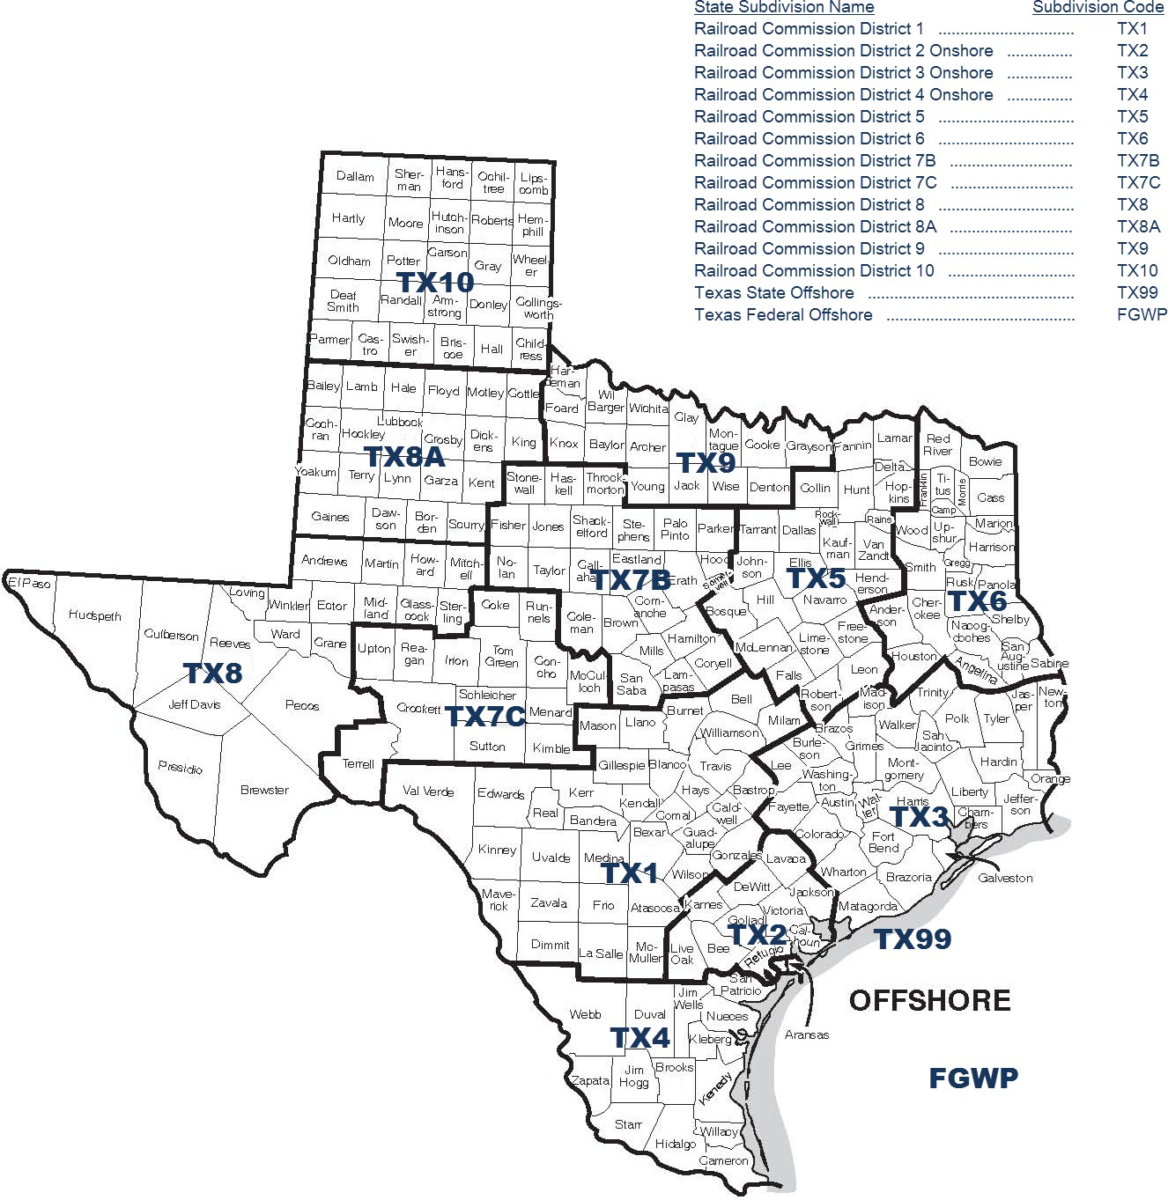

Subdivisions of Texas

Western Planning Area, Gulf of Mexico Outer Continental Shelf Region

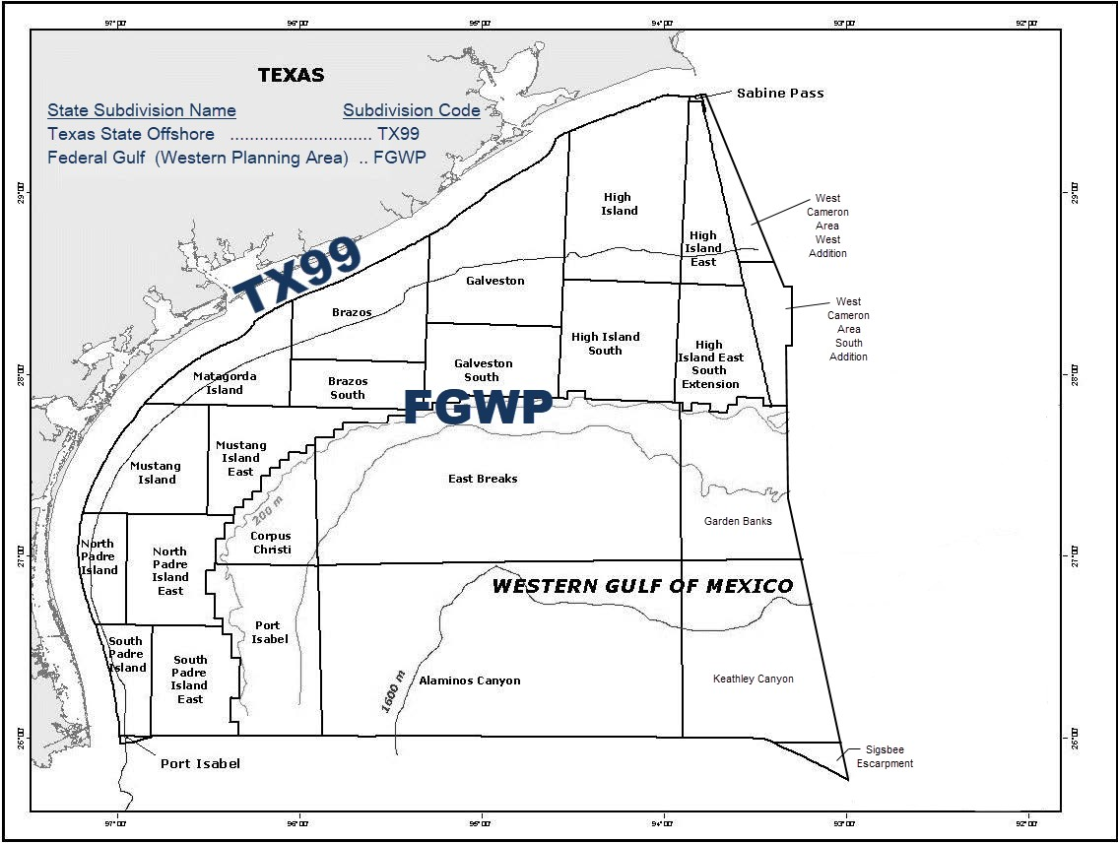
Source: U.S. Department of the Interior

Central Planning Area, Gulf of Mexico Outer Continental Shelf Region

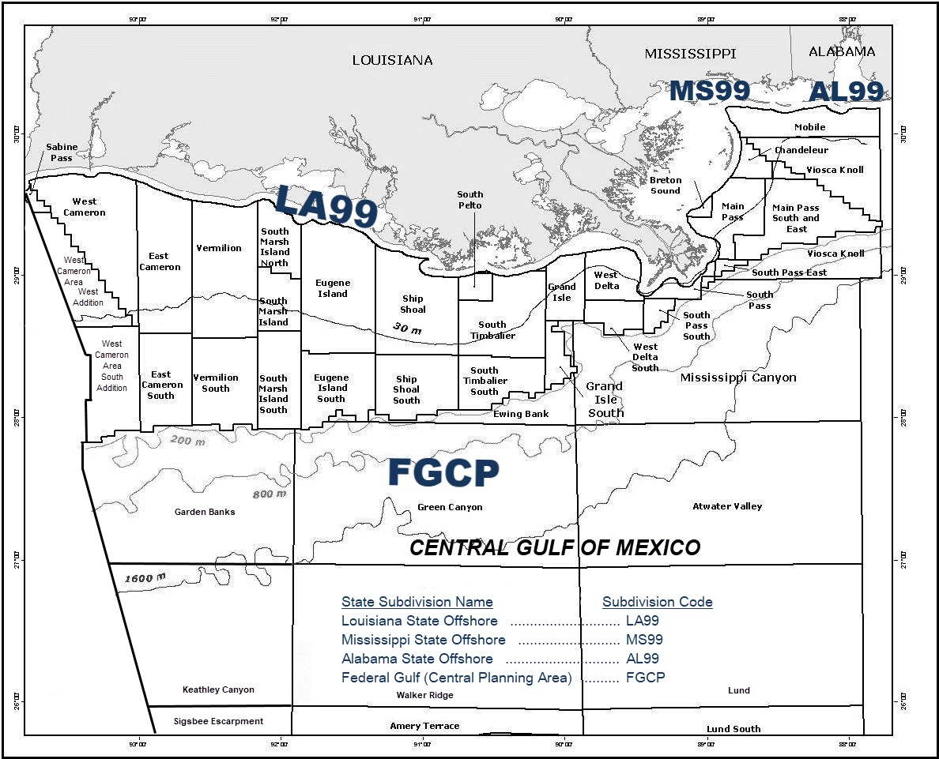
Source: U.S. Department of the Interior

Eastern Planning Area, Gulf of Mexico Outer Continental Shelf Region

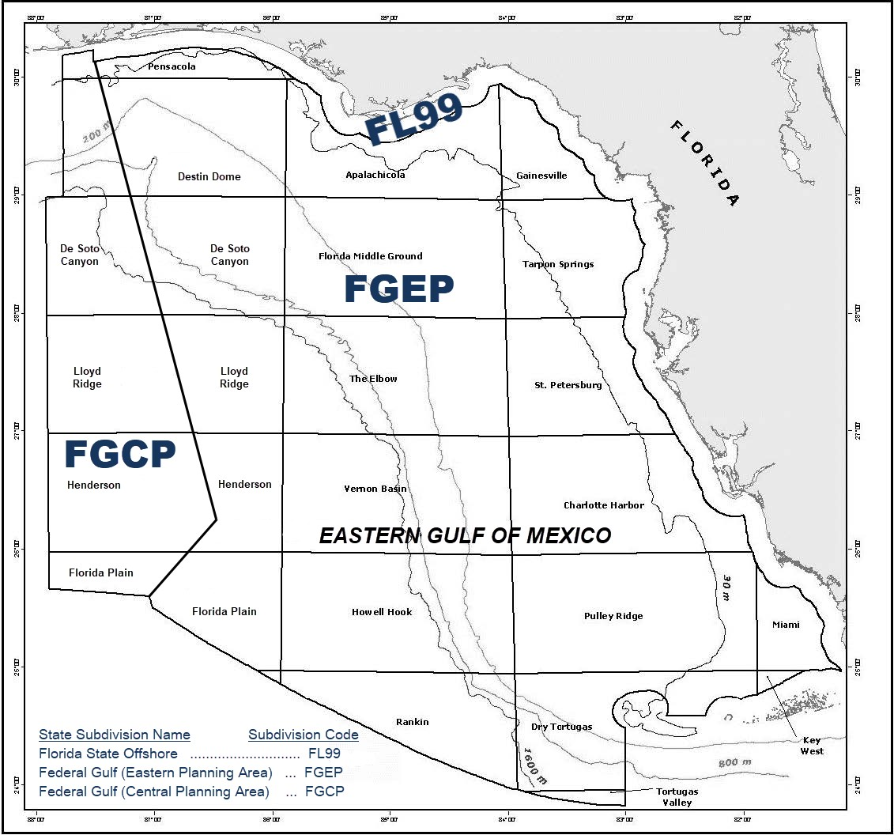
Source: U.S. Department of the Interior.

Energy Information Administration Secure File Transfer System
Welcome to EIA’s Secure File Transfer System. Following are the instructions for sending your Excel files to EIA by HTTPS.

  - Open your browser and type in the URL: https://signon.eia.doe.gov/upload/noticeoog.jsp
The Secure File Transfer Notice to Users page will come up.

  - If you wish to continue, press the Accept button with your mouse. The Secure File Transfer page will come up.

  - You may navigate through the boxes on the page either with the tab key or with your mouse.

  - Type your name, company name, phone number and email address into the boxes provided. Note that the email address is required so that we can send you a confirmation of the receipt of your data.

  - In the yellow box, select the Browse button after File 1.

  - A dialog box will come up which will allow you to find the file on your hard drive or other mapped drives. Select the file with a double mouse click (or single mouse click on the file and mouse click on the Open button). The name will appear in the white box on the Secure File Transfer page. (Note that you can type in the full path of the file if you wish, but there is a greater chance of making a mistake.)

  - If you have other files that you want to transfer, repeat steps 6 and 7 up to four more times.

  - If you want to start over with the file selection, select the Reset button.

  - If you are ready to submit your files, select the Submit button. Please be patient; it may take a minute or two to upload your files. Do not close your browser during the upload. Wait to see the confirmation page.

  - A confirmation page will be displayed that will tell you the names of the files you have transferred, the confirmation number for each file, and the date and time of the transfer.

  - If you have more files to transfer, select the Back to Secure Upload button to return to the Secure File Transfer page. Your contact information will remain, but the file section will be empty.

  - Repeat steps 6-10.

  - When you are finished, close your browser by clicking on the X in the upper right corner.

  - If you have any trouble transferring your files, please call the EIA-23L Coordinator at 800-879-1470.

About Transferring Files Securely with HTTPS:

EIA is ensuring the security of your transactions by using the latest Internet security technology. The technology being used to protect your data is encryption which is the scrambling of data into a code that is unreadable to anyone who does not have the key that deciphers it. The secure hypertext transfer protocol (HTTPS) is a communications protocol designed to transfer this encrypted information between computers over the World Wide Web. All information is protected by 128-bit encryption to maintain the privacy and confidentiality of your data. The only thing you need to take advantage of strong encryption technology is a secure browser, one that supports 128-bit encryption.

