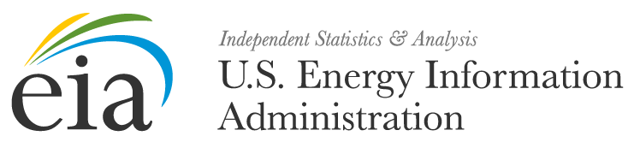
<MONTH, DAY, YEAR>
FROM: <OFFICE DIRECTOR>
OFFICE OF SURVEY OPERATIONS
SUBJECT: YOUR FORM EIA-23L SUBMISSION IS NOW LATE
REFERENCE: OMB NO. 1905-0057

Dear <CONTACT>,
The U.S. Energy Information Administration (EIA) has not yet received your Form EIA-23L submission for calendar year <REPORT YEAR>. Form EIA-23L was due to EIA no later than <DUE DATE>.
According to our records, you are the contact person responsible for:
Company Name Company ID
<COMPANY NAME> <COMPANY ID>
If you are not the person responsible for submitting data for Form EIA-23L, then please forward the Name, Email Address, and Phone number of the new preparer to EIA4USA@eia.gov.
Submission details can be found in the instructions or on the EIA-23L form.
The EIA-23L Form and Instructions can be downloaded at https://www.eia.gov/survey/#eia-23l.
It is recommended that you send your form electronically using Secure File Transfer to EIA.
Instructions to file your form using this method can be found in the form’s instructions.
The timely submission of Form EIA-23L by those required to report is mandatory under Title 15 U.S.C. §772(b), as amended. Failure to respond may result in a civil penalty of not more than $11,630 each day for each violation. The government may bring a civil action to prohibit reporting violations that may result in a temporary restraining order or a preliminary or permanent injunction without bond. In such civil action, the court may also issue mandatory injunctions commanding any person to comply with these reporting requirements.
If you have any questions, contact us directly at EIA4USA@eia.gov or call 1-855-EIA-4USA (1-855-342-4872) Monday through Friday, 8:00 AM - 6:00 PM ET.

