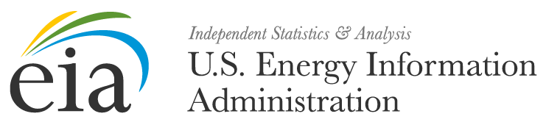
<MONTH, DAY, YEAR>
FROM: <OFFICE DIRECTOR>
OFFICE OF SURVEY OPERATIONS
SUBJECT: YOUR FORM EIA-64A SUBMISSION IS LATE
REFERENCE: OMB NO. 1905-0057

Dear <RESPONDENT NAME>,
The U.S. Energy Information Administration (EIA) has not yet received your Form EIA-64A submission for calendar year <REPORT YEAR>. The due date for your submission was <DUE DATE>.
According to our records, you are the person responsible for submitting data for:
Plant Name Plant ID Number
<PLANT NAME> <PLANT ID NUMBER>
If you are not the person responsible for submitting data for Form EIA-64A, then please forward the Name, Email Address, and Phone number of the new preparer to EIA4USA@eia.gov.
The EIA-64A Form and Instructions can be downloaded at https://www.eia.gov/survey/#eia-64a.
It is recommended that you send your form electronically using Secure File Transfer to EIA.
Instructions to file your form using this method can be found in the form’s instructions.
The timely submission of Form EIA-64A by those required to report is mandatory under Title 15 U.S.C. §772(b), as amended. Failure to respond may result in a civil penalty of not more than $11,630 each day for each violation. The government may bring a civil action to prohibit reporting violations that may result in a temporary restraining order or a preliminary or permanent injunction without bond. In such civil action, the court may also issue mandatory injunctions commanding any person to comply with these reporting requirements.
If you have any questions, contact us directly at EIA4USA@eia.gov or call 1-855-EIA-4USA (1-855-342-4872) Monday through Friday, 8:00 AM - 6:00 PM ET.

