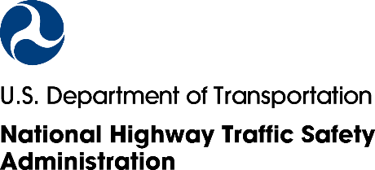
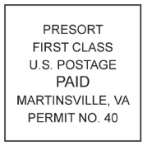
*12345678A* 12345678A
{CITY} Resident
{ADDRESS}
{CITY}, {ST} {ZIP}
***************AUTO**MIXED AADC 270
DDFAAAAATATFFATTDFDATATATTAFAAAFFAFFTTFFFDAFDFTFFFFFDFTFDAADAFTAA
1 1

We recently invited you to take part in a national survey about your personal transportation habits conducted by the National Highway Traffic Safety Administration (NHTSA).
Learning about your habits and opinions will help us make better decisions about important transportation topics that affect people like you every day.
You will get a ${“5”, “$10”} Amazon.com gift code for completing the survey.
If someone in your household has already completed the survey, thank you! If not, please follow these simple steps:
Step 1: Give this to the adult in your household with the next birthday
Step 2: Scan this code to go right to your survey
[QR CODE]
Step 2: Go to
www.USTransportationSurvey.com
Step 3: Enter this PIN: {12345678A}
OR

Thank you in advance for your help!
Sincerely,
Essie Wagner
Director, Office of Behavioral Safety Research, NHTSA
Para completar la encuesta en español, visite www.USTransportationSurvey.com
Questions? Please visit [FAQ URL]
NHTSA Form 1546

Para completar la encuesta en español, visite www.USTRAFFICSURVEY.com NHTSA
NHTSA Form 1546

NHTSA Form 1615

