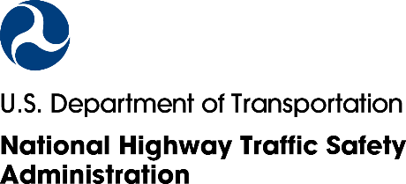
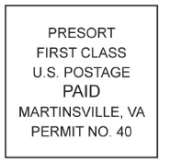
*12345678A* 12345678A
{CITY} Resident
{ADDRESS}
{CITY}, {ST} {ZIP}
***************AUTO**MIXED AADC 270
DDFAAAAATATFFATTDFDATATATTAFAAAFFAFFTTFFFDAFDFTFFFFFDFTFDAADAFTAA
1 1

We have tried to reach you about our National Highway Traffic Safety Administration (NHTSA) survey of personal transportation habits. Your household cannot be replaced! Please help represent people like you in this important study.
You will receive a ${“5”, “10”} Amazon.com gift code for completing the survey.
Thank you if you have already responded. If not, please follow these simple steps:
[QR CODE]
Online…
Step 2: Go to www.USTransportationSurvey.com
and enter {12345678A}
OR
Scan this code
Step 1: Give this to the adult in your household with the next birthday
By mail…
Step 2: Fill out the survey we mailed you
Step 3: Return it in the postage-paid envelope provided earlier

OR
Thank you in advance for your help!
Sincerely,
Essie Wagner
Director, Office of Behavioral Safety Research, NHTSA
NHTSA Form 1617
Para completar la encuesta en español, visite www.USTransportationSurvey.com
Questions? Please visit [FAQ URL]
NHTSA Form 1546

Para completar la encuesta en español, visite www.USTRAFFICSURVEY.com NHTSA
NHTSA Form 1546

