National Survey of Pedestrian and Bicyclist Attitudes and Behavior
Contents
Overall Comments 2
Landing Page 3
Frequently Asked Questions 4
Consent Statement 6
SECTION A: AGE SCREENER (2 Reg) 8
SECTION B: PRIMARY MODE (2 Reg) 8
SECTION C: PEDESTRIAN ACTIVITY (35 Reg; 8 grids; 3 images) 9
WALKING BEHAVIOR (10 Reg/3 Grid) 9
PEDESTRIAN FACILITIES USAGE (1 Reg, 1 Grid) 12
PEDESTRIAN CROSSING SIGNS & DEVICES (10 Reg/3 Images) 13
A. Pedestrian Hybrid Beacon 13
B. Rectangular Rapid Flashing Beacon (RRFB) 14
C. LED-embedded Sign 15
WALKING AT NIGHT & ILLUMINATION (1 Reg/1 Grid) 17
TECHNOLOGY (1 Reg, 1 Grid) 18
INJURIES (5 Reg) 18
THREATS (1 Grid) 20
CROSSWALKS AND SIDEWALKS (5 Reg) 21
IMPAIRMENT (2 Reg, 1 Grid) 22
SECTION D: BICYCLE ACTIVITY (42 Reg; 11 Grids; 9 images) 23
BICYCLE RIDING BEHAVIOR (10 Reg, 1 Grid) 23
BICYCLE FACILITY USAGE AND LEVEL OF COMFORT (1 Reg, 3 grids, 7 images) 27
COLLISIONS AND INJURIES (5 Reg) 31
RIDING AT NIGHT & ILLUMINATION (1 Reg; 1 Grid) 32
TECHNOLOGY (1 Reg, 1 Grid) 33
THREATS (3 Reg; 2 Grids) 34
COMMUNITY (2 Reg) 36
HELMETS AND LAWS (7 Reg, 1 Grid) 37
SAFETY TRAINING (5 Reg) 39
IMPAIRMENT (2 Reg;) 41
E-BIKES (2 Reg; 2 Images) 41
EMPATHY (3 Reg; 2 Grids) 42
SECTION E: E-SCOOTERS (5 Reg; 1 Grid; 1 Image) 44
SECTION F: CHILDREN WALKING/BIKING (7 Reg) 46
SECTION G: NEIGHBORHOOD CHARACTERISTICS (3 Reg/1 Grid) 48
SECTION H: DEMOGRAPHICS (14 Reg) 50
SECTION I: DISABILITY (6 Reg) 53

Overall Comments
- Public-facing survey name: National Survey of Personal Transportation
- URL: www.USTransportationSurvey.com
- Programming Note: On Mobile/web, display one question per screen with vertical response options.
- Current number of questions:
  - Regular: 116
  - Grid questions: 21
  - Images: 13
  - Other (Specify) responses: 9
  - This survey assumes a 16-page mail booklet

Landing Page

U.S. Department of Transportation
National Highway Traffic Safety Administration (NHTSA)

Welcome to the National Survey of Personal Transportation

As noted in the letter you received, please have the member of your household who is 18 years of age or older, AND has the next birthday complete the survey. This is a method of random selection.

To access the survey, please enter the PIN you received in your letter:

__________ Go to Survey

Haga clic aquí para Español

For assistance, please contact our Help Desk USTransportationSurvey@icfsurvey.com.
You can find answers to frequently asked questions here.

[Paperwork Reduction Act Burden Statement is displayed as separate HTML page when link is clicked]
Paperwork Reduction Act Burden Statement Under the Paperwork Reduction Act, a federal agency may not conduct or sponsor, and a person is not required to respond to, a collection of information subject to the requirements of the Paperwork Reduction Act unless that collection of information displays a current valid OMB Control Number. The OMB Control Number for this information collection is 2127-0684. The average amount of time to complete this survey is 20 minutes. All responses to this collection of information are voluntary. If you have comments regarding this burden estimate or any other aspect of this collection of information, including suggestions for reducing this burden, send them to: Information Collection Clearance Officer, National Highway Traffic Safety Administration, 1200 New Jersey Ave, SE, Washington, DC, 20590.
NHTSA Form 1148/1613.

Frequently Asked Questions

National Survey of Personal Transportation Safety – National Highway Traffic Safety Administration (NHTSA)

- Who is sponsoring this survey?

The National Highway Traffic Safety Administration (NHTSA) is sponsoring this survey. NHTSA is the agency within the U.S. Department of Transportation responsible for reducing deaths and injuries resulting from motor vehicle crashes. NHTSA has contracted with ICF, an independent research firm, to conduct the survey.

- Why are you doing this survey?

NHTSA is sponsoring this survey to better understand the transportation habits and opinions of people living in the United States.

- How will my information be used? Will my privacy be protected?

Results from this survey will help inform safety initiatives and improve transportation safety. Keep in mind that any survey results shared with the public will be presented in group form and cannot be traced back to you.

- How did you get my address?

Your household was randomly selected from a list of residential addresses in the United States. Your participation will help represent your community.

- Why should I participate?

Participating in the National Survey of Personal Transportation helps NHTSA, communities, researchers, policymakers, and others better understand and respond to the transportation safety needs of the public. Your response also helps provide information for important safety initiatives in your community and across the country.

- I don’t drive. Should I still participate?

Yes! We want to hear from you no matter what type of transportation you use, whether you drive, walk, bike, take the bus or subway, or use some other type of transportation.

- Do I have to participate?

No, but your participation is very important because each person who answers the survey represents thousands of others. Not participating in the survey may mean that you and your community will not be represented in the results. Many people find the survey to be interesting and enjoyable. You may choose not to answer any question for any reason.

- Who should complete the survey?

The person in your household who is 18 years or older with the next birthday has been selected to complete this survey. This is a method of random selection and is important to make sure that the experiences of all types of people are represented.

- How long will the survey take?

It should take approximately 20 minutes to complete.

- Has this study been approved by Office of Management and Budget (OMB)?

The OMB control number for this study is 2127-0684.

- Who should I contact with questions?

Please direct any additional questions to USTransportationSurvey@icfsurvey.com or dial TBD.

Consent Statement
[DISPLAY IF RESPONDENT ENTERED THROUGH PERSONALIZED QR CODE]
U.S. Department of Transportation
National Highway Traffic Safety Administration (NHTSA)

Welcome to the National Survey of Personal Transportation

As noted in the letter you received, please have the member of your household who is 18 years of age or older AND has the next birthday complete the survey. This is a method of random selection.
[DISPLAY FOR ALL RESPONDENTS]
Thank you for participating in the National Survey of Personal Transportation. The information you share will help the National Highway Traffic Safety Administration improve the lives of people across the country. Your household was randomly selected for this survey. To protect your privacy, your answers will be confidential and combined with answers from all other participants in any reports. The survey will take about 20 minutes. You do not need to gather any records to answer the questions – your best guess is OK. Participation in this survey is voluntary.
[IF WEB]
If you are eligible to participate, you will receive a $[IF INCENT=1 INSERT “5”][IF INCENT=2, INSERT “10”] Amazon gift code immediately after completing and submitting the questionnaire, in appreciation for your participation.
[IF MAIL]
If you are eligible to participate, a $[IF INCENT=1 INSERT “5”][IF INCENT=2, INSERT “10”] Amazon gift code will be mailed to this address about a month after the completed questionnaire has been received.
[FOOTER FOR CONSENT STATEMENT PAGE:]
For assistance, please contact our Help Desk USTransportationSurvey@icfsurvey.com.
You can find answers to frequently asked questions here.
[Paperwork Reduction Act Burden Statement is displayed as separate HTML page when link is clicked]
Paperwork Reduction Act Burden Statement Under the Paperwork Reduction Act, a federal agency may not conduct or sponsor, and a person is not required to respond to, a collection of information subject to the requirements of the Paperwork Reduction Act unless that collection of information displays a current valid OMB Control Number. The OMB Control Number for this information collection is 2127-0684. The average amount of time to complete this survey is 20 minutes. All responses to this collection of information are voluntary. If you have comments regarding this burden estimate or any other aspect of this collection of information, including suggestions for reducing this burden, send them to: Information Collection Clearance Officer, National Highway Traffic Safety Administration, 1200 New Jersey Ave, SE, Washington, DC, 20590.
NHTSA Form 1148/1613.

SECTION A: AGE SCREENER (2 Reg)
First, we have a few general questions about you and how you get around.
A1. What is your age?
- 18 years of age or older
- 17 years of age or younger
[ASK if A1=02]
A2. Is there anyone living in this household who is 18 years of age or older?
- Yes
- No

SECTION B: PRIMARY MODE (2 Reg)
[ASK ALL]
B1. What is your primary mode of transportation? By primary, we mean the way you get around most often.
- Personal vehicle, cab, or ridesharing service (e.g., Uber, Lyft)
- Public transportation
- Walking
- Biking
- Motorcycle
- Other

- I have no primary mode of transportation
[ASK If B1 = 03, 04]
B2. Why is this your primary mode of transportation? Select all that apply.
- Personal preference
- Most convenient option
- Cost concerns/affordability
- No personal vehicle available
- No public transportation options available
- Better for the environment
- Increase exercise

- Other (Specify)

SECTION C: PEDESTRIAN ACTIVITY (35 Reg; 8 grids; 3 images)

WALKING BEHAVIOR (10 Reg/3 Grid)
This next section asks about your experiences walking around outside. Please include any outdoor walking, jogging, or running that lasts more than 5 minutes. If you use a wheelchair, walker, or other assistive device, please include times when you used it to get around outside for more than 5 minutes.
[ASK ALL]
C1. When was the last time you walked, jogged or ran outside, on a road, street, sidewalk, or trail for more than 5 minutes? (2012 #51, open-ended with codes)
- Within the past week
- Within the past month, but not the past week
- Within the past year, but not the past month
- 1-2 years ago
- 3-5 years ago
- More than 5 years ago
- Never
[ASK All]
C2. How much do you agree or disagree with the following statement?
I would like to walk more than I do now.
(2012 #86 option A – modified to follow Prof. Dill’s bicyclist Typology scale; No “Don’t know” option.)
- Strongly agree
- Somewhat agree
- Somewhat disagree
- Strongly disagree
[ASK IF C1= 04, 05, 06, 07, ie R last walked more than a year ago]
[PROGRAMMING NOTE: Randomize order of response options other than 07 – Other for each respondent]
C3. Below are some common reasons people don’t walk, jog, or run outside at all or may have stopped. Which of these reasons apply to you? Select all that apply. (New – Mirrors bike equivalent 2012 #3; equivalent of 2012 # 87 – was not read)
- I’ve been too busy, or had no opportunity to walk
- There is no safe place to walk near me
- Inadequate lighting to walk at night
- I have a disability or other health impairment
- Other transportation options are faster
- No interest/I don’t like to walk
- Some other reason (specify)
- IF YOU’VE WALKED OUTSIDE FOR MORE THAN FIVE MINUTES IN THE LAST YEAR, CONTINUE BELOW.
- IF YOU HAVEN’T WALKED OUTSIDE IN THE LAST YEAR (C1 = 04, 05, 06), SKIP TO THREATS.
- IF YOU’VE NEVER WALKED (C1 = 07), SKIP TO THE BIKING SECTION.

[ASK IF C1= 01, 02, 03, ie walked in the past year]
C4. On average, how often do you walk, jog, or run outside for more than 5 minutes? (2012 #52 – Modified: 30-day timeframe removed and changed to frequency scale instead of number of days; was previously open-ended)
- Daily
- Four to six times a week
- Two to three times a week
- Once a week
- A few times a month
- Once a month or less
[ASK IF C1= 01, 02, 03]
C5. Do you typically walk, run, or jog more on the weekdays or the weekend? (Modification of 2012 #53 – asking generally rather than specific occasion)
- Weekday (Monday – Friday)
- Weekend (Saturday or Sunday)
- Equally between weekday and weekend
[ASK IF C1= 01, 02, 03]
C6. During what time of day do you walk, jog, or run outside the most? (New – Request from Ruth)
- Morning, before sunrise
- Morning, after sunrise but before noon
- Afternoon
- Evening, before sunset
- Evening, after sunset
- Nighttime
[ASK IF C1= 01, 02, 03]
C7. How often do you walk, run, or jog outdoors in the following seasons?
 | Frequently | Sometimes | Seldom | Never
Winter
Spring
Summer
Fall

[ASK IF C1= 01, 02, 03]
C8. On a typical day during the months that you walk, about how long do you walk? Don’t count any stops – just the average amount of time you walk. (New - Ped equivalent of Bike version 2012 #28-29)
____ Hours _____Minutes
[ASK IF C1= 01, 02, 03]
C10. Compared to about a year ago, would you say you are now walking more often, less often or about the same amount? (2012 #73)
- More often
- Same amount
- Less often
[ASK IF C1= 01, 02, 03]
C11. What are the main reasons you walk? Select all that apply. (2012 #55, – WAS NOT READ – General question as opposed to specific trip loop. Some options removed, combined)
- Commuting to/from work
- Commuting to/from school
- Recreation or pleasure
- Exercise/for my health
- Personal errands (to/from the store, post office, and so on)
- Required for my job
- Drop off/Pick up someone, including children at school
- Visit a friend or relative
- Walk the dog
- Some other reason (specify)
[ASK IF C1= 01, 02, 03]
C12. How often do you walk, jog, or run with others compared to walking alone? (Expanded version of 2012 #64)
 | Always with others | More often with others | Equally with others and alone | More often alone | Always alone | Not applicable
- Walk
- Run or jog

PEDESTRIAN FACILITIES USAGE (1 Reg, 1 Grid)
[ASK IF C1= 01, 02, 03]
C13. When you walk, jog, or run, how often do you use the following type of path or road? (2012 #62 – Added frequency scale)
 | Always | Frequently | Sometimes | Seldom | Never | Not available
- Sidewalks
- Shoulders of paved roads
- Paved roads, not on shoulder
- Bike paths, walking paths, or trails
- Unpaved roads (e.g., dirt, gravel, sand)
- Grass or fields next to road

[ASK IF C13A = 02, 03, 04, 05 (Doesn’t always use sidewalks)]
C14. What is the main reason that you don’t always use sidewalks? (2012 #77, was not read, added one option based on 2012 answer)
- Not in good repair
- Don't go where I need to go
- Too crowded
- Prefer softer surface
- Don't feel safe
- Other (specify)

PEDESTRIAN CROSSING SIGNS & DEVICES (10 Reg/3 Images)
[ASK IF C1= 01, 02, 03]
[PROGRAMMING NOTE: The next 3 screens will need to be randomized for each respondent. Each image should be followed by the three questions listed below.]

Pedestrian Hybrid Beacon
Shown below is a traffic control device designed to help pedestrians cross busy roadways at crossings and intersections without traffic signals. When the pedestrian wishes to cross, they press a button. The overhead lights flash red to tell motorists to stop and the pedestrian signal flashes a WALK display.
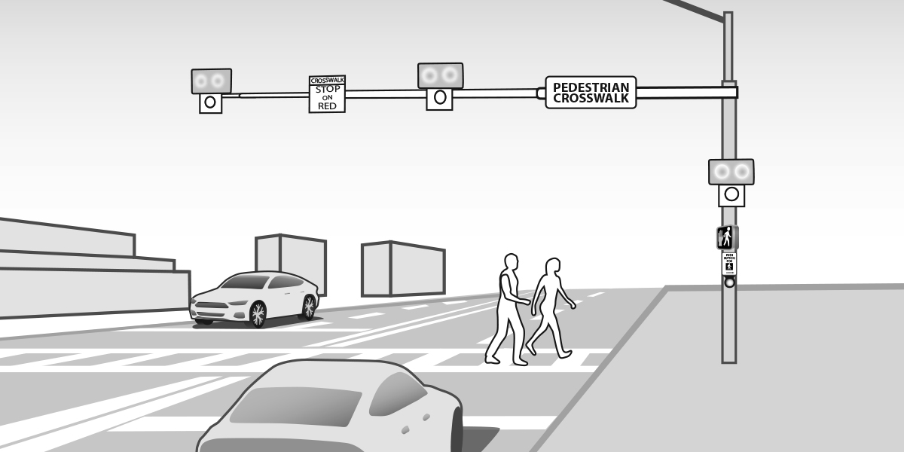

Rectangular Rapid Flashing Beacon (RRFB)
Shown below is another type of pedestrian-warning sign for crossings without traffic signals. The lights on the sign are turned on when a pedestrian pushes a button or when the device senses that a pedestrian is nearby. The lights flash very quickly to alert motorists to pedestrians attempting to cross.
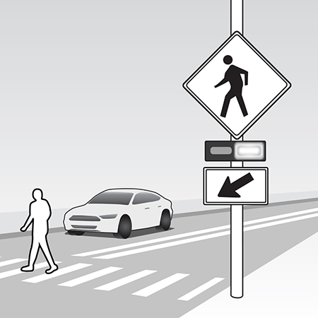

LED-embedded Sign
Shown below is another type of pedestrian-warning sign for crossings without traffic signals. Bright LED-lights around the edges of the sign are turned on when a pedestrian pushes a button or when the device senses that a pedestrian is nearby. The lights make the sign more visible to motorists.
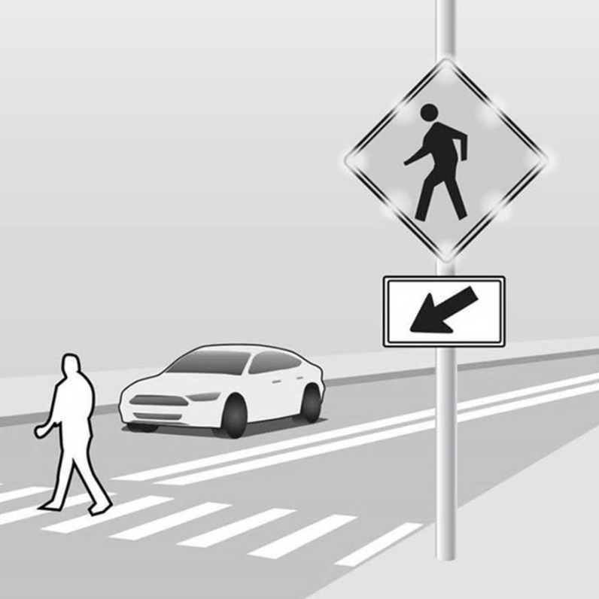

C15. Have you ever used this type of crossing? (New)
- Yes
- No
- Not sure

[ASK IF C15 = Yes]
[PROGRAMMING NOTE: R should receive the two follow-up questions below while still on the same screen as the image above.]
C16. Did you feel it increased your safety while crossing the street? (New)
- Yes
- No
- Not Sure

[Ask All]
C17. Regardless of whether or not you’ve used this type of crossing, would you ever go out of your way or change your route to use it if it was available? (New, added for consistency with bike series Part C)
- Yes
- No
[ASK IF C3 NE 6]
C18. When you are walking, jogging, or running on a roadway without a sidewalk, do you usually position yourself . . . (2012 #63)
- Facing traffic, that is, walking, jogging, or running against the direction of the cars
- With traffic, that is, walking, jogging, or running in the same direction as the cars
- Depends on the situation
- I never walk in the road

WALKING AT NIGHT & ILLUMINATION (1 Reg/1 Grid)
[ASK IF C1= 01, 02, 03]
C19. During the past year, how much of your walking was done when it was dark or nearly dark outside? (2012 #68)
- Nearly all
- More than half
- About half
- Some
- Almost none
- None
[ASK IF C19 = (01, 02, 03, 04)]
C20. When you walk, jog, or run after dark, how often do you do any of the following to make yourself more visible? (2012 #70 – Added frequency scale)
 | Always | Frequently | Sometimes | Seldom | Never
- Wear light colored clothing
- Wear fluorescent or reflective clothing/Shoes
- Wear or carry a flashlight
- Walk only in well-lit areas

TECHNOLOGY (1 Reg, 1 Grid)
[ASK IF C1= 01, 02, 03]
C21. Do you use a pedometer or other activity tracking device (e.g., FitBit, Cell phone app) to track your physical activity? (New)
- Yes
- No
[ASK IF C1= 01, 02, 03]
C22. How often do you do any of the following with your cell phone or other electronic device while walking, jogging, or running outside? (New)
 | Always | Frequently | Sometimes | Seldom | Never
- Talking or calling
- Listening to music or audio
- Reading or scrolling
- Texting or typing
- Using a navigation app
- Using a fitness app

INJURIES (5 Reg)
[ASK IF C1= 01, 02, 03]
C23. In the past 12 months, were you ever injured while you were walking, running, or jogging outside? (Variation of 2012 #78; modified to one-year timeframe; modified to also include minor injuries)
- Yes =>Enter number (enter zero if none)
- No
[ASK IF C23> 0]
C24. What kind of medical attention did you need for your most recent injury? (New)
- Emergency room visit
- Non-emergency doctor visit
- Treated at home
- No treatment needed
[ASK IF C23> 0]
C25. What was the cause of this injury? (2012 #79-80 – Was completely open-ended)
- Incident with a motorist (e.g., driver of car, motorcycle, truck)
- Incident with a bicyclist
- Incident with e-scooter rider
- Incident with a pedestrian
- Incident with an animal
- Icy or wet pavement
- Uneven pavement
- Walked or ran into fixed object
- Other
[ASK IF C25 = 01]
C26. Was the incident with the motorist reported to the police?
- Yes
- No
[ASK IF C23 > 0]
C27. Was distraction from a cell phone a factor in the cause of the injury? (New)
- Yes, I was distracted
- Yes, the other person involved was distracted
- Yes, both the other person and I were distracted
- No, distraction was not a factor
- I don’t know

THREATS (1 Grid)
[ASK IF C1= 01, 02, 03, 04, 05, 06 – Walkers from over a year ago skip here]
C28. Below is a list of situations that can make walkers, joggers, and runners feel threatened for their personal safety. Have you ever felt threatened for your personal safety when you are walking, jogging, or running outside because of any of the following? (2012 #66-67)
(Mark “Yes” if you have ever felt threatened by a situation. Mark “No” if you have never felt threatened by a situation)
 | Yes | No
- Motorist (e.g., driver of car, motorcycle, truck) cutting me off
- Motorist entering intersection without looking
- Motorist driving very close to me
- Motorist honking at me
- Motorist almost hitting me
- Motorist driving very fast
- Motorist using a cell phone while driving
- Path too close to motor vehicle traffic
- Path crowded with non-motorists (bicyclists, pedestrians, etc.) competing for space
- Dogs or other animals
- Obstacles blocking the path (e.g., parked vehicles, trash cans)
- Poorly maintained paths or roadway surfaces (e.g., cracks, potholes, broken glass)
- Poorly lit path
- Potential for physical assault
- Potential for robbery

CROSSWALKS AND SIDEWALKS (5 Reg)
[ASK IF C1= 01, 02, 03, 04, 05, 06]
C29. Do drivers in your community usually yield to pedestrians in crosswalks? (2012 #85)
- Yes
- No
[ASK IF C1= 01, 02, 03, 04, 05, 06]
C30. Are there sidewalks in your neighborhood… (2012 #74)
- Along almost all streets
- Along most streets
- Along some streets
- Along no streets [Skip ahead to C32]
[ASK IF C1 = 01, 02, 03, 04, 05, 06 AND C29 = 01, 02, 03]
C31. In what condition are these sidewalks? Are they in excellent, good, fair, or poor condition? (2012 #75)
- Excellent
- Good
- Fair
- Poor
[ASK IF C1= 01, 02, 03, 04, 05, 06]
C32. How satisfied are you with how your local community is designed for making walking safe? Are you . . . ? (2012 #81)
- Very satisfied
- Somewhat satisfied
- Neither satisfied nor dissatisfied
- Somewhat dissatisfied
- Very dissatisfied
[ASK IF C1= 01, 02, 03, 04, 05, 06]
C33. What changes, if any, would you like to see your local government make in your community for pedestrians? Select all that apply. (2012 #82 – was not read, added one option based on 2012)
- More crosswalks
- More sidewalks
- More pedestrian paths or trails
- Sidewalk/walkway improvements
- More lights on streets
- More lights on paths/trails
- Other (specify)
- None, can’t think of any

IMPAIRMENT (2 Reg, 1 Grid)
[ASK IF C1= 01, 02, 03, 04, 05, 06]
C34. Have you ever walked along a public street while impaired due to drinking alcohol or using substances?
- Yes
- No
[ASK IF C34= 01]
C35. Why have you walked along a public street while impaired due to drinking alcohol or using substances? Select all that apply.
- Too impaired to drive
- Walked to vehicle or transit a distance away
- No public transit available
- Couldn’t afford public transit
- No taxi or ridehailing service available
- Couldn’t afford a taxi or ridehailing service
- Didn’t have the option to ask for a ride from a friend or family member
- Don’t have a driver’s license
- Trip was short enough that I could manage it safely
- Other

[ASK IF C1 = (01, 02, 03, 04, 05, 06)]
C36. If you were too impaired to drive due to drinking or using substances, couldn’t use public transit, and had to travel several miles, how likely would you be to choose the following options? (New)
 | Very likely | Somewhat likely | Somewhat unlikely | Very unlikely
- Ask a friend or family member to drive me
- Call a cab or ridesharing service (e.g., Uber, Lyft)
- Ride a bike
- Walk
- Other (e.g., e-scooter)

SECTION D: BICYCLE ACTIVITY (42 Reg; 11 Grids; 9 images)

BICYCLE RIDING BEHAVIOR (10 Reg, 1 Grid)
Now we have some questions about your bicycling habits. We want to hear from you even if you don’t ride a bike very often. If you use any type of assistive device to ride a bicycle, please count that as riding.
[ASK All]
D1. When was the last time you rode a bicycle on a road, street, sidewalk, or trail? Do not include stationary bikes. (2012 #1)
- Within the past week
- Within the past month, but not the past week
- Within the past year, but not the past month
- 1-2 years ago
- 3-5 years ago
- More than 5 years ago
- Never
[ASK All]
D2. How much do you agree or disagree with the following statement?
I would like to travel by bike more than I do now.
(2012 #86 option B – modified to follow Prof. Dill’s bicyclist wording and typology scale; No “Don’t know” option.)
- Strongly agree
- Somewhat agree
- Somewhat disagree
- Strongly disagree
[ASK IF D1 = (04, 05, 06, 07 ie R last rode bike more than 1 year ago)
[PROGRAMMING NOTE: Randomize order of response options other than 10 (some other reason) for each respondent]
D3. Below are some common reasons people don’t ride a bicycle or may have stopped. Which of these reasons apply to you? Select all that apply. (2012 #3 – Was not read. Question reworded and answer options expanded for clarity. “I don’t have a bicycle available” option added here instead of being standalone question [was #2 in 2012])
- I don’t own a bicycle or have one available to use
- I’ve been too busy
- My bike is broken
- There is no safe place to ride near me
- I have a disability or other health impairment
- Other transportation options are faster
- No interest
- I don’t know how to ride a bike
- Some other reason (specify)
- IF YOU’VE RIDDEN A BICYCLE IN THE LAST YEAR, CONTINUE BELOW.
- IF YOU’VE RIDDEN A BICYCLE MORE THAN 1 YEAR AGO (D1 = 04, 05, 06), SKIP TO THE THREATS SECTION.
- IF YOU’VE NEVER RIDDEN A BICYCLE, SKIP TO EMPATHY.

[ASK If D1 = 01, 02, 03, ie R has ridden in the past year]
D4. On average, how often do you ride? (2012 #4 and #27 – Adjusted after removing trip loop – Specific timeframe removed; was previously open-ended)
- Daily
- Four to six times a week
- Two to three times a week
- Once a week
- A few times a month
- Once a month or less

[ASK IF D1 = 01, 02, 03]
D5. Do you typically ride more on the weekdays or the weekend? (2012 #5, Modified to no longer ask about specific occasion, now that trip loop has been removed)
- Weekday (Monday – Friday)
- Weekend (Saturday or Sunday)
- Equally between weekday and weekend

[ASK IF D1= 01, 02, 03]
D6. During what time of day do you ride the most? (New – Equivalent of ped question which was a request from Ruth)
- Morning, before sunrise
- Morning, after sunrise but before noon
- Afternoon
- Evening, before sunset
- Evening, after sunset
- Nighttime

[ASK IF D1= 01, 02, 03]
D7. How often do you ride a bike outdoors in the following seasons?
 | Frequently | Sometimes | Seldom | Never
Winter
Spring
Summer
Fall

[ASK IF D1 = (01, 02, 03)]
D8. On a typical day that you ride a bicycle, about how long do you ride? Don’t count any stops – just the average amount of time you travel on your bike. (COMBINES 2012 #28-29)
____ Hours _____Minutes
[ASK IF D1 = (01, 02, 03)]
D9. Compared to about a year ago, would you say you are now riding a bike more often, less often or about the same amount? (2012 #30)
- More often
- Same amount
- Less often
[PROGRAMMING NOTE: Randomize order of response options other than 08 for each respondent]
[ASK IF D1 = (01, 02, 03)]
D10. What are the main reasons you ride a bike? Select all that apply. (2012 #7 – WAS NOT READ – General question as opposed to specific trip loop. Some options removed, combined)
- Commuting to/from work
- Commuting to/from school
- Recreation or pleasure
- Exercise/For My Health
- Personal Errands (to/from the store, post office, and so on)
- Required for my job
- Visit a friend or relative
- Some other reason (specify)
[ASK IF D1 = 01, 02, 03]
D11. How often do you ride with others compared to riding alone? (2012 #16 – Modified by adding frequency scale and removing timeframe)
- Always with others
- More often with others
- Equally with others and alone
- More often alone
- Always alone

BICYCLE FACILITY USAGE AND LEVEL OF COMFORT (1 Reg, 3 grids, 7 images)
[ASK IF D1 = (01, 02, 03)]
D12. Are bike lanes, that is, marked lanes on a public road reserved for bikes to travel, available within a quarter mile, or about 3 blocks, from where you live? (2012 #34)
- Yes
- No
- Don’t know
[ASK IF D1 = (01, 02, 03)]
D13. How comfortable or uncomfortable would you feel biking in the following places?
 | Very Comfortable | Somewhat Comfortable | Somewhat Uncomfortable | Very Uncomfortable
A path or trail separate from the street
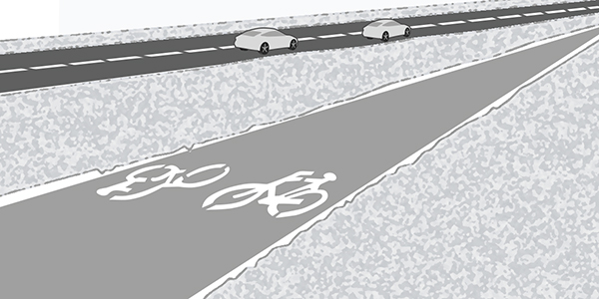
A quiet residential street with traffic traveling at speeds of 20-25 miles per hour
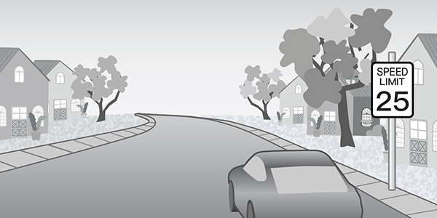
A quiet residential street with traffic traveling at speeds of 20-25 miles per hour that also has bicycle route markings, wide speed humps, and other things to discourage and slow down car traffic
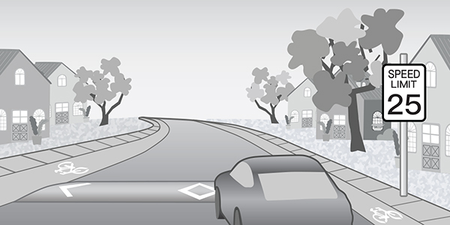
A major urban or suburban street with four lanes, on-street parking, traffic speeds of 30-35 miles per hour and no bike lane
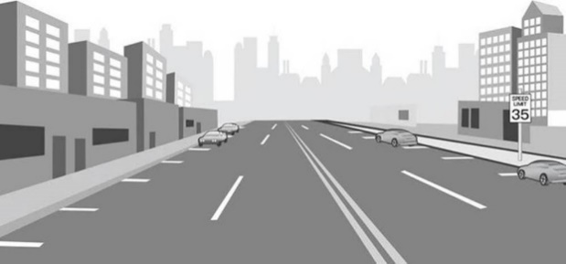
A major urban or suburban street with four lanes, on-street parking, traffic speeds of 30-35 per hour and a striped bike lane
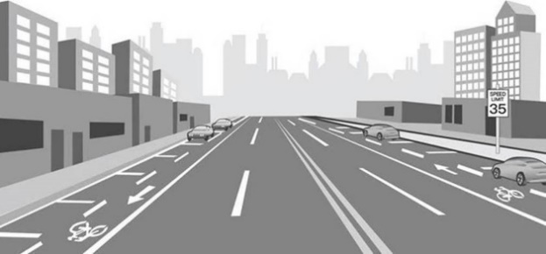
A major urban or suburban street with four lanes, on-street parking, traffic speeds of 30-35 miles per hour and a wide bike lane physically separated from traffic by a raised curb, planters, or parked cars
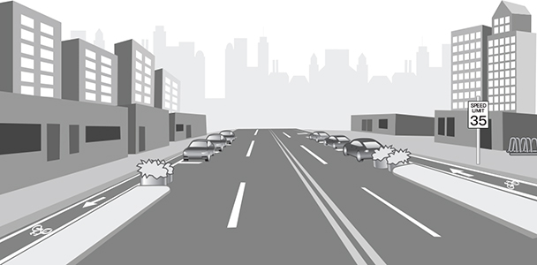
A rural or country road with infrequent traffic
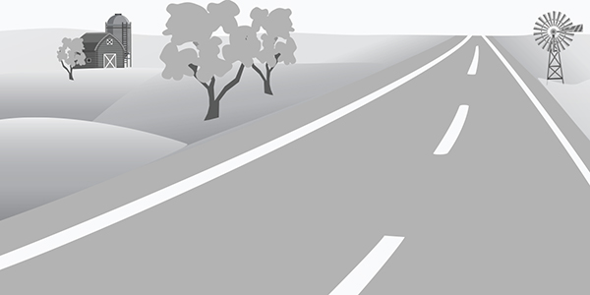

[ASK IF D1 = (01, 02, 03)]
D14.When you bike, how often do you use the following …?
(2012 #14, modified options and added frequency scale)
 | Always | Frequently | Sometimes | Seldom | Never | Not available
- Bike lanes separated from traffic (e.g., by a physical barrier or buffer zone)

- Bike lanes not separated from traffic
- Shoulders or breakdown lanes of paved roads
- Paved roads, sharing the main travel lane with motorists
- Bike paths, walking paths, or trails
- Unpaved roads (e.g., dirt, gravel, sand)
- Sidewalks
[ASK IF D14 = (01, 02, 03, 04)]
D15. Regardless of whether or not you’ve used any of these facilities, would you ever go out of your way or change your route to bike on them if they were available? (New)
 | Yes | No
- Bike lanes separated from traffic (e.g., by a physical barrier or buffer zone)
- Bike lanes not separated from traffic
- Shoulders or breakdown lanes of paved roads
- Paved roads, sharing the main travel lane with motorists
- Bike paths, walking paths, or trails
- Unpaved roads (e.g., dirt, gravel, sand)
- Sidewalks

COLLISIONS AND INJURIES (5 Reg)
[ASK IF D1 = (01, 02, 03)]
D16. In the past 12 months, were you ever injured while you were riding a bike? (Variation of 2012 #38; modified to one-year timeframe; modified to also include minor injuries)
- Yes =>Enter number (enter zero if none)
- No
[ASK IF D16 > 0]
D17. What kind of medical attention did you need for your most recent injury? (New)
- Emergency room visit
- Non-emergency doctor visit
- Treated at home
- No treatment needed
[ASK IF D16 > 0]
D18. What was the cause of this injury? (2012 #39-40; 40 was previously completely open-ended)
- Incident with motorist (e.g., driver of car, motorcycle, truck)
- Incident with another bicyclist
- Incident with e-scooter rider
- Incident with a pedestrian
- Incident with an animal
- Icy or wet pavement
- Fell off my bike/lost balance
- Bike malfunction
- Struck a fixed object
- Other
[ASK IF D18 = 1 (incident WITH MOTORIST)]
D19. Was the incident with the motorist reported to the police? (New)
- Yes
- No
[ASK IF D16 > 0]
D20. Was distraction from a cell phone a factor in the cause of the injury? (New)
- Yes, I was distracted
- Yes, the other person involved was distracted
- Yes, both the other person and I were distracted
- No, distraction was not a factor
- I don’t know

RIDING AT NIGHT & ILLUMINATION (1 Reg; 1 Grid)
[ASK IF D1 = (01, 02, 03)]
D21. During the past year, how much of your biking was done when it was dark or nearly dark outside? (2012 #23)
- Nearly all
- More than half
- About half
- Some
- Almost none
- None
[ASK IF D21 = (01, 02, 03, 04)]
D22. When you ride after dark, how often do you do any of the following to make yourself more visible? (Modified 2012 #25 to capture frequency)
 | Always | Frequently | Sometimes | Seldom | Never
- Use bike headlight
- Use bike tail light
- Wear fluorescent or reflective clothing/shoes
- Wear other lights on self or belongings
- Ensure bicycle has reflectors
- Ride only in well-lit areas
- Other

TECHNOLOGY (1 Reg, 1 Grid)
[ASK IF D1 = (01, 02, 03)]
D23. How often do you do any of the following with your cell phone or other electronic device while on the bike? (New)
 | Always | Frequently | Sometimes | Seldom | Never
- Talking or calling
- Listening to music or audio
- Reading or scrolling
- Texting or typing
- Using a navigation app
- Using a fitness app
[ASK IF ANY OF D23 = ALWAYS, FREQUENTLY, SOMETIMES, or SELDOM]
D24. When you’re doing these things, do you usually hold the electronic device in your hand? (New)
- Yes
- No

THREATS (3 Reg; 2 Grids)
[ASK IF D1 = (01, 02, 03, 04, 05, 06) biCyclists from over a year ago skip here]
D25. How confident do you feel navigating a bicycle in the following types of situations? (New)
 | Very confident | Somewhat confident | Somewhat hesitant | Very hesitant
- Non-traditional intersections (e.g., roundabout, traffic circle)
- Intersections with no designated bike space
- Railway crossings
- Heavy or fast-moving motor vehicle traffic
- Heavy bicycle, pedestrian, or other traffic on shared paths
- Poor pavement conditions (potholes, cracks, etc.)
- Poor lighting
- Disconnected bike lanes or pathways (e.g., “bike lane ends” sign)
[ASK IF D1 = (01, 02, 03, 04, 05, 06)]
D26. When riding your bike in the road, do you mostly ride. . .? (2012 #15, edited slightly to add C and D, which were not read aloud, but included as options that the interviewer could check if volunteered by respondent)
- Facing traffic, that is, riding against the direction of the cars
- With traffic, that is riding in the same direction as the cars
- Depends on the situation
- I never ride on the road
[ASK IF D1 = (01, 02, 03, 04, 05, 06)]
D27. When you are bicycling, how often do you have to change your route because of obstacles, road environment or condition, or other problems? (Slightly edited version of 2012 #37.)
- Nearly all of the time
- Most of the time
- Some of the time
- Almost none of the time

[ASK IF D27 = (01, 02, 03)]
D28. What types of obstacles would cause you to change your route? Select all that apply. (Expansion of 2012 #37 with some additional options; modified to remove frequency scale)
- Construction
- Heavy or fast-moving motor vehicle traffic
- Poor pavement conditions (potholes, cracks, etc.)
- Broken glass or litter in road
- Poor lighting
- Disconnected bike lanes or pathways
- Railroad crossings
- Heavy bicycle, pedestrian, or other traffic on shared paths
- Other
[ASK IF D1 = (01, 02, 03, 04, 05, 06)]
D29. Below is a list of some situations that can make bicyclists feel threatened for their personal safety. Have you felt threatened for your personal safety when you are riding your bike because of any of the following? (Combination of 2012 #18 and #19)
 | Yes | No
- Motorist passing too closely
- Motorist using a cell phone
- Motorist cutting me off or turning across my path
- Motorist honking at me
- Motorist entering intersection without looking
- Interactions with buses or other large commercial vehicles
- Increased presence of large SUVs on the road
- Parked car door opening into my path
- Physical assault by a motorist
- Physical assault by a pedestrian
- Dog chasing me

COMMUNITY (2 Reg)
[ASK IF D1 = (01, 02, 03, 04, 05, 06)]
D30. How satisfied are you with how your local community is designed for making bike riding safe? (2012 #45)
- Very satisfied
- Somewhat satisfied
- Neither satisfied nor dissatisfied
- Somewhat dissatisfied
- Very dissatisfied
[ASK IF D1 = (01, 02, 03, 04, 05, 06)]
D31. What changes, if any, would you like to see your local government make in your community for bicyclists? (2012 #46, was not read; answer options modified)
- More bike lanes on streets
- More separated bike lanes on streets
- More bike trails
- Allow bikes on sidewalks
- Don't allow bikes on sidewalks
- Other (specify)
- None, can’t think of any

HELMETS AND LAWS (7 Reg, 1 Grid)
[ASK IF D1 = (01, 02, 03, 04, 05, 06)]
D32. When riding a bike, how often do you wear a helmet? (2012 #41)
- All of my rides
- Nearly all of my rides
- Most of my rides
- Some of my rides
- Not very many of my rides
- None of my rides - Never
[ASK IF D32 = 02, 03, 04, 05, 06 (R doesn’t wear helment for any rides)]
D33. Below are some reasons people don’t wear bike helmets every time they ride. Are any of these true for you? (2012 #42 – List shortened to include top options from 2012. Removed “Helmets obstruct vision; helmets cost too much.”)
 | Yes | No
- I forget to wear it
- I don’t think helmets provide much protection in case of a crash
- The law doesn’t require me to wear a helmet
- I don’t like the way I look when I wear a helmet
- I don’t wear a helmet for short trips
- Helmets are uncomfortable or too hot
- I don’t have a helmet
- Some other reason

[ASK IF D1 = (01, 02, 03, 04, 05, 06)]
D34. Is there a law or ordinance in your state, city, or county that requires adults and/or children to wear a helmet when riding a bike? (2012 #47)
- Yes
- No
- Don’t Know
[ASK IF D34 = 01]
D35. Does this law require all bicyclists, or only children, to wear helmets? (2012 #49)
- All bicyclists
- Only children
- Don’t Know
[ASK IF D1 = (01, 02, 03, 04, 05, 06)]
D36. Do you favor or oppose laws that require children to wear helmets whenever they ride a bike? (2012 #50)
- Favor
- Oppose

[ASK IF D1 = (01, 02, 03, 04, 05, 06)]
D37. Do you favor or oppose laws that require adults to wear helmets whenever they ride a bike? (2012 #50)
- Favor
- Oppose
[ASK IF D1 = (01, 02, 03, 04, 05, 06)]
D38. How do helmet laws influence your decision to wear a helmet? (New)
- I would wear a helmet whether or not it was required
- I would wear a helmet if it were required, but not if it weren’t
- I wouldn’t wear a helmet, whether or not it was required
[ASK IF D1 = (01, 02, 03, 04, 05, 06)]
D39. In your community, are bicyclists supposed to stop at red lights and stop signs, like motor vehicles, or are they supposed to use their own judgment on whether they need to stop at red lights and stop signs? (Variation of 2012 #83)
- Must stop, like motor vehicles
- Can use own judgment
- Don’t Know

SAFETY TRAINING (5 Reg)
[ASK IF D1 = (01, 02, 03, 04, 05, 06)]
D40. The following few questions are about how people learn about bicycling safety.
In the past five years, have you received any training in bicycling safety? (2012 #20)
- Yes
- No [Skip to D43]
[ASK IF D40 = 01 (R RECEIVED BIKE TRAINING IN PAST 5 YEARS)]
D41. In the past five years, in which of the following formats have you received bicycle safety training? Select all that apply. (New)
- Instructor-led class or workshop
- Self-paced reading, workbook, or online course
- Private lessons
- Other
[ASK IF D40 = 01 (R RECEIVED BIKE TRAINING IN PAST 5 YEARS)]
D42. Who provided the training to you? Select all that apply. (2012 #21, Was not read)
- Bicycle shop
- Police
- Friends
- Teachers/schools
- Bicycle club
- State/Local bike programs
- Family
- Other

[ASK IF D1 = (01, 02, 03, 04, 05, 06)]
D43. Where did you learn how to properly fit a helmet? (New)
- Bicycle shop
- Police
- Friends
- Teachers/schools
- Bicycle club
- State/Local bike programs
- Family
- Other

- I have not learned how to properly fit a helmet.

[ASK IF D1 = (01, 02, 03, 04, 05, 06)]
D44. If you wanted to learn about bicycling safety, where would you go or look for information? (2012 #22 – Was not read, list shortened to include top 2012 selections)
- Bicycle shop
- State agency or Department of Motor Vehicles
- Police
- Teachers/Schools
- State/Local bike program or club
- Internet search
- Social media
- Family or friend
- Other (Specify)

IMPAIRMENT (2 Reg;)
[ASK IF D1= 01, 02, 03, 04, 05, 06]
D45. Have you ever biked along a public street while impaired due to drinking alcohol or using substances??
- Yes
- No
[ASK IF D40= 01]
D46. Why have you biked along a public street while impaired due to drinking alcohol or using substances?
- Too impaired to drive
- No public transit available
- Couldn’t afford public transit
- No taxi or ridehailing service available
- Couldn’t afford a taxi or ridehailing service
- Didn’t have the option to ask for a ride from a friend or family member
- Don’t have a driver’s license
- Trip was short enough that I could manage it safely
- Other

E-BIKES (2 Reg; 2 Images)
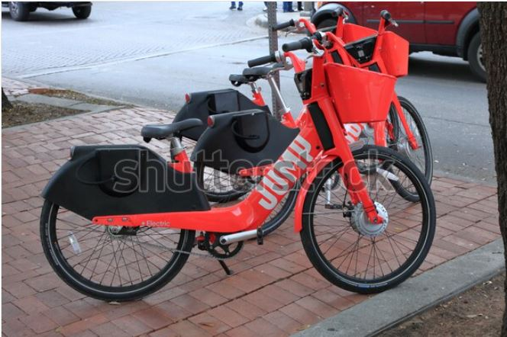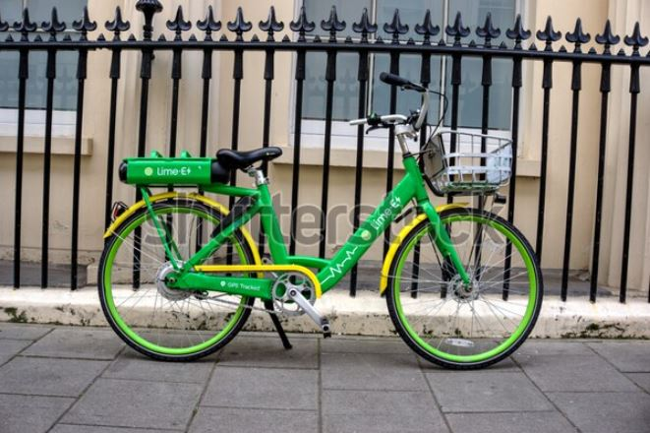
Shutterstock ID: 1354949432 Shutterstock ID: 1498828841
[ASK IF D3 = (01, 02, 03, 04, 05, 06)]
D47. Electric bikes or e-bikes are bicycles with a battery-powered “assist” that makes pedaling easier and gives the rider a boost.
Have you ever used an e-bike (such as pictured above)? This could be one that you’ve rented or one that you own. (New)
- Yes [SKIP TO NEXT SECTION]
- No
[ASK IF D47 = 02]
D48. Why have you never used an e-bike? Select all that apply. (New)
- Preferred to use a different mode of transportation (e.g., a car, standard bike, or bus)
- Never seen one available
- Concerned about safety
- Not sure how they work
- Too expensive
- Problem with the rental process (e.g., downloading the app, setting up an account)
- Other

EMPATHY (3 Reg; 2 Grids)
[ASK All – Never bikers skip to here]
D49. Do you have friends or family members who ride bicycles? (New)
- Yes
- No

[ASK ALL]
D50. How often do you drive a motor vehicle? Almost every day, a few days a week, a few days a month, a few days a year, or do you never drive? (2012 #109)
- Almost every day/every day
- Few days a week
- Few days a month
- Few days a year
- Never => Skip to next section
- Other

[ASK ALL]
D51. How many licensed motor vehicles are owned, leased, or available for regular use by members of your household? (Was not read - 2012 #110)
[ENTER NUMBER]
[ASK if D50 = (01,02,03,04,06)]
D52. People don’t always pay close attention to bicyclists on the road, for many reasons. When you’re driving a motor vehicle, how often do you do any of the following? (New)
 | Always | Frequently | Sometimes | Seldom | Never
- Wait to pass bicyclists until there’s at least three feet of passing distance, even if it means I have to drive slowly behind them for several minutes.
- Double check for nearby bicyclists or pedestrians before I pull out of a driveway or move ahead at an intersection.
- Before I make a right turn, check the rearview mirrors to make sure there isn’t a bicyclist coming up behind me.
- After parking on the street, look behind me for bicyclists before opening the car door.
- At dusk or dawn, pay special attention to make sure I see bicyclists riding ahead of me.

[ASK ALL]
D53. Do you agree, disagree, or neither agree nor disagree with the following statements? (2012 #86 – removed top two options so it can be answered by all)
 | Agree | Disagree | Neither agree nor disagree
- Bicyclists are just as entitled to ride on the road as are motorists
- Driver training should prioritize how to avoid collisions with pedestrians and bicyclists
- A driver who doesn’t yield to pedestrians walking legally at a crosswalk should be ticketed.
- Bicyclists should be allowed to treat a stop sign as a yield sign and a red light as a stop sign.
- It’s safe for people to walk outside if they have been drinking or using substances and are too impaired to drive.
- It’s safe for people to bicycle if they have been drinking or using substances and are too impaired to drive.

SECTION E: E-SCOOTERS (5 Reg; 1 Grid; 1 Image)
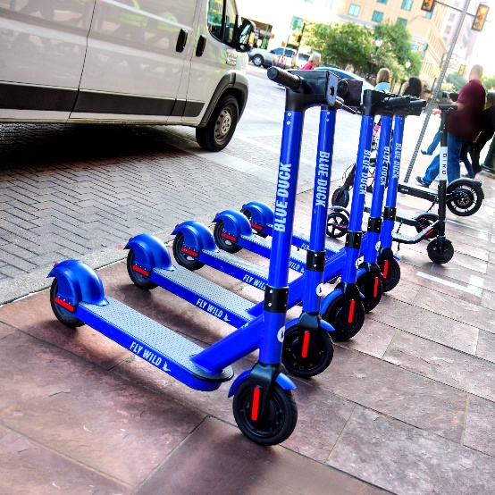
[ASK ALL]
E1. Electric scooters or E-scooters are scooters that you stand or sit on and are powered by an electric motor. Do you think e-scooters are a safe mode of transportation…? (New)
 | Yes | No
- For adults
- For older teens (16 and older)
- For younger teens (13 through 15)
- For pre-teens and younger children

[ASK ALL]
E2. Have you ever used an e-scooter? This could be one that you rented (e.g., Lime, Bird, etc.) or one that you’ve purchased. (New)
- Yes
- No
[ASK IF E2 = No]
E3. Why haven’t you used an e-scooter? (New)
- Preferred to use a different mode of transportation
- Never seen one available
- Concerned about safety
- Not sure how they work
- Too expensive
- Problem with the rental process (e.g., downloading the app, setting up an account)
- Other

[ASK IF E2 = Yes]
E4. In which of the following places do you commonly ride an e-scooter? Select all that apply. (New)
- Bike lane
- Sidewalk
- Main travel lane

[ASK IF E2 = Yes]
E5. When riding an e-scooter, how often do you wear a helmet? (2012 #41)
- All of my rides
- Nearly all of my rides
- Most of my rides
- Some of my rides
- Not very many of my rides
- None of my rides - Never

[ASK IF E2 = 01]
E6. In the past two years, were you ever injured while you were riding an e-scooter? (New)
- Yes =>Enter number (enter zero if none)
- No

SECTION F: CHILDREN WALKING/BIKING (7 Reg)
This next set of questions asks about children in your household and their walking and biking habits.
[ASK ALL]
F1. How many children, less than 16 years of age, currently reside in your household? Please do not count students living away from home or boarders. (2012 #93)
Enter number (enter zero if none) => If None, SKIP TO NEXT SECTION
[ASK IF F1 > 0]
F2. How old is [the/the oldest] child residing in your household? (2012 #95)
Enter number
[ASK IF F1 > 0]
F3. On average, how often does this child ride a bicycle? (New version of 2012 #96; adapted to mirror adult question at the beginning of the section S2AQ3)
- Daily
- Four to six times a week
- Two to three times a week
- Once a week
- A few times a month
- Once a month or less
[ASK IF F3 = (01, 02, 03, 04, 05)]
F4. When riding a bicycle, does this child wear a helmet for . . . (2012 #97)
- All rides
- Nearly all rides
- Most rides
- Some rides
- Not very many rides
- Never
F5_INT. The following few questions are about how this child learned about bicycling safety.
F5. In the past five years, has this child received any training in bicycling safety from someone outside the household? (New)
- Yes
- No [Skip to NEXT SECTION]

[ASK IF D40 = 01 (R RECEIVED BIKE TRAINING IN PAST 5 YEARS)]
F6. In the past five years, in which of the following formats did the child receive this bicycle safety training? Select all that apply. (New)
- Instructor-led class or workshop
- Self-paced reading, workbook, or online course
- Individual lessons
- Other

[ASK IF D40 = 01 (R RECEIVED BIKE TRAINING IN PAST 5 YEARS)]
F7. Who provided the training to the child? Select all that apply. (2012 #21, Was not read)
- Bicycle shop
- Police
- Friends
- Public school
- Private school
- Bicycle club
- State/Local bike programs
- Family

SECTION G: NEIGHBORHOOD CHARACTERISTICS (3 Reg/1 Grid)
Now, we want to ask a few questions about the area where you live.
[ASK ALL]
These next few questions are about your general travel habits. We are interested in all the ways you get around, including commuting for work, visiting friends, going to the grocery store, etc.
[ASK ALL]
G1. In general, how easy or difficult is it for you to travel to the places in your COMMUNITY where you want to go? Do not include out of town travel. Would you say it is… (2012 #113)
- Very easy
- Somewhat easy
- Somewhat difficult
- Very difficult
- It depends on where I am traveling from
[ASK IF G1 = (03, 04, 05)]
G2. Where in your community do you find it more difficult to travel to? Select all that apply. (2012 #114 – Was not read – Top answer option from 2012 open-ends added; changed direction from “from” to “to” to align with series)
- Home
- Work
- Doctor’s Office
- Center of town or business area
- Place doesn’t matter/All the same
- Other
[ASK IF G1 = (03, 04, 05)]
G3. What are the reasons it is difficult for you to travel to the places in your community where you want to go? Select all that apply. (2012 #115 – Was not read – Top answer options from 2012 open-ends added)
- Don’t have access to vehicle
- Too much traffic congestion
- Sidewalks are inadequate/poor condition
- No or few public transportation options
- I cannot afford transportation
- I have a disability or health impairment
- Other (Specify)
[ASK ALL]
G4. These next questions ask about the area that is within a quarter mile, or about 3 blocks, around where you live. Are there any of the following within ¼ mile of where you live? (2012 #99 – Urbanicity)
 | Yes | No
- Single-family houses
- Townhouses, apartments, or condos
- Mobile homes
- Parks or recreational areas
- Farms or ranches
- Commercial businesses such as stores or restaurants
- Public buildings such as schools, hospitals, or government offices
- Industrial buildings or factories
- Heavy street traffic

SECTION H: DEMOGRAPHICS (14 Reg)
These final questions ask for information about you and your household. These questions are for classification purposes only. It is important that we collect this information so that we can report information about specific groups of people.
[ASK ALL]
H1. Do you currently own or rent your home? (New)
- Own
- Rent
- Other arrangement
[ASK ALL]
H2. Including yourself, how many persons age 16 and older live in your household? (2012 #118)
[ENTER NUMBER]
[ASK ALL]
H3. What is your age? [open-ended/code actual age] (2012 #100-101)
Enter number
[ASK ALL]
H4. What is your gender? Mark all that apply. (2012 # SA3 - Was recorded from interviewer observation)
- Female
- Male
- Transgendered, non-binary, or another gender
- Prefer to self-identify
- Prefer not to say
[ASK ALL]
H5. What is your current employment status? Select all that apply. (2012 #102)
- Employed full-time
- Employed part-time
- Unemployed
- Retired
- Going to school
- Caregiver or stay-at-home parent
- Disabled
- Something else
[ASK IF H5 = 01, 02]
H6. Do you work from home? (New)
- Yes, one or two days per week
- Yes, three or more days per week
- No, I commute to an office or job site every day that I work
- Other
[ASK IF H5 = 01, 02, 05 – Employed or going to school]
H7. Some employers and schools offer incentives to encourage walking, biking, or other physical activity, such as reducing insurance premiums or offering prizes for participants that log a given number of weekly steps or minutes of activity. Does your employer or school offer this type of incentive program? (New)
- Yes
- No
- Not Sure
[ASK IF H7 = 01]
H8. Did you participate in this program?
- Yes
- No
[ASK IF H7 = 02]
H9. If such a program was offered, would you participate?
- Yes
- No
- Not Sure
[ASK IF H8 = 01]
H10. What impact did the program have on you?
  - It made me more likely to choose physically active transportation
  - It made me less likely to choose physically active transportation
  - It had no impact
  - Not Sure
[ASK ALL]
H11. What is the highest grade or year of school you have completed? (2012 #103 – Was not read; more granular <High School options removed)
- Less than finishing high school
- High school graduate or GED
- Some college
- 2-year technical/Associates degree
- Four-year college graduate
- Some graduate school
- Graduate degree
[ASK ALL]
H12. Are you of Hispanic, Latino, or Spanish origin? (2012 #104)
- Yes
- No
[ASK ALL]
H13. Which of the following racial categories describes you? Select all that apply. (2012 #105)
- American Indian or Alaska Native
- Asian
- Black or African American
- Native Hawaiian or Other Pacific Islander
- White
[ASK ALL]
H14. Which of the following categories best describes your total household income before taxes in 2021? Your best estimate is fine. Would it be…? (2012 #107 – Adjusted income categories to map to 150% of the Federal Poverty Line)
- Less than $20,000
- $20,000 to less than $25,000
- $25,000 to less than $30,000
- $30,000 to less than $35,000
- $35,000 to less than $40,000
- $40,000 to less than $45,000
- $45,000 to less than $50,000
- $50,000 to less than $55,000
- $55,000 to less than $60,000
- $60,000 to less than $65,000
- $65,000 to less than $85,000
- $85,000 to less than $100,000
- $100,000 to $149,000
- $150,000 or more

SECTION I: DISABILITY (6 Reg)
These last few questions ask about different types of physical and mental impairments or disabilities that you may have. We ask about these to better understand how people with disabilities and mobility limitations get around and how public roads and sidewalks can be safer for everyone.
[ASK ALL]
I1. Are you deaf or do you have serious difficulty hearing? (2012 #111 – New disability series pulled from ACS)
- Yes
- No
I2. Are you blind or do you have serious difficulty seeing even when wearing glasses?
- Yes
- No
I3. Do you have serious difficulty walking or climbing stairs?
- Yes
- No
I4. Because of a physical, mental, or emotional condition, do you have difficulty doing errands alone such as visiting a doctor’s office or shopping?
- Yes
- No
[Ask if (I1=01 or I2=01 or I3=01 or i4=01)]
I5. Do you use special equipment or an assistive device to help you get around? (2012 #112; answer options expanded)
- Yes, a non-motorized wheelchair
- Yes, a motorized chair
- Yes, a walker
- Yes, a walking cane
- Yes, a white cane or guide dog
- Yes, some other kind of special equipment
- No
[Ask if (I1=01 or I2=01 or I3=01 or i4=01)]
I6. Are there additional accommodations that you wish you had, or you wish were available in the places you go, to increase your safety and comfort? [open-ended] (New)

