1200 New Jersey Avenue, SE

Washington, DC 20590

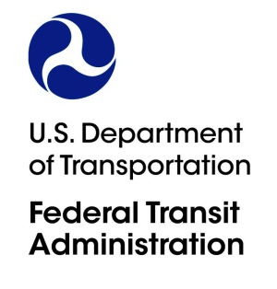

Headquarters

**ACTION MEMORANDUM TO THE OFFICE OF MANAGEMENT AND BUDGET**

**From:**  Bruce Robinson

Associate Administrator for Program Management

202-366-4020

**Prepared by:** John Bodnar

Director of Transit Programs

202-366-9091

**Subject:** Requesting Emergency Clearance from OMB for a New Information

Collection to Support the All-Stations Accessibility Program

**ACTION REQUESTED**

The Federal Transit Administration (FTA) requests the Office of Management and Budget

(OMB) to provide an emergency clearance for a new information collection to enable eligible applicants to apply for grant assistance under the All-Stations Accessibility Program.

**SUMMARY**

FTA is requesting emergency approval due to the urgency of making the associated funds available to eligible applicants, which are States and local government authorities that meet the eligibility requirements under the law. As part of the Bipartisan Infrastructure Law, the All- Stations Accessibility Program supports the Administration’s commitment to modernize the country’s transportation infrastructure, create and maintain good-paying jobs, and improve transit service for communities that have historically had more limited access to transit and provide for substantial upgrades to station accessibility.

**BACKGROUND**

The Bipartisan Infrastructure Law, enacted as the Infrastructure Investment and Jobs Act (Pub. L. 117-58), establishes the All-Stations Accessibility Program (ASAP) to provide

funding to make competitive grants to assist eligible entities in financing capital and planning projects to upgrade the accessibility of legacy rail fixed guideway public transportation systems for persons with disabilities, including those who use wheelchairs, by increasing the number of existing (as of the date of enactment of this Act) stations or facilities for passenger use that meet or exceed the new construction standards of title II of the Americans with Disabilities Act of 1990 (42 U.S.C. 12131 et seq.). Funding available under the program will be announced in a Notice of Funding Opportunity (NOFO) in late spring 2022.

**TIME SENSITIVE**

Due to FTA’s urgent need for this information collection, the FTA requests approval by June 15, 2022.

**RECOMMENDATION**

FTA recommends that OMB approve the new information collection.