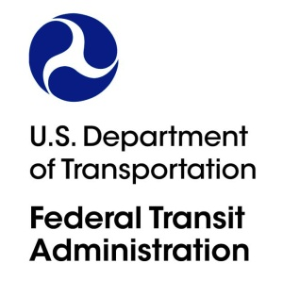
1200 New Jersey Avenue, SE
Washington, DC 20590
Headquarters

ACTION MEMORANDUM TO THE OFFICE OF MANAGEMENT AND BUDGET

From: Bruce Robinson
Associate Administrator for Program Management
202-366-4020

Prepared by: John Bodnar
Director of Transit Programs
202-366-9091

Subject: Requesting Emergency Clearance from OMB for a New Information
Collection to Support the Implementation of Ferry Grant Programs

ACTION REQUESTED

The Federal Transit Administration (FTA) requests the Office of Management and Budget

(OMB) to provide an emergency clearance for a new information collection to enable eligible applicants to apply for grant assistance under the Passenger Ferry Program, Electric or Low-Emitting Ferry Pilot Program and Ferry Service for Rural Communities Program.

SUMMARY

FTA is requesting emergency approval due to the urgency of making the associated funds available to eligible applicants, which are public transportation providers, local governmental entities, States and federally recognized Tribes that meet the eligibility requirements under the law. As part of the Bipartisan Infrastructure Law, these ferry programs support the Administration’s commitment to modernize the country’s transportation infrastructure, create and maintain good-paying jobs, and build clean energy fleets to combat climate change.

BACKGROUND

The Bipartisan Infrastructure Law, enacted as the Infrastructure Investment and Jobs Act, established two new ferry grant programs: Electric or Low-Emitting Ferry Pilot Program (IIJA § 71102) and Ferry Service for Rural Communities (IIJA § 71103). Funding available under these two new programs will be announced along with FTA’s existing Passenger Ferry Grant Program (49 U.S.C. 5307(h), which already has an approved information collection) in one Notice of Funding Opportunity (NOFO) in late spring 2022.

The Passenger Ferry Grant Program provides competitive funding for projects that support passenger ferry systems in urbanized areas. The Electric or Low-Emitting Ferry Pilot Program provides competitive funding for projects that support the purchase of electric or low-emitting ferry vessels. The Ferry Service for Rural Communities provides competitive funding to states to ensure basic essential ferry service is provided to rural areas.

TIME SENSITIVE
Due to FTA’s urgent need for this information collection, the FTA requests approval by June 15, 2022.

RECOMMENDATION
FTA recommends that OMB approve the new information collection.

