US Small Business Administration
SBA Lender and Microloan Intermediary Reporting Requirements
OMB Control Number 3245-0365
Justification—Part A Supporting Statement

Overview of Information Collection
This information collection, used by SBA’s Office of Credit Risk Management (OCRM), supports agency supervision of and enforcement for SBA’s approximately 3,177 7(a) Lenders, Certified Development Companies (“CDCs”), and Microloan Intermediaries that participate in the SBA business loan programs. It is a revision to a current collection. With this revision, SBA has revised and retitled the Federally Regulated 7(a) Lender review forms, updated some of the other existing forms and created two additional review forms (one for the existing microloan information collection and an additional one for Delegated Authority Review information collection within. See attached chart summarizing changes.

1. Need and Method for the Information Collection:
The required reporting is primarily conducted in conjunction with lender reviews or examinations as authorized by 15 U.S.C. 634(b)(14) (Authorization to collect and retain review/exam fees) and note, 636 (PLP reviews), 650 (SBA Supervised Lender exams), 657t (Authorization to supervise lenders and conduct reviews), and 697e (Bureau of PCLP Oversight); 13 CFR 120.440 (Delegated Authority), 120.1000 )Risk-based Lender Oversight), 120.1025 (Monitoring), 120.1050 (Reviews and examinations), and 120.1055 (Frequency of Reviews and Examinations); and SBA’s Standard Operating Procedures (SOPs) 50 10, Lender and Development Company Loan Programs; SOP 51 00, On-site Lender Reviews and Examinations; SOP 50 53, Supervision and Enforcement; and SOP 52 00(B), Microloan Program; Recordkeeping and reporting are further authorized by 13 CFR 120.180 (Compliance with Loan Program Requirements), 120.461 (SBA Supervised Lenders’ Additional Requirements Re Records), 120.464 (Reports to SBA), 120.830 (Reports a CDC Must Submit), and 120.1010 (SBA Access to SBA Lender/Intermediary Files). (See attached copies of authorities.) The information collected in 3245-0365 is critical to protecting the safety and soundness of SBA’s loan programs and taxpayer dollars.

As provided for in the SBA Loan Program Requirements identified above, SBA uses an analytical framework and set of protocols when analyzing the review/examination information that SBA collects from SBA Lenders. The protocols are collectively referred to as Risk-Based Review (RBR) protocols and reflect SBA’s priority of targeting its lender review/exam data collection and analysis based on lender risk. The RBRs feature two composite risk measurement methodology and scoring guides: one called “PARRiS,” which SBA developed for the oversight of 7(a) Lenders, and a second one called “SMART,” which SBA developed for the oversight of CDCs.

The PARRiS and SMART components cover the areas that SBA has traditionally reviewed: portfolio performance, credit administration, compliance with SBA Loan Program Requirements and SBA operations management under 13 CFR 120.1050(a). Each PARRiS and SMART component includes qualitative and quantitative performance factors. The quantitative factors (e.g. 12-month default rates, high-risk origination rates) are benchmarked and scored against set risk tolerance levels established by SBA, producing a PARRiS or SMART Score. The qualitative factors include, but are not limited to, consideration of: compliance with SBA Loan Program Requirements (as defined under 13 CFR 120.10), changes in SBA Lender’s loan policies, management and staff capabilities, and any other aspect of the lender’s SBA program. Review of the qualitative and quantitative factors allows SBA to better identify an SBA Lender’s specific risk areas, assess the level of risk a lender poses to SBA, and make recommendations for corrective action, as needed.

Levels of Review

The Risk-Based Review protocol generally features three levels of review. The first level of review for all lenders is the Lender Profile Assessment (LPA) or Desktop Review, which is a data driven virtual review that serves as a diagnostic. For purposes of the LPA/Desktop Review, a virtual review means a review that is generally performed using electronic transmission and analysis of lender information without the need to ask the lender for additional information or visit the lender’s location. The results of the first level review may indicate a level of risk warranting a second level of review.

The second level of review may be a Limited Scope or an Analytical Review. Limited Scope Reviews are performed on 7(a) Lenders (See 7(a) Lender Limited Scope/Limited Scope (Targeted) Information Request Form). A Limited Scope Review is also generally a virtual review. These typically include a review of a Lender’s loan portfolio data, and additional documentation from the SBA Lender including loan files. SBA may use random and/or judgmental sampling in selecting loan files. The objective of the Limited Scope Review is to determine whether the Lender is generally conforming with SBA Loan Program Requirements. This review is intended to provide Lenders with a recommendation of actions required to improve compliance and to help OCRM determine whether a Lender is generally non-compliant and requires additional assessment and resolution activities—including, but not limited to, conducting more in-depth or follow-up reviews.

If the second level of review is an Analytical Review, for CDCs, it is called a SMART Analytical Review (See Certified Development Company SMART Analytical Review Information Request Form). For 7(a) Lenders, it is called a 7(a) Diagnostic Review (See 7(a) Lender Diagnostic Review Information Request Form). Here, SBA analyzes a lender’s LPA which includes the quantitative and qualitative factors for each PARRiS or SMART component. Analytical Reviews are generally performed on higher risk lenders and/or in connection with a Delegated Authority Review. In selecting SBA Lenders for an Analytical Review, SBA may consider, for example, a Lender’s or CDC’s Risk Rating, PARRiS or SMART Score, last review assessment, delegated authority expiration date, whether the SBA Lender has been reviewed recently, and other risk criteria such as rapid growth. In addition, SBA may perform an Analytical Review on a population of randomly selected SBA Lenders.

Analytical Reviews are generally a virtual review. A 7(a) Diagnostic/Review generally includes a review of a Lender’s loan portfolio data rather than loan files. A SMART Analytical Review generally includes a review of a CDC’s loan portfolio data and up to five (5) loan files. SBA may also solicit additional information from the Lender/CDC, such as credit memoranda; credit and internal control policies; and copies of audit reports. . The results of an Analytical Review may conclude the process or may indicate the need for a subsequent level of review, such as a SMART Full Review, a Safety and Soundness Exam or a Limited Scope (Targeted) Review.

SBA conducts a comprehensive analysis of each PARRiS or SMART component in the third level of review, a Full Review SBA Supervised Lender Safety and Soundness Examination and Limited Scope (Targeted) Full Review ) . (See Certified Development Company SMART Full Review Information Request Form, SBA Supervised Lender Safety and Soundness Examination/Full Review Information Request Form, Limited Scope (Targeted) Review Information Request Form). Full Reviews and Exams are generally conducted at lender’s location but may include a virtual portion. SBA selects Lenders and CDCs that indicate the most risk for Full Reviews, Exams, and Limited Scope (Targeted) Full Reviews considering the same factors set out in the Analytical Review analysis along with portfolio size, ￼ whether SBA has performed a Full Review or Exam recently,￼￼of Lenders and CDCs to receive Full Reviews and Exams.

An SBA Lender selected for a Full Review or Exam receives an engagement letter and request for certain information (e.g., loan files, loan policies and procedures, SBA lending organizational chart, and copies of audits). In a Full Review and Exam, the LPA diagnostic serves as the preliminary part of the review. Full Reviews and Exams include reviews of loan files. SBA generally performs a random and/or judgmental loan file selection that may, for example, include current, past due and delinquent loans, loans in liquidation and loans in active purchase.

With the full implementation of the PARRiS and SMART risk-based protocols as currently conducted, OCRM tailors its requests for information to the risk level of the Lender or CDC. Also, with the PARRiS and SMART RBR protocols, most if not all information collected is electronically submittable or fillable.

Microloan Intermediaries.
SBA District Offices perform an annual site visit for active Intermediaries. SBA requests information on SBA program management and operations including an organizational chart with responsibilities, contact information, promissory notes, and credit policies and procedures, SBA primarily reviews the Intermediary’s credit administration through a loan sample file request. Specifics on the information collected are contained in SBA’s Microloan Intermediary Site Visit/Review Notification Letter and Form –

Finally, the information collection includes the requirement for Small Business Lending Companies (SBLCs) to submit annual validation, with supporting documentation and methodologies demonstrating that any scoring model used by the SBLC is predictive of loan performance (See SBA Supervised Lender Safety and Soundness Examination/Full Review Information Request Form).

2. Use of the Information
SBA will use the information collected to oversee and monitor performance and compliance of SBA Lenders and Microloan Intermediaries, and to timely assess an SBA Lender’s or Intermediary’s risk to SBA programs. SBA uses reporting to plan, facilitate, and lessen the burden of risk-based reviews. SBA will use reporting, when appropriate, in lieu of more onerous reviews. SBA may also use the information reported for the following purposes: 1) in determining SBA Lenders’ participation in delegated authority programs; 2) in determining whether to approve Secondary Market loan sales by higher-risk Lenders; or 3) in determining the need for increased supervision or enforcement. SBA Lender corrective action reporting informs SBA about how the SBA Lender is addressing or intends to address deficiencies identified during the review and examination process. SBA may then use those reports to assess the adequacy of the SBA Lender’s corrective action. Finally, reporting enables important feedback to SBA Lenders that assists them in correcting deficiencies to avoid unnecessary losses.

Depending on the type of SBA Lender, 7(a) lender or CDC, and the level of risk identified, SBA collects information necessary to perform a Diagnostic Review or SMART Analytical Review (SAR); a Limited Scope Review; a Limited Scope (Targeted) Full Review; a SMART Full Review (SFR); or a Safety and Soundness Examination. In addition, SBA collects information for Delegated Authority Reviews performed, in general, every two years for those SBA Lenders seeking delegated authority (e.g., Preferred Lender Program for 7(a) Lenders and Accredited Lender Program or Premier Certified Lender Program for CDCs). SBA also conducts other reviews for which SBA may request some of the information described below. However, other reviews are generally tailored to a lender’s specific facts and circumstances.

SBA also collects information in advance of on-site reviews of Microloan Intermediaries, which are generally conducted every year including information specific to the . minimum of three microloan files for review.

Finally, although SBA, 7(a) Lenders, and CDCs (indirectly through SBA feedback) are the primary users of the information, SBA may share information in accordance with information sharing agreements with other regulators (e.g., the FDIC or state financial institution regulators) to assist with supervision, regulation, and program responsibilities and to avoid redundant information requests from multiple regulators. Should Privacy Act concerns be triggered, SBA included in its Privacy Act routine uses for SOR #21, Loan Systems, sharing of information with other regulators.

3. Use of Information Technology:
SBA generally accepts transmission of this information electronically via SBA’s secure document management system or via e-mail. SBA has also established secure data storage servers, which allow SBA Lenders to upload information securely via the internet. SBA has also established within the agency a secure centralized document repository in which authorized staff can access information collected for multiple authorized purposes thus avoiding duplicative information requests. SBA encourages the use of electronic submissions as a means of reducing the burden and cost of paper submissions to SBA.

4.Non-Duplication

SBA’s OCRM recently examined current lists of documents collected to identify duplicative document requests. OCRM identified a few duplicative document requests, which were eliminated from the collection. There remains no similar information available that can be used for this purpose. Further, each assessment and corrective action relates to a specific review, therefore, existing information would not provide meaningful data for SBA to carry out its oversight responsibility. For example, only the SBA Lender can provide SBA with that lender’s updated policies and procedures, its corrective action plan, and its loan payment history for reconciling with SBA’s records. For OCRM Secondary Market information requests, SBA cannot obtain 7(a) Lenders’ credit memoranda or loan file information unless that information is provided by the 7(a) Lender. Finally, the collections state that if an SBA Lender has previously supplied the information and it remains unchanged, the SBA Lender can, in lieu of resubmission, provide a simple certification to that effect.

5. Burden on Small Business:

Generally, SBA considers the size of a Participant’s portfolio among the risk factors that SBA considers when determining the extent of oversight needed. Although some of these SBA Lenders and Microloan Intermediaries may be small under SBA size regulations, this collection of information will not have a significant economic impact on a substantial number of these entities.

6. Less Frequent Collection

Failure to collect and review this information would increase the risk of losses and have an adverse impact on the costs of operating the SBA-guaranteed financial assistance programs. Less frequent collection of this information could adversely impact or lessen the Agency’s understanding of the true operating conduct of the regulated entities, which would also increase the risk of program losses. In addition, SBA would not have the information to inform SBA Lenders and Intermediaries of deficiencies that allow these entities to proactively make corrections and potentially avoid subsequent losses.

7. Paperwork Reduction Act Guidelines:

No special circumstances exist; however, if it is determined that an SBA Lender or Intermediary is operating in a state of financial distress or a lender’s risk levels are concerning, SBA may require more frequent reporting.

8. Consultation and Public Comments:
Notice of this information collection with request for public comment was published in the Federal Register at 87 FR 9404 on February 18, 2022. The comment period was scheduled to end on April 19, 2022. See attached notice. SBA received no comments. In addition, the draft forms submitted for OMB approval include language seeking ongoing feedback on burden going forward.

9. Payments of Gifts
No payment or gift will be provided to respondents.

10. Privacy & Confidentiality
Describe any assurance of confidentiality provided to respondents and the basis for the assurance in statute, regulation, or agency policy
The information collected will be protected to the extent permitted by law, including the Freedom of Information Act, 5 U.S.C. 552.
11. Sensitive Questions:

No information of a sensitive nature is required.

12. Burden Estimate
Our best estimate at this time is that this informational collection will apply to 1,985 respondents. The table below sets forth OCRM’s estimates for the hourly burden of the information collection by the review categories discussed in response to Question #1 above. For example, line 1 covers 7(a) Limited Scope (Targeted) Full Reviews . It indicates that a financial manager will spend 24 hours providing information in connection with SBA’sreview. An additional 8 hours of time by an administrative support employee is also estimated. The financial manager’s hourly wage is estimated at $73.78 per hour (column 3) and the administrative support employee’s hourly wage is estimated at $20.47 per hour (column 6). The cost of the financial manager per response is indicated as $1770.72 (24 x $73.78) (column 4). The cost of the administrative support employee per response is indicated as $163.76 (8 x $20.47) (column 7). The total cost per response is indicated as $1,934.48 ($1770.72+ $163.76) (column 8). The anticipated number of responses is 35 (column 9) leading to a total cost of $67,706.80(35 x $1,934.48) (column 10). The total number of hours (column 11) is the total of the financial manager hours (column 2) plus the total of the administrative support hours (column 5) times the number of responses (column 9).

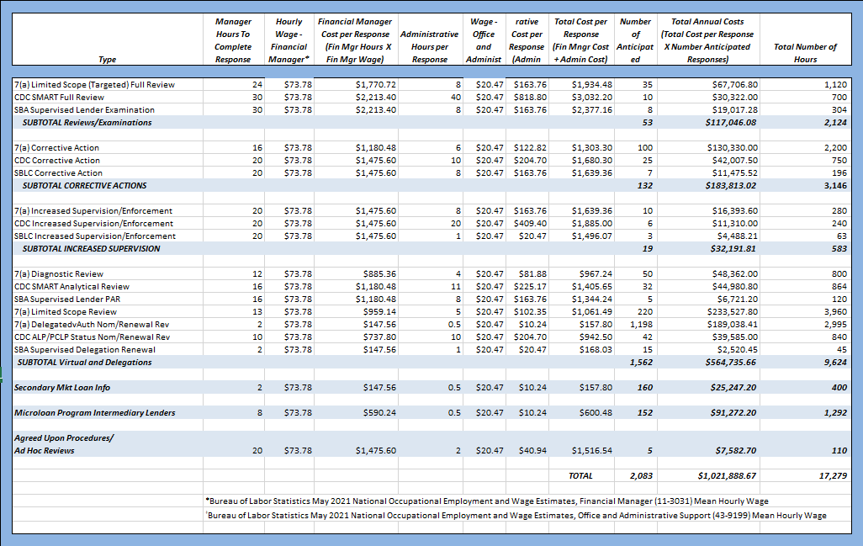
These estimates are based on discussions with the SBA contractors who assist in conducting lender reviews, and internal estimates by the Office of Credit Risk Management financial analysts. Salary rates used were based on the Bureau of Labor Statistics May 2021 National Occupational Employment and Wage Estimates, Financial Manager (11-3031) Mean Hourly Wage ($73.78) and Administrative Support (43-9199) Mean Hourly Wage ($20.47).

13. Estimated Nonrecurring Cost
Other than detailed above, there are no additional costs resulting from the collection of information.

14. Estimated Cost to the Government:
SBA will not incur any significantly measurable direct costs for the lender oversight functions related to this information collection. Any additional indirect costs to SBA would be covered by the already-existing OCRM infrastructure.

15. Reasons for changes. Explain the reasons for any program changes or adjustments reported on the burden worksheet.

Changes were based on increased costs and increased number of SMART Reviews and the addition of Limited Scope Reviews. New forms are identified, and changes are highlighted within this package.

16. Publicizing Results. For collections of information whose results will be published, outline plans for tabulation and publication. Address any complex analytical techniques that will be used. Provide the time schedule for the entire project, including beginning and ending dates of the collection of information, completion of report, publication dates, and other actions.

There are no plans to publish data from this collection of information, other than aggregated data as part of annual program reporting.

17. OMB Not to Display Approval. If seeking approval to not display the expiration date for OMB approval of the information collection, explain the reasons that display would be inappropriate.
Not applicable.

18. Exceptions to "Certification for Paperwork Reduction Submissions."
Not Applicable
19. Surveys, Censuses, and Other Collections that Employ Statistical Methods.
Not Applicable

“PARRiS” is an acronym for the specific risk areas or components that SBA reviews for 7(a) lenders. The acronym stands for Portfolio Performance, Asset Management, Regulatory Compliance, Risk Management, and Special Items. “SMART” is an acronym for the specific risk areas or components that SBA reviews for Certified Development Companies participating in SBA’s 504 Loan Program. The acronym stands for Solvency and Financial Condition, Management and Board Governance, Asset Quality and Servicing, Regulatory Compliance and Technical Issues and Mission.
Information is collected on SBA Form 1502 under OMB Collection number 3245-0185.
SBA performs Delegated Authority review upon an initial request for additional/independent authority to process loans and generally every two years after. Information collected for Delegated Authority Reviews is contained in the following attachments: 7(a) Lender Information Request for Initial Approval of Delegated Authority; 7(a) Lender Information Request for Renewal of Delegated Authority; and Accredited Lenders Program (ALP)/Premier Certified Lenders Program (PCLP) Application and Renewal Requirements Guide and Information Request for Certified Development Companies.
A full review for a 7(a) Lender is referred to as a Limited Scope (Targeted) or PARRiS full review (PFR). A full review for a CDC is known as a SMART Full review (SFR).
SBA conducts Safety and Soundness exams on 7(a) Lenders that are not federally regulated. SBA refers to these lenders as SBA Supervised Lenders.
We note that the Limited Scope Targeted Review is also a type of Full Review, although it requires the same information collected as the Limited Scope Review. The difference in the review is not in information collection; rather in the targeted depth of the analysis.
SBA is the primary federal regulator for Small Business Lending Companies licensed by SBA and Non-federally Regulated Lenders as defined in 15 USC 650 and 13 CFR 120.10, and for Certified Development Companies
OCRM anticipates that of the 1,861 responses to information requests, approximately 236 respondents will submit responses for more than one information request (e.g., a 7(a) lender submitting information for a full review and also for a corrective action), bringing the total number of respondents to 1,625.

