2022 SUPPORTING STATEMENT

Community Wildfire Defense Grant Program (CWDG)
OMB Control Number 0596 - XXXX

Terms of Clearance:

A. Justification

1. Explain the circumstances that make the collection of information necessary. Identify any legal or administrative requirements that necessitate the collection. Attach a copy of the appropriate section of each statute and regulation mandating or authorizing the collection of information.

USDA Forest Service, in cooperation with the States, is delivering the Community Wildfire Defense Grant (CWDG) Program as part of the Bipartisan Infrastructure Law. Title VIII of IIJA outlines the CWDG Program. The Agency is tasked with designing and implementing this Program that will award grants to at-risk communities, including Indian Tribes. According to 2 CFR Part 200 and Forest Service Handbook 1590.11, Chapter 20, there is certain narrative and budget information required for the Agency to determine if the project meets the legislative requirements and if the costs are reasonable, allocable, allowable, and necessary for the project.

U.S. Department of Agriculture’s Forest Service announces the availability of up to $1 billion in grant funding, appropriated under the Infrastructure Investment and Jobs Act, for the establishment of the Community Wildfire Defense Grant (CDWG) Program. As authorized under Title VIII, Section 40803 of the Infrastructure Investment and Jobs Act, funds will be made available and distributed to eligible applicants within the footprints of the Western States, Northeast-Midwest States, Southern States, and Indian Tribes/Alaska Native Corporations. There are two primary project types for which the CDWG provides funding: the development and revising of Community Wildfire Protection Plans (CWPP) and the implementation of projects described in a CWPP that is less than ten years old. The Act prioritizes at-risk communities that are in an area identified as having high or very high wildfire hazard potential, are low-income, and/or have been impacted by a severe disaster.

2. Indicate how, by whom, and for what purpose the information is to be used. Except for a new collection, indicate the actual use the agency has made of the information received from the current collection.

Data collection procedures for the information on the CWDG Project Narrative Form (FS-1500-0045), SF-424 Application for Federal Assistance, and SF-424a BUDGET INFORMATION - Non-Construction Programs will be electronic through Grants.gov for public applicants. For those applicants that cannot submit the information electronically, please request a paper version of this CWDG Project Narrative Form (FS-1500-0045) by calling 503-313-2784 or sending a written request to USDA, Forest Service, Attention Sheila Walker, Washington Office Fire and Aviation Management (FAM), 1400 Independence Avenue Southwest, Mailstop 1107, Washington, DC 20250.

Data collection procedures for the information on the CWDG Project Narrative Form (FS-1500-0045), Application for Federal Assistance 424 (FS-1500-0046), and BUDGET INFORMATION - Non-Construction Programs 424a (FS-1500-0047) will be electronic through forestrygrants.org for public applicants. For those applicants that cannot submit the information electronically, please request a paper version of the CWDG Project Narrative Form (FS-1500-0045), Application for Federal Assistance 424 (FS-1500-0046), and BUDGET INFORMATION - Non-Construction Programs 424a (FS-1500-0047) by calling 503-313-2784 or sending a written request to USDA, Forest Service, Attention Sheila Walker, Washington Office Fire and Aviation Management (FAM), 1400 Independence Avenue Southwest, Mailstop 1107, Washington, DC 20250.

- What information will be collected - reported or recorded? (If there are pieces of information that are especially burdensome in the collection, a specific explanation should be provided.)

- Who Can Apply: Entities eligible to apply for funding under the CWDG include:
- Units of local governments representing communities located in an area with a risk of wildfires,
- Indian Tribes,
- Non-profit organizations including homeowner associations that assist such communities,
- State forestry agencies (including U.S. territories and interests), and
- Alaska Native Corporations
For-profit entities are not eligible to apply for this funding opportunity.
- Eligible Lands: Eligible applicants may apply for grant funding for a project proposal to be conducted on lands with the following ownership types, as long as the project proposal directly reduces wildfire risk to a community:
- Private lands
- Local government
- Homeowner associations
- State government
- Tribal/Alaska native corporation (includes Trust lands)
Federal lands are not eligible for this funding opportunity with the exception of Federal Tribal trust lands.
- State Forest Action Plans and the Cohesive Wildland Fire Management Strategy: Projects should further the priorities, e.g., goal, strategy, and/or priority landscape in the most recent State Forest Action Plans as well as the relevant regional cohesive wildland fire management strategy document.
- Executive Order 13985: Advancing Racial Equity and Support for Underserved Communities Through the Federal Government: We encourage applications that show a clear benefit to underserved/ historically marginalized people and the communities where they reside or the forest areas that they value. Where this is the case, this should be described in the “Project Narrative Form.” Underserved communities are also eligible to request a waiver of match requirements.
- Minimum and Maximum Funding Levels:
- There is no minimum Federal funding limit for projects under CWDG.
- The maximum amount of Federal funding awarded to any one community or Tribe via this competitive process is:
      - $250,000 for the creation or updating of a Community Wildfire Protection Plan, and
      - $10 million for a project described within a Community Wildfire Protection Plan less than 10 years old.
- For planning purposes, the Federal funding allocated through the CWDG competitive process is expected to be approximately $160 million annually for the next five years.
- Required Matching Funds: The CWDG program has differing levels of match dependent upon the proposal for which is being applied. For proposals to develop or update a CWPP, the required match is 10%. For proposals to implement projects described within a CWPP, the required match is 25%. Matching funds must be derived entirely from non-Federal sources. The match must be met by eligible and allowable costs and is subject to match provisions in grant regulations (Code of Federal Regulations Title 2 Part 200.306 and Subpart E for Cost Principles). Match must meet all the same requirements as the Federal share and be documented sufficiently to support financial tracking and accountability. See the Matching Funds document for more guidance. Communities meeting the definition of underserved per Executive Order 13985 may request a waiver of match; no other waivers are allowable under this program.
- Lead Agency or Organization: All applications must identify the lead agency or organization that will have primary responsibility for coordinating project work and reporting. The lead agency may pass funds to other partners performing work as relevant.
- Grant Timeframes: Projects must be completed within five (5) years.
- For Proposals including multiple communities: A single application within grants.gov may be submitted that includes more than one community, however, a separate narrative and budget form will need to be filled out for each community for purposes of determining eligibility, prioritization, and ranking.
- Scoring and Ranking of applications: Applications will be scored by members of a regional review panel. Individual reviewer scores will be normalized using a Z-score. All regionally-scored applications will be compiled in a single nationally-ranked list, which will be used to distribute funding.
- Reporting: Funded CWDG projects will be required to provide financial reports to the grant’s administrator on a quarterly basis, and project performance reports on an annual basis. The annual performance report shall include a spatial data component. This requires both Forest Service grant monitors and CWDG grant recipients to coordinate in entering project information.
- From whom will the information be collected? If there are different respondent categories (e.g., loan applicant versus a bank versus an appraiser), each should be described along with the type of collection activity that applies.
Information Collected | Description | Information Provided to: | Prepared by
Individual | CWDG Program Project Narrative Form (FS-1500-0045) | USDA Forest Service | Public
Individual | CWDG Program Project Narrative Form (FS-1500-0045) | USDA Forest Service | Tribal
Individual | Application for Federal Assistance 424 (FS-1500-0046) | USDA Forest Service | Public
Individual | Application for Federal Assistance 424 (FS-1500-0046) | USDA Forest Service | Tribal
Individual | BUDGET INFORMATION - Non-Construction Programs 424a (FS-1500-0047) | USDA Forest Service | Public
Individual | BUDGET INFORMATION - Non-Construction Programs 424a (FS-1500-0047) | USDA Forest Service | Tribal
Individual | CWDG Program Project Narrative Form (FS-1500-0045) | USDA Forest Service | Federal Government

- Describe whether, and to what extent, the collection of information involves the use of automated, electronic, mechanical, or other technological collection techniques or other forms of information technology, e.g., permitting electronic submission of responses, and the basis for the decision for adopting this means of collection. Also, describe any consideration of using information technology to reduce burden.

Data collection procedures for the information on the CWDG Project Narrative Form (FS-1500-0045) will be electronic through Grants.gov and ForestryGrants.org. For those applicants that cannot submit the information electronically in Grants.gov and ForestryGrants.org, please request a paper version of this CWDG Project Narrative Form (FS-1500-0045) by calling 503-313-2784 or sending a written request to USDA, Forest Service, Attention Sheila Walker, Washington Office Fire and Aviation Management (FAM), 1400 Independence Avenue Southwest, Mailstop 1107, Washington, DC 20250.

4. Describe efforts to identify duplication. Show specifically why any similar information already available cannot be used or modified for use for the purpose described in item 2 above.

The CWDG Program is a new program authorized in Public Law 117-58 Infrastructure Investment and Jobs Act, commonly referred to as the Bipartisan Infrastructure Law (BIL), which was signed by the President on November 15, 2021. This is the first request for information associated with this new Program. This information being collected is not duplicated by any other source.

5. If the collection of information impacts small businesses or other small entities, describe any methods used to minimize burden.

The CWDG prioritizes underserved communities and “for profit” entities are not eligible to apply for the Community Wildfire Defense Grant Program. The collection of information may affect 1-2 % of small entities. The required information has been kept to a minimum on the CWDG Project Narrative Form (FS-1500-0045) to facilitate applications from small entities.

6. Describe the consequence to Federal program or policy activities if the collection is not conducted or is conducted less frequently, as well as any technical or legal obstacles to reducing burden.

If the Agency were not able to collect this information or frequency of collection is reduced, at-risk communities would not be able to obtain the new Federal resources authorized by the Community Wildfire Defense Grant Program and the fuels reduction work would either be delayed or not accomplished, and the communities would continue to be at risk from wildland fire.

7. Explain any special circumstances that would cause an information collection to be conducted in a manner:
- requiring respondents to report information to the agency more often than quarterly; requiring respondents to prepare a written response to a collection of information in fewer than 30 days after receipt of it;
- requiring respondents to submit more than an original and two copies of any document;
- requiring respondents to retain records, other than health, medical, government contract, grant-in-aid, or tax records for more than three years;
- in connection with a statistical survey, that is not designed to produce valid and reliable results that can be generalized to the universe of study;
- requiring the use of a statistical data classification that has not been reviewed and approved by OMB;
- that includes a pledge of confidentiality that is not supported by authority established in statute or regulation, that is not supported by disclosure and data security policies that are consistent with the pledge, or which unnecessarily impedes sharing of data with other agencies for compatible confidential use; or
- requiring respondents to submit proprietary trade secret, or other confidential information unless the agency can demonstrate that it has instituted procedures to protect the information's confidentiality to the extent permitted by law
There are no special circumstances that would require this.

- If applicable, provide a copy and identify the date and page number of publication in the Federal Register of the agency's notice, soliciting comments on the information collection prior to submission to OMB. Summarize public comments received in response to that notice and describe actions taken by the agency in response to these comments. This collection package is being submitted as an emergency. Forest Service will publish a 60 day notice upon emergency approval.

Describe efforts to consult with persons outside the agency to obtain their views on the availability of data, frequency of collection, the clarity of instructions and recordkeeping, disclosure, or reporting form, and on the data elements to be recorded, disclosed, or reported. Due to the urgency of the Secretary’s announcement the Forest Service did not seek outside, formal consultation.

9. Explain any decision to provide any payment or gift to respondents, other than reenumeration of contractors or grantees. No payment or gifts are provided.

- Describe any assurance of confidentiality provided to respondents and the basis for the assurance in statute, regulation, or agency policy. There is no assurance of confidentiality provided to respondents.

- Provide additional justification for any questions of a sensitive nature, such as sexual behavior or attitudes, religious beliefs, and other matters that are commonly considered private. This justification should include the reasons why the agency considers the questions necessary, the specific uses to be made of the information, the explanation to be given to persons from whom the information is requested, and any steps to be taken to obtain their consent. The application will not contain questions of a sensitive nature.

- Provide estimates of the hour burden of the collection of information. The statement should:

- Indicate the number of respondents, frequency of response, annual hour burden, and an explanation of how the burden was estimated. If this request for approval covers more than one form, provide separate hour burden estimates for each form and aggregate the hour burdens in Item 13 of OMB Form 83-I.

Information collected on Grants.gov:

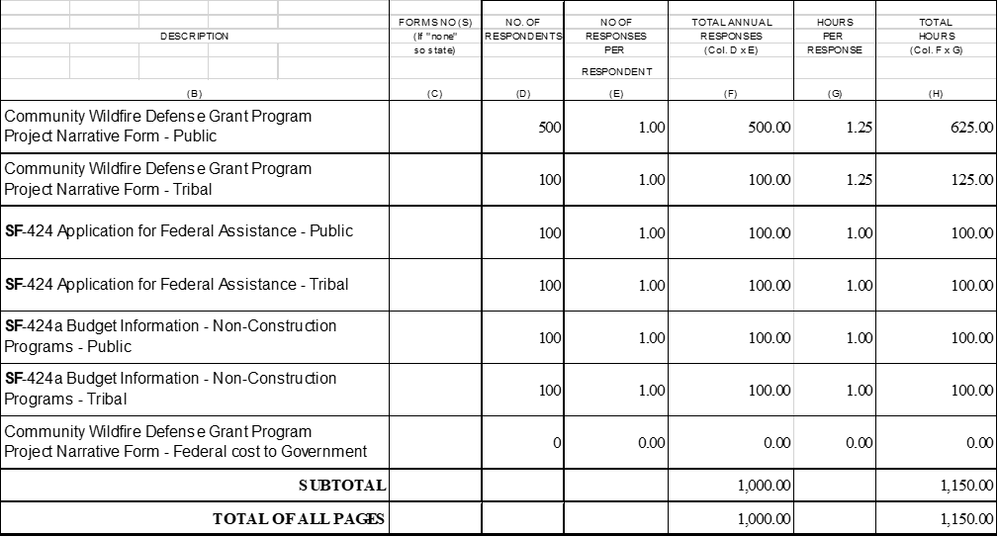

Information collected on ForestryGrants.gov:

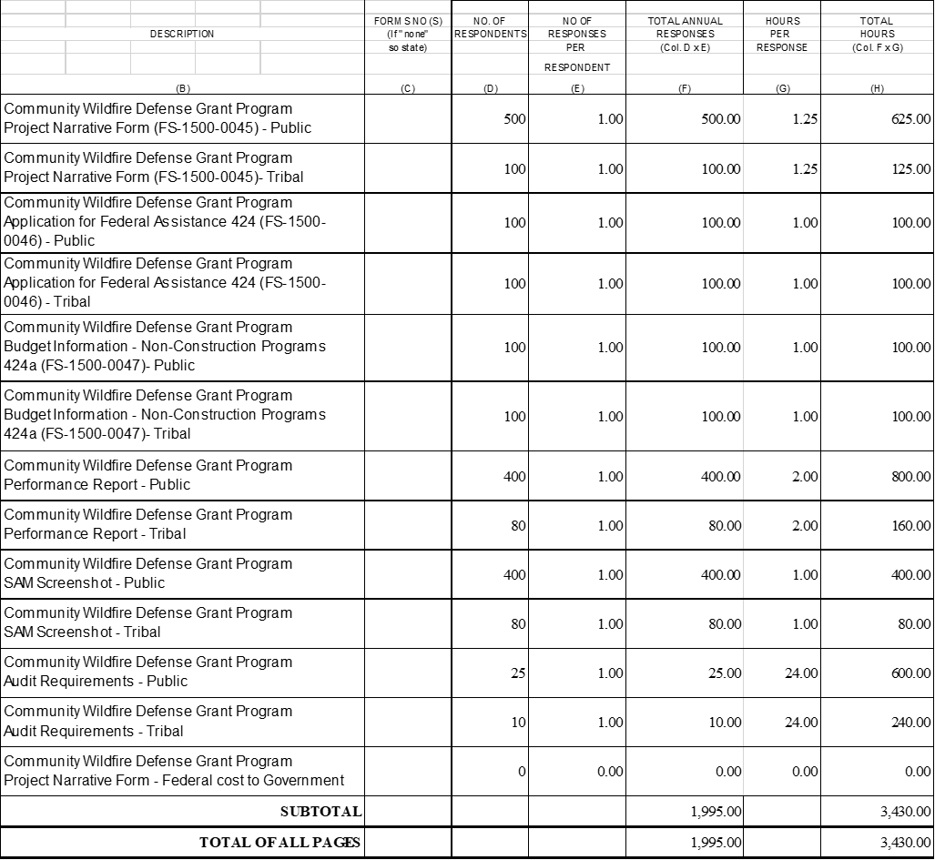

13. Provide estimates of the total annual cost burden to respondents or record keepers resulting from the collection of information, (do not include the cost of any hour burden shown in items 12 and 14). The cost estimates should be split into two components: (a) a total capital and start-up cost component annualized over its expected useful life; and (b) a total operation and maintenance and purchase of services component. There is no estimated cost burden to respondents or record keepers resulting from the collection of information.

14. Provide estimates of annualized cost to the Federal government. Also, provide a description of the method used to estimate cost and any other expense that would not have been incurred without this collection of information. There are no estimates of annualized cost to the Federal government.

15. Explain the reasons for any program changes or adjustments reported in Items 13 or 14 of the OMB Form 83-1. There are no program changes.

16. For collections of information whose results are planned to be published, outline plans for tabulation and publication. Collections of information results are not planned to be published.

17. If seeking approval to not display the expiration date for OMB approval of the information collection, explain the reasons that display would be inappropriate. We are not seeking non-display approval and will display the expiration date for OMB approval.

18. Explain each exception to the certification statement identified in Item 19 "Certification for Paperwork Reduction Act." There are no exceptions.

19. How is this Information collection related to the Customer Service Center? This is not related to the Customer Service Center.

