Seeking Input on the Baldrige Excellence Framework
January 06, 2022

Share
Facebook
Linkedin
Twitter
Email
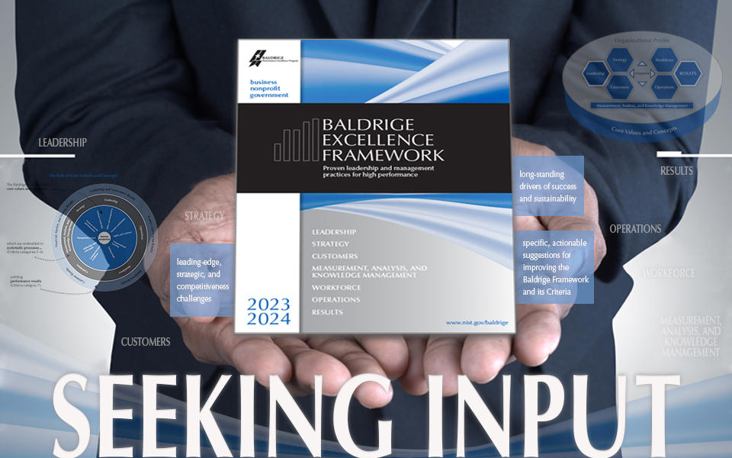
Credit: Horoscope/Shutterstock
What are the leading-edge, strategic, and competitiveness challenges that you are facing in your organization/industry (or seeing in the organizations with whom you work)?
What changes have there been to the long-standing drivers of success and sustainability?
For more than 30 years, organizational leaders have depended on the Baldrige Excellence Framework® to help them reach their goals, improve results, and become more competitive. To make sure that the framework always represents the leading edge of validated leadership and performance practice, we continually gather insights from role-model organizations, from thought leaders, and from studies of organizations and their CEOs to inform the evolution of the framework. We are now beginning to synthesize the findings and identify themes to incorporate into the 2023–2024 framework (expected to be published in January 2023).
To add to this this body of knowledge, we invite you to submit your answers to the questions above—or offer other specific, actionable suggestions for improving the Baldrige Framework and its Criteria for Performance Excellence®—to iday@nist.gov by May 23, 2022.
What will happen to all of this input?
- We’ll share the themes for revision, invite responses and reactions, and reconcile conflicting recommendations.
- We'll draft the 2023–2024 Criteria, inviting experts who have been influential in the thought process to contribute to or review the revision.
- The draft Criteria will also be sent to the Baldrige Board of Overseers and Judges Panel (the two advisory bodies to the Baldrige Program)—and to people whose thoughts and comments have resulted in significant revisions to the Criteria—for comments and reactions.
- Using this input, we will produce the final version of the 2023–2024 Criteria for Performance Excellence (Business/Nonprofit Criteria).
- We'll align the Education and Health Care Criteria to the Business/Nonprofit Criteria and send them to a group of experts in each sector for review.
Thank you in advance for your willingness to help us revise the Baldrige Excellence Framework. We look forward to receiving your suggestions and comments at iday@nist.gov.

OMB Control # 0693-0033
Expiration date: 07/31/2022
A Federal agency may not conduct or sponsor, and a person is not required to respond to, nor shall a person be subject to a penalty for failure to comply with an information collection subject to the requirements of the Paperwork Reduction Act of 1995 unless the information collection has a currently valid OMB Control Number. The approved OMB Control Number for this information collection is 0693-0033. Without this approval, we could not conduct this survey/information collection. Public reporting for this information collection is estimated to be approximately 15 minutes per response, including the time for reviewing instructions, searching existing data sources, gathering and maintaining the data needed, and completing and reviewing the information collection. All responses to this information collection are voluntary. Send comments regarding this burden estimate or any other aspect of this information collection, including suggestions for reducing this burden to the National Institute of Standards and Technology, Attn: Robert Fangmeyer, Director Baldrige Program, robert.fangmeyer@nist.gov.

This following tweet directs the responder to the tool above.
