VIA EMAIL FROM IRT Member to Servicemember Identified for Inclusion in Focus Group Pool at each Installation

*************************************
OMB CONTROL NUMBER: 0704-XXXX

OMB EXPIRATION DATE: XX/XX/XXXX

Dear Sergeant XXXXX:

I am a member of the Internal Review Team (IRT) on Racial Disparities in the Investigative and Military Justice Systems of the Department of Defense, and I am writing to request your assistance. By way of background, on June 1st of this year, the Deputy Secretary of Defense established the IRT to address the root causes of racial disparities in the DoD investigative and military justice systems. Not later than August 24th, the IRT must provide the Deputy Secretary with actionable recommendations the Department can implement to improve programs, policies, and resources to address these disparities. I am enclosing an article the Deputy Secretary published late last year to give you a sense of the urgency of the IRT’s work.

We know that [first- and second-line leaders] like yourself have a duty to take actions and decisions to address servicemember misconduct and poor performance “on the ground”, as it occurs. Thus, we believe you may have experiences, observations, and insights that would be of great value to the IRT.

I am travelling to [Norfolk] [next week] and would like to invite you to participate in a focus group on X July 2022, at [location] on [post/base]. The focus group will begin at XXXX and conclude no later than XXXX. You would be joined in the focus group by a number of your [enlisted/noncommissioned officer/officer] peers who have chosen to participate. XXXXX (IRT Member) and I would facilitate the conduct of the focus group. We would be assisted by members of our support team designated to serve as note takers. As indicated by the Office of Management and Budget (OMB) control number above, OMB has authorized these interviews/focus groups.

First, please know that your participation in this focus group is voluntary. Although I hope that you will choose to participate, you are free to decline. Even should you choose now to participate, you can terminate your participation at any time, and may decline to answer any or all of the questions posed for discussion by the group. Second, the IRT will take measures to protect your participation in this focus group. Neither your name, your unit of assignment, nor any other personally identifiable information (PII), will be recorded or documented by the IRT. Further, nothing you say in the focus group session will be attributed to you and nothing you say in the session will be shared by the IRT with any member of your chain of command.

Please let me know if you will participate by responding to this email. As the Deputy Secretary of Defense said in her article, “The Department is committed to change. . . .[b]ut it is way past time.” The IRT needs the input of Soldiers/Sailors/Airmen/Marines/Guardians like you if we are to achieve our mission.

If you have any questions, please do not hesitate to [ reply / call /email ].

I look forward to hearing from you and to speaking with you in person later this month at [Norfolk].

Sincerely,

IRT Member

OPINION>NATIONAL SECURITY

Addressing racial disparities in the military justice system
BY DEPUTY SECRETARY OF DEFENSE KATHLEEN H. HICKS, OPINION CONTRIBUTOR - 09/01/21 7:01 PM ET
THE VIEWS EXPRESSED BY CONTRIBUTORS ARE THEIR OWN AND NOT THE VIEW OF THE HILL
SHARETWEET
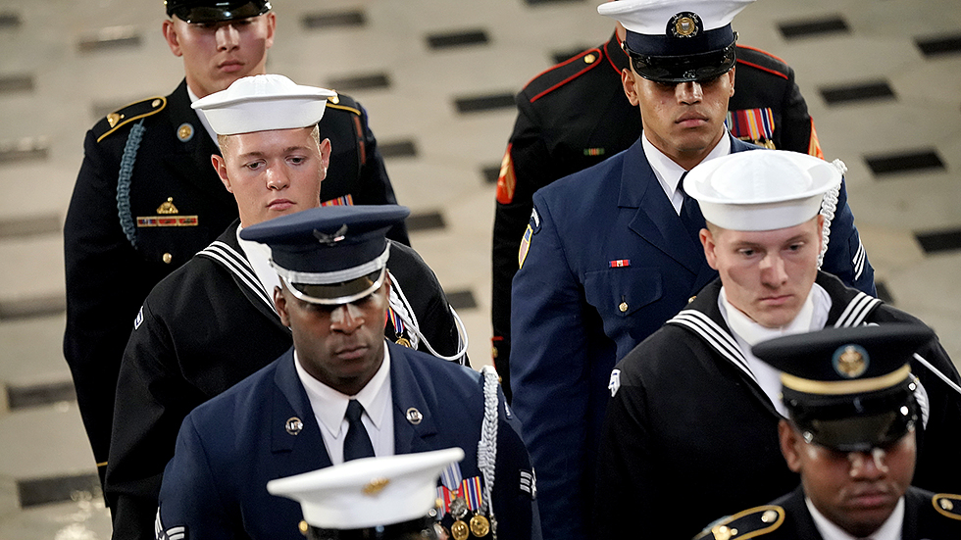Greg Nash
Racial disparities in the military justice system have been a problem for far too long. We know it, and we are going to work hard to fix it.
Earlier this year, I had a number of discussions with members of Congress and key stakeholders about reforms to our military justice system. We also have heard from service members about painful experiences that are unacceptable in the military or any justice system.
Most recently, a 2019 report by the Government Accountability Office highlighted that members of color were more likely to be tried in a court martial proceeding, but going back decades studies have highlighted this problem.
The men and women who risk their lives in defense of the United States deserve better, and we are committed to change. Leveraging evidence-based best practices, we will drive meaningful and lasting progress. And while driving change across one of the world’s largest enterprises is never easy, this challenge demands we do so quickly and methodically.
A plethora of studies have identified the problem, and we believe we can build on these to target meaningful solutions. We have directed the rapid collection of the data required to conduct a root-cause analysis of racial disparities in military justice. Working closely with the secretaries of the Military Departments, we expect to have that data ready for analysis by the end of this month.
As we generate interim findings, we won’t wait to take action. A dedicated team of experts will conduct an internal analysis by the end of 2021. For each area identified, the team will work with the services to develop targeted corrective action plans for specific issues. The internal working group will provide actionable recommendations to the department’s senior-most leadership — both civilian and uniformed — ensuring the people most impacted have a voice in this initiative, not only now but in the future.
To hold ourselves accountable, and consistent with congressional intent, we have also launched an independent assessment of the root causes of racial disparities in the military justice system. As that assessment completes in mid-2022, we will ensure the findings and any recommendations are incorporated into our action plans
We are committed to identifying solutions fitted to this problem with detailed attention and careful implementation. That will require commitment and action from all leaders in the department and at all levels. But it is way past time. Rapid action now will help us achieve sustained progress in the years to come. Our people deserve nothing less.
Dr. Kathleen H. Hicks is deputy secretary of Defense. She previously served as principal deputy under secretary of defense for policy during the Obama administration and was senior vice president and director of the international security program as the Center for Strategic and International Studies. Follow her on Twitter: @DepSecDef

TAGS DEPARTMENT OF DEFENSE JUSTICE KATHLEEN HICKS RACIAL DISPARITIES RACIAL DISPARITIES IN DISCIPLINE US MILITARY

