There is a link in the log in page to the disclosures: <https://grants.oldcc.gov/s_Login.jsp>

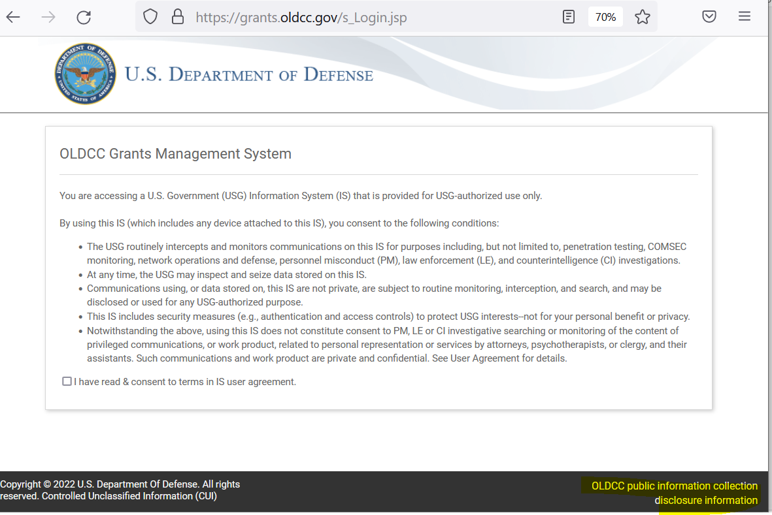

When that is clicked it brings up another page showing the full list of OLDCC disclosures:

NOTE: Agency Disclosure Notice for the Performance Reporting information collection portion of 0704-0625 is being added to the list of disclosures below.

