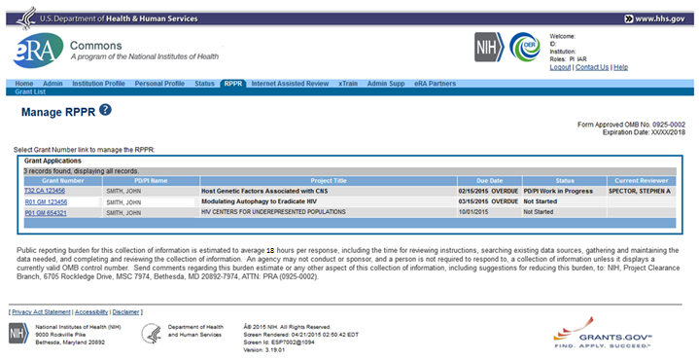

Expiration date: 02/28/2023

Section A – Cover Page

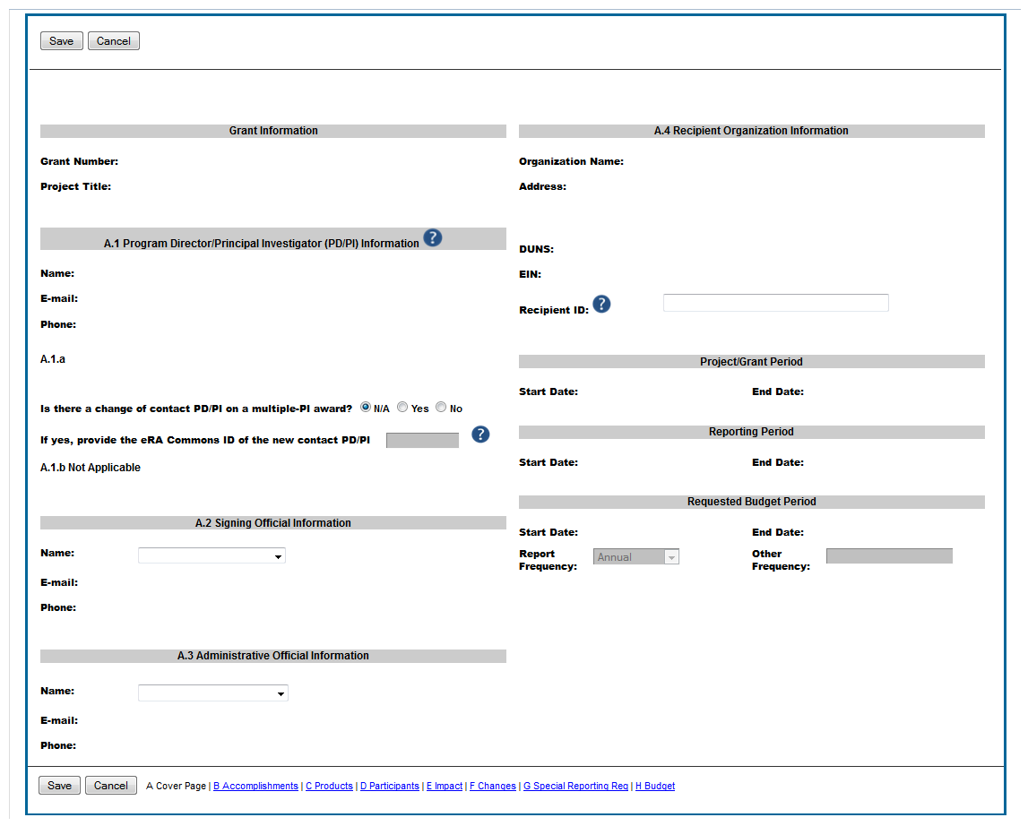



**A.5 Notice of Award Authorized Official**

**Name:**

**Title:**

**Phone:**

**Email:**

Section B – Accomplishments

B. Accomplishments (full screen)

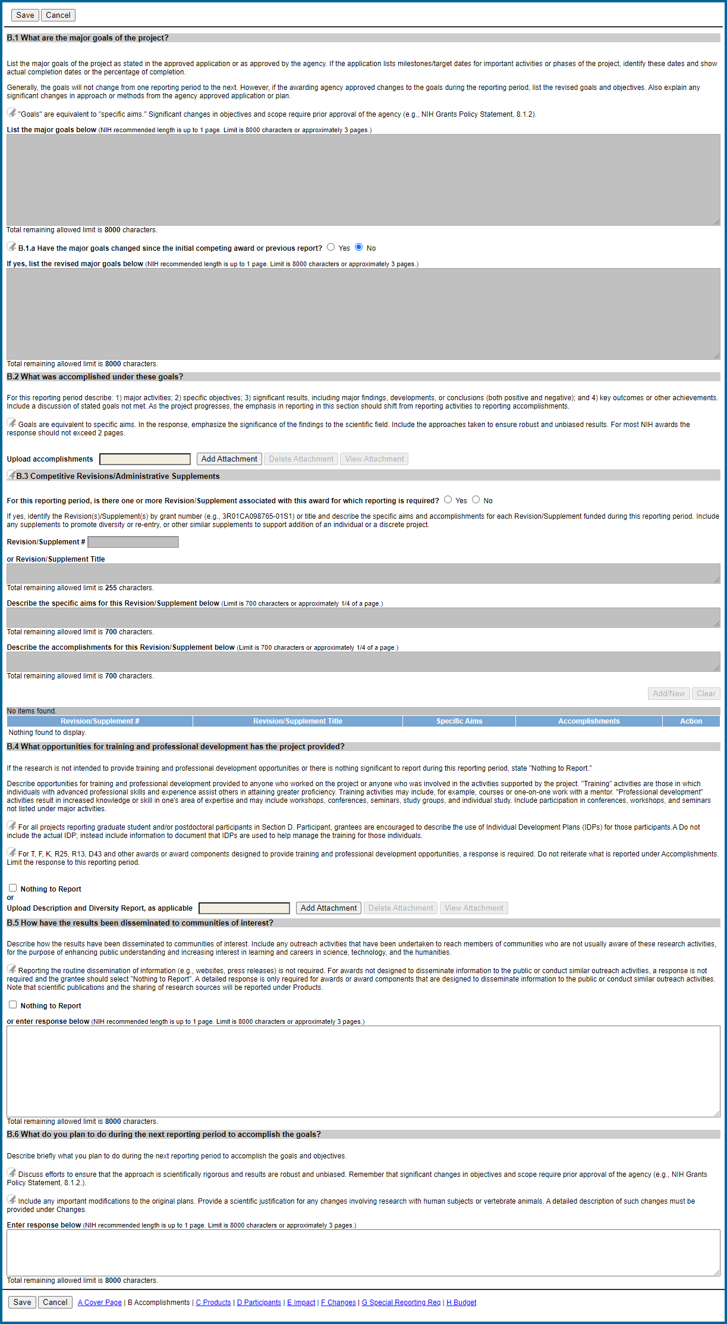

B1-2

B. Accomplishments (sections B1 – B4)

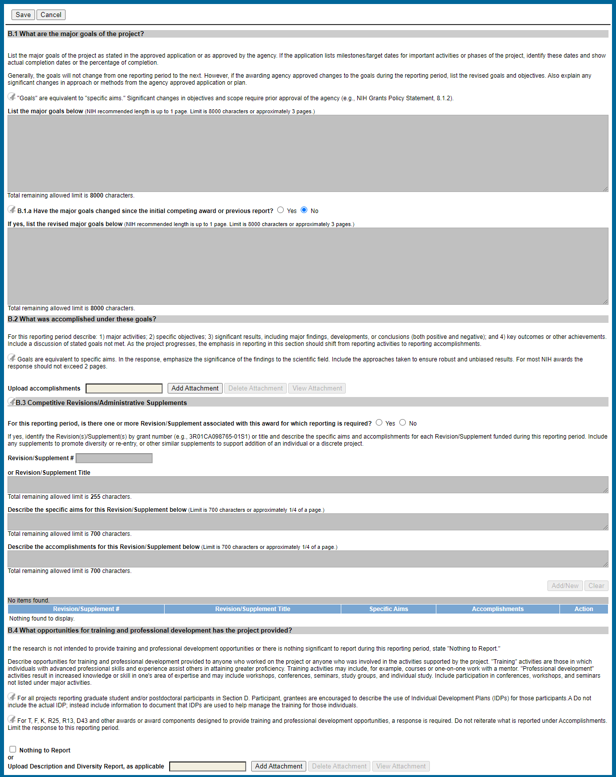

B3-4

B. Accomplishments (sections B3 – B4)

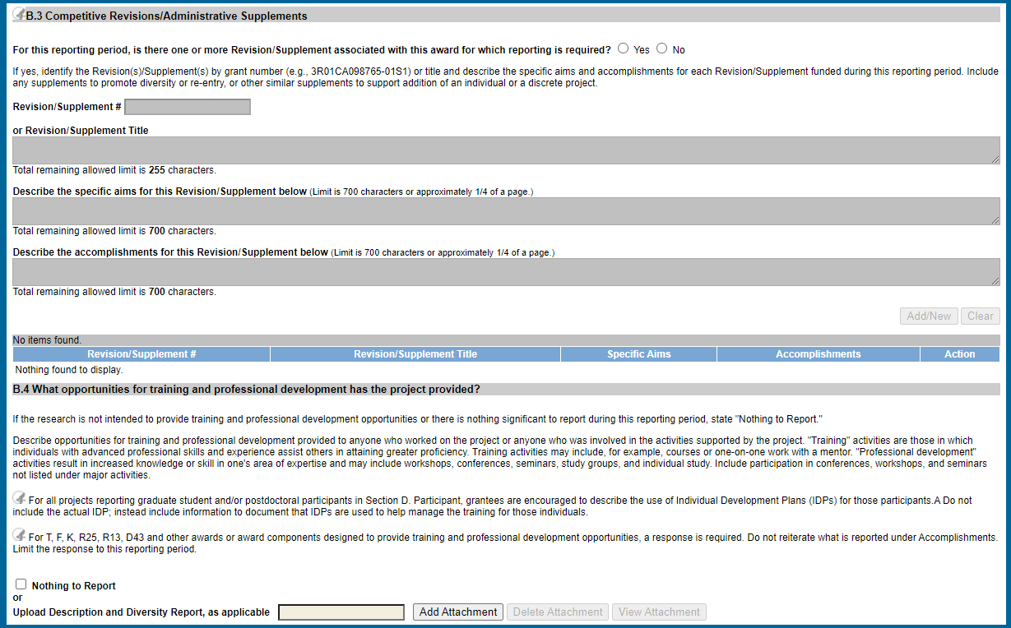

B5-6

B. Accomplishments (sections B5 – B6)

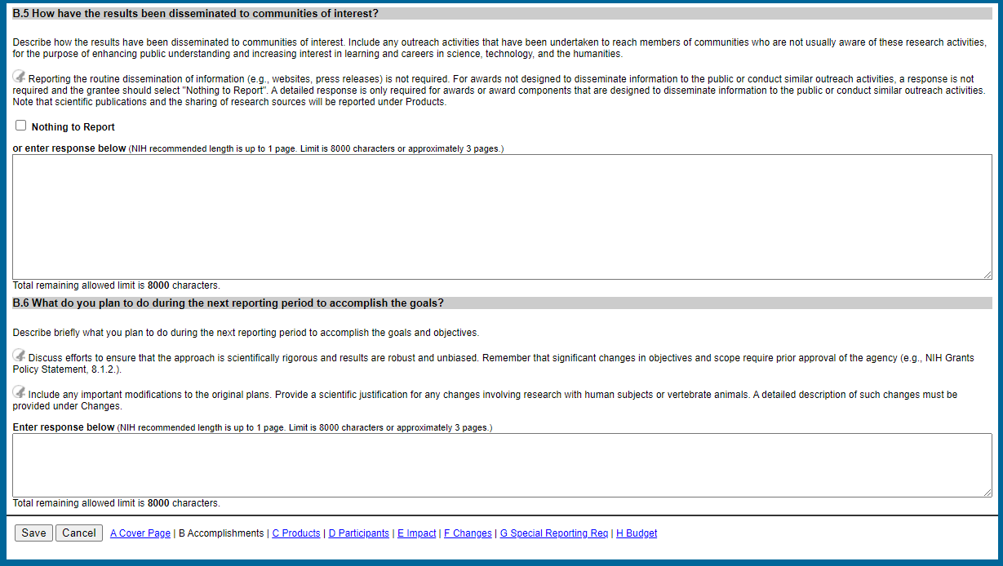

Section C – Products

C. Products (full screen)

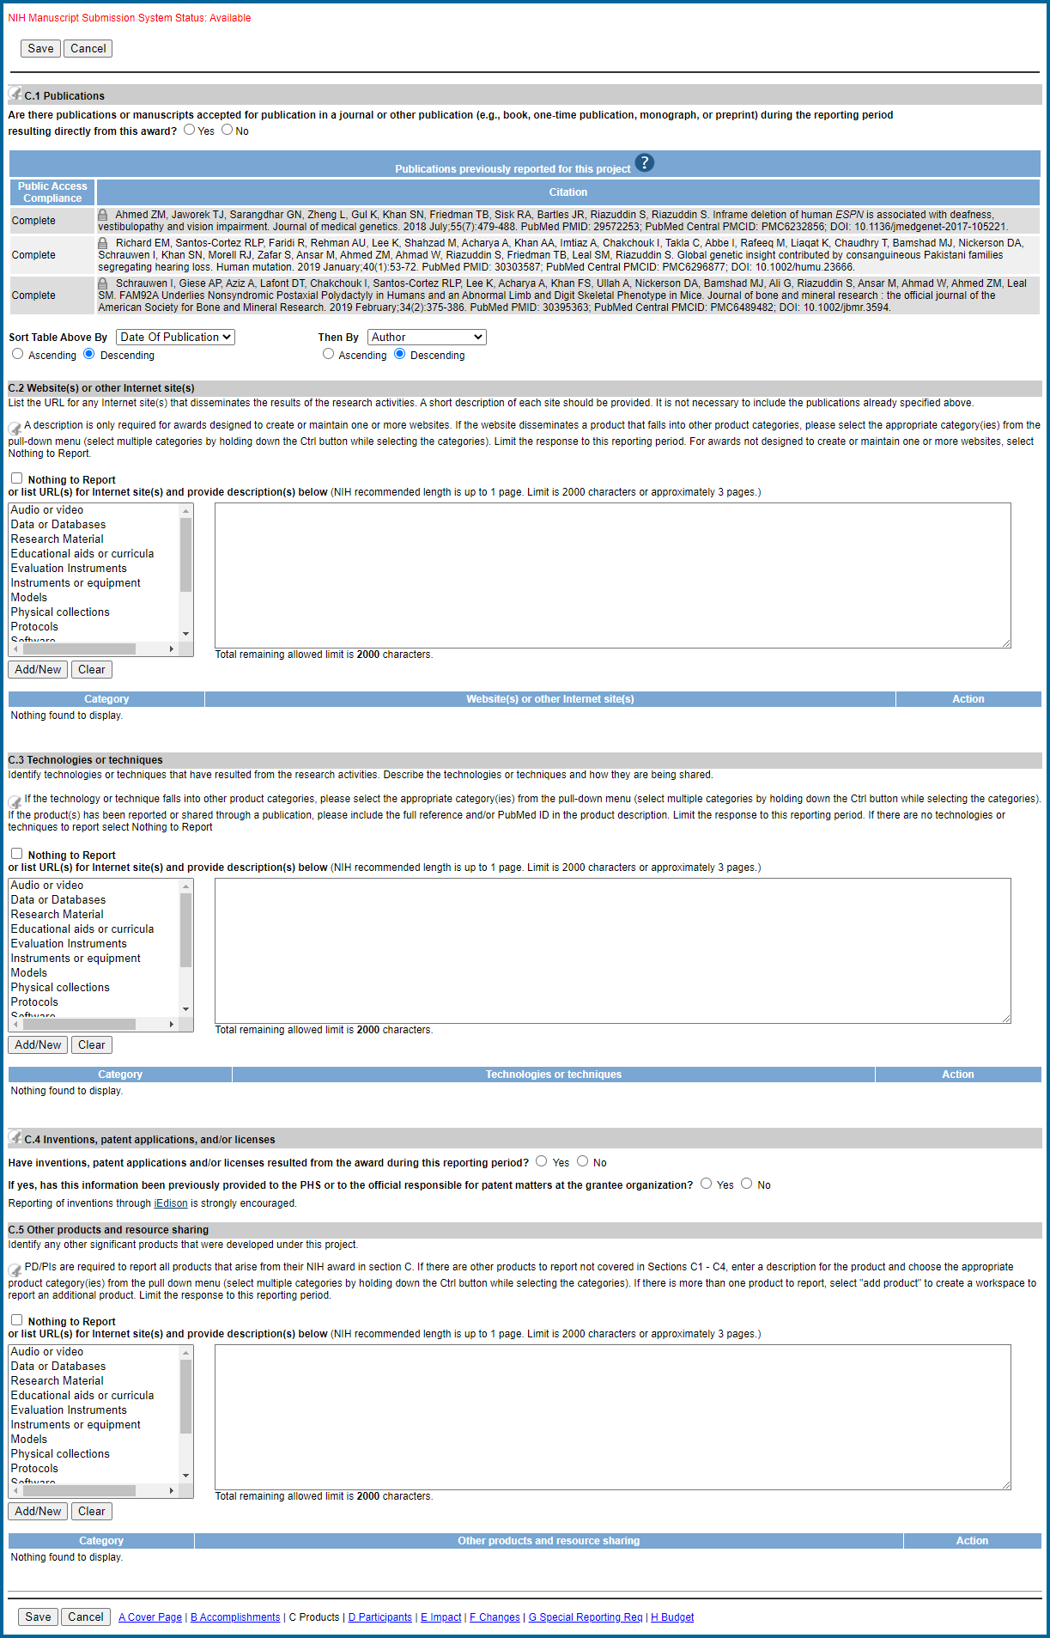

C1

C. Products (section C1)

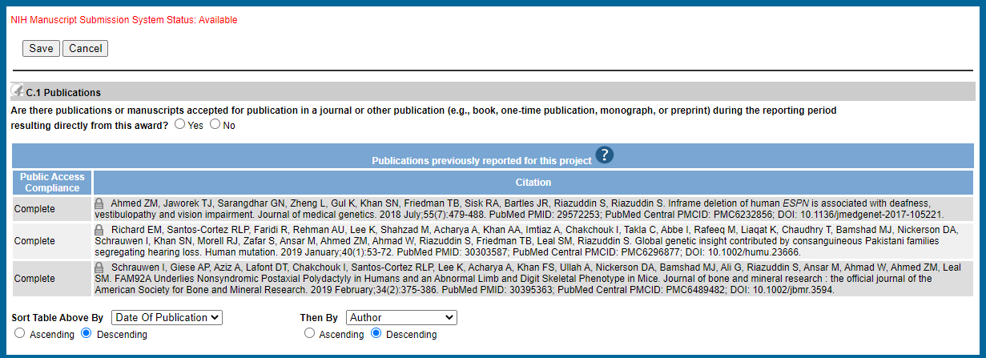

Proposed C2-5

C. Products (sections C2-C5)

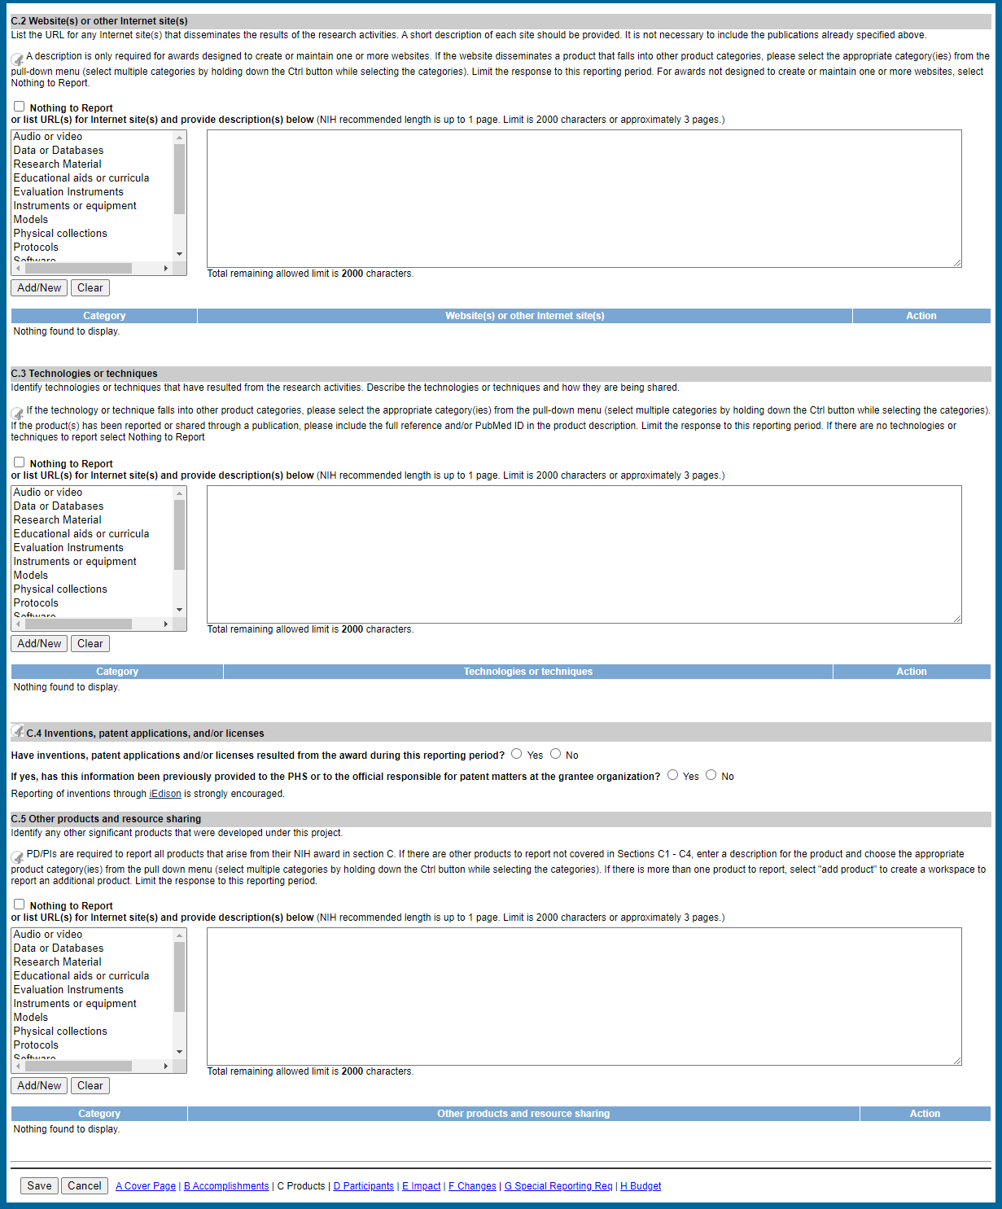

Section D – Participants

D. Participants (full screen)

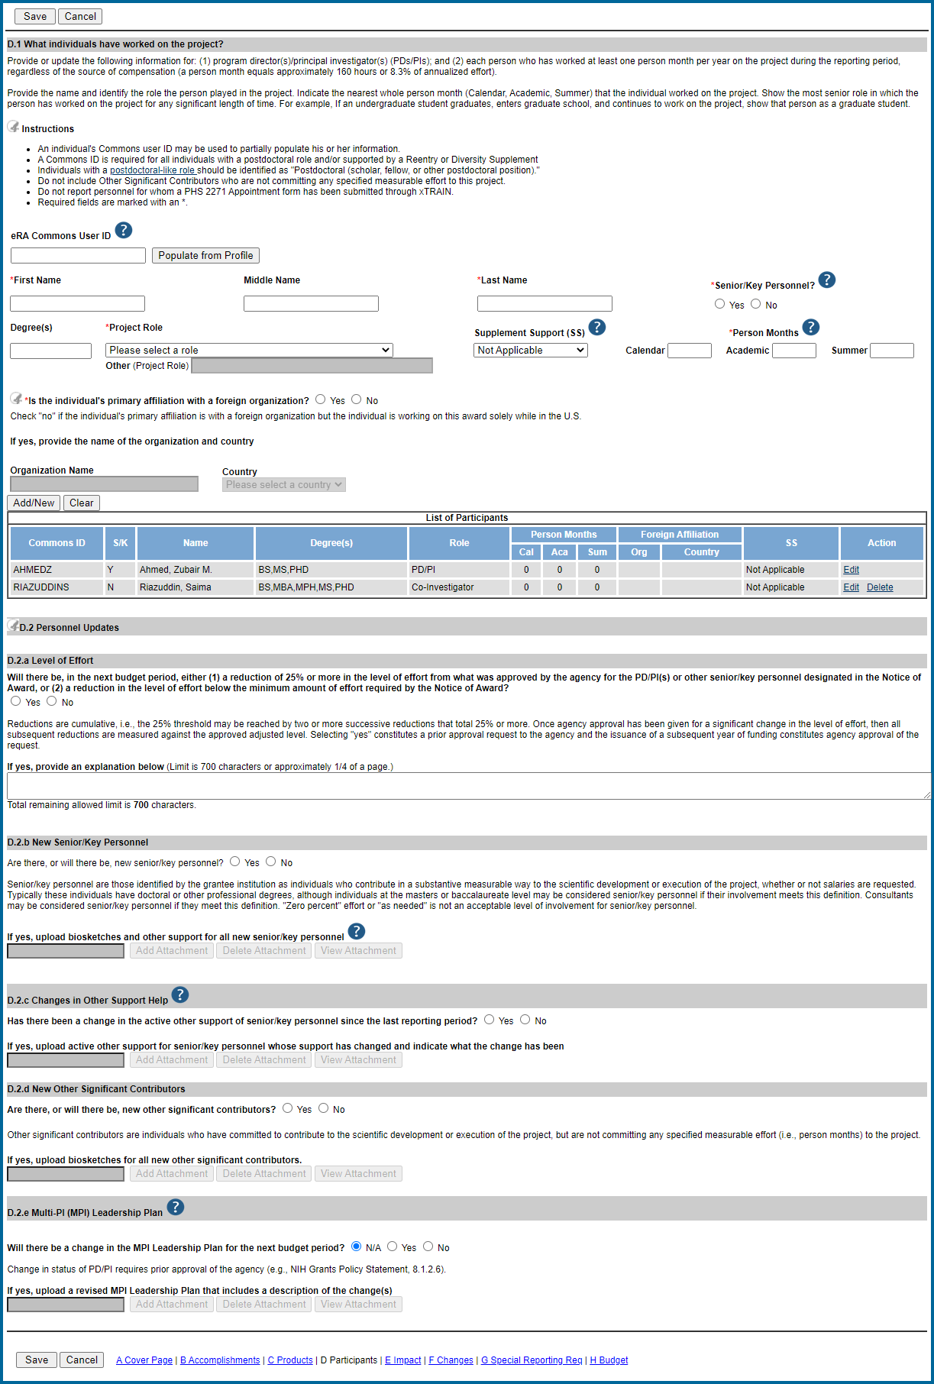

D1

D. Participants (section D1)

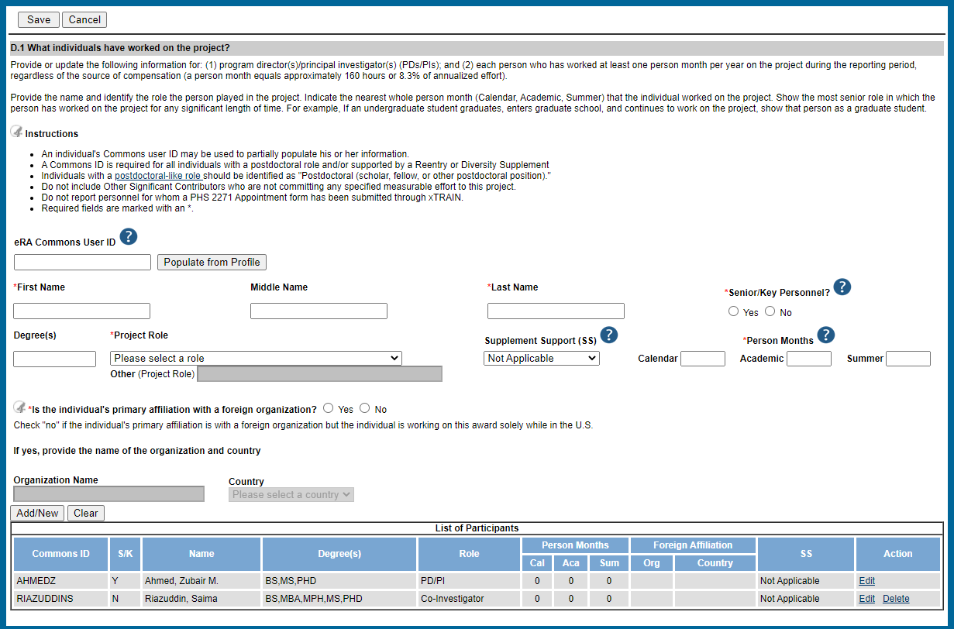

D2a-d

D. Participants (section D2, subsections a-d)

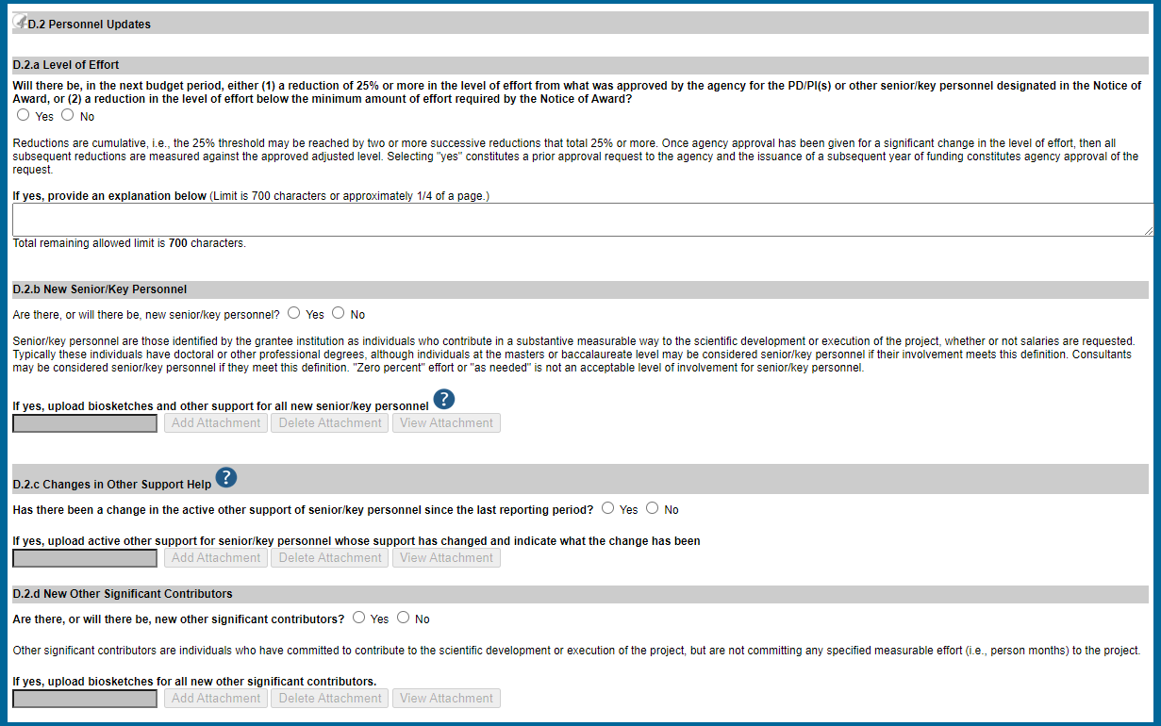

D2e

D. Participants (section D2, subsection e)

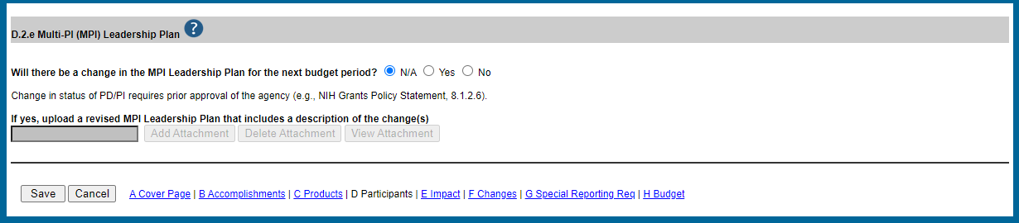

Section E - Impact

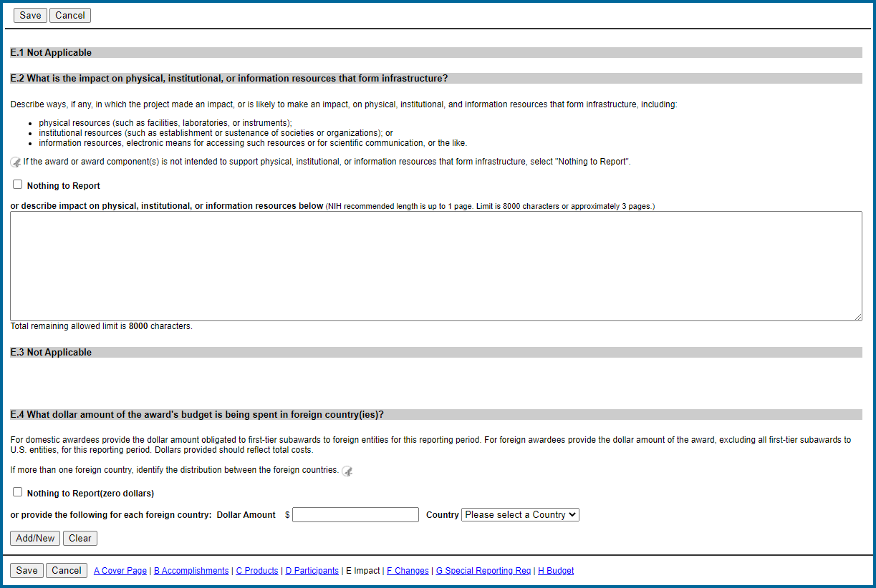

Section F - Changes

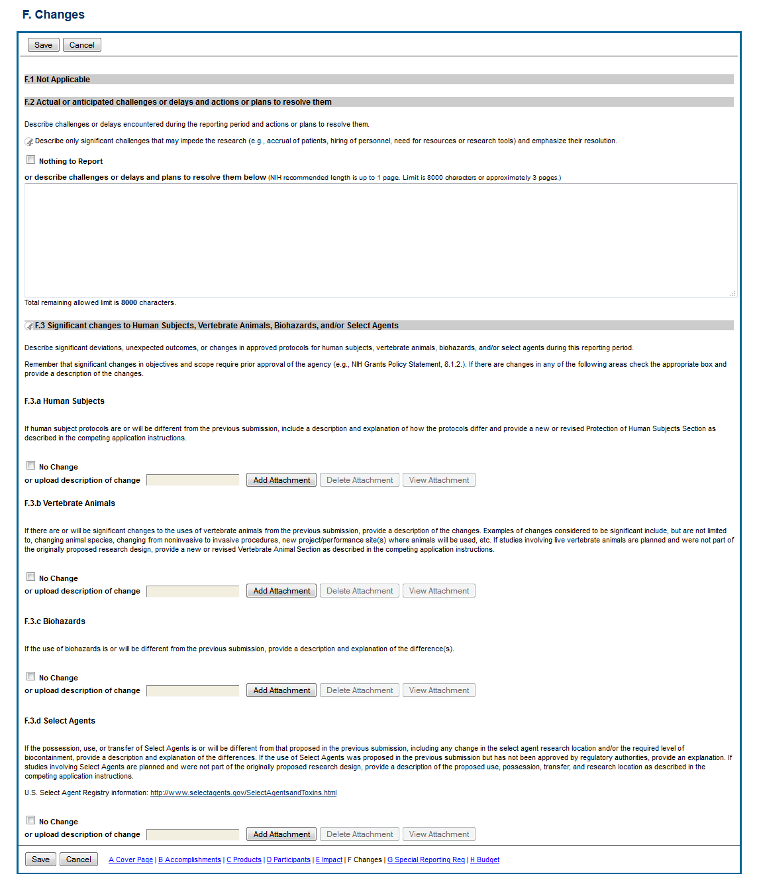

F1-2

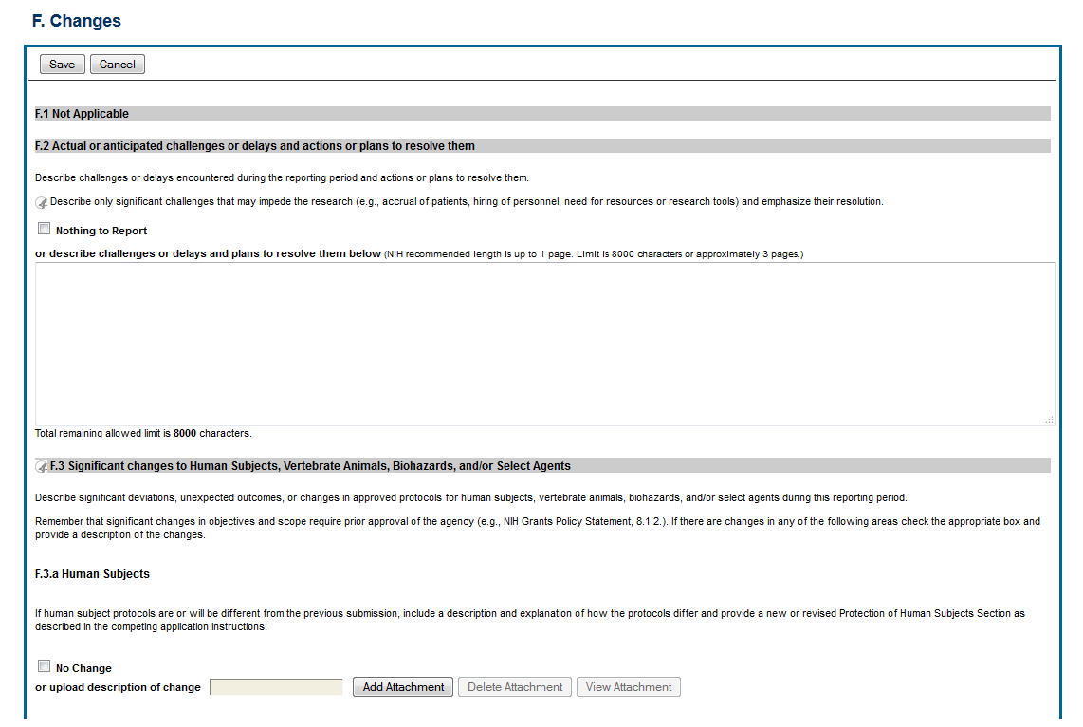

F3a-d

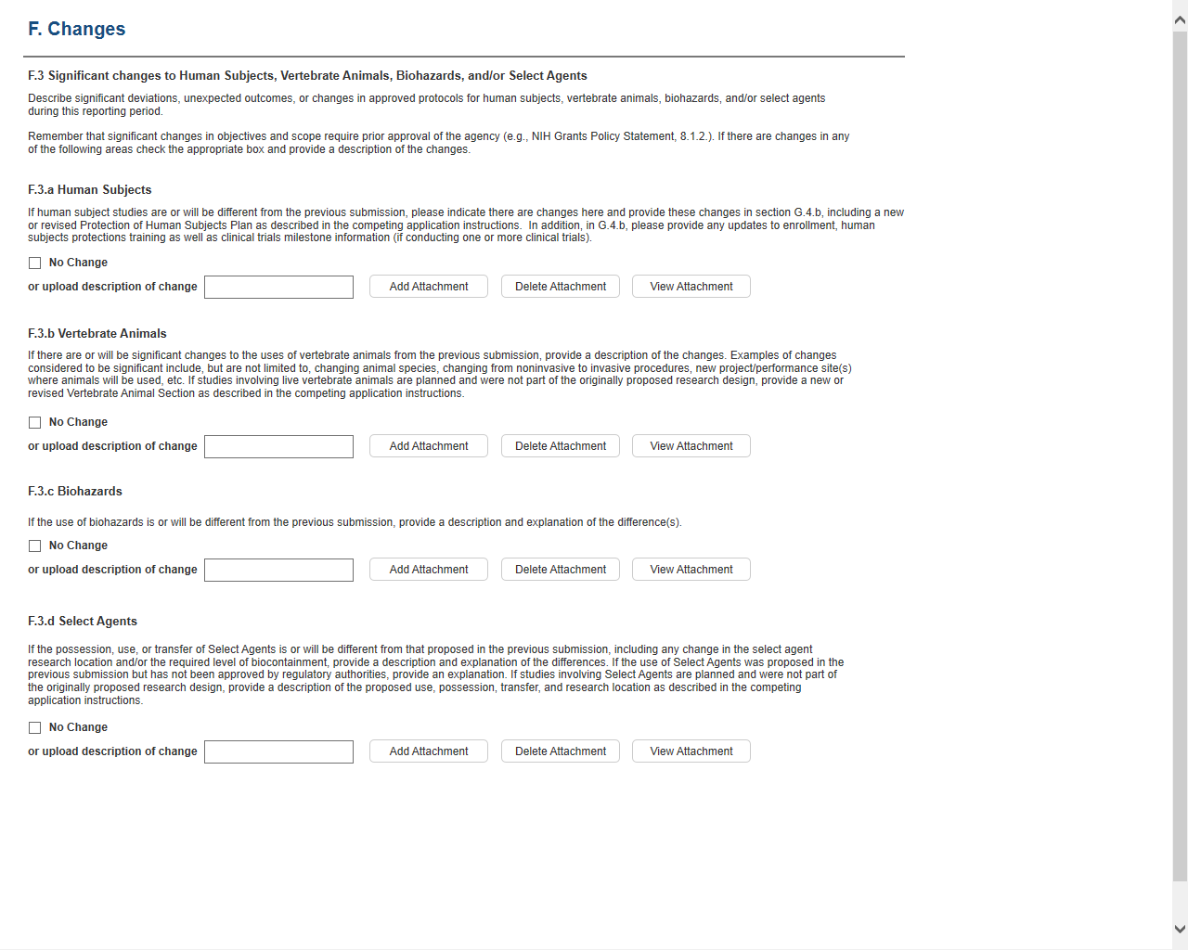Section G – Special Reporting

G. Special Reporting (full screen)

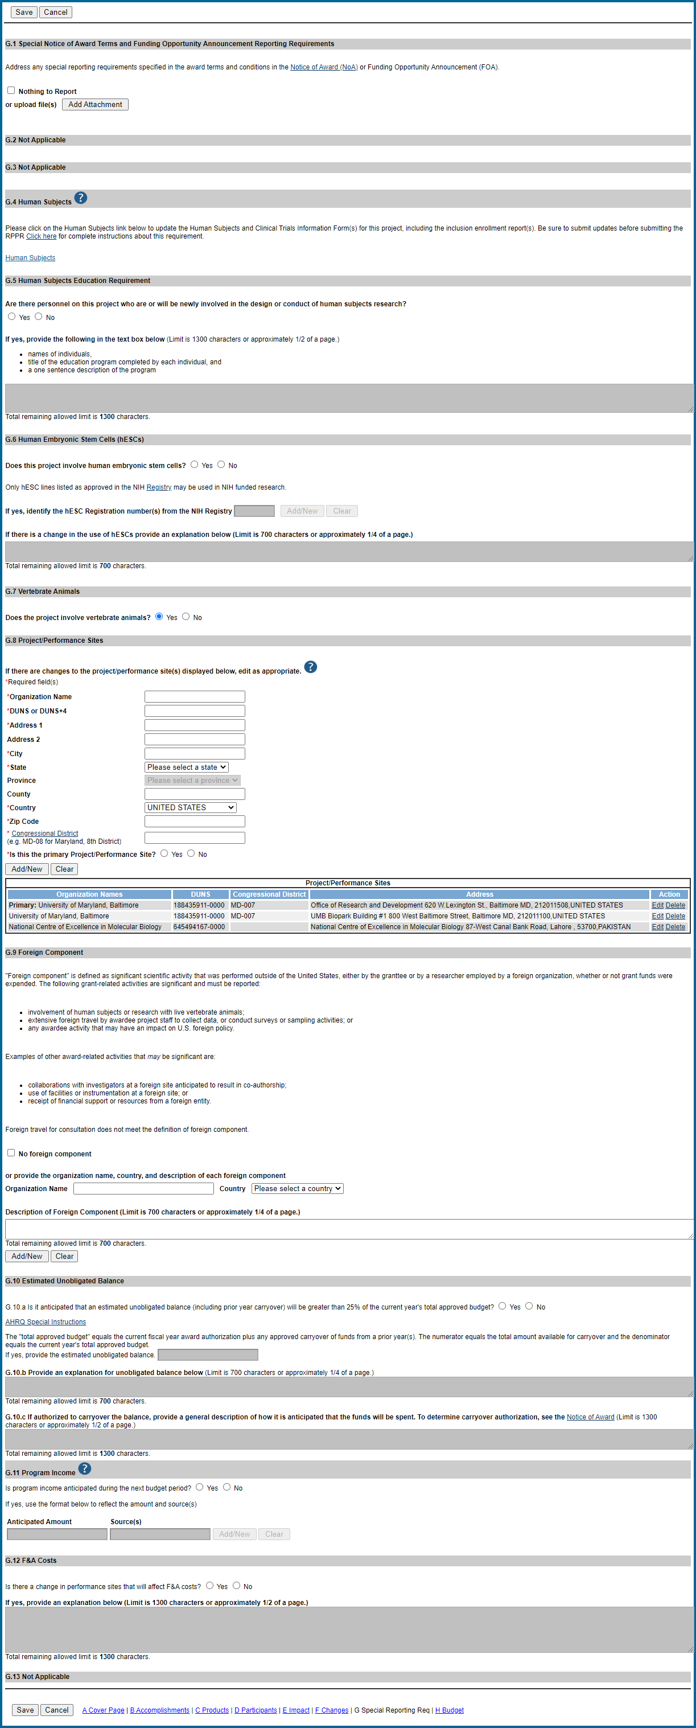

G1-3

G. Special Reporting (sections G1 – G3)

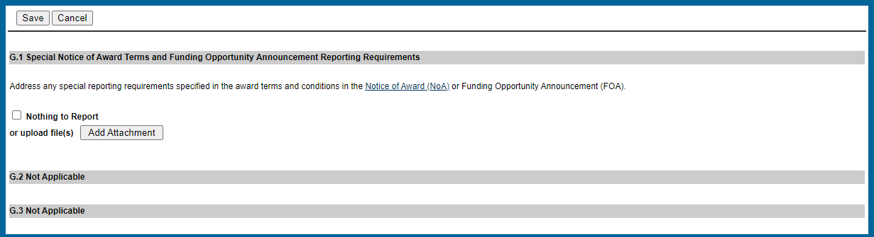

G4-5

G. Special Reporting (sections G4 – G5)

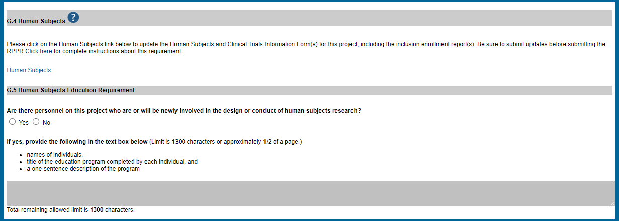

G6

G. Special Reporting (section G6)

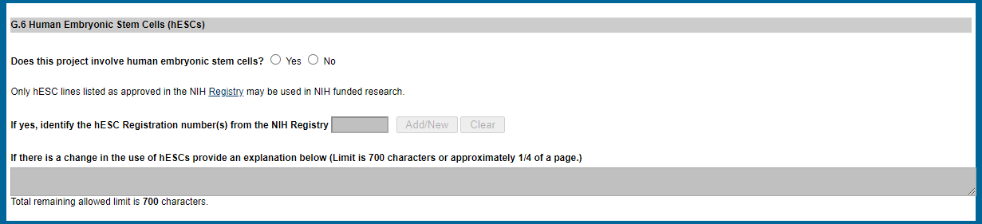

G7-8

G. Special Reporting (sections G7 – G8)

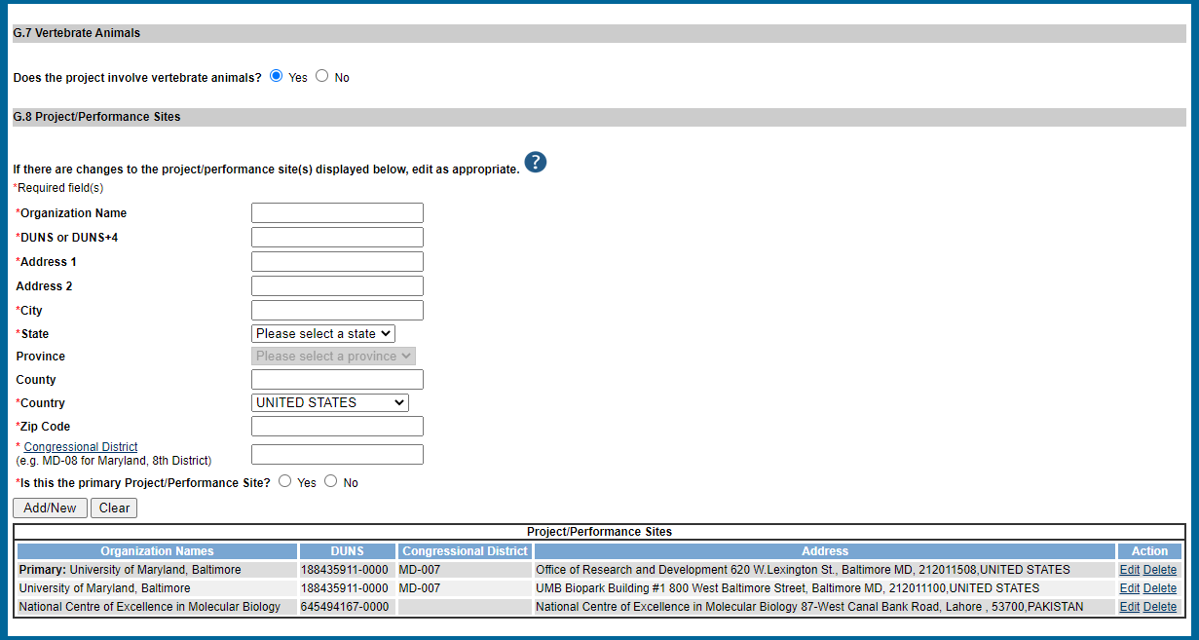

UEI

G9-10

G. Special Reporting (sections G9 – G10)

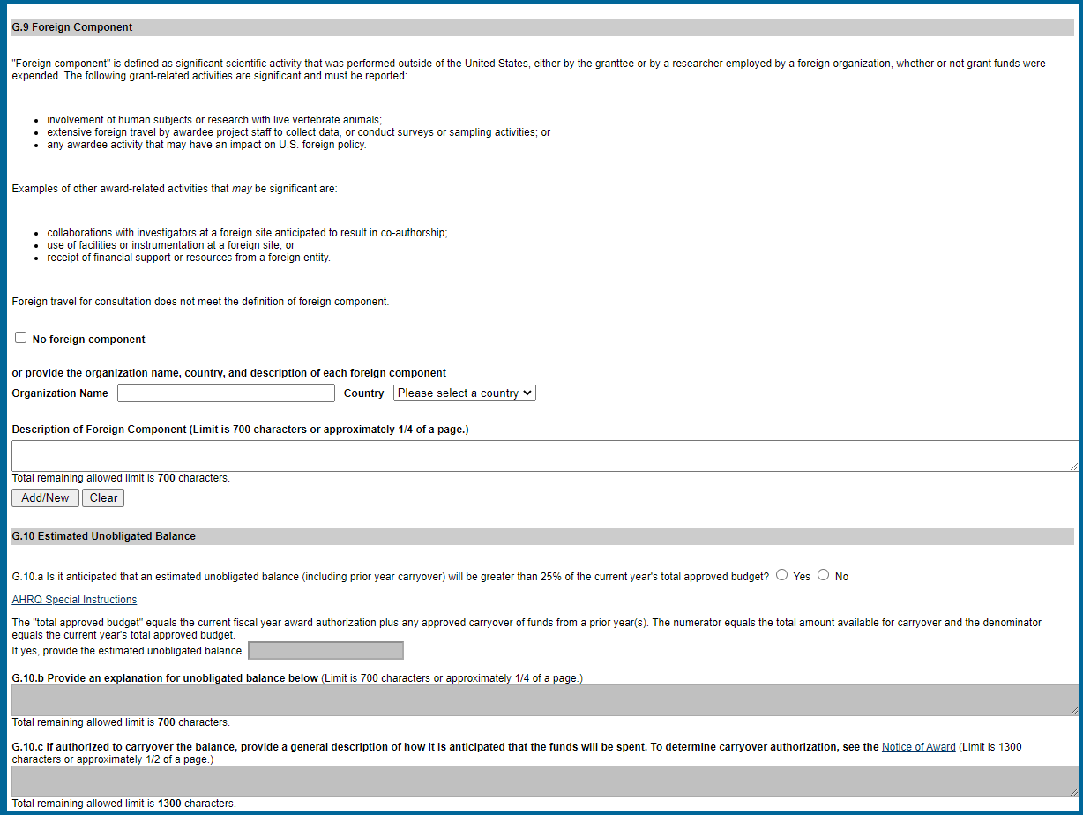

G11-G12

G. Special Reporting (sections G11 – G12)

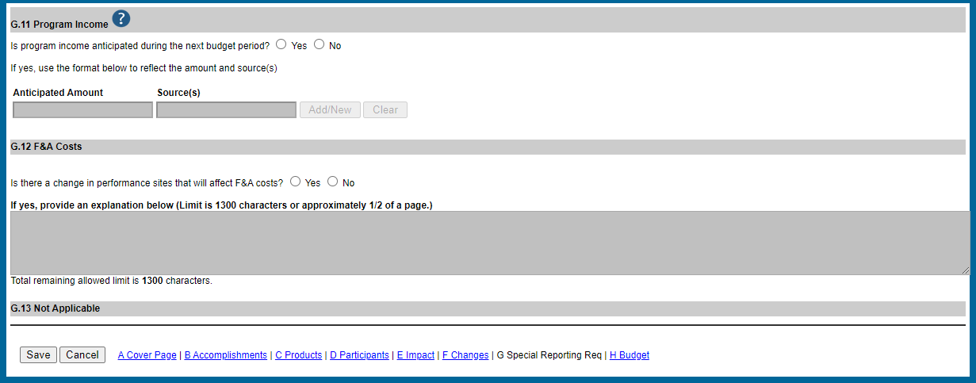

Section H - Budget

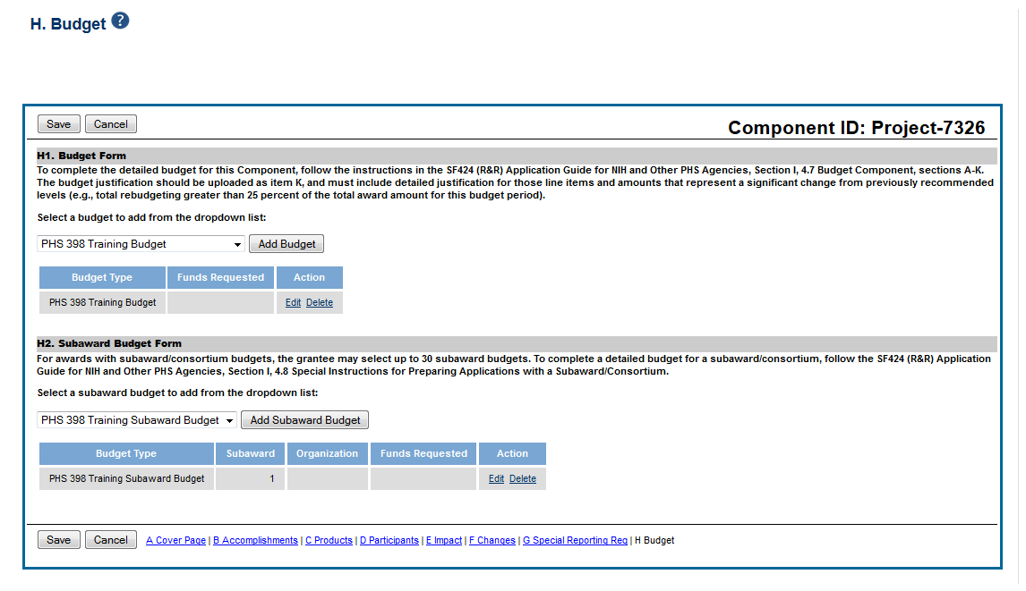

Section I - Outcomes

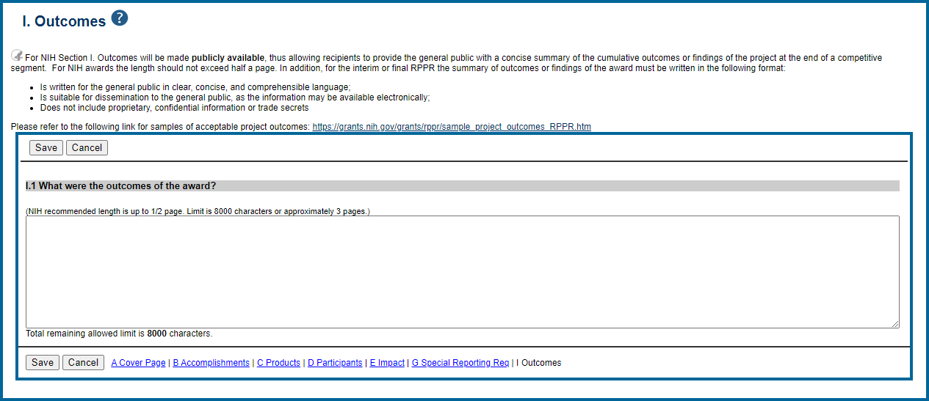

SF424 Budget

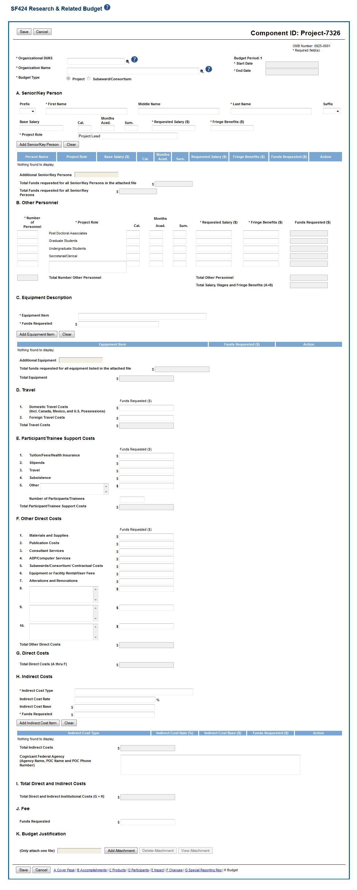

Organizational UEI

SF242 - A

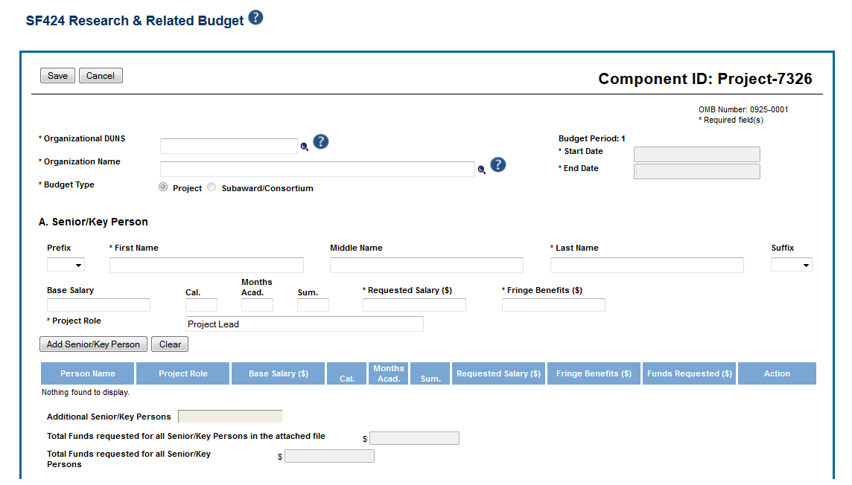

Organizational UEI

SF242 B-D

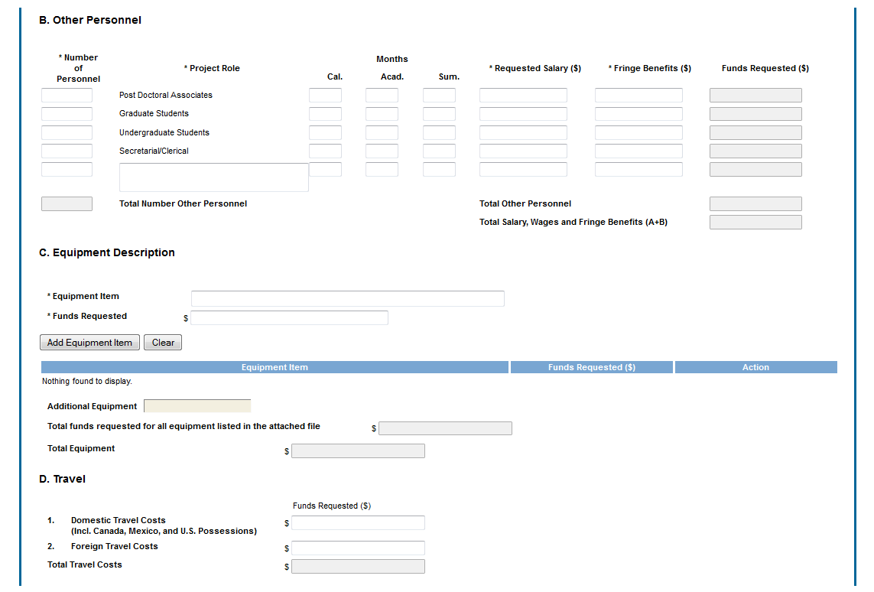

SF424 E-F

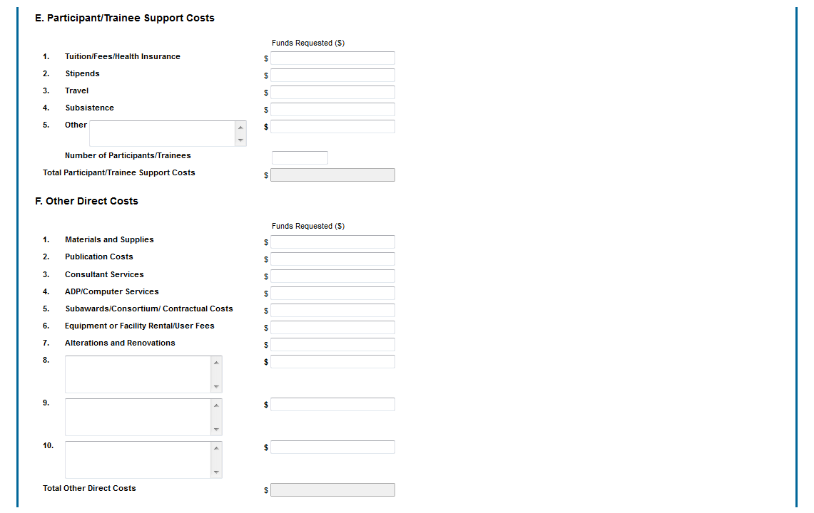

SF242 G-K

User Interface

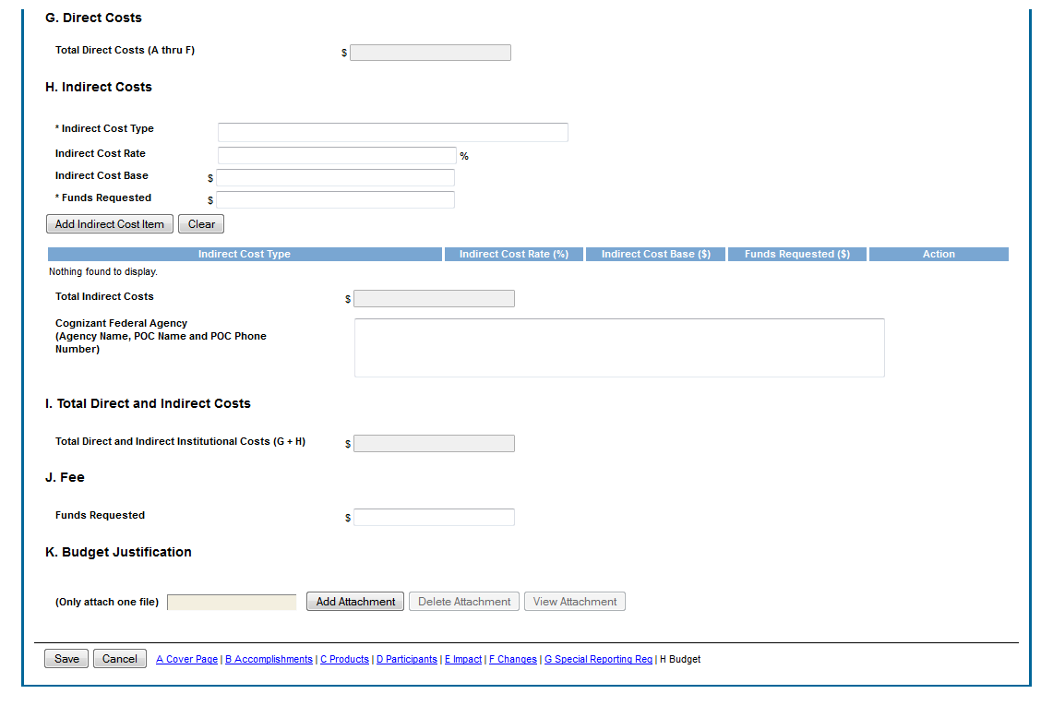

PHS398 Budget

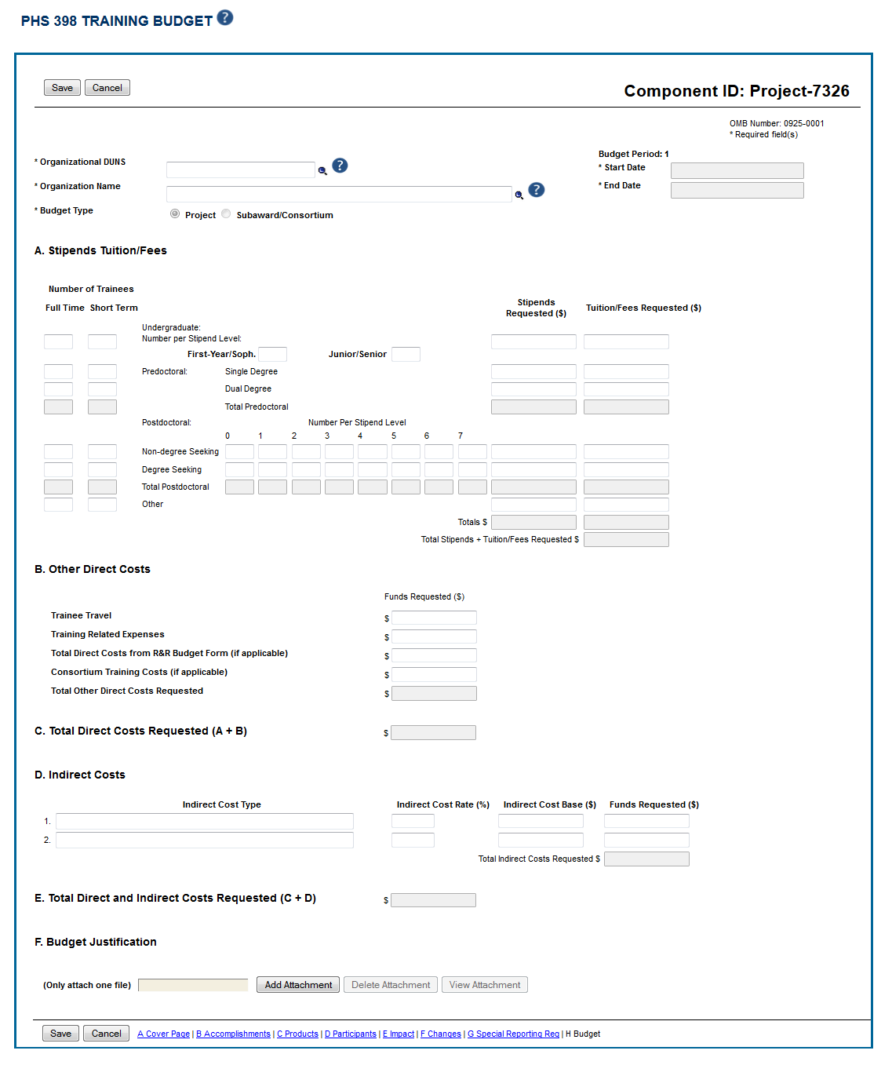

PHS398 - A

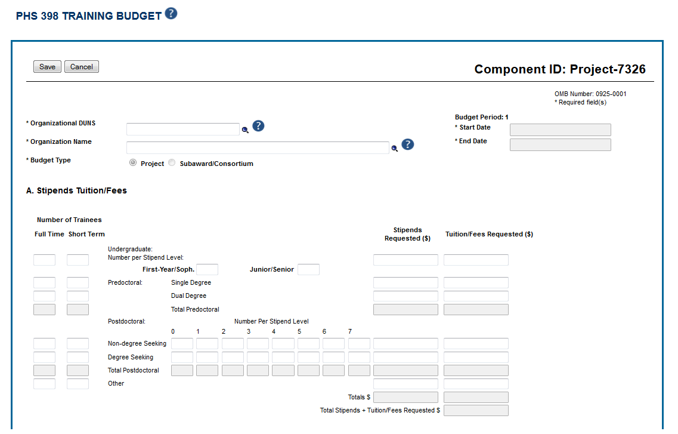

PHS398 - B

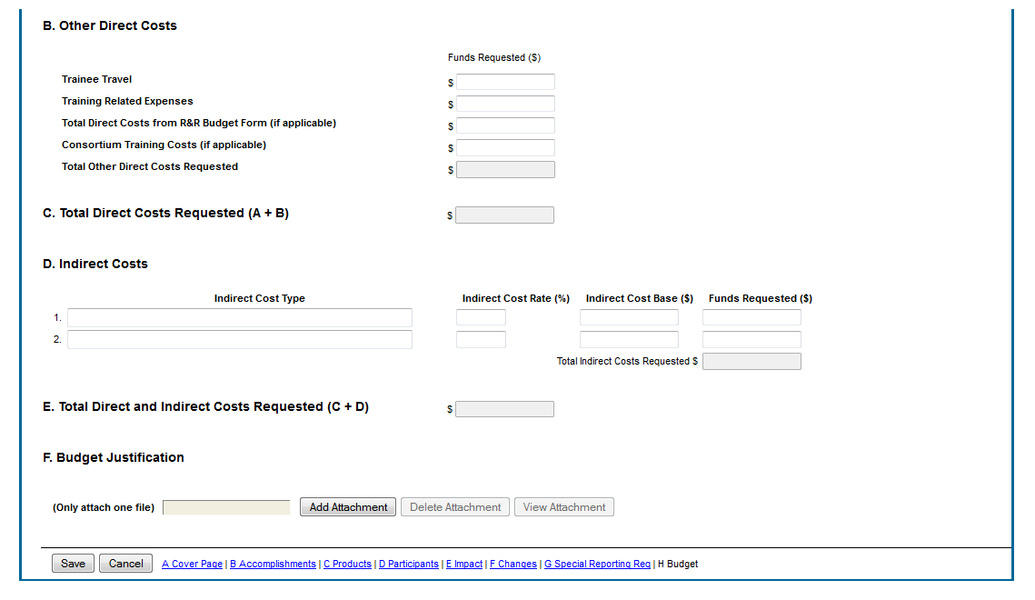

PHS398 Overall Budget

