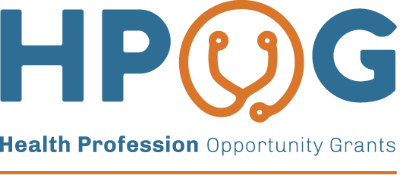 | 
<<Date>>
Dear <First Name><Middle Initial><Last Name>,
Thank you for agreeing to participate in the National Evaluation of the Health Profession Opportunity Grants (HPOG) Program. When you applied to participate in <PROGRAM NAME> at <Site> in <RAD> you signed a consent stating that you agreed to be part of a voluntary research study. The study is being funded by the Administration for Children and Families (ACF). ACF is part of the U.S. Department of Health and Human Services (HHS). Abt Associates is conducting the study for ACF.
The consent form you signed in <RAD> explained that researchers will want to conduct one or more future surveys with you. These surveys will help ACF sees how programs like <PROGRAM NAME> are working.
We are writing to let you know that we are getting ready to start the third of these follow-up surveys.
An interviewer from Abt Associates will contact you to explain the survey. If you want to do the survey, the interviewer will ask you to pick a time that is best for you to complete the interview.
- The survey will ask about experiences since we last spoke to you. It will also ask some multiple-choice questions on various topics.
You can choose whether to participate in this survey.
- We are interested in the experiences of everyone who applied to the HPOG program. Even if you were not selected to participate in the program, your experiences are important to this study.
Whether you choose to participate in the survey or not will not affect any assistance that you may receive now or in the future. If you choose to participate, any information you provide to us will be kept private to the extent allowed by law. Only the researchers involved in this study and related research will see your responses. Your name will not be associated with your responses.
This interview should take about 60 minutes. After you complete the survey, you will receive a gift certificate valued at $50 to thank you for your help with this important study.
If you have any questions or would like to schedule your interview, please call Abt Associates toll-free at 1-xxx-xxx-xxxx
Sincerely,
Brenda Rodriguez
Abt Associates - Survey Director
Paperwork Reduction Act (PRA) Statement: Your participation in this information collection is voluntary. An agency may not conduct or sponsor, and a person is not required to respond to, a collection of information unless it displays a currently valid OMB control number. The OMB control number for this collection is 0970-0462 and it expires xx/xx/xxxx. If you have comments regarding this collection of information, including suggestions for reducing this burden, please send them to Larry Buron 6130 Executive Boulevard Rockville, MD 20852; Attn: OMB-PRA (0970-0462).

